Tugas Pertemuan Minggu 4-5: Asumsi Regresi Linier Sederhana

Analisis Uji Ketidakpasan dan Uji Asumsi Regresi Linier Sederhana mengenai hubungan antara usia Height dan HandSpan pada data handheight

20 Maret 2024

# Membaca Data

handheight<-read.table("C:/Users/LENOVO/OneDrive/Documents/Learning R/Semester 2/handheight.txt", header = TRUE)  
head(handheight)

## Sex Height HandSpan  
## 1 Female 68 21.5  
## 2 Male 71 23.5  
## 3 Male 73 22.5  
## 4 Female 64 18.0  
## 5 Male 68 23.5  
## 6 Female 59 20.0

# Eksplorasi data

summary(handheight)

## Sex Height HandSpan   
## Length:167 Min. :57.00 Min. :16.00   
## Class :character 1st Qu.:65.00 1st Qu.:19.50   
## Mode :character Median :68.00 Median :21.00   
## Mean :68.07 Mean :20.86   
## 3rd Qu.:71.00 3rd Qu.:22.00   
## Max. :78.00 Max. :25.50

plot(handheight$Height, handheight$HandSpan, xlab="Height", ylab="HandSpan", pch=10)

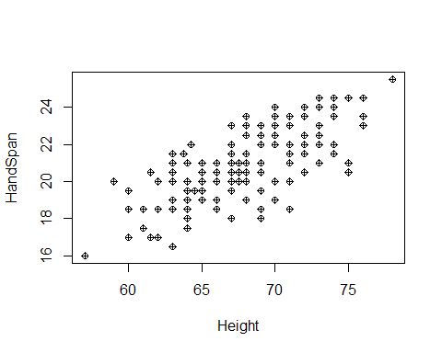

# Persamaan Regresi

model2 <- lm(HandSpan ~ Height, data = handheight)  
summary(model2)

##   
## Call:  
## lm(formula = HandSpan ~ Height, data = handheight)  
##   
## Residuals:  
## Min 1Q Median 3Q Max   
## -3.3888 -0.9348 0.0135 1.0365 2.6629   
##   
## Coefficients:  
## Estimate Std. Error t value Pr(>|t|)   
## (Intercept) -3.00161 1.69394 -1.772 0.0782 .   
## Height 0.35057 0.02484 14.113 <2e-16 ***  
## ---  
## Signif. codes: 0 '***' 0.001 '**' 0.01 '*' 0.05 '.' 0.1 ' ' 1  
##   
## Residual standard error: 1.301 on 165 degrees of freedom  
## Multiple R-squared: 0.5469, Adjusted R-squared: 0.5442   
## F-statistic: 199.2 on 1 and 165 DF, p-value: < 2.2e-16

# Asumsi 1: Rata-rata galat diasumsikan bernilai nol

plot(handheight$Height, handheight$HandSpan,   
 xlab="Height", ylab="HandSpan", pch=10,   
 main="Plot Uji Asumsi Rata-rata Galat bernilai nol")

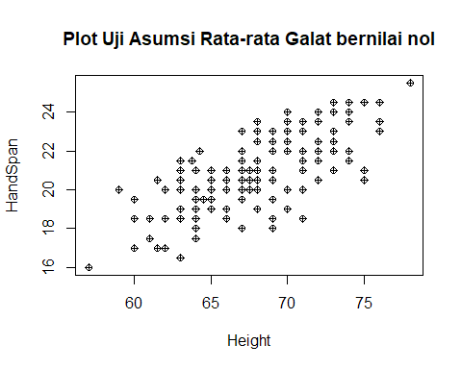

# Asumsi 2: Galat saling bebas

c <- (1:167)  
handheight <- cbind(handheight, c)  
head(handheight)

## Sex Height HandSpan c  
## 1 Female 68 21.5 1  
## 2 Male 71 23.5 2  
## 3 Male 73 22.5 3  
## 4 Female 64 18.0 4  
## 5 Male 68 23.5 5  
## 6 Female 59 20.0 6

plot(handheight$c, model2$residuals,  
 xlab = "amatan", ylab = "residuals", type = "l",  
 main = "Plot Uji Asumsi Galat Saling Bebas")

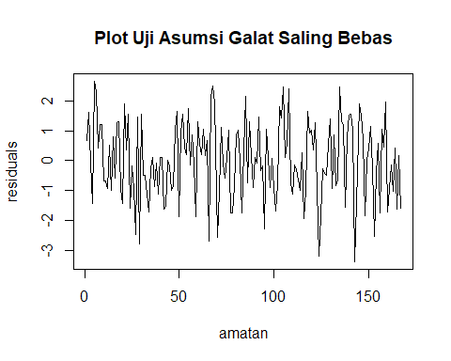

plot(handheight$c,model2$residuals,  
 xlab="Amatan",ylab="Residuals",  
 main="Plot Uji Asumsi Galat Saling Bebas")

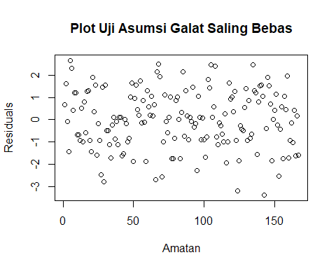

# Asumsi 3: Galat berdistribusi normal

c <- (1:167)  
ytopi <- model2$fitted.values  
ei <- model2$residuals  
eiterurut <- sort(model2$residuals)  
anova(model2)

## Analysis of Variance Table  
##   
## Response: HandSpan  
## Df Sum Sq Mean Sq F value Pr(>F)   
## Height 1 337.08 337.08 199.17 < 2.2e-16 ***  
## Residuals 165 279.25 1.69   
## ---  
## Signif. codes: 0 '***' 0.001 '**' 0.01 '*' 0.05 '.' 0.1 ' ' 1

hi<-sqrt(1.69)*qnorm((c-0.375)/(167+0.25))  
Hi<-cbind(handheight, ytopi, ei, eiterurut, hi)  
head(Hi)

## Sex Height HandSpan c ytopi ei eiterurut hi  
## 1 Female 68 21.5 1 20.83708 0.66291514 -3.388792 -3.477447  
## 2 Male 71 23.5 2 21.88879 1.61120802 -3.187654 -3.038280  
## 3 Male 73 22.5 3 22.58993 -0.08993006 -2.791068 -2.797719  
## 4 Female 64 18.0 4 19.43481 -1.43480870 -2.687654 -2.626440  
## 5 Male 68 23.5 5 20.83708 2.66291514 -2.584240 -2.491399  
## 6 Female 59 20.0 6 17.68196 2.31803650 -2.538223 -2.378873

plot(hi,eiterurut,  
 xlab="hi",ylab="eiterurut",  
 main="Plot Uji Galat Berdistribusi Normal")

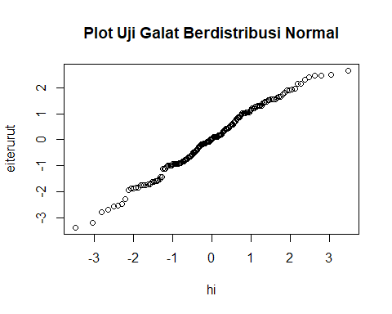

### Atau gunakan fungsi qqnorm dan qqline di R berikut

qqnorm(model2$residuals, ylab = "raw residuals")  
qqline(model2$residuals)

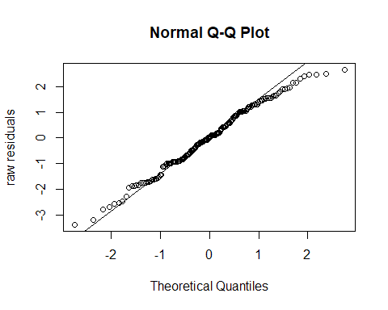

## Histogram

hist(model2$residuals, main="Histogram Uji Galat Berdistribusi Normal")

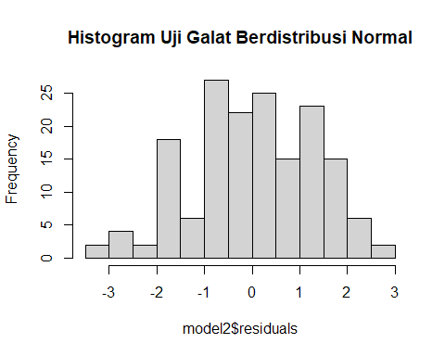

## Histogram untuk interval data = 167

hist(model2$residuals, 167, main="Histogram Uji Galat Berdistribusi Normal untuk Interval Data = 167")

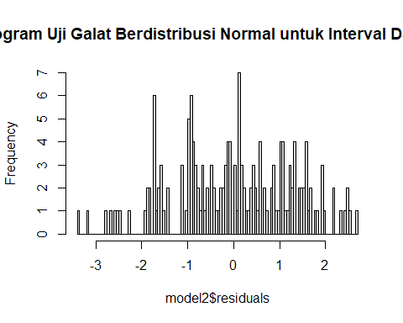

## Boxplot

boxplot(model2$residuals, main="Boxplot")

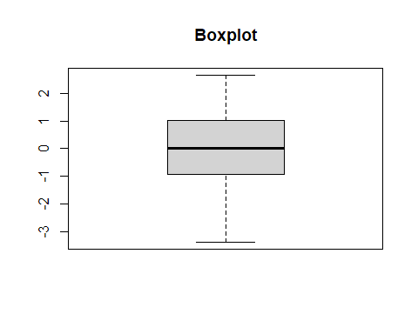

# Asumsi 4: Ragam galat diasumsikan konstan

ytopi<-model2$fitted.values  
ei<-model2$residuals  
plot(ytopi,ei,  
 xlab="fitted values", ylab="residuals",  
 main="Plot Uji Ragam Galat Konstan")

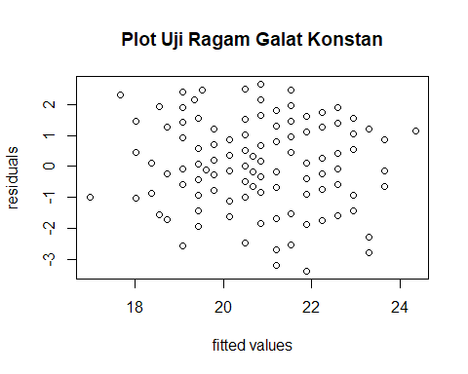

# Asumsi 5: X dan Y berhubungan linear

plot(handheight$Height, handheight$HandSpan, main="Plot Data")

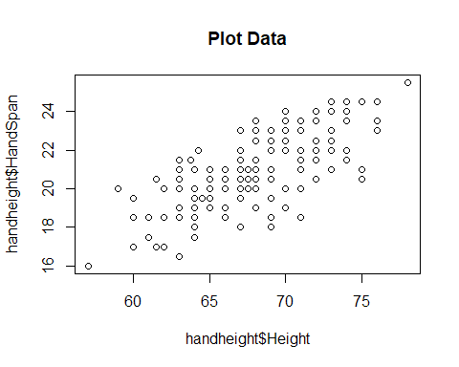

# Asumsi 6: Tidak ada outlier

plot(handheight$Height, handheight$HandSpan, main="Plot Data")



Nama Anggota

1. Fiki Vania Arun Fadila (23031030003)
2. Nariza Rahmadani Putri Mawardi (23031030012)
3. Sahda Huwaidah Estiningtyas (23031030019)
4. Sekar Ayu Nida Nur Afifah (23031030028)
5. Qurrota A’yun Zahirah (23031030029)