SR TAKAT
Gem & Jewellery Management System
Product Requirements Document (PRD)
Version 1.0 | Draft

1. Overview
SR TAKAT requires a purpose-built management system to replace spreadsheet-based tracking of gemstones, jewellery, and watch inventory. The core problem: expensive gemstones move from purchase, into lots/parcels, into finished jewellery and watches, out on memo to dealers, and finally to sale — and at every step the business needs to know exact cost, exact location, and exact profit, including the company's 20% charity allocation.
This document defines the product scope, data model, business rules, and module breakdown for Version 1.

1.1 Goals
- Full traceability: know which gemstone or lot went into which finished product.
- Accurate costing: material + production + other costs rolled up into total cost, selling price, gross profit, charity, and net profit.
- Real-time inventory status across gemstones, lots, materials, and finished goods.
- Memo/consignment tracking with overdue visibility for stock currently outside the company.
- Full audit trail for every inventory movement, costing change, and approval.

1.2 Non-Goals (Out of Scope for V1)
- Full accounting / general ledger
- HR and payroll
- CRM marketing automation
- AI chatbot
- RFID (QR/barcode only for V1)

1.3 User Roles
Role | Access
Admin | Full access to all modules, settings, user management
Manager | Approve costing, release/close memos, complete sales, view all reports
Workshop / Staff | Update job cards and production status only; no inventory value edits, no costing approval

2. Application Flow
Purchase → Inventory → Product Creation → Costing → Approval → Sales / Memo → Profit & Charity → Reports

3. Modules

3.1 Dashboard
Answers one question: what is happening in the company right now.
Card | Purpose
Total Gemstones | Stones in inventory
Jewellery Stock | Finished jewellery
Watch Stock | Finished watches
Inventory Cost | Money invested
Selling Value | Potential sales value
On Memo | Products with clients/dealers (split: On Time / Overdue)
Gross Profit | Profit before charity
Charity Allocation | 20% of profit
Net Profit | Company profit

- Recent Stock
- Low Stock / Missing Certificate
- Products On Memo (overdue highlighted)
- Recent Sales
- Pending Production

3.2 Gemstone Inventory
Gemstones are tracked as individual stones or as lots/parcels. A gemstone record includes: Stone ID, Stock No., type, variety, origin, shape, carat, pieces, colour, clarity, treatment, purchase price, cost/carat, supplier, certificate, location, and status.

Stone status lifecycle
In Stock → Reserved → In Production → On Memo → Sold (also: Returned / Damaged / Missing)

3.3 Gemstone Lots & Parcels
Not every stone is individually tracked. Melee and parcel stones are grouped into a lot (e.g. 159 pieces / 3.09 total carats / $3,000 cost) under a Lot ID such as LOT-EM-0025.
Business Rule — Lot Reduction: stock is deducted from a lot by carat weight only. Piece count on a lot is an estimated/informational field, not used in stock calculations, since melee is weighed rather than counted precisely at issue time.
The system automatically reduces gemstone/lot stock when stones are issued to production.

3.4 Jewellery & Watch Products
Each finished item is a single product record with nested components, giving full traceability back to source gemstones, lots, and materials.
Component | Source | Qty | Weight
Centre Emerald | GEM-001 | 1 pcs | 1.32 ct
Emerald Lot | LOT-EM-25 | 159 pcs (est.) | 2.00 ct issued
Diamond Lot | LOT-DIA-10 | 69 pcs (est.) | 0.25 ct
14K White Gold | Metal Stock | — | 10.19 g
Alligator Strap | Component | 1 | —

3.5 Product Creation / Manufacturing
Job workflow: Design → Materials Issued → Manufacturing → Stone Setting → Polishing → QC → Completed.
Field | Example
Job No. | JOB-0021
Product | Emerald Watch
Start Date | 10 Jul
Assigned To | Workshop A
Status | Stone Setting
Expected Date | 25 Jul

Business Rule — Material Return: every job card material line records qty issued, qty used, and qty returned, with a wastage_type of Returned to Stock / Scrap Recovery / Write-off. Scrap gold is tracked in a separate Scrap Gold Stock bucket rather than merged back into clean metal stock.

3.6 Costing Engine
Cost components: Material Cost (gemstone, diamond, gold, watch components, strap, other) + Production Cost (CAD, casting, stone setting, polishing, assembly, QC) + Other Cost (certificate, shipping, insurance, packaging, marketing, commission).
Percentage-based line items may be calculated against Material Cost, Production Cost, Total Cost, Selling Price, or Gross Profit.
Business Rule — Fixed Calculation Order (prevents circular references):
Material Cost → Production Cost → Other Cost → Total Cost → Selling Price → Gross Profit → Charity (20%) → Net Profit.
Any cost or commission expressed as "% of Selling Price" is applied as a post-selling-price adjustment, never fed back into Total Cost.

3.7 Price & Profit
Field | Example
Total Cost | $10,000
Selling Price | $18,000
Gross Profit | $8,000
Charity (20% of Profit) | $1,600
Net Company Profit | $6,400

Business Rule — Charity %: configurable in Settings, but each transaction stores the percentage used at that time. Changing the company-wide charity setting later never recalculates historical records.

3.8 Memo / Consignment
Field | Value
Memo No. | MEM-0021
Client | ABC Jewellery
Item | Emerald 5.42 ct
Value | $25,000
Date Out | 10 July
Return Date | 25 July
Status | With Client → Returned / Sold / Extended

Business Rule — Overdue Alert: if the current date passes Return Date and status is still "With Client", the system automatically flags the memo as Overdue. Dashboard shows total memo value split into On Time vs Overdue.

3.9 Sales
Select Customer → Add Products/Stones → Discount → Final Price → Payment → Complete Sale.
On completion: gemstone/jewellery status → Sold, inventory reduces, profit and charity calculate, invoice generates.

3.10 Customers & Suppliers
Single contact system. Customer profile: name, company, country, phone, email, WhatsApp, customer type (Private Client / Dealer / Wholesaler / VIP), notes, purchase history, memo history, outstanding amount, total business.
Supplier profile: gemstone purchases, metal purchases, components, outstanding payments.

3.11 Certificates & Documents
Attachable to any gemstone or product: certificate PDF, invoice, supplier invoice, images, videos, CAD files. Certificate fields: Lab (GIA / GRS / SSEF / Gübelin / IGI / Other), Certificate Number, Issue Date, Report Type, PDF. Includes Certificate Missing alert.
Business Rule — File Storage: certificates and images are stored in external cloud storage (S3 / Cloudinary / Drive); the database stores only the reference URL, following a fixed naming convention, e.g. GEM-000124_GRS2026001.pdf.

3.12 Barcode / QR Code
Every item receives a unique code (GEM-0001, JWL-0001, WAT-0001). Scanning opens the product record. QR/barcode for V1 — RFID deferred to a later version.

3.13 Inventory Movement
Every valuable item has a movement history rather than a single overwritten location field, giving a full audit trail, e.g.: Purchased → Hong Kong Vault → Issued to Workshop → Returned → On Memo to Client → Returned → Sold.

3.14 Reports
Report | Purpose
Inventory Valuation | Current investment
Gemstone Stock | Available stones
Jewellery Stock | Finished products
Memo Report | Stock outside the company
Sales Report | Sales performance
Profit Report | Gross / net profit
Charity Report | 20% allocation
Product Cost Report | Cost breakdown
Stock Movement | Item history
Supplier Purchase | Purchase analysis

3.15 Settings
Centralized configuration: Charity %, base currency, ID prefixes (GEM- / JWL- / WAT- / LOT-), certificate lab list, user roles.

3.16 Audit Log
A single activity_log table records: user, action, entity_type, entity_id, timestamp, old_value, new_value — written to from every module (inventory, costing, memo, sales), rather than scattered per-module logs.

4. Cross-Cutting Business Rules
- Multi-currency: every transaction stores base currency, original currency, and exchange rate at the time of the transaction. Reports roll up to a company-wide base currency set in Settings.
- Roles/permissions: Admin / Manager / Workshop-Staff, enforced at the module level; costing approval and memo release restricted to Manager and above.
- Costing calculation order is fixed (see 3.6) to avoid circular percentage references.
- Charity percentage is snapshotted per transaction (see 3.7).
- Lot stock is reduced by carat weight only (see 3.3).
- Material wastage is categorized on return (see 3.5).
- Memo overdue status is calculated automatically, not manually set (see 3.8).
- Certificates/images live in external storage, referenced by URL (see 3.11).
- All create/update/delete actions on inventory, costing, memo, and sales write to the Audit Log (see 3.16).

5. Application Menu
- Dashboard
- Inventory — Gemstones, Jewellery, Watches, Materials
- Production — Job Cards, Work in Progress
- Costing
- Memos
- Sales
- Contacts
- Certificates
- Reports
- Settings
- Audit Log

6. Entity Relationship Diagram
The diagram below shows the core entities and relationships underpinning the modules above — see the accompanying ERD file for a full-resolution version.
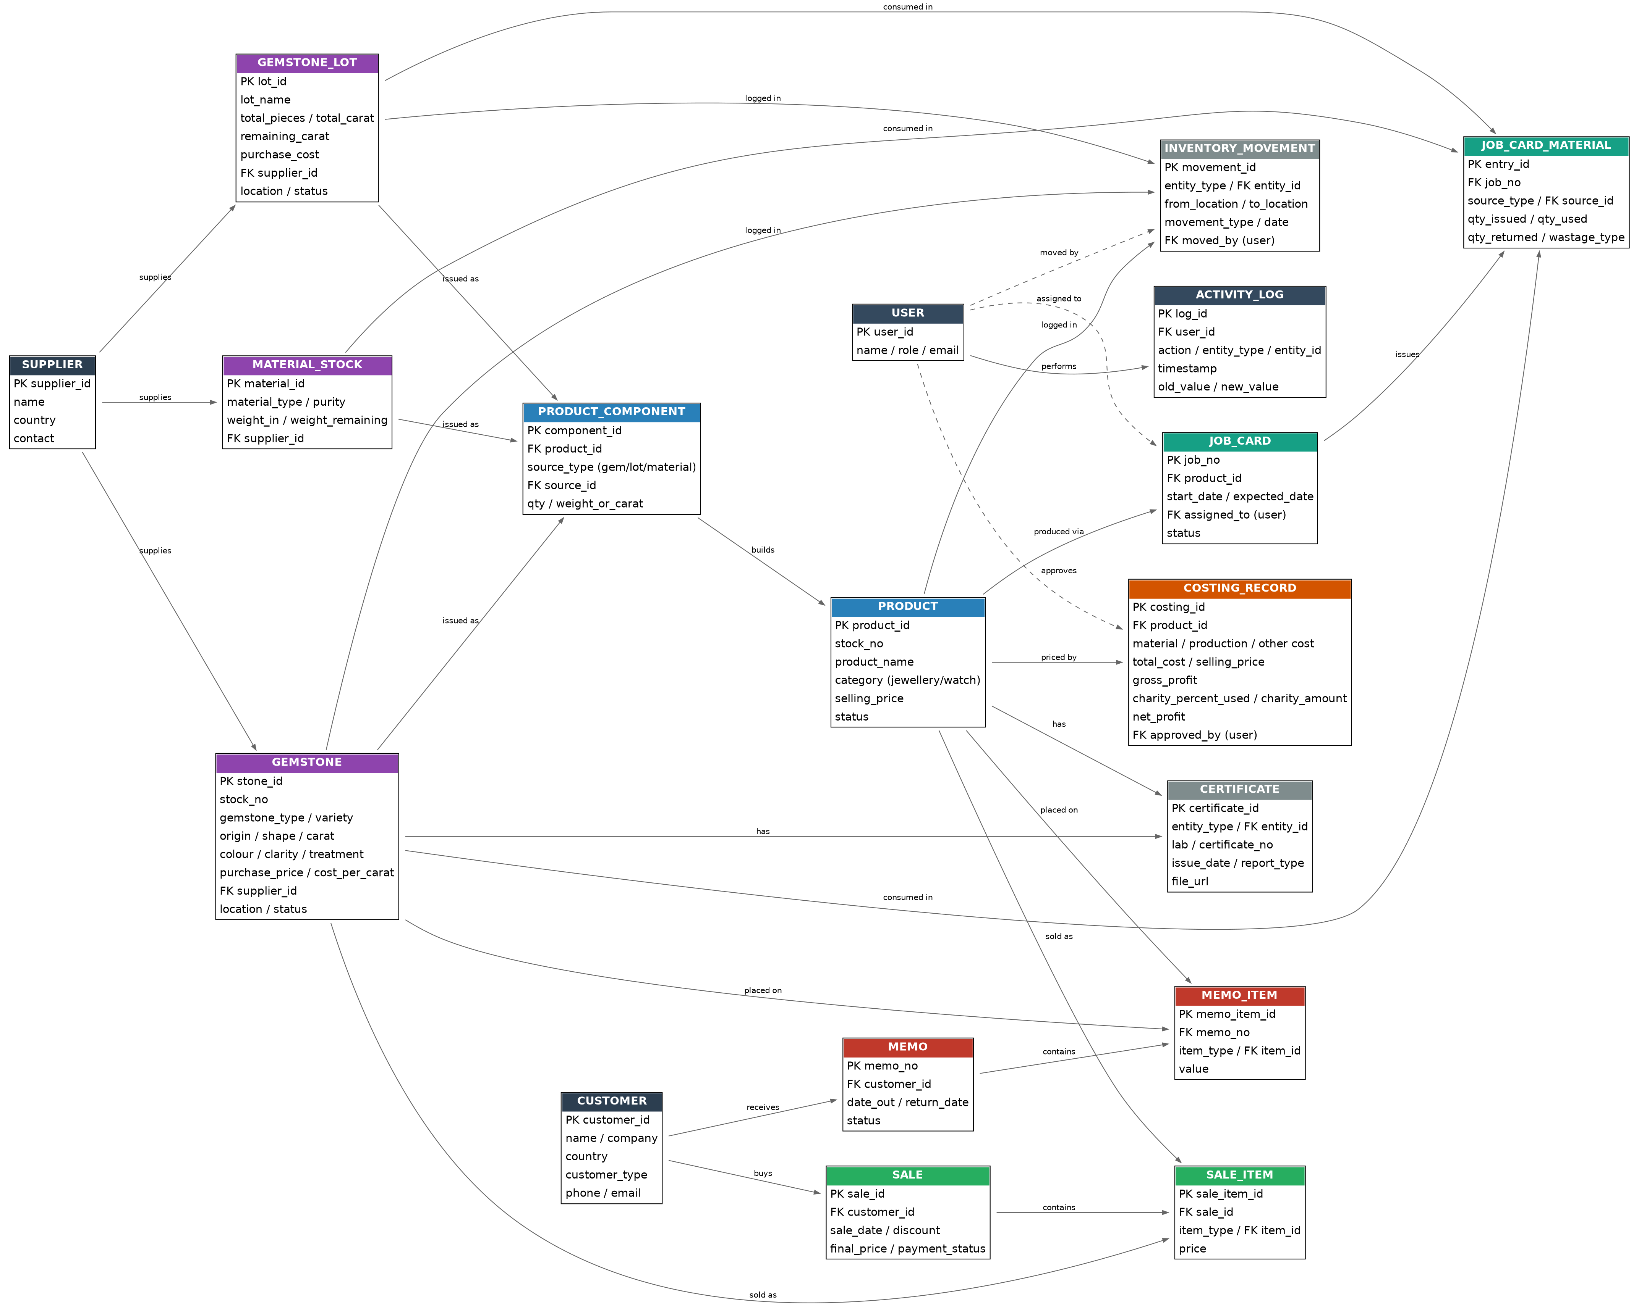

7. Open Questions
- Confirm base currency and which secondary currencies must be supported at launch.
- Confirm exchange rate source: manual entry vs. live API.
- Confirm whether commission/other-cost percentages should ever apply against Selling Price, or should always be Total-Cost-based.
- Confirm cloud storage provider for certificates/images (S3 / Cloudinary / Google Drive) given existing product photography volume.
- Confirm whether Version 1 needs multi-location (Hong Kong / India / Dubai / Paris) stock segregation in reporting, or a single pooled inventory view.

