**ANNEX**

# Clause 49 - Corporate Governance

**The company agrees to comply with the following provisions:**

## I. Board of Directors A. Composition of Board

(i) The board of directors of the company shall have an o combination of executive and non-executive directors with n than fifty percent of the board of directors comprising of non-ex directors. The number of independent directors would depe whether the Chairman is executive or non-executive. In case of executive chairman, at least one-third of board should comp independent directors and in case of an executive chairman, half of board should comprise of independent directors.

**Explanation (i):** For the purpose of this clause, the exp ‘independent director’ shall mean non-executive director company who

1. apart from receiving director’s remuneration, does not have any ma pecuniary relationships or transactions with the company, its promo its senior management or its holding company, its subsidiaries and associated companies;
2. is not related to promoters or management at the board level or at o level below the board;
3. has not been an executive of the company in the immediately prece three financial years;
4. is not a partner or an executive of the statutory audit firm or the inte audit firm that is associated with the company, and has not been a p or an executive of any such firm for the last three years. This will als

apply to legal firm(s) and consulting firm(s) that have a material association with the entity.

1. is not a supplier, service provider or customer of the company. This should include lessor-lessee type relationships also; and
2. is not a substantial shareholder of the company, i.e. owning two per more of the block of voting shares.

**Explanation (ii):** Institutional directors on the boards of com shall be considered as independent directors whether the instit an investing institution or a lending institution.

## (B) Non executive directors’ compensation and disclosures

(i) All compensation paid to non-executive directors shall be fixed Board of Directors and shall be approved by shareholders in g meeting. Limits shall be set for the maximum number of stock optio can be granted to non-executive directors in any financial year aggregate. The stock options granted to the non-executive directo vest after a period of at least one year from the date such non-ex directors have retired from the Board of the Company.

(ii)The considerations as regards compensation paid independent director shall be the same as those applied to executive director.

(iii)The company shall publish its compensation philosoph statement of entitled compensation in respect of non-ex directors in its annual report. Alternatively, this may be put up company’s website and reference drawn thereto in the annual Company shall disclose on an annual basis, details of shares non-executive directors, including on an "if-converted" basis.

(iv)Non-executive directors shall be required to disclose thei holding (both own or held by / for other persons on a beneficia in the listed company in which they are proposed to be appoin directors, prior to their appointment. These details should acco their notice of appointment

## (C) Independent Director

1. Independent Director shall however periodically review legal compli reports prepared by the company as well as steps taken by the com to cure any taint. In the event of any proceedings against an indepe director in connection with the affairs of the company, defence shall permitted on the ground that the independent director was unaware responsibility.
2. The considerations as regards remuneration paid to an independen director shall be the same as those applied to a non executive direc

## (D) Board Procedure

1. The board meeting shall be held at least four times a year, with a maximum time gap of four months between any two meetings. The minimum information to be made available to the board is given in Annexure–IA.
2. A director shall not be a member in more than 10 committees or act Chairman of more than five committees across all companies in wh is a director. Furthermore it should be a mandatory annual requirem every director to inform the company about the committee positions occupies in other companies and notify changes as and when they place.

**Explanation:** For the purpose of considering the limit committees on which a director can serve, all public companies, whether listed or not, shall be included and a companies (i e private limited companies, foreign compani companies under Section 25 of the Companies Act, etc) s excluded.

1. Further only the three committees viz. the Audit Committee, the Shareholders’ Grievance Committee and the Remuneration Commi shall be considered for this purpose.

## (E) Code of Conduct

1. It shall be obligatory for the Board of a company to lay down the cod conduct for all Board members and senior management of a compa

This code of conduct shall be posted on the website of the company

1. All Board members and senior management personnel shall affirm compliance with the code on an annual basis. The annual report of company shall contain a declaration to this effect signed by the CEO COO.

**Explanation:** For this purpose, the term "senior managemen mean personnel of the company who are members management / operating council (i.e. core management excluding Board of Directors). Normally, this would comp members of management one level below the executive directo

## (F) Term of Office of Non–executive directors

i. Person shall be eligible for the office of non-executive director so lo the term of office did not exceed nine years in three terms of three y each, running continuously.

**II Audit Committee.**

## A. Qualified and Independent Audit Committee

A qualified and independent audit committee shall be set up an comply with the following:

1. The audit committee shall have minimum three members. All the members of audit committee shall be non-executive directors, with t majority of them being independent.
2. All members of audit committee shall be financially literate and at le one member shall have accounting or related financial managemen expertise.

**Explanation (i):**The term "financially literate" means the ability t and understand basic financial statements i.e. balance sheet, pro loss account, and statement of cash flows.

**Explanation (ii**): A member will be considered to have accoun related financial management expertise if he or she possesses exp in finance or accounting, or requisite professional certifica accounting, or any other comparable experience or background results in the individual’s financial sophistication, including being or been a chief executive officer, chief financial officer, or other senior with financial oversight responsibilities.

1. The Chairman of the Committee shall be an independent director;
2. The Chairman shall be present at Annual General Meeting to answe shareholder queries;
3. The audit committee should invite such of the executives, as it cons appropriate (and particularly the head of the finance function) to be present at the meetings of the committee, but on occasions it may a meet without the presence of any executives of the company. The f director, head of internal audit and when required, a representative external auditor shall be present as invitees for the meetings of the committee; vi. The Company Secretary shall act as the secretary to the committee

## (B) Meeting of Audit Committee

The audit committee shall meet at least thrice a year. One meetin be held before finalization of annual accounts and one every six m The quorum shall be either two members or one third of the mem the audit committee, whichever is higher and minimum of two indep directors.

## (C) Powers of Audit Committee

The audit committee shall have powers which should inclu following:

1. To investigate any activity within its terms of reference.
2. To seek information from any employee.
3. To obtain outside legal or other professional advice.
4. To secure attendance of outsiders with relevant expertise, if it consi necessary.

## (D) Role of Audit Committee

(i) The role of the audit committee shall include the following:

1. Oversight of the company’s financial reporting process and the disc of its financial information to ensure that the financial statement is c sufficient and credible.
2. Recommending the appointment and removal of external auditor, fix of audit fee and also approval for payment for any other services.
3. Reviewing with management the annual financial statements before submission to the board, focusing primarily on;
4. Any changes in accounting policies and practices.
5. Major accounting entries based on exercise of judgment by manage
6. Qualifications in draft audit report.
7. Significant adjustments arising out of audit.
8. The going concern assumption.
9. Compliance with accounting standards.
10. Compliance with stock exchange and legal requirements concerning financial statements
11. Any related party transactions
12. Reviewing with the management, external and internal auditors, the adequacy of internal control systems.
13. Reviewing the adequacy of internal audit function, including the stru of the internal audit department, staffing and seniority of the official heading the department, reporting structure coverage and frequenc internal audit.
14. Discussion with internal auditors any significant findings and follow there on.
15. Reviewing the findings of any internal investigations by the internal auditors into matters where there is suspected fraud or irregularity o failure of internal control systems of a material nature and reporting matter to the board.
16. Discussion with external auditors before the audit commences abou nature and scope of audit as well as post-audit discussion to ascert area of concern.
17. Reviewing the company’s financial and risk management policies.
18. To look into the reasons for substantial defaults in the payment to th depositors, debenture holders, shareholders (in case of non payme declared dividends) and creditors.

**Explanation (i):** The term "related party transactions" shall ha same meaning as contained in the Accounting Standard 18, R Party Transactions, issued by The Institute of Chartered Acco of India.

**Explanation (ii):** If the company has set up an audit com pursuant to provision of the Companies Act, the company agre the said audit committee shall have such additional func features as is contained in the Listing Agreement.

## (E) Review of information by Audit Committee

(i) The Audit Committee shall mandatorily review the following informatio

1. Financial statements and draft audit report, including quarterly / half financial information;
2. Management discussion and analysis of financial condition and resu operations;
3. Reports relating to compliance with laws and to risk management;
4. Management letters / letters of internal control weaknesses issued b statutory / internal auditors; and
5. Records of related party transactions
6. The appointment, removal and terms of remuneration of the Chief in auditor shall be subject to review by the Audit Committee

**III. Audit Reports and Audit Qualifications**

## A. Disclosure of Accounting Treatment

In case it has followed a treatment different from that prescribed Accounting Standards, management shall justify why they believe alternative treatment is more representative of the underlined bu transactions. Management shall also clearly explain the alternative acc treatment in the footnote of financial statements.

### IV. Whistle Blower Policy

**(A) Internal Policy on access to Audit Committees:**

1. Personnel who observe an unethical or improper practice (not nece a violation of law) shall be able to approach the audit committee wit necessarily informing their supervisors.
2. Companies shall take measures to ensure that this right of access i communicated to all employees through means of internal circulars, The employment and other personnel policies of the company shall contain provisions protecting "whistle blowers" from unfair terminatio other unfair prejudicial employment practices.
3. Company shall annually affirm that it has not denied any personnel to the audit committee of the company (in respect of matters involvi alleged misconduct) and that it has provided protection to "whistle blowers" from unfair termination and other unfair or prejudicial employment practices.
4. Such affirmation shall form a part of the Board report on Corporate Governance that is required to be prepared and submitted together the annual report.
5. The appointment, removal and terms of remuneration of the chief in auditor shall be subject to review by the Audit Committee.

### V. Subsidiary Companies

1. The company agrees that provisions relating to the composition of t Board of Directors of the holding company shall be made applicable composition of the Board of Directors of subsidiary companies
2. At least one independent director on the Board of Directors of the h company shall be a director on the Board of Directors of the subsidi company.
3. The Audit Committee of the holding company shall also review the financial statements, in particular the investments made by the subs company.
   1. The minutes of the Board meetings of the subsidiary company splaced for review at the Board meeting of the holding company.
   2. The Board report of the holding company should state that thereviewed the affairs of the subsidiary company also

### VI. Disclosure of contingent liabilities

(i) The company agrees that management shall provide a description in plain English of each material contingent liability risks, which shall be accompanied by the auditor’s clearly comments on the management’s view. This section sh highlighted in the significant accounting policies and no accounts, as well as, in the auditor’s report, where necessary.

**VII. Disclosures**

# (A) Basis of related party transactions

(i) A statement of all transactions with related parties includin basis shall be placed before the Audit Committee for

approval/ratification. If any transaction is not on an arm’s length management shall provide an explanation to the Audit Com justifying the same.

# (B) Board Disclosures –Risk management

1. It shall put in place procedures to inform Board members abrisk assessment and minimization procedures. These proc shall be periodically reviewed to ensure that executive manag controls risk through means of a properly defined framework.
2. Management shall place a report certified by the complianceof the company, before the entire Board of Directors every documenting the business risks faced by the company, meas address and minimize such risks, and any limitations to the risk capacity of the corporation. This document shall be formally ap by the Board.

# (C) Proceeds from Initial Public Offerings (IPOs)

(i) When money is raised through an Initial Public Offering ( shall disclose to the Audit Committee, the uses / applications o by major category (capital expenditure, sales and marketing, w capital, etc), on a quarterly basis as a part of their qu declaration of financial results. Further, on an annual bas company shall prepare a statement of funds utilized for pu other than those stated in the offer document/prospectus statement shall be certified by the independent auditors

company. The audit committee shall make appr recommendations to the Board to take up steps in this matter.

# (D) Remuneration of Directors

a. All pecuniary relationship or transactions of the non-executive direc vis-à-vis the company shall be disclosed in the Annual Report.

(ii) Further the following disclosures on the remuneration of d shall be made in the section on the corporate governance annual report.

1. All elements of remuneration package of all the directors i.e. salary, benefits, bonuses, stock options, pension etc.
2. Details of fixed component and performance linked incentives, alon the performance criteria.
3. Service contracts, notice period, severance fees.
4. Stock option details, if any – and whether issued at a discount as w the period over which accrued and over which exercisable.

## (E) Management

i. As part of the directors’ report or as an addition there to, a Managem Discussion and Analysis report should form part of the annual repor shareholders. This Management Discussion & Analysis should inclu discussion on the following matters within the limits set by the comp competitive position:

1. Industry structure and developments.
2. Opportunities and Threats.
3. Segment–wise or product-wise performance.
4. Outlook
5. Risks and concerns.
6. Internal control systems and their adequacy.
7. Discussion on financial performance with respect to operational performance.
8. Material developments in Human Resources / Industrial Relations fr including number of people employed.

Management shall make disclosures to the board relating to all m financial and commercial transactions, where they have personal intere may have a potential conflict with the interest of the company at large ( dealing in company shares, commercial dealings with bodies, whic shareholding of management and their relatives etc.)

## (F) Shareholders

(i) In case of the appointment of a new director or re-appointme director the shareholders must be provided with the following inform

1. A brief resume of the director;
2. Nature of his expertise in specific functional areas ; and
3. Names of companies in which the person also holds the directorship the membership of Committees of the board.
   1. Information like quarterly results, presentation made by compaanalysts shall be put on company’s web-site, or shall be sent in form so as to enable the stock exchange on which the company is l put it on its own web-site.
   2. A board committee under the chairmanship of a non-executive d shall be formed to specifically look into the redressal of sharehold investors complaints like transfer of shares, non-receipt of balance non-receipt of declared dividends etc. This Committee shall be des as ‘Shareholders/Investors Grievance Committee’.

(iv)To expedite the process of share transfers the board company shall delegate the power of share transfer to an offic committee or to the registrar and share transfer agent delegated authority shall attend to share transfer formalities a once in a fortnight.

### VIII. CEO/CFO certification

i. CEO (either the Executive Chairman or the Managing Director) and CFO (whole-time Finance Director or other person discharging this function) of the company shall certify that, to the best of their knowle and belief:

1. They have reviewed the balance sheet and profit and loss account a its schedules and notes on accounts, as well as the cash flow statem and the Directors’ Report;
2. These statements do not contain any materially untrue statement or any material fact nor do they contain statements that might be misle
3. These statements together present a true and fair view of the comp and are in compliance with the existing accounting standards and / applicable laws / regulations;
4. They are responsible for establishing and maintaining internal contr and have evaluated the effectiveness of internal control systems of company; and they have also disclosed to the auditors and the Aud Committee, deficiencies in the design or operation of internal contro any, and what they have done or propose to do to rectify these;
5. They have also disclosed to the auditors as well as the Audit Comm instances of significant fraud, if any, that involves management or employees having a significant role in the company’s internal contro systems; and
6. They have indicated to the auditors, the Audit Committee and in the on accounts, whether or not there were significant changes in intern control and / or of accounting policies during the year.

### IX. Report on Corporate Governance

1. There shall be a separate section on Corporate Governanceannual reports of company, with a detailed compliance rep Corporate Governance. Non-compliance of any man

requirement i.e. which is part of the listing agreement with r thereof and the extent to which the non-mandatory requiremen been adopted should be specifically highlighted. The suggeste items to be included in this report is given in Annexure-1B and non-mandatory requirements is given in Annexure –1C.

1. The companies shall submit a quarterly compliance reporstock exchanges within 15 days from the close of quarter as format given below. The report shall be submitted either Compliance Officer or the Chief Executive Officer of the co after obtaining due approvals.

Format of Quarterly Compliance Report on Corporate Governan

Name of the Company:

Quarter ending on:

**Particulars**

**Clause of**

**Listing**

**Agreement**

**Compliance**

**status**

**(**

**Yes/No/N.A.**

**)**

**Rem**

**1**

**2**

**3**

**4**

**I. Board of Directors**

I

49

A)Composition

(

of

Board

)

IA

49(

B)Non-executive

(

Directors’

compensation

&

disclosures

)

(

IB

C)Independent

(

Director

)

IC

(

D)Board Procedure

(

9

(ID

)

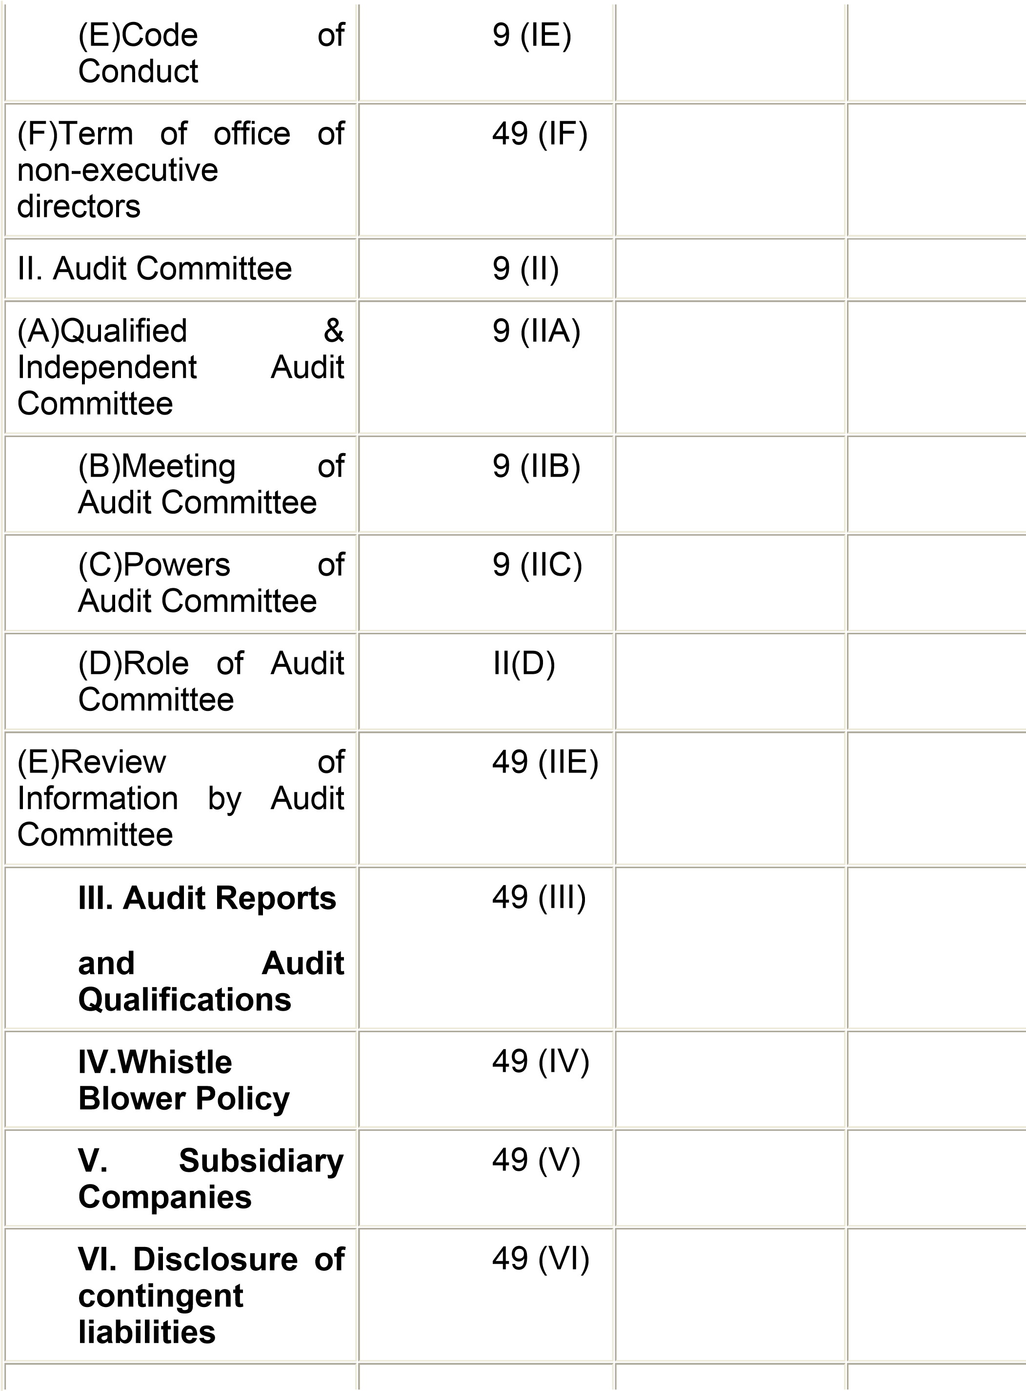

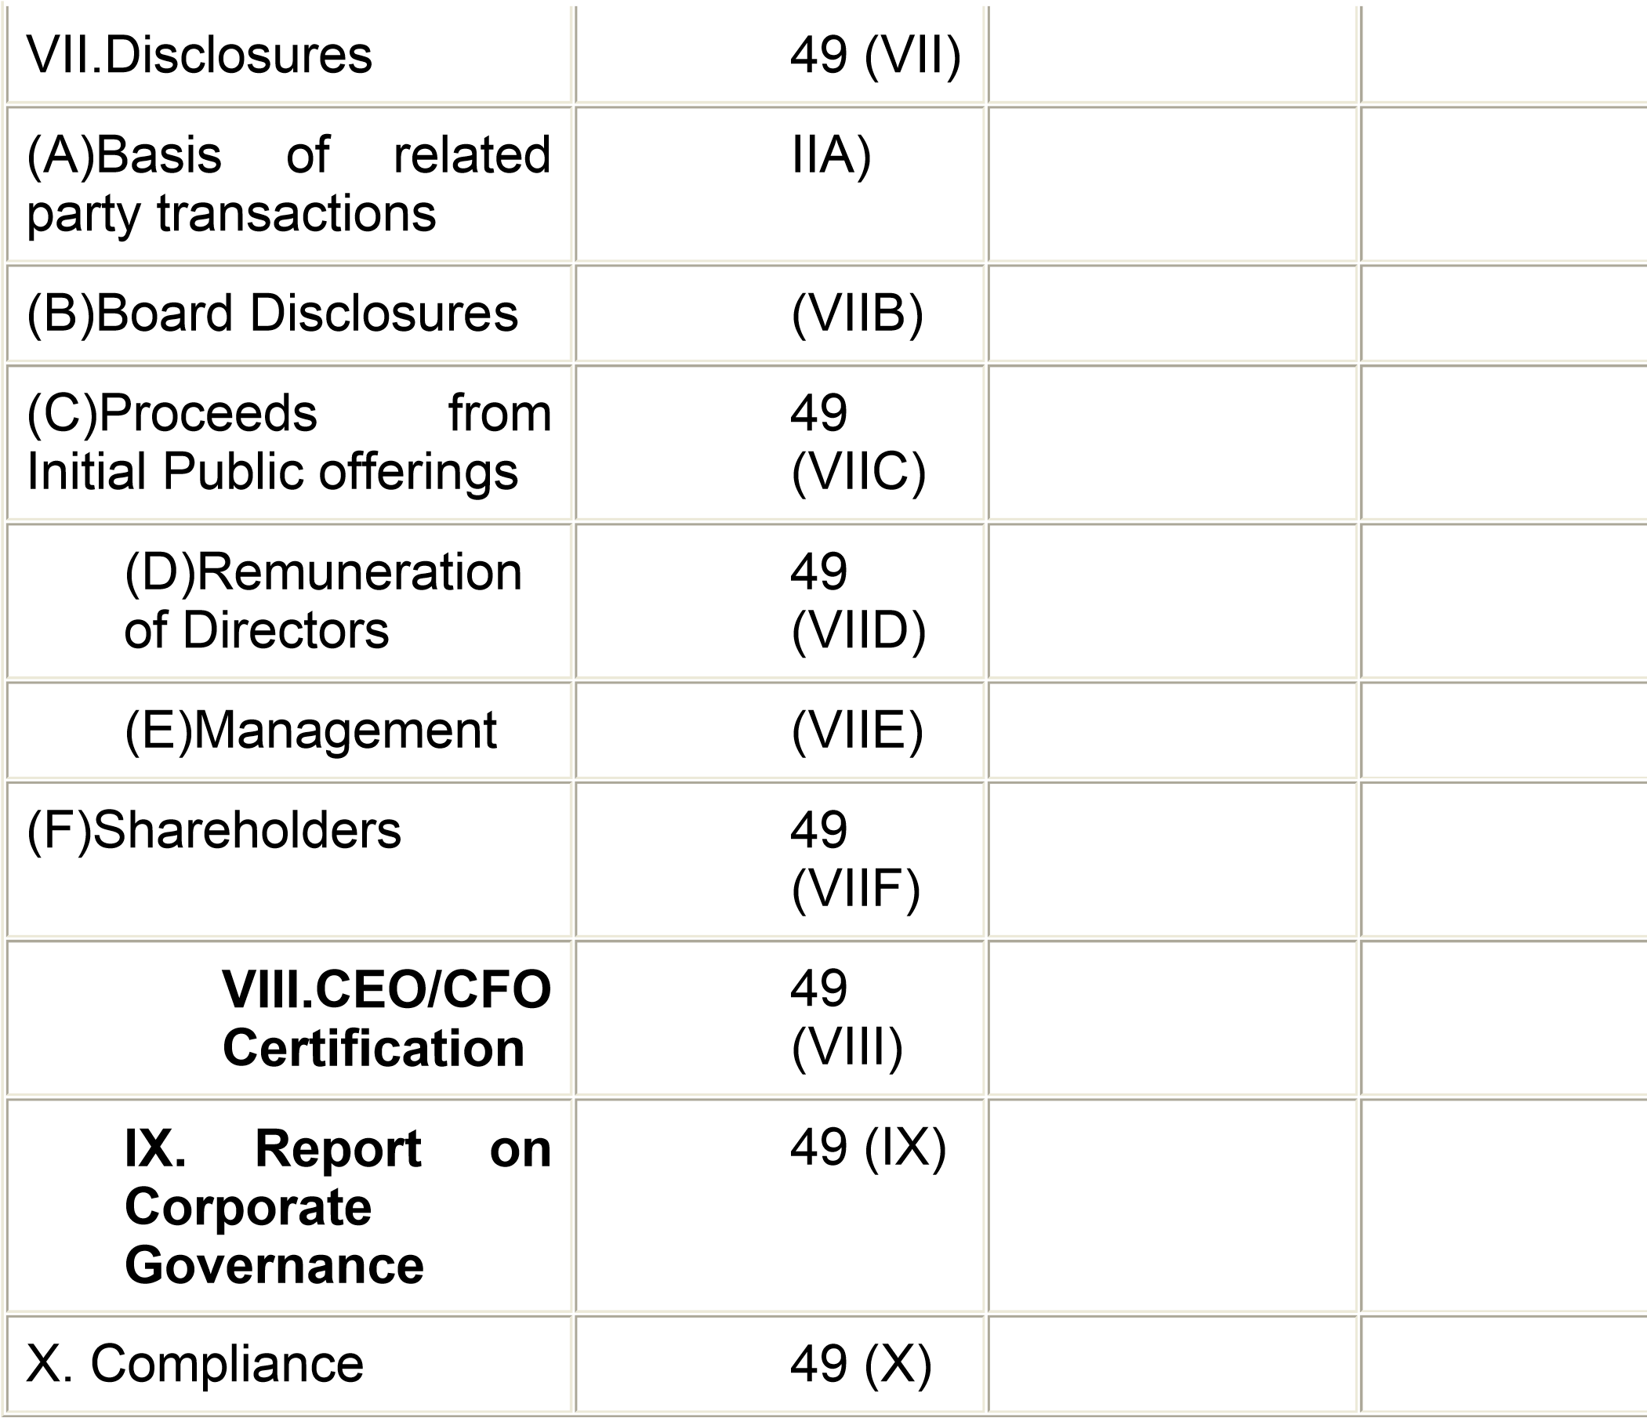

Note:

1. The details under each head shall be provided to incorporateinformation required as per the provisions of the clause 49 of the Agreement.
2. In the column No.3, compliance or non-compliance may be indic Yes/No/N.A.. For example, if the Board has been compo accordance with the clause 49 I of the Listing Agreement, "Yes" m indicated. Similarly, in case the company has not come out with a the words "N.A." may be indicated against 49 (VIIC).

3)In the remarks column, reasons for non-compliance may be ind for example, in case of requirement related to circulation of informa the shareholders, which would be done only in the AGM/EGM, it m

indicated in the "Remarks" column as – "will be complied with AGM". Similarly, in respect of matters which can be complied wi where the situation arises, for example, "Report on Co Governance" is to be a part of Annual Report only, the words " complied in the next Annual Report" may be indicated.

### X. Compliance

The company shall obtain a certificate from either the audi practicing company secretaries regarding compliance of condit corporate governance as stipulated in this clause and annex the ce with the directors’ report, which is sent annually to all the sharehol the company. The same certificate shall also be sent to the Exchanges along with the annual returns filed by the company.

## Schedule of implementation

(1) The provisions of the revised clause 49 shall be implemen per the schedule of implementation given below:

1. By all entities seeking listing for the first time, at the time of listing
2. By all companies which were required to comply with the requiof the erstwhile clause 49 i.e. all listed entities having a paid up capital of Rs 3 crores and above or net worth of Rs 25 crores or m any time in the history of the entity . These entities shall be requ comply with the requirement of this clause on or before March 31, 2

(2) The non-mandatory requirement given in Annexure – 1C s implemented as per the discretion of the company. Howev disclosures of the adoption/non-adoption of the non-man requirements shall be made in the section on corporate govern the Annual Report.