

BHARATI VIDYAPEETH’S
INSTITUTE OF COMPUTER APPLICATIONS & MANAGEMENT
(Affiliated to Guru Gobind Singh Indraprastha University, Approved by AICTE, New Delhi)

Data and File Structures - Lab
(MCA-152)
Practical File

Submitted To: | Submitted By:
Dr. Arpita Nagpal | Prithvi Raj Singh ( 08711604425 )  MCA 2nd Sem, Sec B

I NDEX

S.No. | Problem Description | Date of Execution | Sign.
P1 | Write a program which takes an array of n integers and displays the frequency of each element present in the array.
P2 | Write a program which takes an array of n integers and performs Searching of an element by implementing linear search and binary search techniques.
P3 | Write a program which takes an array of n integers and sorts the integers in descending order using bubble sort and selection sort techniques.
P4 | Write a program which takes an array of n integers and sorts the integers in ascending order using insertion sort technique.
P5 | Write a program which takes an array of n integers and sorts the integers in ascending order using quick sort technique.
AQ1 | Write a program which receives a matrix a[m][n] (represented by a two dimensional array) of integers and determines whether the given matrix is sparse matrix or not. If it is sparse matrix, represent it through appropriate representation with array to save the memory space.
AQ2 | Write a program which receives a matrix x[n][n] (represented by a two dimensional array) of integers and perform the following operations on the received matrix:  a) Transpose the matrix  b) Determine the row-wise sum  c) Determine the column-wise sum  d) Determine the sum of off- diagonal elements  e) Display the upper triangular matrix  f) Display the lower triangular matrix
P6 | Write a menu-driven program which implements a linear linked list with following operations:  a) Insertion of an element at beginning of the list  b) Insertion of an element at specific location of the list  c) Insertion of an element at end of the list  d) Deletion of an element from the beginning of the list  e) Deletion of an element from specific location of the list  f) Deletion of an element from the end of the list  g) Display all elements of the list  h) Search a specific element in the list
P7 | A polynomial is composed of different terms where each of them holds a coefficient and an exponent. Write a program to represent the following polynomials: 4x4 + 4x3 -2x2 + x and 11x3 + 7x2 - 4x with linear linked list, and then perform addition of the given polynomials
AQ3 | Write a program to implement doubly linked list of integers, copy the odd integers in one list and the even integers in another list.
AQ4 | Write a program to implement the following operations in a linear linked list:  a) Remove all occurance of a given element  b) Remove all duplicate elements  c) Sort the elements in ascending order  d) Reverse the list
AQ5 | There is a need to store information about the smart watches that are sold by an online e-commerce company. To do so, a list of products‟ records is maintained, each of which contains information about a single type of product, including how many quantities of it are available in stock. There is no need to change the types of watches that are sold, and thus watches are seldom added or removed from the list. However, there is need to update a watch‟s record whenever inventory of that watch changes due to purchase by someone. A watch‟s position in the list is also its Id, and therefore updating a record involves using the watch Id to get the corresponding record and modifying its contents.
P8 | Write a menu-driven program which implements a stack (using onedimensional array) with following operations:  a) Push (insert an element)  b) Pop (delete an element)  c) Display (print all the elements of stack)
P9 | Write a menu-driven program which implements a linear queue (using one-dimensional array) with following operations:  a) Enqueue (insert an element)  b) Dequeue (delete an element)  c) Display (print all the elements of queue)
P10 | Write a menu-driven program which implements a circular queue (using one-dimensional array) with following operations:  a) Enqueue (insert an element)  b) Dequeue (delete an element)  c) Display (print all the elements of queue).
AQ6 | Write a program that implements two stacks (double stack) in a single array. Both stacks should grow dynamically in opposite directions, one from lower index to higher index and second from higher to lower index.
AQ7 | Write a program that accepts a string of characters and prints the characters in reverse order. The program should make use of appropriate operations of stack.
AQ8 | Write a program that accepts a number in decimal and converts it to its equivalent binary number. The program should make use of appropriate operations of stack.
AQ9 | Write a program that accepts a postfix expression of the form ab+cd-*ab/ and evaluate it after accepting the values of a, b, c and d. The program should make use of appropriate stack operations.
AQ10 | Write a menu-driven program which implements a stack (using linear linked list) with following operations:  a) Push (Insert an element)  b) Pop (Delete an element)  c) Display (Print all elements of stack)
AQ11 | Write a menu-driven program which implements a linear queue (using linear linked list) with following operations:  a) Enqueue (Insert an element)  b) Dequeue (Delete an element)  c) Display (Print all elements of queue)
AQ12 | Write a menu-driven program which implements a double ended queue (using one-dimensional array) with all possible insertion and deletion operations.
P11 | Write a menu-driven program which implements a binary tree (using linked list) with following operations:  a) Insertion of a node  b) Deletion of a node  c) Preorder traversal  d) Inorder traversal  e) Postorder traversal  f) Determine total numer of leaf nodes
P12 | Write a menu-driven program which implements a heap (using onedimensional array) with following operations:  a) Insertion of a node  b) Deletion of a node  c) Display (print all the elements of heap)
P13 | Write a menu-driven program which implements a binary search tree (using linked list) with following operations:  a) Insertion of a node  b) Deletion of a node  c) Preorder traversal  d) Inorder traversal  e) Postorder traversal
P14 | Write a program which takes an array of n integers and sorts the integers in ascending order using heap sort technique
AQ13 | Write a menu-driven program that implements a binary search tree with following operations:  a) Total number of nodes in the tree  b) Total number of leaf nodes in the tree  c) Total number of non-leaf nodes in the tree  d) Smallest node of the tree  e) Largest node of the tree  f) Search a node in the tree  g) Sum of all nodes of the tree  h) Display the nodes in ascending order
AQ14 | Write a program to implement priority queue (using one dimensional array). For deletion of a node, the node having smallest data value will be considered to have highest priority.
AQ15 | Write a program to implement a binary tree and perform preorder, inorder and postorder traversal without performing recursive operations
P15 | Write a menu-driven program which implements a graph (using adjacency matrix) with following operations:  a) Insertion of a vertex  b) Insertion of an edge  c) Deletion of a vertex  d) Deletion of an edge  e) Calculation of degree of each vertex  f) Calculation of number of self-loops in the graph.
P16 | Write a program to traverse the following graph using breadth first search and depth first search techniques.  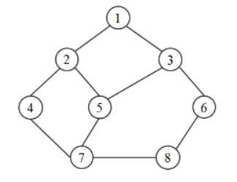
P17 | Apply Dijkstra’s algorithm to determine shortest path from a to f on the below network.  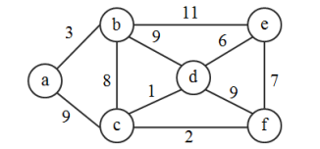
P18 | Apply Warshell’s algorithm to determine shortest paths on the below network.  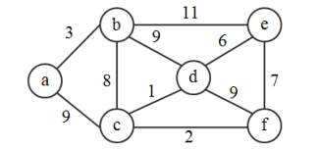
AQ16 | Write a menu-driven program which implements a graph (using adjacency list) with following operations: a) Insertion of a vertex  b) Insertion of an edge  c) Deletion of a vertex  d) Deletion of an edge  e) Calculation of degree of each vertex
AQ17 | Write a program to determine the minimum cost spanning tree (using Prim‟s algorithm) in the following graph.  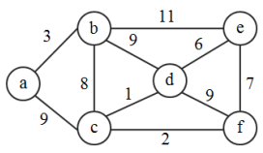
AQ18 | Write a program to determine the minimum cost spanning tree (using Kruskal‟s algorithm) in the following graph.  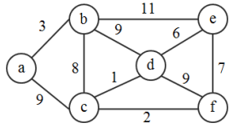
P19 | Write a program that generates n random integers and stores them in a text file, named as “All.txt”. Then, retrieve the stored integers from this file and copy to “Odd.txt” and „Even.txt‟ based upon the type of number, i.e. if the retrieved integer is odd number then store in “Odd.txt” file or if the retrieved integer is even then store in “Even.txt” file. Finally, display the contents of all three files.
P20 | Write a program to implement 20 integers (with some duplicate integers) in a hash table (with separate chaining for collision resolution)
AQ19 | Consider the list (file) of books maintained in a library system. When a user wants to check whether a particular book is available, a search operation is called for. If the book is available and is issued to the user, a delete operation can be performed to remove this book from the set of available books. When the user returns the book, it can be inserted back into the set of available books. Write a C program to solve the problem by using appropriate data structures. It is essential that the above mentioned operations should be performed efficiently as possible since these operations are performed frequently.

P1. Write a program which takes an array of n integers and displays the frequency of each element present in the array.

Solution :

#include <stdio.h>

int main()
{
int n, i, j, count;
printf("Enter the length of array : ");
scanf("%d", &n);

int arr[n], freq[n];
printf("Enter %d elements of the array: ", n);
for (i = 0; i < n; i++)
{
scanf("%d", &arr[i]);
freq[i] = -1;
}

for (i = 0; i < n; i++)
{
if (freq[i] == 0)
continue;

count = 1;
for (j = i + 1; j < n; j++)
{
if (arr[i] == arr[j])
{
count++;
freq[j] = 0;
}
}

freq[i] = count;
}

printf("Element -> Frequency\n");
for (i = 0; i < n; i++)
{
if (freq[i] != 0)
{
printf("%d -> %d\n", arr[i], freq[i]);
}
}

return 0;
}

Output :

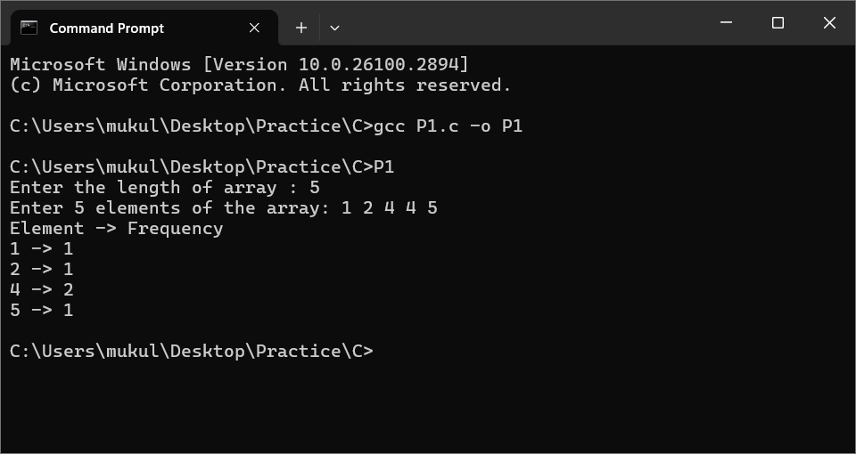

P2. Write a program which takes an array of n integers and performs Searching of an element by implementing linear search and binary search techniques.

Solution :

#include <stdio.h>

void linearSearch(int arr[], int n, int key)
{
for (int i = 0; i < n; i++)
{
if (arr[i] == key)
{
printf("Element %d found at position %d using Linear Search.\n", key, i + 1);
return;
}
}
printf("Element %d not found using Linear Search.\n", key);
}

void binarySearch(int arr[], int n, int key)
{
int low = 0, high = n - 1, mid;
while (low <= high)
{
mid = (low + high) / 2;
if (arr[mid] == key)
{
printf("Element %d found at position %d using Binary Search.\n", key, mid + 1);
return;
}
else if (arr[mid] < key)
{
low = mid + 1;
}
else
{
high = mid - 1;
}
}

printf("Element %d not found using Binary Search.\n", key);
}

int main()
{
int n, i, key;
printf("Enter the size of the array: ");
scanf("%d", &n);

int arr[n];
printf("Enter %d elements of the array in sorted order for Binary Search: ", n);
for (i = 0; i < n; i++)
{
scanf("%d", &arr[i]);
}

printf("Enter the element to search: ");
scanf("%d", &key);

linearSearch(arr, n, key);
binarySearch(arr, n, key);

return 0;
}

Output :

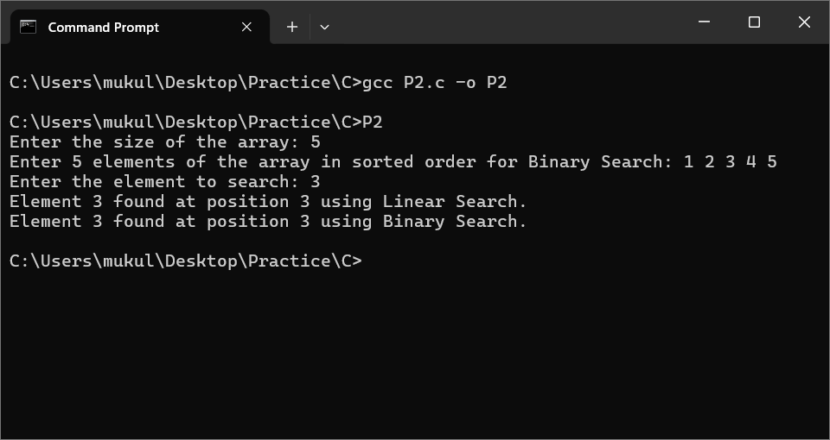

P3. Write a program which takes an array of n integers and sorts the integers in descending order using bubble sort and selection sort techniques.

Solution :

#include <stdio.h>

void bubbleSort(int arr[], int n)
{
int i, j, temp;
for (i = 0; i < n - 1; i++)
{
for (j = 0; j < n - i - 1; j++)
{
if (arr[j] < arr[j + 1])
{
temp = arr[j];
arr[j] = arr[j + 1];
arr[j + 1] = temp;
}
}
}
}

void selectionSort(int arr[], int n)
{
int i, j, max_idx, temp;
for (i = 0; i < n - 1; i++)
{
max_idx = i;
for (j = i + 1; j < n; j++)
{
if (arr[j] > arr[max_idx])
{
max_idx = j;
}
}
if (max_idx != i)
{
temp = arr[i];
arr[i] = arr[max_idx];
arr[max_idx] = temp;
}
}
}

int main()
{
int n, i;
printf("Enter the size of the array: ");
scanf("%d", &n);

int arr1[n], arr2[n];
printf("Enter %d elements of the array: ", n);
for (i = 0; i < n; i++)
{
scanf("%d", &arr1[i]);
arr2[i] = arr1[i];
}

bubbleSort(arr1, n);
printf("Array sorted in descending order using Bubble Sort: ");
for (i = 0; i < n; i++)
{
printf("%d ", arr1[i]);
}
printf("\n");

selectionSort(arr2, n);
printf("Array sorted in descending order using Selection Sort: ");
for (i = 0; i < n; i++)
{
printf("%d ", arr2[i]);
}
printf("\n");

return 0;
}

Output :

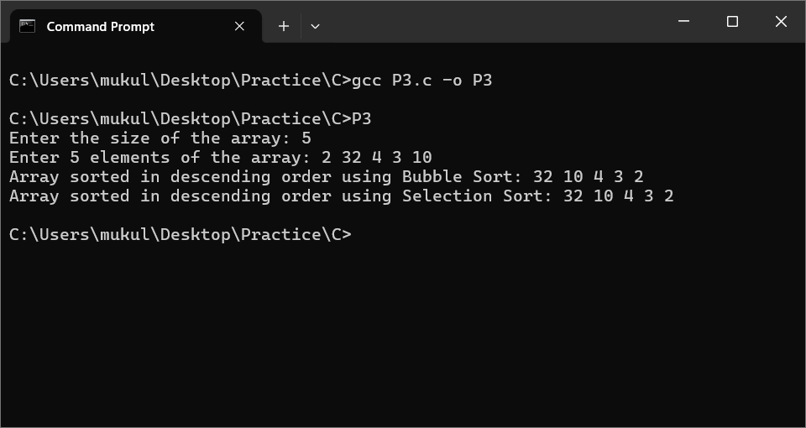

P4. Write a program which takes an array of n integers and sorts the integers in ascending order using insertion sort technique.

Solution :

#include <stdio.h>

void insertionSort(int arr[], int n) {
int i, j, key;
for (i = 1; i < n; i++) {
key = arr[i];
j = i - 1;
while (j >= 0 && arr[j] > key) {
arr[j + 1] = arr[j];
j = j - 1;
}
arr[j + 1] = key;
}
}

int main() {
int n, i;
printf("Enter the size of the array: ");
scanf("%d", &n);

int arr[n];
printf("Enter %d elements of the array: ", n);
for (i = 0; i < n; i++) {
scanf("%d", &arr[i]);
}

insertionSort(arr, n);

printf("Array sorted in ascending order using Insertion Sort: ");
for (i = 0; i < n; i++) {
printf("%d ", arr[i]);
}
printf("\n");

return 0;
}

Output :

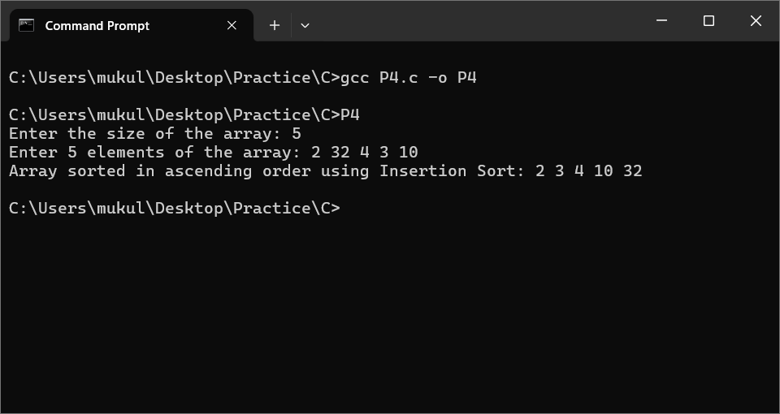

P5. Write a program which takes an array of n integers and sorts the integers in ascending order using quick sort technique.

Solution :

#include <stdio.h>

void quickSort(int arr[], int low, int high) {
if (low < high) {
int pi = partition(arr, low, high);
quickSort(arr, low, pi - 1);
quickSort(arr, pi + 1, high);
}
}

int partition(int arr[], int low, int high) {
int pivot = arr[high];
int i = low - 1;
for (int j = low; j < high; j++) {
if (arr[j] < pivot) {
i++;
int temp = arr[i];
arr[i] = arr[j];
arr[j] = temp;
}
}
int temp = arr[i + 1];
arr[i + 1] = arr[high];
arr[high] = temp;
return i + 1;
}

int main() {
int n, i;
printf("Enter the size of the array: ");
scanf("%d", &n);

int arr[n];
printf("Enter %d elements of the array: ", n);
for (i = 0; i < n; i++) {
scanf("%d", &arr[i]);
}

quickSort(arr, 0, n - 1);

printf("Array sorted in ascending order using Quick Sort: ");
for (i = 0; i < n; i++) {
printf("%d ", arr[i]);
}
printf("\n");

return 0;
}

Output :

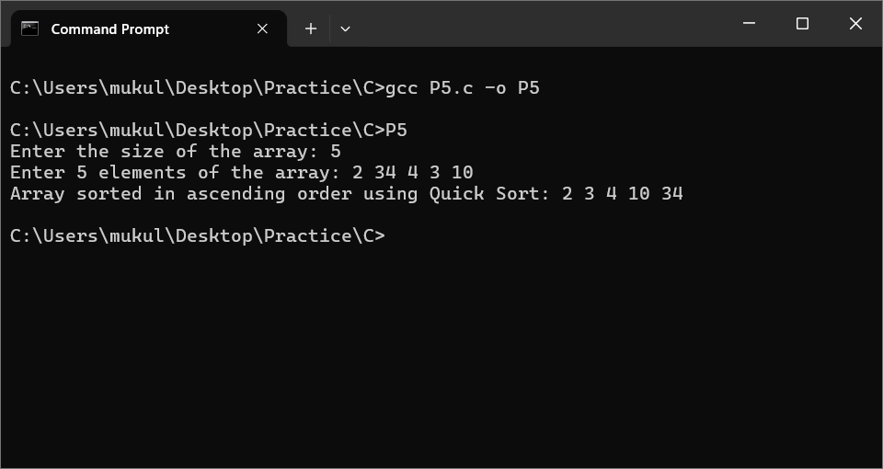

AQ1. Write a program which receives a matrix a[m][n] (represented by a two dimensional array) of integers and determines whether the given matrix is sparse matrix or not. If it is sparse matrix, represent it through appropriate representation with array to save the memory space.

Solution :

#include <stdio.h>

void displaySparse(int sparse[][3], int nonZeroCount)
{
printf("Sparse Matrix Representation:\n");
printf("Row | Column | Value\n");
for (int i = 0; i < nonZeroCount; i++)
{
printf("%4d | %6d | %5d\n", sparse[i][0], sparse[i][1], sparse[i][2]);
}
}

int main()
{
int m, n, i, j, nonZeroCount = 0;
printf("Enter the number of rows: ");
scanf("%d", &m);
printf("Enter the number of columns: ");
scanf("%d", &n);

int matrix[m][n];
printf("Enter the elements of the matrix:\n");
for (i = 0; i < m; i++)
{
for (j = 0; j < n; j++)
{
scanf("%d", &matrix[i][j]);
if (matrix[i][j] != 0)
{
nonZeroCount++;
}
}
}

int totalElements = m * n;
if (nonZeroCount > totalElements / 2)
{
printf("The matrix is NOT a sparse matrix.\n");
}
else
{
printf("The matrix is a SPARSE matrix.\n");
int sparse[nonZeroCount][3];
int k = 0;
for (i = 0; i < m; i++)
{
for (j = 0; j < n; j++)
{
if (matrix[i][j] != 0)
{
sparse[k][0] = i;
sparse[k][1] = j;
sparse[k][2] = matrix[i][j];
k++;
}
}
}
displaySparse(sparse, nonZeroCount);
}

return 0;
}

Output :

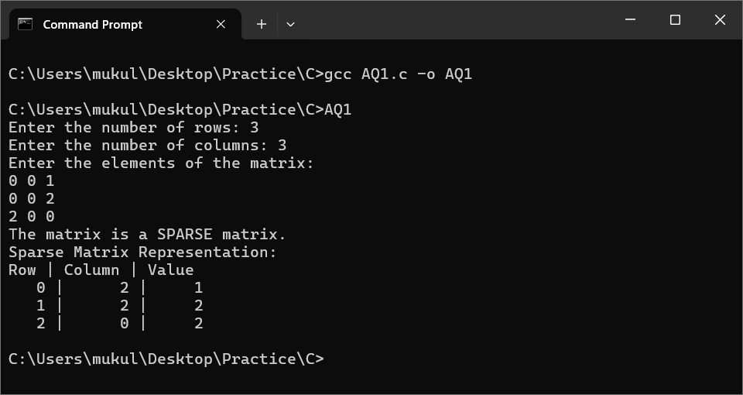

AQ2. Write a program which receives a matrix x[n][n] (represented by a two dimensional array) of integers and perform the following operations on the received matrix:
a) Transpose the matrix
b) Determine the row-wise sum
c) Determine the column-wise sum
d) Determine the sum of off- diagonal elements
e) Display the upper triangular matrix
f) Display the lower triangular matrix

Solution :

#include <stdio.h>
#include <stdlib.h>

void transposeMatrix(int **x, int n)
{
int i, j;
printf("Transpose of the matrix:\n");
for (i = 0; i < n; i++)
{
for (j = 0; j < n; j++)
{
printf("%d ", x[j][i]);
}
printf("\n");
}
}

void rowWiseSum(int **x, int n)
{
int i, j, sum;
printf("Row-wise sum:\n");
for (i = 0; i < n; i++)
{
sum = 0;
for (j = 0; j < n; j++)
{
sum += x[i][j];
}
printf("Sum of row %d: %d\n", i + 1, sum);
}
}

void columnWiseSum(int **x, int n)
{
int i, j, sum;
printf("Column-wise sum:\n");
for (i = 0; i < n; i++)
{
sum = 0;
for (j = 0; j < n; j++)
{
sum += x[j][i];
}
printf("Sum of column %d: %d\n", i + 1, sum);
}
}

void offDiagonalSum(int **x, int n)
{
int i, sum = 0;
printf("Sum of off-diagonal elements:\n");
for (i = 0; i < n; i++)
{
if (i != n - i - 1)
{
sum += x[i][n - i - 1];
}
}
printf("Off-diagonal sum: %d\n", sum);
}

void upperTriangularMatrix(int **x, int n)
{
int i, j;
printf("Upper Triangular Matrix:\n");
for (i = 0; i < n; i++)
{
for (j = 0; j < n; j++)
{
if (i <= j)
{
printf("%d ", x[i][j]);
}
else
{
printf("0 ");
}
}
printf("\n");
}
}

void lowerTriangularMatrix(int **x, int n)
{
int i, j;
printf("Lower Triangular Matrix:\n");
for (i = 0; i < n; i++)
{
for (j = 0; j < n; j++)
{
if (i >= j)
{
printf("%d ", x[i][j]);
}
else
{
printf("0 ");
}
}
printf("\n");
}
}

int main()
{
int n, i, j;
printf("Enter the size of the matrix (n x n): ");
scanf("%d", &n);

int **x = (int **)malloc(n * sizeof(int *));
for (i = 0; i < n; i++)
{
x[i] = (int *)malloc(n * sizeof(int));
}

printf("Enter the elements of the matrix:\n");
for (i = 0; i < n; i++)
{
for (j = 0; j < n; j++)
{
scanf("%d", &x[i][j]);
}
}

printf("a) Transpose the matrix \n");
transposeMatrix(x, n);

printf("\nb) Determine the row-wise sum \n");
rowWiseSum(x, n);

printf("\nc) Determine the column-wise sum \n");
columnWiseSum(x, n);

printf("\nd) Determine the sum of off- diagonal elements \n");
offDiagonalSum(x, n);

printf("\ne) Display the upper triangular matrix \n");
upperTriangularMatrix(x, n);

printf("\nf) Display the lower triangular matrix \n");
lowerTriangularMatrix(x, n);

for (i = 0; i < n; i++)
{
free(x[i]);
}
free(x);

return 0;
}

Output :

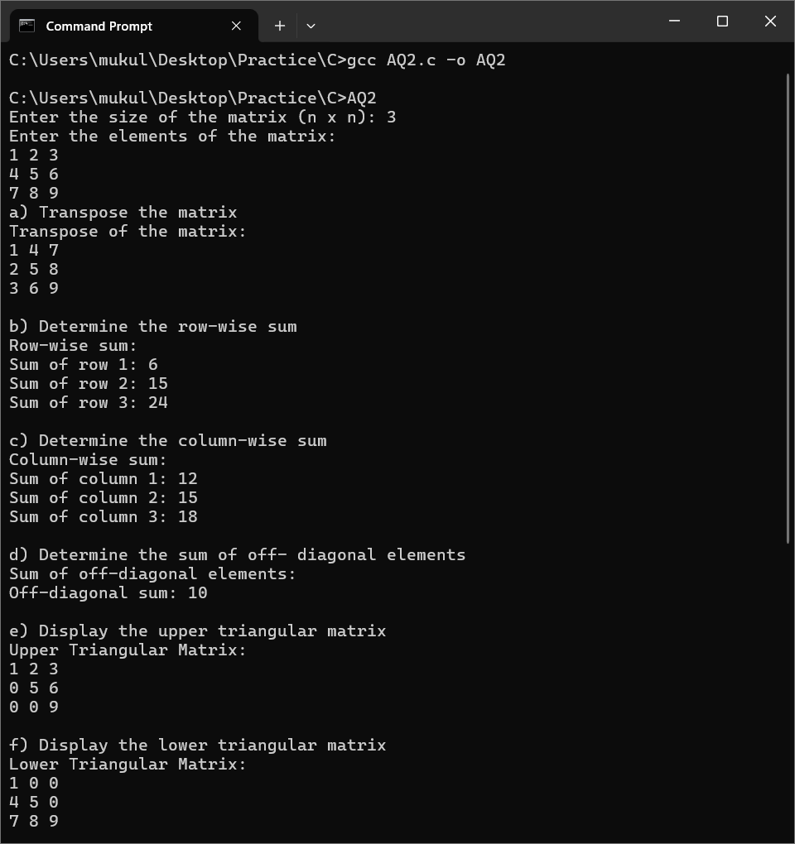

P6. Write a menu-driven program which implements a linear linked list with following operations:
a) Insertion of an element at beginning of the list
b) Insertion of an element at specific location of the list
c) Insertion of an element at end of the list
d) Deletion of an element from the beginning of the list
e) Deletion of an element from specific location of the list
f) Deletion of an element from the end of the list
g) Display all elements of the list
h) Search a specific element in the list

Solution:

#include <stdio.h>
#include <stdlib.h>

typedef struct Node {
int data;
struct Node* next;
} Node;

Node* head = NULL;

void insertAtBeginning(int value) {
Node* newNode = (Node*)malloc(sizeof(Node));
newNode->data = value;
newNode->next = head;
head = newNode;
printf("%d inserted at the beginning.\n", value);
}

void insertAtPosition(int value, int position) {
Node* newNode = (Node*)malloc(sizeof(Node));
newNode->data = value;

if (position == 1) {
newNode->next = head;
head = newNode;
return;
}

Node* temp = head;
for (int i = 1; temp != NULL && i < position - 1; i++) {
temp = temp->next;
}

if (temp == NULL) {
printf("Position out of range.\n");
free(newNode);
return;
}

newNode->next = temp->next;
temp->next = newNode;
printf("%d inserted at position %d.\n", value, position);
}

void insertAtEnd(int value) {
Node* newNode = (Node*)malloc(sizeof(Node));
newNode->data = value;
newNode->next = NULL;

if (head == NULL) {
head = newNode;
return;
}

Node* temp = head;
while (temp->next != NULL) {
temp = temp->next;
}

temp->next = newNode;
printf("%d inserted at the end.\n", value);
}

void deleteFromBeginning() {
if (head == NULL) {
printf("List is empty.\n");
return;
}

Node* temp = head;
head = head->next;
printf("%d deleted from the beginning.\n", temp->data);
free(temp);
}

void deleteFromPosition(int position) {
if (head == NULL) {
printf("List is empty.\n");
return;
}

Node* temp = head;

if (position == 1) {
head = head->next;
printf("%d deleted from position 1.\n", temp->data);
free(temp);
return;
}

Node* prev = NULL;
for (int i = 1; temp != NULL && i < position; i++) {
prev = temp;
temp = temp->next;
}

if (temp == NULL) {
printf("Position out of range.\n");
return;
}

prev->next = temp->next;
printf("%d deleted from position %d.\n", temp->data, position);
free(temp);
}

void deleteFromEnd() {
if (head == NULL) {
printf("List is empty.\n");
return;
}

if (head->next == NULL) {
printf("%d deleted from the end.\n", head->data);
free(head);
head = NULL;
return;
}

Node* temp = head;
while (temp->next->next != NULL) {
temp = temp->next;
}

printf("%d deleted from the end.\n", temp->next->data);
free(temp->next);
temp->next = NULL;
}

void display() {
if (head == NULL) {
printf("List is empty.\n");
return;
}

Node* temp = head;
printf("List elements: ");
while (temp != NULL) {
printf("%d -> ", temp->data);
temp = temp->next;
}
printf("NULL\n");
}

void search(int value) {
Node* temp = head;
int position = 1;

while (temp != NULL) {
if (temp->data == value) {
printf("%d found at position %d.\n", value, position);
return;
}
temp = temp->next;
position++;
}

printf("%d not found in the list.\n", value);
}

int main() {
int choice, value, position;

while (1) {
printf("\nMenu:\n");
printf("1. Insert at beginning\n");
printf("2. Insert at position\n");
printf("3. Insert at end\n");
printf("4. Delete from beginning\n");
printf("5. Delete from position\n");
printf("6. Delete from end\n");
printf("7. Display list\n");
printf("8. Search element\n");
printf("9. Exit\n");
printf("Enter your choice: ");
scanf("%d", &choice);

switch (choice) {
case 1:
printf("Enter value: ");
scanf("%d", &value);
insertAtBeginning(value);
break;
case 2:
printf("Enter value and position: ");
scanf("%d %d", &value, &position);
insertAtPosition(value, position);
break;
case 3:
printf("Enter value: ");
scanf("%d", &value);
insertAtEnd(value);
break;
case 4:
deleteFromBeginning();
break;
case 5:
printf("Enter position: ");
scanf("%d", &position);
deleteFromPosition(position);
break;
case 6:
deleteFromEnd();
break;
case 7:
display();
break;
case 8:
printf("Enter value to search: ");
scanf("%d", &value);
search(value);
break;
case 9:
exit(0);
default:
printf("Invalid choice! Please try again.\n");
}
}
return 0;
}

Output :

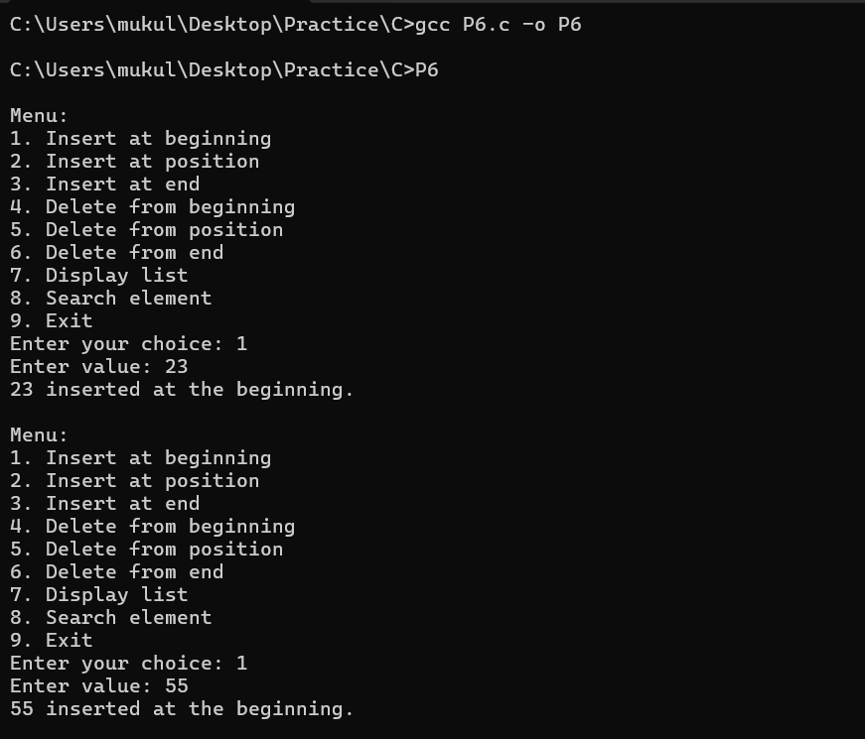

P7. A polynomial is composed of different terms where each of them holds a coefficient and an exponent. Write a program to represent the following polynomials: 4x4 + 4x3 -2x2 + x and 11x3 + 7x2 - 4x with linear linked list, and then perform addition of the given polynomials.

Solution :
#include <stdio.h>
#include <stdlib.h>

typedef struct Node {
int coeff;
int exp;
struct Node* next;
} Node;

Node* createNode(int coeff, int exp) {
Node* newNode = (Node*)malloc(sizeof(Node));
newNode->coeff = coeff;
newNode->exp = exp;
newNode->next = NULL;
return newNode;
}

void insertNode(Node** poly, int coeff, int exp) {
Node* newNode = createNode(coeff, exp);
if (*poly == NULL) {
*poly = newNode;
return;
}
Node* temp = *poly;
while (temp->next != NULL) {
temp = temp->next;
}
temp->next = newNode;
}

void displayPoly(Node* poly) {
while (poly != NULL) {
if (poly->coeff > 0 && poly != poly->next) {
printf("+ ");
}
printf("%dx^%d ", poly->coeff, poly->exp);
poly = poly->next;
}
printf("\n");
}

Node* addPolynomials(Node* poly1, Node* poly2) {
Node* result = NULL;

while (poly1 != NULL && poly2 != NULL) {
if (poly1->exp > poly2->exp) {
insertNode(&result, poly1->coeff, poly1->exp);
poly1 = poly1->next;
} else if (poly1->exp < poly2->exp) {
insertNode(&result, poly2->coeff, poly2->exp);
poly2 = poly2->next;
} else {
insertNode(&result, poly1->coeff + poly2->coeff, poly1->exp);
poly1 = poly1->next;
poly2 = poly2->next;
}
}

while (poly1 != NULL) {
insertNode(&result, poly1->coeff, poly1->exp);
poly1 = poly1->next;
}

while (poly2 != NULL) {
insertNode(&result, poly2->coeff, poly2->exp);
poly2 = poly2->next;
}

return result;
}

int main() {
Node* poly1 = NULL;
Node* poly2 = NULL;

insertNode(&poly1, 4, 4);
insertNode(&poly1, 4, 3);
insertNode(&poly1, -2, 2);
insertNode(&poly1, 1, 1);

insertNode(&poly2, 11, 3);
insertNode(&poly2, 7, 2);
insertNode(&poly2, -4, 1);

printf("Polynomial 1: ");
displayPoly(poly1);

printf("Polynomial 2: ");
displayPoly(poly2);

Node* result = addPolynomials(poly1, poly2);
printf("Resultant Polynomial after addition: ");
displayPoly(result);

return 0;
}

Output :

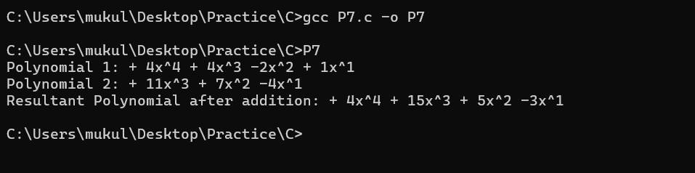

AQ3. Write a program to implement doubly linked list of integers, copy the odd integers in one list and the even integers in another list.

Solution :

#include <stdio.h>
#include <stdlib.h>

typedef struct Node {
int data;
struct Node* prev;
struct Node* next;
} Node;

Node* createNode(int data) {
Node* newNode = (Node*)malloc(sizeof(Node));
newNode->data = data;
newNode->prev = NULL;
newNode->next = NULL;
return newNode;
}

void insertNode(Node** head, int data) {
Node* newNode = createNode(data);
if (*head == NULL) {
*head = newNode;
return;
}
Node* temp = *head;
while (temp->next != NULL) {
temp = temp->next;
}
temp->next = newNode;
newNode->prev = temp;
}

void displayList(Node* head) {
while (head != NULL) {
printf("%d ", head->data);
head = head->next;
}
printf("\n");
}

void splitOddEven(Node* head, Node** oddList, Node** evenList) {
while (head != NULL) {
if (head->data % 2 == 0) {
insertNode(evenList, head->data);
} else {
insertNode(oddList, head->data);
}
head = head->next;
}
}

int main() {
Node* mainList = NULL;
Node* oddList = NULL;
Node* evenList = NULL;

insertNode(&mainList, 10);
insertNode(&mainList, 15);
insertNode(&mainList, 20);
insertNode(&mainList, 25);
insertNode(&mainList, 30);
insertNode(&mainList, 35);

printf("Original List: ");
displayList(mainList);

splitOddEven(mainList, &oddList, &evenList);

printf("Odd List: ");
displayList(oddList);

printf("Even List: ");
displayList(evenList);

return 0;
}

Output :

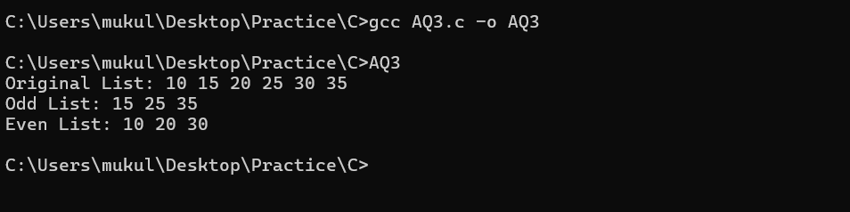

AQ4. Write a program to implement the following operations in a linear linked list:
a) Remove all occurrence of a given element
b) Remove all duplicate elements
c) Sort the elements in ascending order
d) Reverse the list

Solution :

#include <stdio.h>
#include <stdlib.h>

typedef struct Node {
int data;
struct Node* next;
} Node;

Node* createNode(int data) {
Node* newNode = (Node*)malloc(sizeof(Node));
newNode->data = data;
newNode->next = NULL;
return newNode;
}

void insertNode(Node** head, int data) {
Node* newNode = createNode(data);
newNode->next = *head;
*head = newNode;
}

void displayList(Node* head) {
while (head != NULL) {
printf("%d ", head->data);
head = head->next;
}
printf("\n");
}

void removeOccurrences(Node** head, int key) {
Node* temp = *head;
Node* prev = NULL;

while (temp != NULL) {
if (temp->data == key) {
if (prev == NULL) {
*head = temp->next;
} else {
prev->next = temp->next;
}
Node* toDelete = temp;
temp = temp->next;
free(toDelete);
} else {
prev = temp;
temp = temp->next;
}
}
}

void removeDuplicates(Node* head) {
Node* current = head;

while (current != NULL && current->next != NULL) {
Node* temp = current;
while (temp->next != NULL) {
if (temp->next->data == current->data) {
Node* duplicate = temp->next;
temp->next = temp->next->next;
free(duplicate);
} else {
temp = temp->next;
}
}
current = current->next;
}
}

void sortList(Node** head) {
Node* current = *head;
Node* index = NULL;
int temp;

while (current != NULL) {
index = current->next;
while (index != NULL) {
if (current->data > index->data) {
temp = current->data;
current->data = index->data;
index->data = temp;
}
index = index->next;
}
current = current->next;
}
}

void reverseList(Node** head) {
Node* prev = NULL;
Node* current = *head;
Node* next = NULL;

while (current != NULL) {
next = current->next;
current->next = prev;
prev = current;
current = next;
}
*head = prev;
}

int main() {
Node* head = NULL;

insertNode(&head, 5);
insertNode(&head, 3);
insertNode(&head, 2);
insertNode(&head, 3);
insertNode(&head, 4);
insertNode(&head, 5);

printf("Original List: ");
displayList(head);

removeOccurrences(&head, 3);
printf("List after removing 3: ");
displayList(head);

insertNode(&head, 5);
insertNode(&head, 2);
insertNode(&head, 2);
printf("List before removing duplicates: ");
displayList(head);

removeDuplicates(head);
printf("List after removing duplicates: ");
displayList(head);

sortList(&head);
printf("List after sorting: ");
displayList(head);

reverseList(&head);
printf("List after reversing: ");
displayList(head);

return 0;
}

Output :

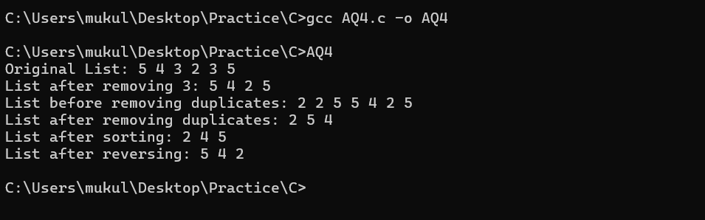

AQ5. There is a need to store information about the smart watches that are sold by an online e-commerce company. To do so, a list of products‟ records is maintained, each of which contains information about a single type of product, including how many quantities of it are available in stock. There is no need to change the types of watches that are sold, and thus watches are seldom added or removed from the list. However, there is need to update a watch’s record whenever inventory of that watch changes due to purchase by someone. A watch’s position in the list is also its Id, and therefore updating a record involves using the watch Id to get the corresponding record and modifying its contents.

Solution :

#include <stdio.h>
#include <stdlib.h>
#include <string.h>

typedef struct Node {
int id;
char name[50];
int stock;
struct Node* next;
} Node;

Node* createNode(int id, const char* name, int stock) {
Node* newNode = (Node*)malloc(sizeof(Node));
newNode->id = id;
strcpy(newNode->name, name);
newNode->stock = stock;
newNode->next = NULL;
return newNode;
}

void insertNode(Node** head, int id, const char* name, int stock) {
Node* newNode = createNode(id, name, stock);
if (*head == NULL) {
*head = newNode;
return;
}
Node* temp = *head;
while (temp->next != NULL) {
temp = temp->next;
}
temp->next = newNode;
}

void displayNodes(Node* head) {
printf("ID | Name | Stock\n");
printf("---------------------------------\n");
while (head != NULL) {
printf("%2d | %-15s | %d\n", head->id, head->name, head->stock);
head = head->next;
}
}

void updateStock(Node* head, int id, int newStock) {
while (head != NULL) {
if (head->id == id) {
head->stock = newStock;
printf("Stock updated for %s to %d units.\n", head->name, head->stock);
return;
}
head = head->next;
}
printf("Node with ID %d not found.\n", id);
}

int main() {
Node* nodeList = NULL;

insertNode(&nodeList, 1, "Apple Watch", 30);
insertNode(&nodeList, 2, "Samsung Galaxy Watch", 20);
insertNode(&nodeList, 3, "Garmin Venu", 15);
insertNode(&nodeList, 4, "Fitbit Sense", 25);

printf("Initial Inventory:\n");
displayNodes(nodeList);

updateStock(nodeList, 2, 10);
updateStock(nodeList, 4, 5);

printf("\nUpdated Inventory:\n");
displayNodes(nodeList);

return 0;
}

Output :

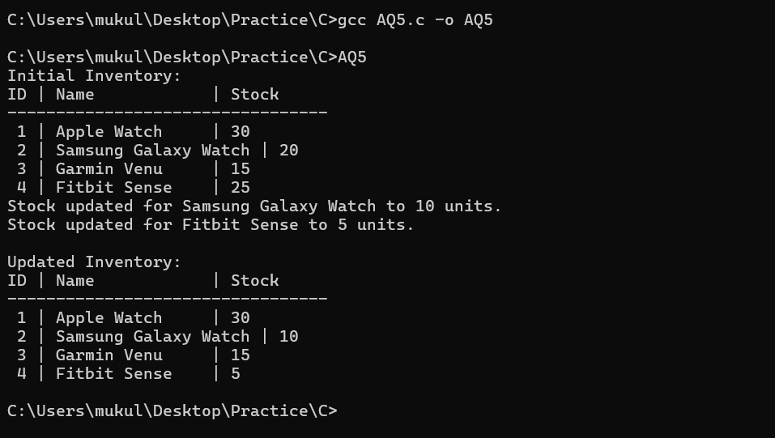

P8. Write a menu-driven program which implements a stack (using onedimensional array) with following operations:
a) Push (insert an element)
b) Pop (delete an element)
c) Display (print all the elements of stack)

Solution :

#include <stdio.h>
#define MAX 10

int stack[MAX];
int top = -1;

void push(int value) {
if (top == MAX - 1) {
printf("Stack Overflow! Cannot push %d.\n", value);
return;
}
stack[++top] = value;
printf("%d pushed into stack.\n", value);
}

void pop() {
if (top == -1) {
printf("Stack Underflow! Cannot pop.\n");
return;
}
printf("%d popped from stack.\n", stack[top--]);
}

void display() {
if (top == -1) {
printf("Stack is empty.\n");
return;
}
printf("Stack elements: ");
for (int i = top; i >= 0; i--) {
printf("%d ", stack[i]);
}
printf("\n");
}

int main() {
int choice, value;

while (1) {
printf("\nStack Operations:\n");
printf("1. Push\n2. Pop\n3. Display\n4. Exit\n");
printf("Enter your choice: ");
scanf("%d", &choice);

switch (choice) {
case 1:
printf("Enter value to push: ");
scanf("%d", &value);
push(value);
break;
case 2:
pop();
break;
case 3:
display();
break;
case 4:
printf("Exiting program...\n");
return 0;
default:
printf("Invalid choice! Please try again.\n");
}
}
}

Output :

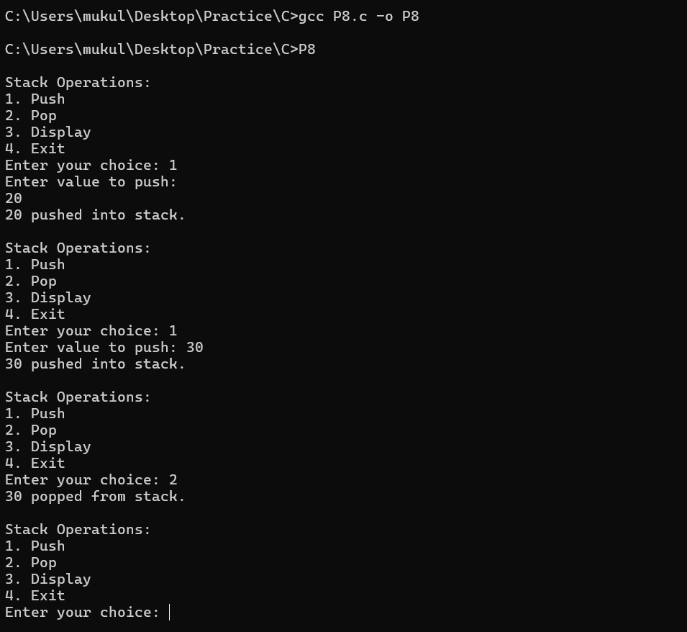

P9. Write a menu-driven program which implements a linear queue (using one-dimensional array) with following operations:
a) Enqueue (insert an element)
b) Dequeue (delete an element)
c) Display (print all the elements of queue)

Solution :

#include <stdio.h>
#define MAX 100

int queue[MAX];
int front = -1, rear = -1;

void enqueue(int value) {
if (rear == MAX - 1) {
printf("Queue Overflow! Cannot enqueue %d.\n", value);
return;
}
if (front == -1) {
front = 0;
}
queue[++rear] = value;
printf("%d enqueued into queue.\n", value);
}

void dequeue() {
if (front == -1 || front > rear) {
printf("Queue Underflow! Cannot dequeue.\n");
return;
}
printf("%d dequeued from queue.\n", queue[front++]);
if (front > rear) {
front = rear = -1;
}
}

void display() {
if (front == -1 || front > rear) {
printf("Queue is empty.\n");
return;
}
printf("Queue elements: ");
for (int i = front; i <= rear; i++) {
printf("%d ", queue[i]);
}
printf("\n");
}

int main() {
int choice, value;

while (1) {
printf("\nQueue Operations:\n");
printf("1. Enqueue\n2. Dequeue\n3. Display\n4. Exit\n");
printf("Enter your choice: ");
scanf("%d", &choice);

switch (choice) {
case 1:
printf("Enter value to enqueue: ");
scanf("%d", &value);
enqueue(value);
break;
case 2:
dequeue();
break;
case 3:
display();
break;
case 4:
printf("Exiting program...\n");
return 0;
default:
printf("Invalid choice! Please try again.\n");
}
}
}

Output :

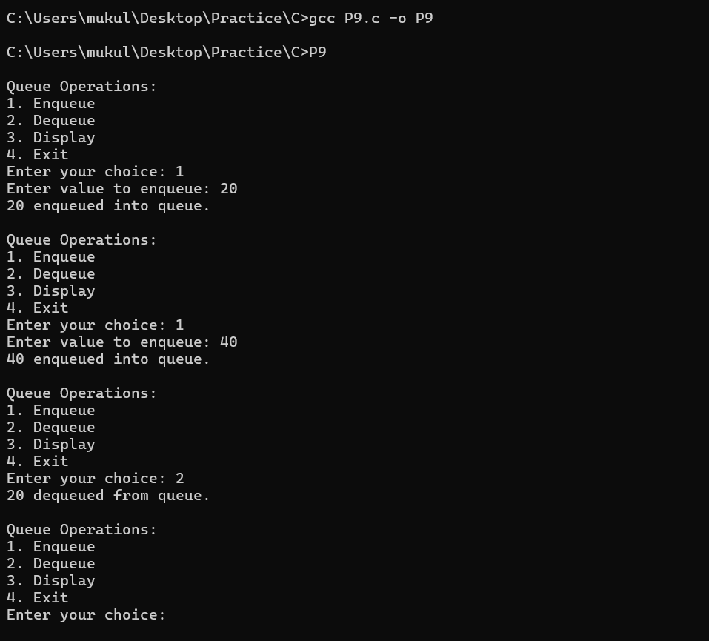

P10. Write a menu-driven program which implements a circular queue (using one-dimensional array) with following operations:
a) Enqueue (insert an element)
b) Dequeue (delete an element)
c) Display (print all the elements of queue).

Solution :

#include <stdio.h>
#define MAX 100

int queue[MAX];
int front = -1, rear = -1;

void enqueue(int value) {
if ((rear + 1) % MAX == front) {
printf("Queue Overflow! Cannot enqueue %d.\n", value);
return;
}
if (front == -1) {
front = rear = 0;
} else {
rear = (rear + 1) % MAX;
}
queue[rear] = value;
printf("%d enqueued into queue.\n", value);
}

void dequeue() {
if (front == -1) {
printf("Queue Underflow! Cannot dequeue.\n");
return;
}
printf("%d dequeued from queue.\n", queue[front]);
if (front == rear) {
front = rear = -1;
} else {
front = (front + 1) % MAX;
}
}

void display() {
if (front == -1) {
printf("Queue is empty.\n");
return;
}
printf("Queue elements: ");
int i = front;
while (1) {
printf("%d ", queue[i]);
if (i == rear) break;
i = (i + 1) % MAX;
}
printf("\n");
}

int main() {
int choice, value;

while (1) {
printf("\nCircular Queue Operations:\n");
printf("1. Enqueue\n2. Dequeue\n3. Display\n4. Exit\n");
printf("Enter your choice: ");
scanf("%d", &choice);

switch (choice) {
case 1:
printf("Enter value to enqueue: ");
scanf("%d", &value);
enqueue(value);
break;
case 2:
dequeue();
break;
case 3:
display();
break;
case 4:
printf("Exiting program...\n");
return 0;
default:
printf("Invalid choice! Please try again.\n");
}
}
}

Output :

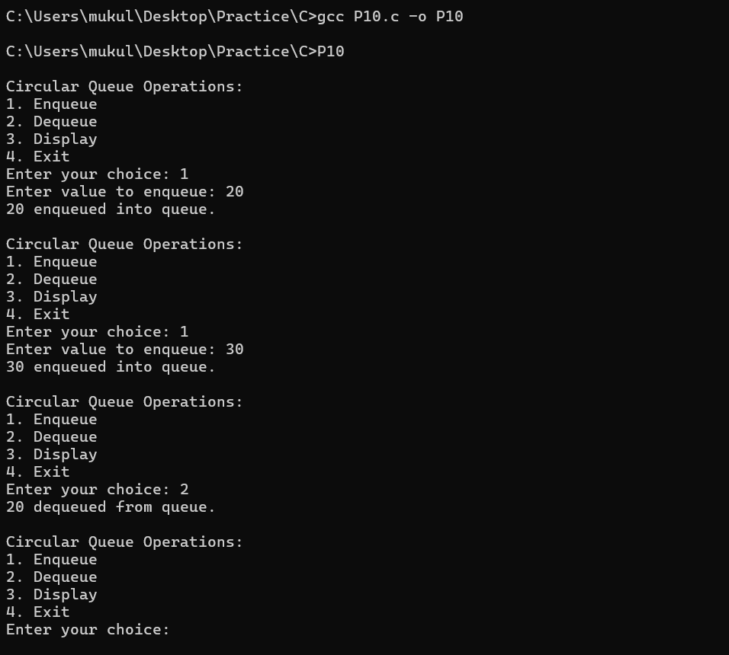

AQ6. Write a program that implements two stacks (double stack) in a single array. Both stacks should grow dynamically in opposite directions, one from lower index to higher index and second from higher to lower index.

Solution :

#include <stdio.h>
#define MAX 100

int stack[MAX];
int top1 = -1;
int top2 = MAX;

void push1(int value) {
if (top1 + 1 == top2) {
printf("Stack Overflow! Cannot push %d into Stack 1.\n", value);
return;
}
stack[++top1] = value;
printf("%d pushed into Stack 1.\n", value);
}

void push2(int value) {
if (top2 - 1 == top1) {
printf("Stack Overflow! Cannot push %d into Stack 2.\n", value);
return;
}
stack[--top2] = value;
printf("%d pushed into Stack 2.\n", value);
}

void pop1() {
if (top1 == -1) {
printf("Stack Underflow! Stack 1 is empty.\n");
return;
}
printf("%d popped from Stack 1.\n", stack[top1--]);
}

void pop2() {
if (top2 == MAX) {
printf("Stack Underflow! Stack 2 is empty.\n");
return;
}
printf("%d popped from Stack 2.\n", stack[top2++]);
}

void display1() {
if (top1 == -1) {
printf("Stack 1 is empty.\n");
return;
}
printf("Stack 1 elements: ");
for (int i = 0; i <= top1; i++) {
printf("%d ", stack[i]);
}
printf("\n");
}

void display2() {
if (top2 == MAX) {
printf("Stack 2 is empty.\n");
return;
}
printf("Stack 2 elements: ");
for (int i = MAX - 1; i >= top2; i--) {
printf("%d ", stack[i]);
}
printf("\n");
}

int main() {
int choice, value, stackChoice;

while (1) {
printf("\nDouble Stack Operations:\n");
printf("1. Push in Stack 1\n2. Push in Stack 2\n3. Pop from Stack 1\n4. Pop from Stack 2\n5. Display Stack 1\n6. Display Stack 2\n7. Exit\n");
printf("Enter your choice: ");
scanf("%d", &choice);

switch (choice) {
case 1:
printf("Enter value to push in Stack 1: ");
scanf("%d", &value);
push1(value);
break;
case 2:
printf("Enter value to push in Stack 2: ");
scanf("%d", &value);
push2(value);
break;
case 3:
pop1();
break;
case 4:
pop2();
break;
case 5:
display1();
break;
case 6:
display2();
break;
case 7:
printf("Exiting program...\n");
return 0;
default:
printf("Invalid choice! Please try again.\n");
}
}
}

Output :

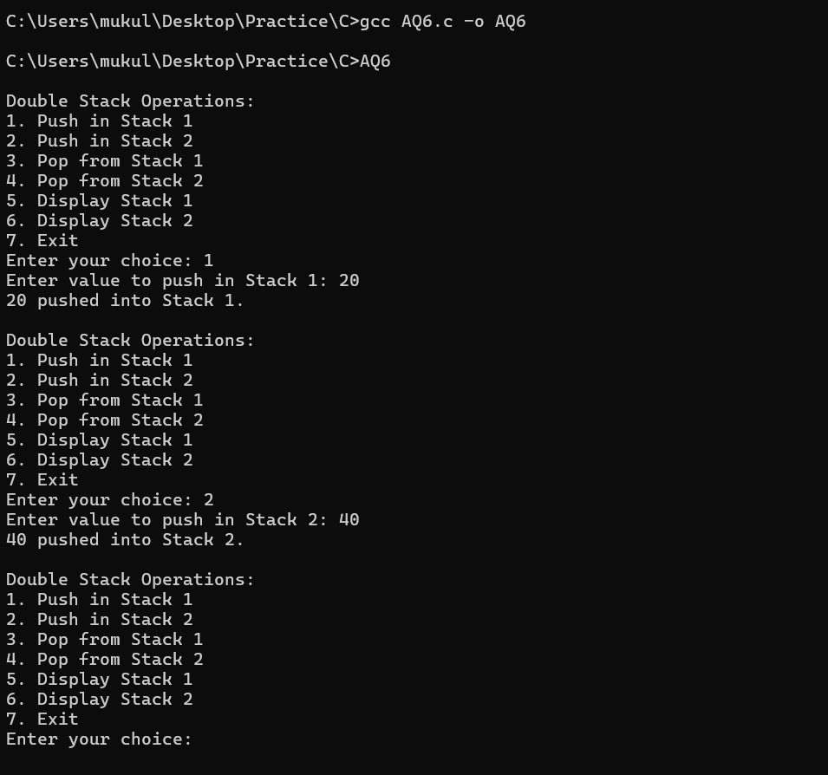

AQ7. Write a program that accepts a string of characters and prints the characters in reverse order. The program should make use of appropriate operations of stack.

Solution :

#include <stdio.h>
#include <string.h>
#define MAX 100

char stack[MAX];
int top = -1;

void push(char ch) {
stack[++top] = ch;
}

char pop() {
return stack[top--];
}

int main() {
char str[MAX];
printf("Enter a string: ");
fgets(str, MAX, stdin);

size_t len = strlen(str);
if (str[len - 1] == '\n') {
str[len - 1] = '\0';
}

for (int i = 0; str[i] != '\0'; i++) {
push(str[i]);
}

printf("Reversed string: ");
while (top != -1) {
printf("%c", pop());
}

printf("\n");
return 0;
}

Output :

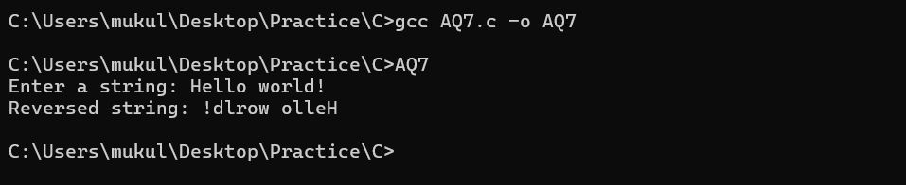

AQ8. Write a program that accepts a number in decimal and converts it to its equivalent binary number. The program should make use of appropriate operations of stack.

Solution :

#include <stdio.h>
#define MAX 32
int stack[MAX];
int top = -1;
int isEmpty() {
return top == -1;
}
int isFull() {
return top == MAX - 1;
}
void push(int value) {
if (!isFull()) {
stack[++top] = value;
} else {
printf("Stack overflow!\n");
}
}
int pop() {
if (!isEmpty()) {
return stack[top--];
} else {
printf("Stack underflow!\n");
return -1;
}
}
void decimalToBinary(int num) {
if (num == 0) {
printf("Binary equivalent: 0\n");
return;
}
while (num > 0) {
push(num % 2);
num /= 2;
}
printf("Binary equivalent: ");
while (!isEmpty()) {
printf("%d", pop());
}
printf("\n");
}
int main() {
int decimal;
printf("Enter a decimal number: ");
scanf("%d", &decimal);
if (decimal < 0) {
printf("Please enter a non-negative integer.\n");
} else {
decimalToBinary(decimal);
}
return 0;
}

Output :

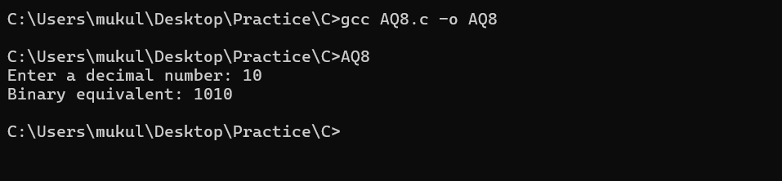

AQ9. Write a program that accepts a postfix expression of the form ab+cd-*ab/ and evaluate it after accepting the values of a, b, c and d. The program should make use of appropriate stack operations.

Solution :

#include <stdio.h>
#include <ctype.h>
#define MAX 100

int stack[MAX];
int top = -1;

void push(int value) {
if (top < MAX - 1) {
stack[++top] = value;
} else {
printf("Stack overflow!\n");
}
}

int pop() {
if (top >= 0) {
return stack[top--];
} else {
printf("Stack underflow!\n");
return -1;
}
}

int evaluatePostfix(char* expression, int a, int b, int c, int d) {
for (int i = 0; expression[i] != '\0'; i++) {
if (isalpha(expression[i])) {
switch (expression[i]) {
case 'a': push(a); break;
case 'b': push(b); break;
case 'c': push(c); break;
case 'd': push(d); break;
}
} else if (expression[i] == '+' || expression[i] == '-' || expression[i] == '*' || expression[i] == '/') {
int op2 = pop();
int op1 = pop();
switch (expression[i]) {
case '+': push(op1 + op2); break;
case '-': push(op1 - op2); break;
case '*': push(op1 * op2); break;
case '/':
if (op2 != 0) {
push(op1 / op2);
} else {
printf("Division by zero error!\n");
return -1;
}
break;
}
}
}
return pop();
}

int main() {
char expression[] = "ab+cd-*ab/";
int a, b, c, d;

printf("Enter value of a: ");
scanf("%d", &a);
printf("Enter value of b: ");
scanf("%d", &b);
printf("Enter value of c: ");
scanf("%d", &c);
printf("Enter value of d: ");
scanf("%d", &d);

int result = evaluatePostfix(expression, a, b, c, d);
if (result != -1) {
printf("Result: %d\n", result);
}

return 0;
}

Output :

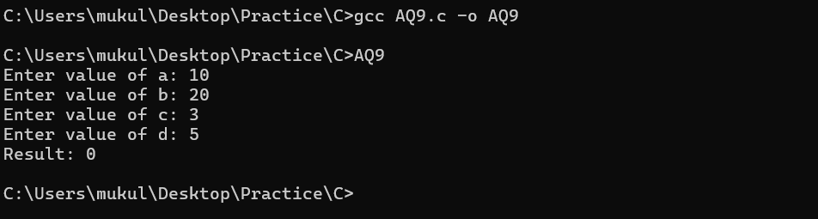

AQ10. Write a menu-driven program which implements a stack (using linear linked list) with following operations:
a) Push (Insert an element)
b) Pop (Delete an element)
c) Display (Print all elements of stack)

Solution :

#include <stdio.h>
#include <stdlib.h>

typedef struct Node {
int data;
struct Node* next;
} Node;

Node* top = NULL;

void push(int value) {
Node* newNode = (Node*)malloc(sizeof(Node));
if (!newNode) {
printf("Memory allocation failed!\n");
return;
}
newNode->data = value;
newNode->next = top;
top = newNode;
printf("%d pushed to stack.\n", value);
}

void pop() {
if (top == NULL) {
printf("Stack underflow!\n");
return;
}
Node* temp = top;
printf("%d popped from stack.\n", temp->data);
top = top->next;
free(temp);
}

void display() {
if (top == NULL) {
printf("Stack is empty.\n");
return;
}
Node* temp = top;
printf("Stack elements: ");
while (temp != NULL) {
printf("%d ", temp->data);
temp = temp->next;
}
printf("\n");
}

int main() {
int choice, value;
do {
printf("\nStack Operations:\n");
printf("1. Push\n");
printf("2. Pop\n");
printf("3. Display\n");
printf("4. Exit\n");
printf("Enter your choice: ");
scanf("%d", &choice);

switch (choice) {
case 1:
printf("Enter value to push: ");
scanf("%d", &value);
push(value);
break;
case 2:
pop();
break;
case 3:
display();
break;
case 4:
printf("Exiting...\n");
break;
default:
printf("Invalid choice! Please try again.\n");
}
} while (choice != 4);

return 0;
}

Output :

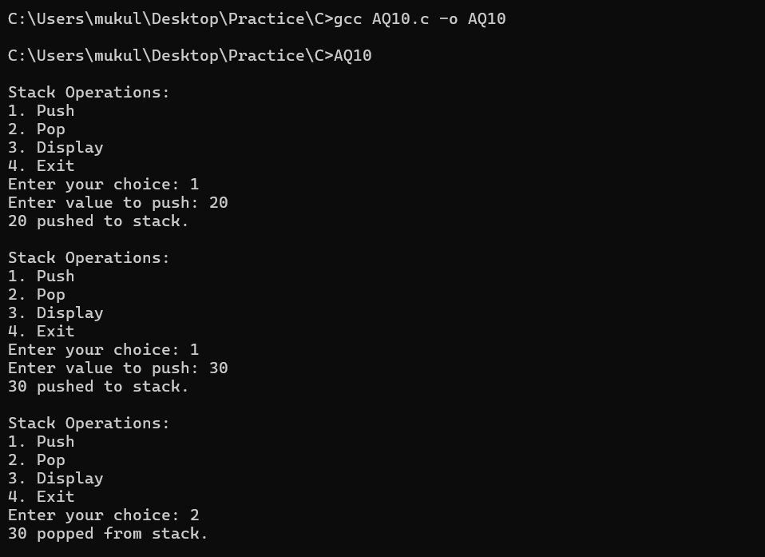

AQ11. Write a menu-driven program which implements a linear queue (using linear linked list) with following operations:
a) Enqueue (Insert an element)
b) Dequeue (Delete an element)
c) Display (Print all elements of queue)

Solution :

#include <stdio.h>
#include <stdlib.h>

typedef struct Node {
int data;
struct Node* next;
} Node;

Node* front = NULL;
Node* rear = NULL;

void enqueue(int value) {
Node* newNode = (Node*)malloc(sizeof(Node));
if (!newNode) {
printf("Memory allocation failed!\n");
return;
}
newNode->data = value;
newNode->next = NULL;

if (rear == NULL) {
front = rear = newNode;
} else {
rear->next = newNode;
rear = newNode;
}
printf("%d enqueued to queue.\n", value);
}

void dequeue() {
if (front == NULL) {
printf("Queue underflow!\n");
return;
}
Node* temp = front;
printf("%d dequeued from queue.\n", temp->data);
front = front->next;
if (front == NULL) {
rear = NULL;
}
free(temp);
}

void display() {
if (front == NULL) {
printf("Queue is empty.\n");
return;
}
Node* temp = front;
printf("Queue elements: ");
while (temp != NULL) {
printf("%d ", temp->data);
temp = temp->next;
}
printf("\n");
}

int main() {
int choice, value;
do {
printf("\nQueue Operations:\n");
printf("1. Enqueue\n");
printf("2. Dequeue\n");
printf("3. Display\n");
printf("4. Exit\n");
printf("Enter your choice: ");
scanf("%d", &choice);

switch (choice) {
case 1:
printf("Enter value to enqueue: ");
scanf("%d", &value);
enqueue(value);
break;
case 2:
dequeue();
break;
case 3:
display();
break;
case 4:
printf("Exiting...\n");
break;
default:
printf("Invalid choice! Please try again.\n");
}
} while (choice != 4);

return 0;
}

Output :

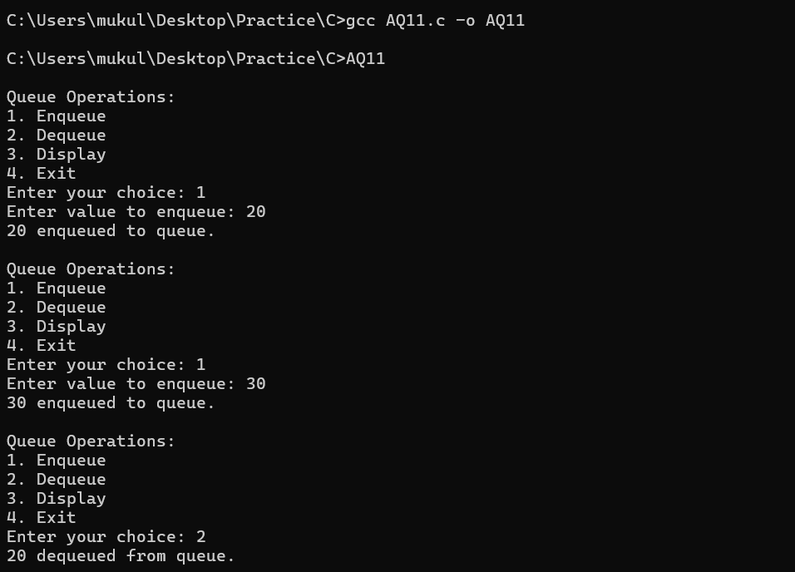

AQ12. Write a menu-driven program which implements a double ended queue (using one-dimensional array) with all possible insertion and deletion operations.

Solution :

#include <stdio.h>
#define MAX 100

int deque[MAX];
int front = -1, rear = -1;

int isFull() {
return (front == 0 && rear == MAX - 1) || (front == rear + 1);
}

int isEmpty() {
return front == -1;
}

void insertFront(int value) {
if (isFull()) {
printf("Deque overflow!\n");
return;
}
if (isEmpty()) {
front = rear = 0;
} else if (front == 0) {
front = MAX - 1;
} else {
front--;
}
deque[front] = value;
printf("%d inserted at front.\n", value);
}

void insertRear(int value) {
if (isFull()) {
printf("Deque overflow!\n");
return;
}
if (isEmpty()) {
front = rear = 0;
} else if (rear == MAX - 1) {
rear = 0;
} else {
rear++;
}
deque[rear] = value;
printf("%d inserted at rear.\n", value);
}

void deleteFront() {
if (isEmpty()) {
printf("Deque underflow!\n");
return;
}
printf("%d deleted from front.\n", deque[front]);
if (front == rear) {
front = rear = -1;
} else if (front == MAX - 1) {
front = 0;
} else {
front++;
}
}

void deleteRear() {
if (isEmpty()) {
printf("Deque underflow!\n");
return;
}
printf("%d deleted from rear.\n", deque[rear]);
if (front == rear) {
front = rear = -1;
} else if (rear == 0) {
rear = MAX - 1;
} else {
rear--;
}
}

void display() {
if (isEmpty()) {
printf("Deque is empty.\n");
return;
}
printf("Deque elements: ");
int i = front;
while (1) {
printf("%d ", deque[i]);
if (i == rear) break;
i = (i + 1) % MAX;
}
printf("\n");
}

int main() {
int choice, value;
do {
printf("\nDeque Operations:\n");
printf("1. Insert at Front\n");
printf("2. Insert at Rear\n");
printf("3. Delete from Front\n");
printf("4. Delete from Rear\n");
printf("5. Display\n");
printf("6. Exit\n");
printf("Enter your choice: ");
scanf("%d", &choice);

switch (choice) {
case 1:
printf("Enter value to insert at front: ");
scanf("%d", &value);
insertFront(value);
break;
case 2:
printf("Enter value to insert at rear: ");
scanf("%d", &value);
insertRear(value);
break;
case 3:
deleteFront();
break;
case 4:
deleteRear();
break;
case 5:
display();
break;
case 6:
printf("Exiting...\n");
break;
default:
printf("Invalid choice! Please try again.\n");
}
} while (choice != 6);

return 0;
}

Output :

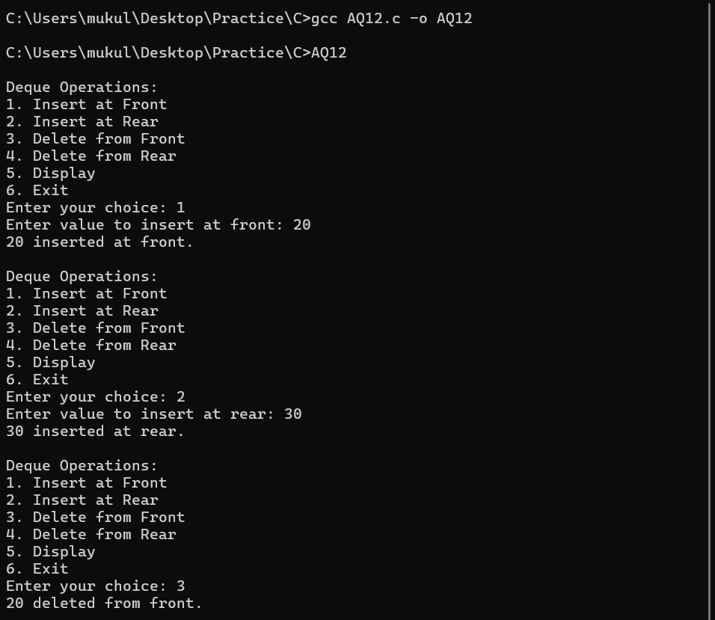

P11. Write a menu-driven program which implements a binary tree (using linked list) with following operations:
a) Insertion of a node
b) Deletion of a node
c) Preorder traversal
d) Inorder traversal
e) Postorder traversal
f) Determine total numer of leaf nodes

Solution :

#include <stdio.h>
#include <stdlib.h>

typedef struct Node {
int data;
struct Node *left, *right;
} Node;

Node* createNode(int data) {
Node* newNode = (Node*)malloc(sizeof(Node));
newNode->data = data;
newNode->left = newNode->right = NULL;
return newNode;
}

Node* insert(Node* root, int data) {
if (root == NULL) return createNode(data);

if (data < root->data)
root->left = insert(root->left, data);
else if (data > root->data)
root->right = insert(root->right, data);

return root;
}

Node* minValueNode(Node* node) {
Node* current = node;
while (current && current->left != NULL)
current = current->left;
return current;
}

Node* deleteNode(Node* root, int data) {
if (root == NULL) return root;

if (data < root->data)
root->left = deleteNode(root->left, data);
else if (data > root->data)
root->right = deleteNode(root->right, data);
else {
if (root->left == NULL) {
Node* temp = root->right;
free(root);
return temp;
} else if (root->right == NULL) {
Node* temp = root->left;
free(root);
return temp;
}

Node* temp = minValueNode(root->right);
root->data = temp->data;
root->right = deleteNode(root->right, temp->data);
}
return root;
}

void preorder(Node* root) {
if (root != NULL) {
printf("%d ", root->data);
preorder(root->left);
preorder(root->right);
}
}

void inorder(Node* root) {
if (root != NULL) {
inorder(root->left);
printf("%d ", root->data);
inorder(root->right);
}
}

void postorder(Node* root) {
if (root != NULL) {
postorder(root->left);
postorder(root->right);
printf("%d ", root->data);
}
}

int countLeafNodes(Node* root) {
if (root == NULL) return 0;
if (root->left == NULL && root->right == NULL) return 1;
return countLeafNodes(root->left) + countLeafNodes(root->right);
}

int main() {
Node* root = NULL;
int choice, value;

while (1) {
printf("\nMenu:\n");
printf("1. Insert a node\n");
printf("2. Delete a node\n");
printf("3. Preorder traversal\n");
printf("4. Inorder traversal\n");
printf("5. Postorder traversal\n");
printf("6. Count leaf nodes\n");
printf("7. Exit\n");
printf("Enter your choice: ");
scanf("%d", &choice);

switch (choice) {
case 1:
printf("Enter value to insert: ");
scanf("%d", &value);
root = insert(root, value);
break;
case 2:
printf("Enter value to delete: ");
scanf("%d", &value);
root = deleteNode(root, value);
break;
case 3:
printf("Preorder Traversal: ");
preorder(root);
printf("\n");
break;
case 4:
printf("Inorder Traversal: ");
inorder(root);
printf("\n");
break;
case 5:
printf("Postorder Traversal: ");
postorder(root);
printf("\n");
break;
case 6:
printf("Total number of leaf nodes: %d\n", countLeafNodes(root));
break;
case 7:
printf("Exiting the program.\n");
exit(0);
default:
printf("Invalid choice! Please try again.\n");
}
}

return 0;
}

Output :

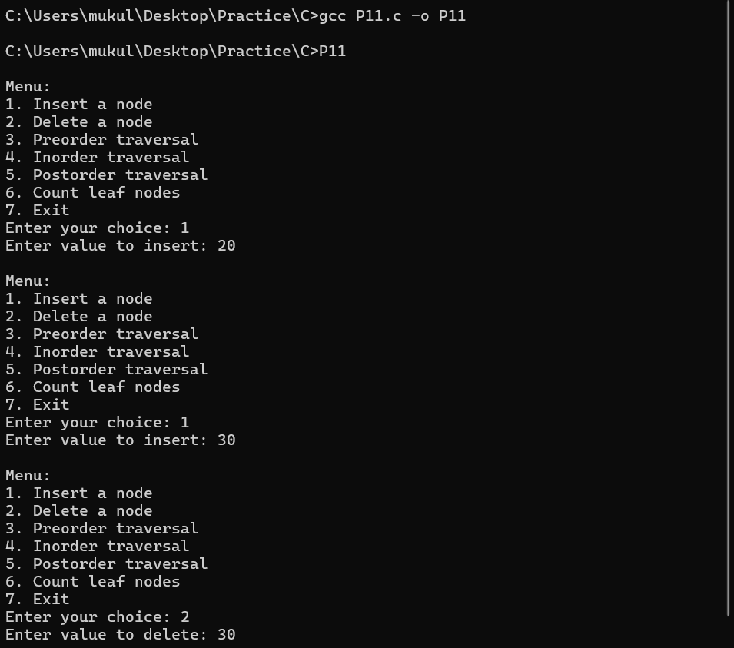

P12. Write a menu-driven program which implements a heap (using onedimensional array) with following operations: a) Insertion of a node b) Deletion of a node c) Display (print all the elements of heap)

Solution :

#include <stdio.h>
#define MAX 100

int heap[MAX];
int size = 0;

void swap(int *a, int *b) {
int temp = *a;
*a = *b;
*b = temp;
}

void insert(int value) {
if (size >= MAX) {
printf("Heap is full.\n");
return;
}
heap[size] = value;
int current = size;

while (current > 0 && heap[(current - 1) / 2] < heap[current]) {
swap(&heap[(current - 1) / 2], &heap[current]);
current = (current - 1) / 2;
}
size++;
}

void heapify(int i) {
int largest = i;
int left = 2 * i + 1;
int right = 2 * i + 2;

if (left < size && heap[left] > heap[largest])
largest = left;

if (right < size && heap[right] > heap[largest])
largest = right;

if (largest != i) {
swap(&heap[i], &heap[largest]);
heapify(largest);
}
}

void deleteRoot() {
if (size <= 0) {
printf("Heap is empty.\n");
return;
}
heap[0] = heap[size - 1];
size--;
heapify(0);
}

void display() {
if (size == 0) {
printf("Heap is empty.\n");
return;
}
for (int i = 0; i < size; i++)
printf("%d ", heap[i]);
printf("\n");
}

int main() {
int choice, value;

while (1) {
printf("\nMenu:\n");
printf("1. Insert a node\n");
printf("2. Delete a node\n");
printf("3. Display heap\n");
printf("4. Exit\n");
printf("Enter your choice: ");
scanf("%d", &choice);

switch (choice) {
case 1:
printf("Enter value to insert: ");
scanf("%d", &value);
insert(value);
break;
case 2:
deleteRoot();
printf("Root node deleted successfully.\n");
break;
case 3:
printf("Heap elements: ");
display();
break;
case 4:
printf("Exiting the program.\n");
return 0;
default:
printf("Invalid choice! Please try again.\n");
}
}
return 0;
}

Output :

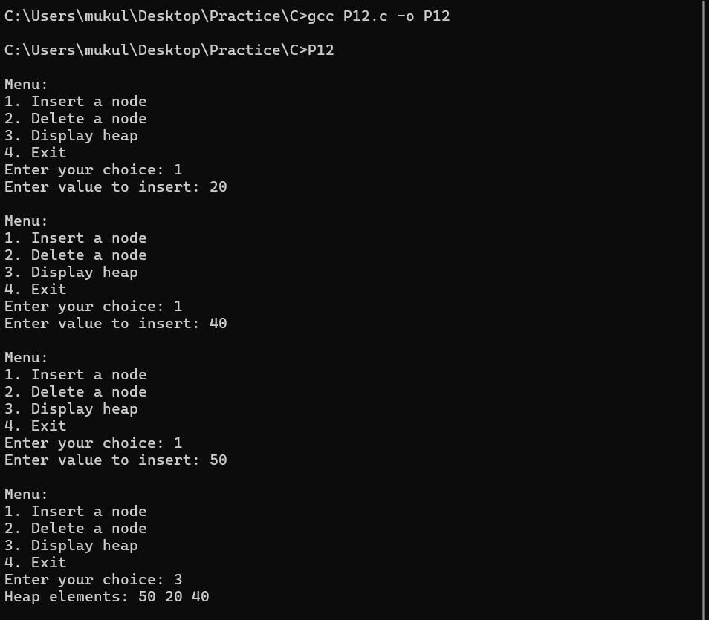

P13. Write a menu-driven program which implements a binary search tree (using linked list) with following operations:
a) Insertion of a node
b) Deletion of a node
c) Preorder traversal
d) Inorder traversal
e) Postorder traversal

Solution :

#include <stdio.h>
#include <stdlib.h>

typedef struct Node {
int data;
struct Node *left, *right;
} Node;

Node* createNode(int data) {
Node* newNode = (Node*)malloc(sizeof(Node));
newNode->data = data;
newNode->left = newNode->right = NULL;
return newNode;
}

Node* insert(Node* root, int data) {
if (root == NULL) return createNode(data);
if (data < root->data)
root->left = insert(root->left, data);
else if (data > root->data)
root->right = insert(root->right, data);
return root;
}

Node* minValueNode(Node* node) {
Node* current = node;
while (current && current->left != NULL)
current = current->left;
return current;
}

Node* deleteNode(Node* root, int data) {
if (root == NULL) return root;
if (data < root->data)
root->left = deleteNode(root->left, data);
else if (data > root->data)
root->right = deleteNode(root->right, data);
else {
if (root->left == NULL) {
Node* temp = root->right;
free(root);
return temp;
} else if (root->right == NULL) {
Node* temp = root->left;
free(root);
return temp;
}
Node* temp = minValueNode(root->right);
root->data = temp->data;
root->right = deleteNode(root->right, temp->data);
}
return root;
}

void preorder(Node* root) {
if (root != NULL) {
printf("%d ", root->data);
preorder(root->left);
preorder(root->right);
}
}

void inorder(Node* root) {
if (root != NULL) {
inorder(root->left);
printf("%d ", root->data);
inorder(root->right);
}
}

void postorder(Node* root) {
if (root != NULL) {
postorder(root->left);
postorder(root->right);
printf("%d ", root->data);
}
}

int main() {
Node* root = NULL;
int choice, value;

while (1) {
printf("\nMenu:\n");
printf("1. Insert a node\n");
printf("2. Delete a node\n");
printf("3. Preorder traversal\n");
printf("4. Inorder traversal\n");
printf("5. Postorder traversal\n");
printf("6. Exit\n");
printf("Enter your choice: ");
scanf("%d", &choice);

switch (choice) {
case 1:
printf("Enter value to insert: ");
scanf("%d", &value);
root = insert(root, value);
break;
case 2:
printf("Enter value to delete: ");
scanf("%d", &value);
root = deleteNode(root, value);
break;
case 3:
printf("Preorder Traversal: ");
preorder(root);
printf("\n");
break;
case 4:
printf("Inorder Traversal: ");
inorder(root);
printf("\n");
break;
case 5:
printf("Postorder Traversal: ");
postorder(root);
printf("\n");
break;
case 6:
printf("Exiting the program.\n");
exit(0);
default:
printf("Invalid choice! Please try again.\n");
}
}
return 0;
}

Output :

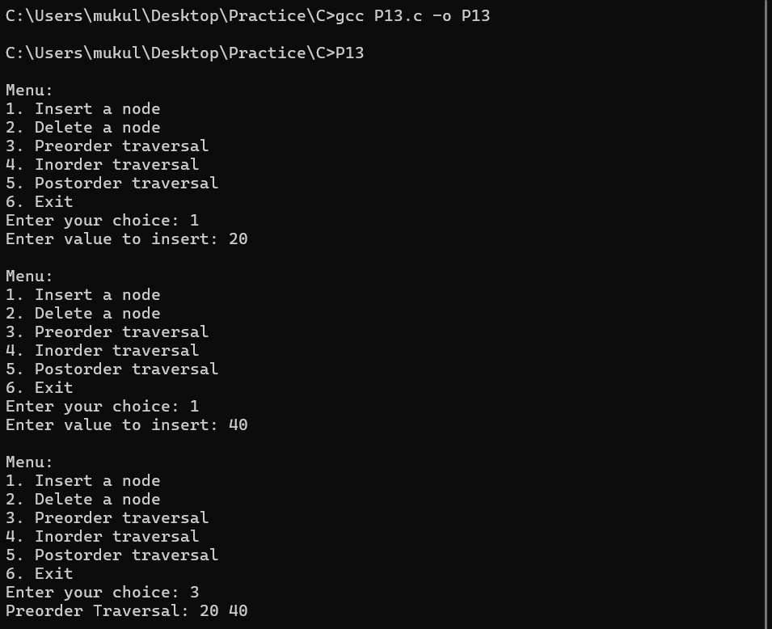

P14. Write a program which takes an array of n integers and sorts the integers in ascending order using heap sort technique

Solution :

#include <stdio.h>

void swap(int *a, int *b) {
int temp = *a;
*a = *b;
*b = temp;
}

void heapify(int arr[], int n, int i) {
int largest = i;
int left = 2 * i + 1;
int right = 2 * i + 2;

if (left < n && arr[left] > arr[largest])
largest = left;

if (right < n && arr[right] > arr[largest])
largest = right;

if (largest != i) {
swap(&arr[i], &arr[largest]);
heapify(arr, n, largest);
}
}

void heapSort(int arr[], int n) {
for (int i = n / 2 - 1; i >= 0; i--)
heapify(arr, n, i);

for (int i = n - 1; i > 0; i--) {
swap(&arr[0], &arr[i]);
heapify(arr, i, 0);
}
}

void printArray(int arr[], int n) {
for (int i = 0; i < n; i++)
printf("%d ", arr[i]);
printf("\n");
}

int main() {
int n;
printf("Enter the number of elements: ");
scanf("%d", &n);

int arr[n];
printf("Enter the elements: ");
for (int i = 0; i < n; i++)
scanf("%d", &arr[i]);

heapSort(arr, n);

printf("Sorted array: ");
printArray(arr, n);

return 0;
}

Output :

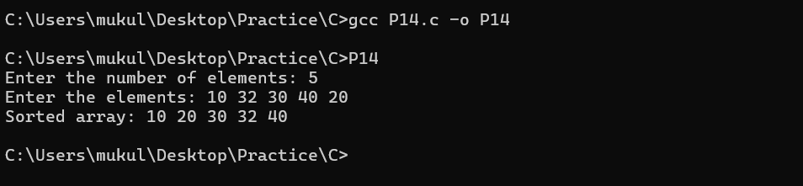

AQ13. Write a menu-driven program that implements a binary search tree with following operations:
a) Total number of nodes in the tree
b) Total number of leaf nodes in the tree
c) Total number of non-leaf nodes in the tree
d) Smallest node of the tree
e) Largest node of the tree
f) Search a node in the tree
g) Sum of all nodes of the tree
h) Display the nodes in ascending order

Solution :

#include <stdio.h>
#include <stdlib.h>

typedef struct Node {
int data;
struct Node *left, *right;
} Node;

Node* createNode(int data) {
Node* newNode = (Node*)malloc(sizeof(Node));
newNode->data = data;
newNode->left = newNode->right = NULL;
return newNode;
}

Node* insert(Node* root, int data) {
if (root == NULL) return createNode(data);
if (data < root->data)
root->left = insert(root->left, data);
else if (data > root->data)
root->right = insert(root->right, data);
return root;
}

int countNodes(Node* root) {
if (root == NULL) return 0;
return 1 + countNodes(root->left) + countNodes(root->right);
}

int countLeafNodes(Node* root) {
if (root == NULL) return 0;
if (root->left == NULL && root->right == NULL) return 1;
return countLeafNodes(root->left) + countLeafNodes(root->right);
}

int countNonLeafNodes(Node* root) {
return countNodes(root) - countLeafNodes(root);
}

Node* findMin(Node* root) {
while (root->left != NULL)
root = root->left;
return root;
}

Node* findMax(Node* root) {
while (root->right != NULL)
root = root->right;
return root;
}

int search(Node* root, int key) {
if (root == NULL) return 0;
if (root->data == key) return 1;
if (key < root->data) return search(root->left, key);
return search(root->right, key);
}

int sumOfNodes(Node* root) {
if (root == NULL) return 0;
return root->data + sumOfNodes(root->left) + sumOfNodes(root->right);
}

void inorder(Node* root) {
if (root != NULL) {
inorder(root->left);
printf("%d ", root->data);
inorder(root->right);
}
}

int main() {
Node* root = NULL;
int choice, value;

while (1) {
printf("\nMenu:\n");
printf("1. Insert a node\n");
printf("2. Total number of nodes\n");
printf("3. Total number of leaf nodes\n");
printf("4. Total number of non-leaf nodes\n");
printf("5. Smallest node\n");
printf("6. Largest node\n");
printf("7. Search a node\n");
printf("8. Sum of all nodes\n");
printf("9. Display nodes in ascending order\n");
printf("10. Exit\n");
printf("Enter your choice: ");
scanf("%d", &choice);

switch (choice) {
case 1:
printf("Enter value to insert: ");
scanf("%d", &value);
root = insert(root, value);
break;
case 2:
printf("Total number of nodes: %d\n", countNodes(root));
break;
case 3:
printf("Total number of leaf nodes: %d\n", countLeafNodes(root));
break;
case 4:
printf("Total number of non-leaf nodes: %d\n", countNonLeafNodes(root));
break;
case 5:
printf("Smallest node: %d\n", findMin(root)->data);
break;
case 6:
printf("Largest node: %d\n", findMax(root)->data);
break;
case 7:
printf("Enter value to search: ");
scanf("%d", &value);
printf(search(root, value) ? "Node found\n" : "Node not found\n");
break;
case 8:
printf("Sum of all nodes: %d\n", sumOfNodes(root));
break;
case 9:
printf("Nodes in ascending order: ");
inorder(root);
printf("\n");
break;
case 10:
printf("Exiting the program.\n");
exit(0);
default:
printf("Invalid choice! Please try again.\n");
}
}
return 0;
}

Output :

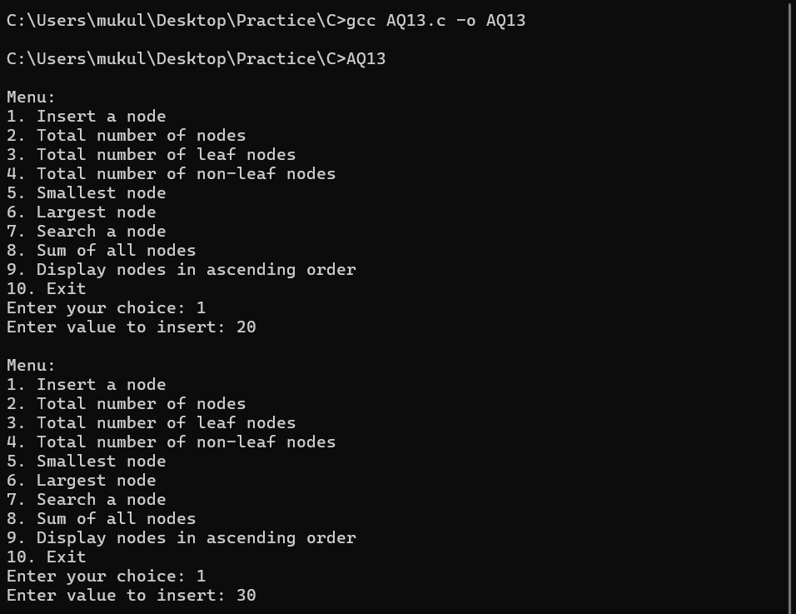

AQ14. Write a program to implement priority queue (using one dimensional array). For deletion of a node, the node having smallest data value will be considered to have highest priority.

Solution :

#include <stdio.h>
#define MAX 100

int heap[MAX];
int size = 0;

void swap(int *a, int *b) {
int temp = *a;
*a = *b;
*b = temp;
}

void insert(int value) {
if (size >= MAX) {
printf("Priority Queue is full.\n");
return;
}
heap[size] = value;
int current = size;

while (current > 0 && heap[(current - 1) / 2] > heap[current]) {
swap(&heap[(current - 1) / 2], &heap[current]);
current = (current - 1) / 2;
}
size++;
}

void heapify(int i) {
int smallest = i;
int left = 2 * i + 1;
int right = 2 * i + 2;

if (left < size && heap[left] < heap[smallest])
smallest = left;

if (right < size && heap[right] < heap[smallest])
smallest = right;

if (smallest != i) {
swap(&heap[i], &heap[smallest]);
heapify(smallest);
}
}

void deleteMin() {
if (size == 0) {
printf("Priority Queue is empty.\n");
return;
}
printf("Deleted element with highest priority: %d\n", heap[0]);
heap[0] = heap[size - 1];
size--;
heapify(0);
}

void display() {
if (size == 0) {
printf("Priority Queue is empty.\n");
return;
}
printf("Priority Queue elements: ");
for (int i = 0; i < size; i++)
printf("%d ", heap[i]);
printf("\n");
}

int main() {
int choice, value;

while (1) {
printf("\nMenu:\n");
printf("1. Insert a node\n");
printf("2. Delete node with highest priority\n");
printf("3. Display priority queue\n");
printf("4. Exit\n");
printf("Enter your choice: ");
scanf("%d", &choice);

switch (choice) {
case 1:
printf("Enter value to insert: ");
scanf("%d", &value);
insert(value);
break;
case 2:
deleteMin();
break;
case 3:
display();
break;
case 4:
printf("Exiting the program.\n");
return 0;
default:
printf("Invalid choice! Please try again.\n");
}
}
return 0;
}

Output :

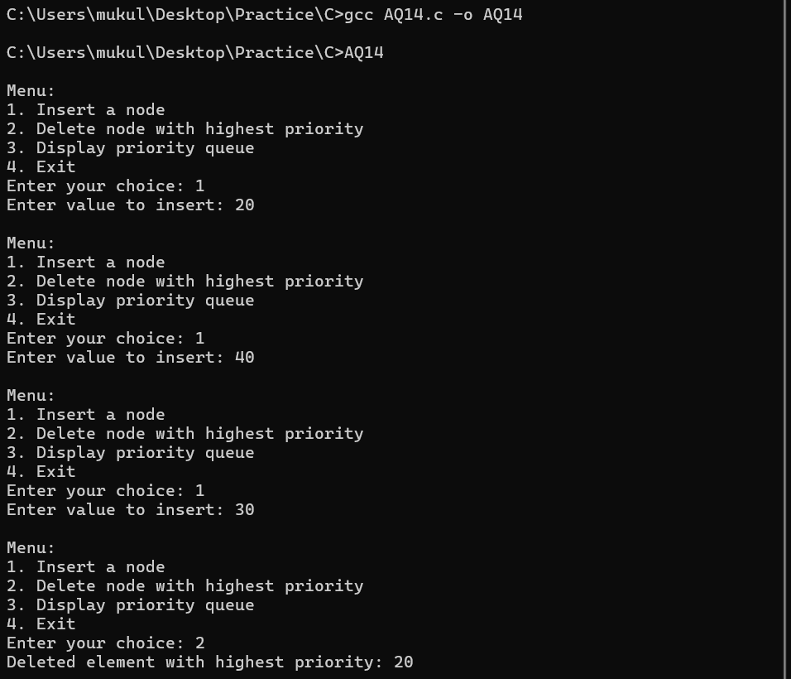

AQ15. Write a program to implement a binary tree and perform preorder, inorder and postorder traversal without performing recursive operations

Solution :

#include <stdio.h>
#include <stdlib.h>
#define MAX 100

typedef struct Node {
int data;
struct Node *left, *right;
} Node;

typedef struct Stack {
Node* data[MAX];
int top;
} Stack;

void initStack(Stack* stack) {
stack->top = -1;
}

int isEmpty(Stack* stack) {
return stack->top == -1;
}

void push(Stack* stack, Node* node) {
if (stack->top < MAX - 1)
stack->data[++stack->top] = node;
}

Node* pop(Stack* stack) {
if (!isEmpty(stack))
return stack->data[stack->top--];
return NULL;
}

Node* createNode(int data) {
Node* newNode = (Node*)malloc(sizeof(Node));
newNode->data = data;
newNode->left = newNode->right = NULL;
return newNode;
}

Node* insert(Node* root, int data) {
if (root == NULL) return createNode(data);
if (data < root->data)
root->left = insert(root->left, data);
else if (data > root->data)
root->right = insert(root->right, data);
return root;
}

void preorder(Node* root) {
if (root == NULL) return;
Stack stack;
initStack(&stack);
push(&stack, root);

while (!isEmpty(&stack)) {
Node* current = pop(&stack);
printf("%d ", current->data);
if (current->right) push(&stack, current->right);
if (current->left) push(&stack, current->left);
}
}

void inorder(Node* root) {
Stack stack;
initStack(&stack);
Node* current = root;

while (current != NULL || !isEmpty(&stack)) {
while (current != NULL) {
push(&stack, current);
current = current->left;
}
current = pop(&stack);
printf("%d ", current->data);
current = current->right;
}
}

void postorder(Node* root) {
Stack stack1, stack2;
initStack(&stack1);
initStack(&stack2);

push(&stack1, root);
while (!isEmpty(&stack1)) {
Node* current = pop(&stack1);
push(&stack2, current);
if (current->left) push(&stack1, current->left);
if (current->right) push(&stack1, current->right);
}

while (!isEmpty(&stack2)) {
printf("%d ", pop(&stack2)->data);
}
}

int main() {
Node* root = NULL;
int choice, value;

while (1) {
printf("\nMenu:\n");
printf("1. Insert a node\n");
printf("2. Preorder traversal\n");
printf("3. Inorder traversal\n");
printf("4. Postorder traversal\n");
printf("5. Exit\n");
printf("Enter your choice: ");
scanf("%d", &choice);

switch (choice) {
case 1:
printf("Enter value to insert: ");
scanf("%d", &value);
root = insert(root, value);
break;
case 2:
printf("Preorder Traversal: ");
preorder(root);
printf("\n");
break;
case 3:
printf("Inorder Traversal: ");
inorder(root);
printf("\n");
break;
case 4:
printf("Postorder Traversal: ");
postorder(root);
printf("\n");
break;
case 5:
printf("Exiting the program.\n");
exit(0);
default:
printf("Invalid choice! Please try again.\n");
}
}
return 0;
}

Output :

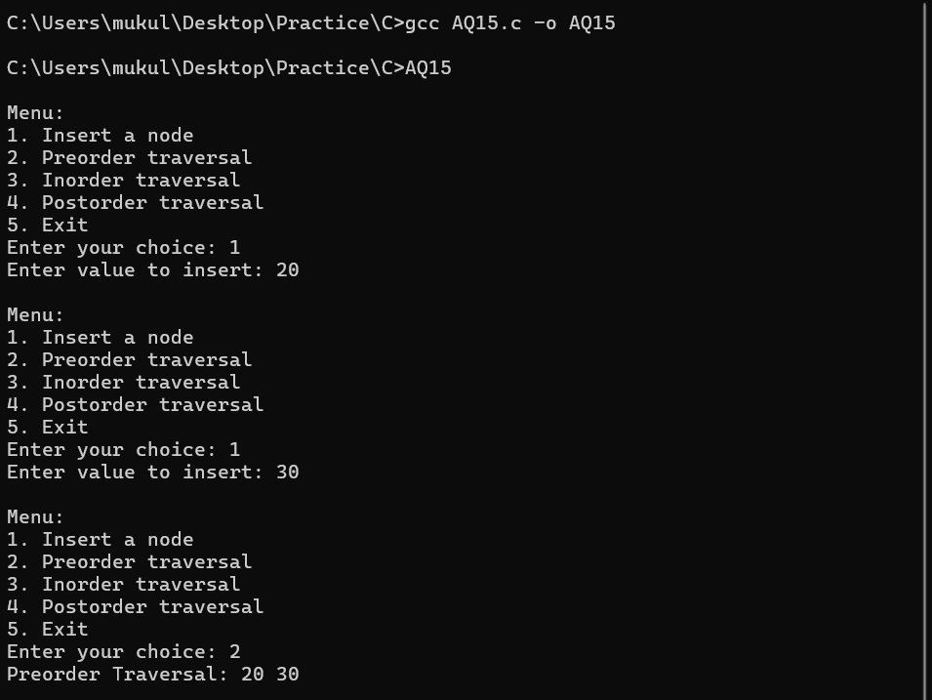

P15. Write a menu-driven program which implements a graph (using adjacency matrix) with following operations:
a) Insertion of a vertex
b) Insertion of an edge
c) Deletion of a vertex
d) Deletion of an edge
e) Calculation of degree of each vertex
f) Calculation of number of self-loops in the graph

Solution :

#include <stdio.h>
#include <stdlib.h>

#define MAX 100

int adj[MAX][MAX];
int vertex_count = 0;

void insert_vertex() {
if (vertex_count >= MAX) {
printf("Vertex limit reached!\n");
return;
}
vertex_count++;
printf("Vertex %d inserted successfully.\n", vertex_count - 1);
}

void insert_edge() {
int u, v;
printf("Enter the vertices to connect (u v): ");
scanf("%d%d", &u, &v);
if (u >= vertex_count || v >= vertex_count) {
printf("Invalid vertex number!\n");
return;
}
adj[u][v] = 1;
printf("Edge inserted between %d and %d.\n", u, v);
}

void delete_edge() {
int u, v;
printf("Enter the vertices to disconnect (u v): ");
scanf("%d%d", &u, &v);
if (u >= vertex_count || v >= vertex_count) {
printf("Invalid vertex number!\n");
return;
}
adj[u][v] = 0;
printf("Edge deleted between %d and %d.\n", u, v);
}

void delete_vertex() {
int v, i, j;
printf("Enter the vertex to delete: ");
scanf("%d", &v);
if (v >= vertex_count) {
printf("Invalid vertex number!\n");
return;
}
for (i = v; i < vertex_count - 1; i++) {
for (j = 0; j < vertex_count; j++) {
adj[i][j] = adj[i + 1][j];
}
}
for (i = 0; i < vertex_count - 1; i++) {
for (j = v; j < vertex_count - 1; j++) {
adj[i][j] = adj[i][j + 1];
}
}
vertex_count--;
printf("Vertex %d deleted successfully.\n", v);
}

void degree_of_vertices() {
int i, j, degree;
for (i = 0; i < vertex_count; i++) {
degree = 0;
for (j = 0; j < vertex_count; j++) {
if (adj[i][j])
degree++;
if (i == j && adj[i][j])
degree++;
}
printf("Degree of vertex %d: %d\n", i, degree);
}
}

void count_self_loops() {
int i, count = 0;
for (i = 0; i < vertex_count; i++) {
if (adj[i][i])
count++;
}
printf("Number of self-loops: %d\n", count);
}

void display_adj_matrix() {
int i, j;
printf("Adjacency Matrix:\n");
for (i = 0; i < vertex_count; i++) {
for (j = 0; j < vertex_count; j++) {
printf("%d ", adj[i][j]);
}
printf("\n");
}
}

int main() {
int choice;
while (1) {
printf("\n--- Graph Menu ---\n");
printf("1. Insert Vertex\n");
printf("2. Insert Edge\n");
printf("3. Delete Vertex\n");
printf("4. Delete Edge\n");
printf("5. Degree of each Vertex\n");
printf("6. Count Self-Loops\n");
printf("7. Display Adjacency Matrix\n");
printf("8. Exit\n");
printf("Enter your choice: ");
scanf("%d", &choice);

switch (choice) {
case 1: insert_vertex(); break;
case 2: insert_edge(); break;
case 3: delete_vertex(); break;
case 4: delete_edge(); break;
case 5: degree_of_vertices(); break;
case 6: count_self_loops(); break;
case 7: display_adj_matrix(); break;
case 8: exit(0);
default: printf("Invalid choice!\n");
}
}
return 0;
}

Output :

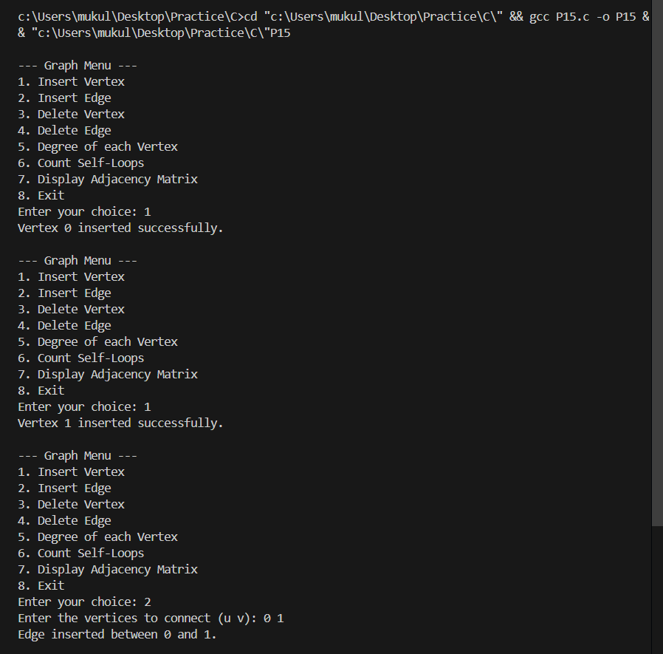

P16. Write a program to traverse the following graph using breadth first search and depth first search techniques.


Solution :

#include <stdio.h>
#include <stdlib.h>

#define MAX 8

int adj[MAX][MAX] = {
{0, 1, 1, 0, 0, 0, 0, 0},
{1, 0, 0, 1, 1, 0, 0, 0},
{1, 0, 0, 0, 1, 1, 0, 0},
{0, 1, 0, 0, 0, 0, 1, 0},
{0, 1, 1, 0, 0, 0, 1, 0},
{0, 0, 1, 0, 0, 0, 0, 0},
{0, 0, 0, 1, 1, 0, 0, 1},
{0, 0, 0, 0, 0, 0, 1, 0}};

int visited[MAX];

void bfs(int start)
{
int queue[MAX], front = 0, rear = 0, i;
for (i = 0; i < MAX; i++)
visited[i] = 0;

queue[rear++] = start;
visited[start] = 1;

printf("BFS Traversal: ");

while (front < rear)
{
int current = queue[front++];
printf("%d ", current + 1);

for (i = 0; i < MAX; i++)
{
if (adj[current][i] && !visited[i])
{
queue[rear++] = i;
visited[i] = 1;
}
}
}
printf("\n");
}

void dfs(int start)
{
int stack[MAX], top = -1, i;
for (i = 0; i < MAX; i++)
visited[i] = 0;

stack[++top] = start;
visited[start] = 1;

printf("DFS Traversal: ");

while (top != -1)
{
int current = stack[top--];
printf("%d ", current + 1);

for (i = MAX - 1; i >= 0; i--)
{
if (adj[current][i] && !visited[i])
{
stack[++top] = i;
visited[i] = 1;
}
}
}
printf("\n");
}

int main()
{
int start_vertex;
printf("Enter the starting vertex (1-8): ");
scanf("%d", &start_vertex);

if (start_vertex < 1 || start_vertex > 8)
{
printf("Invalid starting vertex!\n");
return 0;
}

bfs(start_vertex - 1);
dfs(start_vertex - 1);

return 0;
}

Output :

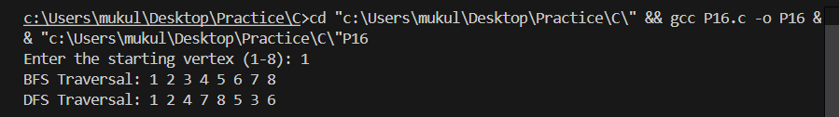

P17. Apply Dijkstra’s algorithm to determine shortest path from a to f on the below network.


Solution :

#include <stdio.h>
#define INFINITY 9999
#define MAX 6

void dijkstra(int graph[MAX][MAX], int startVertex);

int main()
{
int graph[MAX][MAX] = {
{0, 3, 9, 0, 0, 0},
{3, 0, 8, 9, 11, 0},
{9, 8, 0, 1, 0, 2},
{0, 9, 1, 0, 6, 9},
{0, 11, 0, 6, 0, 7},
{0, 0, 2, 9, 7, 0}};

int startVertex = 0; // 'a' is 0
dijkstra(graph, startVertex);

return 0;
}

void dijkstra(int graph[MAX][MAX], int startVertex)
{
int distance[MAX];
int visited[MAX];
int i, j, count, minDistance, nextVertex;

for (i = 0; i < MAX; i++)
{
distance[i] = INFINITY;
visited[i] = 0;
}

distance[startVertex] = 0;

for (count = 0; count < MAX - 1; count++)
{
minDistance = INFINITY;

for (i = 0; i < MAX; i++)
{
if (distance[i] < minDistance && !visited[i])
{
minDistance = distance[i];
nextVertex = i;
}
}

visited[nextVertex] = 1;

for (i = 0; i < MAX; i++)
{
if (!visited[i] && graph[nextVertex][i] && distance[nextVertex] + graph[nextVertex][i] < distance[i])
{
distance[i] = distance[nextVertex] + graph[nextVertex][i];
}
}
}

printf("Vertex\tDistance from a\n");
for (i = 0; i < MAX; i++)
{
printf("%c\t%d\n", i + 'a', distance[i]);
}

printf("\nShortest distance from a to f is: %d\n", distance[5]);
}

Output :

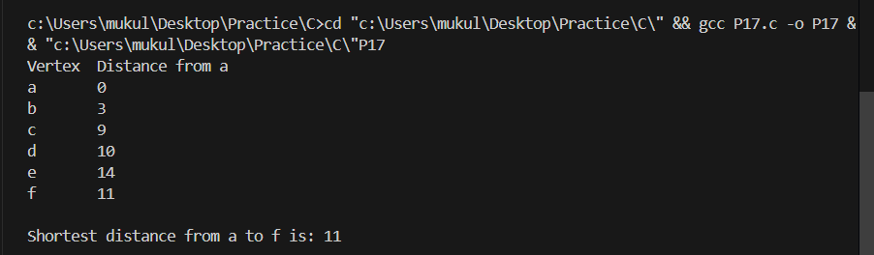

P18. Apply Warshell’s algorithm to determine shortest paths on the below network.


Solution :

#include <stdio.h>
#define MAX 6

void floydWarshall(int graph[MAX][MAX])
{
int dist[MAX][MAX];

for (int i = 0; i < MAX; i++)
{
for (int j = 0; j < MAX; j++)
{
if (graph[i][j] == 0 && i != j)
{
dist[i][j] = 99999;
}
else
{
dist[i][j] = graph[i][j];
}
}
}

for (int k = 0; k < MAX; k++)
{
for (int i = 0; i < MAX; i++)
{
for (int j = 0; j < MAX; j++)
{
if (dist[i][j] > dist[i][k] + dist[k][j])
{
dist[i][j] = dist[i][k] + dist[k][j];
}
}
}
}

printf("Shortest distances between every pair of vertices:\n");
for (int i = 0; i < MAX; i++)
{
for (int j = 0; j < MAX; j++)
{
if (dist[i][j] == 99999)
{
printf("INF\t");
}
else
{
printf("%d\t", dist[i][j]);
}
}
printf("\n");
}
}

int main()
{
int graph[MAX][MAX] = {
{0, 3, 9, 0, 0, 0},
{3, 0, 8, 9, 11, 0},
{9, 8, 0, 1, 0, 2},
{0, 9, 1, 0, 6, 9},
{0, 11, 0, 6, 0, 7},
{0, 0, 2, 9, 7, 0}};

floydWarshall(graph);

return 0;
}

Output :

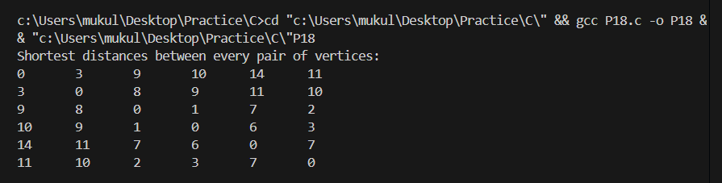

AQ16. Write a menu-driven program which implements a graph (using adjacency list) with following operations:
a) Insertion of a vertex
b) Insertion of an edge
c) Deletion of a vertex
d) Deletion of an edge
e) Calculation of degree of each vertex

Solution :

#include <stdio.h>
#include <stdlib.h>

struct Node
{
int vertex;
struct Node *next;
};

struct Graph
{
int numVertices;
struct Node **adjLists;
};

struct Node *createNode(int v)
{
struct Node *newNode = (struct Node *)malloc(sizeof(struct Node));
newNode->vertex = v;
newNode->next = NULL;
return newNode;
}

struct Graph *createGraph(int vertices)
{
struct Graph *graph = (struct Graph *)malloc(sizeof(struct Graph));
graph->numVertices = vertices;

graph->adjLists = (struct Node **)malloc(vertices * sizeof(struct Node *));

for (int i = 0; i < vertices; i++)
{
graph->adjLists[i] = NULL;
}

return graph;
}

void insertVertex(struct Graph **graph)
{
(*graph)->numVertices++;
(*graph)->adjLists = (struct Node **)realloc((*graph)->adjLists, (*graph)->numVertices * sizeof(struct Node *));
(*graph)->adjLists[(*graph)->numVertices - 1] = NULL;
printf("Vertex %d inserted successfully.\n", (*graph)->numVertices - 1);
}

void insertEdge(struct Graph *graph, int src, int dest)
{
if (src < 0 || src >= graph->numVertices || dest < 0 || dest >= graph->numVertices)
{
printf("Invalid vertices!\n");
return;
}

struct Node *newNode = createNode(dest);
newNode->next = graph->adjLists[src];
graph->adjLists[src] = newNode;

newNode = createNode(src);
newNode->next = graph->adjLists[dest];
graph->adjLists[dest] = newNode;

printf("Edge between %d and %d inserted successfully.\n", src, dest);
}

void deleteEdge(struct Graph *graph, int src, int dest)
{
if (src < 0 || src >= graph->numVertices || dest < 0 || dest >= graph->numVertices)
{
printf("Invalid vertices!\n");
return;
}

struct Node *temp = graph->adjLists[src];
struct Node *prev = NULL;

while (temp != NULL && temp->vertex != dest)
{
prev = temp;
temp = temp->next;
}

if (temp == NULL)
{
printf("Edge does not exist!\n");
return;
}

if (prev == NULL)
{
graph->adjLists[src] = temp->next;
}
else
{
prev->next = temp->next;
}
free(temp);

temp = graph->adjLists[dest];
prev = NULL;

while (temp != NULL && temp->vertex != src)
{
prev = temp;
temp = temp->next;
}

if (prev == NULL)
{
graph->adjLists[dest] = temp->next;
}
else
{
prev->next = temp->next;
}
free(temp);

printf("Edge between %d and %d deleted successfully.\n", src, dest);
}

void deleteVertex(struct Graph *graph, int vertex)
{
if (vertex < 0 || vertex >= graph->numVertices)
{
printf("Invalid vertex!\n");
return;
}

while (graph->adjLists[vertex] != NULL)
{
struct Node *temp = graph->adjLists[vertex];
int connectedVertex = temp->vertex;
graph->adjLists[vertex] = temp->next;
free(temp);

struct Node *connTemp = graph->adjLists[connectedVertex];
struct Node *connPrev = NULL;
while (connTemp != NULL && connTemp->vertex != vertex)
{
connPrev = connTemp;
connTemp = connTemp->next;
}
if (connTemp != NULL)
{
if (connPrev == NULL)
{
graph->adjLists[connectedVertex] = connTemp->next;
}
else
{
connPrev->next = connTemp->next;
}
free(connTemp);
}
}

for (int i = vertex; i < graph->numVertices - 1; i++)
{
graph->adjLists[i] = graph->adjLists[i + 1];
}

for (int i = 0; i < graph->numVertices - 1; i++)
{
struct Node *current = graph->adjLists[i];
while (current != NULL)
{
if (current->vertex == vertex)
{
current->vertex = -1;
}
else if (current->vertex > vertex)
{
current->vertex--;
}
current = current->next;
}
}

for (int i = 0; i < graph->numVertices - 1; i++)
{
struct Node *current = graph->adjLists[i];
struct Node *prev = NULL;
while (current != NULL)
{
if (current->vertex == -1)
{
struct Node *temp = current;
if (prev == NULL)
{
graph->adjLists[i] = current->next;
current = graph->adjLists[i];
}
else
{
prev->next = current->next;
current = prev->next;
}
free(temp);
}
else
{
prev = current;
current = current->next;
}
}
}

graph->numVertices--;
printf("Vertex %d deleted successfully.\n", vertex);
}

void calculateDegrees(struct Graph *graph)
{
int *degrees = (int *)calloc(graph->numVertices, sizeof(int));

for (int i = 0; i < graph->numVertices; i++)
{
struct Node *temp = graph->adjLists[i];
while (temp)
{
degrees[i]++;
temp = temp->next;
}
}

for (int i = 0; i < graph->numVertices; i++)
{
printf("Vertex %d degree: %d\n", i, degrees[i]);
}

free(degrees);
}

void printGraph(struct Graph *graph)
{
for (int i = 0; i < graph->numVertices; i++)
{
struct Node *temp = graph->adjLists[i];
printf("Vertex %d: ", i);
while (temp)
{
printf("%d -> ", temp->vertex);
temp = temp->next;
}
printf("NULL\n");
}
}

int main()
{
struct Graph *graph = createGraph(0);
int choice, src, dest, vertex;

do
{
printf("\n--- Graph Operations Menu ---\n");
printf("1. Insert a vertex\n");
printf("2. Insert an edge\n");
printf("3. Delete a vertex\n");
printf("4. Delete an edge\n");
printf("5. Calculate degree of each vertex\n");
printf("6. Print Graph\n");
printf("0. Exit\n");
printf("Enter your choice: ");
scanf("%d", &choice);

switch (choice)
{
case 1:
insertVertex(&graph);
break;
case 2:
printf("Enter source vertex: ");
scanf("%d", &src);
printf("Enter destination vertex: ");
scanf("%d", &dest);
insertEdge(graph, src, dest);
break;
case 3:
printf("Enter vertex to delete: ");
scanf("%d", &vertex);
deleteVertex(graph, vertex);
break;
case 4:
printf("Enter source vertex: ");
scanf("%d", &src);
printf("Enter destination vertex: ");
scanf("%d", &dest);
deleteEdge(graph, src, dest);
break;
case 5:
calculateDegrees(graph);
break;
case 6:
printGraph(graph);
break;
case 0:
printf("Exiting program...\n");
break;
default:
printf("Invalid choice! Please try again.\n");
}
} while (choice != 0);

for (int i = 0; i < graph->numVertices; i++)
{
struct Node *temp = graph->adjLists[i];
while (temp)
{
struct Node *next = temp->next;
free(temp);
temp = next;
}
}
free(graph->adjLists);
free(graph);

return 0;
}

Output :

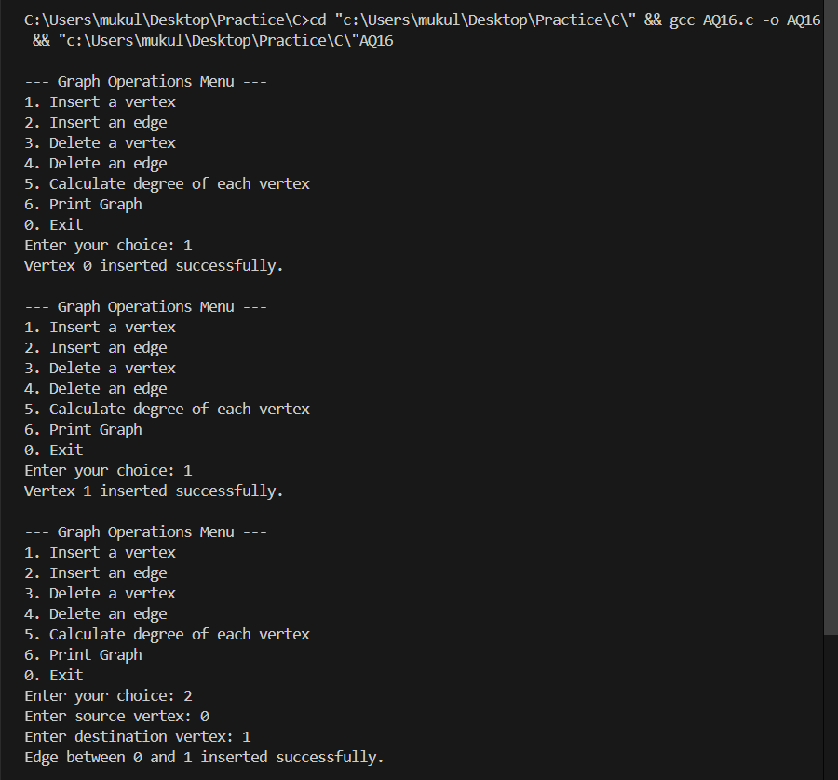

AQ17. Write a program to determine the minimum cost spanning tree (using Prim‟s algorithm) in the following graph.


Solution :

#include <stdio.h>
#include <stdlib.h>
#include <stdbool.h>
#include <limits.h>

#define V 7

int minKey(int key[], bool mstSet[])
{
int min = INT_MAX, min_index;

for (int v = 0; v < V; v++)
{
if (mstSet[v] == false && key[v] < min)
{
min = key[v];
min_index = v;
}
}

return min_index;
}

void printMST(int parent[], int graph[V][V])
{
printf("Edge \tWeight\n");
int totalCost = 0;
for (int i = 1; i < V; i++)
{
printf("%c - %c \t%d\n", parent[i] + 'a', i + 'a', graph[i][parent[i]]);
totalCost += graph[i][parent[i]];
}
printf("Total cost of MST: %d\n", totalCost);
}

void primMST(int graph[V][V])
{
int parent[V];
int key[V];
bool mstSet[V];

for (int i = 0; i < V; i++)
{
key[i] = INT_MAX;
mstSet[i] = false;
}

key[0] = 0;
parent[0] = -1;

for (int count = 0; count < V - 1; count++)
{
int u = minKey(key, mstSet);

mstSet[u] = true;

for (int v = 0; v < V; v++)
{
if (graph[u][v] && mstSet[v] == false && graph[u][v] < key[v])
{
parent[v] = u;
key[v] = graph[u][v];
}
}
}

printMST(parent, graph);
}

int main()
{
int graph[V][V] = {
{0, 8, 0, 0, 9, 0, 0},
{8, 0, 3, 9, 0, 0, 0},
{0, 3, 0, 11, 0, 6, 0},
{0, 9, 11, 0, 1, 9, 0},
{9, 0, 0, 1, 0, 2, 0},
{0, 0, 6, 9, 2, 0, 7},
{0, 0, 0, 0, 0, 7, 0}};

printf("Adjacency Matrix of the Graph:\n");
printf(" a b c d e f g\n");
for (int i = 0; i < V; i++)
{
printf("%c ", i + 'a');
for (int j = 0; j < V; j++)
{
printf("%d ", graph[i][j]);
}
printf("\n");
}

printf("\nMinimum Spanning Tree using Prim's Algorithm:\n");
primMST(graph);

return 0;
}

Output :

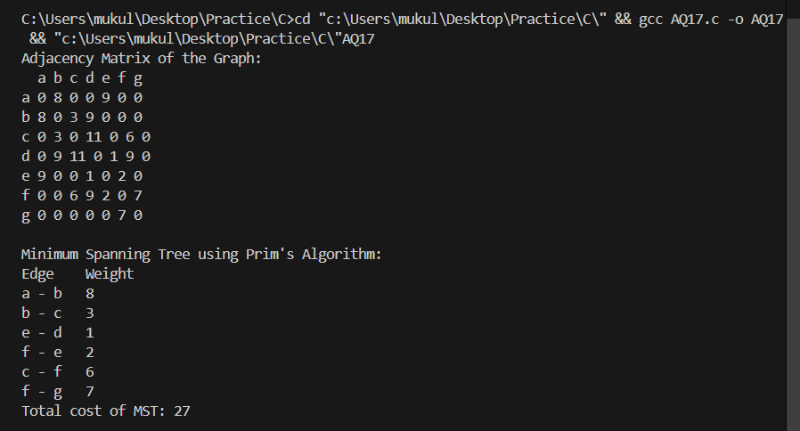

AQ18. Write a program to determine the minimum cost spanning tree (using Kruskal‟s algorithm) in the following graph.


Solution :

#include <stdio.h>
#include <stdlib.h>

#define V 7
#define E 11

typedef struct
{
int src, dest, weight;
} Edge;

typedef struct
{
int parent;
int rank;
} Subset;

Edge edges[E];

void initializeEdges()
{

edges[0].src = 0;
edges[0].dest = 1;
edges[0].weight = 8;

edges[1].src = 0;
edges[1].dest = 4;
edges[1].weight = 9;

edges[2].src = 1;
edges[2].dest = 2;
edges[2].weight = 3;

edges[3].src = 1;
edges[3].dest = 3;
edges[3].weight = 9;

edges[4].src = 2;
edges[4].dest = 3;
edges[4].weight = 11;

edges[5].src = 2;
edges[5].dest = 5;
edges[5].weight = 6;

edges[6].src = 3;
edges[6].dest = 4;
edges[6].weight = 1;

edges[7].src = 3;
edges[7].dest = 5;
edges[7].weight = 9;

edges[8].src = 4;
edges[8].dest = 5;
edges[8].weight = 2;

edges[9].src = 5;
edges[9].dest = 6;
edges[9].weight = 7;

edges[10].src = 4;
edges[10].dest = 0;
edges[10].weight = 9;
}

int compareEdges(const void *a, const void *b)
{
Edge *edge1 = (Edge *)a;
Edge *edge2 = (Edge *)b;
return edge1->weight - edge2->weight;
}

int find(Subset subsets[], int i)
{
if (subsets[i].parent != i)
subsets[i].parent = find(subsets, subsets[i].parent);
return subsets[i].parent;
}

void Union(Subset subsets[], int x, int y)
{
int rootX = find(subsets, x);
int rootY = find(subsets, y);

if (subsets[rootX].rank < subsets[rootY].rank)
subsets[rootX].parent = rootY;
else if (subsets[rootX].rank > subsets[rootY].rank)
subsets[rootY].parent = rootX;
else
{
subsets[rootY].parent = rootX;
subsets[rootX].rank++;
}
}

void kruskalMST()
{
Edge result[V - 1];
int e = 0;
int i = 0;

qsort(edges, E, sizeof(Edge), compareEdges);

Subset *subsets = (Subset *)malloc(V * sizeof(Subset));

for (int v = 0; v < V; v++)
{
subsets[v].parent = v;
subsets[v].rank = 0;
}

while (e < V - 1 && i < E)
{
Edge next_edge = edges[i++];

int x = find(subsets, next_edge.src);
int y = find(subsets, next_edge.dest);

if (x != y)
{
result[e++] = next_edge;
Union(subsets, x, y);
}
}

int totalWeight = 0;
printf("Edges in the Minimum Spanning Tree:\n");
printf("Edge \tWeight\n");
for (i = 0; i < e; i++)
{
printf("%c - %c \t%d\n", result[i].src + 'a', result[i].dest + 'a', result[i].weight);
totalWeight += result[i].weight;
}
printf("Total weight of MST: %d\n", totalWeight);

free(subsets);
}

int main()
{
initializeEdges();

printf("Graph edges:\n");
printf("Edge \tWeight\n");
for (int i = 0; i < E; i++)
{
printf("%c - %c \t%d\n", edges[i].src + 'a', edges[i].dest + 'a', edges[i].weight);
}

printf("\nMinimum Spanning Tree using Kruskal's Algorithm:\n");
kruskalMST();

return 0;
}

Output :

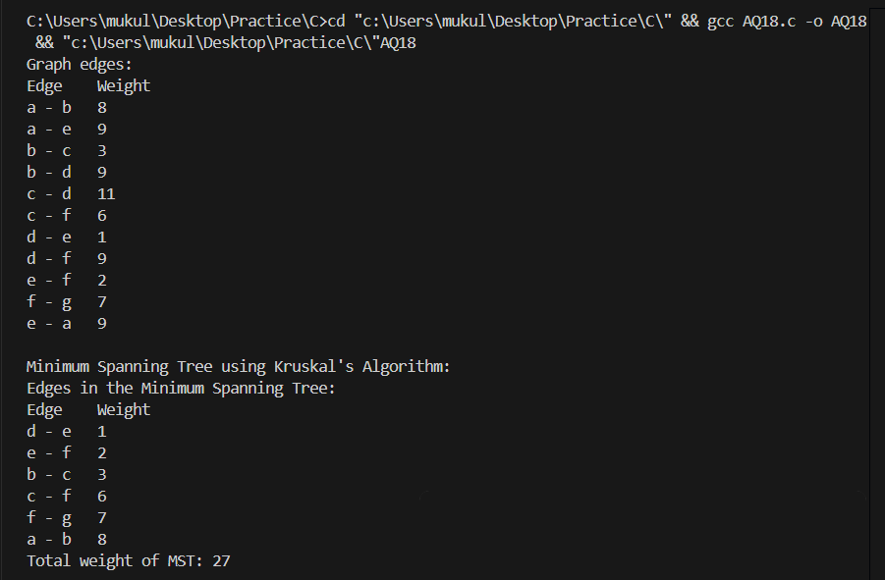

P19. Write a program that generates n random integers and stores them in a text file, named as “All.txt”. Then, retrieve the stored integers from this file and copy to “Odd.txt” and „Even.txt‟ based upon the type of number, i.e. if the retrieved integer is odd number then store in “Odd.txt” file or if the retrieved integer is even then store in “Even.txt” file. Finally, display the contents of all three files.

Solution :

#include <stdio.h>
#include <stdlib.h>
#include <time.h>

void generateRandomIntegers(int n, const char *filename)
{
FILE *file = fopen(filename, "w");
if (file == NULL)
{
printf("Error opening file %s for writing\n", filename);
exit(1);
}

srand(time(NULL));
for (int i = 0; i < n; i++)
{
int num = rand() % 1000; // Generate random numbers between 0 and 999
fprintf(file, "%d\n", num);
}

fclose(file);
printf("Successfully generated %d random integers in %s\n", n, filename);
}

void separateOddEven(const char *sourceFile, const char *oddFile, const char *evenFile)
{
FILE *source = fopen(sourceFile, "r");
FILE *odd = fopen(oddFile, "w");
FILE *even = fopen(evenFile, "w");

if (source == NULL || odd == NULL || even == NULL)
{
printf("Error opening files for reading/writing\n");
exit(1);
}

int num;
while (fscanf(source, "%d", &num) == 1)
{
if (num % 2 == 0)
{
fprintf(even, "%d\n", num);
}
else
{
fprintf(odd, "%d\n", num);
}
}

fclose(source);
fclose(odd);
fclose(even);
printf("Successfully separated odd and even numbers\n");
}

void displayFileContents(const char *filename)
{
FILE *file = fopen(filename, "r");
if (file == NULL)
{
printf("Error opening file %s for reading\n", filename);
exit(1);
}

printf("\nContents of %s:\n", filename);
int num;
while (fscanf(file, "%d", &num) == 1)
{
printf("%d ", num);
}
printf("\n");

fclose(file);
}

int main()
{
int n;
const char *allFile = "All.txt";
const char *oddFile = "Odd.txt";
const char *evenFile = "Even.txt";

printf("Enter the number of random integers to generate: ");
scanf("%d", &n);

generateRandomIntegers(n, allFile);
separateOddEven(allFile, oddFile, evenFile);

displayFileContents(allFile);
displayFileContents(oddFile);
displayFileContents(evenFile);

return 0;
}

Output :

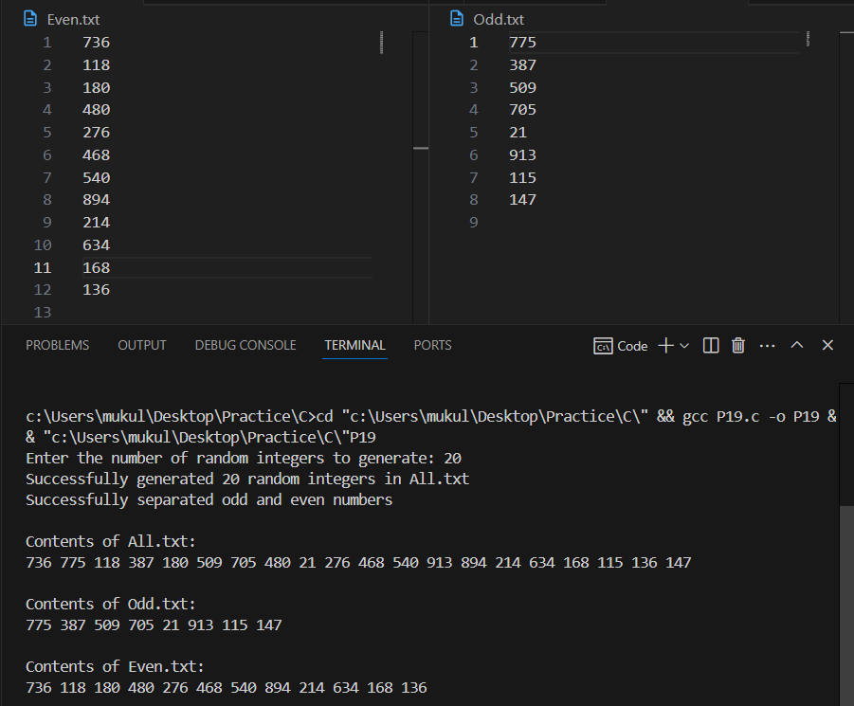
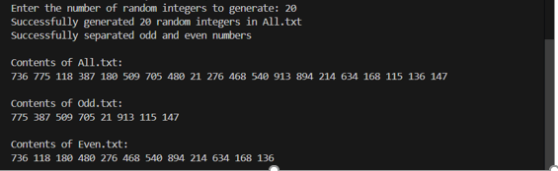

P20. Write a program to implement 20 integers (with some duplicate integers) in a hash table (with separate chaining for collision resolution).

Solution :

#include <stdio.h>
#include <stdlib.h>

#define SIZE 10

struct node
{
int data;
struct node *next;
};

struct node *chain[SIZE];

void init()
{
for (int i = 0; i < SIZE; i++)
chain[i] = NULL;
}

void insert(int value)
{
int key = value % SIZE;

struct node *newNode = (struct node *)malloc(sizeof(struct node));
newNode->data = value;
newNode->next = NULL;

if (chain[key] == NULL)
{
chain[key] = newNode;
}
else
{
struct node *temp = chain[key];
while (temp->next)
{
temp = temp->next;
}
temp->next = newNode;
}
}

void print()
{
for (int i = 0; i < SIZE; i++)
{
printf("chain[%d]-->", i);
struct node *temp = chain[i];
while (temp)
{
printf("%d -->", temp->data);
temp = temp->next;
}
printf("NULL\n");
}
}

int main()
{
init();

int values[20] = {42, 23, 15, 8, 42, 67, 31, 15, 12, 94,
53, 8, 28, 19, 94, 22, 23, 60, 42, 31};

for (int i = 0; i < 20; i++)
{
insert(values[i]);
}

printf("Hash Table with Separate Chaining:\n");
print();

return 0;
}

Output :

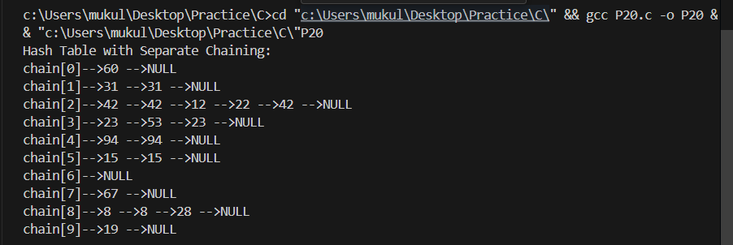

AQ19. Consider the list (file) of books maintained in a library system. When a user wants to check whether a particular book is available, a search operation is called for. If the book is available and is issued to the user, a delete operation can be performed to remove this book from the set of available books. When the user returns the book, it can be inserted back into the set of available books. Write a C program to solve the problem by using appropriate data structures. It is essential that the above mentioned operations should be performed efficiently as possible since these operations are performed frequently.

Solution :

#include <stdio.h>
#include <stdlib.h>
#include <string.h>

#define TABLE_SIZE 100
#define MAX_TITLE_LEN 100
#define MAX_AUTHOR_LEN 50
#define MAX_ISBN_LEN 20
#define MAX_BOOKS 1000

typedef struct Book
{
char title[MAX_TITLE_LEN];
char author[MAX_AUTHOR_LEN];
char isbn[MAX_ISBN_LEN];
int available;
struct Book *next;
} Book;

Book *hashTable[TABLE_SIZE];
Book *bookDatabase[MAX_BOOKS];
int totalBooks = 0;

unsigned int hash(char *isbn)
{
unsigned int hashVal = 0;
for (int i = 0; i < strlen(isbn); i++)
{
hashVal = (hashVal * 31 + isbn[i]) % TABLE_SIZE;
}
return hashVal;
}

void initializeHashTable()
{
for (int i = 0; i < TABLE_SIZE; i++)
{
hashTable[i] = NULL;
}
}

void addBook(char *title, char *author, char *isbn)
{
unsigned int index = hash(isbn);

Book *newBook = (Book *)malloc(sizeof(Book));
strcpy(newBook->title, title);
strcpy(newBook->author, author);
strcpy(newBook->isbn, isbn);
newBook->available = 1;

if (hashTable[index] == NULL)
{
newBook->next = NULL;
hashTable[index] = newBook;
}
else
{
newBook->next = hashTable[index];
hashTable[index] = newBook;
}

bookDatabase[totalBooks++] = newBook;
}

Book *findBook(char *isbn)
{
unsigned int index = hash(isbn);
Book *current = hashTable[index];

while (current != NULL)
{
if (strcmp(current->isbn, isbn) == 0)
{
return current;
}
current = current->next;
}

return NULL;
}

int issueBook(char *isbn)
{
Book *book = findBook(isbn);

if (book == NULL)
{
return 0;
}

if (book->available)
{
book->available = 0;
return 1;
}

return 0;
}

int returnBook(char *isbn)
{
Book *book = findBook(isbn);

if (book == NULL)
{
return 0;
}

if (!book->available)
{
book->available = 1;
return 1;
}

return 0;
}

void loadBooksFromFile(char *filename)
{
FILE *file = fopen(filename, "r");
if (file == NULL)
{
printf("Error opening file %s\n", filename);
return;
}

char title[MAX_TITLE_LEN];
char author[MAX_AUTHOR_LEN];
char isbn[MAX_ISBN_LEN];

while (fscanf(file, "%[^,],%[^,],%s\n", title, author, isbn) == 3)
{
addBook(title, author, isbn);
}

fclose(file);
}

void saveBooksToFile(char *filename)
{
FILE *file = fopen(filename, "w");
if (file == NULL)
{
printf("Error opening file %s for writing\n", filename);
return;
}

for (int i = 0; i < totalBooks; i++)
{
fprintf(file, "%s,%s,%s\n",
bookDatabase[i]->title,
bookDatabase[i]->author,
bookDatabase[i]->isbn);
}

fclose(file);
}

void displayAllBooks()
{
printf("\nLibrary Catalog:\n");
printf("%-40s %-30s %-15s %s\n", "Title", "Author", "ISBN", "Status");
printf("---------------------------------------------------------------------------------\n");

for (int i = 0; i < totalBooks; i++)
{
printf("%-40s %-30s %-15s %s\n",
bookDatabase[i]->title,
bookDatabase[i]->author,
bookDatabase[i]->isbn,
bookDatabase[i]->available ? "Available" : "Issued");
}
}

int main()
{
initializeHashTable();
int choice;
char title[MAX_TITLE_LEN];
char author[MAX_AUTHOR_LEN];
char isbn[MAX_ISBN_LEN];
char filename[100];

printf("Library Management System\n");

do
{
printf("\n1. Add a new book\n");
printf("2. Search for a book\n");
printf("3. Issue a book\n");
printf("4. Return a book\n");
printf("5. Display all books\n");
printf("6. Load books from file\n");
printf("7. Save books to file\n");
printf("0. Exit\n");
printf("Enter your choice: ");
scanf("%d", &choice);
getchar();

switch (choice)
{
case 1:
printf("Enter book title: ");
fgets(title, MAX_TITLE_LEN, stdin);
title[strcspn(title, "\n")] = 0;

printf("Enter author name: ");
fgets(author, MAX_AUTHOR_LEN, stdin);
author[strcspn(author, "\n")] = 0;

printf("Enter ISBN: ");
fgets(isbn, MAX_ISBN_LEN, stdin);
isbn[strcspn(isbn, "\n")] = 0;

addBook(title, author, isbn);
printf("Book added successfully!\n");
break;

case 2:
printf("Enter ISBN to search: ");
fgets(isbn, MAX_ISBN_LEN, stdin);
isbn[strcspn(isbn, "\n")] = 0;

Book *book = findBook(isbn);
if (book != NULL)
{
printf("Book found!\n");
printf("Title: %s\n", book->title);
printf("Author: %s\n", book->author);
printf("ISBN: %s\n", book->isbn);
printf("Status: %s\n", book->available ? "Available" : "Issued");
}
else
{
printf("Book not found!\n");
}
break;

case 3:
printf("Enter ISBN to issue: ");
fgets(isbn, MAX_ISBN_LEN, stdin);
isbn[strcspn(isbn, "\n")] = 0;

if (issueBook(isbn))
{
printf("Book issued successfully!\n");
}
else
{
printf("Book not available or does not exist!\n");
}
break;

case 4:
printf("Enter ISBN to return: ");
fgets(isbn, MAX_ISBN_LEN, stdin);
isbn[strcspn(isbn, "\n")] = 0;

if (returnBook(isbn))
{
printf("Book returned successfully!\n");
}
else
{
printf("Cannot return the book. Either not issued or does not exist!\n");
}
break;

case 5:
displayAllBooks();
break;

case 6:
printf("Enter filename to load books from: ");
fgets(filename, 100, stdin);
filename[strcspn(filename, "\n")] = 0;

loadBooksFromFile(filename);
printf("Books loaded successfully!\n");
break;

case 7:
printf("Enter filename to save books to: ");
fgets(filename, 100, stdin);
filename[strcspn(filename, "\n")] = 0;

saveBooksToFile(filename);
printf("Books saved successfully!\n");
break;

case 0:
printf("Exiting...\n");
break;

default:
printf("Invalid choice! Please try again.\n");
}
} while (choice != 0);

for (int i = 0; i < totalBooks; i++)
{
free(bookDatabase[i]);
}

return 0;
}

Output :

