2021 MCA MCAN-293 L - OBJECT ORIENTED PROGRAMMING WITH JAVA LAB

Name:-Saheb Mukherjee

University Rollno:-11571020039

* **Create a class 'Degree' having a method 'getDegree' that prints "I got a degree". It has two subclasses namely 'Undergraduate' and 'Postgraduate' each having a method with the same name that prints "I am an Undergraduate" and "I am a Postgraduate" respectively. Call the method by creating an object of each of the three classes.**

1. class Degree {
2. void getDegree() {
3. System.out.println("I Got a Degree");
4. }
5. }
6. class Undergraduate extends Degree {
7. void getDegree() {
8. System.out.println("I am an Undergraduate");
9. }
10. }
11. class Postgraduate extends Degree {
12. void getDegree() {
13. System.out.println("I am an Postgraduate");
14. }
15. }
16. class degreeinhert {
17. public static void main(String[] args) {
18. Degree obj = new Degree();
19. obj.getDegree();
20. Undergraduate obj1 = new Undergraduate();
21. obj1.getDegree();
22. Postgraduate obj2 = new Postgraduate();
23. obj2.getDegree();
24. }
25. }

**OUTPUT**

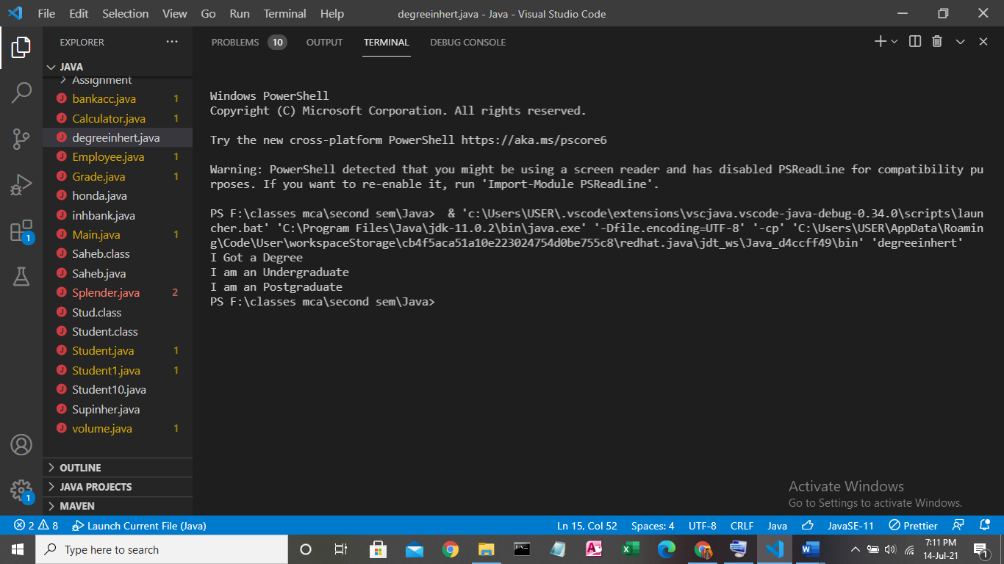

* **A class has an integer data member 'i' and a method named 'printNum' to print the value of 'i'. Its subclass also has an integer data member 'j' and a method named 'printNum' to print the value of 'j'. Make an object of the subclass and use it to assign a value to 'i' and to 'j'. Now call the method 'printNum' by this object.**
* **//code**

1. class A {
2. int i;
3. A(int i) {
4. this.i = i;
5. }
6. void printNum() {
7. System.out.println("i=" + i);
8. }
9. }
10. class B extends A {
11. int j;
12. B(int j) {
13. super(10);
14. this.j = j;
15. }
16. void printNum() {
17. System.out.println("j=" + j + "\ni=" + i);
18. }
19. }
20. public class Supinher {
21. public static void main(String[] args) {
22. B obj = new B(5);
23. obj.printNum();
24. }
25. }

**OUTPUT**

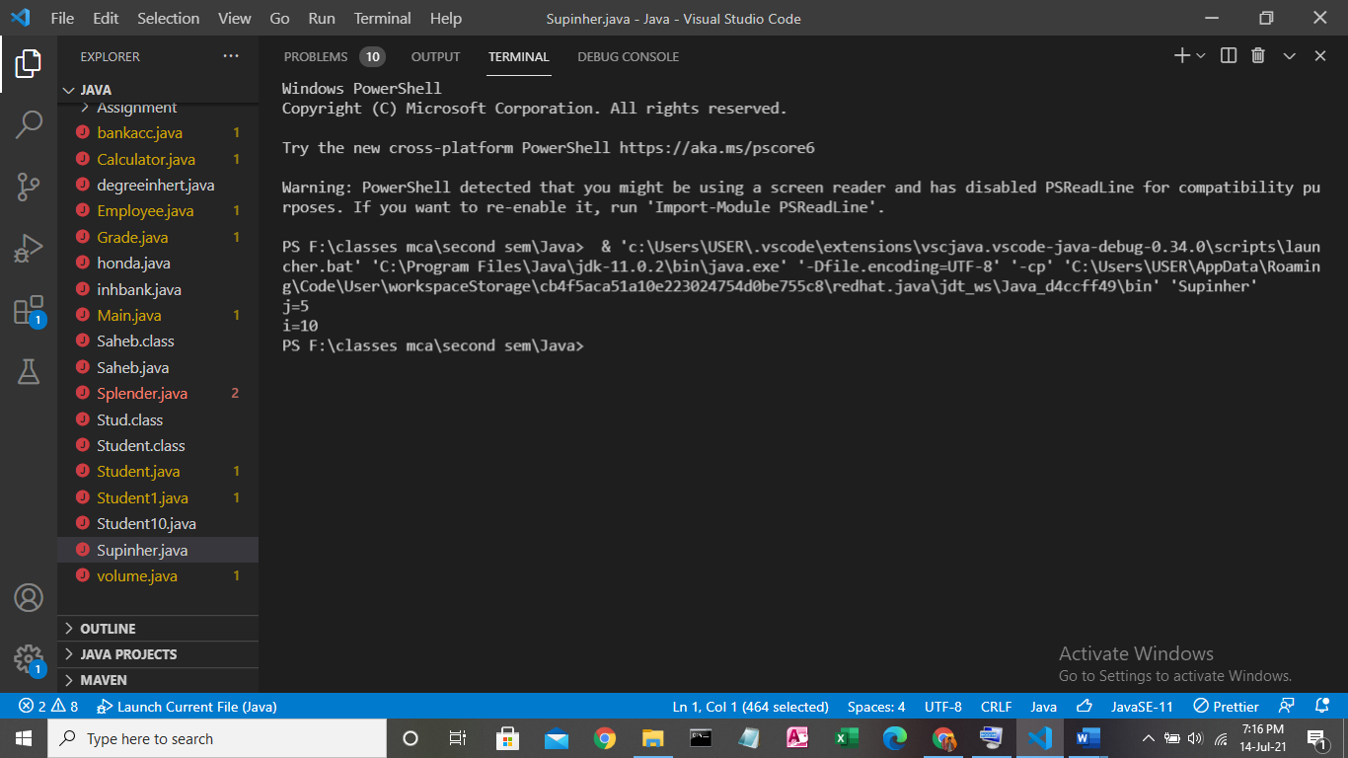

* **A boy has his money deposited $1000, $1500 and $2000 in banks-Bank A, Bank B and Bank C respectively. We have to print the money deposited by him in a particular bank.  
  Create a class 'Bank' with a method 'getBalance' which returns 0. Make its three subclasses named 'BankA', 'BankB' and 'BankC' with a method with the same name 'getBalance' which returns the amount deposited in that particular bank. Call the method 'getBalance' by the object of each of the three banks.**
* **//CODE**

1. class Bank {
2. int bal;
3. Bank() {
4. this.bal = 0;
5. }
6. void getBalance() {
7. System.out.println(bal);
8. }
9. }
10. class BankA extends Bank {
11. int bal;
12. BankA(int bal) {
13. this.bal = bal;
14. }
15. void getBalance() {
16. System.out.println("Balance=" + bal);
17. }
18. }
19. class BankB extends Bank {
20. BankB(int bal) {
21. this.bal = bal;
22. }
23. void getBalance() {
24. System.out.println("Balance=" + bal);
25. }
26. }
27. class BankC extends Bank {
28. BankC(int bal) {
29. this.bal = bal;
30. }
31. void getBalance() {
32. System.out.println("Balance=" + bal);
33. }
34. }
35. public class inhbank {
36. public static void main(String[] args) {
37. BankA obj = new BankA(1000);
38. obj.getBalance();
39. BankB obj1 = new BankB(1500);
40. obj1.getBalance();
41. BankC obj2 = new BankC(2000);
42. obj2.getBalance();
43. }
44. }

* **All the banks operating in India are controlled by RBI. RBI has set a well defined guideline (e.g. minimum interest rate, minimum balance allowed, maximum withdrawal limit etc) which all banks must follow. For example, suppose RBI has set minimum interest rate applicable to a saving bank account to be 4% annually; however, banks are free to use 4% interest rate or to set any rates above it.  
    
  Write a JAVA program to implement bank functionality in the above scenario and demonstrate the dynamic polymorphism concept. Note: Create few classes namely Customer, Account, RBI (Base Class) and few derived classes (SBI, ICICI, PNB etc). Assume and implement required member variables and functions in each class.**
* **//CODE**

1. import java.util.Scanner;
2. class Rbi {
3. int inter, minbal, maxwith;
4. Rbi() {
5. inter = 4;
6. minbal = 0;
7. maxwith = 50000;
8. }
9. void dis() {
10. System.out.println("Miniumum Interest Rate=" + inter);
11. System.out.println("Miniumum Balance=" + minbal);
12. System.out.println("Maximum Withdrawl limit=" + maxwith);
13. }
14. }
15. class Sbi extends Rbi {
16. int a, a1, a2;
17. Sbi() {
18. inter = 5;
19. }
20. void cust(int a) {
21. this.a = a;
22. }
23. // void dis() {
24. // System.out.println("Miniumum Interest Rate of SBI BANK=" + inter);
25. // System.out.println("Miniumum Balance of SBI BANK=" + minbal);
26. // System.out.println("Maximum Withdrawl limit of SBI BANK=" + maxwith);
27. // }
28. void custde() {
29. a1 = (a * inter) / 100;
30. a2 = a + a1;
31. System.out.println("\nPrinting amount details");
32. System.out.println("-------------------------");
33. System.out.println("amount is " + a);
34. System.out.println("Interest amount is " + a1);
35. System.out.println("Total amount is " + a2);
36. }
37. }
38. class Icici extends Rbi {
39. int a, a1, a2;
40. Icici() {
41. minbal = 10000;
42. }
43. void cust(int a) {
44. this.a = a;
45. }
46. void custde() {
47. a1 = (a * inter) / 100;
48. a2 = a + a1;
49. System.out.println("\nPrinting amount details");
50. System.out.println("-------------------------");
51. System.out.println("amount is " + a);
52. System.out.println("Interest amount is " + a1);
53. System.out.println("Total amount is " + a2);
54. }
55. // void dis() {
56. // System.out.println("Miniumum Interest Rate of ICICI BANK=" + inter);
57. // System.out.println("Miniumum Balance of ICICI BANK=" + minbal);
58. // System.out.println("Maximum Withdrawl limit of ICICI BANK=" + maxwith);
59. // }
60. }
61. class Pnb extends Rbi {
62. int a, a1, a2;
63. Pnb() {
64. maxwith = 20000;
65. }
66. void cust(int a) {
67. this.a = a;
68. }
69. void custde() {
70. a1 = (a * inter) / 100;
71. a2 = a + a1;
72. System.out.println("\nPrinting amount details");
73. System.out.println("-------------------------");
74. System.out.println("amount is " + a);
75. System.out.println("Interest amount is " + a1);
76. System.out.println("Total amount is " + a2);
77. }
78. // void dis() {
79. // System.out.println("Miniumum Interest Rate of PNB BANK=" + inter);
80. // System.out.println("Miniumum Balance of PNB BANK=" + minbal);
81. // System.out.println("Maximum Withdrawl limit of PNB BANK=" + maxwith);
82. // }
83. }
84. public class bankacc {
85. public static void main(String[] args) {
86. Scanner sc = new Scanner(System.in);
87. int inp, sel, a;
88. System.out.println("\n\n\n***BANK ACCOUNT MANAGMENT PORTAL BY SAHEB***");
89. // else
90. // {
91. // System.out.println("Wrong Choice");
92. // }
93. while (true) {
94. System.out.println("\n\nPress 1 to display bank details");
95. System.out.println("press 2 to select a bank");
96. inp = sc.nextInt();
97. if (inp == 1) {
98. System.out.println("\nRBI details");
99. System.out.println("-----------");
100. Rbi obj = new Rbi();
101. obj.dis();
102. System.out.println("\nSBI details");
103. System.out.println("-----------");
104. Sbi obj1 = new Sbi();
105. obj1.dis();
106. System.out.println("\nICICI details");
107. System.out.println("-----------");
108. Icici obj2 = new Icici();
109. obj2.dis();
110. System.out.println("\nPNB details");
111. System.out.println("-----------");
112. Pnb obj3 = new Pnb();
113. obj3.dis();
114. } else if (inp == 2) {
115. System.out.println("Press 1 for RBI");
116. System.out.println("Press 2 for ICICI");
117. System.out.println("Press 3 for PNB");
118. sel = sc.nextInt();
119. if (sel == 1) {
120. System.out.println("Enter your amount:");
121. a = sc.nextInt();
122. Sbi obj = new Sbi();
123. obj.cust(a);
124. obj.custde();
125. } else if (sel == 2) {
126. System.out.println("Enter your amount:");
127. a = sc.nextInt();
128. Icici obj = new Icici();
129. obj.cust(a);
130. obj.custde();
131. } else if (sel == 3) {
132. System.out.println("Enter your amount:");
133. a = sc.nextInt();
134. Pnb obj = new Pnb();
135. obj.cust(a);
136. obj.custde();
137. } else {
138. System.out.println("Wrong Choice");
139. }
140. } else {
141. System.out.println("Wrong Choice");
142. }
143. }
144. }
145. }

**OUTPUT**

**SCREEN1:**

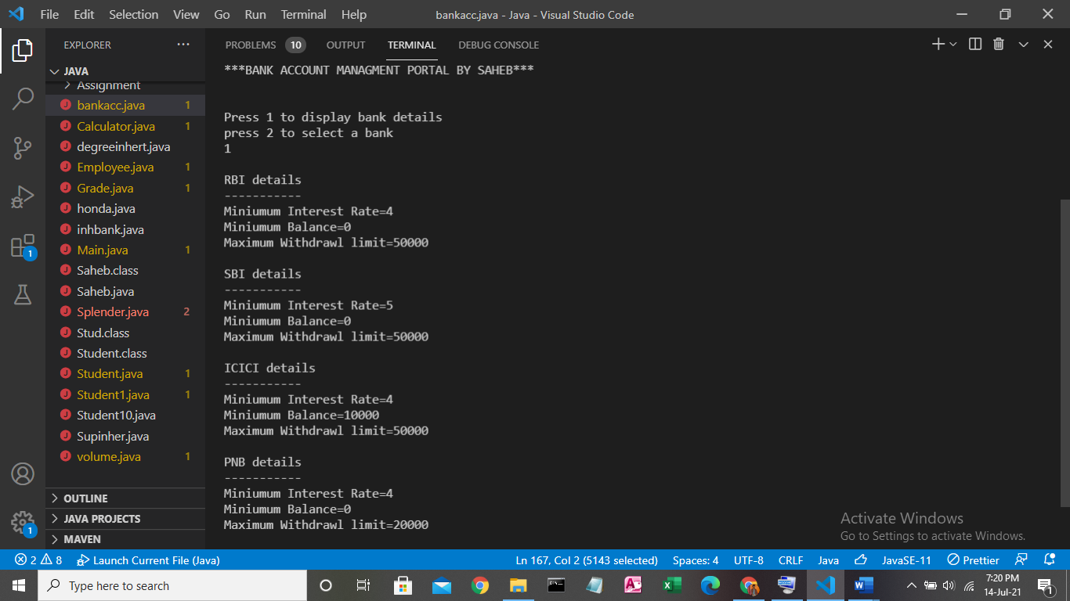

**SCREEN2:**

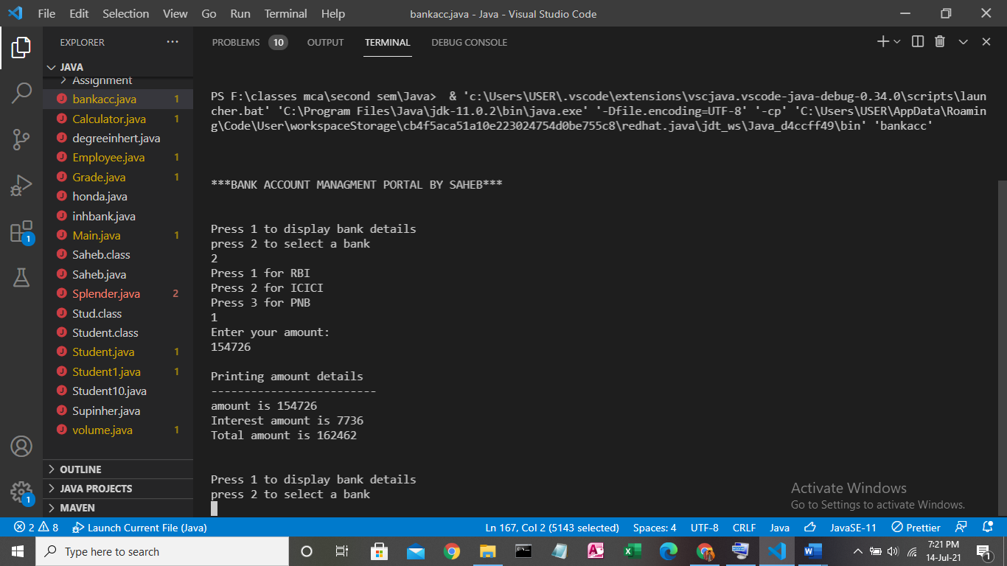

**SCREEN3:**

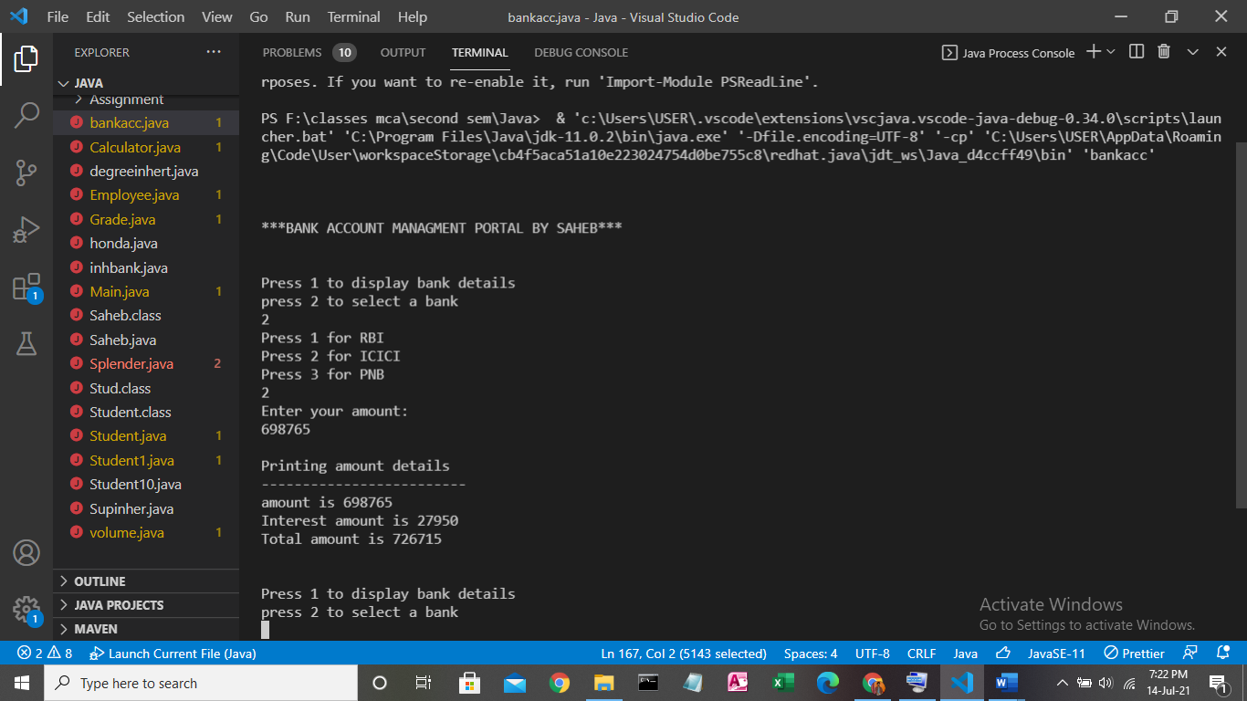

**SCREEN4:**

