2021 MCA MCAN-293 L - OBJECT ORIENTED PROGRAMMING WITH JAVA LAB

## **Assignment 4 :- Package**

* Write a program which have two packages, two classes in one packages and three classes in another package, and show different access specifies.
* F:\classes mca\second sem\Java\mypack1(Package Public Specifier)
* **//Code**

1. package mypack1;
2. public class Mppu {
3. public void display() {
4. System.out.println("Hello This Public Class of myPack1...");
5. }
6. }

* F:\classes mca\second sem\Java\mypack3(Package Public Specifier main)
* **//code**

1. // This is my Public method access from package
2. package mypack3;
3. import mypack1.*;
4. public class Access {
5. public static void main(String[] args) {
6. Mppu obj1 = new Mppu();
7. obj1.display();
8. }
9. }

**OUTPUT**

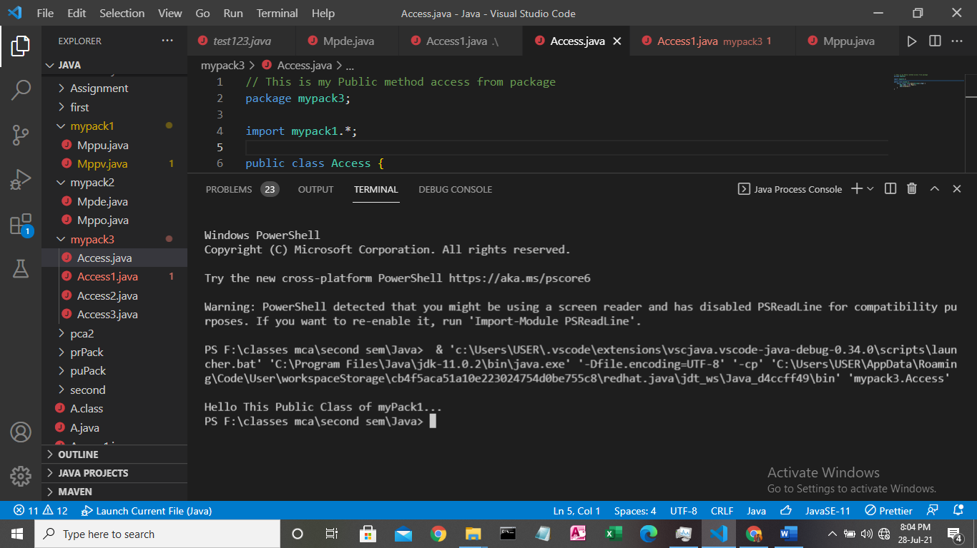

* F:\classes mca\second sem\Java\mypack1(Package Private Specifier)
* **//Code**

1. package mypack1;
2. public class Mppv {
3. private void display() {
4. System.out.println("Hello This Private Class of mypack1...");
5. }
6. }

* F:\classes mca\second sem\Java\mypack3(Package Private Specifier main)
* **//code**
* // This is my Private method access from package
* package mypack3;
* import mypack1.*;
* public class Access1 {
* public static void main(String[] args) {
* Mppv obj1 = new Mppv();
* obj1.display();
* }
* }

**OUTPUT**

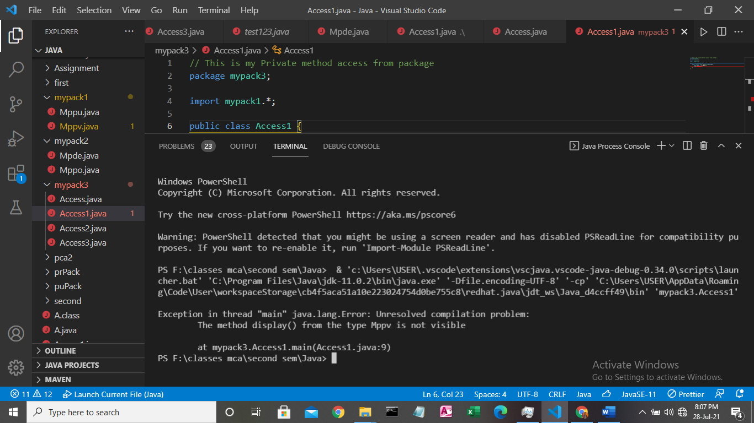

* **F:\classes mca\second sem\Java\mypack2(Package Protected Specifier)**
* **//CODE**

1. package mypack2;
2. public class Mppo {
3. protected void display() {
4. System.out.println("Hello This Protected Class of myPack2...");
5. }
6. }

* **F:\classes mca\second sem\Java\mypack3(Package Protected Specifier main)**
* **//CODE**

1. package mypack3;
2. import mypack2.*;
3. public class Access2 extends Mppo {
4. public static void main(String[] args) {
5. Access2 obj = new Access2();
6. obj.display();
7. }
8. }

**OUTPUT**

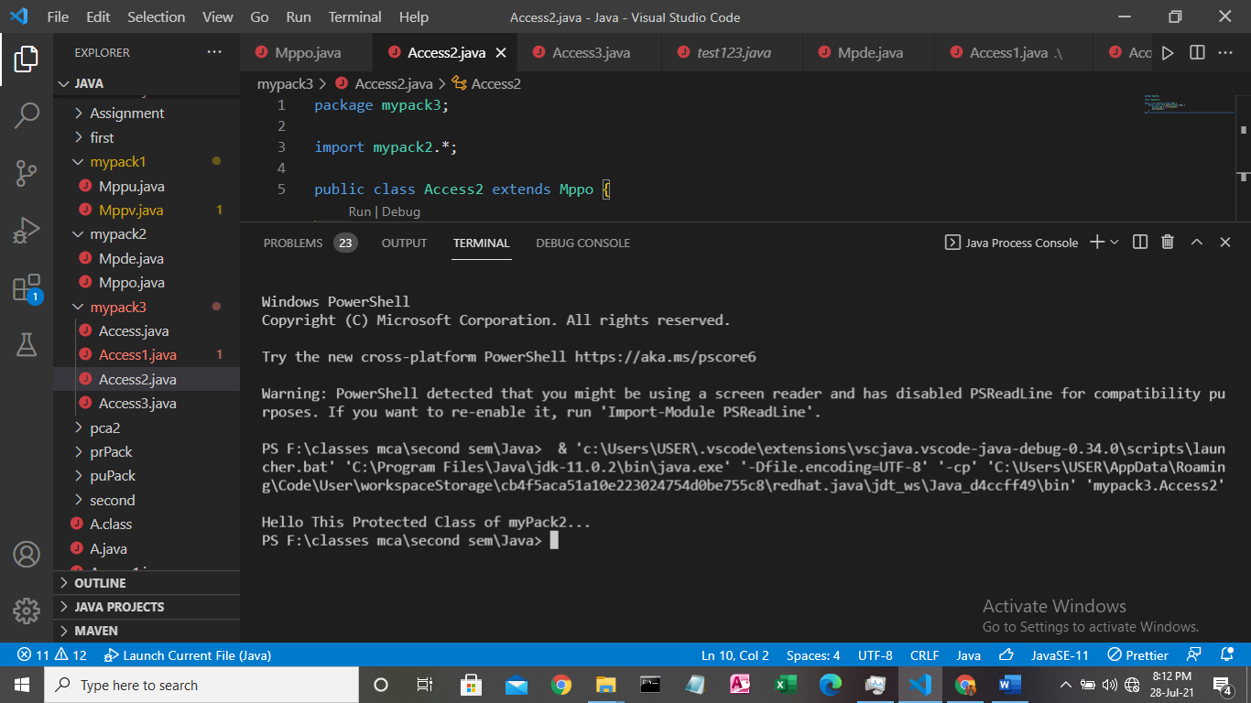

* **F:\classes mca\second sem\Java\mypack2(Package Default Specifier)**
* **\\CODE**

1. package mypack2;
2. public class Mpde {
3. void display() {
4. System.out.println("Hello This is Default Class of mypack2...");
5. }
6. }

* **F:\classes mca\second sem\Java\mypack3(Package Default Specifier main)**
* **\\CODE**

1. package mypack3;
2. import mypack2.*;
3. public class Access3 extends Mpde {
4. public static void main(String[] args) {
5. Access3 obj = new Access3();
6. obj.display();
7. }
8. }

**OUTPUT**

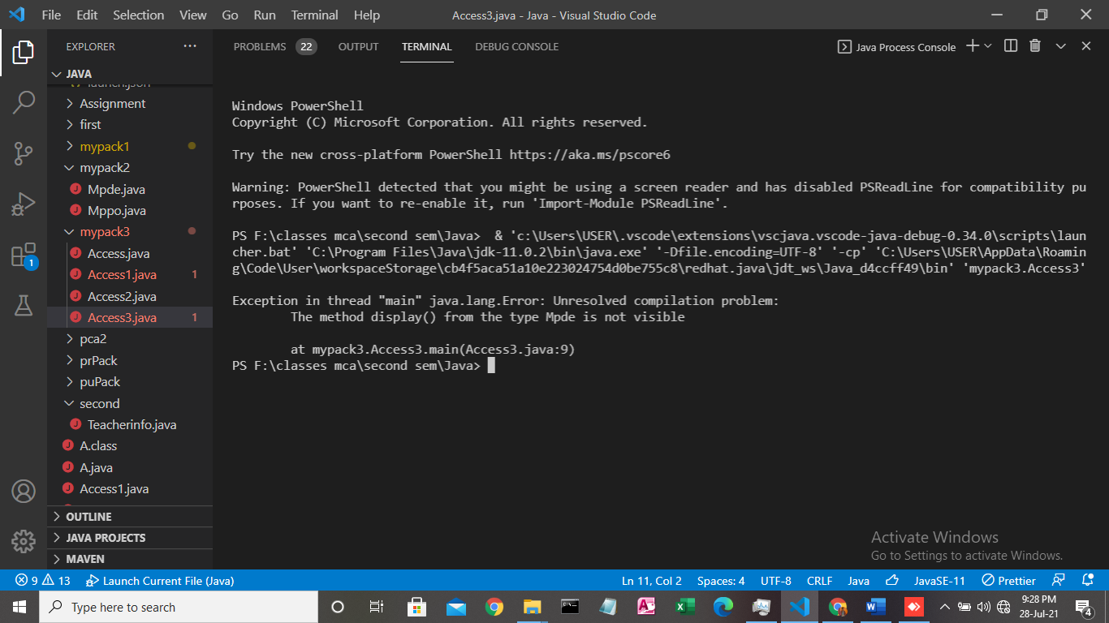

* Write a Java program to create a package which has classes and methods to read Student Admission details.
* **F:\classes mca\second sem\Java\first(1st Class of First package)**
* **//CODE**

1. package first;
2. public class Acedamicinfo {
3. int rollno;
4. float avg_marks, attendace;
5. public Acedamicinfo(float avg_marks, float attendace, int rollno) {
6. this.avg_marks = avg_marks;
7. this.attendace = attendace;
8. this.rollno = rollno;
9. }
10. public void display() {
11. System.out.println("STUDENT EDUCATIONAL DETAILS");
12. System.out.println("---------------------------");
13. System.out.println("Roll no of the student " + rollno);
14. System.out.println("Average of Marks of student is " + avg_marks);
15. System.out.println("Attendance of student is " + attendace + "%");
16. }
17. }

* **F:\classes mca\second sem\Java\first(2nd Class of First package)**
* **//CODE**

1. package first;
2. public class Studentinfo {
3. int age;
4. char sex;
5. String name, address, father_name, mother_name;
6. public Studentinfo(int age, char sex, String name, String address, String father_name, String mother_name) {
7. this.age = age;
8. this.sex = sex;
9. this.name = name;
10. this.address = address;
11. this.father_name = father_name;
12. this.mother_name = mother_name;
13. }
14. public void display() {
15. System.out.println("Student Personal Details");
16. System.out.println("------------------------");
17. System.out.println("Name of the student is " + name);
18. System.out.println("Age is " + age);
19. System.out.println("Student is " + sex);
20. System.out.println("Address of the student is " + address);
21. System.out.println("Father's name Mr." + father_name);
22. System.out.println("Mother'sname is Mrs." + mother_name);
23. }
24. }

* **F:\classes mca\second sem\Java\second(1st Class of Second package)**
* **//CODE**

1. package second;
2. public class Teacherinfo {
3. String name, designation, Department;
4. public Teacherinfo(String name, String designation, String Department) {
5. this.name = name;
6. this.designation = designation;
7. this.Department = Department;
8. }
9. public void display() {
10. System.out.println("STAFF  DETAILS");
11. System.out.println("--------------");
12. System.out.println("Name of the Member " + name);
13. System.out.println("Designation= " + designation);
14. System.out.println("Department = " + Department);
15. }
16. }

* **F:\classes mca\second sem\Java**
* **//CODE**

1. import first.*;
2. import second.*;
3. import java.util.Scanner;
4. class Student007 {
5. public static void main(String[] args) {
6. Scanner sc = new Scanner(System.in);
7. int age, rollno;
8. char sex;
9. String name, address, father_name, mother_name, techName, designation, Department;
10. float avg_marks, attendace;
11. System.out.println("");
12. System.out.println("***Enter Student Informations***\n");
13. System.out.println("Name of the student:");
14. name = sc.next();
15. System.out.println("Student's Age:");
16. age = sc.nextInt();
17. System.out.println("Student's Gender is:");
18. sex = sc.next().charAt(0);
19. System.out.println("Student Address:");
20. address = sc.next();
21. System.out.println("Student's Father's name:");
22. father_name = sc.next();
23. System.out.println("Student's Mother's name:");
24. mother_name = sc.next();
25. Studentinfo obj = new Studentinfo(age, sex, name, address, father_name, mother_name);
26. System.out.println("\n\n***Enter Student Informations***\n");
27. System.out.println("Student's Rollno:");
28. rollno = sc.nextInt();
29. System.out.println("Student's Marks:");
30. avg_marks = sc.nextFloat();
31. System.out.println("Student's Attendence:");
32. attendace = sc.nextFloat();
33. Acedamicinfo obj1 = new Acedamicinfo(avg_marks, attendace, rollno);
34. System.out.println("\n\n***Enter Teacher's Informations***\n");
35. System.out.println("Teacher's Name:");
36. techName = sc.next();
37. System.out.println("Teacher's Designation:");
38. designation = sc.next();
39. System.out.println("Teacher's Department:");
40. Department = sc.next();
41. Teacherinfo obj3 = new Teacherinfo(techName, designation, Department);
42. obj.display();
43. obj1.display();
44. obj3.display();
45. sc.close();
46. }
47. }

**OUTPUT 1**

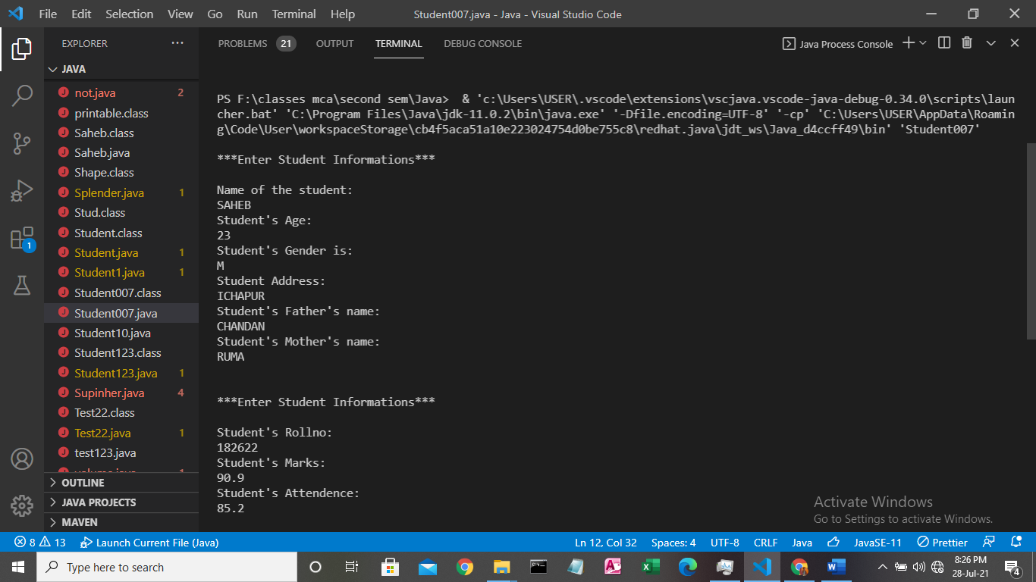

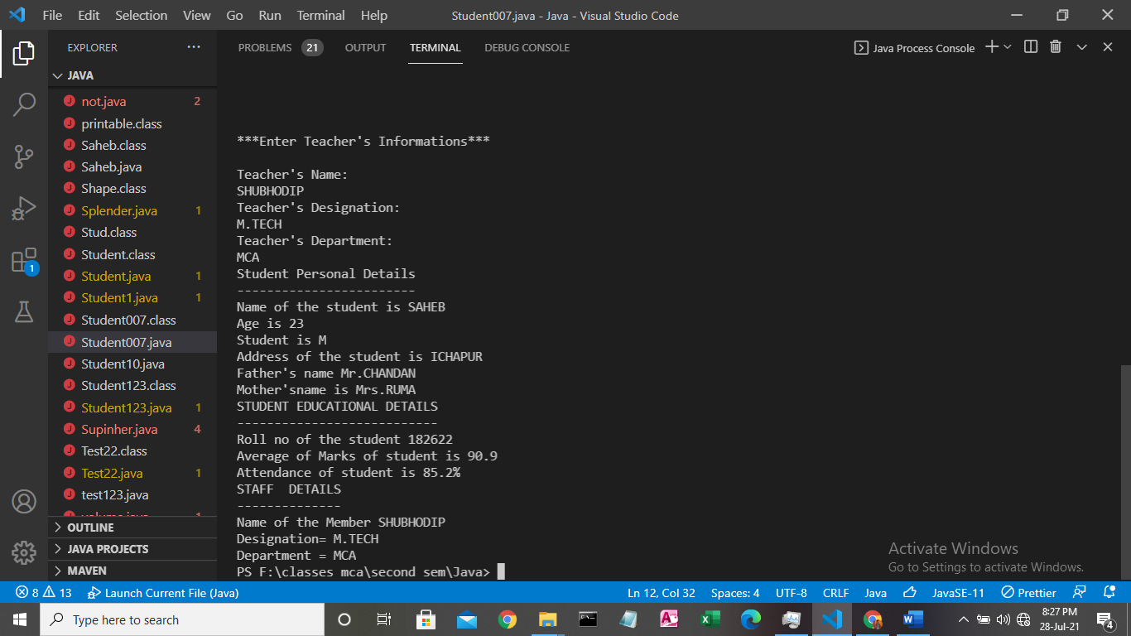**OUTPUT 2**