ACBLPE 2027 Site Content and Visual Map
  - Content review workbook
Content updated from the local site source on 7 November 2026
This workbook maps every published page to its components, nested blocks, text and images. Use the blank space after each text item to enter a correction. Existing wording is reproduced without editorial changes. Header and footer content appears once under common components.
The visual map follows the complete content map. Each page is shown in site order at desktop, tablet and mobile widths. Long components continue across numbered image parts. Screenshots reflect the current local site preview. Browser controls and the floating duplicate section tracker are omitted.

Site scope
Page | Route | Main components
Landing | /landing | 7
Registration | /registration | 3
People | /people | 3
Venue | /venue | 4
Call for Papers | /call-for-papers | 4
The root route / redirects to /landing and has no separate page content. Navigation and footer are common to all five pages. Font loading and document head resources are infrastructure rather than visible content blocks.

Reading the map
The hierarchy runs from page to component to block and finally to a text item or image. The numbered paths preserve nesting and order. Link destinations and image sources are recorded as supporting details. Accessible labels are included even when they are not visible in the default screenshot.
All correction areas are intentionally blank. Text casing follows the source content rather than CSS uppercase styling. Decorative arrows and icons are listed as imagery instead of editable wording. The Upcoming timeline label is time dependent.

Content map
Pages appear in navigation order, followed by the call for papers page. Shared header and footer content follows the page maps.

Landing page
Route: /landing

Page metadata
Browser title
existing content : ACBLPE 2027 | Creoles across the Indian Ocean
Corrected text (if any):

Meta description
existing content : The 25ᵗʰ ACBLPE Conference at Goa University: Creoles across the Indian Ocean, 1–3 September 2027.
Corrected text (if any):

Infrastructure: LandingFonts loads the shared Inter and Libre Baskerville font faces. SectionTracker repeats the active section label while scrolling; its common behavior is mapped after the footer.

L01 Hero
1 SectionLabel
1.1 Text
existing content : 01
Corrected text (if any):

1.2 Text
existing content : Introduction
Corrected text (if any):

2 Conference status and location
2.1 Text
existing content : Call for abstracts open
Corrected text (if any):

2.2 Text
existing content : September 2027
Corrected text (if any):

3 Page heading
existing content : 25th Annual Conference of the Association of Portuguese and Spanish-Lexified Creoles (ACBLPE)
Corrected text (if any):

4 Introduction and actions
4.1 Paragraph
4.1.1 Link
Destination: https://www.acblpe.com/en; opens in a new tab.
4.1.1.1 Link
existing content : ACBLPE
Corrected text (if any):

4.1.1.2 Accessible link label
existing content : ACBLPE (opens in a new tab)
Corrected text (if any):

4.1.2 Text
existing content : in its 25th edition arrives in South Asia for the first time. The Call for Papers is now open
Corrected text (if any):

4.2 Call to action buttons
4.2.1 Link
Destination: /call-for-papers.
4.2.1.1 Link
existing content : Explore the CFP
Corrected text (if any):

4.2.1.2 Image Decorative image
Image source: /landing/arrow-down-right-light.svg
Alt text is empty for decorative imagery.
4.2.2 Link
Destination: /registration.
4.2.2.1 Link
existing content : Registration
Corrected text (if any):

4.2.2.2 Image Decorative image
Image source: /landing/arrow-down-right-blue.svg
Alt text is empty for decorative imagery.

L02 AboutACBLPE
1 SectionLabel
1.1 Text
existing content : 02
Corrected text (if any):

1.2 Text
existing content : About ACBLPE
Corrected text (if any):

2 Section heading
existing content : Two decades of Iberian-lexified creole scholarship
Corrected text (if any):

3 Association description
3.1 Paragraph
3.1.1 Link
Destination: https://www.acblpe.com/en; opens in a new tab.
3.1.1.1 Link
existing content : ACBLPE
Corrected text (if any):

3.1.1.2 Accessible link label
existing content : ACBLPE (opens in a new tab)
Corrected text (if any):

3.1.2 Text
existing content : is a scientific association dedicated to the study of Iberian-lexified creole languages and their communities, and more generally linguistic contact involving Portuguese or Spanish.
Corrected text (if any):

3.2 Paragraph
existing content : Since 2001 its annual meetings have been held in Europe, Africa, the Caribbean and South America, alternating where possible between the Iberian Peninsula and other parts of the world.
Corrected text (if any):

3.3 Paragraph
existing content : The 25ᵗʰ Conference extends this trajectory to South Asia, bringing creolists into dialogue with researchers of the Indian Ocean’s linguistic and historical contexts.
Corrected text (if any):

L03 Satellite
1 SectionLabel
1.1 Text
existing content : 03
Corrected text (if any):

1.2 Text
existing content : Satellite conference
Corrected text (if any):

2 Conference introduction
2.1 Section heading
existing content : Linguistic Encounters in South Asia.
Corrected text (if any):

2.2 Paragraph
existing content : The Satellite Conference will showcase research in contact linguistics involving the languages of South Asia and provide a platform for discussing diverse linguistic contact situations in the region. It aims to bring together renowned scholars and researchers in linguistics and to encourage dialogue on the processes, outcomes, and dynamics of language contact in South Asia.
Corrected text (if any):

3 AzulejoFlipCard
3.1 Ornamental face
3.1.1 Image AzulejoTileArtwork inline SVG
Image source: Inline SVG in the component
Decorative image; hidden from assistive technology.
3.2 Content face
3.2.1 Decorative content border
3.2.1.1 Image AzulejoTileArtwork inline SVG
Image source: Inline SVG in the component
Decorative image; hidden from assistive technology.
3.2.2 SatelliteDatePanel
3.2.2.1 Date
3.2.2.1.1 Text
existing content : 31
Corrected text (if any):

3.2.2.1.2 Text
existing content : August 2027
Corrected text (if any):

3.2.2.2 Paragraph
existing content : A dedicated satellite conference within the 31 August–3 September gathering.
Corrected text (if any):

L04 ConferenceVenue
1 SectionLabel
1.1 Text
existing content : 04
Corrected text (if any):

1.2 Text
existing content : The venue
Corrected text (if any):

2 AzulejoFlipCard
2.1 Ornamental face
2.1.1 Image AzulejoTileArtwork inline SVG
Image source: Inline SVG in the component
Decorative image; hidden from assistive technology.
2.2 Content face
2.2.1 Decorative content border
2.2.1.1 Image AzulejoTileArtwork inline SVG
Image source: Inline SVG in the component
Decorative image; hidden from assistive technology.
2.2.2 Goa location card
2.2.2.1 Region and compass
2.2.2.1.1 Text
existing content : South Asia · India
Corrected text (if any):

2.2.2.1.2 Image Compass inline SVG
Image source: Inline SVG in the component
Decorative image; hidden from assistive technology.
2.2.2.2 Paragraph
existing content : Goa
Corrected text (if any):

2.2.2.3 Link
Destination: /venue.
2.2.2.3.1 Link
existing content : Explore the venue
Corrected text (if any):

2.2.2.3.2 Image Right arrow inline SVG
Image source: Inline SVG in the component
Decorative image; hidden from assistive technology.
3 Venue details
3.1 Section heading
existing content : Conference Hall, Admin Block, Goa University
Corrected text (if any):

3.2 Link
Destination: https://maps.app.goo.gl/bjPpmSJ6iYi32MFV6; opens in a new tab.
3.2.1 Link
existing content : Directions
Corrected text (if any):

3.2.2 Image Decorative image
Image source: /landing/map-pin.svg
(max-width: 1199px): /landing/map-pin-responsive.svg
3.2.3 Accessible link label
existing content : Directions (opens in a new tab)
Corrected text (if any):

3.3 Paragraph
existing content : The conference brings Iberian-lexified creole studies into dialogue with the linguistic and historical contexts of the Indian Ocean.
Corrected text (if any):

L05 KeynoteIntro
1 SectionLabel
1.1 Text
existing content : 05
Corrected text (if any):

1.2 Text
existing content : Keynote speakers
Corrected text (if any):

2 Section heading
existing content : Keynote Speakers
Corrected text (if any):

3 Speaker list
3.1 Speaker
3.1.1 Image Decorative image
Image source: /landing/asterisk.svg
(max-width: 1199px): /landing/asterisk-small.svg
3.1.2 Subheading
existing content : Prof. Hugo C. Cardoso
Corrected text (if any):

3.1.3 Paragraph
existing content : FLUL-Lisbon
Corrected text (if any):

3.2 Speaker
3.2.1 Image Decorative image
Image source: /landing/asterisk.svg
(max-width: 1199px): /landing/asterisk-small.svg
3.2.2 Subheading
existing content : Prof. J. Clancy Clements
Corrected text (if any):

3.2.3 Paragraph
existing content : Indiana University
Corrected text (if any):

3.3 Speaker
3.3.1 Image Decorative image
Image source: /landing/asterisk.svg
(max-width: 1199px): /landing/asterisk-small.svg
3.3.2 Subheading
existing content : Eeva Sippola
Corrected text (if any):

3.3.3 Paragraph
existing content : Universidade de Helsinki
Corrected text (if any):

3.4 Speaker
3.4.1 Image Decorative image
Image source: /landing/asterisk.svg
(max-width: 1199px): /landing/asterisk-small.svg
3.4.2 Subheading
existing content : Sonal Kulkarni-Joshi
Corrected text (if any):

3.4.3 Paragraph
existing content : Deccan College
Corrected text (if any):

3.5 Speaker
3.5.1 Image Decorative image
Image source: /landing/asterisk.svg
(max-width: 1199px): /landing/asterisk-small.svg
3.5.2 Subheading
existing content : Anvita Abbi
Corrected text (if any):

3.5.3 Paragraph
existing content : Jawaharlal Nehru University
Corrected text (if any):

L06 Timeline
1 SectionLabel
1.1 Text
existing content : 06
Corrected text (if any):

1.2 Text
existing content : Important dates
Corrected text (if any):

2 Section heading
existing content : Timeline
Corrected text (if any):

3 Milestone list
3.1 Milestone
3.1.1 Text
existing content : 01
Corrected text (if any):

3.1.2 Subheading
existing content : Submissions open
Corrected text (if any):

3.1.3 Text
3.1.3.1 Text
existing content : 30 October 2026
Corrected text (if any):

3.2 Milestone
3.2.1 Text
existing content : 02
Corrected text (if any):

3.2.2 Subheading
3.2.2.1 Subheading
existing content : Submissions close
Corrected text (if any):

3.2.2.2 Current timeline status badge
existing content : Upcoming
Corrected text (if any):

3.2.3 Text
3.2.3.1 Text
existing content : 15 January 2027
Corrected text (if any):

3.3 Milestone
3.3.1 Text
existing content : 03
Corrected text (if any):

3.3.2 Subheading
existing content : Review Completed
Corrected text (if any):

3.3.3 Text
3.3.3.1 Text
existing content : 15 February 2027
Corrected text (if any):

3.4 Milestone
3.4.1 Text
existing content : 04
Corrected text (if any):

3.4.2 Subheading
existing content : Satellite Conference
Corrected text (if any):

3.4.3 Text
3.4.3.1 Text
existing content : 31 August 2027
Corrected text (if any):

3.5 Milestone
3.5.1 Text
existing content : 05
Corrected text (if any):

3.5.2 Subheading
existing content : Main Conference
Corrected text (if any):

3.5.3 Text
3.5.3.1 Text
existing content : 1
Corrected text (if any):

3.5.3.2 Text
existing content : –
Corrected text (if any):

3.5.3.3 Text
existing content : 3 September 2027
Corrected text (if any):

L07 AzulejoArtwork
1 Image Decorative background image
Image source: /azulejo-frieze.svg
CSS background image.

Registration page
Route: /registration

Page metadata
Browser title
existing content : Registration | ACBLPE 2027
Corrected text (if any):

Meta description
existing content : Registration fees and opening status for the 25th ACBLPE Conference in Goa, 2027.
Corrected text (if any):

Infrastructure: LandingFonts loads the shared Inter and Libre Baskerville font faces. SectionTracker repeats the active section label while scrolling; its common behavior is mapped after the footer.

R01 RegistrationFees
1 SectionLabel
1.1 Text
existing content : 01
Corrected text (if any):

1.2 Text
existing content : Registration
Corrected text (if any):

2 Page heading
existing content : Join the conversation in Goa.
Corrected text (if any):

3 Fee introduction and inclusions
3.1 Paragraph
existing content : Four days of research, exchange and scholarly community.
Corrected text (if any):

3.2 Paragraph
existing content : Fees include the conference kit, tea/coffee breaks and working lunch on all four days: 31 August–3 September 2027.
Corrected text (if any):

3.3 Paragraph
3.3.1 Paragraph
existing content : Accommodation is not included.
Corrected text (if any):

3.3.2 Image Information icon inline SVG
Image source: Inline SVG in the component
Decorative image; hidden from assistive technology.
4 Registration fee table
4.1 Table header
4.1.1 Row
4.1.1.1 Header cell
existing content : Participant category
Corrected text (if any):

4.1.1.2 Header cell
existing content : Fee
Corrected text (if any):

4.2 Table body
4.2.1 Row
4.2.1.1 Header cell
existing content : International researchers
Corrected text (if any):

4.2.1.2 Fee cell
existing content : €60
Corrected text (if any):

4.2.2 Row
4.2.2.1 Header cell
existing content : International student researchers
Corrected text (if any):

4.2.2.2 Fee cell
existing content : €30
Corrected text (if any):

4.2.3 Row
4.2.3.1 Header cell
existing content : Indian researchers
Corrected text (if any):

4.2.3.2 Fee cell
existing content : ₹2,500
Corrected text (if any):

4.2.4 Row
4.2.4.1 Header cell
existing content : Indian students
Corrected text (if any):

4.2.4.2 Fee cell
existing content : ₹1,000
Corrected text (if any):

Accessible table label
existing content : Conference registration fees
Corrected text (if any):

R02 RegistrationNotice
1 SectionLabel
1.1 Text
existing content : 02
Corrected text (if any):

1.2 Text
existing content : Registration update
Corrected text (if any):

2 Section heading
existing content : Registration to the conference will open soon.
Corrected text (if any):

3 Paragraph
3.1 Text
existing content : Kindly check the paper submission guidlines
Corrected text (if any):

3.2 Link
Destination: /call-for-papers.
3.2.1 Link
existing content : here
Corrected text (if any):

R03 AzulejoArtwork
1 Image Decorative background image
Image source: /azulejo-frieze.svg
CSS background image.

People page
Route: /people

Page metadata
Browser title
existing content : People | ACBLPE 2027
Corrected text (if any):

Meta description
existing content : People at the ACBLPE 2027 conference.
Corrected text (if any):

Infrastructure: LandingFonts loads the shared Inter and Libre Baskerville font faces. SectionTracker repeats the active section label while scrolling; its common behavior is mapped after the footer.

P01 OrganisationCommittee
1 SectionLabel
1.1 Text
existing content : 01
Corrected text (if any):

1.2 Text
existing content : Organisation
Corrected text (if any):

2 Page heading
existing content : A shared scholarly undertaking.
Corrected text (if any):

3 Section heading
existing content : Organisation
Corrected text (if any):

4 Organising institutions
4.1 List item
4.1.1 Text
existing content : Goa University
Corrected text (if any):

4.2 List item
4.2.1 Text
existing content : ACBLPE
Corrected text (if any):

4.3 List item
4.3.1 Text
existing content : Directorate, Visiting Research Professor Programme
Corrected text (if any):

4.4 List item
4.4.1 Text
existing content : Joaquim Heliodoro da Cunha Rivara Chair
Corrected text (if any):

4.5 List item
4.5.1 Text
existing content : Camões I.P.
Corrected text (if any):

4.6 List item
4.6.1 Text
existing content : CLP-Camões, Goa
Corrected text (if any):

5 Section heading
existing content : Organising committee
Corrected text (if any):

6 Organising committee
6.1 List item
6.1.1 Text
existing content : Prof. Anuradha Wagle
Corrected text (if any):

6.1.2 Text
existing content : Dean, SGSLL
Corrected text (if any):

6.2 List item
6.2.1 Text
existing content : Dr. Prakash Parienkar
Corrected text (if any):

6.2.2 Text
existing content : Director, VRPP
Corrected text (if any):

6.3 List item
6.3.1 Text
existing content : Delfim Correia da Silva
Corrected text (if any):

6.3.2 Text
existing content : CLP-Camões, Goa
Corrected text (if any):

6.4 List item
6.4.1 Text
existing content : Loraine Alberto
Corrected text (if any):

6.4.2 Text
existing content : P.D.M.A. Portuguese
Corrected text (if any):

6.5 List item
6.5.1 Text
existing content : Dhruv Usgaonkar
Corrected text (if any):

6.6 List item
6.6.1 Text
existing content : Jeanette Barbosa Noronha
Corrected text (if any):

P02 ScientificCommittee
1 SectionLabel
1.1 Text
existing content : 02
Corrected text (if any):

1.2 Text
existing content : Scientific committee
Corrected text (if any):

2 Section heading
existing content : Conference scientific committee
Corrected text (if any):

3 Proposal notice
3.1 Paragraph
existing content : The following composition is a proposal and is not yet confirmed.
Corrected text (if any):

4 Scientific committee members
4.1 List item
4.1.1 Subheading
existing content : Alan Baxter
Corrected text (if any):

4.1.2 Paragraph
existing content : Universidade Federal da Bahia
Corrected text (if any):

4.2 List item
4.2.1 Subheading
existing content : Alexandre Cobbinah
Corrected text (if any):

4.2.2 Paragraph
existing content : Universidade de São Paulo
Corrected text (if any):

4.3 List item
4.3.1 Subheading
existing content : Ana Paula Braga Mattos
Corrected text (if any):

4.3.2 Paragraph
existing content : Aarhus University
Corrected text (if any):

4.4 List item
4.4.1 Subheading
existing content : Clancy Clements
Corrected text (if any):

4.4.2 Paragraph
existing content : Indiana University
Corrected text (if any):

4.5 List item
4.5.1 Subheading
existing content : Dominika Swolkien
Corrected text (if any):

4.5.2 Paragraph
existing content : Universidade de Cabo Verde
Corrected text (if any):

4.6 List item
4.6.1 Subheading
existing content : Eduardo Tobar Delgado
Corrected text (if any):

4.6.2 Paragraph
existing content : Escola de Idiomas de Vigo
Corrected text (if any):

4.7 List item
4.7.1 Subheading
existing content : Eeva Sippola
Corrected text (if any):

4.7.2 Paragraph
existing content : University of Helsinki
Corrected text (if any):

4.8 List item
4.8.1 Subheading
existing content : Hugo Cardoso
Corrected text (if any):

4.8.2 Paragraph
existing content : Universidade de Lisboa
Corrected text (if any):

4.9 List item
4.9.1 Subheading
existing content : Jean-Louis Rougé
Corrected text (if any):

4.9.2 Paragraph
existing content : Université d’Orléans
Corrected text (if any):

4.10 List item
4.10.1 Subheading
existing content : Joachim Steffen
Corrected text (if any):

4.10.2 Paragraph
existing content : Universität Augsburg
Corrected text (if any):

4.11 List item
4.11.1 Subheading
existing content : Kofi Yakpo
Corrected text (if any):

4.11.2 Paragraph
existing content : The University of Hong Kong
Corrected text (if any):

4.12 List item
4.12.1 Subheading
existing content : Laura Álvarez López
Corrected text (if any):

4.12.2 Paragraph
existing content : University of Stockholm
Corrected text (if any):

4.13 List item
4.13.1 Subheading
existing content : Liliana Inverno
Corrected text (if any):

4.13.2 Paragraph
existing content : Universidade de Coimbra
Corrected text (if any):

4.14 List item
4.14.1 Subheading
existing content : Marlyse Baptista
Corrected text (if any):

4.14.2 Paragraph
existing content : University of Pennsylvania
Corrected text (if any):

4.15 List item
4.15.1 Subheading
existing content : Miguel Gutiérrez Maté
Corrected text (if any):

4.15.2 Paragraph
existing content : Universität Augsburg
Corrected text (if any):

4.16 List item
4.16.1 Subheading
existing content : Márcia Oliveira
Corrected text (if any):

4.16.2 Paragraph
existing content : Universidade de São Paulo
Corrected text (if any):

4.17 List item
4.17.1 Subheading
existing content : Mauro Fernández
Corrected text (if any):

4.17.2 Paragraph
existing content : Universidade da Coruña
Corrected text (if any):

4.18 List item
4.18.1 Subheading
existing content : Nélia Alexandre
Corrected text (if any):

4.18.2 Paragraph
existing content : Universidade de Lisboa
Corrected text (if any):

4.19 List item
4.19.1 Subheading
existing content : Nicolas Quint
Corrected text (if any):

4.19.2 Paragraph
existing content : Centre National de la Recherche Scientifique – Paris
Corrected text (if any):

4.20 List item
4.20.1 Subheading
existing content : Rita Gonçalves
Corrected text (if any):

4.20.2 Paragraph
existing content : Universidade de Lisboa
Corrected text (if any):

4.21 List item
4.21.1 Subheading
existing content : Sandro Sessarego
Corrected text (if any):

4.21.2 Paragraph
existing content : University of Texas at Austin
Corrected text (if any):

4.22 List item
4.22.1 Subheading
existing content : Susana Castillo Rodríguez
Corrected text (if any):

4.22.2 Paragraph
existing content : SUNY – State University of New York College - Geneseo
Corrected text (if any):

4.23 List item
4.23.1 Subheading
existing content : Tjerk Hagemeijer
Corrected text (if any):

4.23.2 Paragraph
existing content : Universidade de Lisboa
Corrected text (if any):

P03 AzulejoArtwork
1 Image Decorative background image
Image source: /azulejo-frieze.svg
CSS background image.

Venue page
Route: /venue

Page metadata
Browser title
existing content : Venue | ACBLPE 2027
Corrected text (if any):

Meta description
existing content : Plan your visit to Goa for ACBLPE 2027: local culture, things to do, and travel connections to Goa University.
Corrected text (if any):

Infrastructure: LandingFonts loads the shared Inter and Libre Baskerville font faces. SectionTracker repeats the active section label while scrolling; its common behavior is mapped after the footer.

V01 AboutGoa
1 SectionLabel
1.1 Text
existing content : 01
Corrected text (if any):

1.2 Text
existing content : About Goa
Corrected text (if any):

2 Page heading
existing content : A small state with a proud history
Corrected text (if any):

3 Goa facts
3.1 Fact card
3.1.1 Section heading
existing content : Language
Corrected text (if any):

3.1.2 Paragraph
existing content : Konkani is Goa’s official language; Marathi, Hindi and English are widely spoken, and Portuguese survives in older families and place names.
Corrected text (if any):

3.2 Fact card
3.2.1 Section heading
existing content : Climate
Corrected text (if any):

3.2.2 Paragraph
existing content : The conference falls at the tail of the monsoon. Expect warm, humid days around 28–30°C, occasional showers and a countryside at its greenest.
Corrected text (if any):

3.3 Fact card
3.3.1 Section heading
existing content : Heritage
Corrected text (if any):

3.3.2 Paragraph
existing content : 451 years of Portuguese rule left Goa a blend of Indian and Iberian worlds — baroque churches, whitewashed chapels, azulejo tiles and Indo-Portuguese mansions.
Corrected text (if any):

3.4 Fact card
3.4.1 Section heading
existing content : Food
Corrected text (if any):

3.4.2 Paragraph
existing content : Fish curry rice, xacuti, sorpotel, vindaloo and bebinca. Vegetarian thalis and international cuisine are easy to find everywhere.
Corrected text (if any):

V02 ThingsToDo
1 SectionLabel
1.1 Text
existing content : 02
Corrected text (if any):

1.2 Text
existing content : Explore Goa
Corrected text (if any):

2 Section heading
existing content : Things to do
Corrected text (if any):

3 Activities list
3.1 List item
3.1.1 Text
existing content : 01
Corrected text (if any):

3.1.2 Subheading
existing content : Heritage walk through Fontainhas
Corrected text (if any):

3.1.3 Paragraph
existing content : Panjim’s Latin Quarter, five minutes from the university — colour-washed Portuguese houses, chapels and bakeries.
Corrected text (if any):

3.2 List item
3.2.1 Text
existing content : 02
Corrected text (if any):

3.2.2 Subheading
existing content : Old Goa monuments
Corrected text (if any):

3.2.3 Paragraph
existing content : Bom Jesus Basilica, Se Cathedral and St. Augustine ruins, a UNESCO World Heritage ensemble about 30 km away.
Corrected text (if any):

3.3 List item
3.3.1 Text
existing content : 03
Corrected text (if any):

3.3.2 Subheading
existing content : Mandovi river cruise
Corrected text (if any):

3.3.3 Paragraph
existing content : Evening cruises from the Panjim jetty with Goan music and dance, a short ride from campus.
Corrected text (if any):

3.4 List item
3.4.1 Text
existing content : 04
Corrected text (if any):

3.4.2 Subheading
existing content : Divar and Chorao islands
Corrected text (if any):

3.4.3 Paragraph
existing content : Ferry crossings, village lanes and the Dr. Salim Ali Bird Sanctuary — at their most beautiful just after the rains.
Corrected text (if any):

3.5 List item
3.5.1 Text
existing content : 05
Corrected text (if any):

3.5.2 Subheading
existing content : Dudhsagar Falls day trip
Corrected text (if any):

3.5.3 Paragraph
existing content : One of India’s tallest waterfalls, at full force in early September, on the Karnataka border.
Corrected text (if any):

3.6 List item
3.6.1 Text
existing content : 06
Corrected text (if any):

3.6.2 Subheading
existing content : Spice plantation, Ponda
Corrected text (if any):

3.6.3 Paragraph
existing content : A guided walk through a working spice farm with a traditional Goan lunch, about 30 km inland.
Corrected text (if any):

3.7 List item
3.7.1 Text
existing content : 07
Corrected text (if any):

3.7.2 Subheading
existing content : Beaches near the city
Corrected text (if any):

3.7.3 Paragraph
existing content : Miramar and Dona Paula are minutes from campus; Calangute and Baga lie further north.
Corrected text (if any):

3.8 List item
3.8.1 Text
existing content : 08
Corrected text (if any):

3.8.2 Subheading
existing content : Goan food tour
Corrected text (if any):

3.8.3 Paragraph
existing content : Try local cafés and family kitchens for vindaloo, chorizo pão and bebinca dessert.
Corrected text (if any):

3.9 List item
3.9.1 Text
existing content : 09
Corrected text (if any):

3.9.2 Subheading
existing content : Forts of the coast
Corrected text (if any):

3.9.3 Paragraph
existing content : Fort Aguada and Chapora above the mouths of the Mandovi and Chapora rivers.
Corrected text (if any):

3.10 List item
3.10.1 Text
existing content : 10
Corrected text (if any):

3.10.2 Subheading
existing content : Art and museums
Corrected text (if any):

3.10.3 Paragraph
existing content : Museum of Goa in Pilerne and the Goa State Museum, both a short drive away.
Corrected text (if any):

V03 ReachingGoaUniversity
1 SectionLabel
1.1 Text
existing content : 03
Corrected text (if any):

1.2 Text
existing content : Connectivity
Corrected text (if any):

2 Section heading
existing content : Reaching Goa University
Corrected text (if any):

3 Travel connections
3.1 Transport category
3.1.1 Subheading
existing content : Airports
Corrected text (if any):

3.1.2 List
3.1.2.1 List item
3.1.2.1.1 Item heading
existing content : Dabolim / Goa International Airport (GOI)
Corrected text (if any):

3.1.2.1.2 Paragraph
existing content : Located at a distance of 29 km.
Corrected text (if any):

3.1.2.2 List item
3.1.2.2.1 Item heading
existing content : Manohar International Airport (GOX)
Corrected text (if any):

3.1.2.2.2 Paragraph
existing content : Located at a distance of 40 km.
Corrected text (if any):

3.2 Transport category
3.2.1 Subheading
existing content : Railway stations
Corrected text (if any):

3.2.2 List
3.2.2.1 List item
3.2.2.1.1 Item heading
existing content : Karmali
Corrected text (if any):

3.2.2.1.2 Paragraph
existing content : Located at a distance of 10 km.
Corrected text (if any):

3.2.2.2 List item
3.2.2.2.1 Item heading
existing content : Madgaon (Margao)
Corrected text (if any):

3.2.2.2.2 Paragraph
existing content : Located at a distance of 35 km.
Corrected text (if any):

3.3 Transport category
3.3.1 Subheading
existing content : Bus stand
Corrected text (if any):

3.3.2 List
3.3.2.1 List item
3.3.2.1.1 Item heading
existing content : Panaji
Corrected text (if any):

3.3.2.1.2 Paragraph
existing content : Located 7 km away. With regular, direct connection to Goa University.
Corrected text (if any):

V04 AzulejoArtwork
1 Image Decorative background image
Image source: /azulejo-frieze.svg
CSS background image.

Call for Papers page
Route: /call-for-papers

Page metadata
Browser title
existing content : Call for Papers | ACBLPE 2027
Corrected text (if any):

Meta description
existing content : Call for papers for the ACBLPE 2027 conference.
Corrected text (if any):

Infrastructure: LandingFonts loads the shared Inter and Libre Baskerville font faces. SectionTracker repeats the active section label while scrolling; its common behavior is mapped after the footer.

C01 CallForPapersHero
1 Image Decorative background image
Image source: /keynote-azulejo.svg
CSS background image.
2 SectionLabel
2.1 Text
existing content : Call for papers
Corrected text (if any):

3 Page heading
existing content : Submit your abstract
Corrected text (if any):

4 Paragraph
existing content : Abstracts are invited on any topic of language contact involving Portuguese or Spanish. Submissions open 30 October 2026 and close 15 January 2027.
Corrected text (if any):

5 Link
Destination: https://easyabs.linguistlist.org/; opens in a new tab.
5.1 Link
existing content : Submission Link
Corrected text (if any):

5.2 Image Decorative image
Image source: /call-for-papers/external-link.svg
Alt text is empty for decorative imagery.
5.3 Accessible supporting text
existing content : (opens in a new tab)
Corrected text (if any):

C02 SubmissionInstructions
1 SectionLabel
1.1 Text
existing content : 01
Corrected text (if any):

1.2 Text
existing content : Suggested outline
Corrected text (if any):

2 Abstract guidance introduction
2.1 Section heading
existing content : Organisation of the Abstract
Corrected text (if any):

2.2 Submission reminder
2.2.1 Subheading
existing content : Before you submit
Corrected text (if any):

2.2.2 Paragraph
existing content : Use these nine points as a checklist for a clear, well-supported abstract.
Corrected text (if any):

2.3 Paragraph
existing content : Many abstracts are rejected because they omit crucial information rather than because of errors in what they include. A suggested outline for abstracts follows:
Corrected text (if any):

3 Abstract checklist
3.1 Checklist item
3.1.1 Text
existing content : 01
Corrected text (if any):

3.1.2 Subheading
existing content : Title
Corrected text (if any):

3.1.3 Paragraph
existing content : Choose a title that clearly indicates the topic of the paper and is no more than one line long.
Corrected text (if any):

3.2 Checklist item
3.2.1 Text
existing content : 02
Corrected text (if any):

3.2.2 Subheading
existing content : Topic
Corrected text (if any):

3.2.3 Paragraph
existing content : In the abstract, state the topic clearly.
Corrected text (if any):

3.3 Checklist item
3.3.1 Text
existing content : 03
Corrected text (if any):

3.3.2 Subheading
existing content : Prior work
Corrected text (if any):

3.3.3 Paragraph
existing content : Make reference to prior work on the topic.
Corrected text (if any):

3.4 Checklist item
3.4.1 Text
existing content : 04
Corrected text (if any):

3.4.2 Subheading
existing content : Linguistic data
Corrected text (if any):

3.4.3 Paragraph
existing content : When essential to the clarity of the argumentation, present linguistic data (with glosses).
Corrected text (if any):

3.5 Checklist item
3.5.1 Text
existing content : 05
Corrected text (if any):

3.5.2 Subheading
existing content : Abbreviations
Corrected text (if any):

3.5.3 Paragraph
existing content : Explain abbreviations at their first occurrence.
Corrected text (if any):

3.6 Checklist item
3.6.1 Text
existing content : 06
Corrected text (if any):

3.6.2 Subheading
existing content : Experimental results
Corrected text (if any):

3.6.3 Paragraph
existing content : If the paper presents the results of experiments but the collection of results is not yet complete, present the provisional results in detail. Also indicate the nature of the experimental design and the specific hypothesis tested.
Corrected text (if any):

3.7 Checklist item
3.7.1 Text
existing content : 07
Corrected text (if any):

3.7.2 Subheading
existing content : Hypothesis and analysis
Corrected text (if any):

3.7.3 Paragraph
existing content : State the relevance of your hypothesis to past work. Describe the analysis in as much detail as possible. Avoid vague or unsubstantiated statements.
Corrected text (if any):

3.8 Checklist item
3.8.1 Text
existing content : 08
Corrected text (if any):

3.8.2 Subheading
existing content : Contribution
Corrected text (if any):

3.8.3 Paragraph
existing content : State the contribution to linguistic research made by the analysis.
Corrected text (if any):

3.9 Checklist item
3.9.1 Text
existing content : 09
Corrected text (if any):

3.9.2 Subheading
existing content : Citations
Corrected text (if any):

3.9.3 Paragraph
existing content : Citation of the relevant literature is essential within the abstract; however, the inclusion of a list of references at the end of the abstract is not obligatory.
Corrected text (if any):

C03 ReviewPresentationGuidance
1 SectionLabel
1.1 Text
existing content : 02
Corrected text (if any):

1.2 Text
existing content : Review Guidelines
Corrected text (if any):

2 Section heading
existing content : Clarity in research. Dialogue in presentation.
Corrected text (if any):

3 Paragraph
existing content : Reviewer instructions: abstracts will be assessed based on the following three criteria:
Corrected text (if any):

4 Review criteria
4.1 Review criterion
4.1.1 Text
existing content : 01
Corrected text (if any):

4.1.2 Subheading
existing content : Relevance & originality
Corrected text (if any):

4.1.3 Paragraph
existing content : The relevance and significance of the proposed topic and/or the originality of the study.
Corrected text (if any):

4.2 Review criterion
4.2.1 Text
existing content : 02
Corrected text (if any):

4.2.2 Subheading
existing content : Argumentation
Corrected text (if any):

4.2.3 Paragraph
existing content : The argumentation (including the clarity of the argument and the results/conclusions).
Corrected text (if any):

4.3 Review criterion
4.3.1 Text
existing content : 03
Corrected text (if any):

4.3.2 Subheading
existing content : Research & theory
Corrected text (if any):

4.3.3 Paragraph
existing content : Knowledge of the relevant research literature and theory.
Corrected text (if any):

5 Language guidance
5.1 Subheading
existing content : Accepted Langauges:
Corrected text (if any):

5.2 Accepted languages
5.2.1 List item
5.2.1.1 Text
existing content : English
Corrected text (if any):

5.2.2 List item
5.2.2.1 Text
existing content : French
Corrected text (if any):

5.2.3 List item
5.2.3.1 Text
existing content : Portuguese
Corrected text (if any):

5.2.4 List item
5.2.4.1 Text
existing content : Spanish
Corrected text (if any):

5.3 Paragraph
existing content : Abstracts may be submitted in English, French, Portuguese or Spanish. Presentations should be delivered in the same language as the abstract, although the screen language and spoken language may differ.
Corrected text (if any):

6 Session timing card
6.1 Subheading
existing content : Format
Corrected text (if any):

6.2 Timing breakdown
6.2.1 Session part
6.2.1.1 Paragraph
existing content : 20
Corrected text (if any):

6.2.1.2 Paragraph
existing content : min presentation
Corrected text (if any):

6.2.2 Text
existing content : +
Corrected text (if any):

6.2.3 Session part
6.2.3.1 Paragraph
existing content : 10
Corrected text (if any):

6.2.3.2 Paragraph
existing content : min discussion
Corrected text (if any):

Accessible language list label
existing content : Accepted abstract languages
Corrected text (if any):

C04 AzulejoArtwork
1 Image Decorative background image
Image source: /azulejo-frieze.svg
CSS background image.

Common components
These components are shared across all published pages and are excluded from the individual page maps above.

Navigation
1 Header
1.1 Navigation
1.1.1 Link
Destination: https://www.unigoa.ac.in/; opens in a new tab.
1.1.1.1 Image Decorative image
Image source: /goa-university-logo.svg
Alt text is empty for decorative imagery.
1.1.1.2 Accessible link label
existing content : Goa University (opens in a new tab)
Corrected text (if any):

1.1.2 Navigation links
1.1.2.1 List item
1.1.2.1.1 Link
Destination: /.
1.1.2.1.1.1 Link
existing content : Home
Corrected text (if any):

1.1.2.2 List item
1.1.2.2.1 Link
Destination: /registration.
1.1.2.2.1.1 Link
existing content : Registration
Corrected text (if any):

1.1.2.3 List item
1.1.2.3.1 Link
Destination: /people.
1.1.2.3.1.1 Link
existing content : People
Corrected text (if any):

1.1.2.4 List item
1.1.2.4.1 Link
Destination: /venue.
1.1.2.4.1.1 Link
existing content : Venue
Corrected text (if any):

1.1.2.5 List item
1.1.2.5.1 Link
Destination: /call-for-papers.
1.1.2.5.1.1 Link
existing content : Call for papers↗
Corrected text (if any):

Accessible navigation label
existing content : Main navigation
Corrected text (if any):

MinimalFooter
1 Footer
1.1 Conference identity
1.1.1 Paragraph
existing content : 25ᵗʰ ACBLPE Conference
Corrected text (if any):

1.1.2 Paragraph
existing content : 1–3 September 2027
Corrected text (if any):

1.2 Link
Destination: https://www.unigoa.ac.in/; opens in a new tab.
1.2.1 Image Decorative image
Image source: /goa-university-logo.svg
Alt text is empty for decorative imagery.
1.2.2 Accessible link label
existing content : Goa University (opens in a new tab)
Corrected text (if any):

1.3 Organiser credit
1.3.1 Paragraph
existing content : Organised by
Corrected text (if any):

1.3.2 Paragraph
existing content : Goa University in associations with ACBLPE & Camões I.P.
Corrected text (if any):

SectionTracker
Accessible region label
existing content : Current section
Corrected text (if any):

Displays a duplicate of the number and label from the current SectionLabel. All possible label values are already mapped inside their page components. It adds no independent visible copy.

SectionLabel
A reusable section number, rule and label. Its actual text values are listed at every usage in the page map. The rule is decorative.

AzulejoFlipCard and AzulejoTileArtwork
The landing page date and Goa cards use an ornamental SVG face and a quiet bordered content face. Text and icons remain HTML over SVG. The cards reveal content on entry and return to ornament on exit. Reduced motion shows content immediately. Both card instances and their images are mapped under Satellite and ConferenceVenue.

Document head resources
Image source: /favicon.svg with /favicon.ico as the fallback favicon. These small browser icons are shared by all pages.

Visual map
Screenshots are ordered by page, then desktop 1440 by 1000 pixels, tablet 768 by 1024 pixels and mobile 390 by 844 pixels. Within each device size, components follow their order on the page. Screenshot heights expand to include the full component. Shared Navigation and MinimalFooter screenshots appear separately at the end.
Screenshots use reduced motion, a hidden duplicate section tracker, and an unpinned abstract introduction.

Landing page desktop

Hero
Route /landing | Viewport 1440 × 1000 px
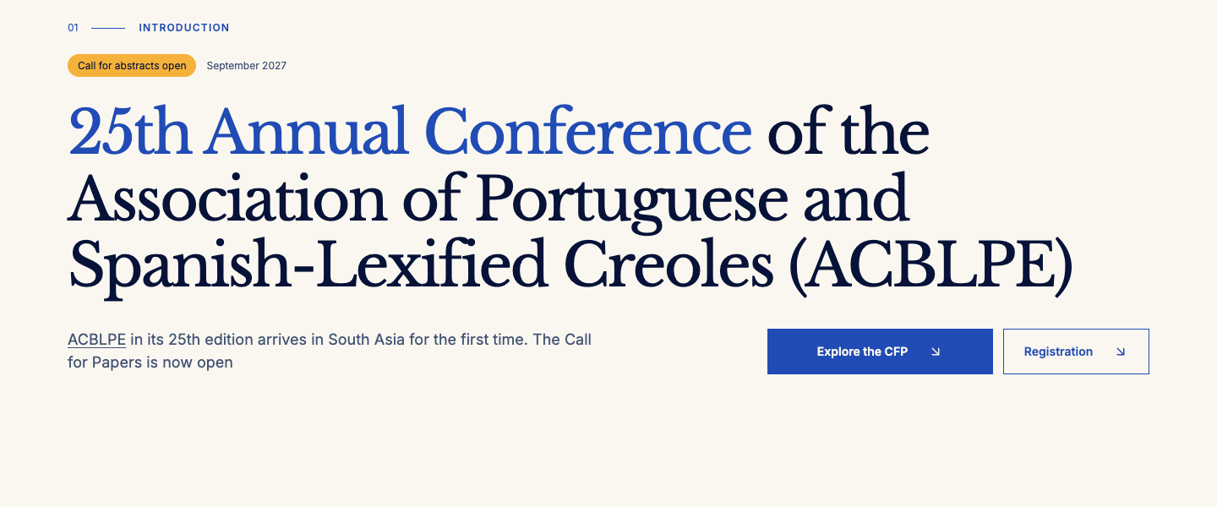

Landing page desktop

AboutACBLPE
Route /landing | Viewport 1440 × 1000 px
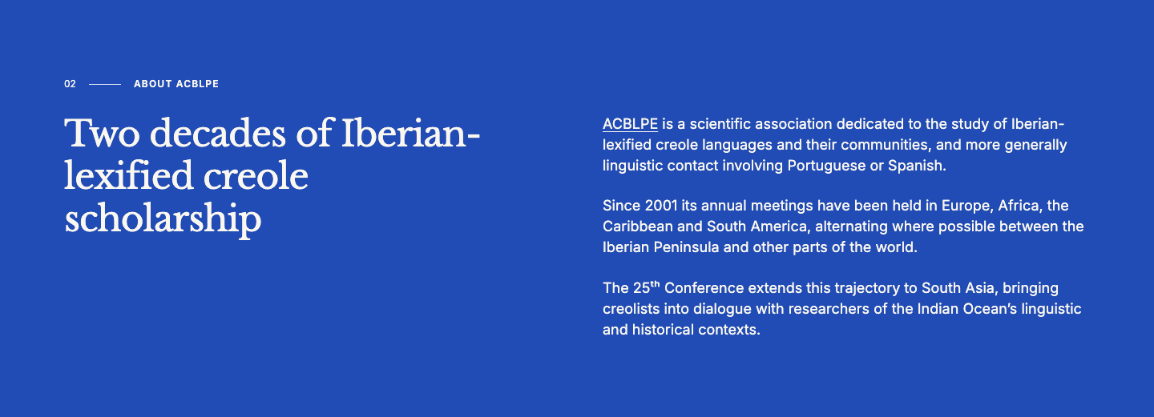

Landing page desktop

Satellite
Route /landing | Viewport 1440 × 1000 px
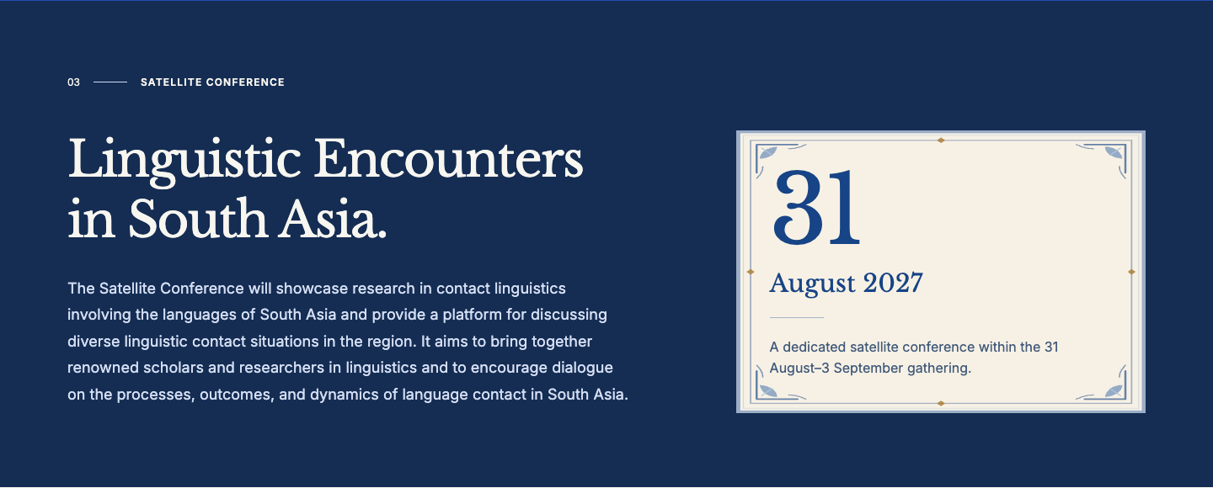

Landing page desktop

ConferenceVenue
Route /landing | Viewport 1440 × 1000 px
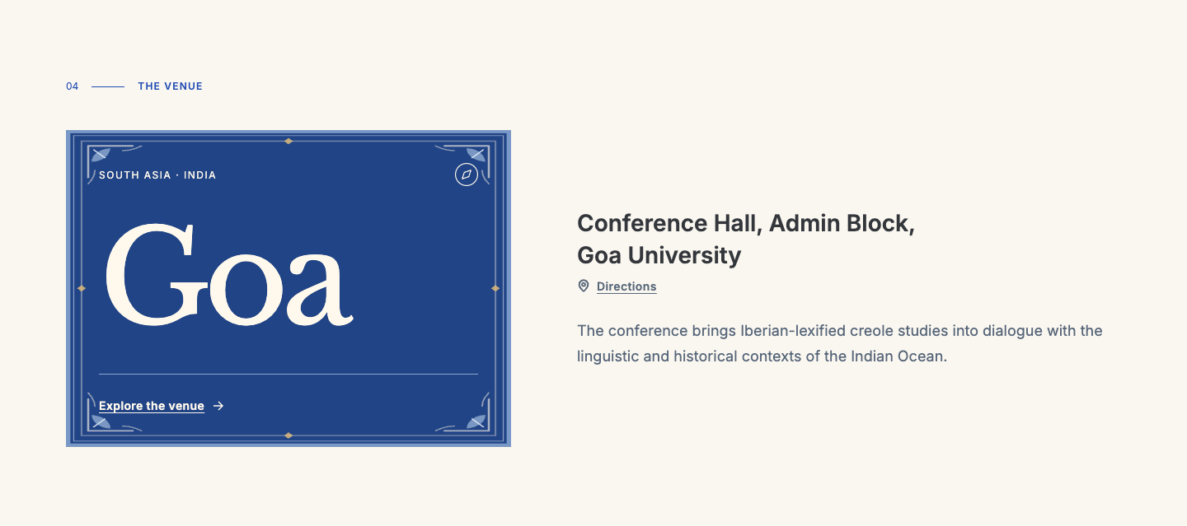

Landing page desktop

KeynoteIntro
Route /landing | Viewport 1440 × 1000 px
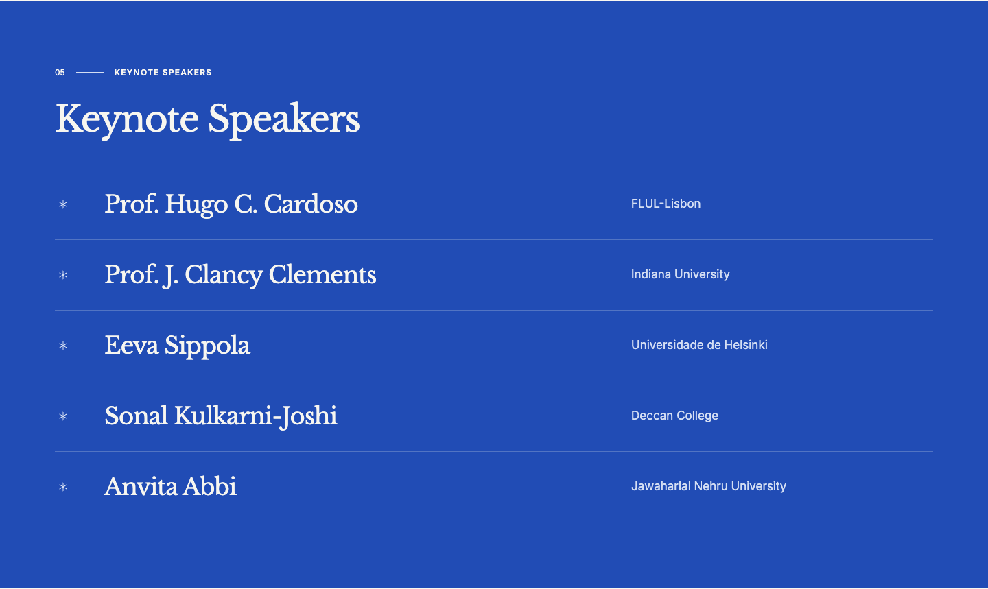

Landing page desktop

Timeline
Route /landing | Viewport 1440 × 1000 px
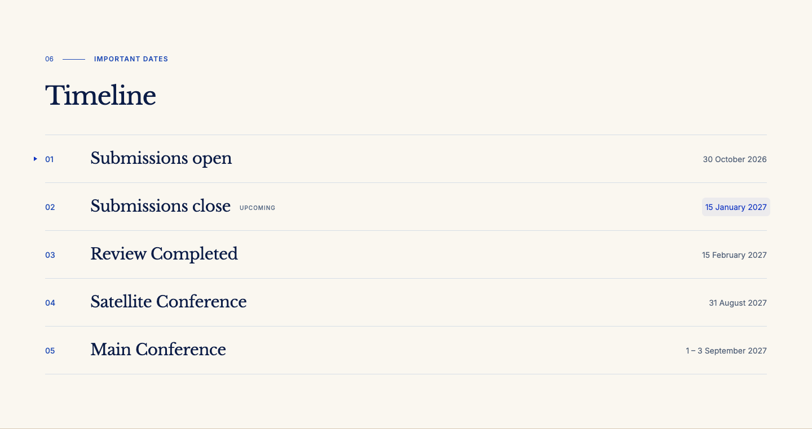

Landing page desktop

AzulejoArtwork
Route /landing | Viewport 1440 × 1000 px

Landing page tablet

Hero
Route /landing | Viewport 768 × 1024 px
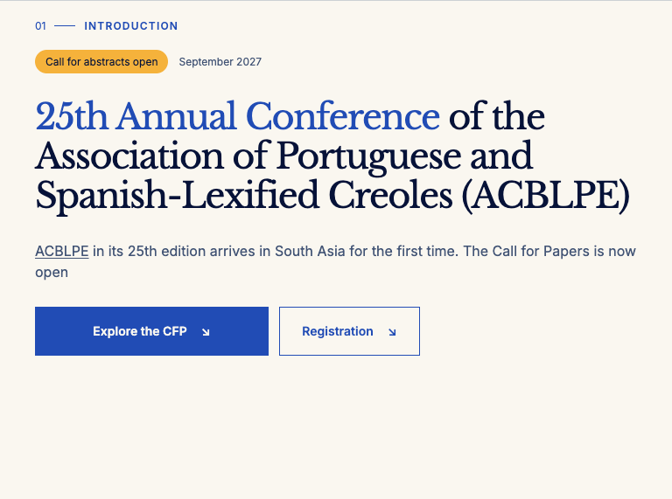

Landing page tablet

AboutACBLPE
Route /landing | Viewport 768 × 1024 px
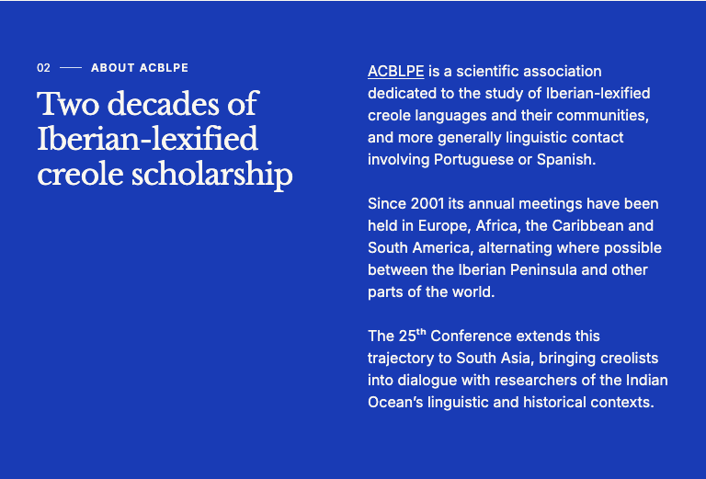

Landing page tablet

Satellite
Route /landing | Viewport 768 × 1024 px
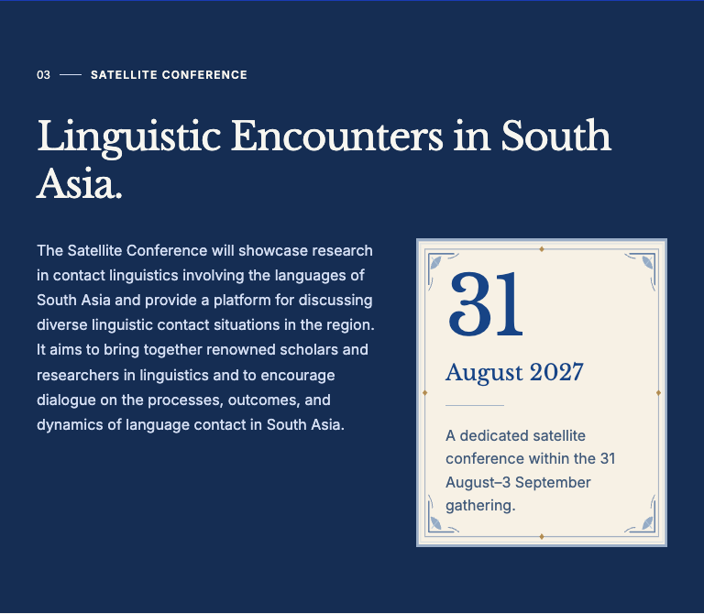

Landing page tablet

ConferenceVenue
Route /landing | Viewport 768 × 1024 px
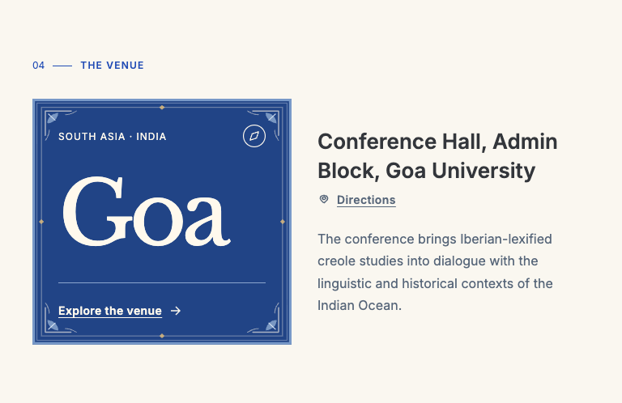

Landing page tablet

KeynoteIntro
Route /landing | Viewport 768 × 1024 px
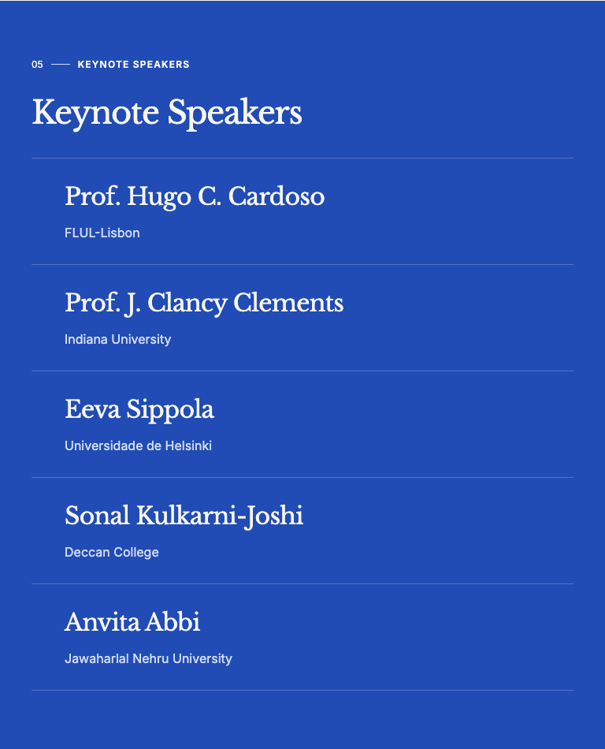

Landing page tablet

Timeline
Route /landing | Viewport 768 × 1024 px
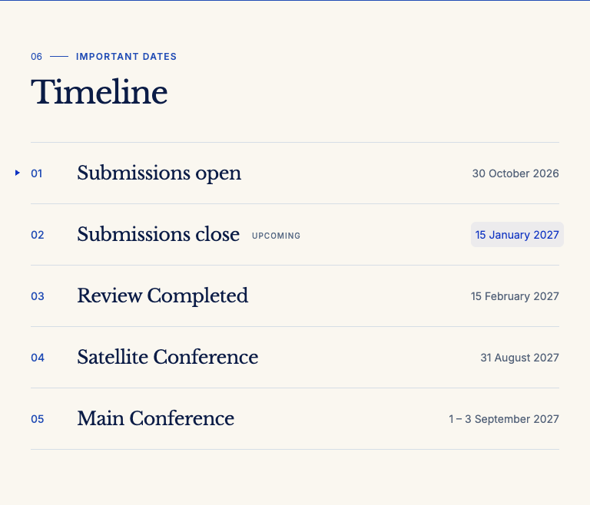

Landing page tablet

AzulejoArtwork
Route /landing | Viewport 768 × 1024 px


Landing page mobile

Hero
Route /landing | Viewport 390 × 844 px
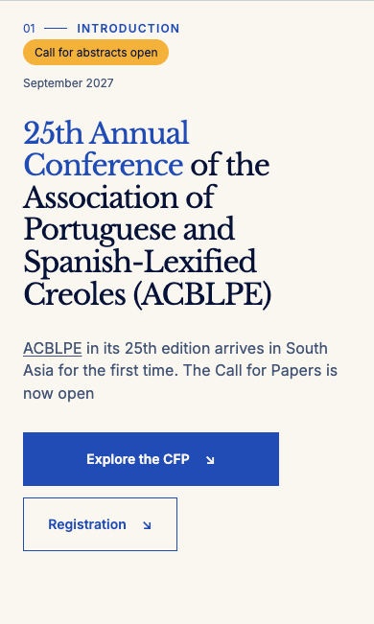

Landing page mobile

AboutACBLPE
Route /landing | Viewport 390 × 844 px
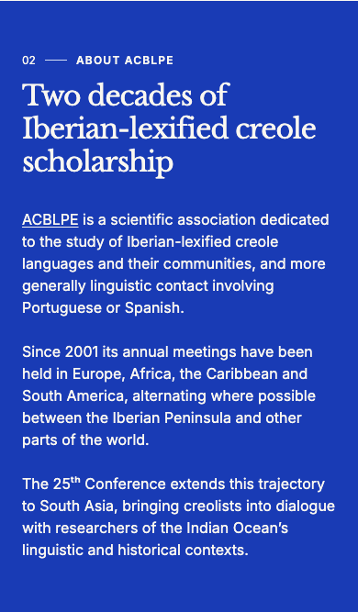

Landing page mobile

Satellite
Route /landing | Viewport 390 × 844 px
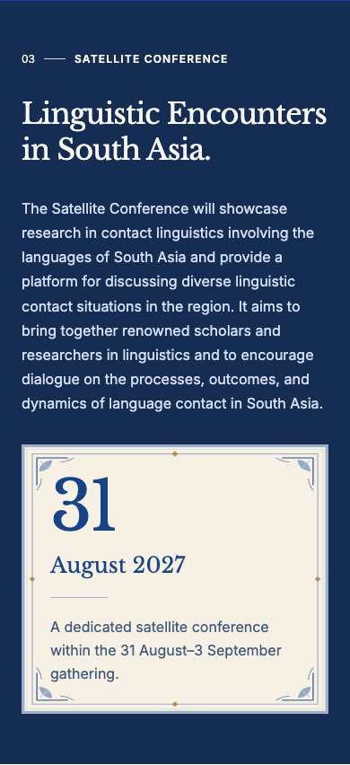

Landing page mobile

ConferenceVenue
Route /landing | Viewport 390 × 844 px
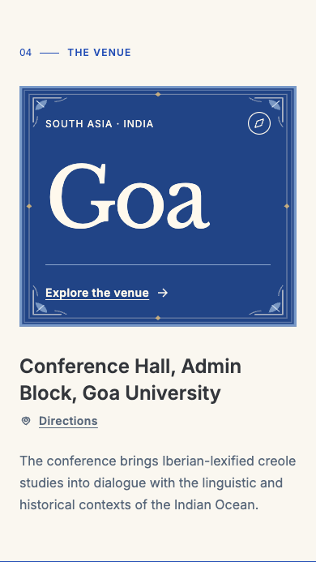

Landing page mobile

KeynoteIntro
Route /landing | Viewport 390 × 844 px
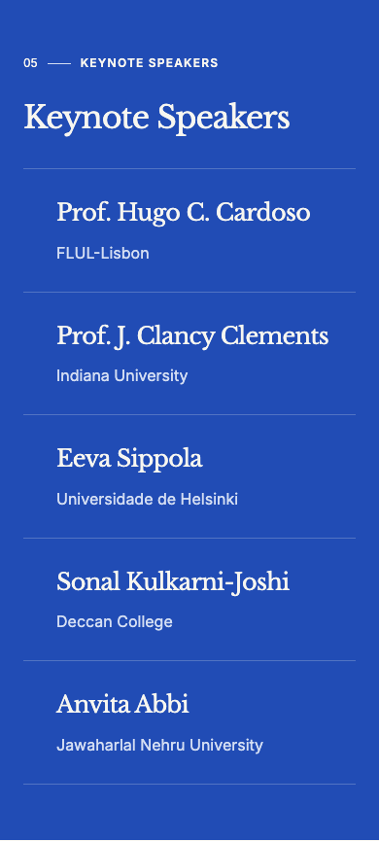

Landing page mobile

Timeline
Route /landing | Viewport 390 × 844 px
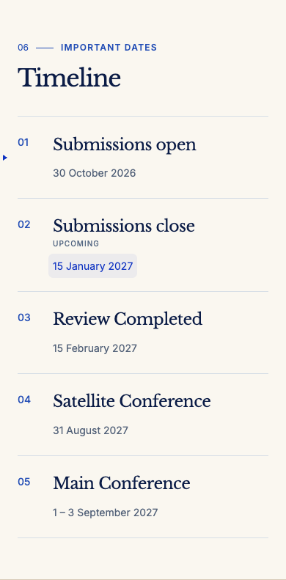

Landing page mobile

AzulejoArtwork
Route /landing | Viewport 390 × 844 px


Registration page desktop

RegistrationFees
Route /registration | Viewport 1440 × 1000 px


Registration page desktop

RegistrationNotice
Route /registration | Viewport 1440 × 1000 px


Registration page desktop

AzulejoArtwork
Route /registration | Viewport 1440 × 1000 px

Registration page tablet

RegistrationFees
Route /registration | Viewport 768 × 1024 px | Part 1 of 2


Registration page tablet

RegistrationFees
Route /registration | Viewport 768 × 1024 px | Part 2 of 2
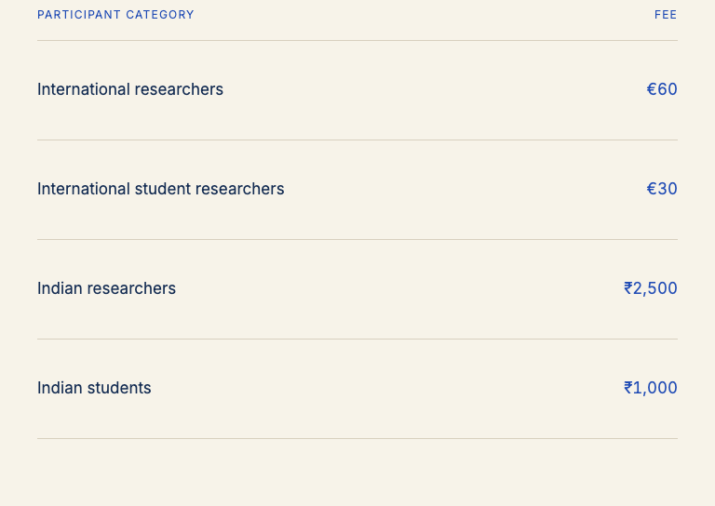

Registration page tablet

RegistrationNotice
Route /registration | Viewport 768 × 1024 px
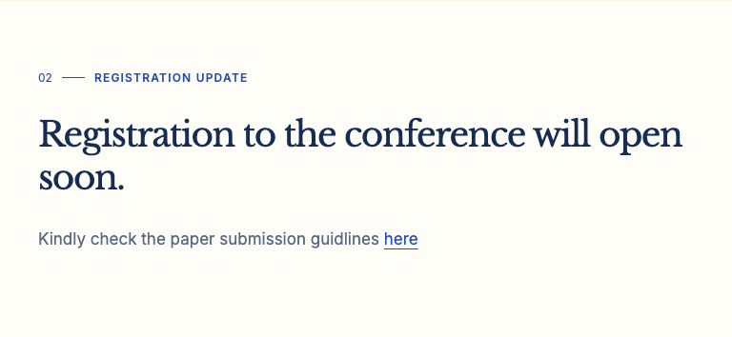

Registration page tablet

AzulejoArtwork
Route /registration | Viewport 768 × 1024 px


Registration page mobile

RegistrationFees
Route /registration | Viewport 390 × 844 px
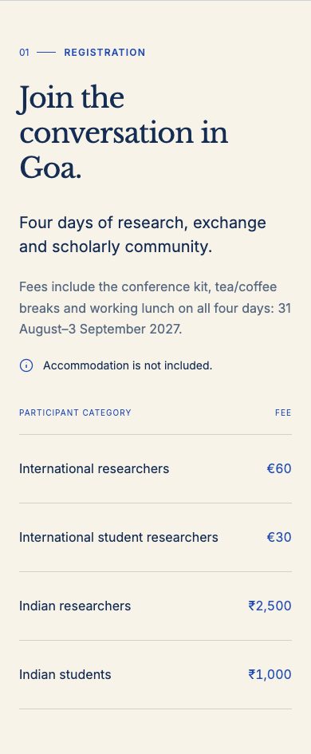

Registration page mobile

RegistrationNotice
Route /registration | Viewport 390 × 844 px
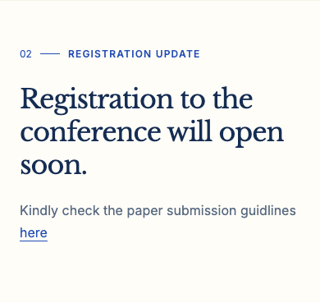

Registration page mobile

AzulejoArtwork
Route /registration | Viewport 390 × 844 px


People page desktop

OrganisationCommittee
Route /people | Viewport 1440 × 1000 px
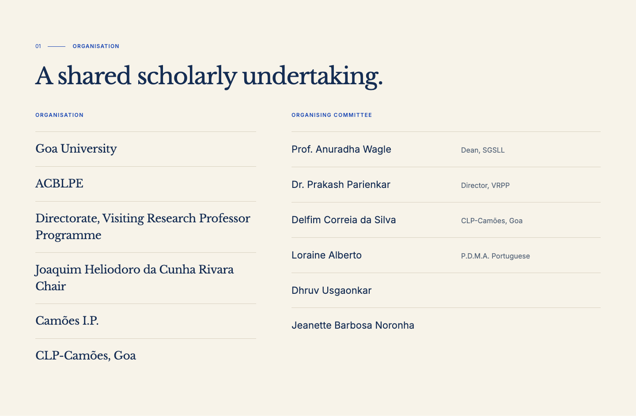

People page desktop

ScientificCommittee
Route /people | Viewport 1440 × 1000 px
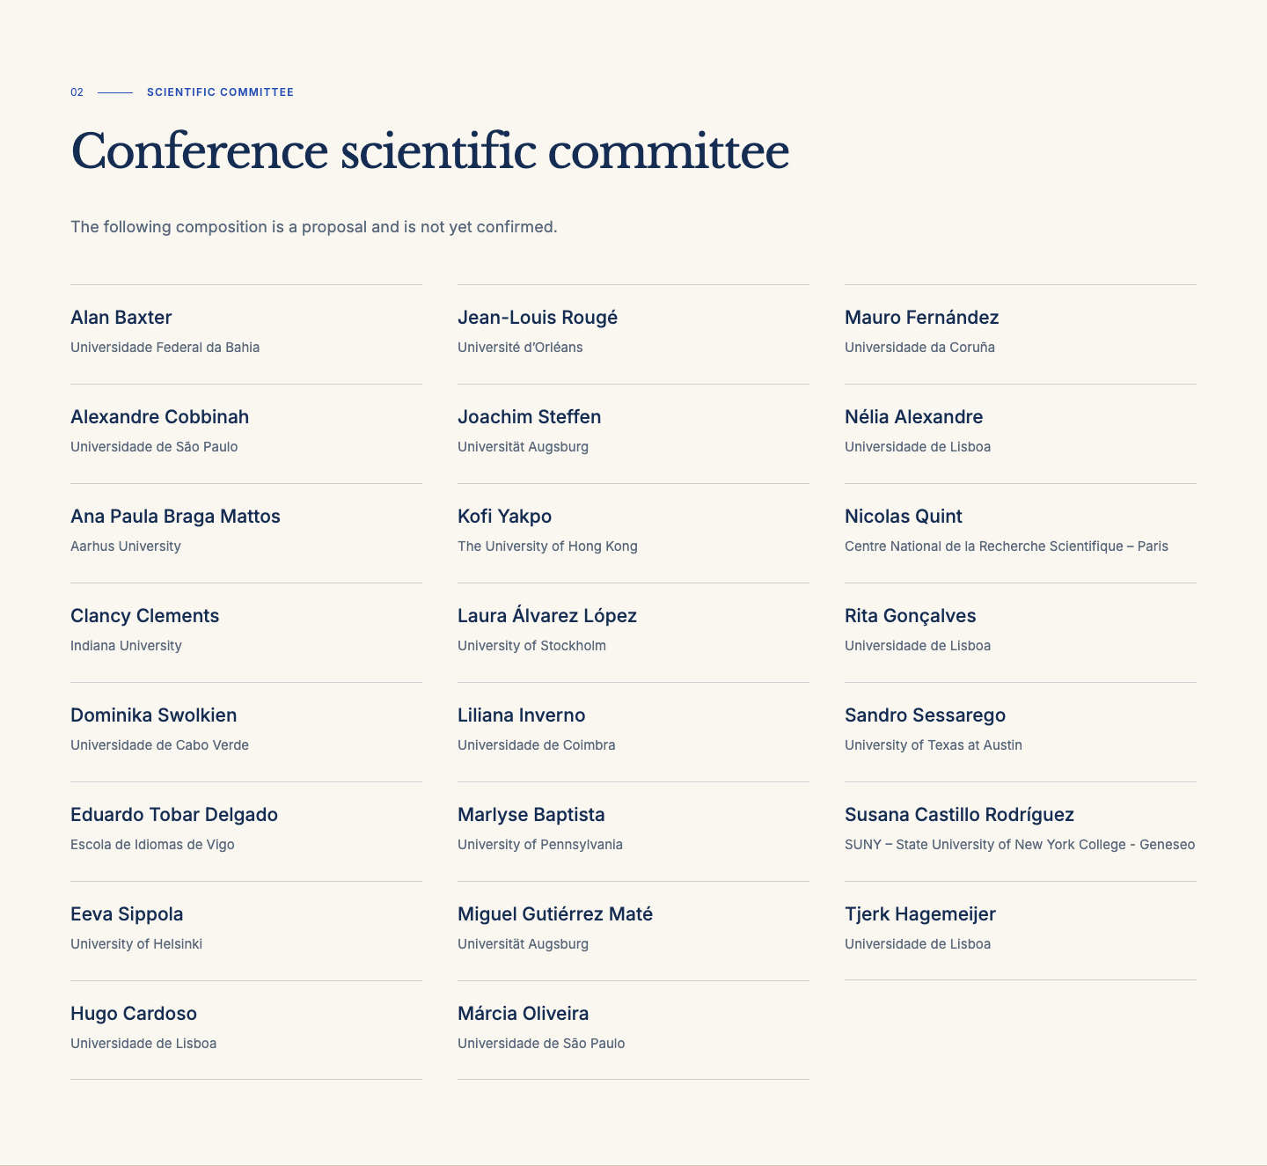

People page desktop

AzulejoArtwork
Route /people | Viewport 1440 × 1000 px

People page tablet

OrganisationCommittee
Route /people | Viewport 768 × 1024 px
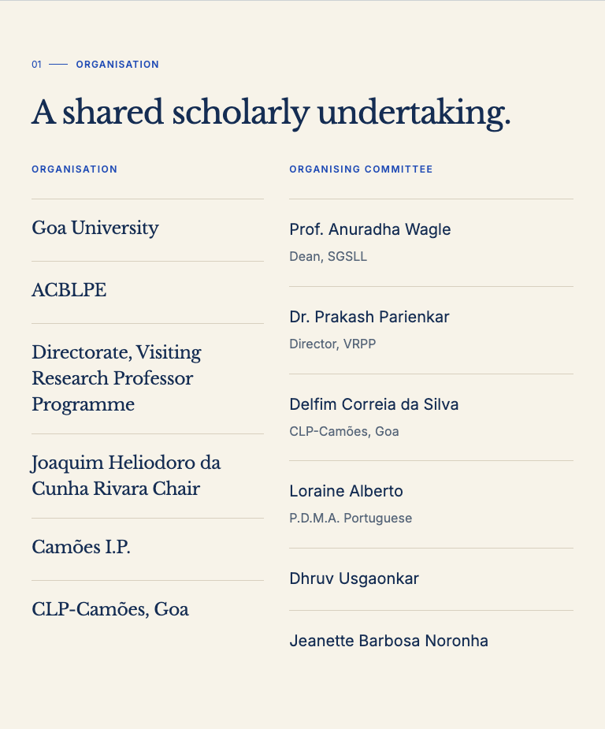

People page tablet

ScientificCommittee
Route /people | Viewport 768 × 1024 px | Part 1 of 3
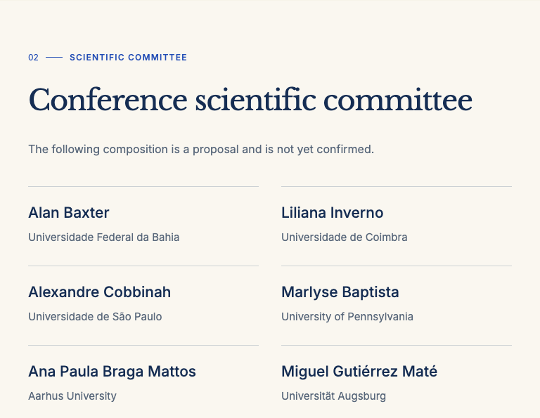

People page tablet

ScientificCommittee
Route /people | Viewport 768 × 1024 px | Part 2 of 3
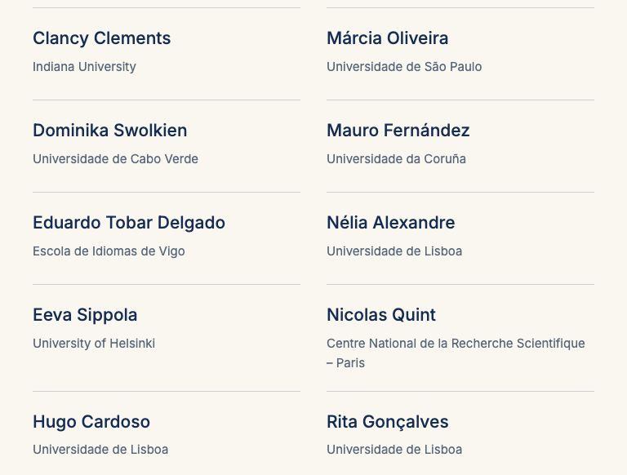

People page tablet

ScientificCommittee
Route /people | Viewport 768 × 1024 px | Part 3 of 3
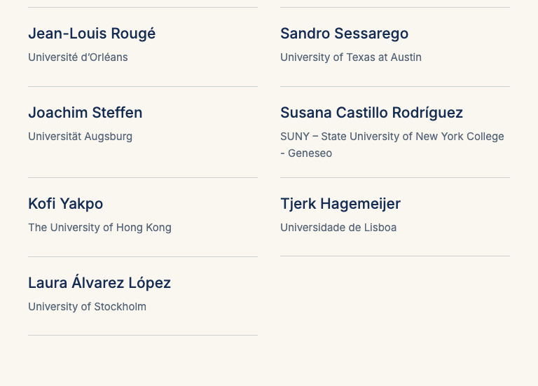

People page tablet

AzulejoArtwork
Route /people | Viewport 768 × 1024 px

People page mobile

OrganisationCommittee
Route /people | Viewport 390 × 844 px | Part 1 of 2


People page mobile

OrganisationCommittee
Route /people | Viewport 390 × 844 px | Part 2 of 2
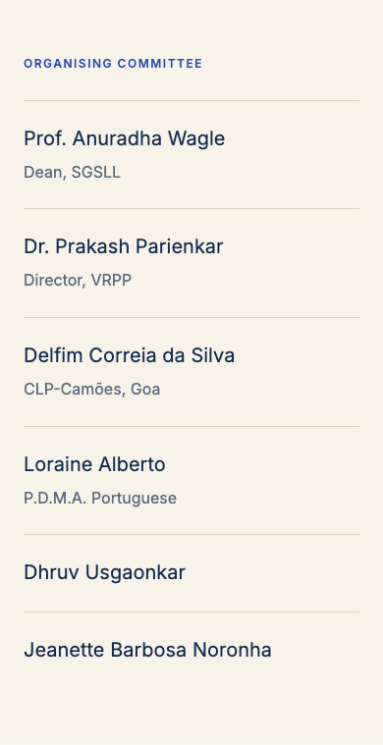

People page mobile

ScientificCommittee
Route /people | Viewport 390 × 844 px | Part 1 of 4
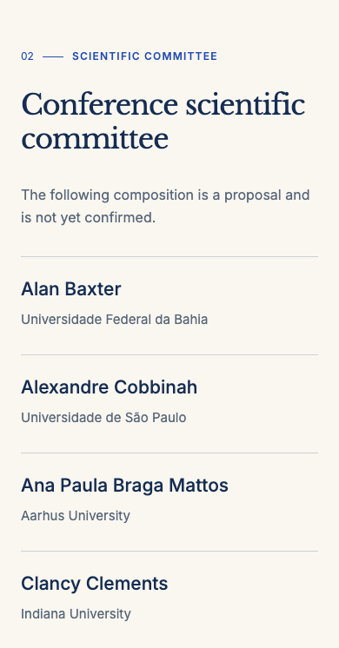

People page mobile

ScientificCommittee
Route /people | Viewport 390 × 844 px | Part 2 of 4
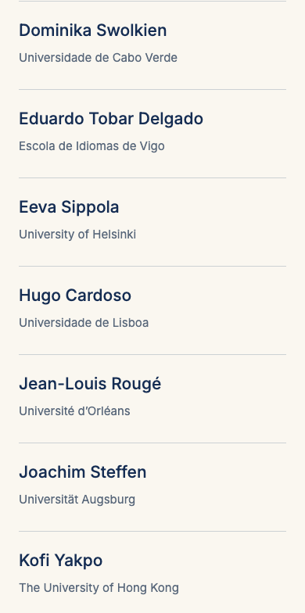

People page mobile

ScientificCommittee
Route /people | Viewport 390 × 844 px | Part 3 of 4
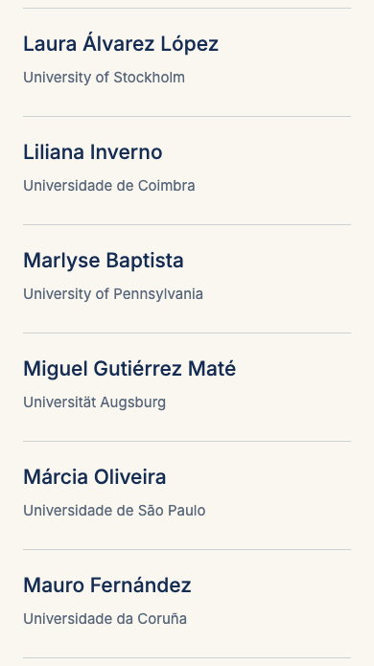

People page mobile

ScientificCommittee
Route /people | Viewport 390 × 844 px | Part 4 of 4
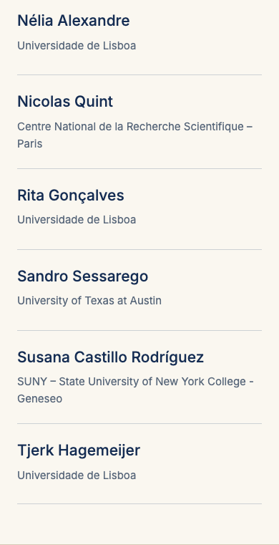

People page mobile

AzulejoArtwork
Route /people | Viewport 390 × 844 px


Venue page desktop

AboutGoa
Route /venue | Viewport 1440 × 1000 px
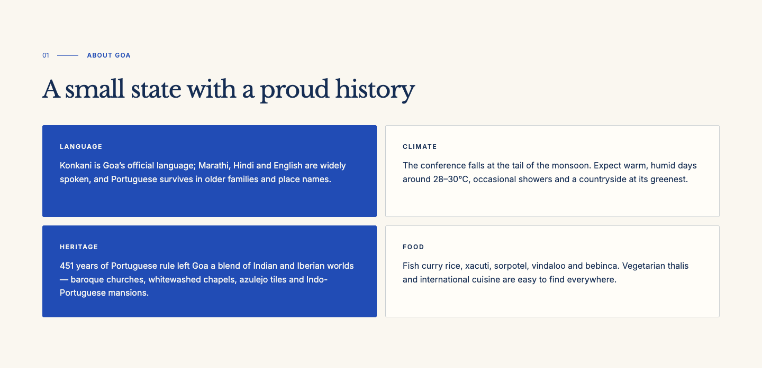

Venue page desktop

ThingsToDo
Route /venue | Viewport 1440 × 1000 px
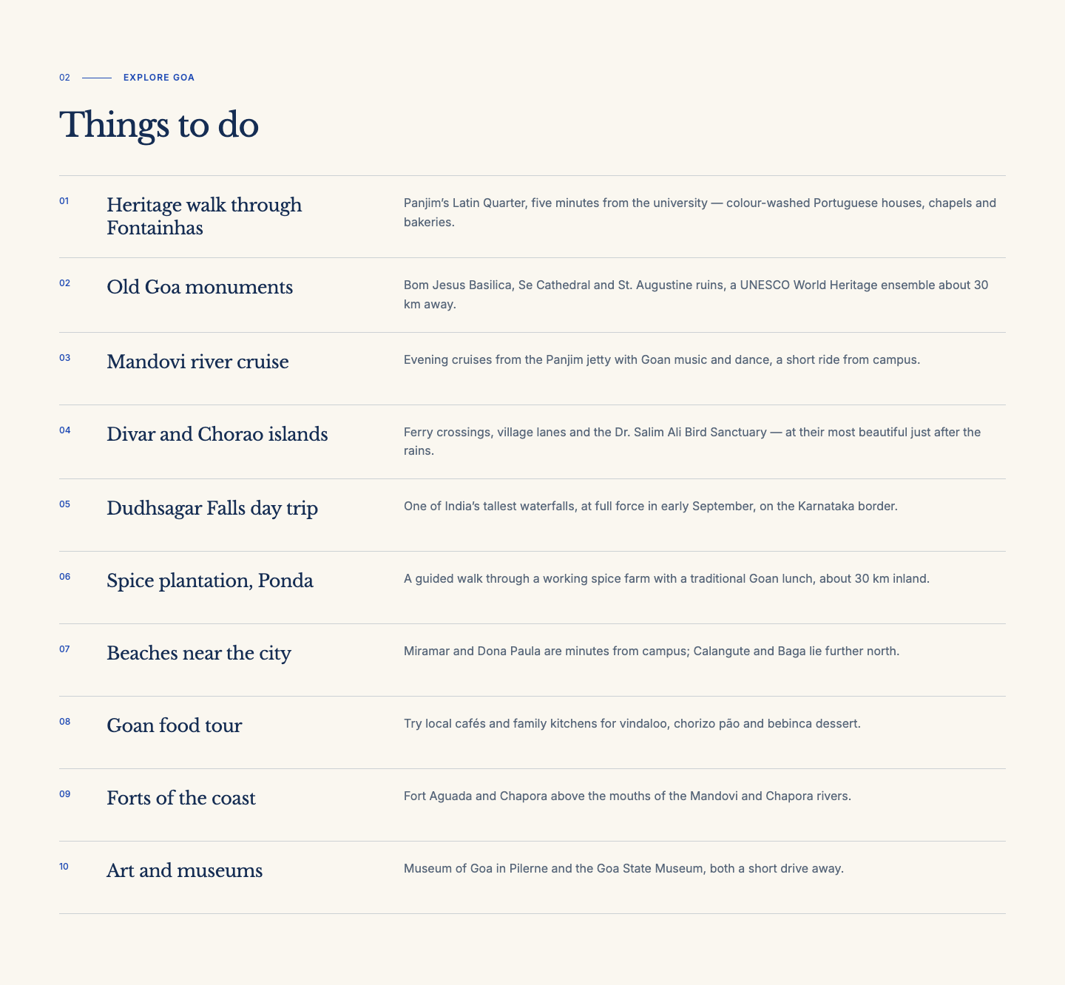

Venue page desktop

ReachingGoaUniversity
Route /venue | Viewport 1440 × 1000 px
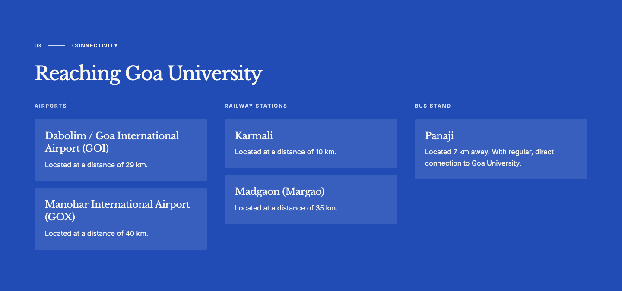

Venue page desktop

AzulejoArtwork
Route /venue | Viewport 1440 × 1000 px

Venue page tablet

AboutGoa
Route /venue | Viewport 768 × 1024 px
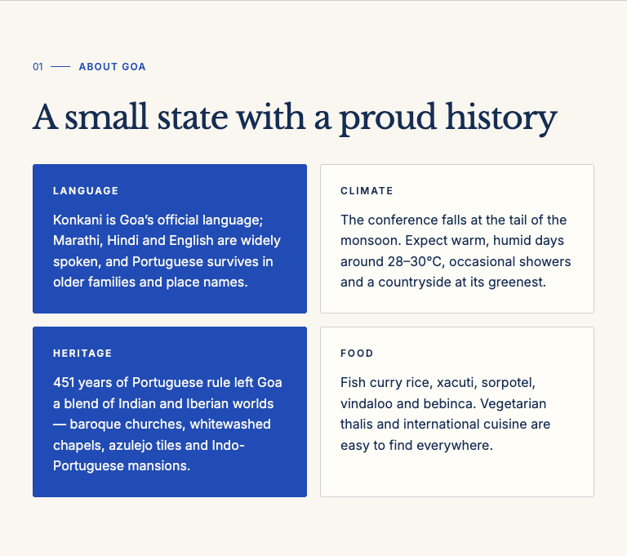

Venue page tablet

ThingsToDo
Route /venue | Viewport 768 × 1024 px | Part 1 of 2
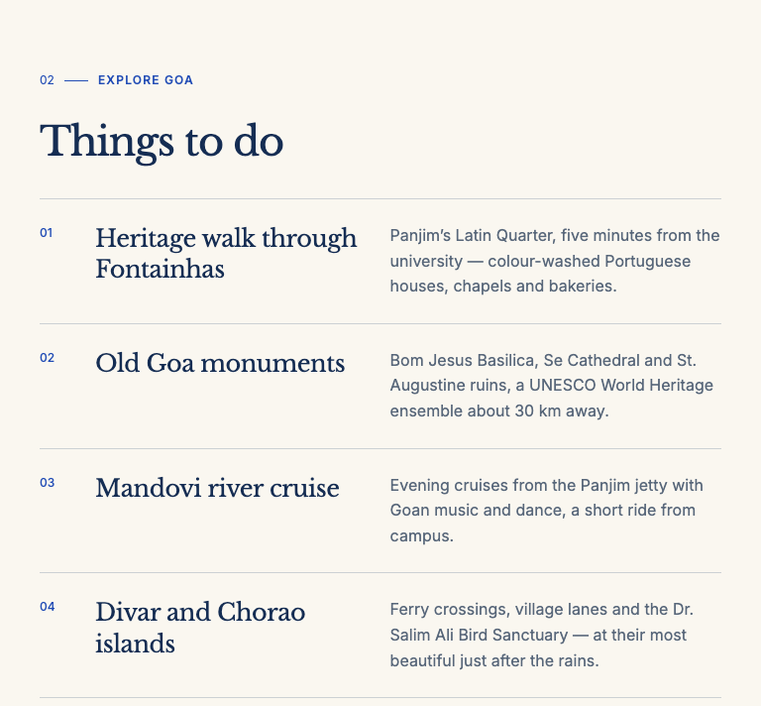

Venue page tablet

ThingsToDo
Route /venue | Viewport 768 × 1024 px | Part 2 of 2
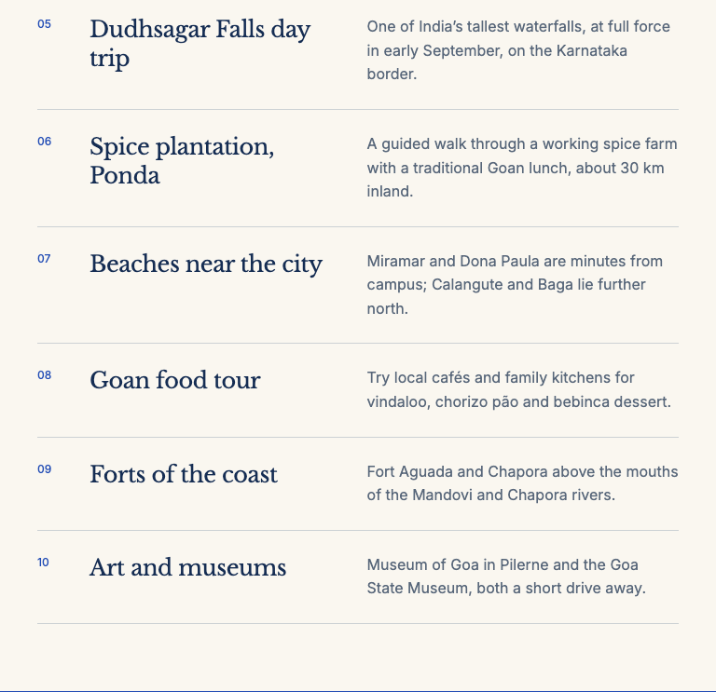

Venue page tablet

ReachingGoaUniversity
Route /venue | Viewport 768 × 1024 px
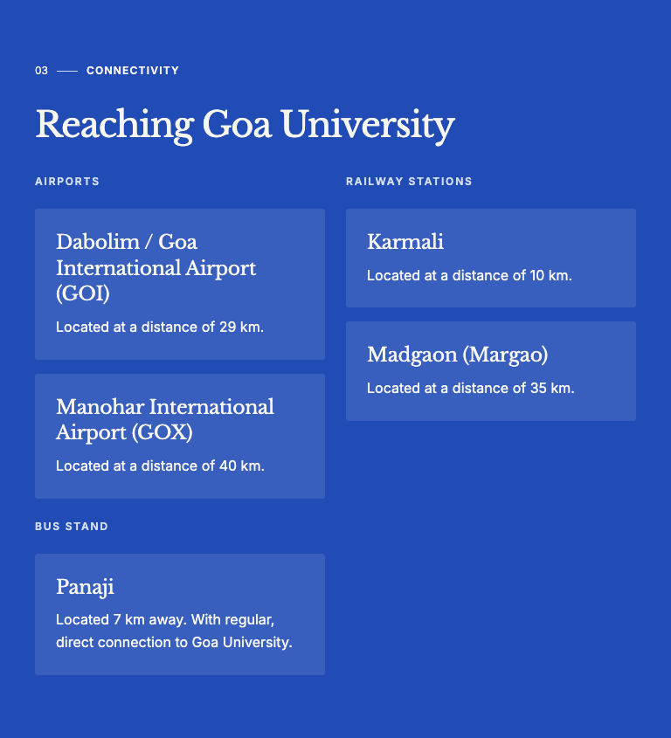

Venue page tablet

AzulejoArtwork
Route /venue | Viewport 768 × 1024 px


Venue page mobile

AboutGoa
Route /venue | Viewport 390 × 844 px | Part 1 of 2
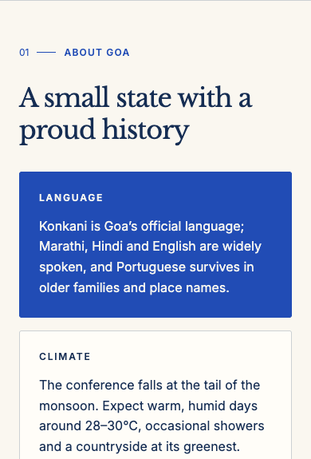

Venue page mobile

AboutGoa
Route /venue | Viewport 390 × 844 px | Part 2 of 2
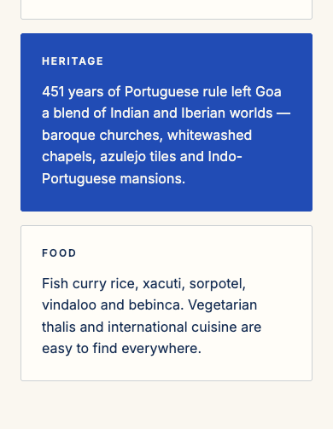

Venue page mobile

ThingsToDo
Route /venue | Viewport 390 × 844 px | Part 1 of 3
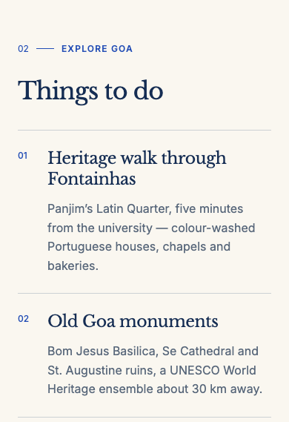

Venue page mobile

ThingsToDo
Route /venue | Viewport 390 × 844 px | Part 2 of 3
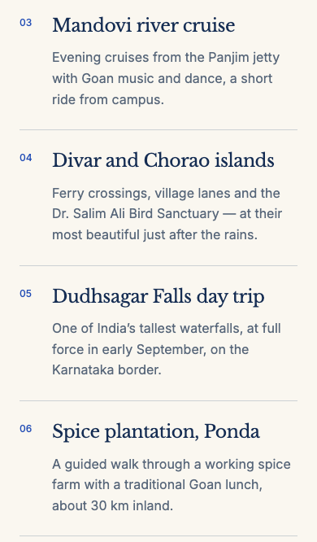

Venue page mobile

ThingsToDo
Route /venue | Viewport 390 × 844 px | Part 3 of 3
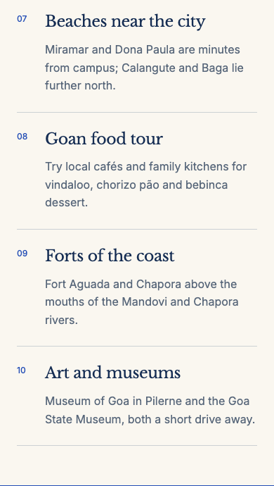

Venue page mobile

ReachingGoaUniversity
Route /venue | Viewport 390 × 844 px | Part 1 of 2
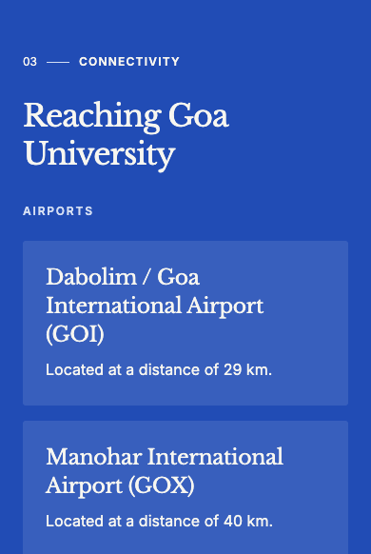

Venue page mobile

ReachingGoaUniversity
Route /venue | Viewport 390 × 844 px | Part 2 of 2
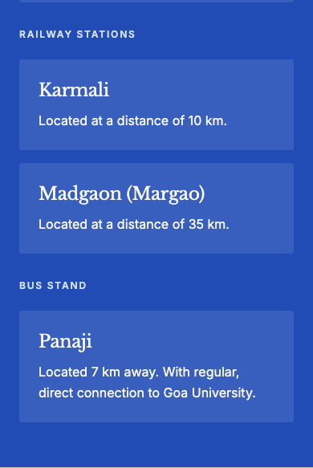

Venue page mobile

AzulejoArtwork
Route /venue | Viewport 390 × 844 px


Call for Papers page desktop

CallForPapersHero
Route /call-for-papers | Viewport 1440 × 1000 px


Call for Papers page desktop

SubmissionInstructions
Route /call-for-papers | Viewport 1440 × 1000 px
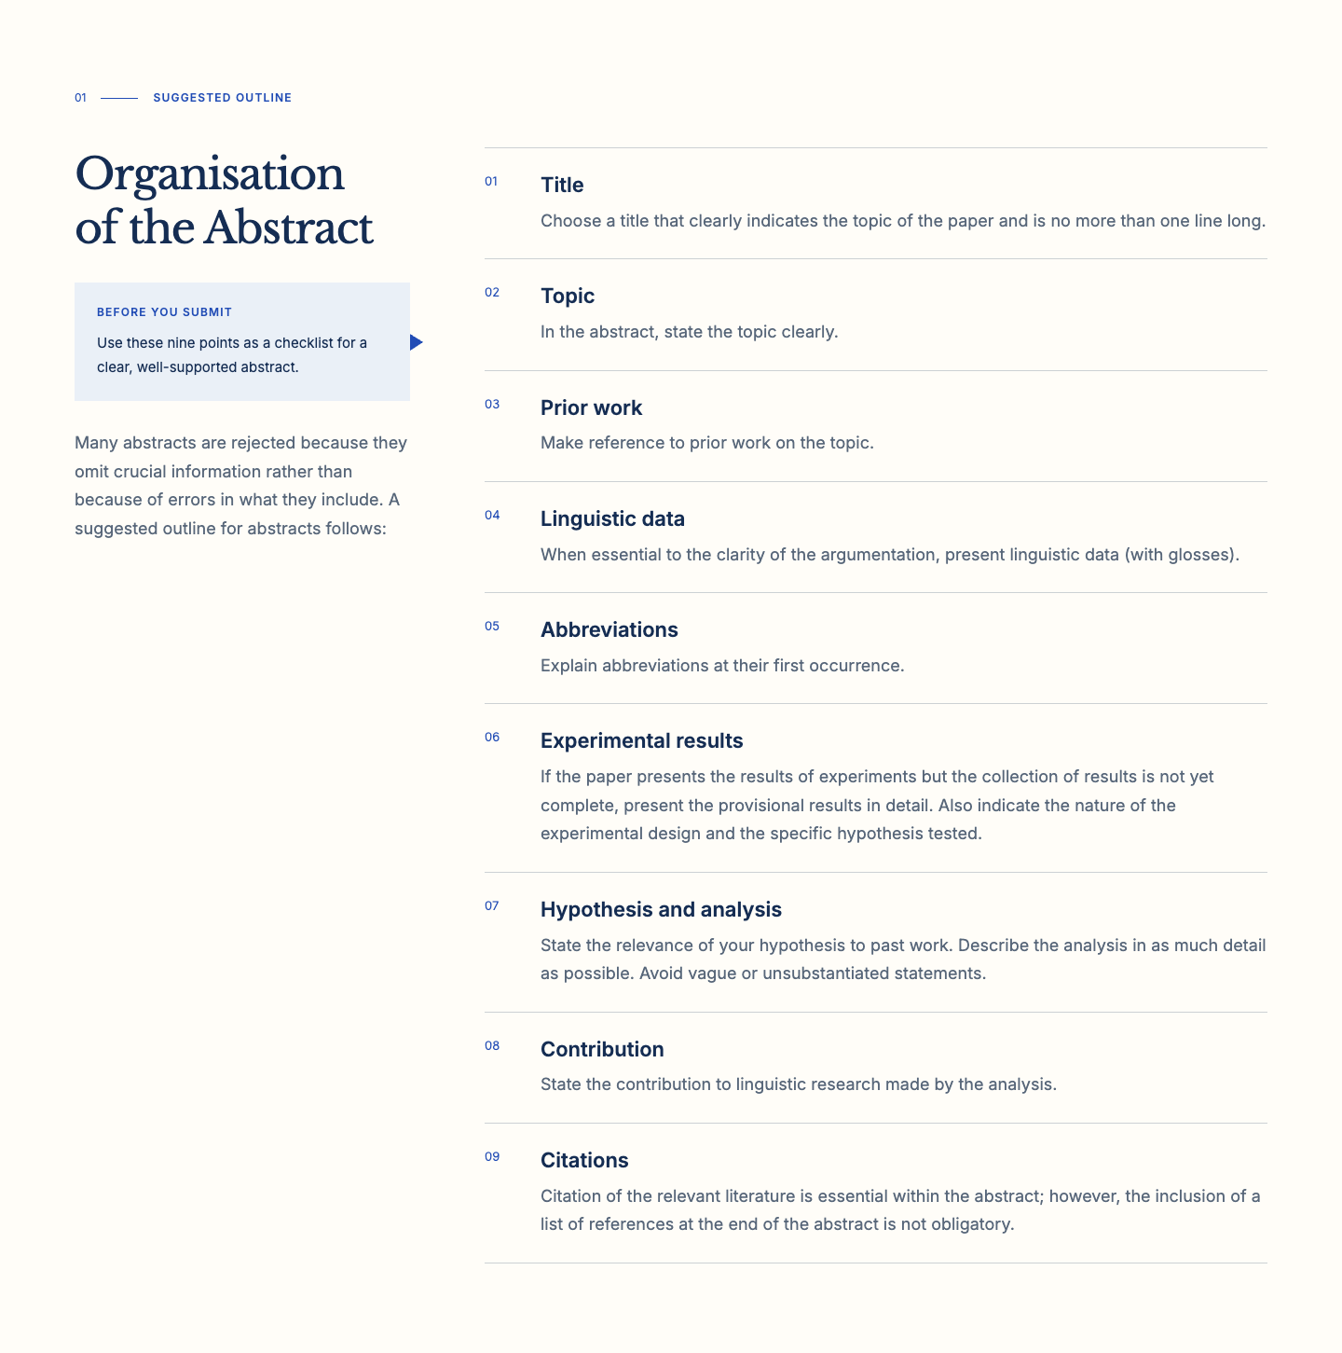

Call for Papers page desktop

ReviewPresentationGuidance
Route /call-for-papers | Viewport 1440 × 1000 px
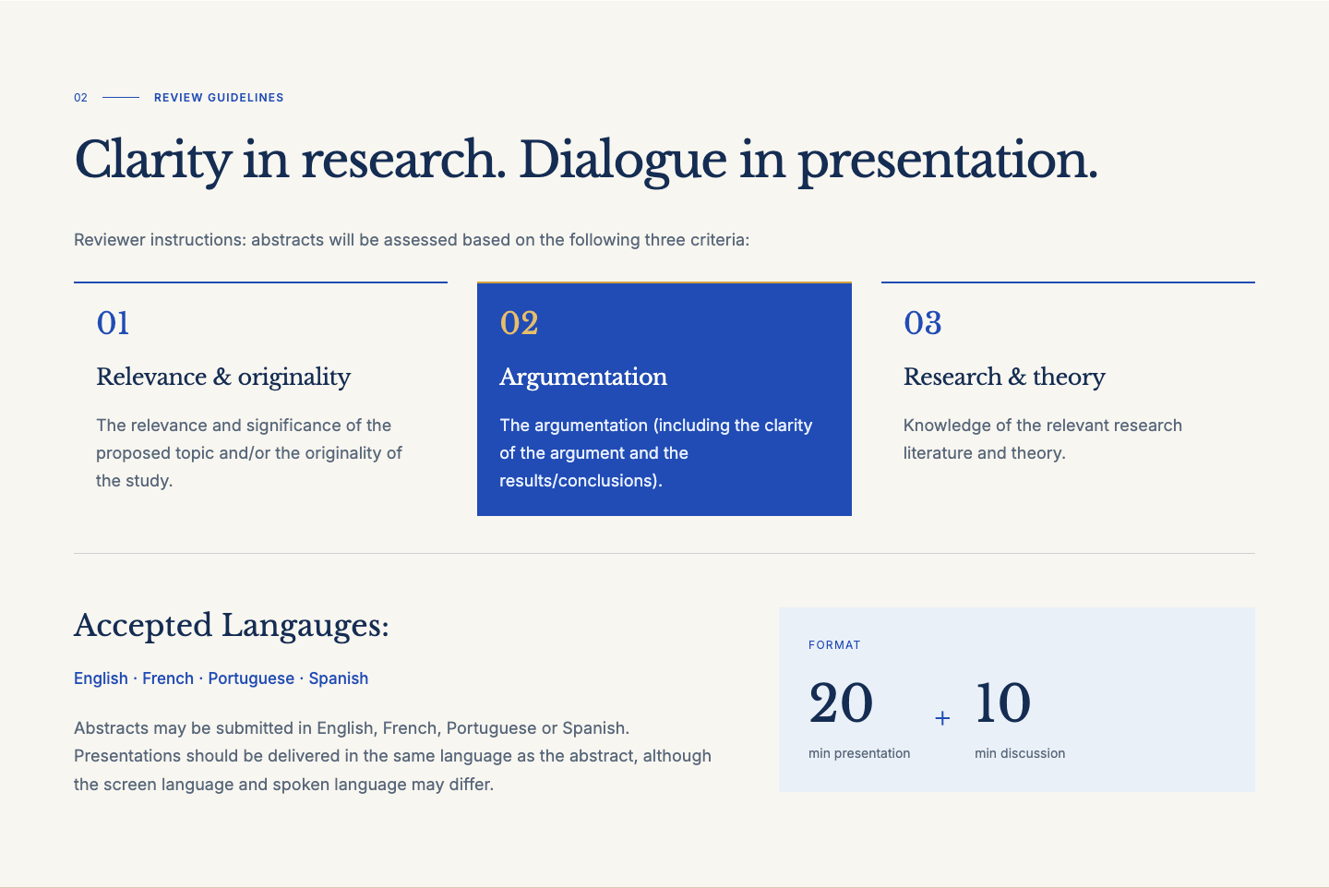

Call for Papers page desktop

AzulejoArtwork
Route /call-for-papers | Viewport 1440 × 1000 px

Call for Papers page tablet

CallForPapersHero
Route /call-for-papers | Viewport 768 × 1024 px


Call for Papers page tablet

SubmissionInstructions
Route /call-for-papers | Viewport 768 × 1024 px | Part 1 of 3
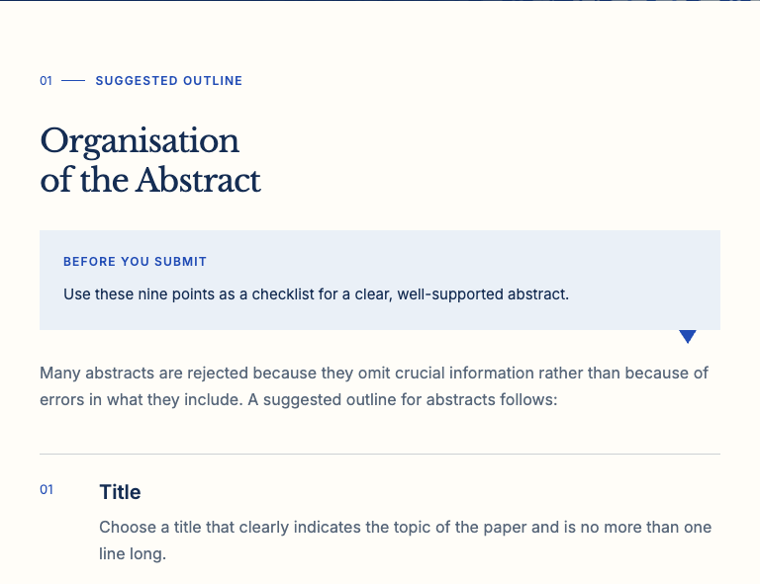

Call for Papers page tablet

SubmissionInstructions
Route /call-for-papers | Viewport 768 × 1024 px | Part 2 of 3
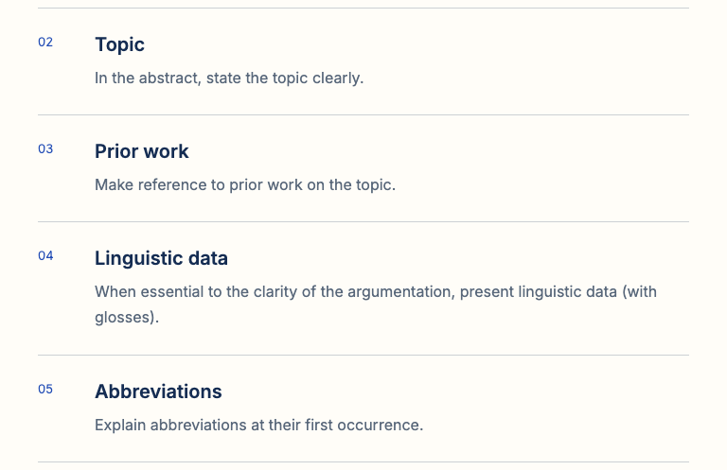

Call for Papers page tablet

SubmissionInstructions
Route /call-for-papers | Viewport 768 × 1024 px | Part 3 of 3
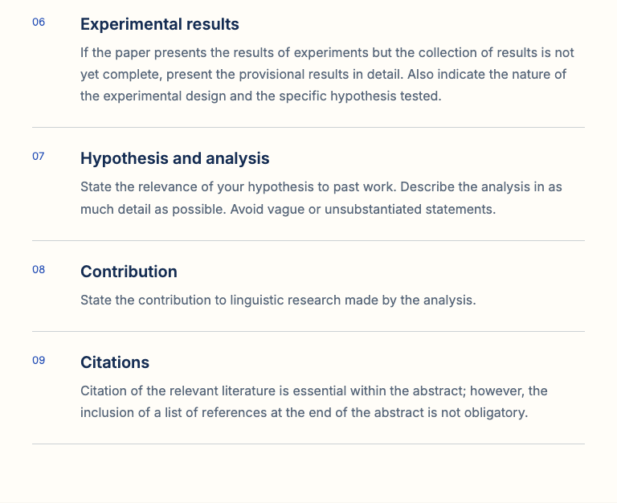

Call for Papers page tablet

ReviewPresentationGuidance
Route /call-for-papers | Viewport 768 × 1024 px | Part 1 of 2
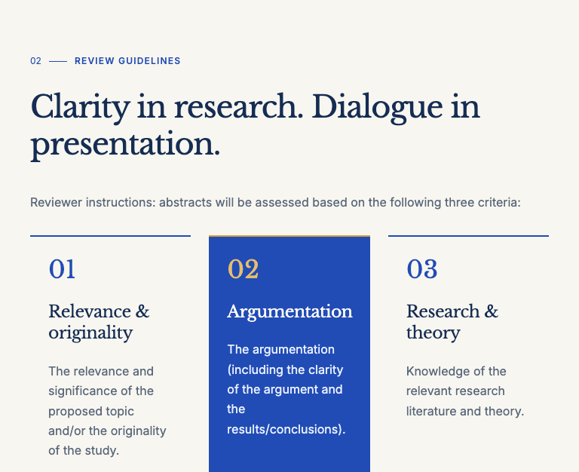

Call for Papers page tablet

ReviewPresentationGuidance
Route /call-for-papers | Viewport 768 × 1024 px | Part 2 of 2
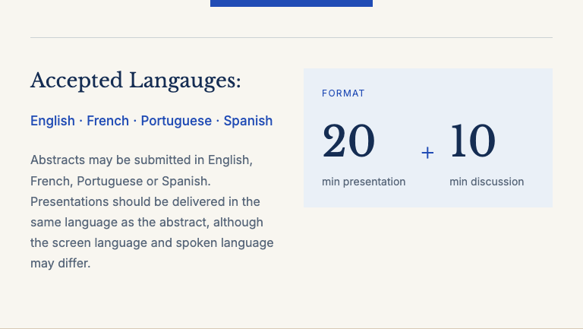

Call for Papers page tablet

AzulejoArtwork
Route /call-for-papers | Viewport 768 × 1024 px


Call for Papers page mobile

CallForPapersHero
Route /call-for-papers | Viewport 390 × 844 px


Call for Papers page mobile

SubmissionInstructions
Route /call-for-papers | Viewport 390 × 844 px | Part 1 of 3
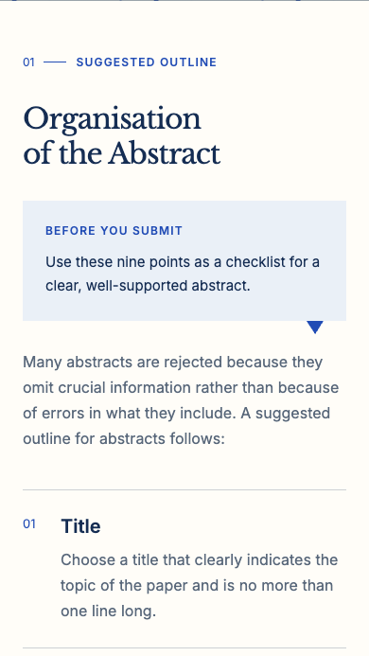

Call for Papers page mobile

SubmissionInstructions
Route /call-for-papers | Viewport 390 × 844 px | Part 2 of 3
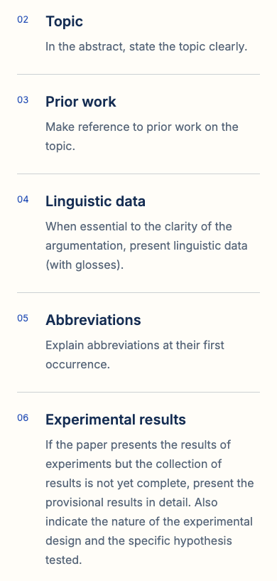

Call for Papers page mobile

SubmissionInstructions
Route /call-for-papers | Viewport 390 × 844 px | Part 3 of 3
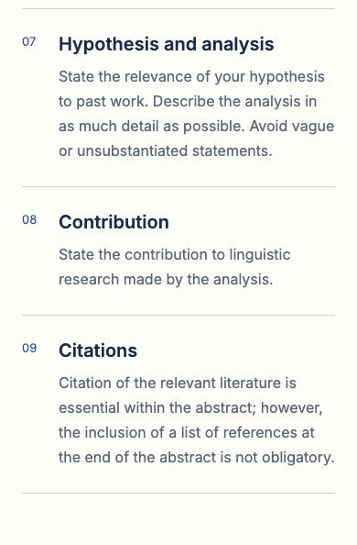

Call for Papers page mobile

ReviewPresentationGuidance
Route /call-for-papers | Viewport 390 × 844 px | Part 1 of 2
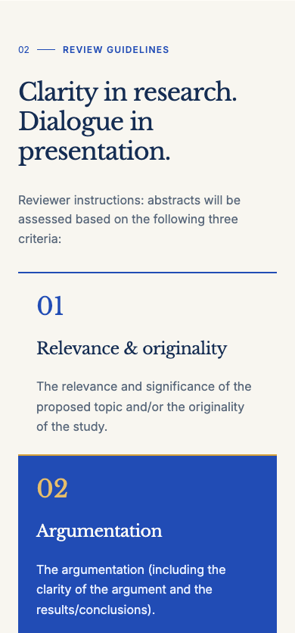

Call for Papers page mobile

ReviewPresentationGuidance
Route /call-for-papers | Viewport 390 × 844 px | Part 2 of 2
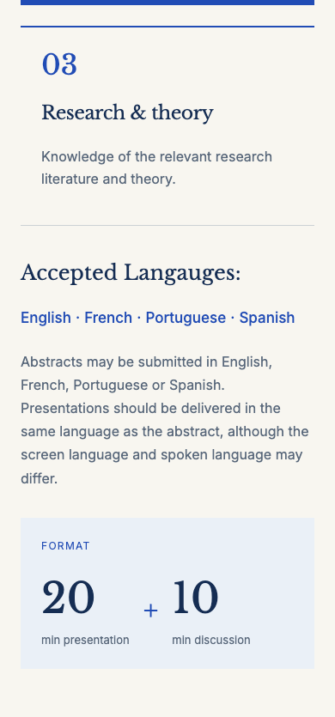

Call for Papers page mobile

AzulejoArtwork
Route /call-for-papers | Viewport 390 × 844 px


Common components desktop

Navigation
Shared by all pages | Viewport 1440 × 1000 px

Common components desktop

MinimalFooter
Shared by all pages | Viewport 1440 × 1000 px
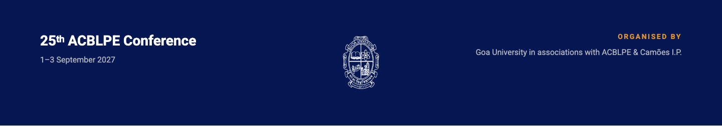

Common components tablet

Navigation
Shared by all pages | Viewport 768 × 1024 px


Common components tablet

MinimalFooter
Shared by all pages | Viewport 768 × 1024 px
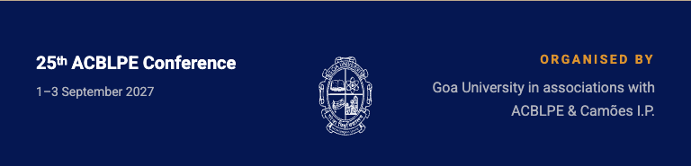

Common components mobile

Navigation
Shared by all pages | Viewport 390 × 844 px


Common components mobile

MinimalFooter
Shared by all pages | Viewport 390 × 844 px


