CIS6005 – Computational Intelligence
Coursework Report

Student Name: Saheen Alam Shuvo
Student ID: v2526-29
Module: CIS6005
University: Varna University of Management
Submission Date: 20.01.2026

1. Introduction
This coursework focuses on the application of computational intelligence techniques to solve two different real-world problems: medical image classification and sentiment analysis. Neural networks were used as the primary computational intelligence approach for both tasks.
For the medical task, a chest X-ray image dataset was used to classify images as either normal or pneumonia. Two different neural network architectures were implemented and compared: a custom Convolutional Neural Network (CNN) and a transfer learning model based on MobileNetV2.
For the sentiment analysis task, movie reviews were classified as positive or negative using the IMDB dataset. Two different neural network models were implemented: a Long Short-Term Memory (LSTM) network and a Multi-Layer Perceptron (MLP)-style model.
The goal of this coursework is to design, train, evaluate, and compare different neural network models and analyze their performance using appropriate evaluation metrics and visualizations.

2. Dataset Preparation
2.1 Medical Image Dataset
The medical image classification task used the PneumoniaMNIST dataset from the MedMNIST collection. This dataset consists of grayscale chest X-ray images of size 28×28 pixels. Each image is labeled as either normal or pneumonia, making it a binary classification problem.
The dataset provides predefined splits for training, validation, and testing. The training set was used to train the models, the validation set was used to monitor performance during training, and the test set was used for final evaluation.
Before training, the images were normalized to improve numerical stability. For the transfer learning model, grayscale images were converted into three-channel RGB images and resized to 224×224 pixels to match the input requirements of MobileNetV2.

2.2 Sentiment Analysis Dataset
The sentiment analysis task used the IMDB movie review dataset provided by Keras. This dataset contains movie reviews labeled as either positive or negative.
Text data was represented as sequences of word indices, limited to the top 10,000 most frequent words. To create a validation set, the original training data was split into 80% training data and 20% validation data. All sequences were padded to a fixed length of 200 to ensure uniform input size for the neural networks.

3. Model Design and Hyperparameters
3.1 Medical Image Classification Models
Model 1: Custom CNN
A custom Convolutional Neural Network was designed from scratch. The model consists of multiple convolutional layers followed by max-pooling layers to extract spatial features from the images. A global average pooling layer and fully connected layers were used for classification.
Hyperparameters:
- Optimizer: Adam
- Learning rate: 0.001
- Batch size: 64
- Epochs: 8
- Loss function: Binary Cross-Entropy

Model 2: Transfer Learning (MobileNetV2)
For the second medical model, transfer learning was applied using MobileNetV2 pretrained on ImageNet. The pretrained layers were frozen, and only the final classification layers were trained. This approach allows the model to benefit from features learned on large-scale datasets.
Hyperparameters:
- Optimizer: Adam
- Learning rate: 0.001
- Batch size: 32
- Epochs: 5
- Loss function: Binary Cross-Entropy

3.2 Sentiment Analysis Models
Model 1: LSTM
The first sentiment analysis model used an Embedding layer followed by an LSTM layer. This architecture is effective for sequential data, as LSTM networks can capture long-term dependencies in text.
Hyperparameters:
- Vocabulary size: 10,000
- Sequence length: 200
- Optimizer: Adam
- Learning rate: 0.001
- Batch size: 64
- Epochs: 5
Model 2: MLP-Style Model
The second sentiment model used an Embedding layer followed by a Global Average Pooling layer and fully connected layers. This model does not explicitly model word order but provides faster training and competitive performance.
Hyperparameters:
- Vocabulary size: 10,000
- Sequence length: 200
- Optimizer: Adam
- Learning rate: 0.001
- Batch size: 64
- Epochs: 5

4. Model Evaluation and Results
Model performance was evaluated using accuracy, loss curves, confusion matrices, and classification reports. Training and validation accuracy and loss were visualized using plots saved during training.
4.1 Medical Image Classification Results
Both the custom CNN and the transfer learning model achieved strong performance on the PneumoniaMNIST dataset. The transfer learning model generally achieved higher validation accuracy and more stable convergence compared to the custom CNN.
Figure 1: Training and validation accuracy for Medical CNN model
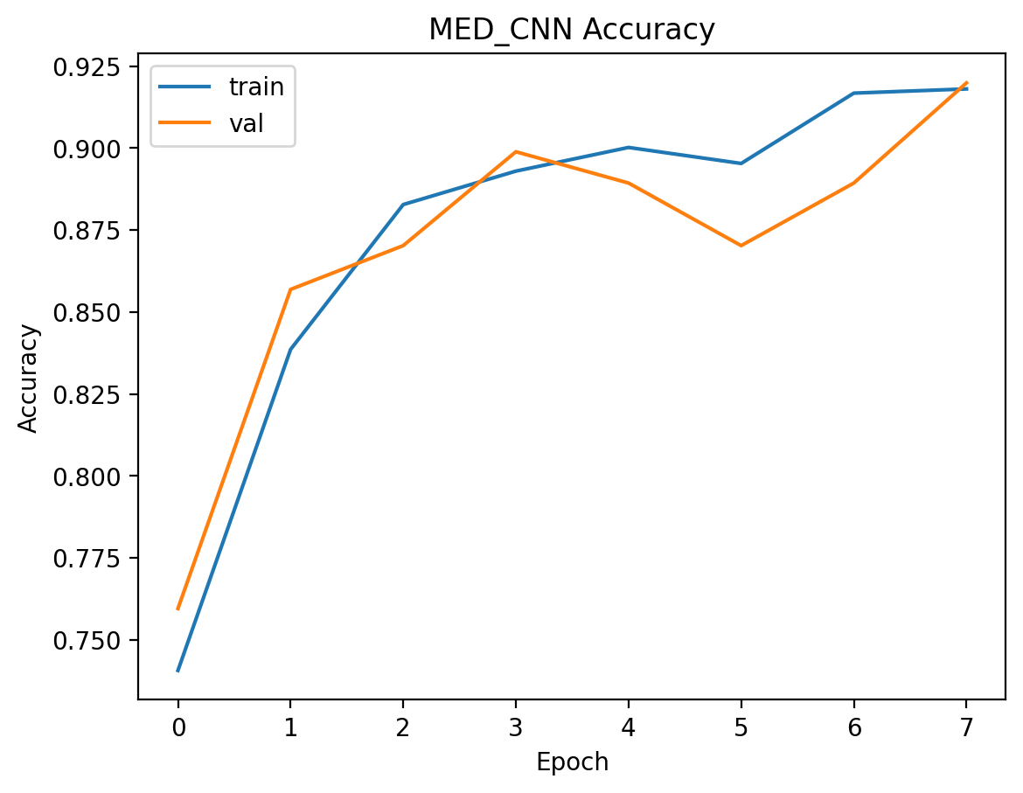
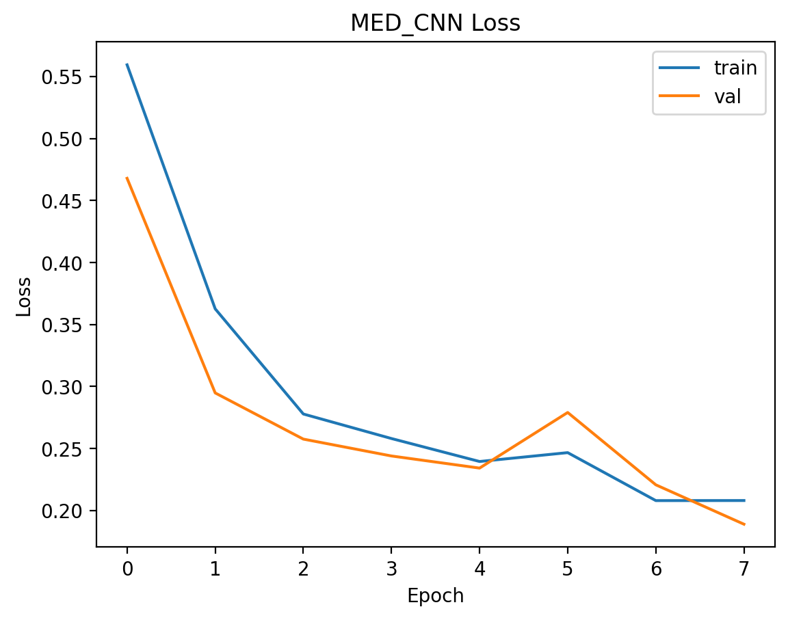

Figure 2: Training and validation accuracy for Transfer Learning model
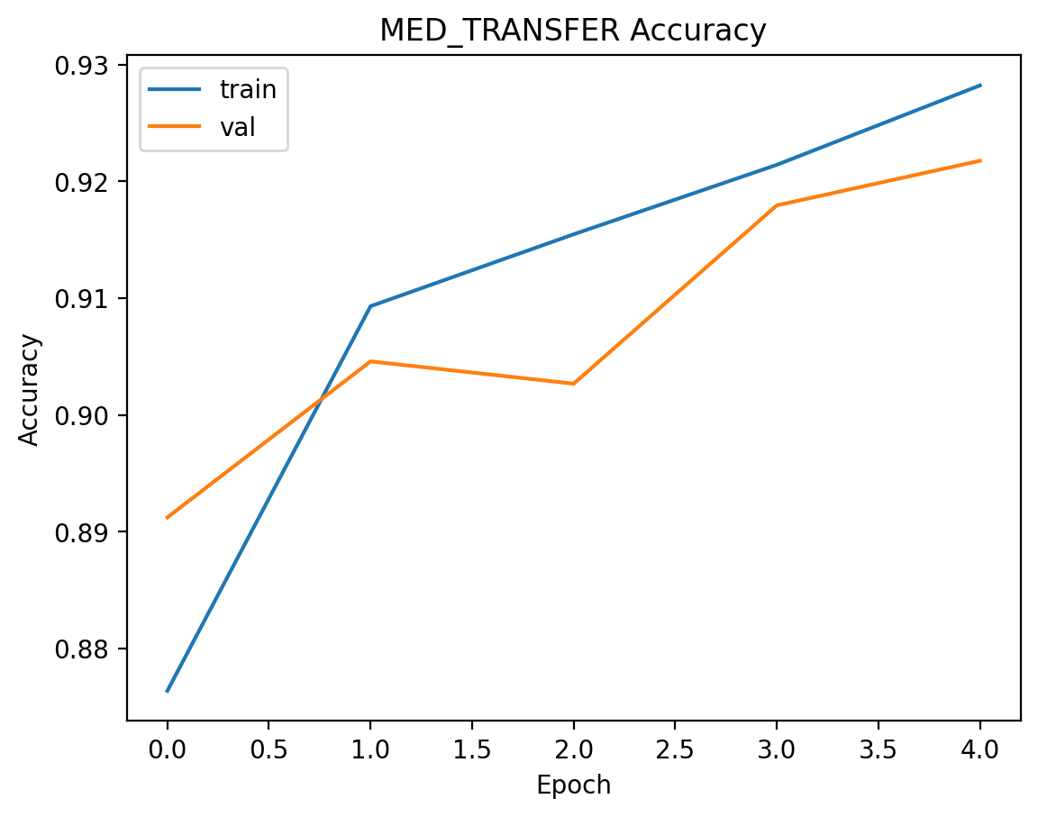
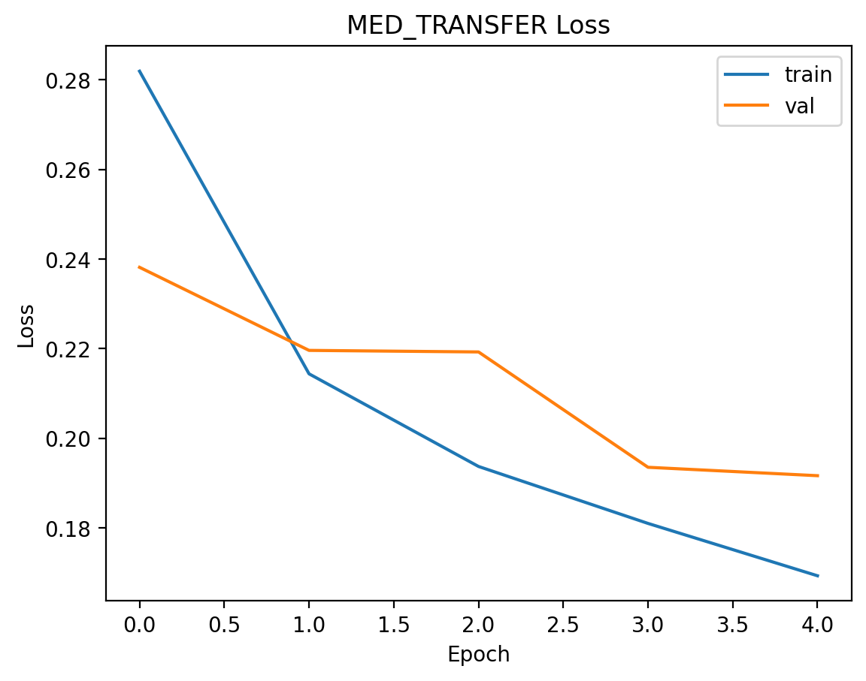

4.2 Sentiment Analysis Results
For sentiment analysis, both LSTM and MLP-style models performed well. The LSTM model captured sequential information and showed strong validation accuracy. The MLP-style model trained faster and achieved competitive results despite its simpler architecture.
Figure 3: Training and validation accuracy for LSTM sentiment model
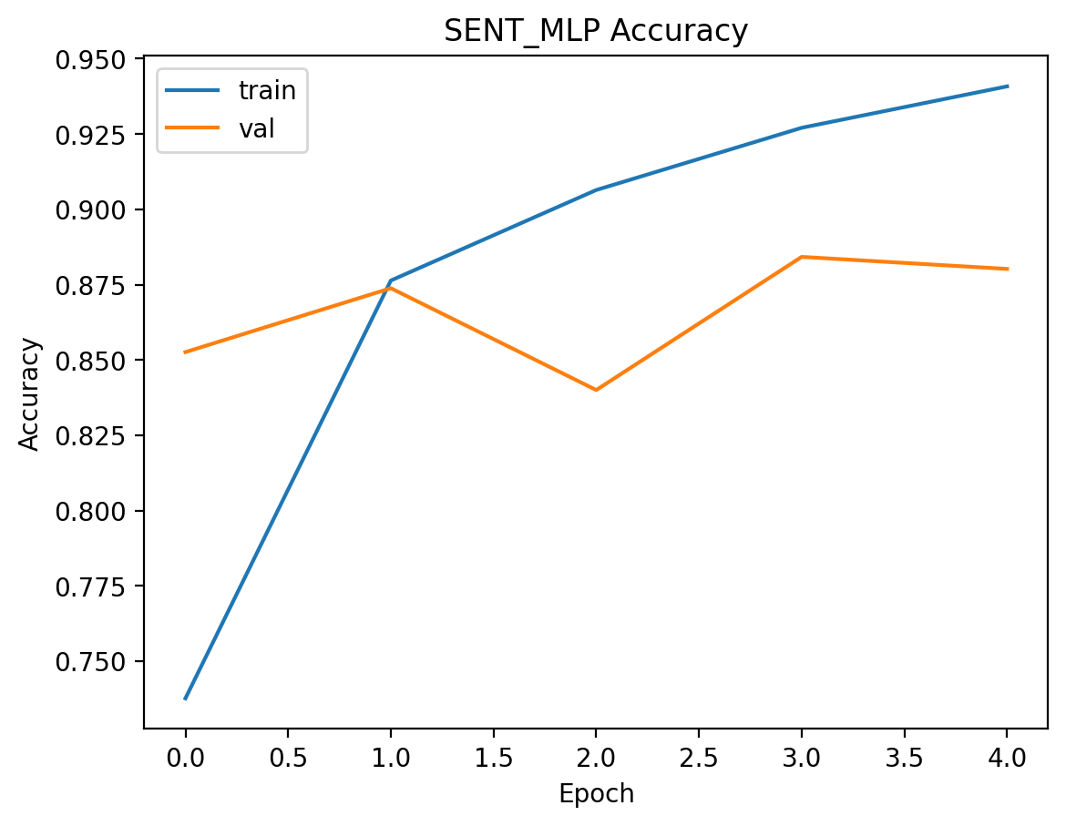

Figure 4: Training and validation accuracy for MLP sentiment model
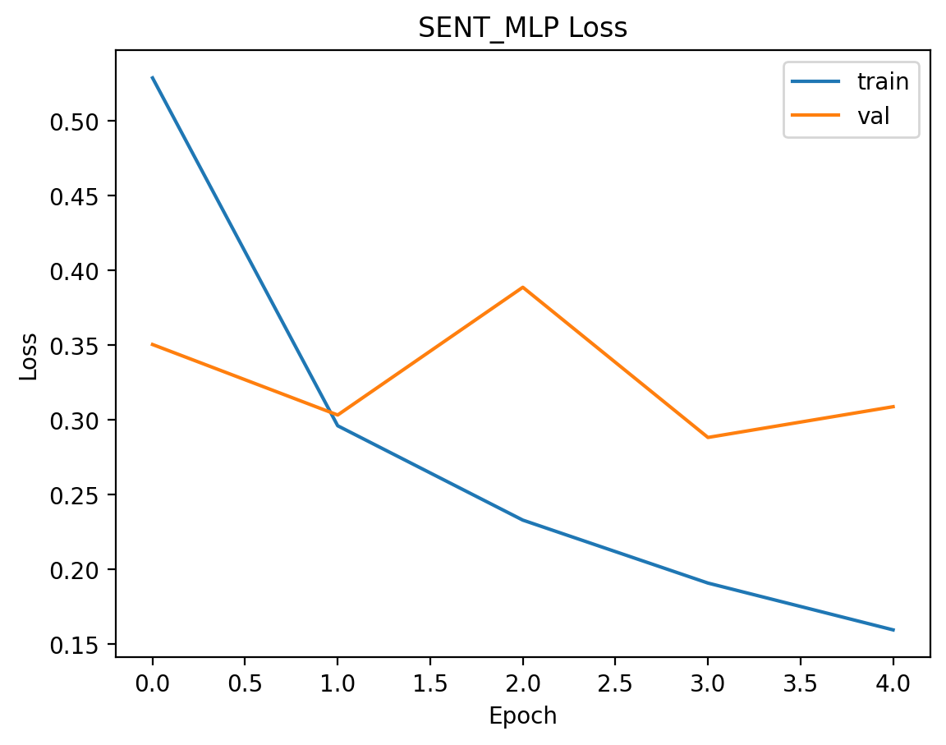
5. Comparison of Models
For the medical task, transfer learning outperformed the custom CNN in terms of validation accuracy and generalization. This demonstrates the advantage of pretrained models when working with limited medical datasets.
For sentiment analysis, the LSTM model was effective in handling sequential text data, while the MLP-style model provided faster training with comparable accuracy. Each model has advantages depending on computational cost and performance requirements.
Figure 5: Accuracy comparison between medical models
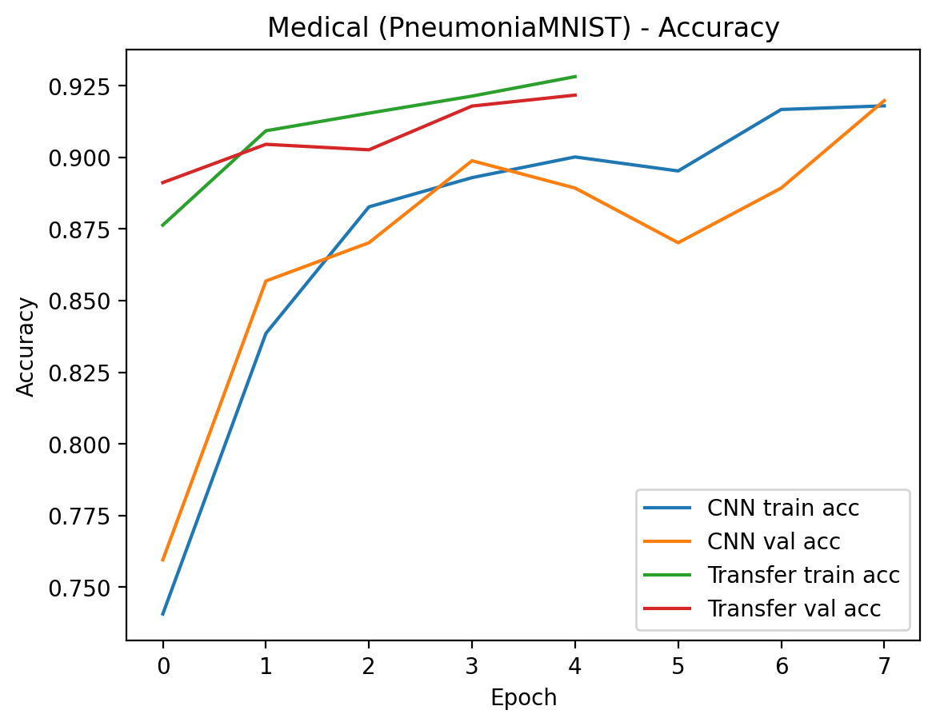
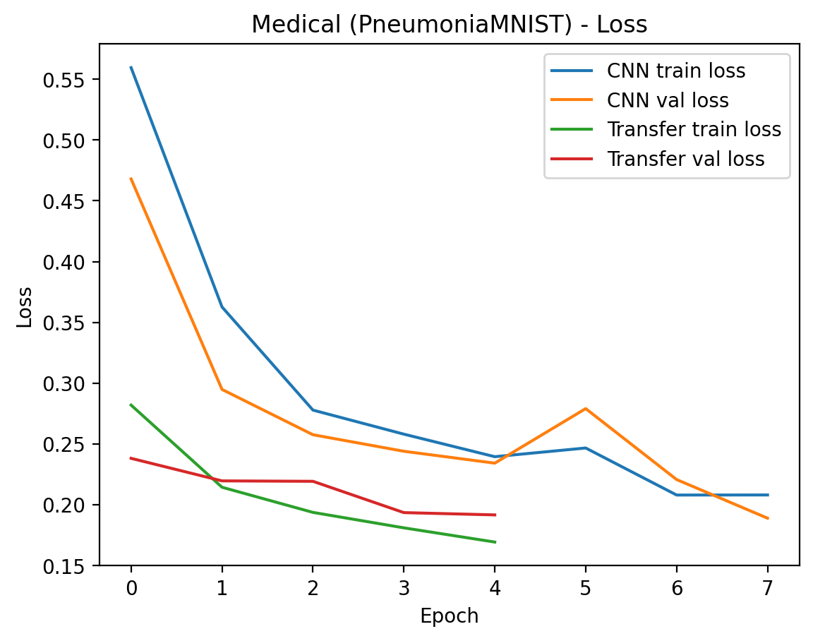
The medical comparison shows that transfer learning achieves higher and more stable validation accuracy compared to the custom CNN. For sentiment analysis, both models perform competitively, with LSTM showing stronger sequence modeling capability.

Figure 6: Accuracy comparison between sentiment models
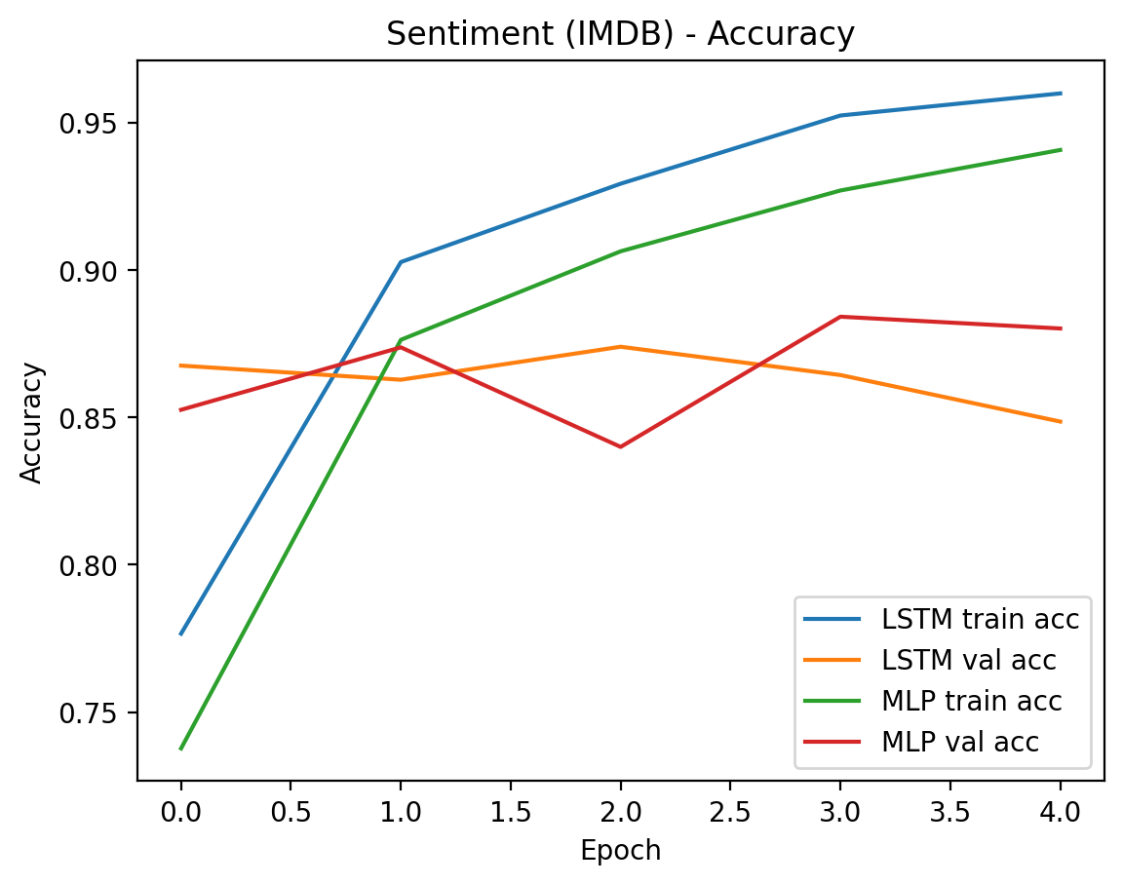

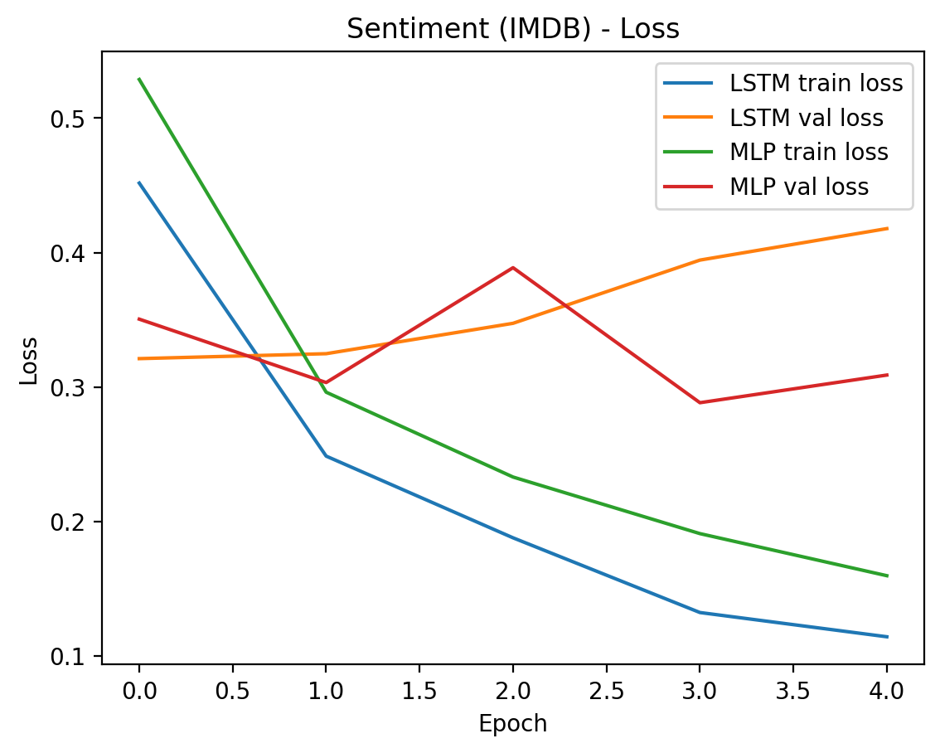
6. Conclusion
This coursework demonstrated the effective use of computational intelligence techniques for both image classification and text sentiment analysis. Implementing multiple neural network architectures allowed meaningful comparison between different approaches.
The results show that transfer learning can significantly improve performance in medical image classification, while different neural network structures can achieve competitive results in sentiment analysis. Proper dataset preparation, validation strategies, and evaluation metrics played a crucial role in achieving reliable and interpretable results.

