- Generalities

The TOPKAPI package
The file TOPKAPI_package.zip contains:
- Software_package: a directory containing the Python installation executable and the Python packages required by the TOPKAPI model, as well as some other useful software utilities.
- TOPKAPI_python_package.exe: the package containing the TOPKAPI program.
- TOPKAPI_Example: a directory containing an example to run the model.

Conditions of use of the TOPKAPI package
The use of the TOPKAPI package is free, however it is the property of the developers of the model: Théo Vischel, Geoff Pegram, Scott Sinclair. Under this condition:
  - Users are required to inform the authors about their use and application of the TOPKAPI package.
  - The developers must be associated as co-authors with any publications that would use the codes of the TOPKAPI package.
Comments and proposition of improvements of the model are welcomed, as well as students and researchers who would like to join the developer team!

Objective of the manual
This manual is aiming at giving to the future users of TOPKAPI the keys to handle the TOPKAPI package. It is not a description of the theoretical aspects of the TOPKAPI model, nor a detailed description of the modelling methodology, although some methodological aspects are addressed in the manual. For an all-comprehensive description of the theory and methodology associated with the TOPKAPI model, readers will refer to the following references: Liu and Todini (2002); Pegram et al. (2007); Vischel et al. (2007a) and Vischel et al. (2007b, submitted to Water SA).
There are three main steps in the use of the TOPKAPI model. The first step is the creation of the parameter files of the models according mainly to the catchment data, as well as the creation of the forcing variables (rain and reference crop evapotranspiration fields). The second step is to simply run the model with the created inputs. The third step is the analysis of the simulations by plotting graphics.
Nota Bene
- The extraction of catchment data (mainly by using GIS) as well as the creation of forcing fields is left to the initiative of the users who are assumed to make use of their own expertise, software and numerical tools to do it.
- Numerically speaking, efforts have been made by the developers in coding and organising properly the TOPKAPI model itself, so that is can be easily run once the parameter files are created.
- Scientifically speaking, it is clear that the most crucial step is the creation of the parameter files, and particularly the way they are used to link the data available on the catchment, to the effective physical parameters required by TOPKAPI. This step requires knowledge of hydrology and must be conducted under the expertise of the user. However, in order to facilitate the process of using TOPKAPI, a module called parameter_utils was included in the TOPKAPI package. This module is only a suggestion from the developers to help future users in the creation of the parameter files starting from the catchment data. However, since this module was created for the specific case study on the Liebenbergsvlei catchment (4625 km², South Africa) using the personal choices of the developers, it is to be used with care and requires from the user to carefully read and sometimes modify the Python codes if different applications or scientific choices would have to be made.
- The analysis of the results of the TOPKAPI model is reduced to a simple analysis of the simulations, so that the user can rapidly evaluate the quality of the run.

Overview of the manual
The manual is organised as follows. The second section describes the installation of the model. In the third section are described the TOPKAPI Python package and the example of application used for the tutorial that is presented in Sections 4, 5 & 6. This tutorial mainly explains how to (i) run the model, (ii) analyse the simulation results and (iii) create and modify the parameter files.

- Installation of the TOPKAPI model
TOPKAPI was coded in the Python programming language. Python is a package of free software (see http://www.python.org for detailed information) that was chosen, primarily since it is suited to the management of large data arrays and because it can be extended and interfaced with many other existing languages (FORTRAN, C, C++, etc.).
The minimal version of Python to be used for installing the TOPKAPI_python_package is Python 2.5. The following packages are required: Numpy (at least version 1.0.3), Scipy (at least version 0.5.2), Tables (at least version 2.0), Matplotlib (at least version 0.90.1)
For a convenient command shell the authors recommend the use of IPython (at least version 0.8.1) that requires pyreadline (at least version 1.4.4).
Python and required package executables are available in the directory software_package and must be installed in the following order:
- For Python:
Execute (double click) python-2.5.1.msi
- For the required packages:
Execute (double click) numpy-1.0.3.win32-py2.5.exe
Execute scipy-0.5.2.win32-py2.5.exe
Execute tables-2.0.win32-py2.5.exe
Execute matplotlib-0.90.1.win32-py2.5.exe
Execute TOPKAPI_python_package.exe
- For the IPython command shell
Execute pyreadline-1.4.4.win32.exe
Execute ipython-0.8.1.win32.exe
Some specific formats called HDF5 formats are used in the TOPKAPI package for their convenience in compressing and archiving the data (see http://hdf.ncsa.uiuc.edu/products/hdf5/index.html for more information). Several programs exist to navigate into the HDF5 files through user-friendly interfaces.
- The authors recommend the use of HDF_Explorer, which is provided in the Software_package and can be installed by:
Executing HDF_ExploreSetup.exe.

- Description of the model and the example

  - Description of the example
The example consists of a simulation of 42 days (lasting from 23/02/2000 to 05/04/2000) over a sub-catchment (3563 km², see Figure 1) of the Liebenbergsvlei catchment. The simulations will be achieved at a 6-hour time-step at a spatial resolution of 1 km.
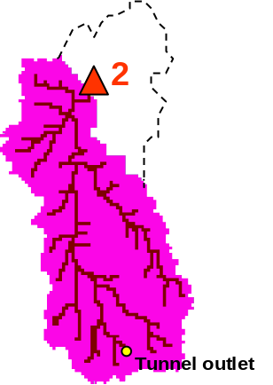
Figure 1. The Liebenbergsvlei catchment and the simulated sub-catchment in pink delimited by the flow station 2 on the picture.

- Running the model

Input data
In the directory TOPKAPI_Example/ is a directory called run_the_model/ that contains one file (TOPKAPI.ini) and two sub-directories (forcing_variables/ and parameter_files/).
- In the directory forcing_variables/ are 3 files:
  - rainfield.h5 and ET.h5: these two files are respectively the rain fields and the evapotranspiration fields. The files are compressed binary files in a HDF5 format. The file structure can be easily seen (Figure 2) with the interface software HDF_Explorer provided in the directory Software_package. The file rainfields.h5 and ET.h5 are both composed of 1 group called sample_event. For the file rainfields.h5 the group contains one table called rainfall. For the file ET.h5 the group contains two tables called ETr and ETo, being respectively the reference crop evapotranspiration and the free surface reference evapotranspiration. In the tables rainfall, ETr and ETo the columns are the cells and the lines are the time steps.
  - external_lesotho_flows.dat: this file contains the external flows coming from Lesotho via the inter-basin transfer tunnel whose outlet is located at the Southern part of the catchment (see Figure 1). It is a simple 6 columns format in an ASCII format file containing the date (year, month, day, hour, minute) and the discharge at the outlet of the tunnel in m³/s (Figure 3).
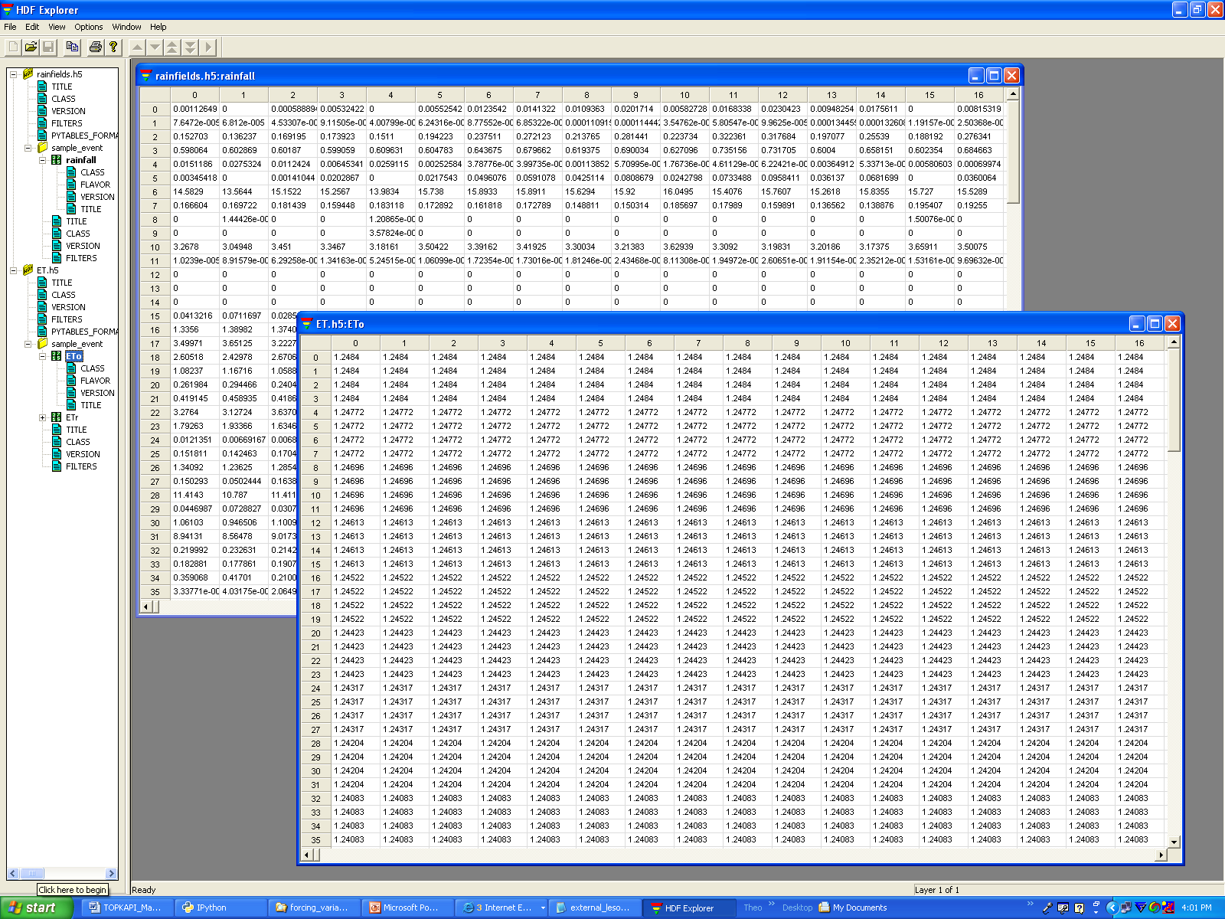
Figure 2. Forcing variable file rainfields.h5 and ET.h5 visualized with the software HDF_Explorer.

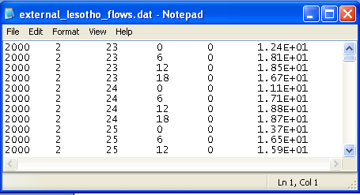
Figure 3. File external_lesotho_flows.dat : a simple column ASCII format containing the external flows coming in the catchment from the Lesotho by a tunnel.

- The directory parameter_files/ contains the two parameter files required by the TOPKAPI model:
  - global_param.dat: it is an ASCII file containing all the parameters that are constant in the model. In the first line are the names of the variables. The values of the variables are reported in the second line (Figure 4).
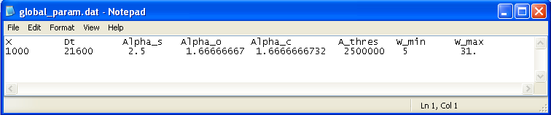
Figure 4. File global_param.dat: an ASCII file containing all the parameters that are constant in the model.
From left to right in the file the reported parameters are:
  - X is the lateral dimension of the grid-cell (in m).
  - Δt is the time step of the model (in s)
  - 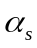 is a dimensionless pore-size distribution parameter (Brooks and Corey, 1964)
  - 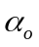 and 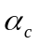 are the well known power coefficient equal to 5/3 originating from Manning’s equation.
  - A_{threshold} is the area over which a cell is considered to initiate a river channel (in m²)
  - W_{min} is the minimum width of channel (in m)
  - W_{max} is the maximum width of channel (in m)

  - cell_param.dat: it is an ASCII file containing all the parameters that are spatially variable in the model. It is composed of 17 columns corresponding to 17 parameters (see Figure 5). Each line is a catchment cell, thus for our example (catchment area of 3563 km² at a resolution of 1km²) the file is composed of 3563 lines.

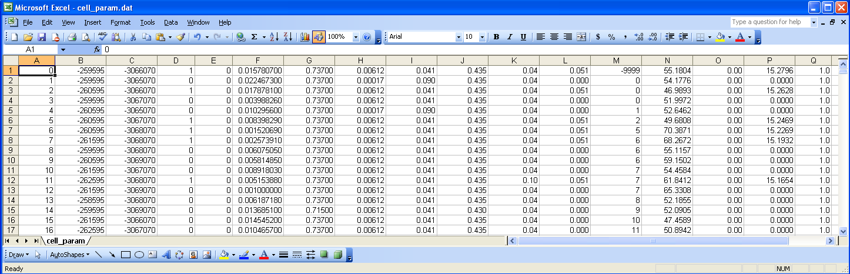
Figure 5. File cell_param.dat: an ASCII file containing all the parameters that are spatially variable in the model.

From left to right in the file the parameters are (note that the parameters are not labelled inside the file, but we identify them here by their column labels in the Excel list in Figure 5):
- cell_label an integer labelling the cell
- coorx the longitude of the centre of the cell (in UTM)
- coory the latitude of the centre of the cell (in UTM)
- λ 1 if the cell is a channel cell, 0 otherwise.
- Dam 1 if the cell is a dam cell, 0 otherwise. (This option is not yet available in the model, but space is open for further developments)
- 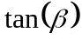 the tangent of the ground slope angle 
- the soil depth (in m)
- 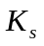 the saturated hydraulic conductivity
- 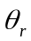 the residual soil moisture content
- 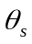 the saturated soil moisture content
- 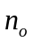 the Manning’s roughness coefficient for overland flows
- 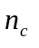 the Manning’s roughness coefficient for the channel flows
- cell_down the label of the cell down.
- pVs_t0 the initial saturation of the soil reservoir (in %)
- Vo_t0 the initial water content of the overland reservoir (in m³)
- Qc_t0 the initial discharge in the channel (in m³/s)
- k_{c} the crop coefficient

- TOPKAPI.ini (in the directory run_the_model) is the input file (text file) required to run the model.
It contains 6 main labels ([input_files], [output_files], [groups], [external_flow], [numerical_options] and [calib_params], see Figure 6).
In [input_files] are reported all the parameter and forcing files required by the model (labelled as file_global_param, file_cell_param, file_rain, file_ET).
In [output_files] is reported file_out an HDF format file in which will be written the simulation results.
In [groups] is reported the name of the group considered in the forcing HDF files.
In [external_flow] are reported: a Boolean parameter called external_flow, which is True when external flows are coming into the catchment, False otherwise; the coordinates Xexternal_flow and Yexternal_flow of the point where the flows come in; file_Qexternal_flow the file containing the discharge series of external flows.
In [numerical_options] are reported three variable solve_s, solve_o, solve_c, which take the value 1 to solve the ODE of respectively the soil, overland and channel reservoir by using a combination between the Quasi Analytical Solution and the Runge Kutta Fehlberg methods, the value 0 is set when only the Runge Kutta Felhberg method is to be used.
In [calib_params] are reported the four multiplying factors fac_L, fac_Ks, fac_n_o and fac_n_c that are applied on the a priori estimated parameters L, Ks, n_o and n_c. The factors proposed in the example come from the calibration procedure realized on the Liebenbergsvlei catchment.

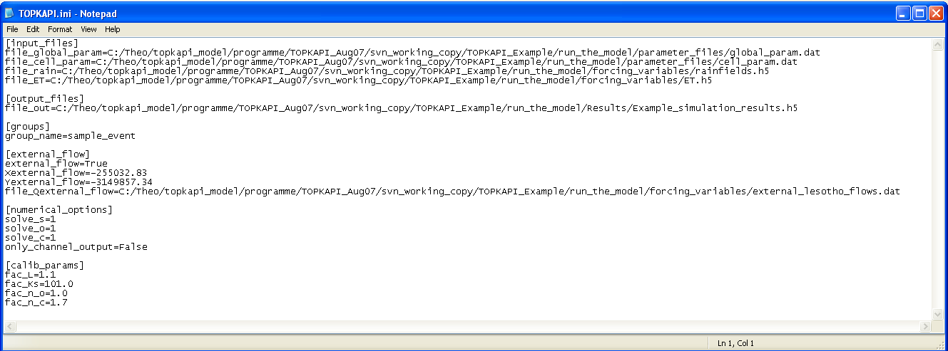
Figure 6. TOPKAPI.ini is the input file (text file) required to run the model.
Tutorial
Open the directory TOPKAPI_Example/. It contains three sub-directories that correspond to the three steps of the process presented in the introduction (create_the_parameter_files, run_the_model and analyse_the_results). In addition there is a small file called run_example.py which is a Python command file, designed to run the tutorial in one action. The following discussion takes the reader step-by-step through the process to provide a better idea of the structure of the processes.

Open a Python shell
Open a command shell for Python.
If you installed IPython on Windows then click on Start→All programs→ IPython.

Run the model
Type the following commands in the Python Shell (the shell commands are hereafter highlighted in grey).
Import the package TOPKAPI
In [1]: import TOPKAPI
A list of warnings is written on the shell. Don’t worry this is normal and will be fixed with the new versions of the Python package scipy.
In the Python shell, navigate to the TOPKAPI_Example directory by copying the address in the Windows folder. Typically this can be achieved using the ‘cd’ command:
In [2]: cd C:\ … \TOPKAPI_Example
Then run the model by typing (or copying without a leading space):
ln [3]: TOPKAPI.model.run(‘run_the_model/TOPKAPI.ini’)
The simulation starts and will last around 3 to 5 minutes depending on your machine. Some comments are written and the number of time steps (to 169 of 6 hours each) scrolls followed by ‘***** THE END *****’. Leave the iPython window open - we will use it shortly.

At the end of the simulation, a folder results/ should have been created in the run_the_model folder, containing an HDF5 file called Example_simulation_results.h5; to open it you will have to associate the file (if it’s the first *.h5 file you’ve opened) with HDF_Explorer. This file is composed of three groups: Channel, Overland and Soil. The group Channel contains the table Qc_out that is the channel flow of each cell (in m³/s) [to view a file’s content, double click on the little green square under the yellow label in the left panel of the window - see Figure 7.] The group Overland contains the table V_o that is the volume of the overland reservoir (in m³). The group Soil contains the table V_s that is the volume of the soil reservoir (in m³). For the three tables Qc_out, V_o and V_s, the 3563 columns are the cells and the 170 rows are the time steps.
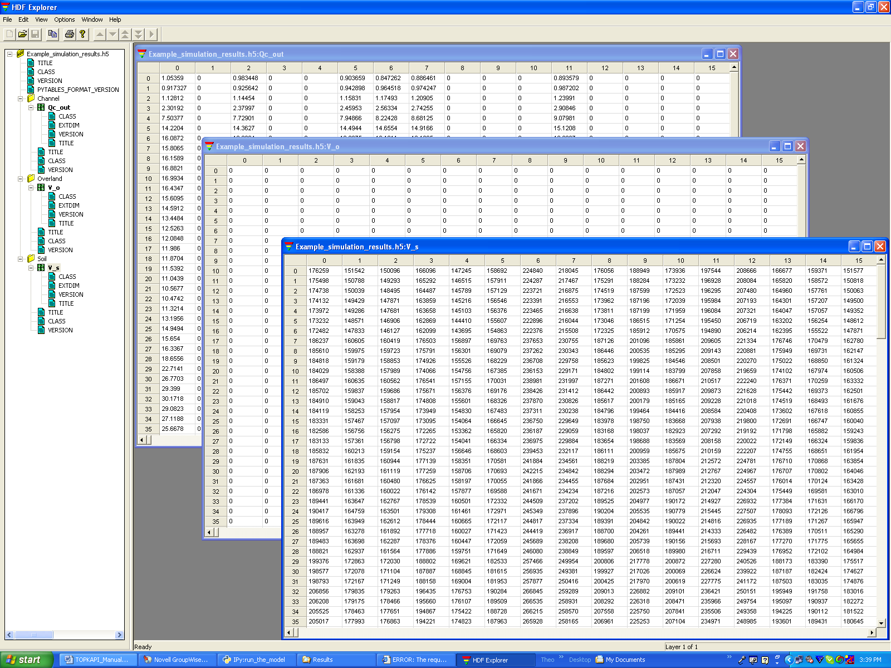
Figure 7. File Example_simulation_results.h5 in which are written the simulation results.

- Analysing the simulations

The analysis of the simulations consist of two simple modules that allow the user to (i) plot the rainfall-runoff graphic (simulated and observed discharge and rainfall on the same graph), module called plot_Qsim_Qobs_Rain and (ii) plot maps of soil moisture over the catchment, module called plot_soil_moisture_maps.

  - Plot of the rainfall runoff graphic
The directory TOPKAPI_Example/ contains a directory called analyse_the_results/.
In analyse_the_results/ the results are three files amongst them plot_Qsim_Qobs_Rain.ini and C8H020_6h_Obs_Example.dat.
  - C8H020_6h_Obs_Example.dat is an ASCII file in a column format containing the date and the value of discharge (in m³/s) at the flow station at the outlet of the simulated catchment (station labelled 2 in Figure 1).
  - plot_Qsim_Qobs_Rain.ini is the input file to the module plot_Qsim_Qobs_Rain. As reported on Figure 8, it contains three items [files], [groups] and [flags]. In [files] are reported all the input files required by the program as well as the output file which must be ended by a typical picture format (*.png, *.jpg,…). In [groups] is reported the name of the group to look in the result of simulation file. With [flags] are associated three Boolean that correspond to different options in the graphic: Qobs must be True to plot the observed discharges, Pobs must be True to plot the observed rainfall and nash must be True to write on the graph the Nash efficiency comparing observed and simulated discharges.

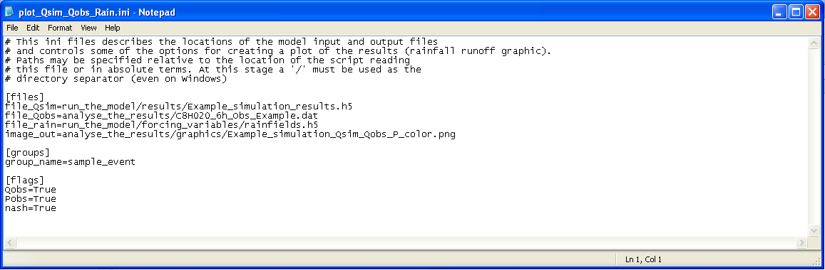
Figure 8. File plot_Qsim_Qobs_Rain.ini, input file to the module plot_Qsim_Qobs_Rain.

Tutorial
In the Python shell, import the module plot_Qsim_Qobs_Rain by typing (>>> stands for the line prompt seen as ‘ln [n]’:
ln [4]: from TOPKAPI.results_analysis import plot_Qsim_Qobs_Rain
Create a plot of the simulated and observed discharge records by typing:
ln [5]: plot_Qsim_Qobs_Rain.run('analyse_the_results/plot_Qsim_Qobs_Rain.ini')
This should create an image file called Example_simulation_Qsim_Qobs_P_color.png (Figure 9) in the directory TOPKAPI_Example/analyse_the_results/graphics.
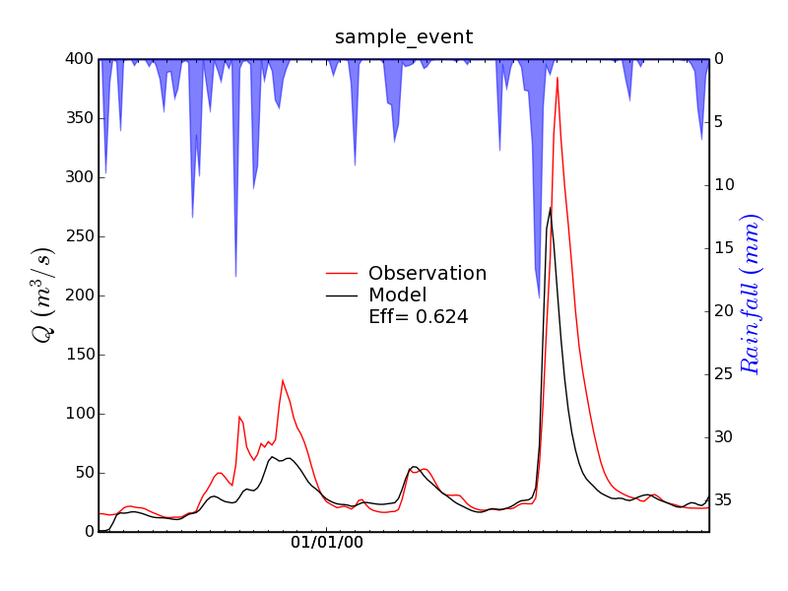
Figure 9. The image file Example_simulation_Qsim_Qobs_P_color.png.

  - Plot of the soil moisture maps
In the directory TOPKAPI_Example/analyse_the_results., the last of three files is plot_soil_moisture_maps.ini. As reported on Figure 10, it contains three items [files], [paths] [calib_params] and [flags].
[files] contains all the input files required by the program meaning the two parameter files of the TOPKAPI model (cell and global), and the result of simulation file.
In [paths] is reported the path in which the maps will be saved. In [calib_params] are reported the four multiplying factors fac_L, fac_Ks, fac_n_o and fac_n_c that were applied in the TOPKAPI simulation (see Section 2.1).
In [flags] are reported several variables required by the program: the maps will be plotted from the time step t1 to the time step t2, the first time step at the beginning of the simulation being 0. Four choices (1,2,3 or 4) are available for the variable called variable which determines which variable is to be plotted among (1) the soil moisture content i.e. the volume of the soil reservoir in m³, (2) the water content of the overland i.e. the volume of the overland reservoir in m³, (3) the saturation binary index which is 1 for the saturated cells, 0 otherwise, (4) the soil water index i.e. the saturation rate of the cell in %.

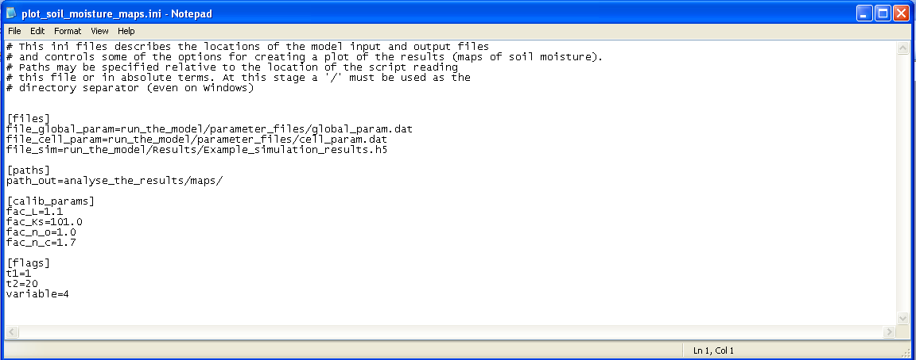
Figure 10. File plot_Qsim_Qobs_Rain.ini, input file to the module plot_Qsim_Qobs_Rain.

Tutorial
In the Python shell, import the module plot_soil_moisture_maps by typing:
ln [6]: from TOPKAPI.results_analysis import plot_soil_moisture_maps
Create a plot of soil moisture maps by typing:
ln [7]: plot_soil_moisture_maps.run('analyse_the_results/plot_soil_moisture_maps.ini')
This should create 20 pictures called field_SWI_0001.png,…, field_SWI_0020.png in the directory TOPKAPI_Example/analyse_the_results/maps. One of them is plotted on Figure 11.

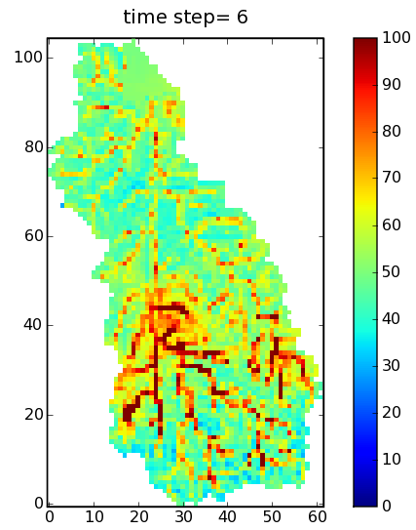
Figure 11. One of the 20 soil moisture maps (here the Soil Water Index is plotted) as a result of the program plot_soil_moisture_maps.

Nota Bene
Alternatively the entire process (from running the model to analysing the results) can be produced by running the script contained in the file run_example.py located in TOPKAPI_Example/.
ln [0]: python run_example.py

- Creation and modification of the parameter files
References

Liu Z. and Todini E., 2002. Towards a comprehensive physically-based rainfall-runoff model, Hydrol. Earth Syst. Sci., 6(5), 859 – 881.
Pegram G.G.S., Nxumalo N. and Sinclair S., 2006. Soil Moisture Mapping from Satellites. Report K8/598 on a consultancy to the Water Research Commission, Pretoria
Vischel T., Pegram G.G.S., Sinclair S.,. Wagner W, and Bartsch A., 2007a. Comparison of soil moisture fields estimated by catchment modelling and remote sensing: a case study in South Africa. Hydrol. Earth Syst. Sci. Discuss., 4, 2273-2306.
Vischel T., Pegram G. G. S., Sinclair S., Parak M, 2007b. Implementation of the TOPKAPI model in South Africa. First results on the Liebenbergsvlei catchment. Submitted to Water SA.

