Standard inconsistencies

* 12 shows only once due to no input from second midterm (-1)
* 18 shows only once due to no input from second midterm (-1)
  + Also, no input from quiz, not mastered there though
* 19 does not show any due to the bonus attempt not counting from problem set 9 (-0)
* 23 shows none due to no input from problem set 11 (-1)
* 24 shows none due to no input from problem set 11 (-1)

Standards to do on final exam:

* 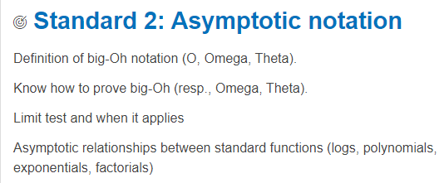
  + Problem Set 2 (Q1, Q2)
  + Quiz 2 (Q1)
  + Midterm 1 (Q2)
* 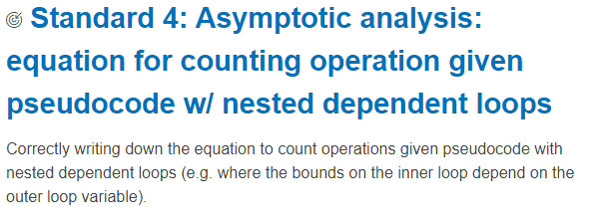
  + Problem Set 2 (Q3b, c)
  + Quiz 2 (Q3)
  + Midterm 1 (Q4)
* 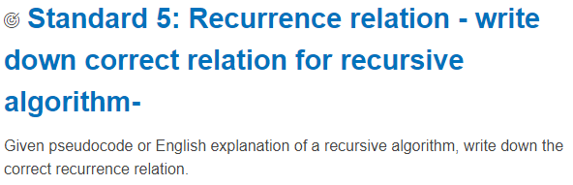
  + Problem Set 3 (Q2a, Q2b, Q3)
  + Quiz 3 (Q1)
  + Midterm 1 (Q5)
* 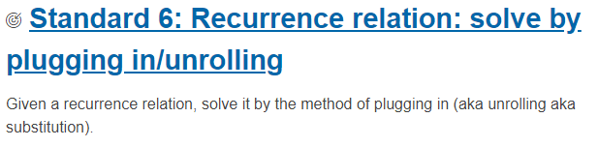
  + Problem Set 3 (Q1a, Q1b, Q3)
  + Quiz 3 (Q2), Requiz (S6)
  + Midterm 1 (Q6)
* 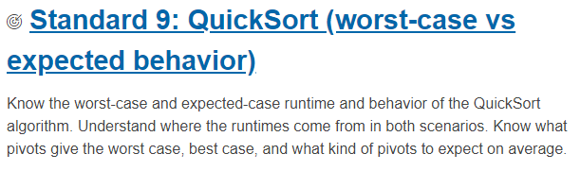
* Problem Set 4 (Q2, Q3)
* Quiz 4 (Q1) Requiz (S9)
* Midterm 1 (Q9)
* 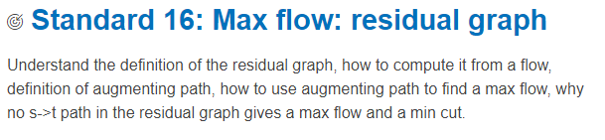
  + Problem Set 8 (Q1)
  + Quiz 8 (Standard 16)
  + Midterm 2 (S16)
* 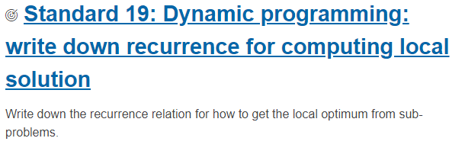
  + Problem Set 9 (Q2)
  + Quiz 9 (S19)
  + Midterm 2 (S19)
* 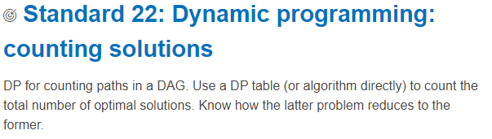
  + Problem Set 10 (Q2)
  + Quiz 10 (Standard 22)