Contents
Introduction 1
Objectives 1
Scope 1
1. Task 1 — Custom Decoders & Rules 2
1.1. LabShop Application Log Preparation 2
1.2. Wazuh Agent Log Collection Configuration 3
1.3. Custom LabShop Decoder Implementation 3
1.4. Custom Failed Login Detection Rule 4
1.4.1. Initial Rule Verification 5
1.5. Brute-Force Correlation Rule 7
1.6. Rule Validation and Testing 7
Detection Testing Results 8
1.7. Live Detection Verification in Wazuh Dashboard 8
1.7.1. Failed Login Detection — Level 5 8
1.7.2. Brute-Force Detection — Level 12 9
1.8. Task 1 Summary 10
2. Task 2 — File Integrity Monitoring (FIM) 11
2.1. Linux Real-Time FIM Configuration 11
2.2. Linux File Creation and Deleting Testing 11
2.3. Linux File Modification and Content Difference Verification 12
2.4. Linux Scheduled FIM Testing 12
2.5. Windows Real-Time FIM Configuration 14
2.6. Windows File Integrity Testing 14
2.6.1. File Creation Detection 14
2.6.2. File Modification Detection 15
2.6.3. File Deletion Detection 15
2.7. Windows Registry Monitoring 16
2.7.1. Registry Modification Detection 16
2.8. Task 2 Summary 17
3. Task 3 — Suricata IDS Integration 18
3.1. Suricata Installation and Network Preparation 18
3.2. Custom HTTP Detection Rule 18
3.3. Suricata IDS Detection Verification 19
3.4. Suricata Integration with Wazuh 20
3.5. Custom Wazuh Severity Escalation Rule 21
3.5.1. Live Severity Escalation Verification 22
3.6. Resource Verification and Network Cleanup 23
3.7. Task 3 Summary 23
4. Task 4 — Security Configuration Assessment & Vulnerability Assessment 24
4.1. Security Configuration Assessment (SCA) 24
Ubuntu Web Server — Initial Assessment 24
4.2. Ubuntu Security Hardening 25
Hardening Implementation 25
4.3. Risk Acceptance 26
4.4. Windows 10 Security Configuration Assessment 27
4.5. Vulnerability Assessment 27
4.5.1. Windows 10 Vulnerability Assessment 27
4.5.2. Ubuntu Web Vulnerability Assessment 28
4.6. Task 4 Summary 29

Introduction
Week 2 of the Mini-SOC in a Box project focuses on extending the security monitoring capabilities established during Week 1. The existing Wazuh infrastructure is used to implement more advanced detection, monitoring, and security assessment capabilities across the Linux and Windows endpoints.
This phase introduces custom application log decoding, authentication attack correlation, File Integrity Monitoring (FIM), network intrusion detection using Suricata, and endpoint security configuration assessments.
All activities are performed within the isolated PNETLab laboratory environment using Wazuh 4.14.8 deployed through Docker.

Objectives
The primary objectives of Week 2 are:
- Implement custom Wazuh decoders and detection rules for LabShop application authentication events.
- Detect brute-force authentication attempts using event correlation, source IP matching, and MITRE ATT&CK mapping.
- Configure and validate File Integrity Monitoring on Linux and Windows endpoints.
- Integrate Suricata IDS alerts into Wazuh for centralized network threat detection.
- Evaluate endpoint security posture using Wazuh Security Configuration Assessment (SCA) and vulnerability information.
- Validate detection accuracy through controlled security tests and document the observed results.

Scope
Week 2 builds upon the existing three-node Mini-SOC infrastructure deployed during Week 1.
Component | IP Address | Role
siem-host | 10.10.10.10 | Wazuh Manager, Indexer, and Dashboard
ubuntu-web | 10.10.10.30 | Application Logging, FIM, and Suricata
win-client | 10.10.10.20 | Windows FIM, Registry Monitoring, and Security Assessment
The scope includes custom detection engineering, endpoint file and registry monitoring, network intrusion detection, security configuration assessment, and validation of generated alerts through the Wazuh Dashboard.
All testing is conducted within the authorized laboratory network. The existing infrastructure is retained, and configuration changes are documented to support reproducibility and future recovery.

1. Task 1 — Custom Decoders & Rules

1.1. LabShop Application Log Preparation
The first task of Week 2 focused on implementing custom application log monitoring and authentication attack detection in Wazuh.
A Bash script named labshop_gen.sh was created on the Ubuntu web endpoint to simulate authentication events for the LabShop application.
The script generates LOGIN_FAILED and LOGIN_OK events and writes them to the following log file:
/var/log/labshop/app.log Example command ~/labshop_gen.sh fail admin 10.10.10.50 1
The generated logs contain the timestamp, hostname, application name, authentication action, username, and source IP address.
The output was verified by examining the application log file.
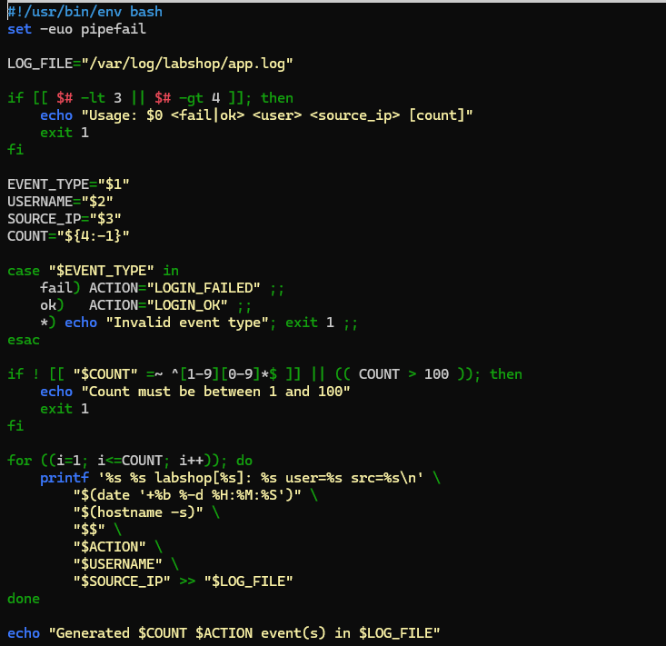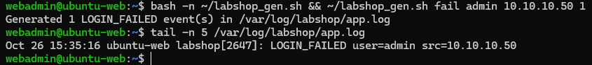
Figure 1. Creation and Verification of the LabShop Authentication Log Generator on the Ubuntu Web Endpoint.

1.2. Wazuh Agent Log Collection Configuration
The Wazuh Agent installed on ubuntu-web was configured to collect authentication events from the LabShop application.
Configuration file: /var/ossec/etc/ossec.conf
A new <localfile> configuration entry was added with the following parameters:
- Log location: /var/log/labshop/app.log
- Log format: syslog
This configuration allows the Wazuh Agent to monitor the application log and forward the collected events to the Wazuh Manager for analysis.
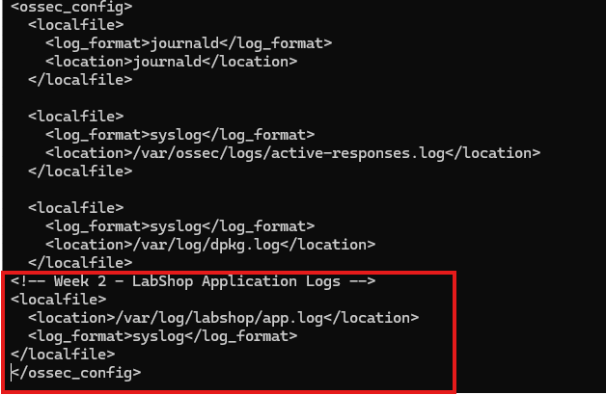
Figure 2. Configuration of LabShop Application Log Collection in the Ubuntu Wazuh Agent.

1.3. Custom LabShop Decoder Implementation
A custom decoder was created to extract authentication information from the LabShop application logs.
Decoder file: labshop_decoder.xml The decoder uses a parent-child structure.
The parent decoder identifies events originating from the labshop application, while the child decoder uses a PCRE2 regular expression to extract the authentication action, username, and source IP address.
Field | Example Value
action | LOGIN_FAILED
dstuser | admin
srcip | 10.10.10.50
The decoder configuration was stored in the Wazuh Manager's custom decoder directory:
/var/ossec/etc/decoders/
Figure 3. Custom Parent and Child Decoder Configuration for LabShop Authentication Events.
The decoder was tested using the Wazuh Logtest utility. The results confirmed that the authentication fields were successfully extracted from the raw application logs.
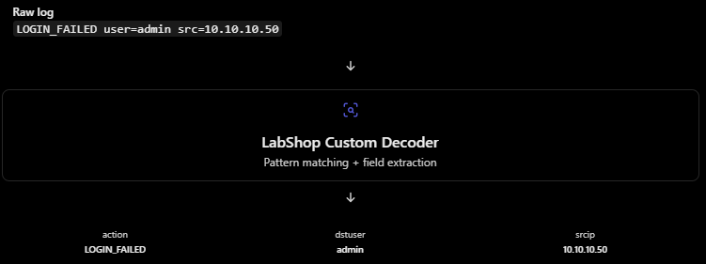
Figure 4. Successful Extraction of Authentication Action, Username, and Source IP Using the LabShop Custom Decoder.

1.4. Custom Failed Login Detection Rule
The first custom detection rule was implemented to identify individual failed authentication attempts.
Rule configuration:
Parameter | Value
Rule ID | 100100
Severity Level | 5
Decoder | labshop
Detection Condition | LOGIN_FAILED
Excluded Account | monitor
The rule generates a Level 5 alert whenever a failed authentication attempt is detected.
The monitor account was excluded to prevent expected monitoring activity from generating unnecessary custom authentication alerts.
The rule was added to the custom rules file: labshop_rules.xml
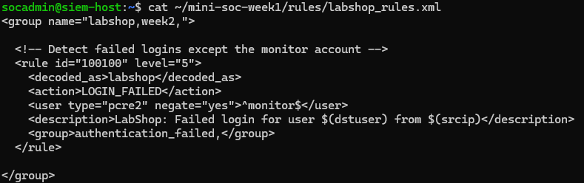
Figure 5. Custom Wazuh Rule 100100 for Failed Login Detection with Monitoring Account Exclusion.

1.4.1. Initial Rule Verification
The rule was tested using Wazuh Logtest with failed authentication, monitoring account, and successful authentication events.
The results confirmed the following:
- An admin failed login triggered Rule 100100, Level 5.
- A monitor failed login did not trigger the custom rule.
- A successful LOGIN_OK event did not generate a failed-login alert.
The monitoring event was handled by the generic Wazuh Rule 1002, Level 2, rather than the custom authentication rule.
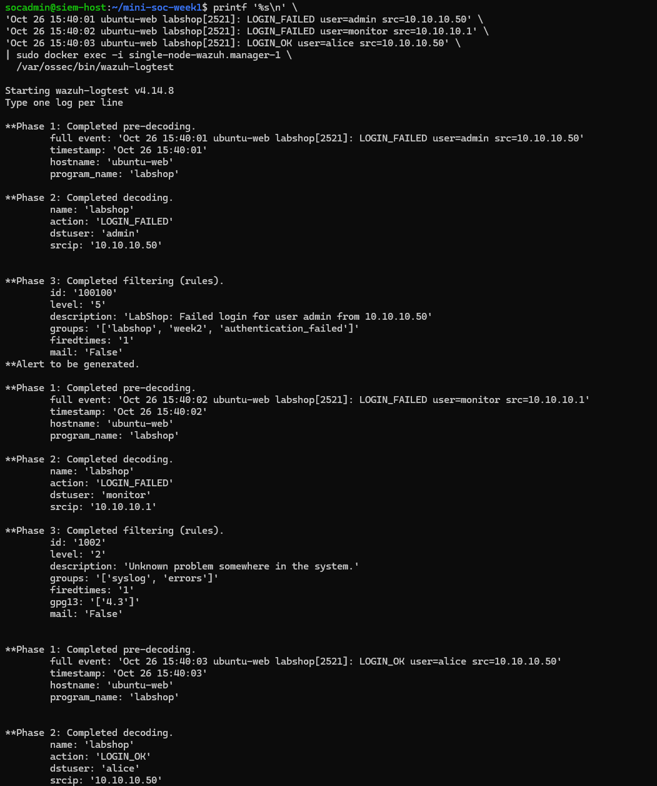
Figure 6. Validation of Failed Login Detection and Monitoring Account Exclusion Using Wazuh Logtest.

1.5. Brute-Force Correlation Rule
A second custom rule was created to identify repeated failed authentication attempts from the same source IP address.
Rule configuration:
Parameter | Value
Rule ID | 100101
Severity Level | 12
Parent Rule | 100100
Frequency | 5
Timeframe | 60 seconds
Correlation | Same Source IP
MITRE ATT&CK | T1110 — Brute Force
The rule uses the if_matched_sid condition to correlate events previously detected by Rule 100100.
The same_srcip condition ensures that failed login attempts from different IP addresses are counted separately.
When five matching authentication failures occur from the same source IP within 60 seconds, Wazuh generates a Level 12 brute-force alert.
The detection was mapped to the MITRE ATT&CK Credential Access tactic.
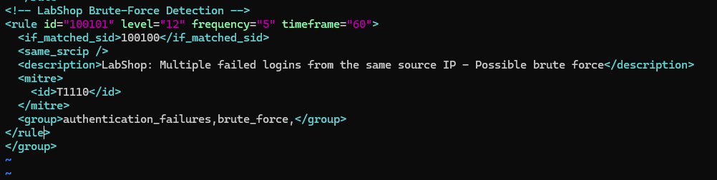
Figure 7. Custom Wazuh Brute-Force Correlation Rule 100101 with Five Failed Logins Within 60 Seconds.

1.6. Rule Validation and Testing
Both detection rules were validated using Wazuh's analysis engine before activating them in the live environment.
Validation command: sudo docker exec single-node-wazuh.manager-1 /var/ossec/bin/wazuh-analysisd -t
The configuration validation completed successfully with exit code 0.

Detection Testing Results
Test Scenario | Expected Result | Actual Result | Status
Single failed login | Level 5 alert | Rule 100100 | PASS
Six failed logins from the same IP | Level 12 alert | Rule 100101 | PASS
Three failures from each of two different IPs | No brute-force alert | Level 5 alerts only | PASS
Failed login from monitor account | No custom alert | Rule 1002 only | PASS
Successful authentication | No failed-login alert | No custom alert | PASS
Invalid event format | No custom alert | No custom alert | PASS
The different-source-IP test confirmed that failed authentication attempts from separate IP addresses were not incorrectly combined into a brute-force detection.

1.7. Live Detection Verification in Wazuh Dashboard
After successful validation, the updated rules were activated by restarting the Wazuh Manager Docker service.
The Manager, Indexer, and Dashboard containers were verified as running.
Two additional tests were performed using real authentication logs generated on the Ubuntu web endpoint.

1.7.1. Failed Login Detection — Level 5
A failed authentication event was generated on ubuntu-web.
Test command: ~/labshop_gen.sh fail admin 10.10.10.50 1
The event was successfully collected by the Wazuh Agent and detected in Wazuh Dashboard through Explore → Discover.

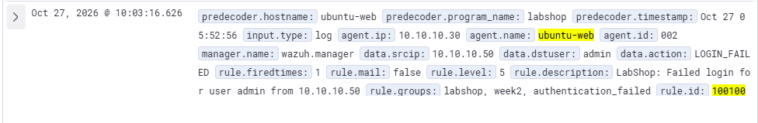
Figure 8. Successful Detection of a LabShop Failed Authentication Event in Wazuh Dashboard Using Rule 100100.

1.7.2. Brute-Force Detection — Level 12
Six consecutive failed authentication events were generated from the same source IP address.
Test command: ~/labshop_gen.sh fail admin 10.10.10.50 6
Wazuh successfully correlated the authentication failures and generated a Level 12 alert.
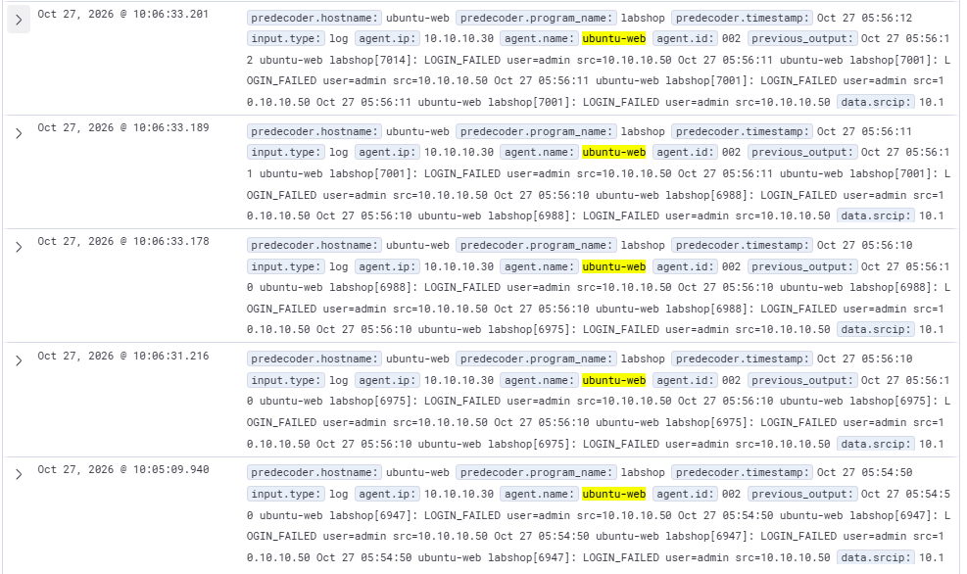
Figure 9. Successful Live Detection of Multiple Failed Authentication Attempts Using the Custom Brute-Force Correlation Rule.
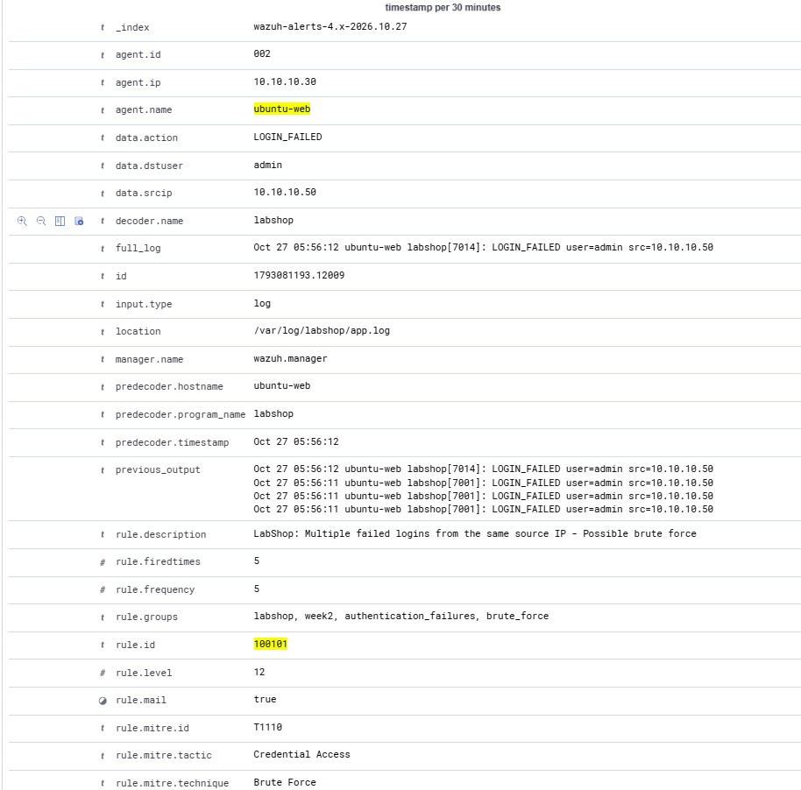Figure 10. Detailed Analysis of the LabShop Brute-Force Alert Showing Rule 100101, Severity Level 12, and MITRE ATT&CK T1110.

1.8. Task 1 Summary
The custom decoder and detection rule implementation was completed successfully.The Wazuh Agent collected LabShop authentication logs, and the custom decoder extracted the required authentication fields.Rule 100100 detected individual failed logins, while Rule 100101 successfully identified repeated failed authentication attempts from the same IP address.All six Logtest scenarios passed, and both custom detection rules were verified using live endpoint events in the Wazuh Dashboard.The results demonstrate successful custom log parsing, authentication monitoring, source IP correlation, detection tuning, and MITRE ATT&CK mapping.Verification of configuration persistence after container recreation and final repository documentation will be addressed during Week 2 finalization.

2. Task 2 — File Integrity Monitoring (FIM)

2.1. Linux Real-Time FIM Configuration
The second task of Week 2 focused on implementing File Integrity Monitoring (FIM) across the Linux and Windows endpoints.
The objective was to detect file creation, modification, and deletion events, monitor Windows Registry changes, and compare real-time monitoring with scheduled integrity scans.
The Ubuntu web endpoint was configured to monitor the Apache webroot directory using Wazuh Real-Time FIM.
Monitored directory: /var/www/html Configuration file: /var/ossec/etc/ossec.conf
The following configuration was added to the existing <syscheck> section:
<directories check_all="yes" realtime="yes" report_changes="yes">/var/www/html</directories>
The realtime parameter enables immediate detection of file changes, while report_changes allows Wazuh to record content differences in supported text files.
After updating the configuration, the Wazuh Agent was restarted.
Validation command: sudo /var/ossec/bin/wazuh-syscheckd -t
The validation returned exit code 0, and the Wazuh Agent was confirmed to be running.
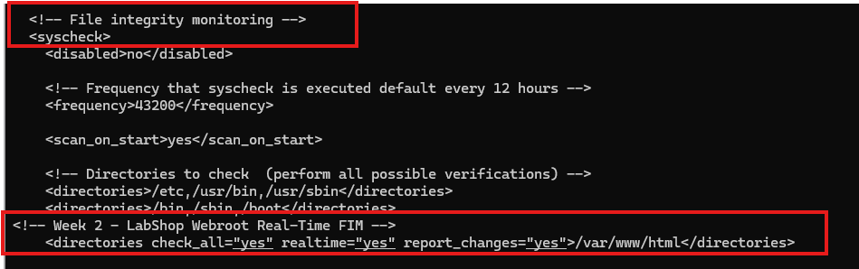
Figure 11. Configuration of Real-Time File Integrity Monitoring for the Ubuntu Apache Webroot.

2.2. Linux File Creation and Deleting Testing
Controlled file operations were performed inside the monitored Apache webroot to verify real-time detection.
A test file named labshop-ifimtest.txt was created and subsequently deleted.
Wazuh successfully recorded both events and identified the affected file path.
The results confirmed that real-time monitoring was operational on the Ubuntu web endpoint.
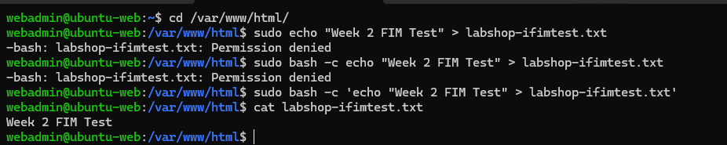
Figure 12. Creation and Verification of a Test File in the Ubuntu Apache Webroot for Real-Time FIM Testing.

2.3. Linux File Modification and Content Difference Verification
An additional test was performed by modifying the contents of the monitored file.
The alert included changes to file attributes and cryptographic hash values, confirming that the file's integrity had been modified.
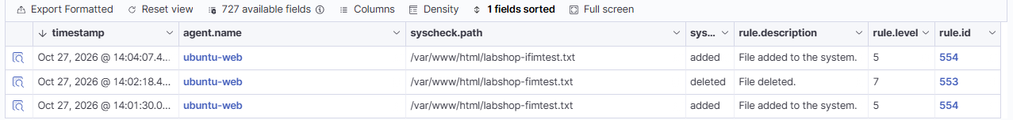
Figure 13. Detection of Linux File Modification and Integrity Checksum Changes Using Wazuh FIM.
The syscheck.diff field was examined to verify whether the actual content modification was recorded.:
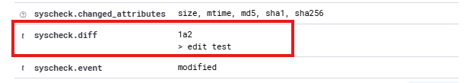
Figure 14. Verification of Linux File Content Changes Through the Wazuh syscheck.diff Field.

2.4. Linux Scheduled FIM Testing
The existing Ubuntu Wazuh Agent configuration also monitored important system directories through scheduled integrity scans.
The monitored paths included /etc, /usr/bin, /usr/sbin, /bin, /sbin, and /boot.
The original scan interval was configured to run every 12 hours.
To test scheduled monitoring without waiting for the default interval, the FIM scan frequency was temporarily reduced to 60 seconds.
Temporary configuration:
<frequency>60</frequency>
A test file was created inside the /etc directory.
Test file: /etc/labshop-scheduled-test.txt
Wazuh successfully generated alerts for file creation and modification.
The expanded alert contained the following information:
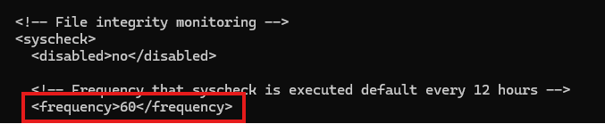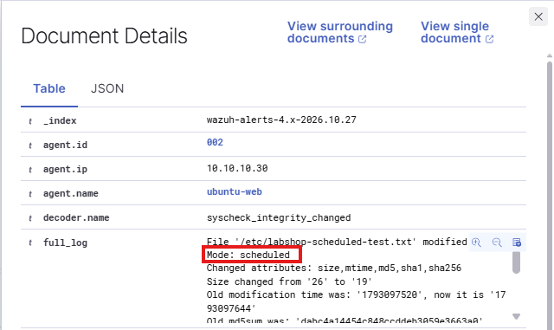
Figure 15. Detection of File Creation and Modification in the Linux /etc Directory Using Scheduled FIM.

2.5. Windows Real-Time FIM Configuration
The Windows endpoint was configured to monitor a dedicated directory for file integrity changes.
Monitored directory: C:\LabShopData Configuration file: C:\Program Files (x86)\ossec-agent\ossec.conf
The directory was created using PowerShell, and a backup of the existing Wazuh Agent configuration was prepared before applying changes.
The following configuration was added to the existing <syscheck> section:
<directories check_all="yes" realtime="yes" report_changes="yes">C:\LabShopData</directories>
This enabled real-time file monitoring and content difference reporting for the Windows LabShop directory.
The Wazuh Agent service was restarted to apply the configuration.
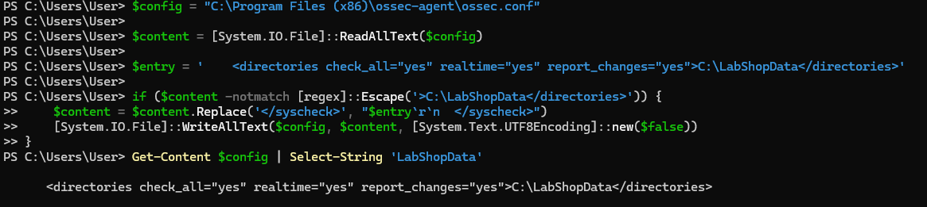
Figure 16. Configuration of Real-Time File Integrity Monitoring for the Windows LabShopData Directory.

2.6. Windows File Integrity Testing
Three controlled file operations were performed inside the monitored Windows directory to verify file creation, modification, and deletion detection.

2.6.1. File Creation Detection
A test file was created using PowerShell.
Test command: Set-Content -Path "C:\LabShopData\fim-test.txt" -Value "Week 2 Windows FIM - Initial Content"
Wazuh successfully detected the newly created file and generated a File Added alert.
Figure 17. Successful Detection of File Creation in the Windows LabShopData Directory Using Real-Time FIM.

2.6.2. File Modification Detection
The existing text file was modified by appending additional content.
Wazuh generated an integrity checksum alert and recorded the content difference through the syscheck.diff field.
The modification was detected using Rule 550, Level 7. This verified that Wazuh could detect both integrity changes and modified file content on the Windows endpoint.
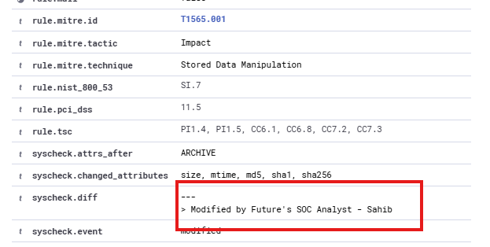
Figure 18. Detection of Windows File Modification and Content Changes Using Wazuh File Integrity Monitoring.

2.6.3. File Deletion Detection
The test file was subsequently deleted from the monitored directory. Wazuh successfully detected the deletion and generated Rule 553, Level 7.

The results confirmed that the Windows Wazuh Agent successfully monitored the complete file lifecycle within C:\LabShopData.
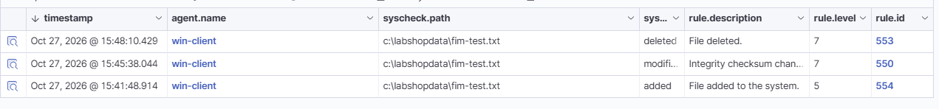
Figure 19. Successful Detection of Windows File Creation, Modification, and Deletion Events in Wazuh Discover.

2.7. Windows Registry Monitoring
The final part of Task 2 focused on detecting modifications to the Windows Registry.
A dedicated LabShop Registry key was created on the Windows endpoint.
Registry key: HKEY_LOCAL_MACHINE\SOFTWARE\LabShop The Wazuh Agent configuration was extended to monitor the LabShop Registry key.
Registry monitoring configuration:
<windows_registry arch="both" report_changes="yes">HKEY_LOCAL_MACHINE\SOFTWARE\LabShop</windows_registry>
Registry monitoring was performed through scheduled FIM scanning.
The scan interval was temporarily reduced to 60 seconds, and the Wazuh Agent was restarted.
The agent log confirmed that the FIM scan started and completed successfully, establishing the initial monitoring baseline.
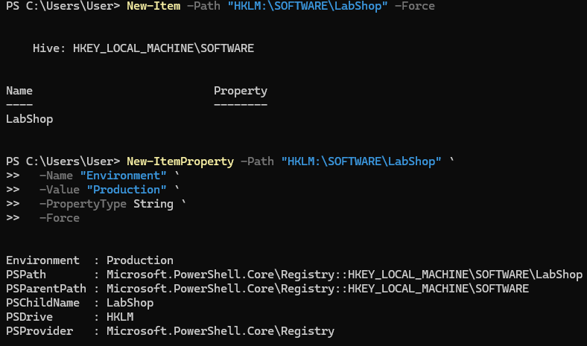
Figure 20. Configuration of Scheduled Windows Registry Monitoring and Creation of the LabShop Registry Baseline.

2.7.1. Registry Modification Detection
After the initial monitoring baseline was established, the Registry value was modified using PowerShell.
Test command: Set-ItemProperty -Path "HKLM:\SOFTWARE\LabShop" -Name "Environment" -Value "Testing"
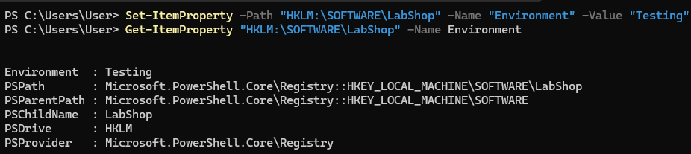
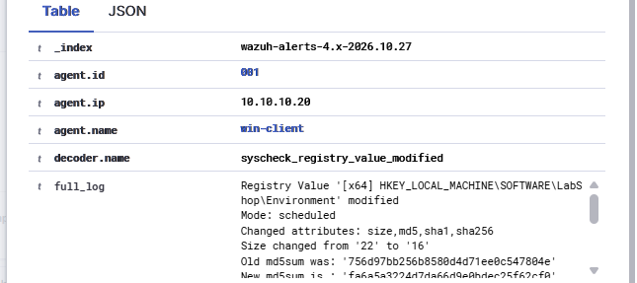
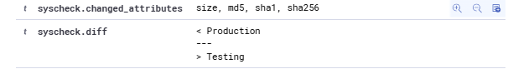
Figure 21. Successful Detection of Windows LabShop Registry Value Modification and Content Differences in Wazuh.

2.8. Task 2 Summary
File Integrity Monitoring was successfully configured and tested across the Linux and Windows endpoints.Real-time FIM was implemented for the Ubuntu Apache webroot and Windows LabShopData directory. Both agents successfully detected file creation, modification, and deletion events.The syscheck.diff field also provided evidence of file content changes.Scheduled FIM was verified on the Linux /etc directory and the Windows LabShop Registry key.The Registry monitoring test confirmed that Wazuh could detect modifications to Registry values and record their previous and updated contents.The tests demonstrated successful detection of file and Registry integrity changes, improving visibility into unauthorized modifications across the Mini-SOC environment.Both real-time and scheduled monitoring were verified. A precise numerical comparison of detection latency remains unverified due to the identified clock synchronization difference between systems.

3. Task 3 — Suricata IDS Integration

3.1. Suricata Installation and Network Preparation
The third task of Week 2 focused on implementing network intrusion detection using Suricata IDS and integrating its security alerts into the existing Wazuh SIEM environment.
Suricata was deployed on the Ubuntu web endpoint (10.10.10.30) to monitor incoming HTTP traffic and identify requests targeting the /admin URL path.
Because the Ubuntu endpoint did not have direct internet access, the SIEM host was temporarily configured as a NAT gateway to download the required installation packages.
After resolving the Ubuntu repository signature verification issue, Suricata was successfully installed.
Installed version: Suricata 7.0.3 RELEASE
The IDS was configured to monitor the SOC-LAN interface ens3, with the protected network defined as:
HOME_NET: "[10.10.10.0/24]"
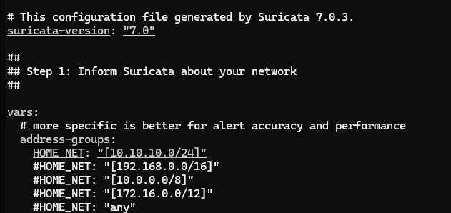
To minimize resource consumption on the 2 GB Ubuntu VM, only a lightweight custom IDS rule was used instead of a large community ruleset.

3.2. Custom HTTP Detection Rule
A custom Suricata signature was created to detect HTTP requests targeting the /admin URL path.
Rule file: /var/lib/suricata/rules/local.rules
Custom IDS signature:
alert http any any -> $HOME_NET 80 (msg:"LABSHOP: HTTP Admin Path Access Detected"; flow:established,to_server; http.uri; content:"/admin"; startswith; sid:1000001; rev:1;)
The Suricata configuration was updated to load local.rules instead of the missing default ruleset.
Validation command: sudo suricata -T -c /etc/suricata/suricata.yaml
The configuration validation completed successfully, confirming that one custom detection signature was loaded without errors.

3.3. Suricata IDS Detection Verification
Controlled HTTP requests were generated from the SIEM host toward the Ubuntu web server.
Test commands: curl http://10.10.10.30/ curl http://10.10.10.30/admin
The normal request returned HTTP status 200, while the /admin request returned 404.
Despite the HTTP 404 response, Suricata successfully detected the /admin request and generated an IDS alert.
The event was recorded in: /var/log/suricata/eve.json
The allowed action confirmed that Suricata operated in IDS mode, detecting suspicious traffic without blocking it.
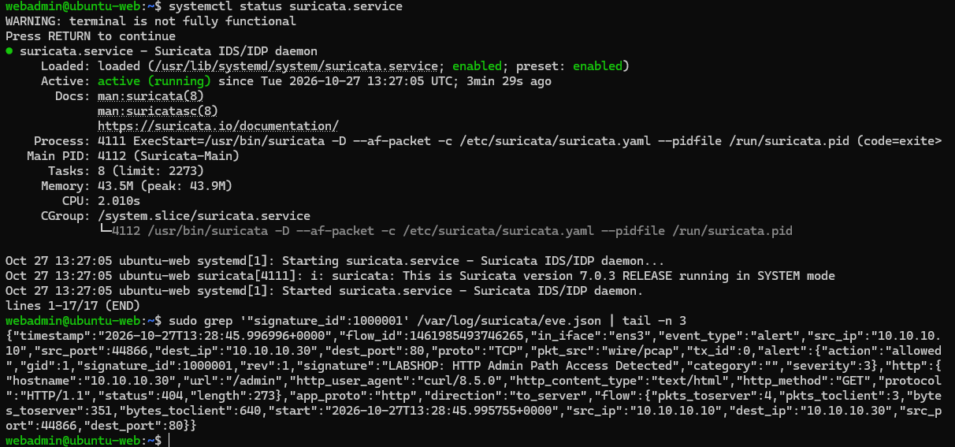
Figure 22. Successful Suricata IDS Operation and Detection of HTTP Admin Path Access in EVE JSON Logs.

3.4. Suricata Integration with Wazuh
To enable centralized monitoring, the Ubuntu Wazuh Agent was configured to collect Suricata EVE JSON logs.
Configuration file: /var/ossec/etc/ossec.conf
The following entry was added:
<localfile>
<log_format>json</log_format>
<location>/var/log/suricata/eve.json</location>
</localfile>
The Wazuh logcollector configuration was validated successfully, and the agent service was restarted.
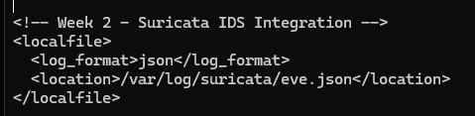
Figure 23. Configuration of Suricata EVE JSON Log Collection in the Ubuntu Wazuh Agent.
A new HTTP /admin request was generated from the SIEM host.
The corresponding Suricata alert was successfully received and displayed in Wazuh Explore → Discover.
The event included the Suricata signature, destination IP address, and IDS detection information.
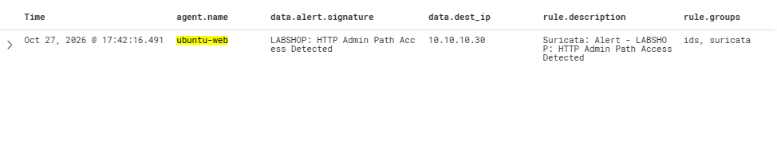
Figure 24. Successful Integration of Suricata HTTP Admin Path Detection into Wazuh Dashboard.

3.5. Custom Wazuh Severity Escalation Rule
A custom Wazuh rule was created to increase the severity of the LabShop Suricata detection.
Rule file: suricata_rules.xml
<group name="labshop,week2,suricata,">
<rule id="100110" level="12">
<if_sid>86601</if_sid>
<field name="alert.signature_id">^1000001$</field>
<description>LabShop: Suricata HTTP Admin Access - $(src_ip) to $(dest_ip)</description>
<group>ids,web_access,</group>
</rule>
</group>
Rule 100110 references the existing Wazuh Suricata detection rule and specifically matches Suricata signature ID 1000001.
The custom rule was deployed to the Wazuh Manager Docker container. Wazuh configuration validation and Logtest both completed successfully.
The Logtest results confirmed that the matching Suricata event triggered Rule 100110 with severity Level 12.
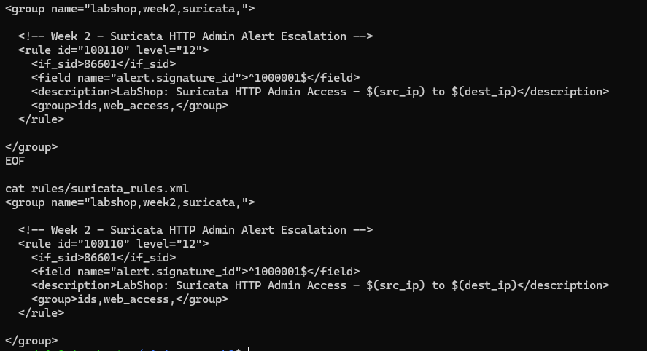
Figure 25. Custom Wazuh Rule 100110 for Escalating Suricata HTTP Admin Access Alerts to Severity Level 12.

3.5.1. Live Severity Escalation Verification
After restarting the Wazuh Manager, another HTTP /admin request was generated.
The event was successfully detected in Wazuh Dashboard with the following results:
Field | Result
Endpoint | ubuntu-web
Suricata Signature ID | 1000001
Custom Wazuh Rule ID | 100110
Rule Level | 12
Source IP | 10.10.10.10
Destination IP | 10.10.10.30
Status | Detected
A negative test was also performed using a normal HTTP / request.
The normal request returned HTTP 200 OK and did not generate an additional custom Rule 100110 alert.
Testing summary:
Test Scenario | Expected Result | Actual Result | Status
HTTP GET /admin | Suricata alert | Signature 1000001 | PASS
Suricata alert in Wazuh | Centralized detection | Alert received | PASS
Custom severity escalation | Level 12 | Rule 100110 | PASS
HTTP GET / | No custom alert | No new Rule 100110 | PASS
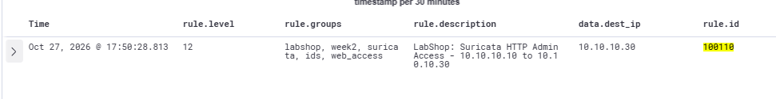
Figure 26. Successful Live Suricata Severity Escalation and Negative HTTP Detection Test in Wazuh.

3.6. Resource Verification and Network Cleanup
The Suricata service was verified as active and enabled for automatic startup.
Memory consumption was measured to confirm that the IDS could operate within the limited resources of the Ubuntu endpoint.
Resource verification results:
Parameter | Result
Suricata Version | 7.0.3
Service Status | Active
Auto-Start | Enabled
Physical Memory Usage (RSS) | 52.7 MiB
Memory Percentage | 2.6%
Available System RAM | Approximately 1.5 GiB
Swap Usage | 0 B
After completing the installation and detection tests, the temporary NAT configuration was removed.
The additional default gateway and DNS settings on the Ubuntu endpoint were reverted, and the temporary forwarding and masquerading rules on the SIEM host were deleted.
The original Docker networking rules were preserved.

3.7. Task 3 Summary
Suricata IDS was successfully deployed and integrated with the Wazuh SIEM environment.The custom Suricata signature detected HTTP requests targeting /admin, and the generated security events were collected through the Ubuntu Wazuh Agent.Custom Wazuh Rule 100110 successfully escalated matching Suricata events to severity Level 12.Both positive and negative HTTP detection tests passed.Resource monitoring confirmed that Suricata operated with low memory consumption, while final network cleanup restored the original isolated SOC-LAN configuration.The implementation demonstrates successful network intrusion detection, custom signature development, centralized IDS log monitoring, and SIEM alert severity escalation.

4. Task 4 — Security Configuration Assessment & Vulnerability Assessment

4.1. Security Configuration Assessment (SCA)
The fourth task of Week 2 focused on evaluating endpoint security configurations using Wazuh Security Configuration Assessment (SCA), performing targeted security hardening, and reviewing detected vulnerabilities.
SCA assessments were performed on both the Ubuntu web server and the Windows 10 client using their corresponding CIS security benchmarks.

Ubuntu Web Server — Initial Assessment
Endpoint: ubuntu-web (10.10.10.30)
Policy: CIS Ubuntu Linux 24.04 LTS Benchmark v1.0.0
The initial assessment identified 118 failed security configuration checks, including insecure login banners, filesystem mount configurations, and other operating system hardening requirements.
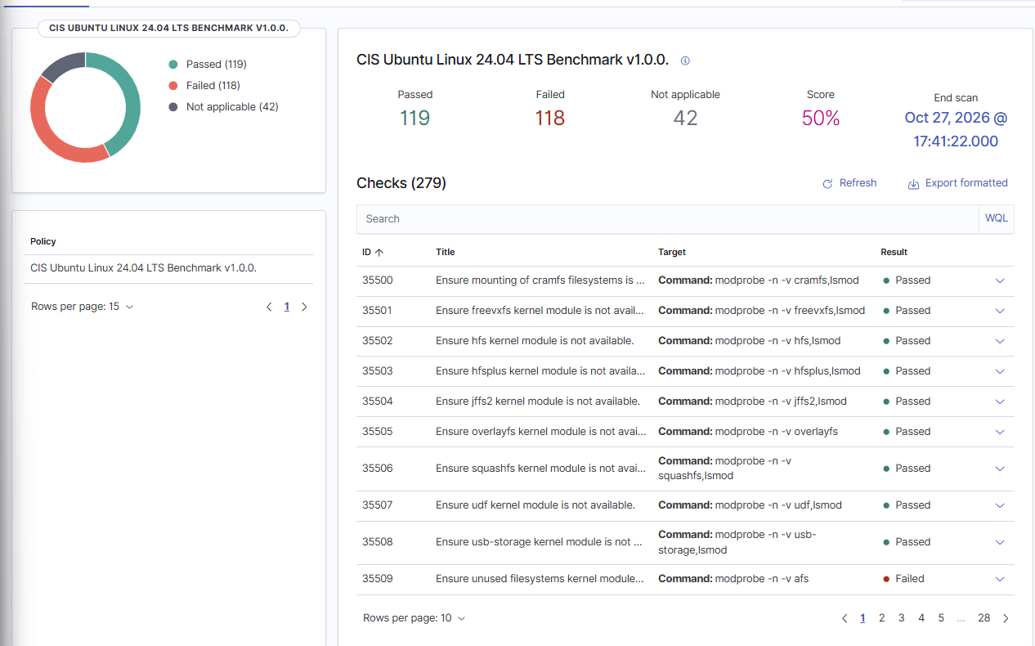
Figure 32. Initial Ubuntu Linux Security Configuration Assessment Results.

4.2. Ubuntu Security Hardening
Two low-risk CIS security checks were selected for remediation:
CIS Check ID | Security Requirement | Initial Status
35547 | Ensure local login warning banner is configured properly | Failed
35548 | Ensure remote login warning banner is configured properly | Failed
Both checks initially failed because /etc/issue and /etc/issue.net displayed operating system identification and version information instead of an appropriate security warning.
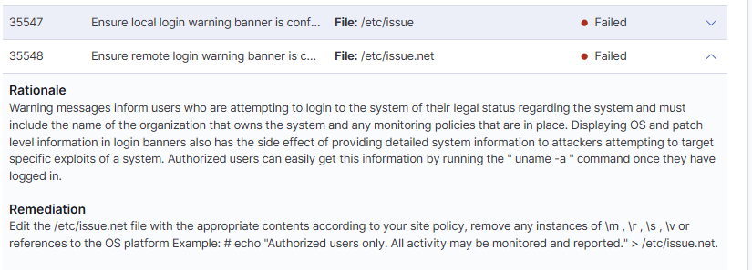
Figure 33. Failed CIS Login Banner Security Checks Before Remediation.

Hardening Implementation
The following commands were executed on the Ubuntu web server:
# Check 35547: Configure local login banner
printf '%s\n' \
'LabShop SOC - Authorized users only. All activity may be monitored and recorded.' \
| sudo tee /etc/issue

# Check 35548: Configure remote login banner
printf '%s\n' \
'LabShop SOC - Authorized users only. All activity may be monitored and recorded.' \
| sudo tee /etc/issue.net

Both configuration files were successfully updated to display the following security warning:
LabShop SOC - Authorized users only. All activity may be monitored and recorded.

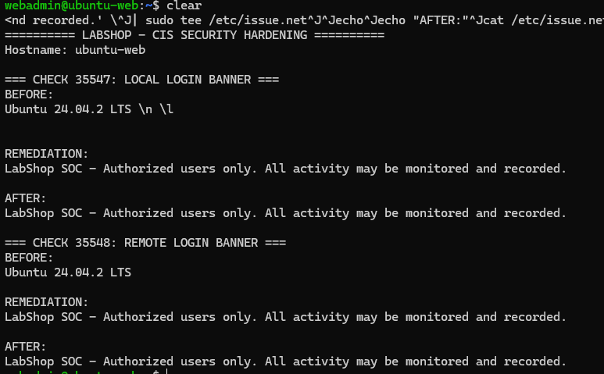
Figure 34. Ubuntu Login Banner Hardening Commands and Successful Remediation of CIS Check 35547.
Figure 35. Successful Remediation of CIS Check 35548 — Remote Login Warning Banner.

4.3. Risk Acceptance
One additional failed security check was reviewed and intentionally left unchanged.
CIS Check ID: 35510
Requirement: Ensure /tmp is a separate partition.
Decision: Risk Accepted — Laboratory Environment.
Justification:
Creating a dedicated /tmp partition would require filesystem modifications and introduce unnecessary operational risk to the existing virtual machine. Because LabShop is an isolated, temporary cybersecurity laboratory, the finding was documented and accepted rather than remediated.
The remaining risk relates to the lack of filesystem-level separation for temporary files. For a production deployment, a dedicated /tmp filesystem with appropriate mount restrictions should be considered.
Status: Failed — Documented Risk Acceptance.

4.4. Windows 10 Security Configuration Assessment
A separate SCA assessment was performed on the Windows 10 endpoint.
Endpoint: win-client (10.10.10.20)
Policy: CIS Microsoft Windows 10 Enterprise Benchmark v4.0.0
Metric | Result
Total Checks | 424
Passed | 116
Failed | 303
Not Applicable | 5
Compliance Score | 27%
The Windows assessment identified multiple security configuration gaps. These results establish a security baseline for potential future hardening activities.
No Windows security configuration changes were performed during this task.
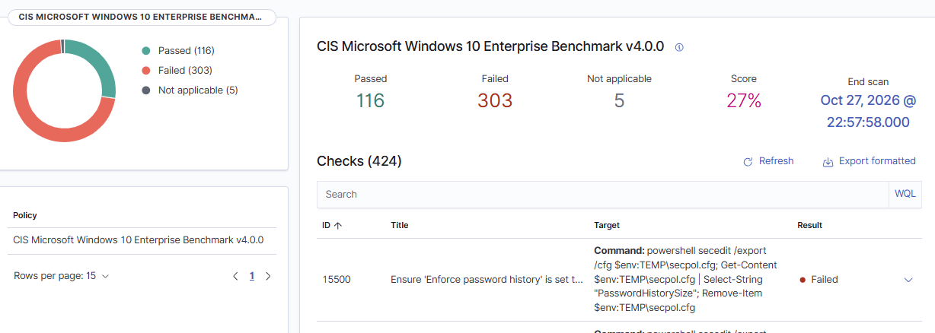
Figure 36. Windows 10 Enterprise Security Configuration Assessment Baseline.

4.5. Vulnerability Assessment
Wazuh Vulnerability Detection was used to review identified vulnerabilities on both monitored endpoints.
The vulnerability inventories were filtered by agent and sorted by CVSS base score in descending order to identify the highest-severity findings.

4.5.1. Windows 10 Vulnerability Assessment
Endpoint: win-client Affected Product: Microsoft Windows 10 Enterprise Reported Version: 10.0.19045.2006
The Wazuh vulnerability inventory contained multiple Critical, High, and Medium severity findings.
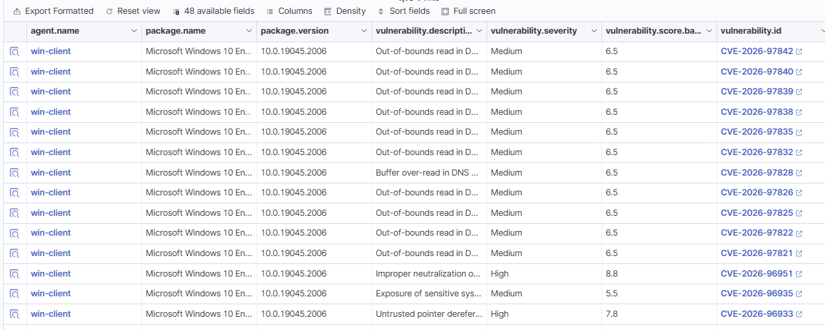
Figure 37. Windows 10 Vulnerability Detection Inventory in Wazuh.
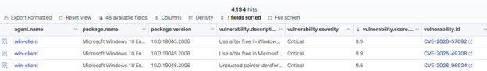
Figure 38. Top Three Critical Windows 10 Vulnerabilities Ranked by CVSS Score.

4.5.2. Ubuntu Web Vulnerability Assessment
Endpoint: ubuntu-web Affected Package: linux-image-6.8.0-53-generic Package Vers. 6.8.0-53.55
The Ubuntu vulnerability inventory identified multiple Critical severity findings associated with the installed Linux kernel package.
Top Three Vulnerabilities by CVSS Score:
CVE ID | CVSS Score | Severity
CVE-2026-74280 | 10.0 | Critical
CVE-2026-63795 | 10.0 | Critical
CVE-2026-72421 | 10.0 | Critical
Several additional Ubuntu findings shared the same maximum CVSS score. The table records the first three results from the sorted inventory.
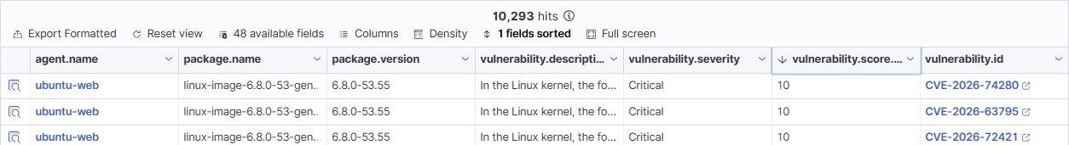
Figure 39. Top Three Critical Ubuntu Web Vulnerabilities Ranked by CVSS Score.
The identified vulnerabilities were reviewed and documented without applying operating system patches. These findings represent Wazuh vulnerability inventory results and do not establish that the systems have been exploited.

4.6. Task 4 Summary
Security Configuration Assessment and Vulnerability Assessment were successfully performed on both LabShop endpoints.The initial Ubuntu compliance score was 50%, while the Windows 10 compliance score was 27%.Two Ubuntu CIS security configuration checks, 35547 and 35548, were successfully remediated and verified as Passed in Wazuh. A third check, 35510, was documented as an accepted laboratory risk.Vulnerability Detection results were collected for both endpoints, and the three highest-ranked CVE findings were documented for each system.

