LinkedIn Post Automation Documentation

The purpose of this document is to provide a clear overview and step-by-step explanation of the Make.com automation workflow that integrates Airtable, OpenAI, Google Docs, and LinkedIn.

# What is Make.com?

Make.com (formerly Integromat) is a visual automation platform that lets you connect different apps, services, and APIs without heavy coding.

It is used to automate workflows, such as moving data between apps, triggering actions based on conditions, or generating AI-powered responses.

For LinkedIn, Make.com helps automatically generate and publish posts, track engagement, and manage content pipelines.

# Airtable Integration

Airtable is a cloud-based database platform that combines the **simplicity of spreadsheets** with the **power of relational databases**.

* It is used here as a **content management system (CMS)** to store LinkedIn post ideas, AI-generated drafts, and processing status.

**Integration with Make.com**

1. Add the **Airtable module** in Make.com.
2. Authenticate using **OAuth 2.0** (recommended for security).

* Choose **Add connection → OAuth**.
* Sign in with your Airtable account.
* Authorize Make.com to access your bases.

# Workflow Overview

This automation takes unprocessed post ideas from Airtable, generates LinkedIn content using OpenAI, logs the results in Google Docs, publishes to LinkedIn, and updates Airtable to mark completion.

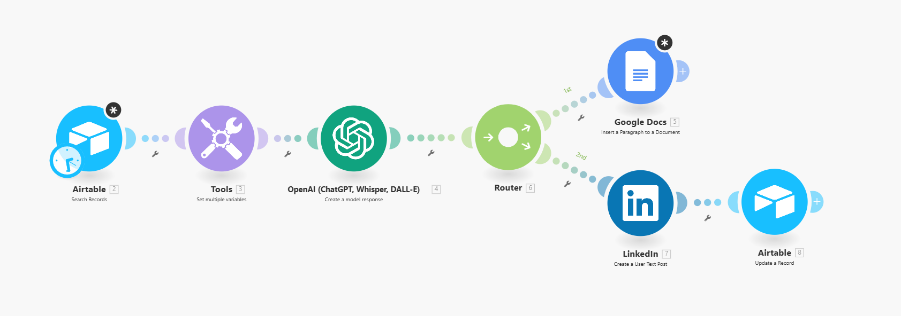

The flow ensures:  
- No duplicate posts  
- AI-generated content is tracked  
- Posts are auto-published to LinkedIn

# 2. Workflow Steps

## Step 1: Airtable (Search Records)

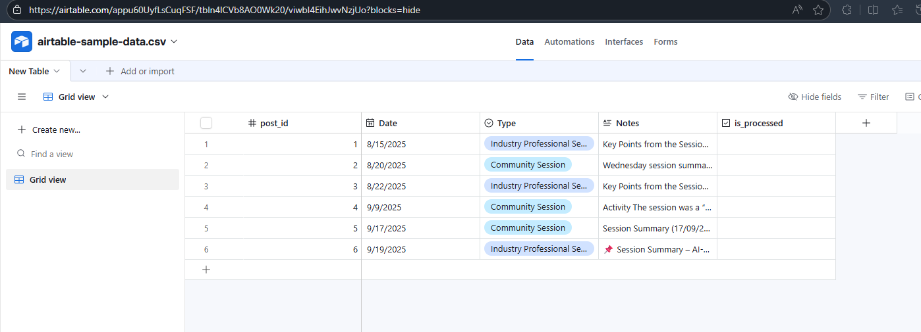

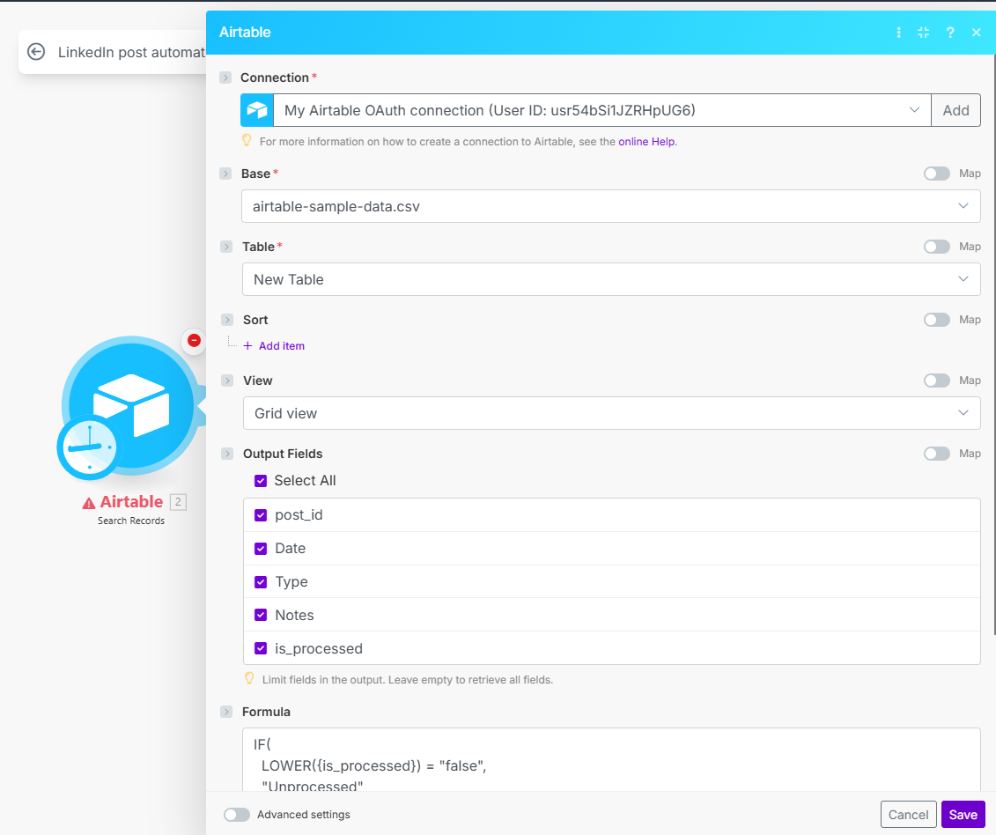

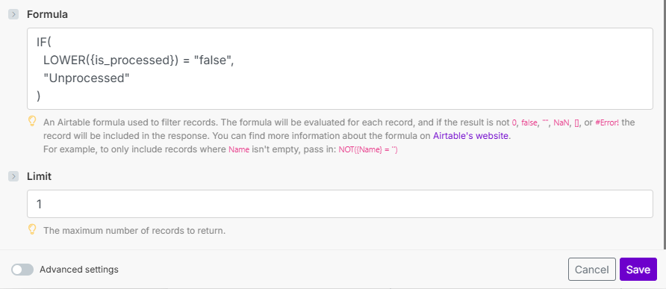

Module: Airtable → Search Records  
Action: Finds all rows where is_processed = FALSE  
Purpose: Fetches unprocessed post entries  
Limit: Fetch result to 1 at a time

## Step 2: Tools (Set Variables)

Module: Tools → Set Multiple Variables  
Action: Extracts variables (post_id, Notes, Type, etc.) from Airtable  
Purpose: Prepares the data to send to OpenAI

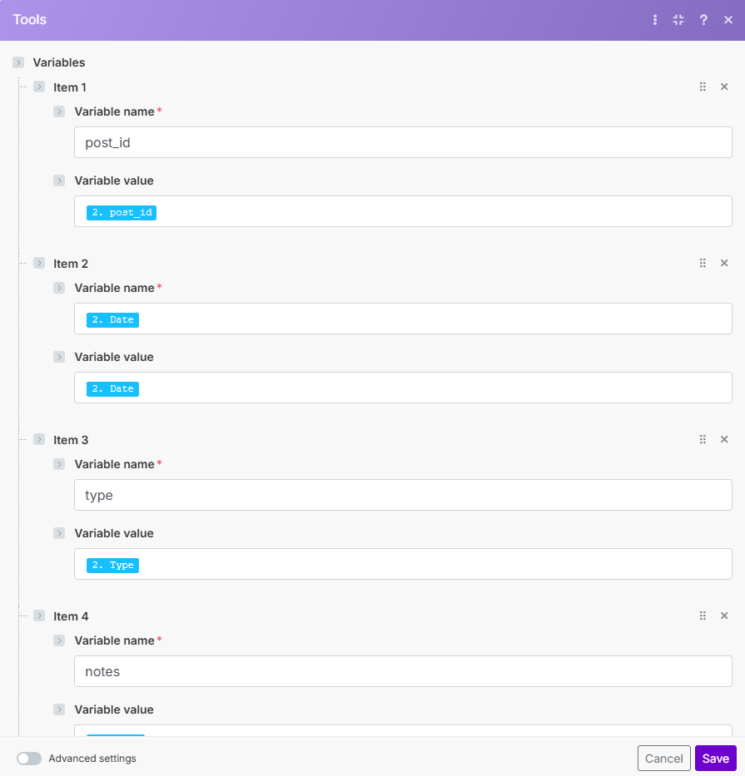

## Step 3: OpenAI (Content Generation)

Module: OpenAI (ChatGPT, Whisper, DALL·E) → Create a model response  
Action: Sends prompt (based on Airtable Notes & Type) to OpenAI  
Purpose: Generates a polished LinkedIn post draft

**Steps to Generate OpenAI API Key and Add to Make.com**

* Generate OpenAI API Key
* Go to [OpenAI Platform](https://platform.openai.com/).
* Log in with your OpenAI account (or sign up if new).
* In the top-right corner, click on your profile picture → View API Keys.
* Click Create new secret key.
* Copy the key that is generated (it starts with sk-...).

**Store it safely.** You won’t be able to see it again after closing the popup.

* Add OpenAI API Key in Make.com
* Log in to your Make.com account.
* Open your Scenario where you’re using OpenAI.
* Click on the OpenAI module (e.g., *ChatGPT, Whisper, DALL·E → Create a model response*).
* In the connection field, click Add.
* A pop-up will appear asking for your OpenAI API Key.
* Paste the key you copied from OpenAI.

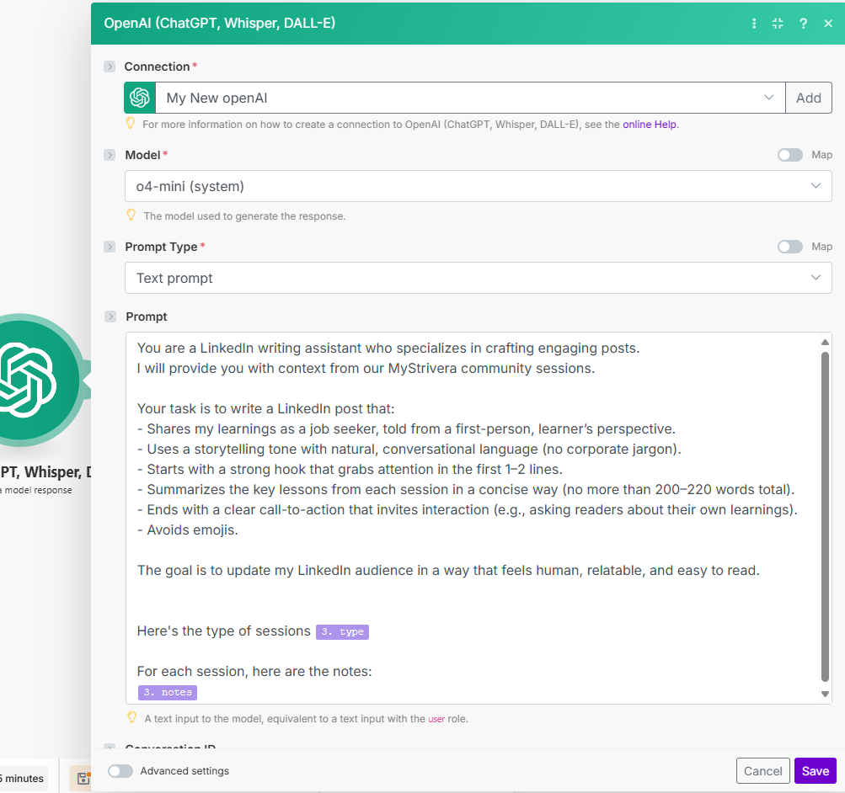

# Step 4: Router (Branching the Workflow)

The router splits the output into two paths:

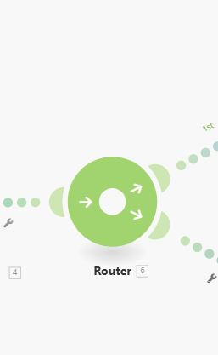

### Path 1 Google Docs (Insert Content)

Module: Google Docs → Insert a Paragraph  
Action: Appends a row with: Post_ID, Created_At timestamp, AI-generated Result  
Purpose: Keeps a record of every post generated

**Create a Google Drive Connection**

1. In the **Connection** field of the Google Docs module, click **Add**.
2. A popup will appear asking you to connect your **Google Account**.
3. Click **Continue** and log in with the Google account where your Google Docs files are stored.
4. Review the list of permissions (Make.com needs access to read/write your Google Drive and Docs).
5. Click **Allow** to grant access.

**Verify and Save**

* After authentication, the connection will be saved as a reusable **Google Drive connection** in Make.com.
* You can now select your Google Drive folder and Docs files inside the module.

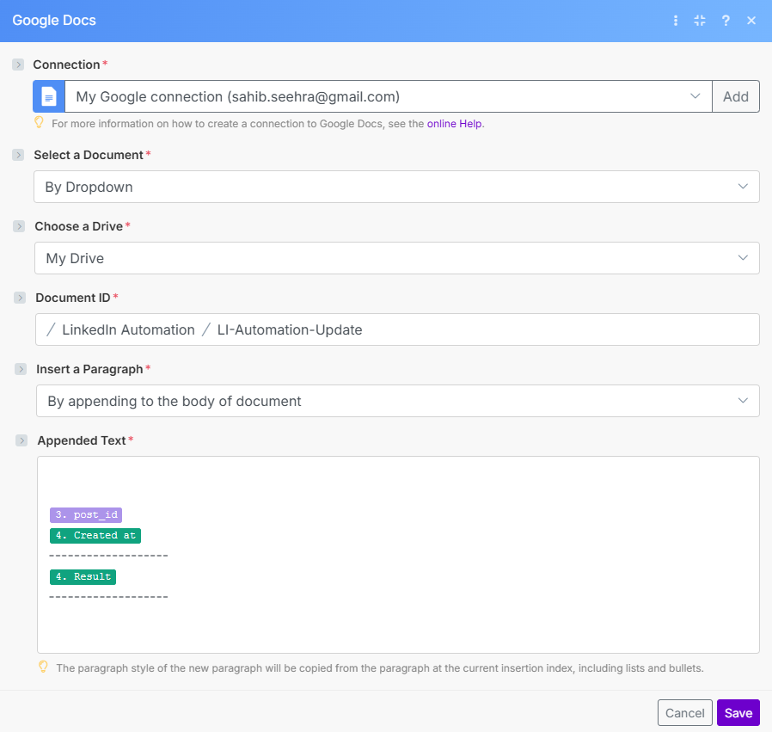

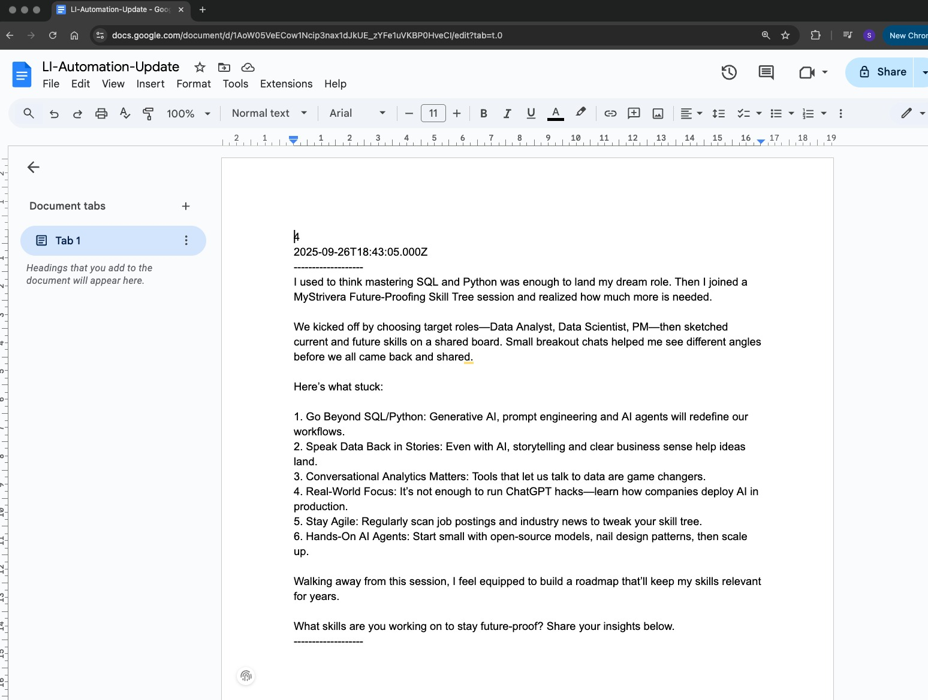

### Path 2 LinkedIn (Post Content)

Module: LinkedIn → Create a User Text Post  
Action: Publishes AI-generated content to LinkedIn  
Purpose: Posts directly on the LinkedIn account

**Create LinkedIn Connection**

1. In the **Connection** field of the LinkedIn module, click **Add**.
2. A popup will appear prompting you to sign in to LinkedIn.
3. Log in with your **LinkedIn account credentials** (personal or company page admin).
4. Review the requested permissions (Make.com needs access to post on your behalf and manage content).
5. Click **Allow** to grant permissions.

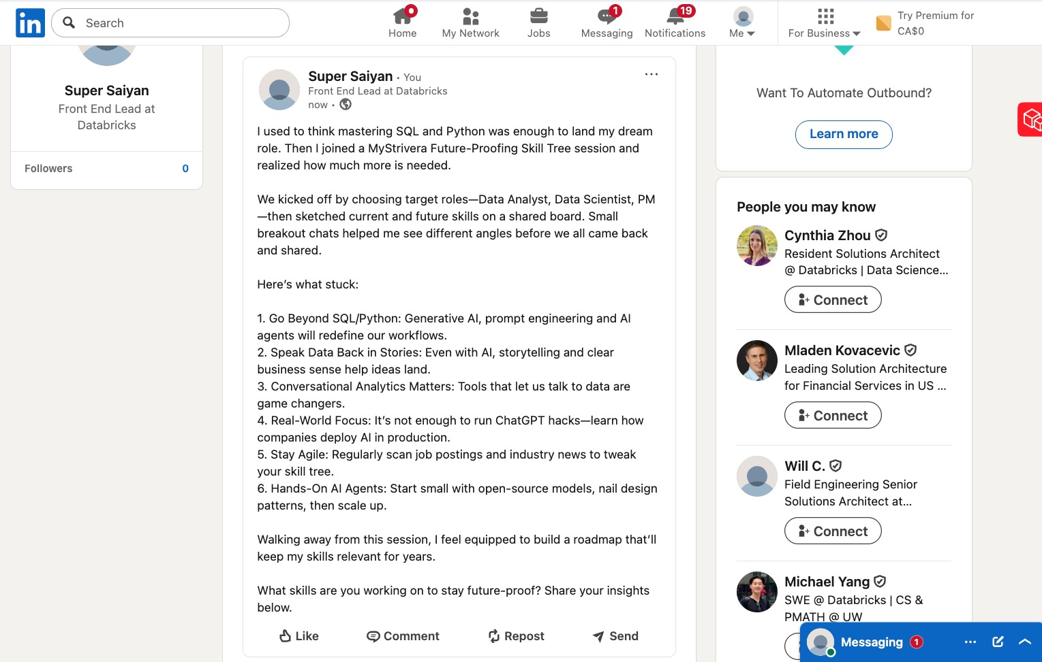

## Step 5: Airtable (Update Record)

Module: Airtable → Update Record  
Action: Sets is_processed = TRUE for the post after it is successfully published

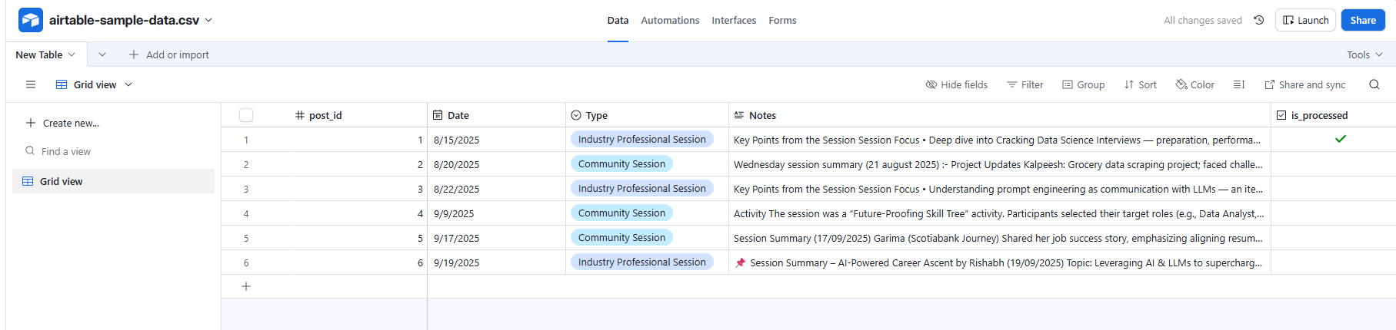  
Purpose: Prevents reposting and allows new unprocessed entries to flow in the next automation run

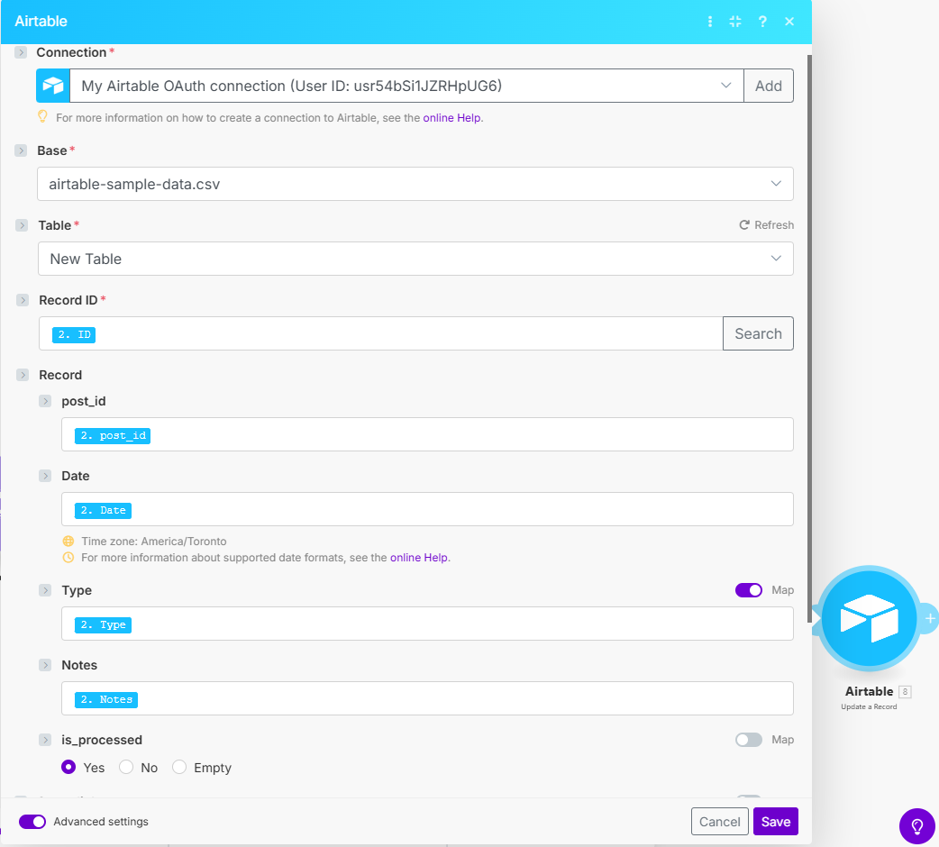

# 3. End-to-End Flow Diagram

The automation flow is:  
  
**1. Airtable (Search Records)   
2. Tools (Set Variables)  
3. OpenAI (Generate Post)**   
**4. Router**  
 Path 1: Save to Google Docs  
 Path 2: Publish to LinkedIn → Update Airtable (is_processed = TRUE)

# 4. Key Benefits

- Hands-free posting → Content is created and published automatically  
- Central tracking → Google Docs acts as a historical log  
- Error prevention → Airtable flag avoids duplicate posting  
- Scalable → Can handle multiple entries at once with the router