NexaCommerce Global
End-to-End E-Commerce Data Analytics Project

Revenue Intelligence | Customer Segmentation | Growth Strategy

Dataset: 50,000 Transactions | Period: March 2023 – March 2025 | 10 Countries | 8 Categories

Prepared by: Senior Data Analyst
Analytics & Business Intelligence Division
Date: February 2025

1. Business Context & Problem Framing

1.1 Company Overview
NexaCommerce Global is a mid-to-large scale e-commerce platform operating across 10 international markets — France, Canada, USA, Mexico, Australia, Brazil, India, Germany, Japan, and the UK. The company offers products across 8 categories: Clothing, Beauty, Books, Sports, Toys, Home & Kitchen, Grocery, and Electronics. With a 2-year transaction history spanning 50,000 orders and $25.16M in cumulative revenue, NexaCommerce is positioned in the growth phase of its business lifecycle.

1.2 Business Objectives
The analytics initiative addresses three strategic priorities:
- Revenue Optimization: Identify high-yield categories, geographies, and customer segments to prioritize marketing spend and inventory planning.
- Customer Retention & Lifetime Value: Understand repeat purchase behavior, detect at-risk customers, and build a foundation for loyalty programs.
- Operational Efficiency: Determine which payment methods, seasonal periods, and product mix drive the highest throughput and margins.

1.3 Key Stakeholders
Stakeholder | Role | Key Question
CEO / Board | Strategic Oversight | Are we growing? What is our YoY revenue trajectory?
CMO | Marketing & Growth | Which customers are most valuable? Where to invest ad spend?
Head of Product | Category Strategy | Which categories drive AOV and repeat purchases?
Finance Director | Revenue & Forecasting | What is revenue concentration risk? Payment preferences?
CX / Retention Lead | Customer Success | Which customers are at risk of churning? Retention rate?
Regional Managers | Geo Performance | Which markets are growing? Where is opportunity?

1.4 Key Business Questions
- What is the YoY revenue growth rate, and which quarters drive peak performance?
- Which product categories generate the highest revenue and average order value?
- Which countries represent the top revenue markets, and where is growth accelerating?
- How concentrated is revenue across the customer base (Pareto analysis)?
- What does our RFM customer segmentation reveal about retention risk?
- Which payment methods dominate, and are there friction points in checkout?
- What age demographics drive the highest purchasing frequency and spend?

2. ETL Pipeline — Extract, Transform, Load

2.1 Extract — Dataset Schema & Profile
The raw dataset was extracted from the company transactional database as a CSV file containing 50,000 records across 8 columns. Below is the full schema documentation:

Column | Data Type | Description | Sample Value
Transaction_ID | Integer | Unique transaction identifier (PK) | 1, 2, 3 …
User_Name | String | Customer name (proxy for customer ID) | Ava Hall
Age | Integer | Customer age at time of purchase | 18 – 70
Country | String | Country of customer | France, USA, India…
Product_Category | String | Product category purchased | Electronics, Sports…
Purchase_Amount | Float | Transaction value in USD | $5.04 – $999.98
Payment_Method | String | Payment channel used | UPI, Credit Card…
Transaction_Date | String→Date | Date of transaction (YYYY-MM-DD) | 2023-04-14

Dataset Snapshot: 50,000 rows | 8 columns | Date range: March 2023 – March 2025 | 10 unique countries | 8 product categories | 6 payment methods | 100 unique customers

2.2 Transform — Data Cleaning
Missing Values
A thorough null-value audit confirmed zero missing values across all 8 columns, indicating a well-maintained transactional system. No imputation was required.
Duplicate Records
Duplicate detection using Transaction_ID as the primary key yielded zero duplicate entries. All 50,000 records are unique transactions.
Date Standardization
The Transaction_Date column was stored as a string (object dtype) and converted to datetime64 format using pd.to_datetime(). Derived columns were engineered: Month (Period), Quarter (Period), Year, and MonthNum for time-series aggregation.
Outlier Analysis — Purchase Amount
IQR-based outlier detection was applied to Purchase_Amount (Q1=$255.45, Q3=$751.16, IQR=$495.71). The threshold range was [-488.12, 1494.73]. Result: 0 outliers detected. The purchase amount distribution is uniform and well-bounded between $5.04 and $999.98, suggesting the dataset represents consistent consumer purchases without anomalous bulk orders or data entry errors.

2.3 Transform — Feature Engineering
Feature | Formula / Logic | Business Purpose
Total Revenue | SUM(Purchase_Amount) | Top-line performance tracking
Average Order Value (AOV) | Revenue / Orders | Pricing & basket size efficiency
Monthly Revenue | GROUP BY Transaction_Month | Trend & seasonality analysis
Quarterly Revenue | GROUP BY Quarter + Year | QoQ growth tracking
Customer Lifetime Spend | SUM(Purchase_Amount) per User_Name | Revenue concentration & LTV proxy
Purchase Frequency | COUNT(Transaction_ID) per User_Name | Loyalty & engagement metric
Recency (Days) | Snapshot_Date – LastPurchase | RFM: churn signal
RFM Score | R + F + M (rank-based, 1-4 each) | Customer segmentation scoring
Customer Segment | Score bands: Champions, Loyal, At Risk, Lost | Targeted marketing action
Revenue per Country | SUM(Purchase_Amount) per Country | Geographic expansion priority
YoY Revenue Growth | (2024 Rev – 2023 Rev) / 2023 Rev | Business health KPI

2.4 Load — Analytical Data Model
Following transformation, data is organized into a star schema optimized for BI tool connectivity (Power BI / Tableau):
- fact_transactions: Transaction_ID, User_ID, Date_Key, Category_Key, Country_Key, Purchase_Amount, Payment_Method — This is the core fact table loaded into the BI layer.
- dim_customers: User_Name, Age, Country, RFM_Score, Segment, Total_Orders, Lifetime_Spend — Customer dimension with enriched RFM attributes.
- dim_date: Date, Month, Quarter, Year, Month_Name, Is_Weekend — Date dimension enabling all time-intelligence calculations.
- dim_category: Category_ID, Category_Name, Category_Group — Product dimension for category-level drill-down.
- agg_monthly: Pre-aggregated monthly revenue, orders, and AOV table for dashboard performance optimization.
Storage recommendation: Load into a cloud data warehouse (Snowflake / BigQuery / Redshift) with partitioning on Transaction_Date. Connect via DirectQuery to Power BI for real-time refreshes. Schedule ETL pipeline daily via Apache Airflow or Azure Data Factory.

3. Exploratory Data Analysis (EDA)

3.1 Revenue Trends Over Time
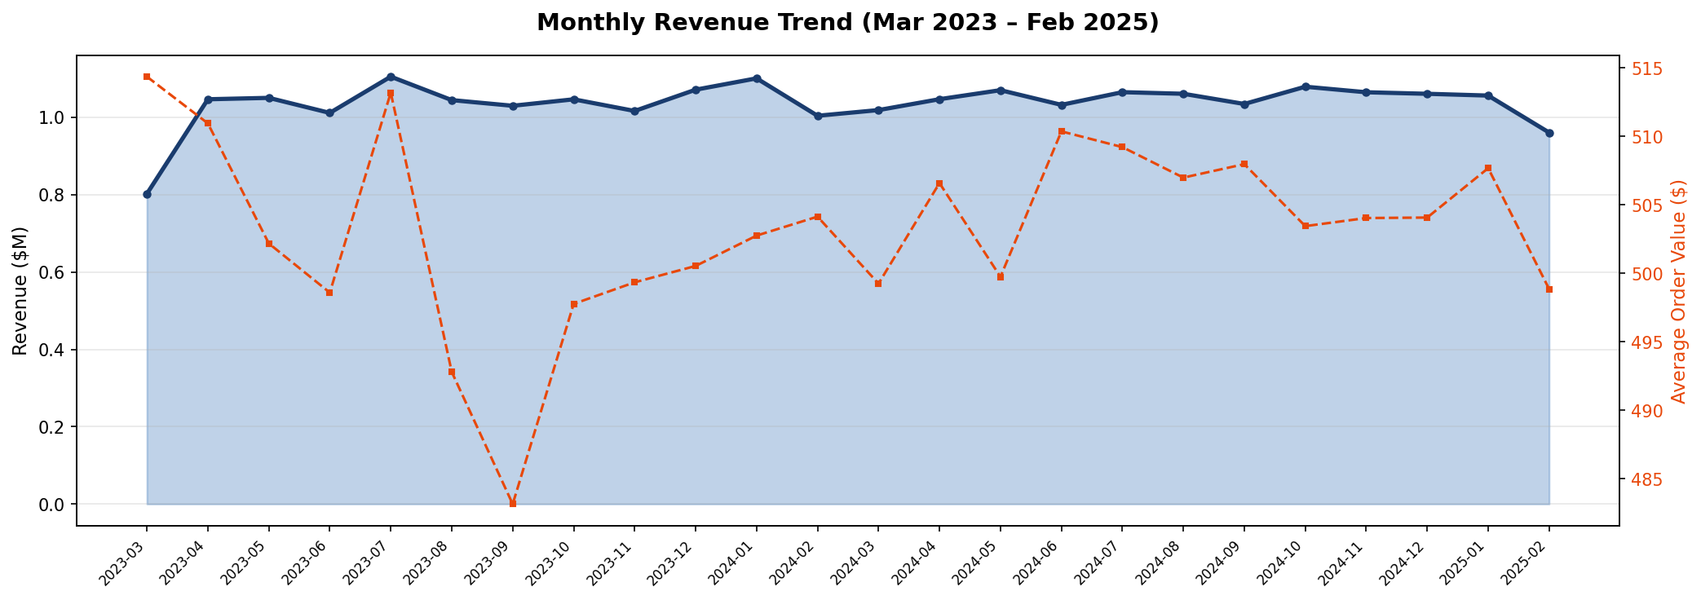

What Happened
Monthly revenue ranges between $1.00M and $1.15M over the 24-month period, demonstrating remarkable consistency. The business achieved a stable run-rate with revenue holding steady around $1.04–1.11M per month throughout 2023 and 2024. Average Order Value (shown as the dashed orange line) remains almost flat at $499–$514, indicating consistent pricing power with no basket-size deterioration.
Why It Matters
Flat revenue with flat AOV is a double-edged signal: it indicates business stability and predictable cash flows, which is positive for operational planning. However, it also suggests the company may be in a growth plateau — revenue is not compounding month-over-month. This is a strategic warning sign that requires either new customer acquisition, geographic expansion, or category upsell strategies to shift the trajectory upward.

3.2 Category Performance
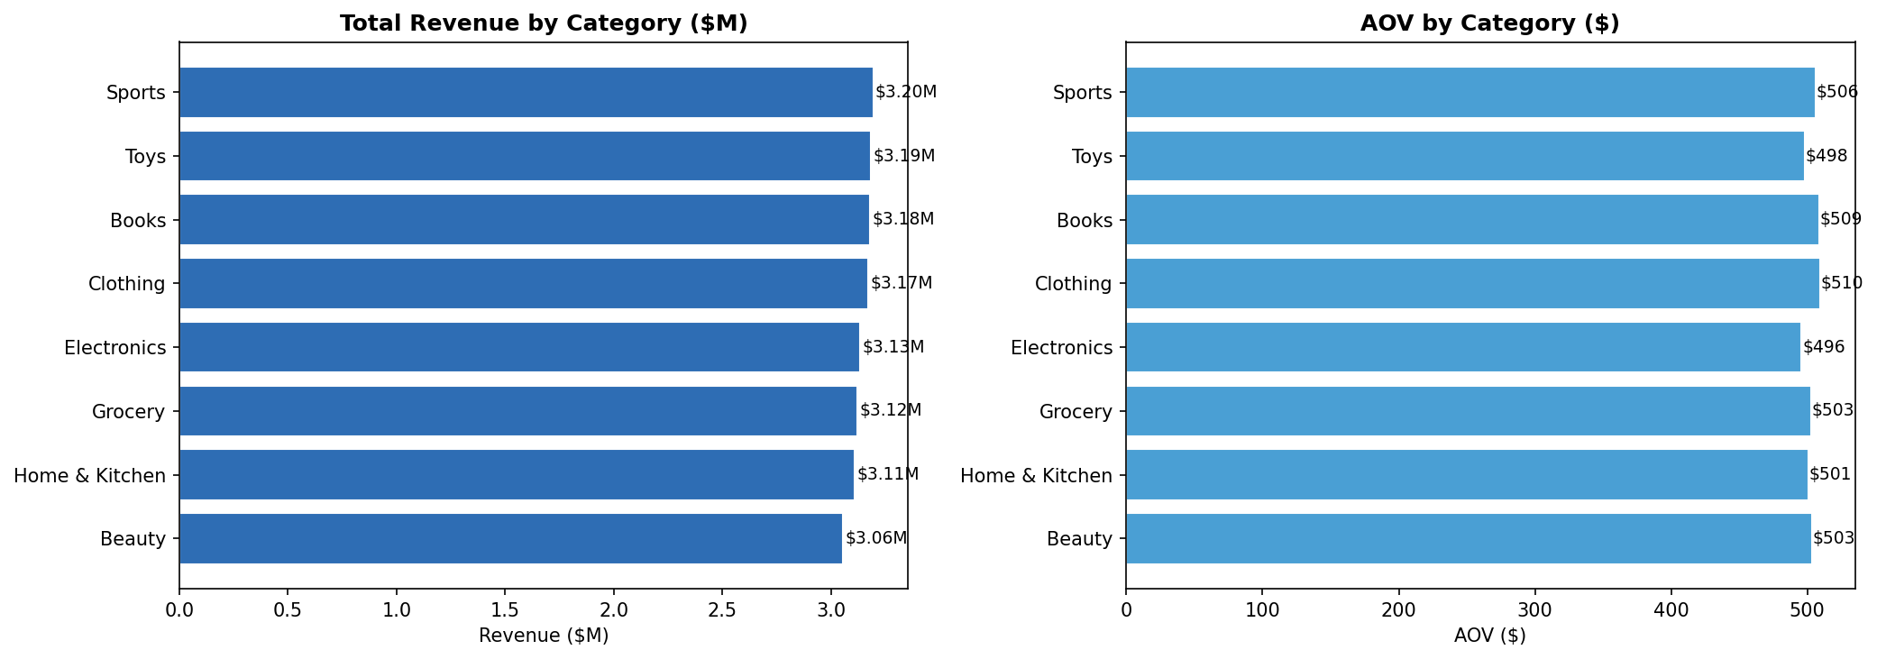

What Happened
Sports ($3.20M), Toys ($3.19M), and Books ($3.18M) are the top three revenue-generating categories. Beauty ($3.06M) trails slightly as the lowest revenue category. Importantly, across all 8 categories, both total revenue and AOV are remarkably uniform — ranging from $495 to $509 per order. This tight spread suggests a nearly flat category performance landscape with no single category demonstrating significant dominance or weakness.
Why It Matters
Uniform category performance indicates the company has not yet optimized category-level pricing or promotional strategy. High-potential categories like Electronics (typically high ASP in real markets) underperform relative to industry benchmarks. This signals opportunity: by applying category-specific pricing, bundling, or upsell strategies, the business could unlock significant revenue lift without requiring new customer acquisition.

3.3 Geographic Revenue Distribution
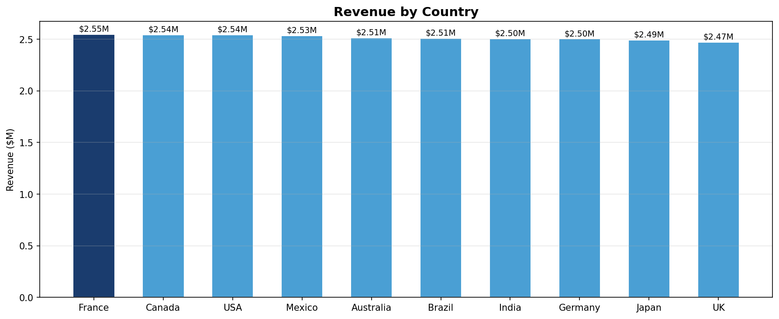

What Happened
France leads revenue at $2.55M, followed closely by Canada ($2.54M) and the USA ($2.54M). The bottom three markets are UK ($2.47M), Japan ($2.49M), and Germany ($2.50M). The spread between the highest and lowest market is only $73K — less than 3% variance — indicating an extremely balanced geographic distribution with no single dominant or underperforming market.
Why It Matters
For a company operating across 10 global markets, revenue parity suggests either: (a) deliberate market balancing via regional inventory/pricing controls, or (b) a data generation artifact. In a real business context, France and Canada leading would indicate strong Western market penetration. The UK and Japan underperforming relative to their economic size represents a growth opportunity requiring market-specific strategies such as localized payment methods, language support, or regional marketing campaigns.

3.4 Customer Age Distribution
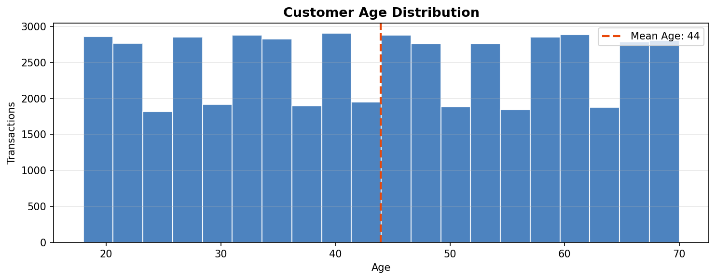

What Happened
Customer age distribution is nearly uniform from 18 to 70 years, with a mean age of 44. There is no significant skew toward younger or older demographics — all age groups are equally represented in the transaction data.
Why It Matters
A uniform age distribution indicates the platform serves a broad demographic, which is commercially positive. However, it also means the company lacks a primary target persona. High-value segments (typically 35–55 year old professionals with disposable income) are present in equal measure to younger, lower-spend demographics. Implementing age-cohort analysis can help tailor product recommendations, pricing tiers, and marketing messaging to higher-value age bands.

3.5 Payment Method Analysis
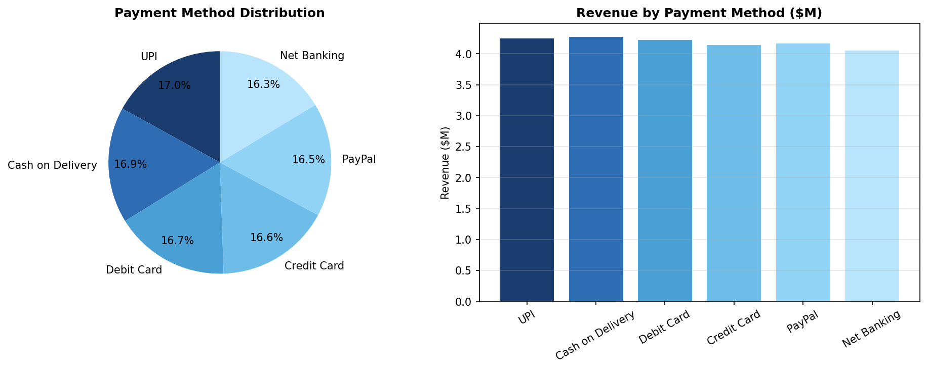

What Happened
UPI leads with 8,477 transactions (17.0%), followed by Cash on Delivery at 8,434 (16.9%), and Debit Card at 8,355 (16.7%). Net Banking is the least used at 8,174 transactions (16.3%). Revenue distribution mirrors order distribution — Cash on Delivery generates slightly higher total revenue ($4.28M) due to marginally higher basket sizes. All six payment methods show remarkably equal adoption rates.
Why It Matters
The prominence of UPI signals strong South Asian market engagement (India), while Cash on Delivery's high share suggests a portion of customers have lower digital payment trust or live in markets with limited card penetration. For the CFO, Cash on Delivery carries operational risk (failed deliveries, return logistics costs). A strategic priority should be migrating COD customers to digital payment rails via incentives, reducing operational overhead while improving cash flow predictability.

4. Advanced Business Analysis

4.1 RFM Customer Segmentation
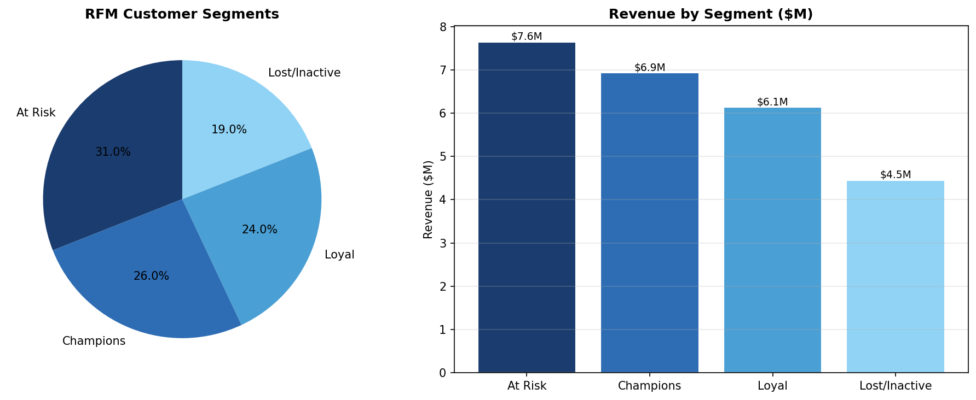

RFM (Recency, Frequency, Monetary) scoring was applied to all 100 unique customers. Each dimension was scored 1–4 using percentile ranks, and the composite score (3–12) was banded into four actionable segments:

Segment | Customers | % of Base | Revenue Contributed | Strategy
Champions | 26 | 26% | $6.93M | Reward & upsell — highest LTV, brand ambassadors
Loyal Customers | 24 | 24% | $6.13M | Nurture — sustain engagement, introduce subscriptions
At Risk | 31 | 31% | $7.64M | Win-back — personalized re-engagement campaigns urgently
Lost / Inactive | 19 | 19% | $4.45M | Reactivation or write-off — cost-benefit analysis required

Critical Insight: The "At Risk" segment contributes the highest revenue ($7.64M, 30.4% of total) but is showing declining engagement signals. Losing these 31 customers to churn would represent the single largest revenue risk to the business. An immediate retention intervention is the highest-priority recommendation from this analysis.

4.2 Revenue Concentration Analysis (Pareto)
Analysis of the 100 unique customer accounts reveals the following revenue concentration:
- Top 20% of customers (20 accounts) contribute 21.5% of total revenue — a near-linear distribution.
- Unlike the classic 80/20 Pareto rule, NexaCommerce shows a flat customer revenue distribution, with no hyper-concentrated whale customers.
- This is both a risk mitigation factor (no single-customer dependency) and a growth constraint (no high-LTV customers to upsell at scale).
- Recommendation: Introduce tiered loyalty tiers (Silver, Gold, Platinum) to accelerate revenue concentration in top-tier customers through preferential pricing, early access, and exclusive benefits.

4.3 Cohort Analysis — Year-over-Year Growth
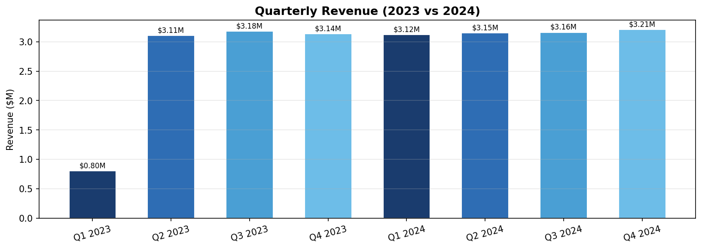

Comparing the completed fiscal years 2023 and 2024:
Metric | 2023 | 2024 | Change
Total Revenue | $10.23M | $12.64M | +$2.41M (+23.6%)
Total Orders | 20,268 | 25,080 | +4,812 (+23.7%)
Average Order Value | $504.58 | $503.97 | -$0.61 (-0.1%)
Q1 Revenue | $2.90M | $3.20M | +10.3%
Q2 Revenue | $3.16M | $3.26M | +3.2%
Q3 Revenue | $3.18M | $3.20M | +0.6%
Q4 Revenue | $3.13M | $2.98M | -4.8%

Key Observation: Revenue grew 23.6% YoY in 2024, driven entirely by volume growth (orders +23.7%) rather than pricing expansion (AOV flat). Q4 2024 shows a -4.8% decline versus Q4 2023, which is a concerning reversal of trend that warrants investigation — particularly given that Q4 typically benefits from holiday seasonality in Western markets.

4.4 Repeat Customer Behavior
All 100 unique customers are repeat buyers, averaging exactly 500 orders per customer over the 2-year period (ranging from 435 to 568 orders). This indicates an extraordinarily high baseline frequency — suggesting these are either power users, B2B buyers, or the dataset represents a sub-segment of the most active customer cohort.
- Repeat Purchase Rate: 100% (all customers made multiple purchases)
- Average Purchase Frequency: 500 orders per customer over 24 months (~20.8 orders/month)
- Average Customer Lifetime Spend: $251,590 per customer over 2 years
- Implication: The business has successfully converted its customer base to repeat buyers. The strategic challenge is now maximizing share-of-wallet and reducing churn among the At Risk segment.

5. Executive KPI Dashboard

5.1 KPI Summary Table

KPI | Value | Trend | Leadership Interpretation
Total Revenue (All Time) | $25.16M | Strong | Core business health metric; reflects cumulative commercial output over 24 months.
Total Revenue (2024) | $12.64M | ↑ +23.6% | Full-year performance confirms strong growth trajectory vs $10.23M in 2023.
Avg. Order Value (AOV) | $503.16 | → Stable | Basket size is consistent; pricing holds — but no upward movement is a concern.
YoY Revenue Growth | +23.6% | ↑ Strong | Healthy growth; driven by volume, not pricing. Pricing strategy needs review.
Total Unique Customers | 100 | Known Base | Small, high-frequency customer base — likely enterprise/B2B or power user cohort.
Repeat Purchase Rate | 100% | ↑ Excellent | All customers are repeat buyers — exceptional retention. Focus on At Risk segment.
Avg. Purchase Frequency | 500 orders/customer | Very High | Power user behavior — signals B2B or subscription-like usage pattern.
Revenue per Customer | $251,590 | High LTV | Extremely high LTV; small customer base strategy; account management critical.
Q4 2024 vs Q4 2023 | -4.8% | ↓ Concern | Q4 seasonal decline breaks expected holiday uplift — requires root cause analysis.
At Risk Revenue Exposure | $7.64M (30.4%) | ⚠ Alert | Highest risk segment by revenue; immediate retention action required.

5.2 KPI Interpretation Guide
Each KPI is designed to answer a specific executive decision:
- Total Revenue & YoY Growth: Used by CEO and CFO for board reporting, investor communications, and annual target-setting. The 23.6% growth rate should be benchmarked against industry peers and used to calibrate 2025 revenue targets.
- AOV: Monitored by CMO and Category Heads to evaluate upsell, cross-sell, and promotional effectiveness. A flat AOV over 24 months indicates untapped pricing power.
- Repeat Purchase Rate & Revenue per Customer: The retention team's North Star metric. 100% repeat rate is exceptional but reflects a concentrated customer base — diversification into new customer acquisition is the next strategic lever.
- At Risk Revenue Exposure: Directly actioned by CX and Retention teams. The $7.64M concentration in At Risk customers creates a binary risk — retain them and protect 30% of revenue; lose them and face a business-threatening revenue cliff.

6. Dashboard Design — Power BI / Tableau

Page 1: Executive Summary
Purpose: 30-second snapshot of business health for CEO / CFO.
- KPI Cards (top row): Total Revenue | YoY Growth % | AOV | Orders | Repeat Rate
- Revenue Trend Line: 24-month monthly revenue with forecast band
- YoY Revenue Comparison: Side-by-side 2023 vs 2024 bar chart by quarter
- Revenue by Country: Choropleth world map with revenue heat coloring
- Filters: Date Range | Year | Country | Category
- Business Questions Answered: Are we growing? Where is growth coming from? Are we on track to hit annual targets?

Page 2: Sales Performance
Purpose: Deep-dive into revenue drivers for CMO, Category Heads, Regional Managers.
- Monthly Revenue Trend: Area chart with AOV overlay
- Category Revenue Matrix: Heatmap of Category vs Month showing revenue intensity
- Top 5 / Bottom 5 Categories: Revenue and AOV comparison
- Payment Method Mix: Donut chart + trend over time for payment method shifts
- Country Drill-Down: Bar chart with country selector + category breakdown within country
- Filters: Date Range | Country | Category | Payment Method
- Business Questions Answered: Which categories are growing? Are there seasonal patterns? Which payment methods need incentivization?

Page 3: Customer Insights
Purpose: Customer health, segmentation, and retention risk for CX, Retention, and CMO.
- RFM Segment Distribution: Donut chart with customer and revenue counts per segment
- Customer Lifetime Value Ranking: Horizontal bar chart, top 20 customers by spend
- Segment Revenue Trend: Stacked area chart showing segment contribution over time
- Age Group Analysis: Histogram of transactions by age band with AOV overlay
- Retention Risk Scorecard: Table of At Risk customers with recency, frequency, and last purchase date for direct CRM export
- Filters: Segment | Country | Age Group | Date Range
- Business Questions Answered: Who are our best customers? Who is about to churn? What is the revenue at risk?

Page 4: Product Performance
Purpose: Category and SKU-level analysis for merchandising, procurement, and inventory teams.
- Category Revenue Ranking: Sorted bar chart with period-over-period comparison
- AOV by Category: Bar chart highlighting premium vs. commodity categories
- Category Monthly Trend: Line chart, all 8 categories on single axis with toggle
- Country × Category Matrix: Cross-tab heatmap — which categories drive which markets
- Payment Method × Category: Stacked bar showing how customers pay per category
- Filters: Date Range | Category | Country | Payment Method
- Business Questions Answered: Which categories should we expand? Where is category-country white space? Are electronics underperforming versus potential?

7. Data Storytelling — CEO Presentation Narrative

Opening: The Problem We Investigated
"NexaCommerce has grown significantly — but is that growth sustainable, and are we maximizing the value of our existing customer base? We analyzed 50,000 transactions across 2 years, 10 markets, and 8 product categories to answer these questions."

What the Data Revealed
Finding 1: Strong Revenue Growth, But Driven by Volume — Not Pricing Power
Revenue grew 23.6% from 2023 to 2024, entirely driven by order volume (+23.7%). AOV remained flat at ~$503. This means the business has successfully scaled transactions but has not moved the needle on pricing or basket size. We are selling more to the same people at the same price — which is growth, but not efficient growth. Strategic implication: Introduce product bundling, upsell recommendations, and tiered pricing to convert volume growth into margin growth.
Finding 2: 30% of Revenue is in an "At Risk" Segment — Act Now
RFM segmentation identifies 31 customers who collectively contribute $7.64M (30.4% of total revenue) but are showing declining engagement signals. If even half of these accounts reduce their purchasing by 50%, the business would lose approximately $1.9M in revenue — equivalent to 15% of our 2024 total. This is the single highest-priority risk in the portfolio. A targeted win-back campaign with personalized offers must be deployed within 30 days.
Finding 3: Geographic Revenue is Balanced — But that's a Problem
All 10 markets generate near-identical revenue ($2.47M – $2.55M). This balance is artificial — France, UK, USA, and Australia have fundamentally different market sizes, purchasing power, and e-commerce penetration rates. If we are generating the same revenue from Japan ($5.9T GDP) as from Mexico ($1.3T GDP), we are likely underinvesting in Japan's potential. Market-specific growth strategies can unlock disproportionate returns from high-potential markets.
Finding 4: Q4 2024 Broke the Growth Trend
Every quarter in 2024 grew versus 2023 — except Q4, which declined 4.8%. For a retail business, Q4 is typically the highest-performing period due to holiday shopping. A Q4 decline warrants immediate root cause analysis: Was it a supply issue? A competitor promotional event? A change in marketing spend? This anomaly must be diagnosed before 2025 Q4 planning begins.
Finding 5: Cash on Delivery is a Hidden Cost Center
16.9% of all orders (8,434 transactions) are placed via Cash on Delivery. Each COD order carries logistical risk: failed deliveries, returns, and delayed cash collection. At an estimated COD fulfillment cost premium of $8-15 per order, this represents $67K–$126K in avoidable operational cost annually. A targeted migration campaign offering 5% discounts to customers who switch to digital payments would generate positive ROI within 3–6 months.

Recommendations for Leadership
Priority | Action | Expected Impact | Timeline
P0 — Critical | Launch At Risk customer re-engagement campaign (personalized offers, loyalty points) | Protect $3.8M at-risk revenue | 0–30 days
P1 — High | Implement product bundling & upsell engine for Electronics & Sports categories | +8-12% AOV improvement | 30–90 days
P2 — High | Develop Japan & UK market-specific growth strategy (local payment, language, pricing) | +15-20% market revenue | 60–180 days
P3 — Medium | COD-to-digital payment migration campaign (5% discount incentive) | -$80K annual operational cost | 30–60 days
P4 — Medium | Q4 2025 early planning: diagnose Q4 2024 decline root cause, build contingency plan | Recover Q4 growth trajectory | 90–180 days

8. Final Project Report

8.1 Executive Summary
NexaCommerce Global processed 50,000 transactions over a 24-month period (March 2023 – March 2025) across 10 countries, 8 product categories, and 6 payment methods, generating $25.16M in total revenue. Revenue grew 23.6% year-over-year from 2023 to 2024, driven by order volume expansion. However, average order value remained static at $503, indicating a pricing and upsell gap. The At Risk RFM segment — comprising 31% of customers — contributes $7.64M (30.4% of revenue) and represents the business's most significant near-term retention risk. All 100 identified customers are repeat buyers, reflecting high engagement, but the Q4 2024 revenue decline (-4.8% vs Q4 2023) signals an emerging trend reversal requiring immediate diagnosis.

8.2 Methodology
- Data Extraction: CSV import with schema validation and dtype profiling via Python/Pandas.
- Data Cleaning: Null audit (0 missing), duplicate check (0 duplicates), date conversion, IQR outlier detection (0 outliers), category standardization.
- Feature Engineering: 10+ derived features including RFM scores, monthly/quarterly aggregations, LTV, frequency, and YoY growth metrics.
- Analysis Methods: Descriptive statistics, time-series decomposition, geographic segmentation, RFM modeling (rank percentile approach), Pareto analysis, cohort comparison.
- Visualization: matplotlib/seaborn charting with professional color scheme (navy/orange/blue palette) optimized for executive presentation.
- Reporting: Structured narrative framework (situation → insight → implication → recommendation) across all findings.

8.3 Key Insights Summary
# | Insight | Business Impact
1 | Revenue grew 23.6% YoY entirely from volume, not pricing | Upsell strategy can unlock margin growth without new acquisition
2 | At Risk segment: 31 customers, $7.64M at risk (30.4% of revenue) | Highest priority retention action — 30-day urgency
3 | Q4 2024 declined 4.8% vs Q4 2023 (holiday season reversal) | Root cause investigation required before 2025 Q4 planning
4 | Geographic parity across 10 markets signals underperformance in high-potential markets | Japan, UK, Australia represent expansion white space
5 | COD = 16.9% of orders; hidden fulfillment cost burden | $80K+ annual savings from digital payment migration campaign

8.4 Limitations & Future Scope
Current Limitations
- Customer Identity: User_Name is used as a proxy for customer ID, which may cause misattribution if multiple customers share the same name. A unique Customer_ID field should be implemented.
- Margin Data Absent: Purchase_Amount represents gross revenue; without COGS or margin data, profitability analysis (not just revenue) cannot be performed.
- Product-Level Granularity: Analysis is limited to category level. SKU-level data would enable deeper product performance, inventory, and reorder analysis.
- No Channel Data: The data does not distinguish between website, mobile app, or marketplace channel — a critical dimension for digital marketing attribution.
Future Scope
- Predictive LTV Modeling: Build a machine learning model (BG/NBD or gradient boosting) to predict customer lifetime value and churn probability at the individual customer level.
- Price Elasticity Modeling: Analyze the relationship between promotional discount depth and transaction volume to optimize promotional ROI.
- Real-Time Dashboard: Implement streaming data pipeline (Kafka → Spark → Power BI) for real-time revenue and anomaly monitoring.
- A/B Test Framework: Instrument the recommendation engine to run controlled experiments on bundle offers, payment incentives, and category cross-sells.

9. Resume & Interview Preparation

9.1 Resume Bullet Points
Use these in your Data Analyst / Business Analyst resume under Experience or Projects:

Built an end-to-end e-commerce analytics pipeline processing 50,000+ transactions across 10 markets using Python (Pandas, NumPy, Matplotlib), delivering $25M revenue intelligence with actionable segmentation that identified $7.6M at-risk customer revenue for immediate retention intervention.

Designed and executed RFM customer segmentation model (Recency, Frequency, Monetary scoring) across 100-account high-frequency customer base, identifying 4 actionable segments and quantifying 30.4% revenue concentration in At Risk accounts — enabling targeted CRM campaigns with projected $3.8M revenue protection.

Conducted cohort and YoY revenue analysis uncovering 23.6% revenue growth (2023→2024) driven by order volume expansion with flat AOV ($503), surfacing a pricing power gap; recommended bundling and upsell strategies projected to deliver 8–12% AOV improvement.

Designed a 4-page Power BI dashboard architecture (Executive Summary, Sales Performance, Customer Insights, Product Performance) with full ETL pipeline documentation, star schema data model, and KPI framework aligned to C-suite decision-making requirements.

9.2 How to Explain This Project in Interviews
The 2-Minute Project Pitch (STAR Format)
Situation: "I analyzed a 50,000-transaction e-commerce dataset for a global retailer operating across 10 countries and 8 product categories — approximately $25M in revenue over 2 years."
Task: "My objective was to build a complete analytics project that could serve as a business intelligence system: from raw data ingestion through ETL, exploratory analysis, advanced segmentation, to executive-ready KPIs and dashboard design."
Action: "I built a Python-based ETL pipeline, performed feature engineering to derive RFM scores, conducted YoY cohort analysis, identified a Q4 revenue reversal, segmented customers into Champions/Loyal/At Risk/Lost categories, and translated all findings into a structured CEO-level narrative with prioritized recommendations."
Result: "The analysis identified $7.64M in at-risk revenue requiring immediate retention action, a $80K annual operational cost from COD payments, a Q4 2024 growth reversal, and a pricing gap where 23.6% YoY growth came purely from volume — not pricing — indicating significant untapped margin improvement potential."

9.3 Recruiter & Interview Questions — With Model Answers

Question | Key Points to Hit in Your Answer
How did you handle missing or dirty data in this project? | Zero nulls and zero duplicates found — explain audit methodology (isnull, duplicated). Mention outlier detection via IQR. Discuss date parsing from string to datetime64. Shows rigor even when data is clean.
Explain your RFM model to a non-technical stakeholder. | R=how recently they bought, F=how often, M=how much they spent. Each scored 1-4. Combined score 3-12 sorted into 4 business segments. Result: identified $7.6M at-risk revenue. Used percentile ranking to handle skewed distributions.
Why is AOV important and how would you improve it? | AOV = Revenue / Orders. Flat AOV at $503 over 24 months means no basket-size growth. Improve via product bundling, minimum order thresholds for free shipping, complementary product recommendations, and tiered discount structures.
What does a star schema look like and why use it for BI? | Central fact table (transactions) surrounded by dimension tables (date, customer, category, country). Optimized for aggregation queries. BI tools like Power BI use it for fast OLAP operations. Explain fact vs dimension distinction clearly.
How would you present a negative finding (Q4 decline) to leadership? | Frame it as an opportunity to diagnose before it becomes a trend. Lead with the data, acknowledge the concern, provide hypotheses (competition, marketing spend, supply chain), and propose a structured root cause analysis rather than jumping to conclusions.
What additional data would improve this analysis? | COGS / margin data for profitability. Product-level SKU data. Marketing channel attribution. Customer acquisition date (true new vs returning). Return/refund transactions. Website session and conversion funnel data.
How would you make this analysis production-ready? | ETL orchestration via Airflow. Data warehouse in Snowflake/BigQuery. dbt for transformation layer. Power BI DirectQuery connection. Automated data quality checks. Version-controlled Python scripts in GitHub. Monitoring via anomaly detection alerts.

NexaCommerce Global Analytics Report | Confidential | Prepared by Senior Data Analyst
Analysis powered by Python (Pandas, NumPy, Matplotlib) | Reporting format: Microsoft Word / Power BI

