**1. Program to draw Circle, Rectangle, Line in Applet.**

import java.awt.*;  
import java.applet.*;  
  
public class CO5Q1 extends Applet {  
 public void paint(Graphics g) {  
 // Draw a circle  
 g.setColor(Color.red);  
 g.drawOval(50, 50, 100, 100);  
  
 // Draw a rectangle  
 g.setColor(Color.green);  
 g.drawRect(200, 50, 150, 100);  
  
 // Draw a line  
 g.setColor(Color.blue);  
 g.drawLine(50, 200, 350, 200);  
 }  
}  
  
/*  
<applet code="CO5Q1.class" width="500" height="500">  
</applet>

*/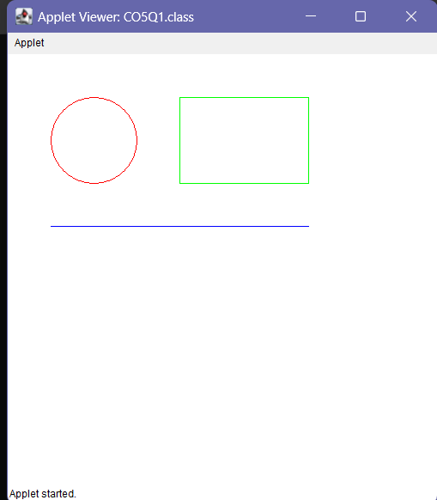

**2. Program to find maximum of three numbers using AWT.**

import java.awt.*;  
import java.awt.event.*;  
  
public class CO5Q2 extends Frame {  
 private TextField t1, t2, t3;  
 private Button button;  
 private Label resultLabel;  
  
 public CO5Q2() {  
 setTitle("Max Number Finder");  
 setSize(600, 300);  
 setLayout(new FlowLayout());  
  
 // Text fields  
 t1 = new TextField(10);  
 t2 = new TextField(10);  
 t3 = new TextField(10);  
 button = new Button("Find Maximum");  
  
 button.addActionListener(new ButtonClickListener());  
  
 resultLabel = new Label();  
  
 add(new Label("Enter three numbers:"));  
 add(t1);  
 add(t2);  
 add(t3);  
 add(button);  
 add(resultLabel);  
  
 addWindowListener(new WindowAdapter() {  
 public void windowClosing(WindowEvent e) {  
 dispose(); // Close the window  
 System.exit(0); // Terminate the application  
 }  
 });  
  
 setVisible(true);  
 }  
  
 private class ButtonClickListener implements ActionListener {  
 public void actionPerformed(ActionEvent e) {  
 int num1 = Integer.parseInt(t1.getText());  
 int num2 = Integer.parseInt(t2.getText());  
 int num3 = Integer.parseInt(t3.getText());  
 int max;  
  
 if (num1 >= num2 && num1 >= num3) {  
 max = num1;  
 } else if (num2 >= num1 && num2 >= num3) {  
 max = num2;  
 } else {  
 max = num3;  
 }  
  
 resultLabel.setText("Maximum number: " + max);  
 }  
 }  
  
 public static void main(String[] args) {  
 new CO5Q2();  
 }  
}

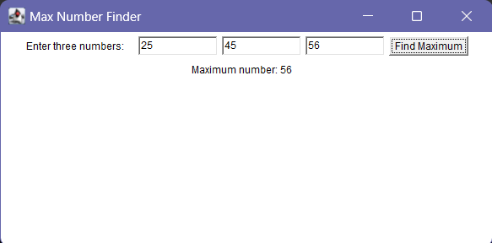

**3. Find the percentage of marks obtained by a student in 5 subjects. Display a happy face if he secures above 50% or a sad face if otherwise.**

import java.applet.*;  
import java.awt.*;  
import java.awt.event.*;  
public class CO5Q3 extends Applet implements ActionListener{  
 Label l1,l2,l3,l4,l5,l6;  
 TextField t1,t2,t3,t4,t5,t6;  
 Button btn;  
 public void init(){  
 l1 = new Label("Enter Mark 1 :");  
 t1 = new TextField();  
 l2 = new Label("Enter Mark 2 :");  
 t2 = new TextField();  
 l3 = new Label("Enter Mark 3 :");  
 t3 = new TextField();  
 l4 = new Label("Enter Mark 4 :");  
 t4 = new TextField();  
 l5 = new Label("Enter Mark 5 :");  
 t5 = new TextField();  
 l6 = new Label("PERCENTAGE :");  
 t6 = new TextField();  
 btn = new Button(" RESULT ");  
 setLayout(null);  
 l1.setBounds(50,50,80,20);  
 t1.setBounds(150,50,110,20);  
 l2.setBounds(50,80,80,20);  
 t2.setBounds(150,80,110,20);  
 l3.setBounds(50,110,80,20);  
 t3.setBounds(150,110,110,20);  
 l4.setBounds(50,140,80,20);  
 t4.setBounds(150,140,110,20);  
 l5.setBounds(50,170,80,20);  
 t5.setBounds(150,170,110,20);  
 l6.setBounds(50,200,100,20);  
 t6.setBounds(150,200,100,20);  
 btn.setBounds(50,230,90,30);  
 add(l1);  
 add(l2);  
 add(l3);  
 add(l4);  
 add(l5);  
 add(l6);  
 add(t1);  
 add(t2);  
 add(t3);  
 add(t4);  
 add(t5);  
 add(t6);  
 add(btn);  
 btn.addActionListener(this);  
 }  
 public void actionPerformed(ActionEvent e)  
 {  
 float m1,m2,m3,m4,m5,Percentage,total;  
 m1=Float.parseFloat(t1.getText());  
 m2=Float.parseFloat(t2.getText());  
 m3=Float.parseFloat(t3.getText());  
 m4=Float.parseFloat(t4.getText());  
 m5=Float.parseFloat(t5.getText());  
 total = m1+m2+m3+m4+m5;  
 Percentage =(total*100)/500;  
 t6.setText(String.valueOf(Percentage));  
 repaint();  
  
 }  
 public void paint(Graphics g){  
 float p;  
 p=Float.parseFloat(t6.getText());  
 if(p>50)  
 {  
 g.drawOval(80,300,240,240);  
 g.drawOval(130,350,50,50);  
 g.drawOval(220,350,50,50);  
 g.drawArc(150,400,100,90,200,150);  
 }  
 else{  
 g.drawOval(80,300,240,240);  
 g.drawOval(130,350,50,50);  
 g.drawOval(220,350,50,50);  
 g.drawArc(150,450,100,90,15,150);  
 }  
 }  
}  
  
/*  
<applet code="CO5Q3.class" width="500" height="500">  
</applet>  
*/

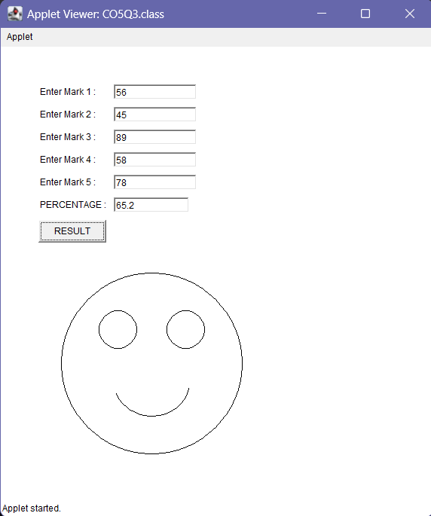

**4. Using 2D graphics commands in an Applet, construct a house. On mouse click event, change the color of the door from blue to red.**

import java.awt.*;  
import java.applet.*;  
import java.awt.event.*;  
  
public class CO5Q4 extends Applet implements MouseListener {  
 int a, b;  
  
 public void init() {  
 addMouseListener(this);  
 }  
  
 public void paint(Graphics g) {  
 int x[] = { 200, 400, 300 };  
 int y[] = { 200, 200, 50 };  
 g.drawPolygon(x, y, 3);  
 g.setColor(Color.black);  
 g.fillPolygon(x, y, 3);  
 g.drawRect(200, 200, 200, 300); // House  
 g.setColor(Color.pink);  
 g.fillRect(200, 200, 200, 300);  
 g.drawRect(275, 350, 50, 150); // Door  
 g.setColor(Color.blue);  
 g.fillRect(275, 350, 50, 150);  
 if (a > 275 && a < 325 && b > 350 && b < 500) {  
 g.setColor(Color.red);  
 g.fillRect(275, 350, 50, 150);  
 }  
 }  
 public void mouseClicked(MouseEvent e) {  
 }  
 public void mouseEntered(MouseEvent e) {  
 }  
 @Override  
 public void mouseExited(MouseEvent e) {  
 }  
 public void mousePressed(MouseEvent e) {  
 a = e.getX();  
 b = e.getY();  
 repaint();  
 }  
 public void mouseReleased(MouseEvent e) {  
 }  
 public static void main(String[] args) {  
 CO5Q4 applet = new CO5Q4();  
 Frame frame = new Frame("House Door Applet");  
 frame.add(applet);  
 frame.setSize(800, 600);  
 applet.init();  
 applet.start();  
 frame.setVisible(true);  
 }  
}  
/*  
 * <applet code="CO5Q4.class" width="600" height="600">  
 * </applet>  
 */

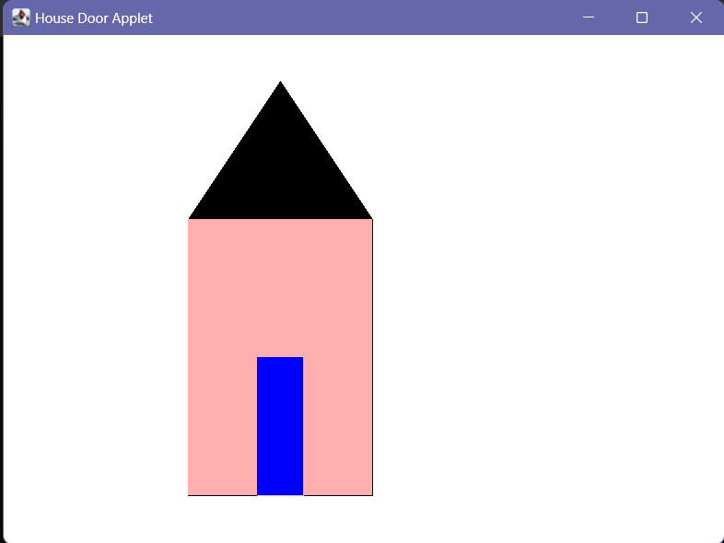

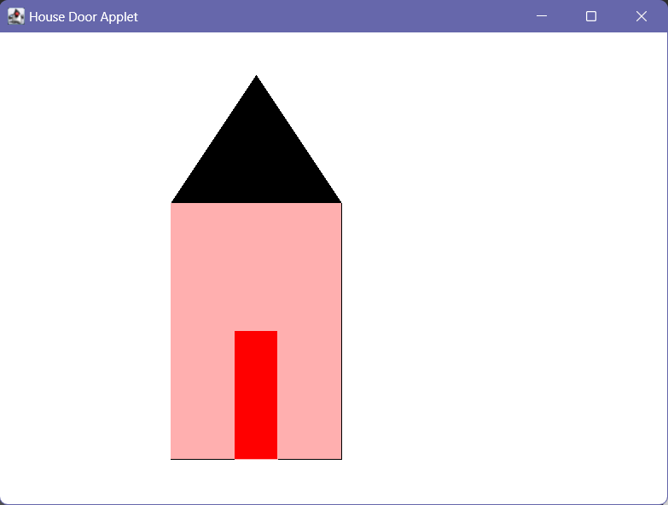

**5. Implement a simple calculator using AWT components.**

import java.awt.*;  
import java.awt.event.*;  
  
public class CO5Q5 extends Frame implements ActionListener {  
 TextField tInput;  
 Panel panel;  
 String btnString[] = {"7", "8", "9", "+",  
 "4", "5", "6", "-",  
 "1", "2", "3", "*",  
 "C", "0", "=", "/"};  
 Button btn[] = new Button[16];  
 int num1 = 0, num2 = 0, result = 0;  
 char op;  
  
 public CO5Q5() {  
 Font f = new Font("Cambria", Font.BOLD, 18);  
 tInput = new TextField(10);  
 tInput.setFont(f);  
  
 panel = new Panel();  
 add(tInput, "North");  
 add(panel, "Center");  
 panel.setLayout(new GridLayout(4, 4));  
 for (int i = 0; i < 16; i++) {  
 btn[i] = new Button(btnString[i]);  
 btn[i].setFont(f);  
 btn[i].addActionListener(this);  
 panel.add(btn[i]);  
 }  
 addWindowListener(new WindowAdapter() {  
 public void windowClosing(WindowEvent we) {  
 System.exit(0);  
 }  
 });  
 }  
  
 public void actionPerformed(ActionEvent ae) {  
 String str = ae.getActionCommand();  
 if (str.equals("+")) {  
 op = '+';  
 if (!tInput.getText().isEmpty()) {  
 num1 = Integer.parseInt(tInput.getText());  
 }  
 tInput.setText("");  
 } else if (str.equals("-")) {  
 op = '-';  
 if (!tInput.getText().isEmpty()) {  
 num1 = Integer.parseInt(tInput.getText());  
 }  
 tInput.setText("");  
 } else if (str.equals("*")) {  
 op = '*';  
 if (!tInput.getText().isEmpty()) {  
 num1 = Integer.parseInt(tInput.getText());  
 }  
 tInput.setText("");  
 } else if (str.equals("/")) {  
 op = '/';  
 if (!tInput.getText().isEmpty()) {  
 num1 = Integer.parseInt(tInput.getText());  
 }  
 tInput.setText("");  
 } else if (str.equals("=")) {  
 if (!tInput.getText().isEmpty()) {  
 num2 = Integer.parseInt(tInput.getText());  
 }  
 switch (op) {  
 case '+':  
 result = num1 + num2;  
 break;  
 case '-':  
 result = num1 - num2;  
 break;  
 case '*':  
 result = num1 * num2;  
 break;  
 case '/':  
 result = num1 / num2;  
 break;  
 }  
 tInput.setText(String.valueOf(result));  
 num1 = result;  
 } else if (str.equals("C")) {  
 tInput.setText("");  
 num1 = 0;  
 num2 = 0;  
 result = 0;  
 } else {  
 tInput.setText(tInput.getText() + str);  
 }  
 }  
  
 public static void main(String[] args) {  
 CO5Q5 calc = new CO5Q5();  
 calc.setSize(300, 300);  
 calc.setVisible(true);  
 }  
}

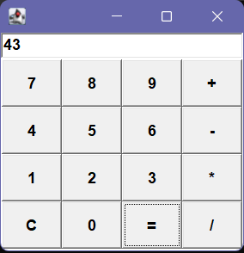

**6. Develop a program that has a Choice component which contains the names of shapes such as rectangle, triangle, square and circle. Draw the corresponding shapes for given parameters as per user’s choice.**

import java.awt.*;  
import java.awt.event.*;  
import java.applet.*;  
  
public class CO5Q6 extends Applet implements ActionListener {  
 Button rectangleButton;  
 Button triangleButton;  
 Button squareButton;  
 Button circleButton;  
  
 String selectedShape;  
  
 public void init() {  
 rectangleButton = new Button("Rectangle");  
 triangleButton = new Button("Triangle");  
 squareButton = new Button("Square");  
 circleButton = new Button("Circle");  
  
 rectangleButton.addActionListener(this);  
 triangleButton.addActionListener(this);  
 squareButton.addActionListener(this);  
 circleButton.addActionListener(this);  
  
 add(rectangleButton);  
 add(triangleButton);  
 add(squareButton);  
 add(circleButton);  
 }  
  
 public void paint(Graphics g) {  
 if (selectedShape != null) {  
 if (selectedShape.equals("Rectangle")) {  
 g.drawRect(50, 50, 200, 100);  
 } else if (selectedShape.equals("Triangle")) {  
 int[] xPoints = {150, 50, 250};  
 int[] yPoints = {50, 150, 150};  
 g.drawPolygon(xPoints, yPoints, 3);  
 } else if (selectedShape.equals("Square")) {  
 g.drawRect(50, 50, 100, 100);  
 } else if (selectedShape.equals("Circle")) {  
 g.drawOval(100, 100, 150, 150);  
 }  
 }  
 }  
  
 public void actionPerformed(ActionEvent e) {  
 Button clickedButton = (Button) e.getSource();  
 selectedShape = clickedButton.getLabel();  
 repaint();  
 }  
}  
  
/*  
 * <applet code="CO5Q6.class" width="600" height="600">  
 * </applet>  
 */

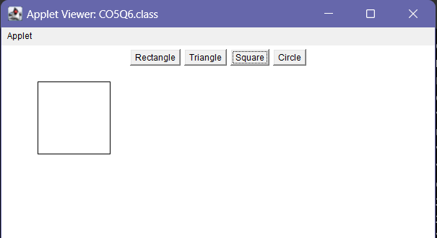

**7. Develop a program to handle all mouse events and window events**

import java.awt.*;  
import java.awt.event.*;  
  
public class CO5Q7 extends Frame  
 implements MouseListener, MouseMotionListener, WindowListener {  
  
 public CO5Q7() {  
 // Set the frame properties  
 setTitle("Event Handling Example");  
 setSize(400, 300);  
  
 // Add event listeners  
 addMouseListener(this);  
 addMouseMotionListener(this);  
 addWindowListener(this);  
 }  
  
 public void paint(Graphics g) {  
 g.drawString("Move the mouse or click the mouse buttons", 20, 50);  
 }  
  
 // MouseListener methods  
 public void mouseClicked(MouseEvent e) {  
 System.out.println("Mouse Clicked");  
 }  
  
 public void mouseEntered(MouseEvent e) {  
 System.out.println("Mouse Entered");  
 }  
  
 public void mouseExited(MouseEvent e) {  
 System.out.println("Mouse Exited");  
 }  
  
 public void mousePressed(MouseEvent e) {  
 System.out.println("Mouse Pressed");  
 }  
  
 public void mouseReleased(MouseEvent e) {  
 System.out.println("Mouse Released");  
 }  
  
 // MouseMotionListener methods  
 public void mouseDragged(MouseEvent e) {  
 System.out.println("Mouse Dragged: " + e.getX() + ", " + e.getY());  
 }  
  
 public void mouseMoved(MouseEvent e) {  
 System.out.println("Mouse Moved: " + e.getX() + ", " + e.getY());  
 }  
 // WindowListener methods  
 public void windowClosing(WindowEvent e) {  
 System.out.println("Window Closing");  
 dispose();  
 }  
 public void windowOpened(WindowEvent e) {  
 System.out.println("Window Opened");  
 }  
 public void windowClosed(WindowEvent e) {  
 System.out.println("Window Closed");  
 }  
 public void windowIconified(WindowEvent e) {  
 System.out.println("Window Iconified");  
 }  
 public void windowDeiconified(WindowEvent e) {  
 System.out.println("Window Deiconified");  
 }  
 public void windowActivated(WindowEvent e) {  
 System.out.println("Window Activated");  
 }  
 public void windowDeactivated(WindowEvent e) {  
 System.out.println("Window Deactivated");  
 }  
 public static void main(String[] args) {  
 CO5Q7 frame = new CO5Q7();  
 frame.setVisible(true);  
 }  
}

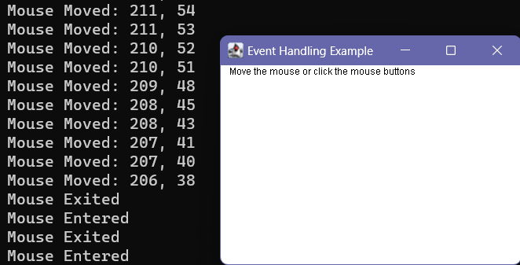

**8. Develop a program to handle Key events**

import java.awt.*;  
import java.awt.event.*;  
  
public class CO5Q8 extends Frame implements KeyListener {  
 public CO5Q8() {  
 // Set the frame properties  
 setTitle("Key Event Example");  
 setSize(400, 300);  
  
 // Add the key listener  
 addKeyListener(this);  
 }  
 public void paint(Graphics g) {  
 g.drawString("Press any key", 20, 50);  
 }  
 // KeyListener methods  
 public void keyPressed(KeyEvent e) {  
 System.out.println("Key Pressed: " + e.getKeyChar());  
 }  
 public void keyReleased(KeyEvent e) {  
 System.out.println("Key Released: " + e.getKeyChar());  
 }  
 public void keyTyped(KeyEvent e) {  
 System.out.println("Key Typed: " + e.getKeyChar());  
 }  
 public static void main(String[] args) {  
 CO5Q8 frame = new CO5Q8();  
 frame.setVisible(true);  
 }  
}

