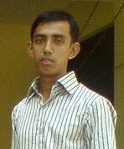
CURICULAM VITA OF 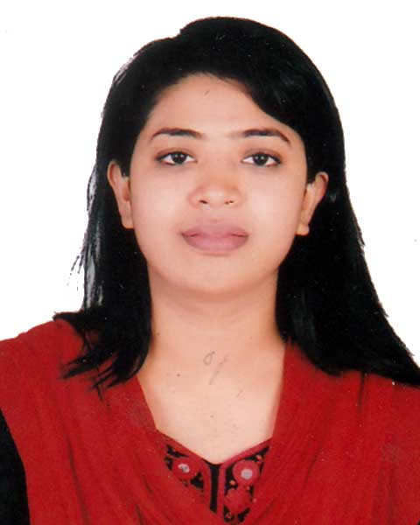
Sabiha Aziz.
C/O : Azizul Haque Heron
Address:- Vill+Post: Dhalgram
Upazila: Kashiani, District: Gopalgonj, Bangladesh
Mobile No.: 01750494684
Email:sabiaazizgj@yahoo.com

Career Objective:
Building up career in a challenging position at a challenging organization where creativity, sincerity, skill and performance are at the heart of one’s appraisal and recognition.

Exam Title | Major | Course Duration | Passing Year | Institution | GPA/CGPA
Msc Engg(CSE) | Computer Science & Engineering | On going | On going | Jessore Science & Technology University, Jessore. | On going
BSc Engg. (CSE) | Computer Science & Engineering | 4 years | 2014 | Jessore Science & Technology University, Jessore. | 3.21 out of 4.00
H.S.C | Science | 2 years | 2008 | Sheikh Fazilatunnessa Mohila College. | 4.00 Out of 5.00
S.S.C | Science | 10 years | 2006 | Fukra M.M. Academy. | 4.44 Out of 5.00

Personal Skills:
- Flexible, adaptable, and both willing and able to learn quickly.
- Able to generate innovative ideas & Capable of working efficiently under high pressure.
- Constructive and diplomatic team player with strong communication skills.

Computer Skills:
Computing: Expert on OS: Windows (XP, 7, 8), Linux Mint, Ubuntu, , MS Word, Adobe Photoshop, Adobe Illustrator.

Mobile Apps Dev.: Familiar about Android, iOS, Windows Phone.

Web Dev.: PHP, HTML, HTML5, CSS, JavaScript, jQuery,PSDH2ML, CSS3

Database: MySQL, MS SQL-2005, 2008, MS Access.
Programming Languages: Objective C, CPP, C#, Java.

Network Protocols, Applications and Utilities: Configuration of DNS, Web Server, Mail Server, VLAN, Routing Configuring.

IDE’s: Dreamweaver, Visual Studio-2008, 2010, Eclipse, Net beans IDE, Notepad++, Turbo C.

Others Skills:
Language: Fluent in Bengali and English.
Communication: Able to speak and write clearly convincingly.

Implementation (Completed Project: Academy) Based Specialization:

Project Name: Bank Transaction Management System
Language: C, C++;
Role: Design and implementation

Project Name: Bank Transaction Management System
Language: C# & sql
Platform: Visual Studio 2008
Role: Design and partial implementation

Project Name: Online Clinic Management System
Language: PHP, HTML, CSS
Platform: PHPStorm
Role: Design and implementation

Project Name: Online Tourism Company
Language: PHP, HTML, CSS
Platform: PhpStorm
Role: Design and implementation

Professional Skills:
Employer: Working as Junior Quality Assurance Engineer in W3Engineers from 2015. Details are given bellow:
- I can make Test Scenarios, Test Plans and Test Objectives and Maintaining documentation task.
- I can prepare Test Case for specific project.
- I have some knowledge about JIRA Test Management Tools.
- I can evaluate manual test case and report test result..
- I can identify any type of issue. Such as, Functional issue and UI issue.

Certificates:
Certificate on Android Mobile Application from Ministry of Information and Communication Technology (MOICT)

Certificate on Basic Network Design & Deployment from Network Development Learning Center (NDLC)

Certificate on Campus Network Design & Deployment from Network Development Learning Center (NDLC)

Language Proficiency:
Language | Reading | Writing | Speaking
Bengali | High | High | High
English | High | High | High

Personal Information

Name : Sabiha Aziz
Father’s Name: Azizul Haque Heron
Mother’s Nam : Sultana Aziz
Date of Birth: 30th April, 1991
Present Address: Village: Dhalgram, Post: Dhalgram, Upazila: Kashiani, District: Gopalgonj;
Permanent Address: Village: Dhalgram, Post: Dhalgram, Upazila: Kashiani, District: Gopalgonj;
Religion : Muslim (sunni)
Nationality : Bangladeshi (by birth)
Sex : Female
Height : 5’ 2”
Blood Grou: o (+ve)
Marital Status: Single

REFERENCE

1. Md Alam Hossain
Assistant Professor
Computer Science & Engineering Discipline
Jessore University of Science and Technology
Contact No:+8801913580057

2. Commodors S M kamrul Hoque (L),ndc,psc
Director General (RD& E).
Sena Kalyan Sangstha
Contact No-01730334041

I affirm that the information given here in is true and accurate to the best of my knowledge and belief.

Sabiha Aziz.

