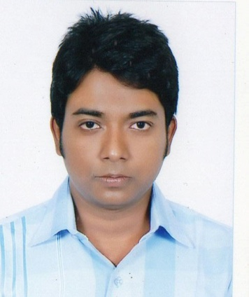**CURRICULAM VITAE**

**Md. Mustafizur Rahman**

**Mobile**  : +8801739116166

**Email** : [mustafizur08@ymail.com](mailto:mustafizur08@ymail.com)

**Career Object:**

To build up a highly professional working skill working with a renowned organization and tie up own knowledge and experience and the employee’s expectation in order to meet the goal with success.

**Personal Information:**

**Name** : Md. Mustafizur Rahman

**Father’s Name**  : Md. Ashraf Ali Sikder

**Mother’s Name** : Mst. Sefali Begum

**Date of Birth** : 22nd Feb 1993

**Religion**  : Islam

**Nationality** : Bangladeshi

**Sex** : Male

**Marital Status** : Unmarried

**Height** : 5 Feet 6.5 Inch

**Weight**  : 68 Kgs

**Contact Information:**

**Present Address** : House no: 17, Road no: 2, Block: H, Mirpur-2, Dhaka-1216.

**Permanent Address** : Vill:Kumarkota, Post: Arpara, Upz: Shalikha, Dist: Magura.

**Academic Qualification:**

|  |  |  |  |  |
| --- | --- | --- | --- | --- |
| **Name of Exam** | **Group** | **Board/Institute** | **Result** | **Passing Year** |
| **S.S.C** | **Science** | **Jessore** | **G.P.A – 4.75** | **2008** |
| **Diploma in engineering** | **Computer** | **Bangladesh Technical Education Board ( Jessore polytechnic Institute)** | **C.G.P.A –**  **2.87** | **2014** |

**Professional Qualification:**

Web design and development . I have experienced in HTML,PHP,MYSQL language.

**Learning Center** : New Horizons

**Address**  : Momtaz Plaza (3rd Floor), House # 7, Road # 4, Dhanmondi R/A,

Dhaka-1205, Bangladesh

**Interest:**

Research and development, creative work, social activities, reading books & famous magazines, travelling, playing cricket & football.

**Language Proficiency:**

Proficiency in both oral and written skills in Bangla and English.

**Career And Application Information:**

**Looking for** : Entry Level Job

**Available For** : Full Time

**Preferred Job Category**  : Any Suitable Job

**Preferred District** : Any Where In Bangladesh

**Preferred Organization:**

Multinational organizations, National organizations & Govt. organizations.

**Declaration:**

I do hereby declare that the above information is true and correct to the best of my knowledge.

**Date:** …………….……………………………………………….

**(Md.Mustafizur Rahman)**