**Ticket# RND-59**

|  |  |  |  |  |  |
| --- | --- | --- | --- | --- | --- |
| **Sl** | **Date** | **Ver** | **Description** | **Changed by** | **Approved/Reviewed by** |
| 01 | 12-April-22 | 1.0 | Python Doc Generator | MD. SAHIDUL ISLAM  JR. SOFTWARE ENGINEER |  |

**Description**

We will be describing how to generate doc or docx files using python.

**Prerequisite**

You must be able to install Python (2.6 or higher) on the machine where you plan to run the script. Pycharm will be an bonus to work on python files.

Download links:

1. Python ([python](https://www.python.org/downloads/))
2. PyCharm ([PyCharm](https://www.jetbrains.com/pycharm/download))

**Installation Process**

## Step 1 − Select Version of Python to Install

Python has various versions available with differences between the syntax and working of different versions of the language. We need to choose the version which we want to use or need. There are different versions of Python 2 and Python 3 available.

## Step 2 − Download Python Executable Installer

On the web browser, in the official site of python ([www.python.org](https://www.tutorialspoint.com/www.python.org)), move to the Download for Windows section.

All the available versions of Python will be listed. Select the version required by you and click on Download. Let suppose, we chose the Python 3.9.1 version.

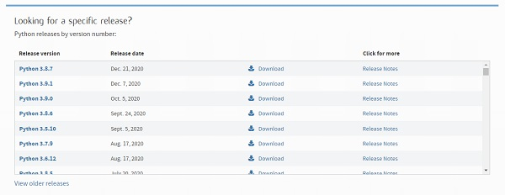

On clicking download, various available executable installers shall be visible with different operating system specifications. Choose the installer which suits your system operating system and download the instlaller. Let suppose, we select the Windows installer(64 bits).

The download size is less than 30MB.

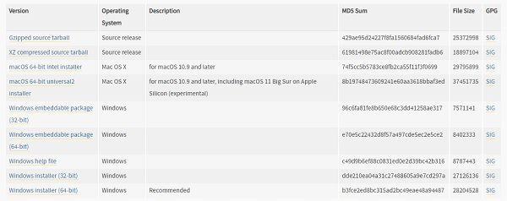

## Step 3 − Run Executable Installer

We downloaded the Python 3.9.1 Windows 64 bit installer.

Run the installer. Make sure to select both the checkboxes at the bottom and then click Install New.

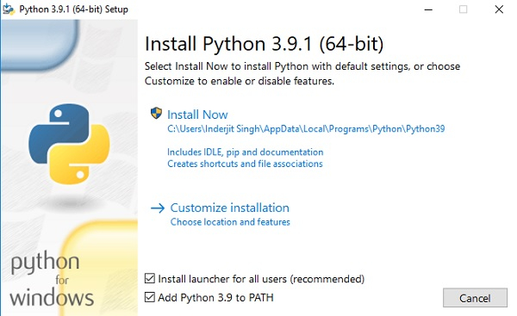

On clicking the Install Now, The installation process starts.

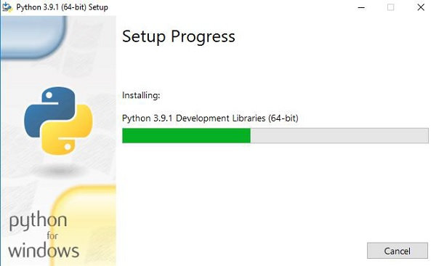

The installation process will take few minutes to complete and once the installation is successful, the following screen is displayed.

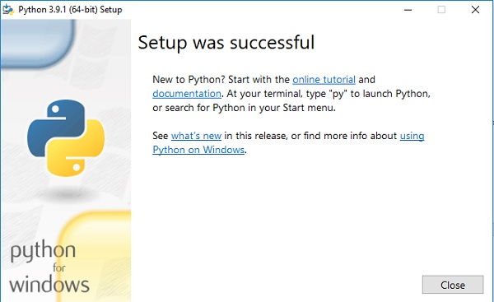

## Step 4 − Verify Python is installed on Windows

To ensure if Python is succesfully installed on your system. Follow the given steps −

* Open the command prompt.
* Type ‘python’ and press enter.
* The version of the python which you have installed will be displayed if the python is successfully installed on your windows.

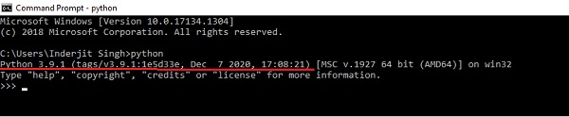

## Step 5 − Verify Pip was installed

Pip is a powerful package management system for Python software packages. Thus, make sure that you have it installed.

To verify if pip was installed, follow the given steps −

* Open the command prompt.
* Enter pip –V to check if pip was installed.
* The following output appears if pip is installed successfully.

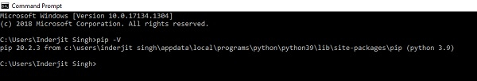

We have successfully installed python and pip on our Windows system.

To install pycharm : <https://www.jetbrains.com/help/pycharm/installation-guide.html#toolbox>

To create a blank project in pycharm : <https://www.jetbrains.com/help/pycharm/creating-empty-project.html>

Note: You can use any IDE as per your preference.

**Installing Required Packages**

* Open Terminal on PyCharm
* Run Commands:

pip/pip3 install matplotlib

pip/pip3 install docX

**Let’s Start Coding**

# Open_template.py

* To learn about docX and its functionality’s: <https://python-docx.readthedocs.io/en/latest/>
* The demo project uses a template “INTERNAL AUDIT REPORT.docx”, edits this file and produces the output file “template_output.docx”
* The output data is from dictionaries (example: coverPageDict: Contains data of cover page).

To edit paragraphs (a line can be a paragraph) we use pre-defined code words to replace it with data from these dictionaries.

* + In code: paragraph.text = coverPageDict[paragraph.text.strip()]
* The effect: 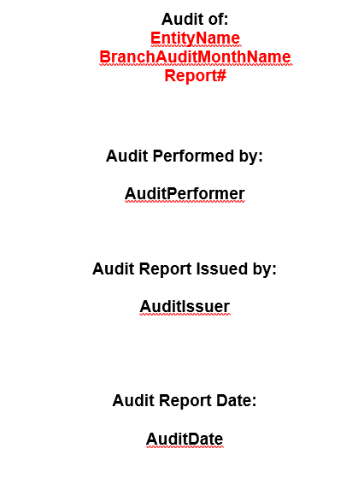 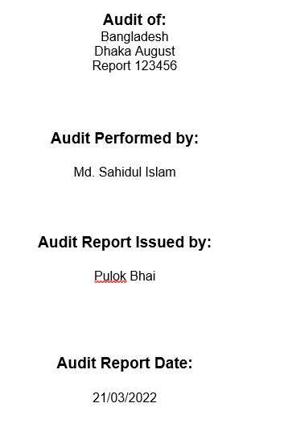

Template 🡺 Output

It uses the dictionary: coverPageDict = {"EntityName": "Bangladesh", "BranchAuditMonthName": "Dhaka August", "Report#": "Report 123456",  
 "AuditPerformer": "Md. Sahidul Islam", "AuditIssuer": "Pulok Bhai", "AuditDate": "21/03/2022"}

To add/edit header/footer go to the headerfooter section and add/edit paragraphs with stylings.

section = document.sections[section]  
header = section.header  
paragraph = header.paragraphs[0]  
paragraph.text = "\t\tReport No: 123456"  
paragraph.style = document.styles["Header"]

To edit table cells, use cell method of table to change the values of these cells. Example:

table.cell(0, 1).text = detailedIssueTableContent["IssueTitle"]

To add/edit chart:

* Use matplotlib to generate chart and then insert this as an image to the doc.
* In the demo project, GraphMaker generates the chart.

For detailed information: <https://python-docx.readthedocs.io/en/latest/>

# Servermaker.py

This python script is for making a server, which expects a json file containing the dictionary key-value pairs and data for making the graph. Here is the example json:

{

    "coverPageDict": {

        "EntityName": "Bangladesh",

        "BranchAuditMonthName": "Dhaka August",

        "Report#": "Report 123456",

        "AuditPerformer": "Md. Sahidul Islam",

        "AuditIssuer": "Pulok Bhai",

        "AuditDate": "21/03/2022"

    },

    "sectionData": {

        "ContentOfEnvironment": "Environment Content",

        "ContentOfScope": "Scope Content",

        "ContentOfOpinion": "Opinion Content"

    },

    "detailedIssueTableContent": {

        "IssueTitle": "Shezan Bhai",

        "IssueOwner": "Rahimin bhai",

        "IssueRating": "Five star",

        "IssueTargetDate": "23-03-2022",

        "IssueDescription": "Le Lorem Ipsum est simplement du faux texte employé dans la composition et la mise en page avant impression. Le Lorem Ipsum est le faux texte standard de l'imprimerie depuis les années 1500, quand un imprimeur anonyme assembla ensemble des morceaux de texte pour réaliser un livre spécimen de polices de texte. Il n'a pas fait que survivre cinq siècles, mais s'est aussi adapté à la bureautique informatique, sans que son contenu n'en soit modifié. Il a été popularisé dans les années 1960 grâce à la vente de feuilles Letraset contenant des passages du Lorem Ipsum, et, plus récemment, par son inclusion dans des applications de mise en page de texte, comme Aldus PageMaker."

    },

    "graph": {

        "graphData": {

            "xAxis": {

                "data": [1, 2, 3, 4, 5]

            },

            "yAxis": {

                "data": ["Insignificant", "Minor", "Moderate", "Major", "Catastrophic"]

            }

        }

    }

}

# GraphMaker.py

The purpose of this script is to generate a PNG file (graph) from the given data in the request Json.