**Assignment 4**

**Name: Sahil Mahendra Mody**

**CWID: 20007262**

**Network (G) = (N, A),**

N is a set of nodes (vertex) indexed by i, j $∈$ N

A is a set of links (edges) indexed by (i, j)

Xij => flow i -> j, where i, j $∈$ N

Xij Capij (i, j) $∈$ A

**Supply Constraints:**

- Si, i $∈$ N+

**Demand Constraints:**

- - Fi, i $∈$ N-

Xij Capij (i, j) $∈$ A

Fi 0, $∀$ i $∈$ N-

Fi Di

Di 0, (i, j) $∈$ A

Xij $≥$ 0

**Objective Function**

**Z = Zmin $\frac{\sum_{i ∈ N_{-}}{D_{i}} - \sum_{i ∈ N_{-}}{F_{i}}}{\sum_{i ∈ N_{-}}{D_{i}}}$**

**Network Graph:**

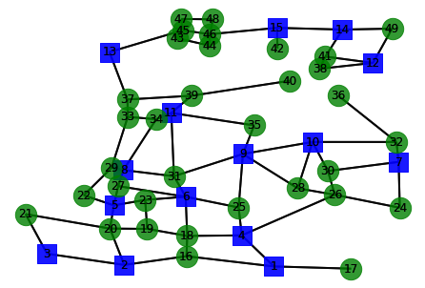

* **Comparison**

**In part 3, we received results as:**

* Solved in 18 iterations and 0.01 seconds (0.00 work units)
* Optimal objective: -2.220446049e-16
* Optimal value: $ -2.220446049250313e-16

We solved in 18 iterations first and we got the optimal value as -2.220446049e-16

**After removing the first 5 nodes ranked based on degree centrality**:

* Solved in 7 iterations and 0.01 seconds (0.00 work units)
* Optimal objective: 3.109327984e-02
* Optimal value: $ 0.031093279839518595

We solved in 7 iterations after removing the first 5 nodes ranked based on degree centrality and we got the optimal value as 3.109327984e-02.

We got more optimum solution after removing the nodes based on degree centrality.