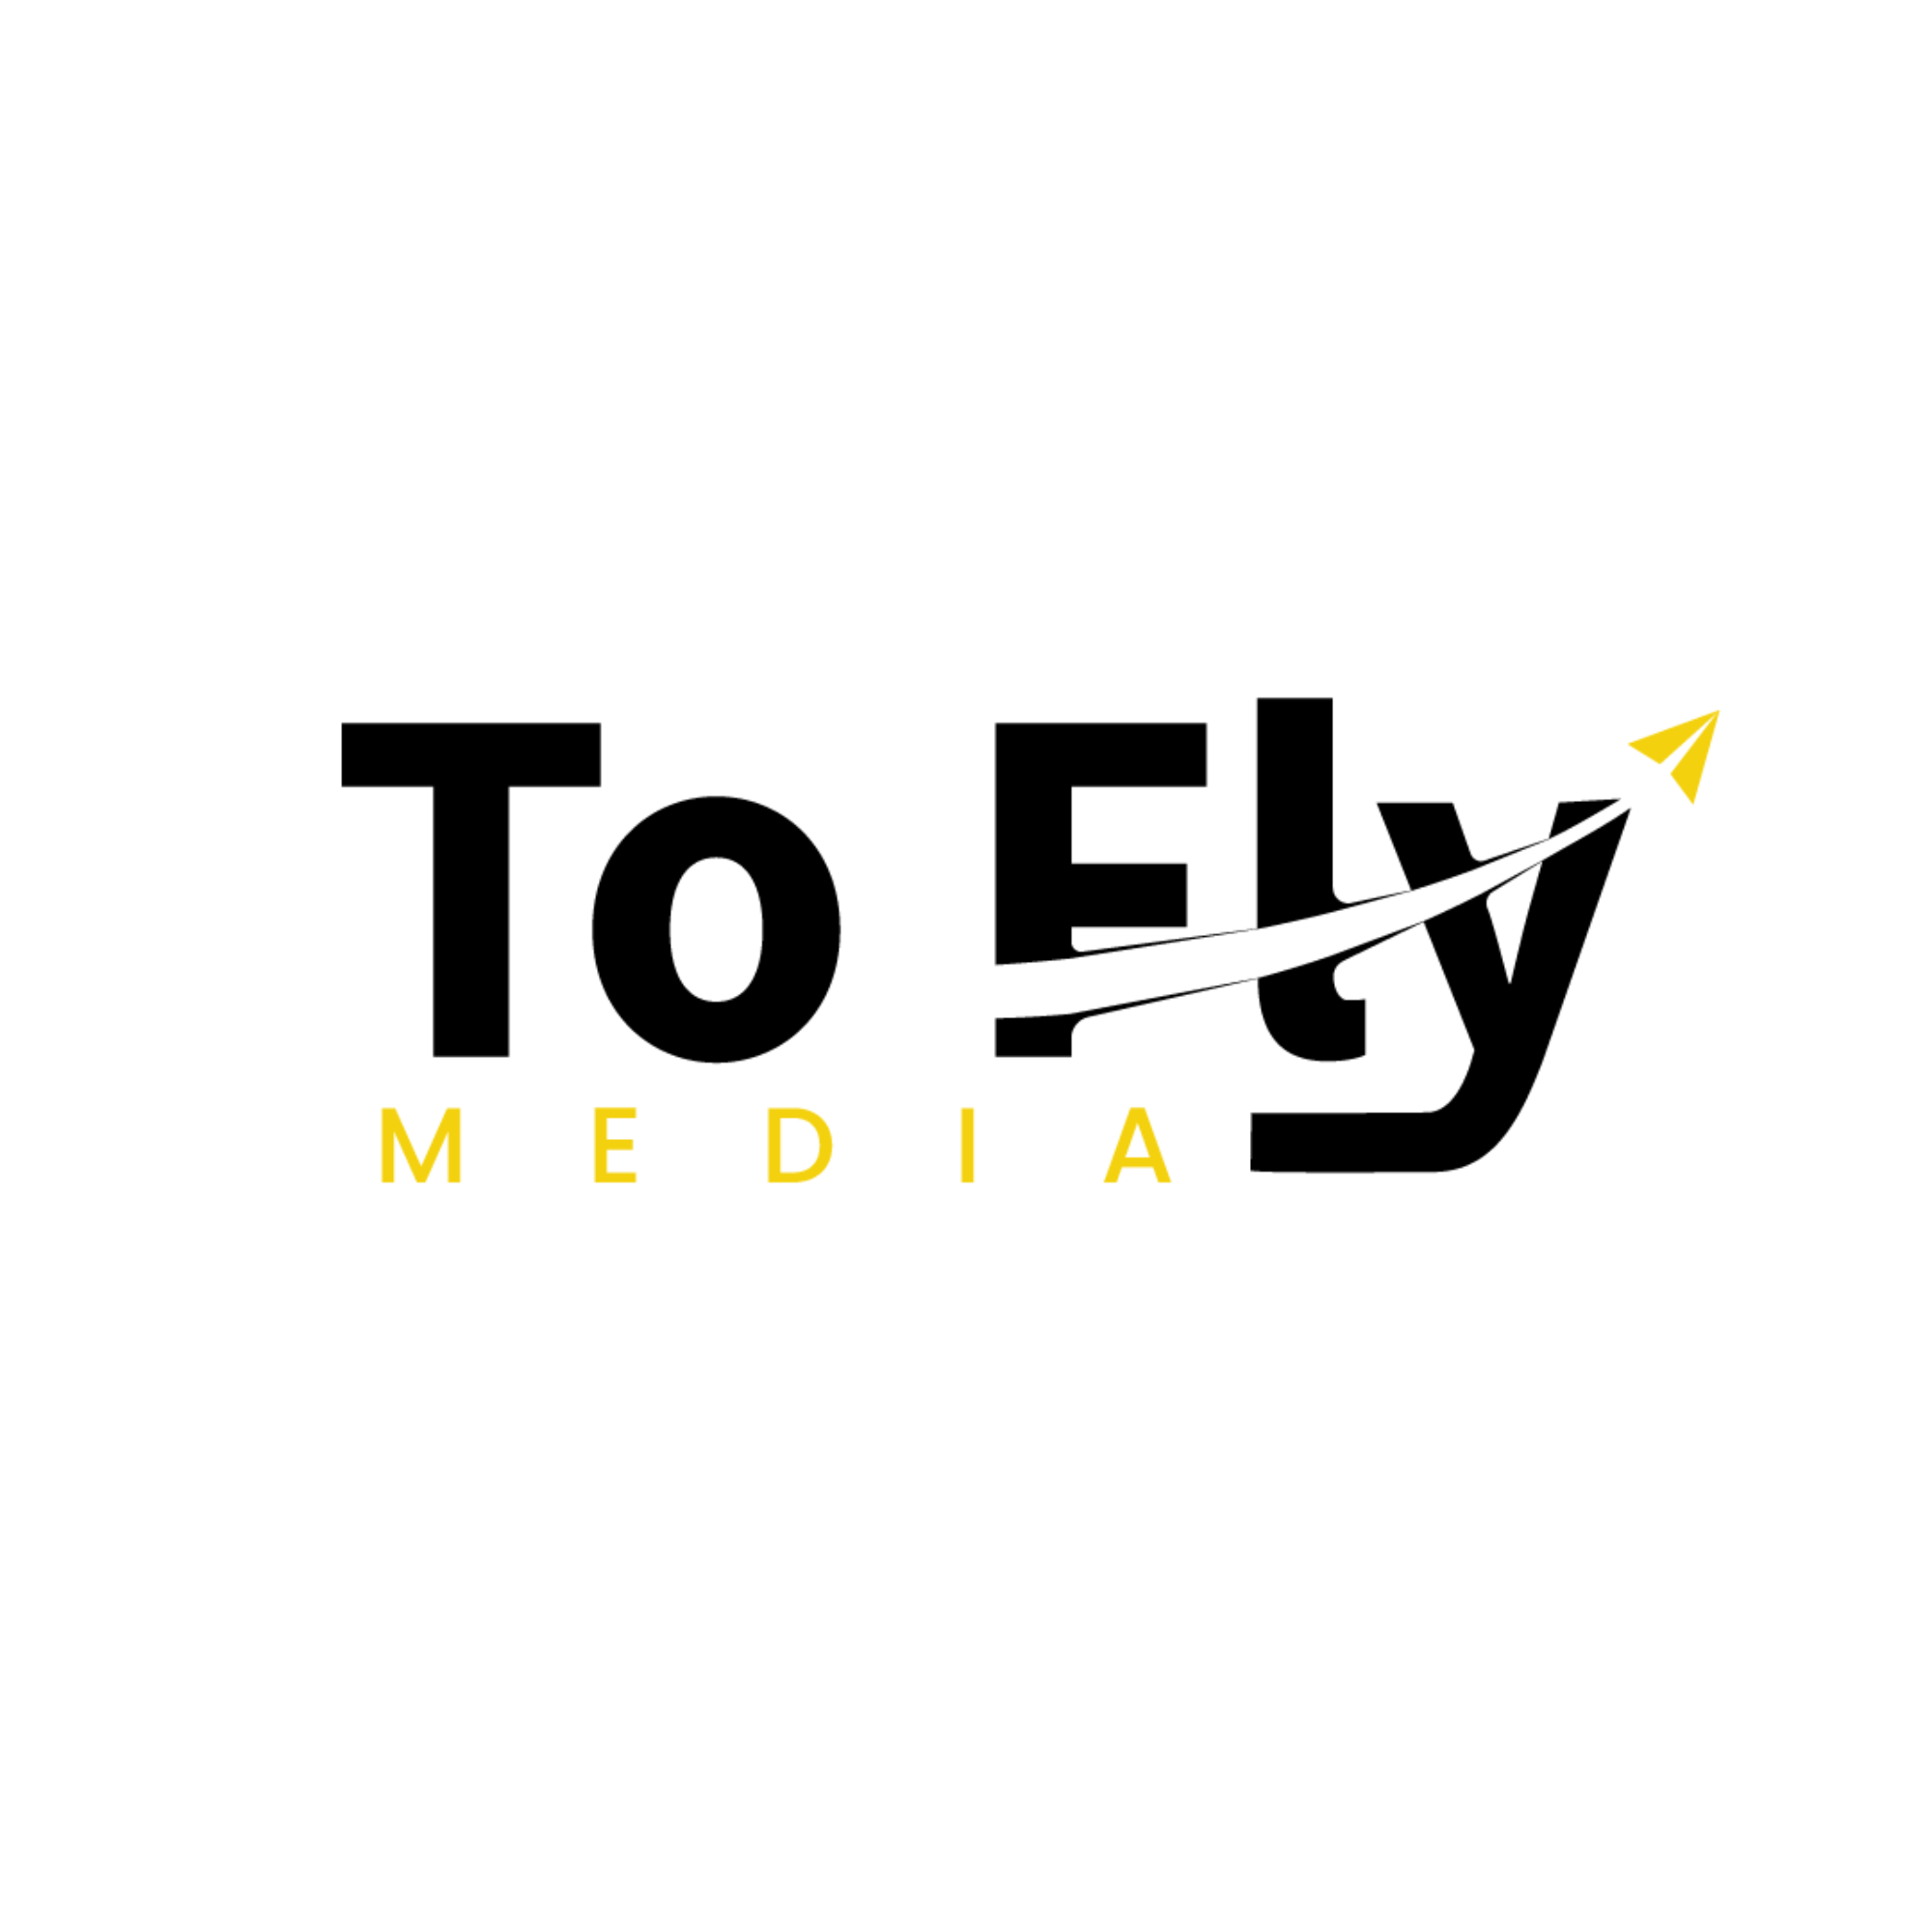
SOCIAL MEDIA PERFORMANCE REPORT
Monthly Report

Client Name: | Reporting Period:

1️⃣ Content Posting Summary

📌 Instagram / Facebook

Content Type | Total Posted | Notes
Carousel Posts
Reels
Stories
Total Content

➡️ Reason for Reduced Content Output (if any)

➡️ YouTube Channel

2️⃣ Reach & Growth Performance

Metric | Growth / Value
Total Views Increase
Profile Visits
New Followers Gained
Engagement (Likes, Shares, Saves)

3️⃣ Client Coordination & Communication

Activity | Count
Phone Calls
WhatsApp Messages
Follow-ups & Updates

4️⃣ Google My Business (GMB) Updates

📍 GMB Activities Performed:

⚠️ Important Note:

According to Google My Business rules and content policies, several videos were automatically rejected due to moderation guidelines.
As a result, some videos are not publicly visible on the GMB profile, even though the upload process was correctly followed.

➡️ In the future, GMB content will continue to be uploaded in policy-friendly formats.

5️⃣ Ads Update

6️⃣ Overall Performance Summary

✔ Brand consistency was maintained
✔ Social media visibility increased
✔ Audience engagement improved
✔ GMB profile was regularly updated
✔ Professional communication & reporting were maintained

REPORT PREPARED BY
To Fly Media
www.toflymedia.com | @toflymedia
Prepared By: | Designation: | Date:

© To Fly Media — Confidential Report

