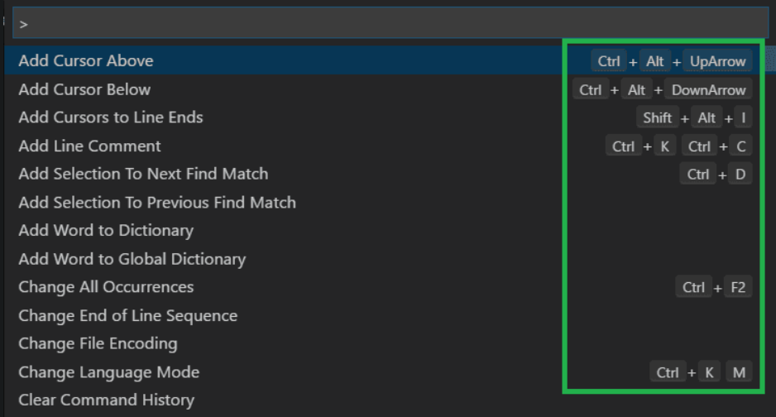

important: body.important || false

part 1: introduction

* React
  + create react application: npx create-react-app part1
  + index.js:   
    import ReactDOM from "react-dom"

import App from "./App"

ReactDOM.render(<App />, document.getElementById("root"))

* javascript:
  + array n = [0,1,2,3]
    - n[0]
  + object n {name: abc, y: 2, greet: function () {return this.name}, z: 4 }
    - n.name
  + function n = (x,y) => x*y
  + event handler: onClick = {() => xyz}
  + stateful component:
    - import { useState } from 'react'
    - const [ counter, setCounter ] = useState(0) or ([]) or ()
    - lift the state up: pass the setCounter, onClick through props
  + object spread syntax

part 2: rendering in react

* create snippets: <https://code.visualstudio.com/docs/editor/userdefinedsnippets#_creating-your-own-snippets>
* managing arrays:
  + find: returns first value eg. notes.find(n => n.id == 2)
  + filter: returns array fulfilling condition eg. notes.filter(n => n.importance == ‘yes’)
  + map: convert parts of array eg. notes.map(n => <p>n.id</p>)
  + reduce: customizable transformation
* forms:
  + <form onSubmit={addNote}>  
     <input

value={newNote}

onChange={handleNoteChange} />  
 <button type="submit">save</button>  
</form>

* + addNote = (event) => {  
     event.preventDefault()  
     console.log('button clicked', event.target)}
* json-server:
  + Installation:
    - npm install json-server --save-dev
    - npx json-server --port 3001 --watch db.json
      * db.json contains notes array
    - npm install axios
    - npm run server
  + to get:

.get('http://localhost:3001/notes')

.then(response => {setNotes(response.data)})

* + to add:

.post('http://localhost:3001/notes', noteObject)

.then(response => {

setNotes(notes.concat(response.data)

setNewNote(‘’)})

* + use .catch(error => console.log(error))
* export from component: export default { getAll, create, update }
  + importing: import noteService from './services/notes'
* using css in javascript:

|  |  |
| --- | --- |
| .note {color: red} | <li className=’note’> |
| .li {color: red} | <li> |
| const liStyle = {color: red} (inline) | <li style = {liStyle}> |

part 3: node.js and REST

* const app = http.createServer((request, response) => {

response.writeHead(200, { 'Content-Type': 'text/plain' })

response.end('Hello World')})

* express: for better interface
* npm install --save-dev nodemon
  + 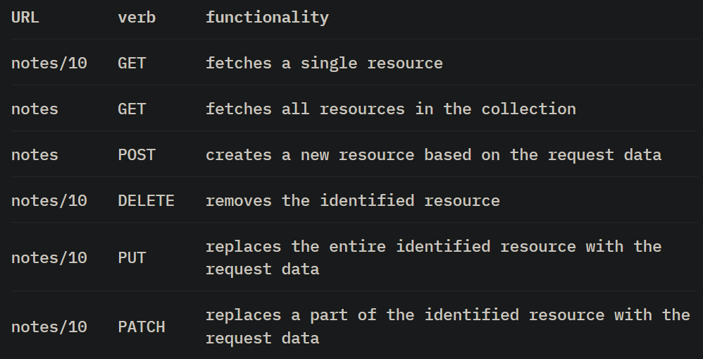node_modules/.bin/nodemon index.js
* REST:
  + app.get('/api/notes/:id', (request, response) => {  
    const id = request.params.id  
    const note = notes.find(note => note.id === id)  
    response.json(note)})
  + use Postman to send requests
  + VSB REST client
  + to parse json, express:
    - app.use(express.json())
    - response.json(note)
  + middleware: eg. morgan