## Phase 5: CI CD Deployment For Spring Boot Application

**Developer Details:**

Name: Sahil Mujawar

Email: mujawarsahil678@gmail.com

Program Name: **CI CD Deployment Spring Boot** GitHub Repository:

https://github.com/sahil-im/phase-5-project

**Program Background :**

As the project is in the final stage, management has asked you to automate the integration and deployment of the web application. You are required to set up an environment where the application will be hosted and accessed by users. The source code is supposed to be fetched from a GitHub repository.

**Program Features:**

* A search form in the home page to allow entry of the ID and Name of the Student
* Based on the details entered, it will show available list of students.
* Once a person selects an item to purchase, they will be redirected to the list of available items.
* In the next page, they are shown the complete list of details in the database in XML and JSON format.
* There will be an admin to manage the Database. And can be able to delete and create the entries using the H2 Database which is in- Memory Database.

The admin will be able to change his password if he wants, he should be able to:

* Manage the entries including categorizing them

**Tools used for development :**

* 1. Eclipse IDE
  2. H2 Database
  3. Apache Tom-Cat 10 server
  4. Spring Boot
  5. Amazon Web Services (AWS)
  6. HTML
  7. Apache Maven
  8. Putty and EC2 Virtual Machine
  9. GitHub

## Sprint Table:

|  |  |  |  |
| --- | --- | --- | --- |
| SPRINT | WORK DONE | TIME PERIOD | RESULT |
| 1 | Spring Boot Application coding | 22/05/2022 to  23/05/2022 | Done ✓ |
| 2 | Designed HTML pages | 23/05/2022 to  24/05/2022 | Done ✓ |
| 3 | Deploying on AWS - EC2 | 24/05/2022 to  25/05/22 | Done ✓ |
| 4 | Creating CI CD pipeline | 26/05/22 to  27/05/22 | Done ✓ |

**Source codes**

1. SpringBootDataJPARestApplication.java

package com.boot.demo;

import org.springframework.boot.SpringApplication; import

org.springframework.boot.autoconfigure.SpringBootApplication; import org.springframework.web.bind.annotation.RestController;

@SpringBootApplication @RestController

public class SpringBootDataJpaRestApplication {

public static void main(String[] args) { SpringApplication.run(SpringBootDataJpaRestApplication.

class, args);

}

}

1. Home Controller.java

package com.boot.demo;

import java.util.List;

import java.util.Optional;

import org.springframework.beans.factory.annotation.Autowired; import org.springframework.stereotype.Controller;

import org.springframework.web.bind.annotation.DeleteMapping; import org.springframework.web.bind.annotation.PathVariable; import org.springframework.web.bind.annotation.PostMapping; import org.springframework.web.bind.annotation.PutMapping; import org.springframework.web.bind.annotation.RequestBody; import org.springframework.web.bind.annotation.RequestMapping; import org.springframework.web.bind.annotation.RequestParam; import org.springframework.web.bind.annotation.ResponseBody; import org.springframework.web.servlet.ModelAndView;

@Controller

public class HomeController {

@Autowired StudentRepo repo;

@RequestMapping("/") public String home() {

*return* "home";

}

@RequestMapping("/addStudent")

public String addStudent(Student student) { repo.save(student);

*return* "home";

}

@RequestMapping("/getData")

public ModelAndView getData(@RequestParam int id) { ModelAndView mv = *new* ModelAndView("showData"); Student student = repo.findById(id).orElse(*new*

Student());

mv.addObject(student);

*return* mv;

}

@RequestMapping("/students") @ResponseBody

public String students() {

*return* repo.findAll().toString();

}

@RequestMapping("/students/{id}") @ResponseBody

public String studentsByID(@PathVariable("id") int id) {

*return* repo.findById(id).toString();

}

@RequestMapping("/studentsList") @ResponseBody

public List<Student> studentsList() {

*return* repo.findAll();

}

@RequestMapping("/studentsIDList/{id}") @ResponseBody

public Optional<Student> studentsByIDList(@PathVariable("id") int id) {

*return* repo.findById(id);

}

@PostMapping("/students")

public Student studentsInsert(@RequestBody Student student)

{

repo.save(student);

*return* student;

}

@DeleteMapping("/students/{id}")

public Student studentsDelete(@PathVariable("id") int id) { @SuppressWarnings("deprecation")

Student student=repo.getOne(id); repo.delete(student);

*return* student;

}

@PutMapping(path="/students", consumes =

{"application/json"})

public Student studentsUpdate(@RequestBody Student student)

{

repo.save(student);

*return* student;

}

}

1. Student.java

package com.boot.demo;

import javax.persistence.Entity; import javax.persistence.Id;

@Entity

public class Student {

@Id

private int id; private String name;

public int getId() {

*return* id;

}

public void setId(int id) {

*this*.id = id;

}

public String getName() {

*return* name;

}

public void setName(String name) {

*this*.name = name;

}

@Override

public String toString() {

*return* "Student [id=" + id + ", name=" + name + "]";

}

}

1. StudentRepo.java

package com.boot.demo;

import org.springframework.data.jpa.repository.JpaRepository;

public interface StudentRepo extends JpaRepository<Student, Integer>{

}

# SCREENSHOTS

* 1. EC2 Instance

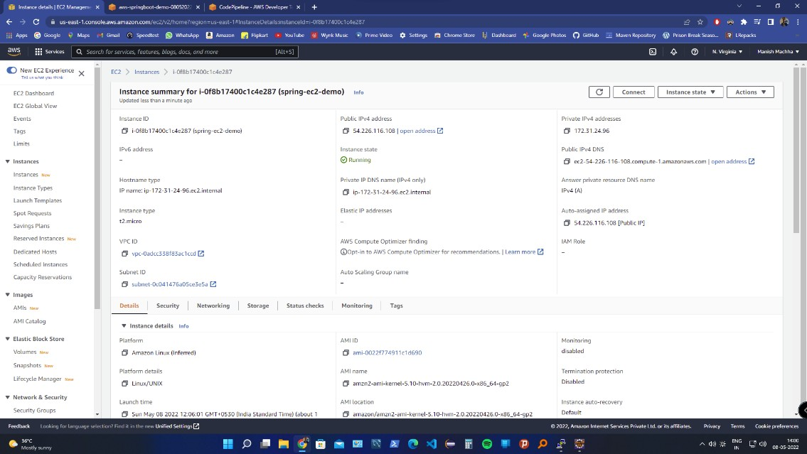

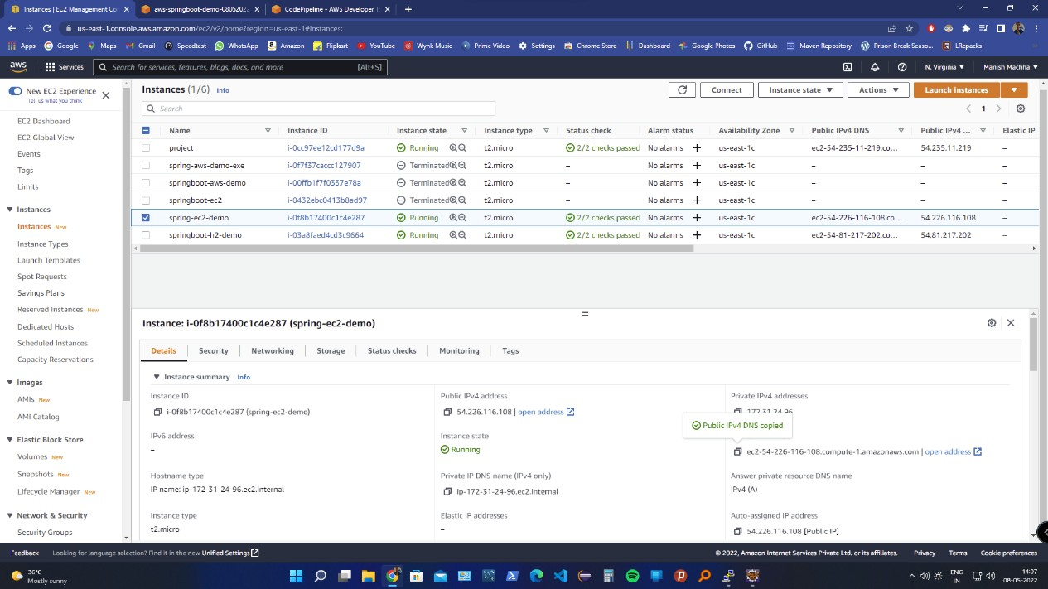

# S3 Bucket

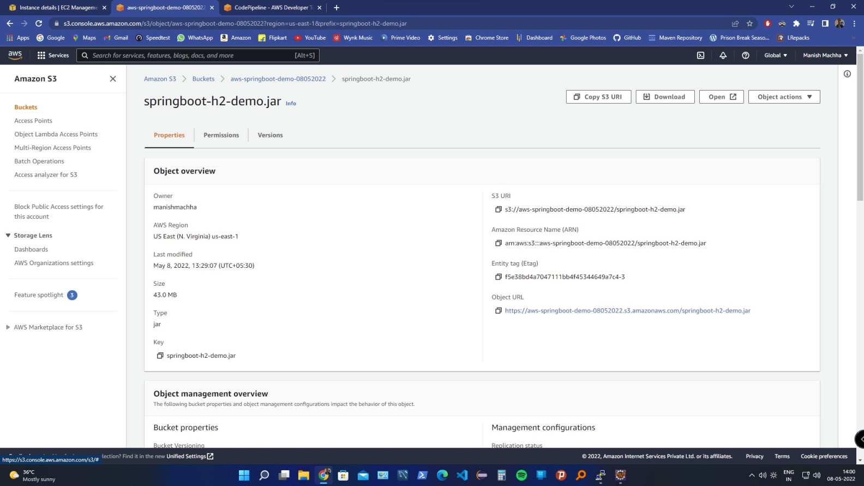

* 1. CI CD pipeline

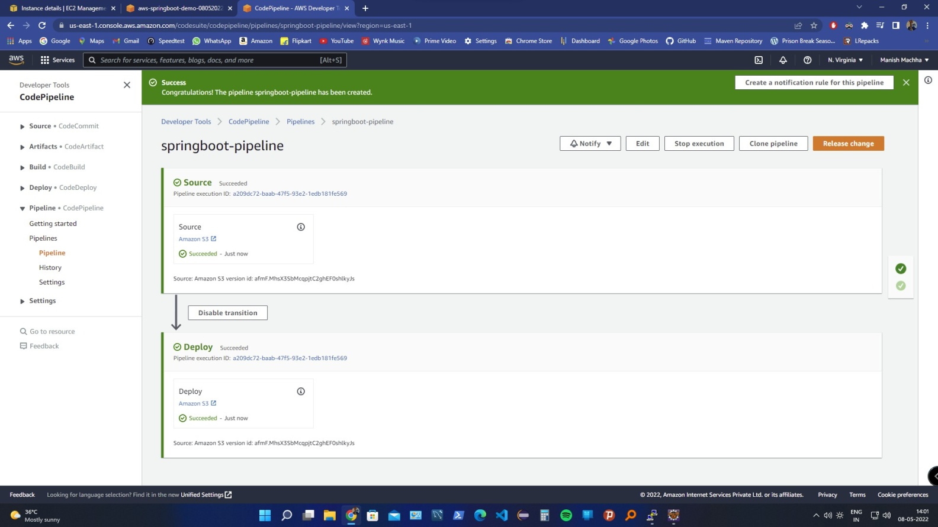

# Application Pages

