

**FINAL YEAR CAPSTONE PROJECT– 1st REVIEW REPROT**

**STUDY ON THE BEHAVIOR OF DC-DC CONVERTER UNDER OPEN LOOP AND CLOSED LOOP CONDITIONS**

**Submitted to the Presidency University, Bengaluru in partial fulfillment of the requirements for the Degree ofBACHELOR OF TECHNOLOGY in ELECTRONICS AND COMMUNICATION ENGINEERING**

**By**

|  |  |  |
| --- | --- | --- |
| NAME | ID NUMBER | Section |
| SAHIL KOLAMBKAR | 20211ECE0204 | 7-ECE-4 |
| RAHUL K A | 20211ECE0209 | 7-ECE-4 |
| SANKETH P V | 20211ECE0256 | 7-ECE-5 |
| VAISHALI PATEL V | 20211ECE0200 | 7-ECE-4 |
| CHAITHRA N | 20211ECE0058 | 7-ECE-1 |

**Under the supervision of**

**Dr. SREENIVASAPPA B.V.**

**Professor  
Department of Electronics and Communication Engineering**

1

**Under the supervision of**

**Dr.SREENIVASAPPA B V**

**Professor  
Department Of Electronics and Communication Engineering  
  
September, 2024**

REVIEW- 1 REPORT

**STUDY ON THE BEHAVIOR OF DC-DC CONVERTER UNDER OPEN LOOP AND CLOSED LOOP CONDITIONS**

**Abstract:**

This study investigates DC-DC converter behavior under open-loop and closed-loop conditions, focusing on output response to varying loads. We present experimental data for a step-down circuit with a single-ended output LC filter, establishing a correlation between circuit output and load characteristics. We explore different Driver and Isolator circuit combinations and aim to optimize existing systems and develop innovative converter topologies. A well-designed LC output filter is crucial for mitigating ripple currents and enhancing overall circuit efficiency. Additionally, we will extend our investigation to include the control of a motor to observe the converter's output behavior under dynamic load conditions, providing valuable insights into its ability to maintain stable output voltage and respond effectively to changing demands.

**Introduction:**

DC Choppers: The DC choppers convert input DC voltage into fixed or variable DC output. Figure show the basic block diagram of the chopper. The chopper has fixed or variable DC input, Vs and the output Vo. hence DC chopper is also called as DC-DC converter. The output voltage can be greater or lesser than input voltage. Hence the choppers can be step-up or step-down converter. The DC choppers use switching principle to give high efficiency. The dynamic response of choppers is fast due to switching nature of the devices.

**Working Principle of a Buck Converter:**

1. **Step-down Conversion:** A buck converter reduces the input DC voltage to a lower output DC voltage, making it a step-down DC-DC converter.
2. **Switching Components:** The converter uses a power semiconductor switch (such as a MOSFET or IGBT) and a freewheeling diode to regulate the flow of current.
3. **LC Filter**: A low-pass LC filter (inductor and capacitor) is used to reduce current and voltage ripples, ensuring a stable DC output. This is a 2nd-order filter, which provides better filtering performance than a first-order filter, resulting in a smoother output.
4. **Two Operating Modes:**

Mode 1 (Switch S1 Closed): The switch S1 is closed, allowing current to flow through the inductor, which stores energy in its magnetic field. The capacitor charges, and the output voltage appears across the load.

Mode 2 (Switch S1 Open, Diode On): When switch S1 is open, the stored energy in the inductor is released, and the freewheeling diode becomes forward-biased, continuing current flow until the inductor's energy is fully discharged.

1. **Energy Storage:** The inductor stores energy during the "on" phase and releases it during the "off" phase, allowing for continuous current to the load.
2. **Duty Cycle:** The output voltage is controlled by adjusting the duty cycle, which is the ratio of the "on" time (Ton) of the switch to the total period (T = Ton + Toff).
3. **Zero Net Change in Inductor Current**: Over one full switching cycle, the net change in current through the inductor is zero, ensuring stable operation.

***Step-Down Chopper with RL Load:***

Normally the choppers are used to drive motors. These motors are considered as RL (inductive) load. Figure shows the circuit diagram of step-down chopper having inductive load.

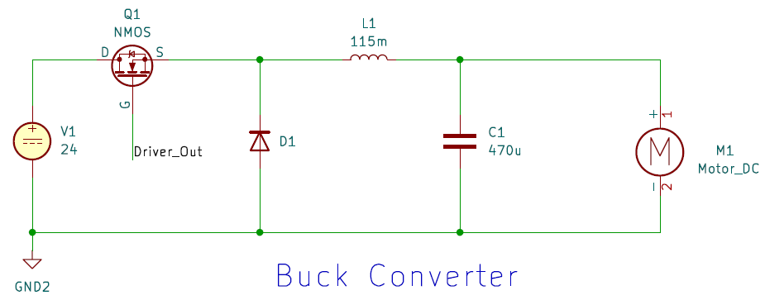

MOSFET is used as a switch. Since the load is inductive, Freewheeling diode is used in the circuit. The output voltage Vo is equal to the supply voltage when the switch conducts. The output voltage is zero when the switch is off. The change in the pulse given to the Gate terminal of the MOSFET results in the changes of the output voltage Vo.

**Formulas:**

1. Ideal Output Voltage,

Practical Output Voltage,

Where Vs is the source voltage.

1. Duty Cycle,
2. Output Current,
3. Efficiency,

Where, PL is the load power.

Ps is the source power.

1. Calculating the Inductor value,

,

1. Calculating the Capacitor value,

,

**Applications:**

1. Battery operated portable Equipment.
2. For Unidirectional supplies.

**Circuit Diagram**

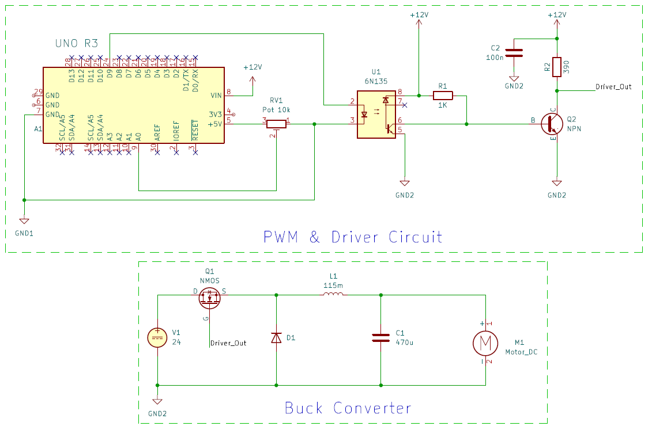

**Optocoupler:**

An optocoupler isolates electrical circuits to prevent direct contact between them. It transfers signals using light between an LED and a photodetector. Provides protection by separating high and low voltage sides. Commonly used to prevent noise or surges from affecting sensitive components. Found in power supplies, microcontroller interfaces, and communication systems. Optocouplers can transmit digital or analog signals depending on the type. They come in various types, including transistor, SCR, and triac output. Used to improve circuit reliability by reducing electrical interference. Often used in switching power supplies, motor control systems, and signal isolation. Can protect devices from high voltage spikes or surges in industrial applications. Typically found in circuits where electrical isolation and signal transfer are needed. Helps in preventing ground loops in sensitive electronic systems.

Optocoupler Circuit

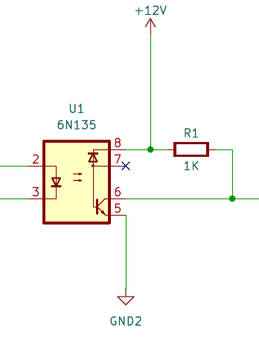

**Driver Circuit:** A driver circuit acts as a middleman between a control system and a high-power device (like a motor or converter)

* Amplifies signals: The control system usually sends weak signals, and the driver circuit boosts them to control larger loads.
* Protects the control system: It prevents high voltages or currents from damaging the sensitive control system by isolating them.
* Improves efficiency: The driver ensures smooth and precise control, making the power transfer more efficient.
* Prevents overheating: By controlling the flow of current, it reduces the risk of overheating in the connected components.
* Allows safe switching: The driver enables safe on/off switching of high-power devices without directly exposing the control system to high voltages.

Driver Circuit

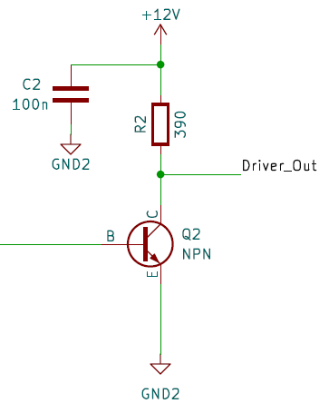

**Arduino Uno:**

The Arduino Uno is a popular microcontroller board used for building various electronic projects. It features an ATmega328 chip that acts as the brain of the board, executing programs that can be easily written and uploaded via USB using the Arduino IDE. The board can be powered by USB or a battery, providing flexibility and portability. It includes 14 digital pins and 6 analog pins for connecting components such as sensors, motors, and LEDs. In a typical setup, A0 can be used to read the value of a 10k ohm potentiometer, while pin 9, which supports PWM, is connected to an optocoupler (6N135) for controlling external devices with pulse-width modulation.

**Hardware List:**

1. Arduino UNO
2. Potentiometer – 10k
3. 6N135 Optocoupler
4. MOSFET – IPW60R041C6
5. Power Diode – APT60DQ60BCT(G)
6. Resistors
7. Inductor
8. Capacitor
9. NPN Transistor
10. Arduino UNO R3
11. 24V DC Motor
12. Battery - 12V DC

**Methodologies:**

1. **Generation of PWM Signal using Arduino UNO and potentiometer:**

In this implementation, a PWM (Pulse Width Modulation) signal is generated using an Arduino Uno in conjunction with a potentiometer to control devices such as motors, LEDs, and heaters by adjusting the power they receive. Instead of switching devices completely on or off, PWM allows for finer control over the amount of power delivered. The Arduino Uno acts as the controller, utilizing a library that enables PWM functionality with a specified frequency of 20 kHz.

In the setup() function, the InitTimersSafe() function is called to initialize the timers safely. The PWM frequency for digital pin 9 is set to 20,000 Hz using the SetPinFrequencySafe() function. If the frequency is successfully set, pin 13 is configured as an output and turned on to indicate that the setup is complete.

In the loop() function, the Arduino reads the analog voltage from the potentiometer connected to analog pin A0 using the analogRead() function, which returns a value between 0 and 1023. This value is then scaled down by dividing it by 4, which adjusts the range to match the PWM duty cycle values (0 to 255) suitable for the pwmWrite() function. This function sends the PWM signal to pin 9, allowing devices connected to this pin to receive varying power levels based on the position of the potentiometer. A brief delay of 10 milliseconds is included to stabilize the readings.

This approach enables smooth and gradual control over the connected devices, enhancing their performance and responsiveness.

1. **Optocoupler is used for Isolation**

The **6N135** optocoupler in the circuit helps to keep the control signals safe from the high-power parts of the system. It separates the low-voltage control signals, coming from the Arduino, from the high-voltage circuits that control the motor. This is important because it prevents any dangerous voltage or electrical noise from affecting the sensitive control signals.

On the input side, the Arduino sends out a **PWM signal** (a type of signal that turns on and off very quickly). This signal is connected to a tiny **LED** inside the 6N135 optocoupler.

When the PWM signal is "high" (on), the LED lights up. This LED doesn’t just give off regular light; it sends out a signal to the other side of the optocoupler.

On the output side, there’s a special part called a **phototransistor**. When the LED is on, the light from the LED turns on the phototransistor. Even though the light moves between the two sides, there is no electrical connection between them. This keeps the control side completely separate from the power side. The phototransistor then allows the signal to pass on to the next part of the circuit.

After the signal goes through the phototransistor, it moves on to the **transistor driver circuit**, which uses transistors (Q1 and Q2) to drive the motor. The signal is then used to control the **buck converter** and adjust the speed of the motor.

1. **Transistors Driver Stage:**

In the transistor driving stage, an NPN transistor is used to complement and amplify the signal coming from the optocoupler. Initially, the Arduino generates a pulse that is sent to the optocoupler for isolation, ensuring protection between the low-voltage control side and the high-voltage power side. However, the output from the optocoupler is a complemented version of the Arduino pulse, meaning it is inverted. To correct this, the NPN transistor is employed to complement the pulse again, restoring it to match the original signal from the Arduino. Additionally, the transistor amplifies the optocoupler's lower voltage output, boosting it to 12V, which is suitable for driving high-power devices like motors. This stage ensures that the control system remains isolated and protected while providing the necessary voltage and signal to control the load effectively. By operating the transistor in a switching mode, it allows for precise on/off control of the motor or power device, enhancing overall efficiency and safety in the circuit.

1. **Buck Conversion:**

In the buck converter, the inductor (L1) and capacitor (C3) work together to change the PWM signal into a steady lower voltage that the motor can use. The PWM signal is made up of quick pulses that turn the power on and off. By smoothing out these pulses, the inductor and capacitor create a steady flow of power, which is what the motor needs to run smoothly.

The duty cycle of the PWM signal decides how much of the time the signal is ON versus OFF. If the duty cycle is higher, meaning the signal is ON for more time, more power is sent to the motor. This makes the motor run faster. If the duty cycle is lower, with the signal being OFF more often, the motor gets less power and runs slower.

So, by adjusting the duty cycle, you can control the speed of the motor. More ON time means more voltage and faster speed, while less ON time gives lower voltage and slower speed. This method allows for smooth control over how fast or slow the motor operates.

1. **Open Loop Feedback System:**

In this circuit, **open-loop control** means that there is no feedback from the motor or output back to the control system (Arduino). The system only adjusts the motor speed based on the initial **PWM signal** generated by the Arduino, without any automatic correction based on the actual motor performance. **Input Control**: The Arduino generates a PWM signal, which is controlled by the potentiometer. This signal controls the **duty cycle**, determining how much power is delivered to the motor via the **buck converter**. In an open-loop system, the motor's speed is not measured or sent back to the Arduino. So, if the load on the motor changes, the system won’t know, and no adjustments will be made. For example, if the motor slows down due to an increased load, the circuit won’t automatically compensate by increasing the power. The power delivered to the motor is fixed by the duty cycle of the PWM signal. Any change in motor speed due to external factors like load or supply voltage will not be corrected because the Arduino has no way of knowing those changes.In open-loop systems, the performance can vary due to changes in the environment (like load or supply voltage variations). This makes it less precise compared to **closed-loop systems**, which have feedback to correct the output.

**Experimental outputs:**

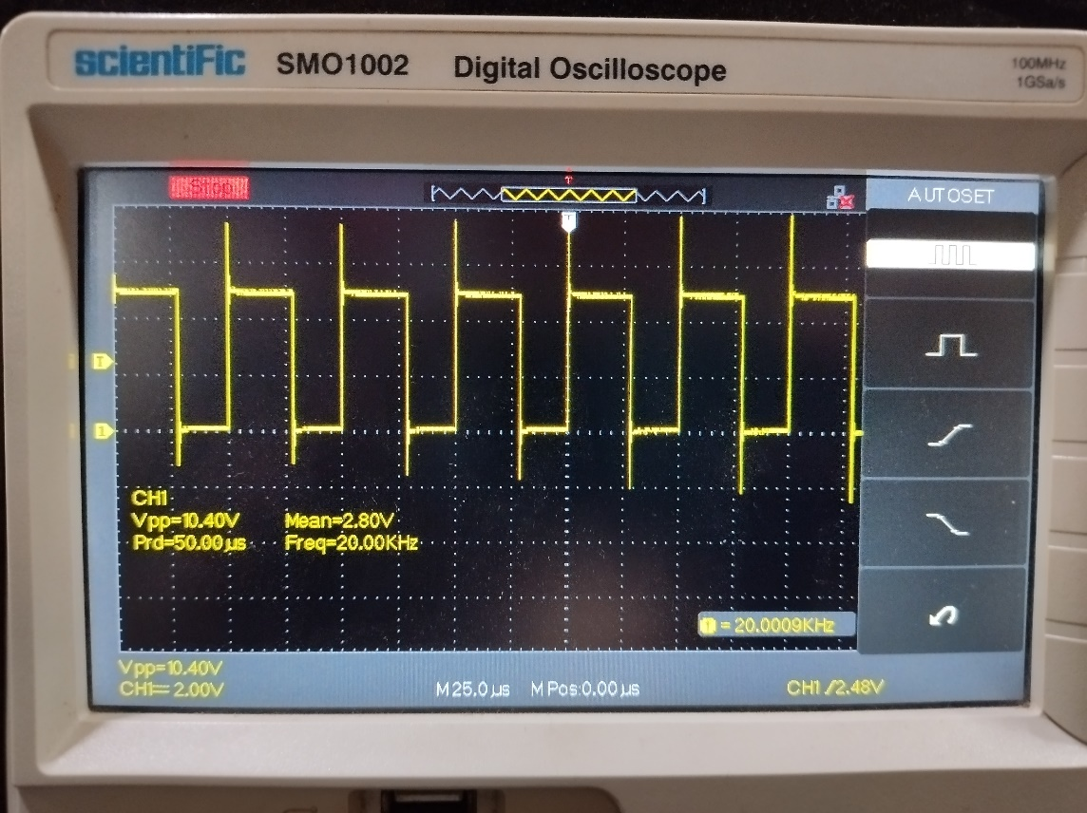

***Arduino PWM Output***

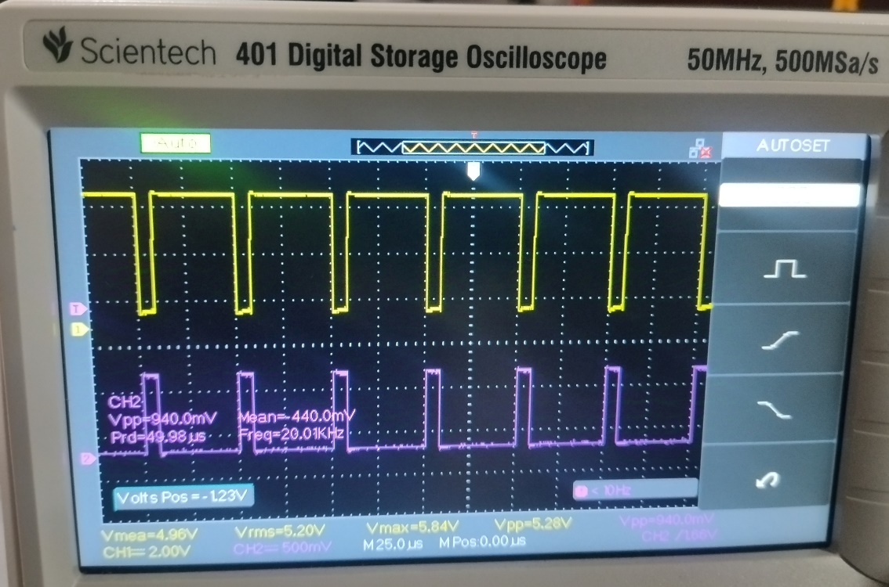

***Arduino*** *(Channel 1)**and* ***Optocoupler Output*** *(Channel 2)*

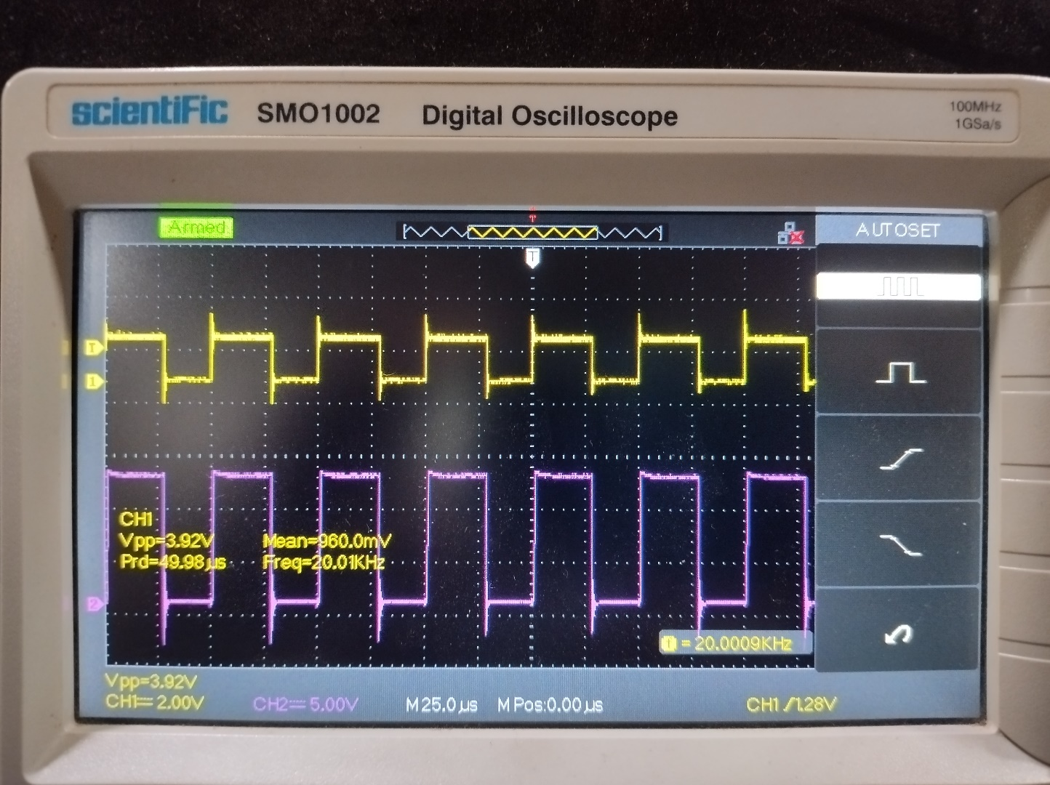

***Arduino*** *(Channel 1)**and* ***Driver Circuit*** *(Channel 2)*

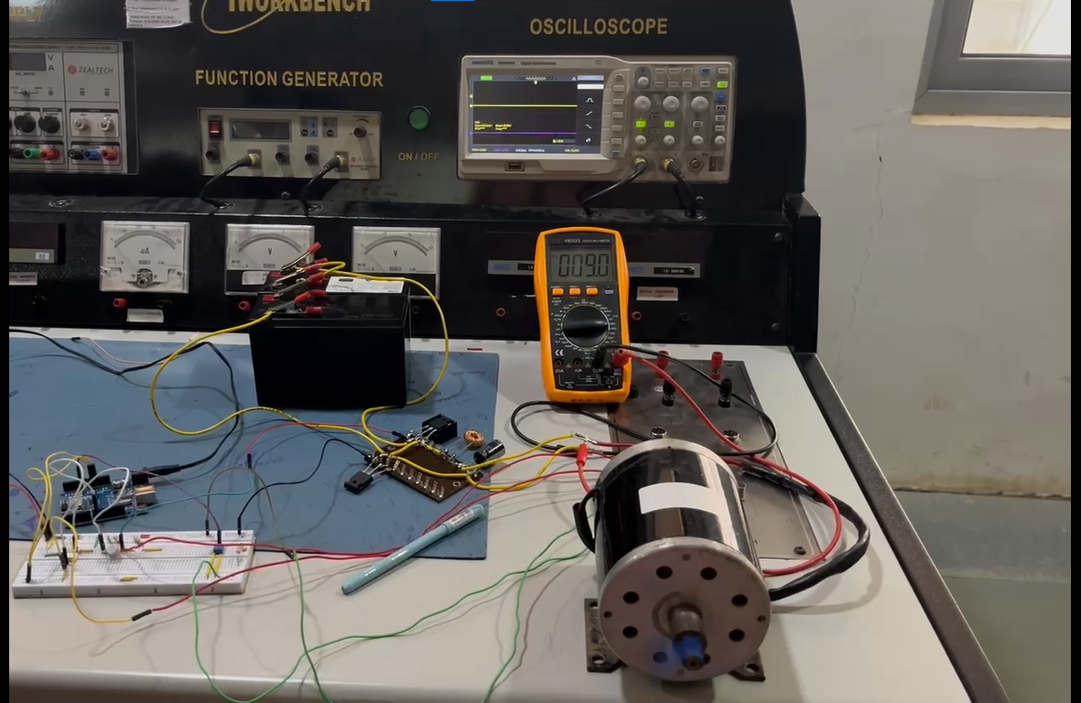

***Voltage Across the DC Motor***

**Conclusion:**

Our experimental findings indicate that the voltage across the maximum DC motor load was limited to 9V, significantly below the expected 24V. This discrepancy suggests a potential limitation or inefficiency in the current circuit configuration. To address this issue and achieve the desired output voltage, we propose incorporating a bootstrapping method in the subsequent phase of our project. Bootstrapping techniques can effectively boost the output voltage of a DC-DC converter, enabling it to deliver the required power to the DC motor load. By implementing this approach, we anticipate achieving the target voltage and enhancing the overall performance of the system.

**References:**

1. Nayanasiri, D., & Li, Y. (2022). Step-Down DC–DC Converters: An Overview and Outlook. *Electronics*, 11(11), 1693. <https://doi.org/10.3390/electronics11111693>
2. Mihov, V., Lichev, A., Madankov, Y., & Spirov, D. (2024). Examination of Two-Quadrant DC–DC Converter with Single-Ended LC Output Filter. *Eng. Proc.*, 70(1), 8. <https://doi.org/10.3390/engproc2024070008>
3. D. C. S. T. Wu, J. H. (2015). A review on DC-DC converters for renewable energy applications. *Renewable and Sustainable Energy Reviews*, 41, 828-836. https://doi.org/10.1016/j.rser.2014.08.032
4. Mohan, N., Undeland, T. M., & Robbins, W. P. (2003). *Power Electronics: Converters, Applications, and Design*. John Wiley & Sons.
5. Khaligh, A., & Zare, F. (2009). A review of non-isolated DC-DC converters for photovoltaic applications. *Renewable and Sustainable Energy Reviews*, 13(8), 1902-1909. https://doi.org/10.1016/j.rser.2008.09.009
6. Rashid, M. H. (2010). *Power Electronics: Circuits, Devices & Applications*. Prentice Hall.
7. Lee, K., & Lee, Y. (2016). Design of a new step-down DC-DC converter with improved efficiency. *IEEE Transactions on Power Electronics*, 31(4), 2986-2996. https://doi.org/10.1109/TPEL.2015.2492279
8. Zhao, Z., & Wang, X. (2020). A comprehensive review of step-down DC-DC converters for energy harvesting. *Energy Reports*, 6, 92-99. https://doi.org/10.1016/j.egyr.2020.06.002
9. Jang, J., & Lee, B. (2017). An overview of control methods for buck converters. *Journal of Power Electronics*, 17(2), 258-268. https://doi.org/10.6113/JPE.2017.17.2.258
10. Kim, J., & Kim, Y. (2021). A high-efficiency buck converter with adaptive control. *IEEE Transactions on Industrial Electronics*, 68(4), 3383-3393. <https://doi.org/10.1109/TIE.2020.2988529>