**Telegram Bot**

Telegram is one of the more popular platforms today, as it allows you to store messages on the cloud instead of just your device and it boasts good multi-platform support, as you can have Telegram on Android, iOS, Windows, and just about any other platform that can support the web version. Building a chatbot on Telegram is simple and requires a few steps that take very little time to complete. The chatbot can be integrated into Telegram groups and channels, and it also works on its own.

We will be creating a Telegram Echo Bot (Echo Bot is a bot that responds with the same output as what the user enters as input). The bot will take either text or image as input and echo the same input text as output. In the case of an image, it will extract text from the image and respond with the extracted text.

**Step 1: Set up your Bot’s profile**

To set up a new bot, start the conversation with BotFather (@BotFather).  
BotFather will help us in creating the new bot.

* Search for @botfather in Telegram.

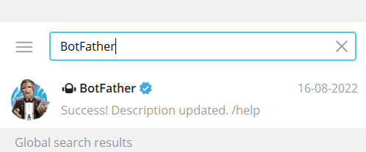

* Start your conversation by pressing the Start button.

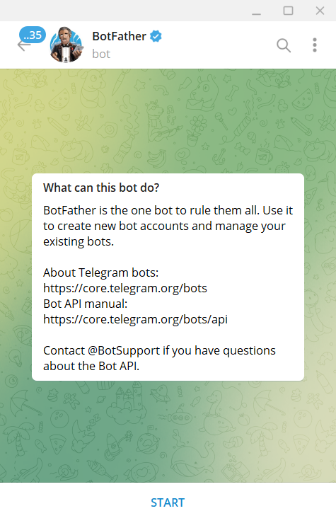

* Create the bot by running /newbot command

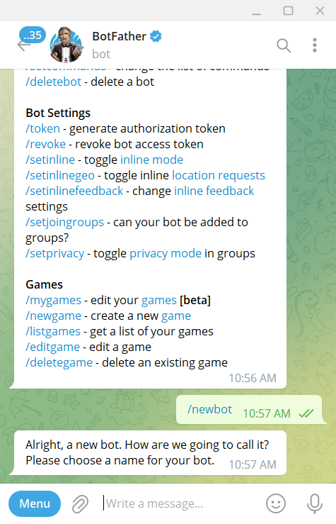

* Enter the Display Name and Username for the bot.

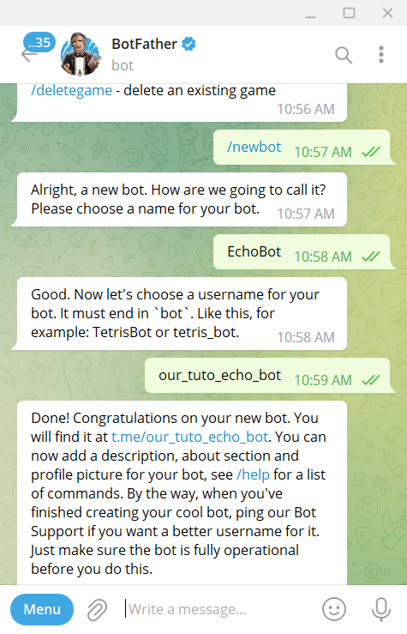

* BotFather will send you a message with the token. (Keep access token of the bot securely. Anyone with your token can manipulate this bot.)

**Step 2: Coding the bot**

(Commands for windows)

* First, let’s create a virtual environment. It helps isolate your project’s requirements from your global Python environment.

python -m venv ./<your_environment_name>

* Go ahead and activate virtual env using the following command. (You need to move to the path where you created the virtual environment)

.\ <your_environment_name> \Scripts\activate

* Install the libraries: Unzip the ‘requirements.txt’ file in your project root folder and install it by running this command in the terminal. If the library is successfully installed, then we are good to go.

pip install -r requirements.txt

**The next step is to start writing the actual python script for the telegram bot.**

* Unzip the code.
* Replace the ‘TOKEN’ value with your telegram bot access token.
* The code contains a function to handle image input. This function takes the image as input and converts it into a byte array and pre-processes using NumPy and OpenCV. After pre-processing we use the ‘easyocr’ library to extract text from the image.

**Step 3: Testing the bot**

* For testing the bot, we need to first run the script which we just created in the virtual environment. To run the script, just unzip and open the python file in a code editor and Run the file. (Please note: The bot will only work while the python script is running. Once the execution of the script is terminated, the bot stops responding)

You can also run the script from the terminal.

* Open terminal
* Move to the location of the file
* Run the following command by replacing your file name. (Please make sure you are using the same interpreter where python is installed in your machine. If you are using anaconda, then you can run the command ‘conda activate base’ to select the base interpreter)

python your_file_name.py

* Open telegram and search for the bot we created in Step 1.
* Start the conversation and test the bot.

