EM108 Examination Report

Mock Exam

**STUDENT ID: 16403142**

**STUDENT NAME: Sahil Mehra**

**Programme: ECE1**

|  |  |
| --- | --- |
| *I hereby declare that the attached submission is all my own work, that it has not previously been submitted for assessment, and that I have not knowingly allowed it to be used by another student. I understand that deceiving or attempting to deceive examiners by passing off the work of another as one's own is not permitted. I also understand that using another's student’s work or knowingly allowing another student to use my work is against the University regulations and that doing so will result in loss of marks and possible disciplinary proceedings.* | |
| **Signed:** 16403142 | **Date: 13/04/2017** |
| Note: Coursework examiners are entitled to reject any coursework which does not have a signed copy of this form attached or are submitted late. | |

**Exercise:**

**Plan**

* Create a struct with houseID, ownername, binwaste, waterused, surfacearea, tax
* Declare welcoming message and functions
* Open the indata.txt
* Open the outdata.txt
* Scan the contents of indata.txt and save them in the struct
* Calculate the tax
* Print the struct to the screen
* Close the indata.txt file

**Development**

The first step in the development of my program was to include the standard C libraries (stdio.h, stdlib.h,) that in order to be able to use certain functions in the program.

I then declared my struct with houseID, ownername, binwaste, waterused, surfacearea, tax. I also declared a function for a choice, user menu and tax.

Then, I started writing up the main function of the program. I opened the indata.txt file and I used the for loop, in the for loop ‘fscanf’ to scan the contents of the file and save it to the struct. I then called the ‘user menu’ function to ask the user for their choice of where to store the end result. I then called the ‘choice’ function. In this function I used a switch statement based off the user choice in the ‘user menu’ function. In this function I called the ‘tax’ function which calculated the tax for each house based on the information given and a set of rules. I then either used a printf statement to print the entire struct to the screen, or I used a fprintf statement to print the entire struct to a file or I used both to print the struct to both the screen and the file.

**Testing**

I compiled and tested the program using the gcc compiler. I was not presented any errors when I compiled my code.

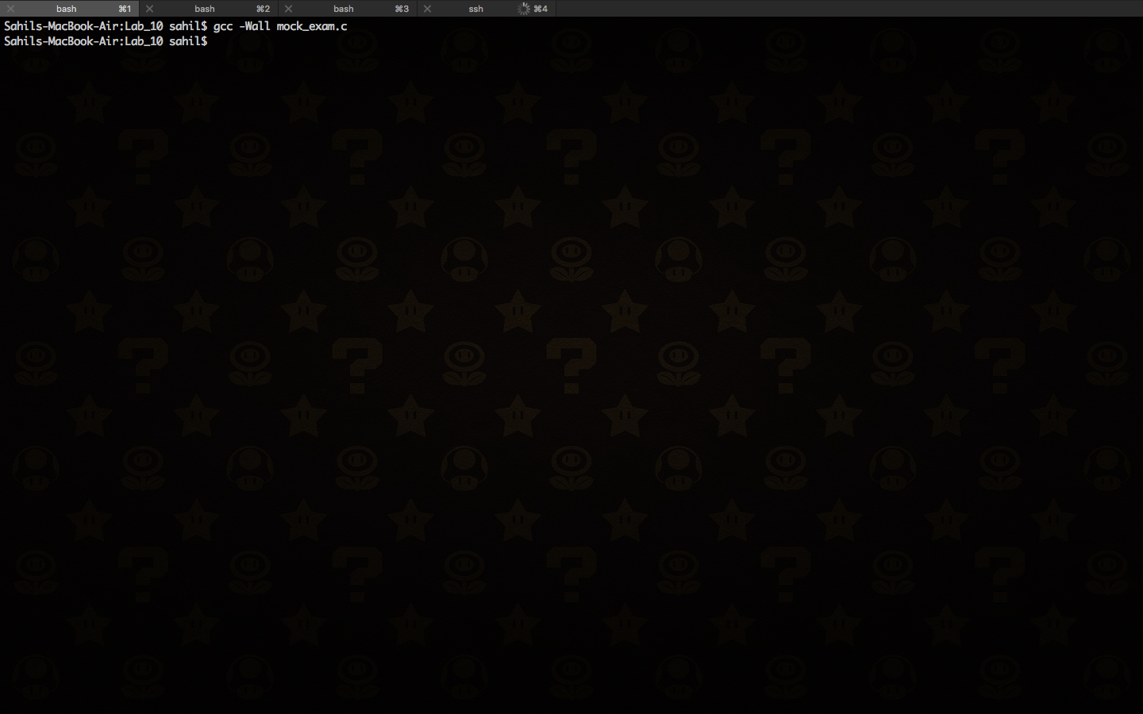

The program ran smoothly without any errors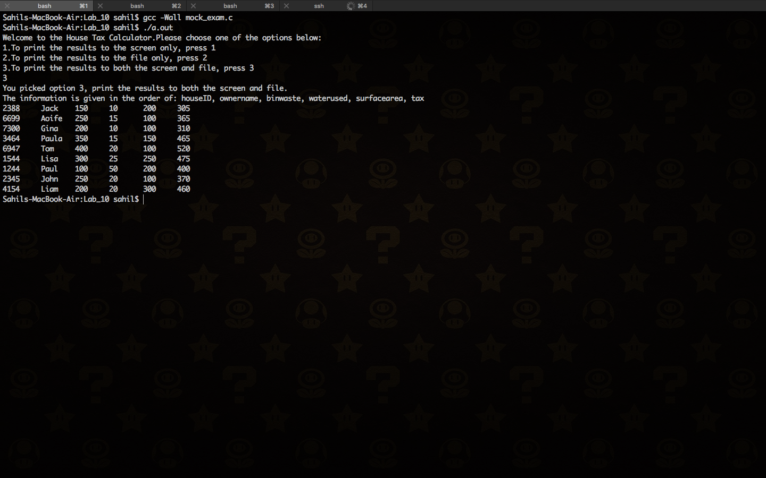

**Code attached**

#include <stdio.h>

#include <stdlib.h>

#include <string.h>

//Struct containing all the information for the house

typedef struct house {

int house_id;

char name[20];

int waste;

int water;

int surface_area;

int tax;

} house_type;

house_type house[9];

int option;

int i;

void user_menu();

int tax(house_type house[],int i);

void choice();

int main() {

FILE *indata;

indata = fopen("input.txt","r");

for (i = 0; i < 9; ++i) {

fscanf(indata , "%d %s %d %d %d", &house[i].house_id, house[i].name, &house[i].waste, &house[i].water, &house[i].surface_area);

}

printf("Welcome to the House Tax Calculator.");

user_menu();

choice();

return 0;

}

void user_menu() {

printf("Please choose one of the options below:\n");

printf("1.To print the results to the screen only, press 1\n");

printf("2.To print the results to the file only, press 2\n");

printf("3.To print the results to both the screen and file, press 3\n");

scanf("%d", &option);

}

int tax(house_type house[], int i){

if(house[i].surface_area >= 200){

house[i].tax = (1 * house[i].surface_area) + (.5 * house[i].waste) + (3 * house[i].water);

}

else {

house[i].tax = 100 + house[i].waste + house[i].water;

}

return house[i].tax;

}

void choice() {

FILE* outdata;

outdata = fopen("outdata.txt", "w");

switch(option){

case 1:

printf("You picked option 1, print the results to the screen only.\n");

printf( "The information is given in the order of: houseID, ownername, binwaste, waterused, surfacearea, tax\n");

for (i = 0; i < 9; ++i){

tax(house,i);

printf( "%d \t %s \t %d \t %d \t %d \t %d \n", house[i].house_id, house[i].name, house[i].waste, house[i].water, house[i].surface_area, house[i].tax);

}

break;

case 2:

printf("You picked option 2, print the results to the file only.\n");

fprintf(outdata, "The information is given in the order of: houseID, ownername, binwaste, waterused, surfacearea, tax\n");

for (i = 0; i < 9; ++i){

tax(house,i);

fprintf(outdata, "%d \t\t %s \t %d \t %d \t %d \t %d \n", house[i].house_id, house[i].name, house[i].waste, house[i].water, house[i].surface_area, house[i].tax);

}

break;

case 3:

printf("You picked option 3, print the results to both the screen and file.\n");

printf( "The information is given in the order of: houseID, ownername, binwaste, waterused, surfacearea, tax\n");

fprintf(outdata, "The information is given in the order of: houseID, ownername, binwaste, waterused, surfacearea, tax\n");

for (i = 0; i < 9; ++i){

tax(house,i);

printf( "%d \t %s \t %d \t %d \t %d \t %d \n", house[i].house_id, house[i].name, house[i].waste, house[i].water, house[i].surface_area, house[i].tax);

fprintf(outdata, "%d \t\t %s \t %d \t %d \t %d \t %d \n", house[i].house_id, house[i].name, house[i].waste, house[i].water, house[i].surface_area, house[i].tax);

}

break;

default:

printf("You have made an illegal choice.\n");

user_menu();

}

fclose(outdata);

}