LABORATORY 3 – REPORT

## Sahil Mehra - 16403142 - ECE1

*I hereby declare that the attached submission is all my own work, that it has not previously been submitted for assessment, and that I have not knowingly allowed it to be used by another student. I understand that deceiving or attempting to deceive examiners by passing off the work of another as one's own is not permitted. I also understand that using another's student’s work or knowingly allowing another student to use my work is against the University regulations and that doing so will result in loss of marks and possible disciplinary proceedings.*

Note: Coursework examiners are entitled to reject any coursework which does not have a signed copy of this form attached or are submitted late.

## Problem 1

The aim of this problem is to look at statements and to check if they are true or false

### Answers

1. True
2. False, as after the equation y will equal 8
3. False, as int _a and float 1c is incorrect. A correct solution would be int integer_a and float floatc
4. True
5. False, b is a float and the correct answer for 1.33333 recurring

## Problem 2

The aim of this problem is to write a C program that reads the dimensions of a rectangular field: length and width as well as the quantity of week killer required to treat the field.

### Plan

* Print a welcoming message.
* Ask the user to input data for the length, width and weed killer
* Store the input in type float.
* Calculate the area
* Calculate the amount of weed killer required to treat the field
* Convert the amount needed to liters/square feet.
* Display the results
* Print a goodbye message

### Development

The first step in the development of my program was to include the standard C libraries (stdio.h, stdlib.h,) that in order to be able to use certain functions in the program.

Then, I started to write the main function of the program.

I used the ‘printf’ command to display welcoming message on my screen on my screen. I used a void function to ask for the input from the user. I then used a separate void function to calculate both area and the amount of weed killer required. I called each of these functions from the main function.

### Testing

I compiled and tested the program using the gcc compiler. I was not presented any errors when I compiled my code.

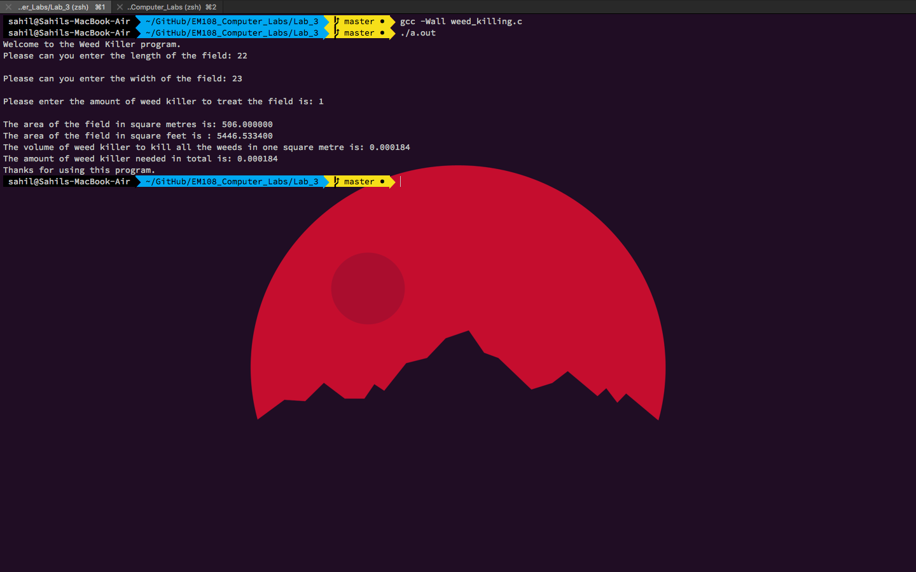

The program ran smoothly without any errors

### Conclusion

During this lab session I learned about some of the functions contained in the stdio.h and stdlib.h libraries (e.g. functions).

The final version of the C source code for problem 2 is attached as weed_killing.c

The code for this is:

#include <stdio.h>

#include <stdlib.h>

//Declare Variables

float length;

float width;

float weed_killer;

//Declare Functions

void input();

void calculations();

int main() {

printf("Welcome to the Weed Killer program.\n");

input();

calculations();

printf("Thanks for using this program.\n");

return 0;

}

//Getting user input for length and width and weed killer needed.

void input() {

printf("Please can you enter the length of the field: ");

scanf("%f", &length);

printf("\n");

printf("Please can you enter the width of the field: ");

scanf("%f", &width);

printf("\n");

printf("Please enter the amount of weed killer to treat the field is: ");

scanf("%f", &weed_killer);

printf("\n");

}

void calculations() {

printf("The area of the field in square metres is: %f\n", length * width);

printf("The area of the field in square feet is : %f\n", length * width * 10.7639);

printf("The volume of weed killer to kill all the weeds in one square metre is: %f\n", weed_killer / (length * width * 10.7639) );

printf("The amount of weed killer needed in total is: %f\n", (weed_killer / (length * width * 10.7639) ) * weed_killer );

}

## Problem 2

The aim of this problem is to write a C program that reads three numbers, computes and displays their sum, their product and their average as well as the minimum and the maximum value of the three numbers.

### Plan

* Print a welcoming message
* Ask the user to input three numbers
* Do the calculations
* Display the results
* Print a goodbye message

### Development

The first step in the development of my program was to include the standard C libraries (stdio.h, stdlib.h, string.h) that in order to be able to use certain functions in the program.

Then, I started writing up the main function of the program. I used the ‘printf’ command to display welcoming message on my screen on my screen. I used a void function to ask for the input from the user. I then used a separate void function to calculate the sum, product, average, maximum and minimum. I used an if, else if, and else statements to check for the maximum and minimum.

### Testing

I compiled and tested the program using the gcc compiler. I was not presented any errors when I compiled my code.

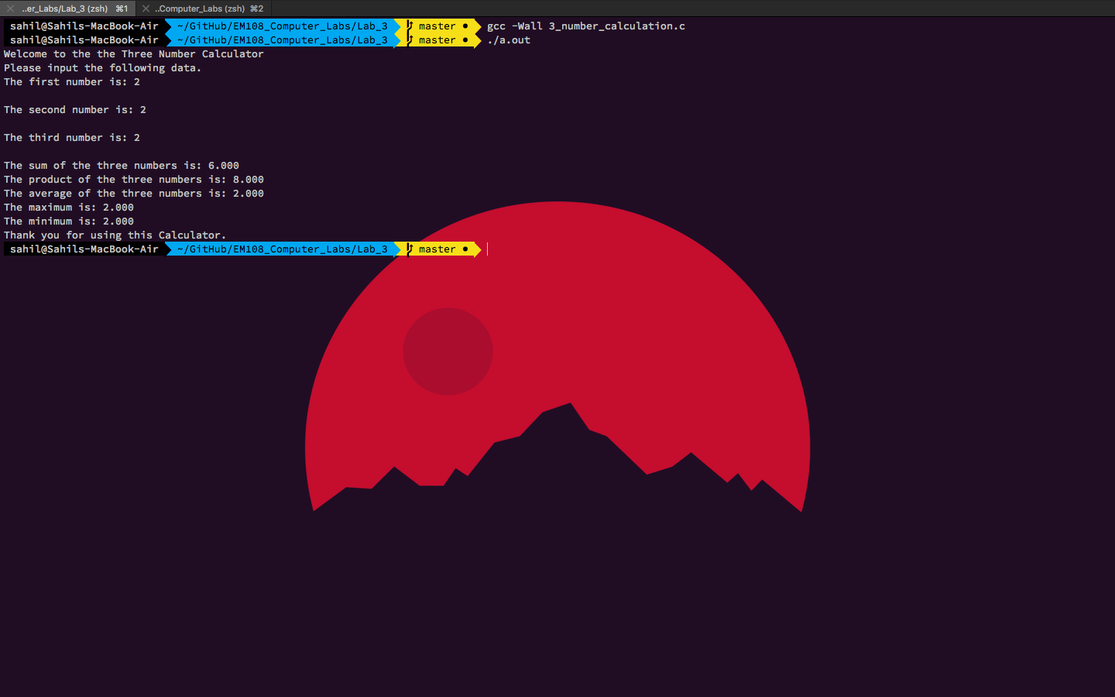

### Conclusion

During this lab session I learned about some of the functions contained in the stdio.h, stdlib.h and string.h libraries (e.g. if statements)..

The final version of the C source code for problem 1 is attached as 3_number_calculation.c

The code for this is:

#include <stdio.h>

#include <stdlib.h>

//Declaring variable and functions for the program

float x;

float y;

float z;

void input();

void calculations();

void maximum();

void minimum();

int main() {

printf("Welcome to the the Three Number Calculator\n");

input();

calculations();

maximum();

minimum();

printf("Thank you for using this Calculator.\n");

return 0;

}

void input() {

printf("Please input the following data.\n");

printf("The first number is: ");

scanf("%f", &x);

printf("\n");

printf("The second number is: ");

scanf("%f", &y);

printf("\n");

printf("The third number is: ");

scanf("%f", &z);

printf("\n");

}

//The calculations for sum, product and average

void calculations() {

printf("The sum of the three numbers is: %.3f\n", x + y + z);

printf("The product of the three numbers is: %.3f\n", x * y * z);

printf("The average of the three numbers is: %.3f\n", (x + y + z)/3 );

}

//The largest number of all three

void maximum() {

if((x >= y) && (x >= z)) {

printf("The maximum is: %.3f\n", x);

}

else if((y >= x) && (y >= z)) {

printf("The maximum is: %.3f\n", y);

}

else if((z >= x) && (z >= y)) {

printf("The maximum is: %.3f\n", z);

}

else {

printf("The numbers equal each other.\n");

}

}

//The smallest number of all three

void minimum() {

if((x <= y) && (x <= z)) {

printf("The minimum is: %.3f\n", x);

}

else if((y <= x) && (y <= z)) {

printf("The minimum is: %.3f\n", y);

}

else if((z <= x) && (z <= y)) {

printf("The minimum is: %.3f\n", z);

}

else {

printf("The numbers equal each other.\n");

}

}

## Problem 3

The aim of this problem is to write a C program that reads reads from the a positive integer N representing how many numbers we have to process then the program should read N numbers, compute and display their sum, their product and their average.

### Plan

* Print a welcoming message
* Ask the user for input
* Do the calculations
* Print the answers
* Print a goodbye message

### Development

The first step in the development of my program was to include the standard C libraries (stdio.h, stdlib.h, string.h) that in order to be able to use certain functions in the program.

Then, I started writing up the main function of the program. I used the ‘printf’ command to display welcoming message on my screen on my screen. I used a void function to ask for the input from the user. I then used a separate void function to calculate the sum, product, average. I used a for loop in the function to calculate the sum and average. I then used multiple ‘printf’ statements to display the results.

### Testing

I compiled and tested the program using the gcc compiler. I was not presented any errors when I compiled my code.

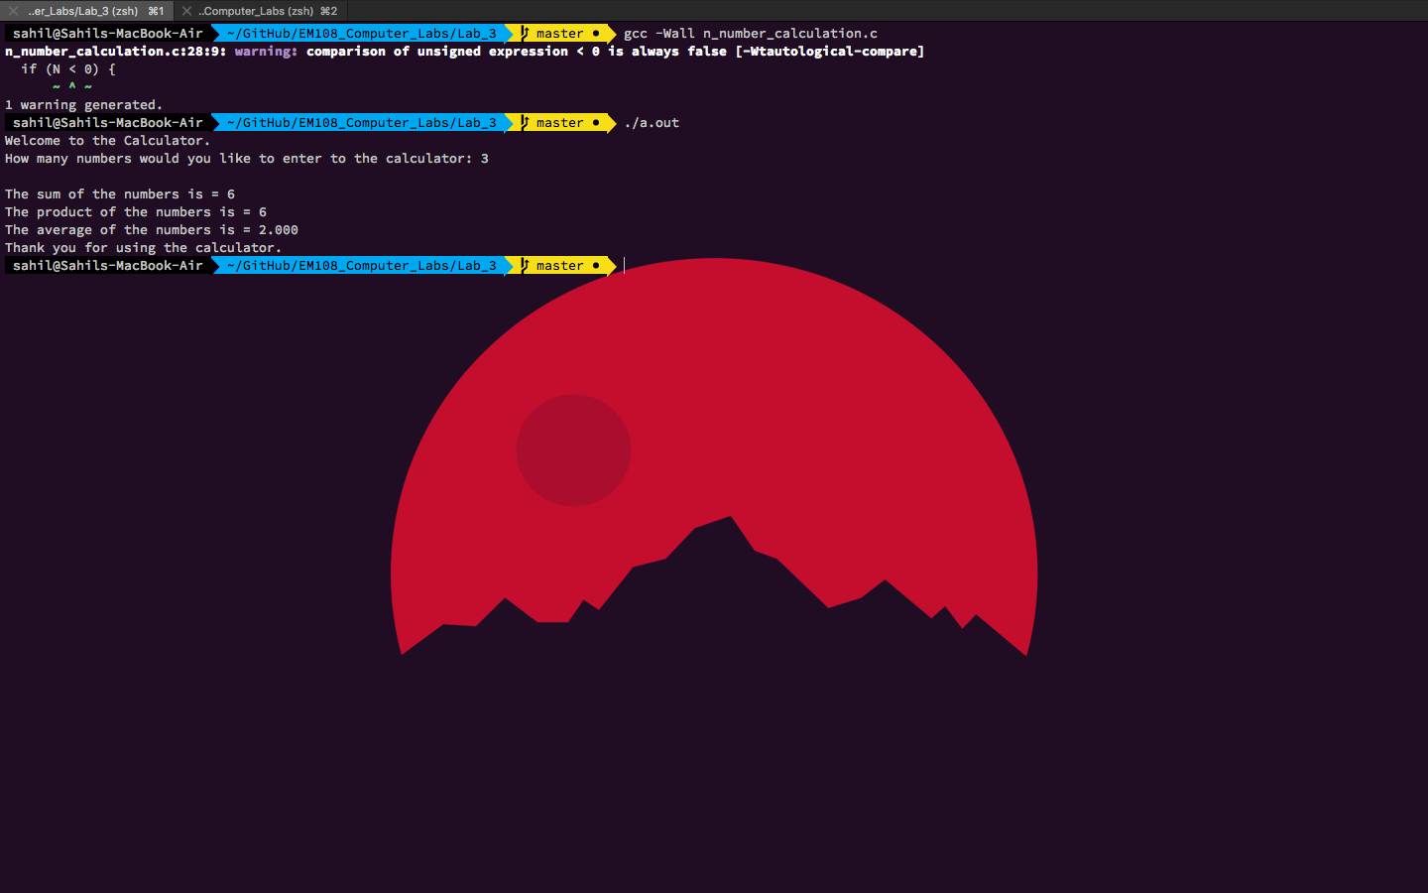

### Conclusion

During this lab session I learned about some of the functions contained in the stdio.h, stdlib.h and string.h libraries (e.g. for loops)..

The final version of the C source code for problem 1 is attached as n_number_calculation.c

The code for this is:

#include <stdio.h>

#include <stdlib.h>

unsigned int N;

int i;

int j;

int sum;//The sum of all the numbers

int prod;//The product of all the numbers

float avrg;//average

void input();

void calculations();

int main() {

printf("Welcome to the Calculator.\n");

input();

calculations();

printf("Thank you for using the calculator.\n");

return 0;

}

void input() {

printf("How many numbers would you like to enter to the calculator: ");

scanf("%d", &N);

printf("\n");

if (N < 0) {

input();

}

}

void calculations() {

prod = 1;

for(i=1; i <=N; ++i)

{

sum = sum + i;

prod = prod *i;

}

avrg = sum / N;

printf("The sum of the numbers is = %d\n", sum);

printf("The product of the numbers is = %d\n", prod);

printf("The average of the numbers is = %.3f\n", avrg);

}