MongoDB ASSIGNMENT 3

1. Total sales per product.

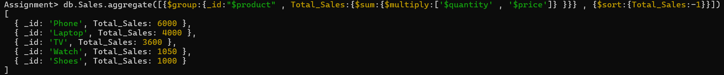

1. Total revenue per product.

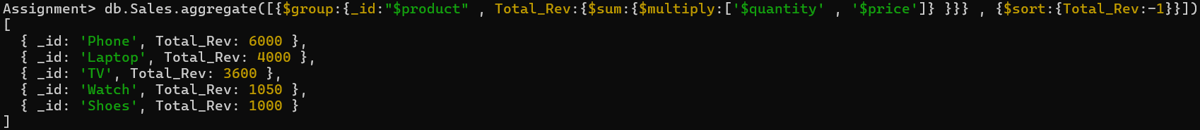

1. Total revenue per category.



1. Count of products per category.



1. Store-wise total sales.



1. Average price of products per category.



1. Top-selling product.



1. Total sales for Electronics category.



1. Sales trend over time (day-wise total sales).

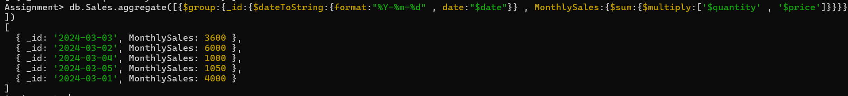

1. Highest revenue-generating product.



1. Average revenue per sale.



1. Sales performance per store.



1. Products sold more than 5 times.

1. Least sold product.



1. Monthly sales summary.



1. Number of unique products sold.



1. Maximum and minimum priced product.

1. Total revenue per product in descending order.

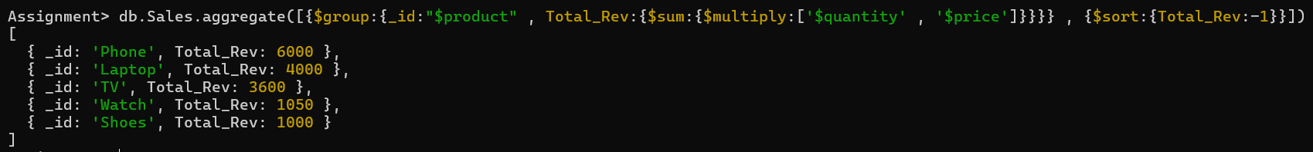

1. Revenue generated per store per category.

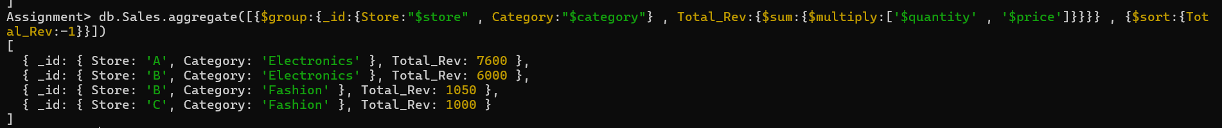

20. Products contributing more than 50% revenue.