GENIEACS TR-069 / CWMP
R&D AND TESTING REPORT
Local ACS Deployment and TP-Link CPE Testing
Prepared By: _SHANKHALA SAHIL G.
Date: 24 August 2026
Project / Organization: TESTING ACS SERVER

1. Introduction
Modern broadband networks require a centralized mechanism to remotely manage Customer Premises Equipment (CPE), such as routers and gateways. TR-069, also known as the CPE WAN Management Protocol (CWMP), provides a standardized way for a CPE to communicate with an Auto Configuration Server (ACS).
GenieACS is an open-source Auto Configuration Server that supports TR-069/CWMP based device management. It can be used to retrieve device information, manage supported parameters, perform provisioning operations, and execute supported remote operations.
In this project, GenieACS is deployed in a local laboratory environment on an Ubuntu Server. A TP-Link router is used as the TR-069 CPE and an Ethernet switch provides LAN connectivity between the server and the CPE. The project verifies basic network connectivity, CWMP communication, device discovery, parameter retrieval, supported parameter modification, and selected remote operations.

2. Objectives
- Understand the fundamentals of TR-069/CWMP and Auto Configuration Server architecture.
- Deploy and configure GenieACS in a Linux-based laboratory environment.
- Establish LAN connectivity between the GenieACS server and the TP-Link CPE.
- Configure the TP-Link router as a TR-069/CWMP client where supported.
- Verify communication between the CPE and ACS.
- Verify device discovery and retrieve supported device parameters.
- Test modification of supported writable parameters.
- Test periodic Inform communication.
- Test supported remote operations such as reboot.
- Capture and analyze CWMP traffic using tcpdump or Wireshark.
- Document failures, troubleshooting steps, observations, and final results.

3. Scope of the Project
The scope of this project is limited to laboratory deployment and functional testing of GenieACS as a TR-069 Auto Configuration Server. The project covers local ACS deployment, CPE connectivity, CWMP communication, device discovery, parameter operations, selected remote operations, traffic analysis, and troubleshooting. Production-scale high availability, large-scale ISP deployment, and complete security hardening are outside the primary scope of this laboratory test.

4. Lab Environment
Component | Details | Actual Value
ACS | GenieACS | GenieACS 1.2.16
Server OS | Ubuntu Server 24.04 LTS | Ubuntu Server 24.04 LTS
Database | MongoDB | MongoDB 8.0.28
CPE | TP-Link Router | TP-Link Router
Switch | Ethernet Switch | Oracle VirtualBox
Protocol | TR-069 / CWMP | TR-069 / CWMP
CWMP Port | ACS endpoint | 7547
Web UI Port | GenieACS UI | 3000

5. Network Topology
Internet
│
ISP ONU
192.168.1.1
│
│ Ethernet
▼
TPLINK SWITCH [UNMANAGABLE 8 PORT]
|
▼
TP-Link Router
192.168.1.2
│
│ Ethernet
▼
Ubuntu Server
192.168.1.75
│
GenieACS

6. System and Service Verification
Record the commands and actual output used during testing.

ip addr
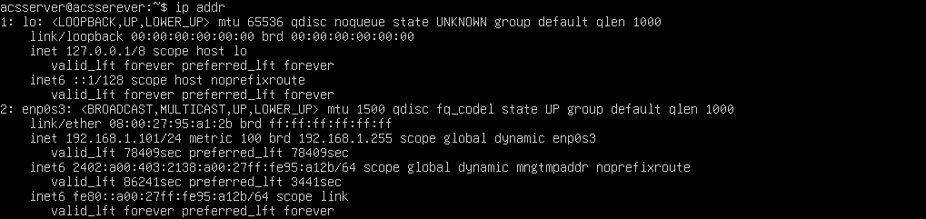
node –version
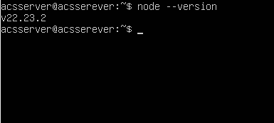

mongod –version
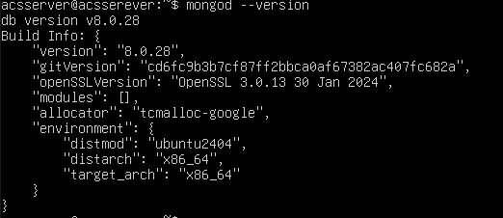

sudo systemctl status genieacs-cwmp
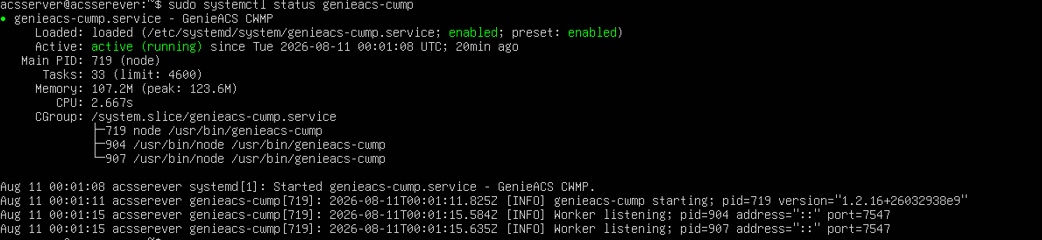
sudo systemctl status genieacs-nbi
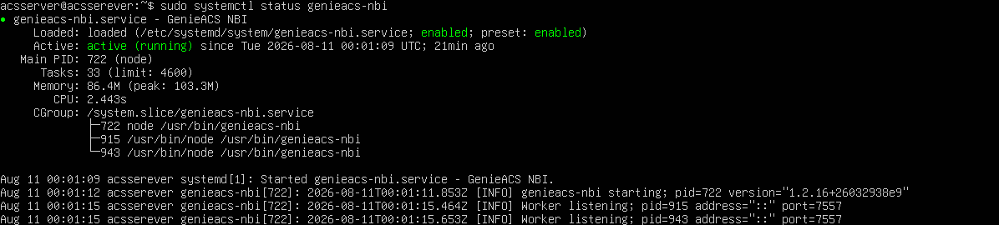
sudo systemctl status genieacs-fs
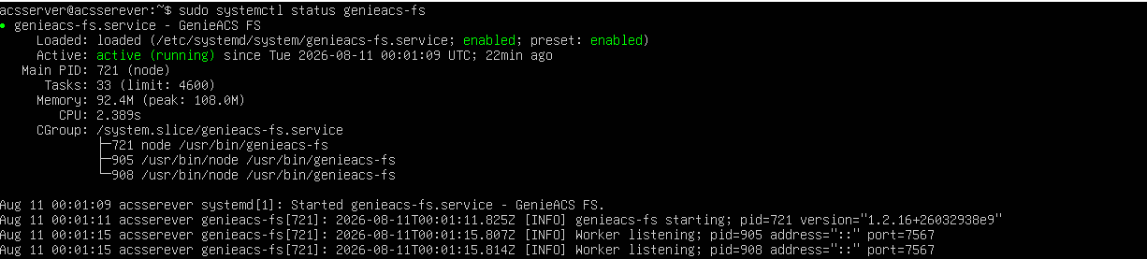
sudo systemctl status genieacs-ui
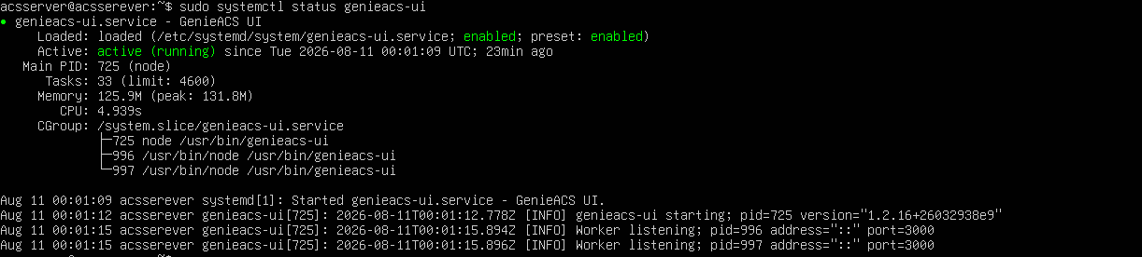
sudo ss –lntp
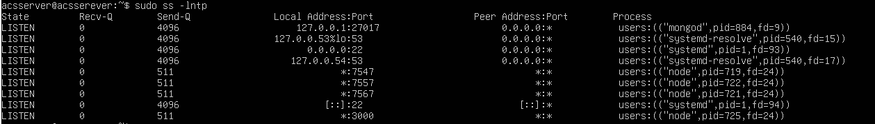

7. TP-Link CPE Configuration
Configure the TP-Link router's TR-069/CWMP settings if the firmware provides a compatible TR-069 client. Record the ACS URL and other non-sensitive settings.
Setting | Value
TR-069/CWMP | Enabled
ACS URL | http://192.168.1.75:7547
ACS Username | Admin
ACS Password | Admin
Periodic Inform | 300s

8. Testing Methodology
Testing is performed in stages. First, IP connectivity between the ACS and CPE is verified. Next, GenieACS services and the CWMP endpoint are checked. The CPE is then configured with the ACS URL and triggered to establish a CWMP session. After the device appears in GenieACS, supported parameters and operations are tested. Finally, CWMP traffic is captured to correlate the application-level behavior with network-level traffic.

9. Test Cases
TC-001 Network connectivity
Objective : Verify CPE reach ACS
Status : pass
Evidence

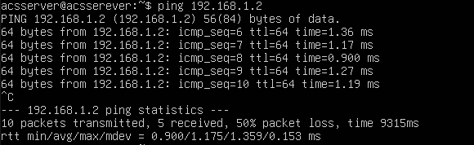
TC-002 CWMP Port Verification
Objective : Verify ACS is listening on TCP 7547
Status : pass
Evidence
TC-003 CPE Registration
Objective : Verify CPE appears in GenieACS
Status : pass
Evidence
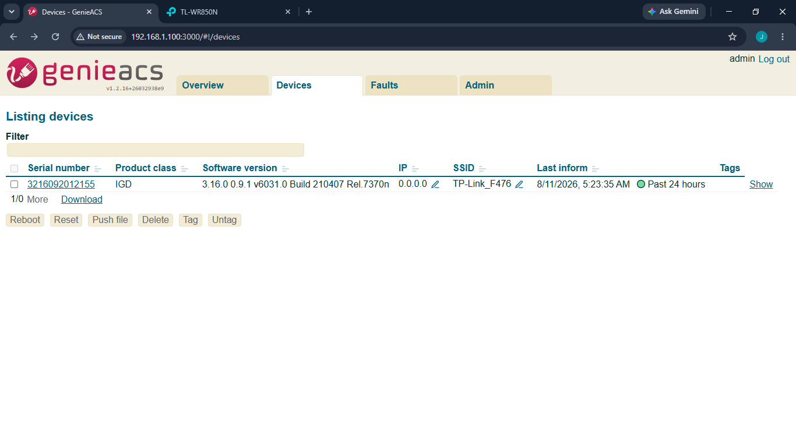
TC-004 Device Discovery
Objective : Verify device information is retrieved
Status : pass
Evidence
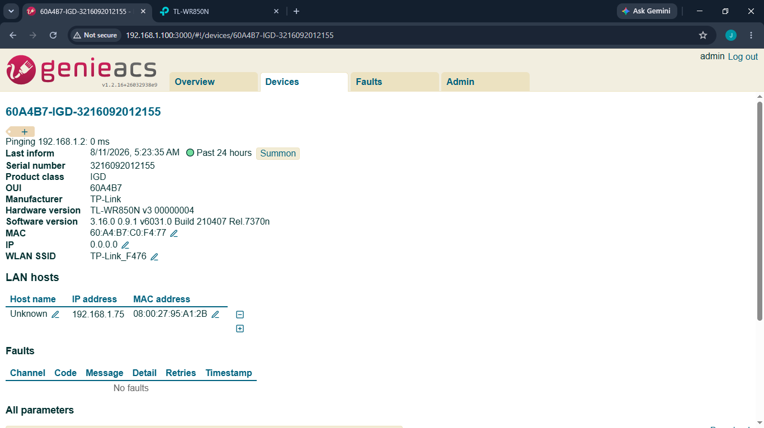
TC-005 Parameter Read
Objective : Read supported device parameters
Status : pass
Evidence
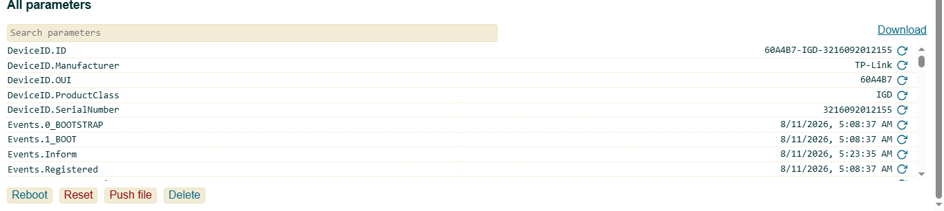
Here parameter we can use for gathering more information of CPE.
DeviceID.ID
DeviceID.Manufacturer
DeviceID.OUI
DeviceID.ProductClass
DeviceID.SerialNumber

TC-006 Parameter Write
Objective : Modify a supported writable parameter
Status : pass
Evidence
1 InternetGatewayDevice.LANDevice.1.WLANConfiguration.1.SSID
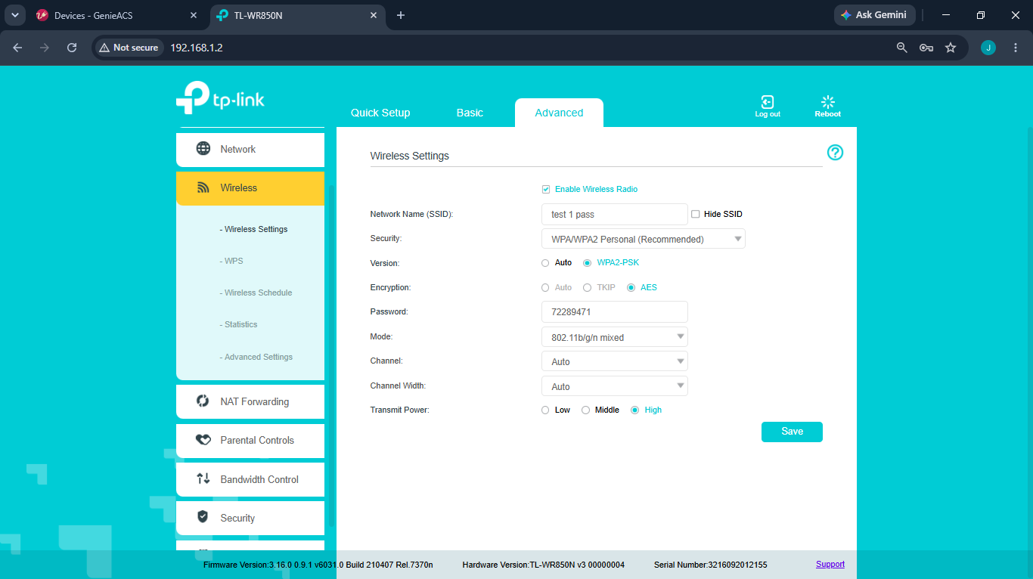

2 InternetGatewayDevice.WANDevice.1.WANConnectionDevice.1.WANIPConnection.1.ExternalIPAddress
THIS IS WORKING IN STATIC IP MODE

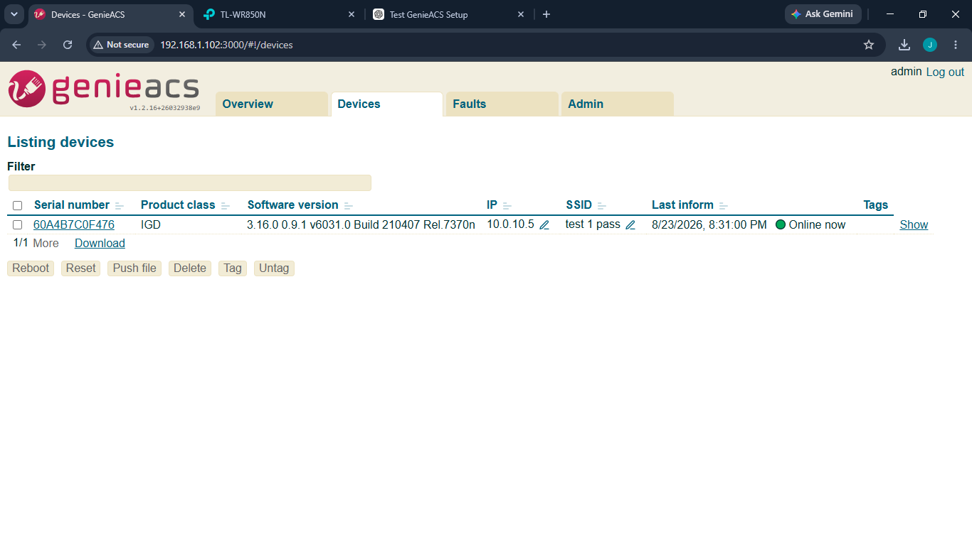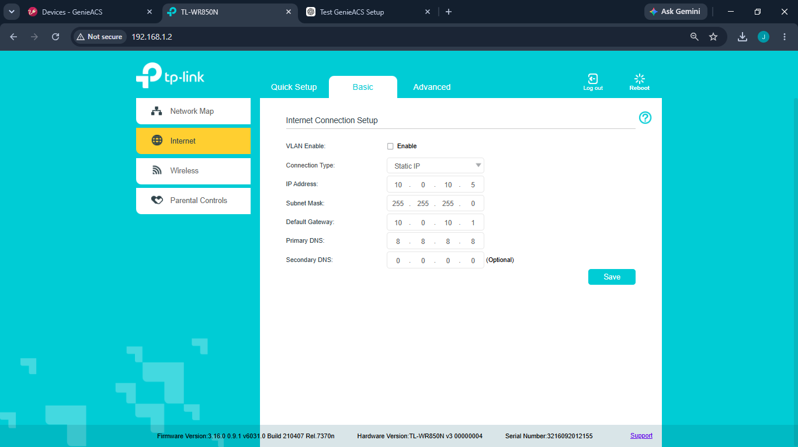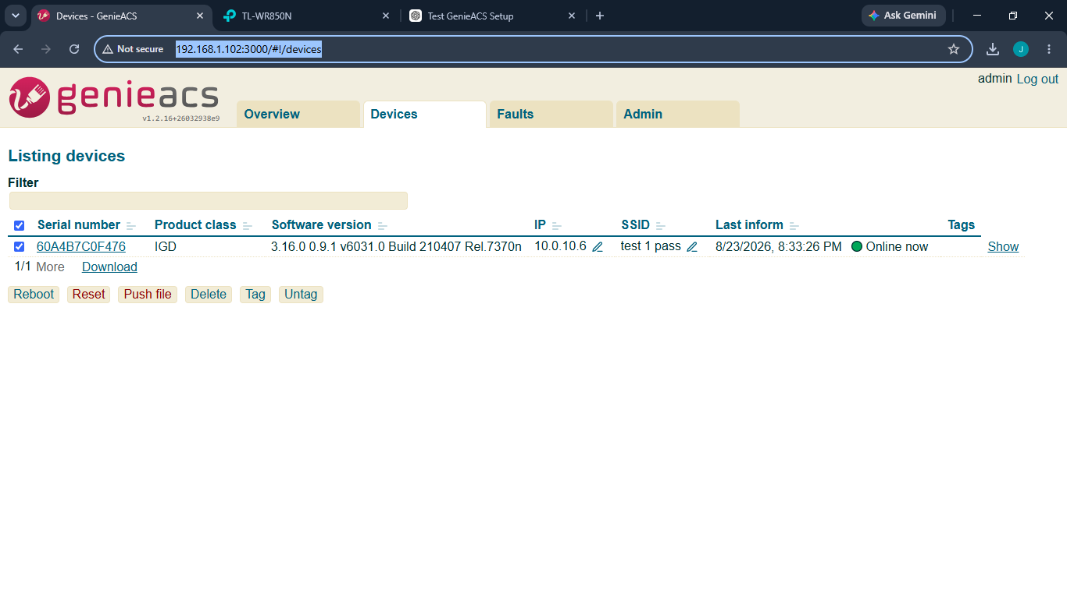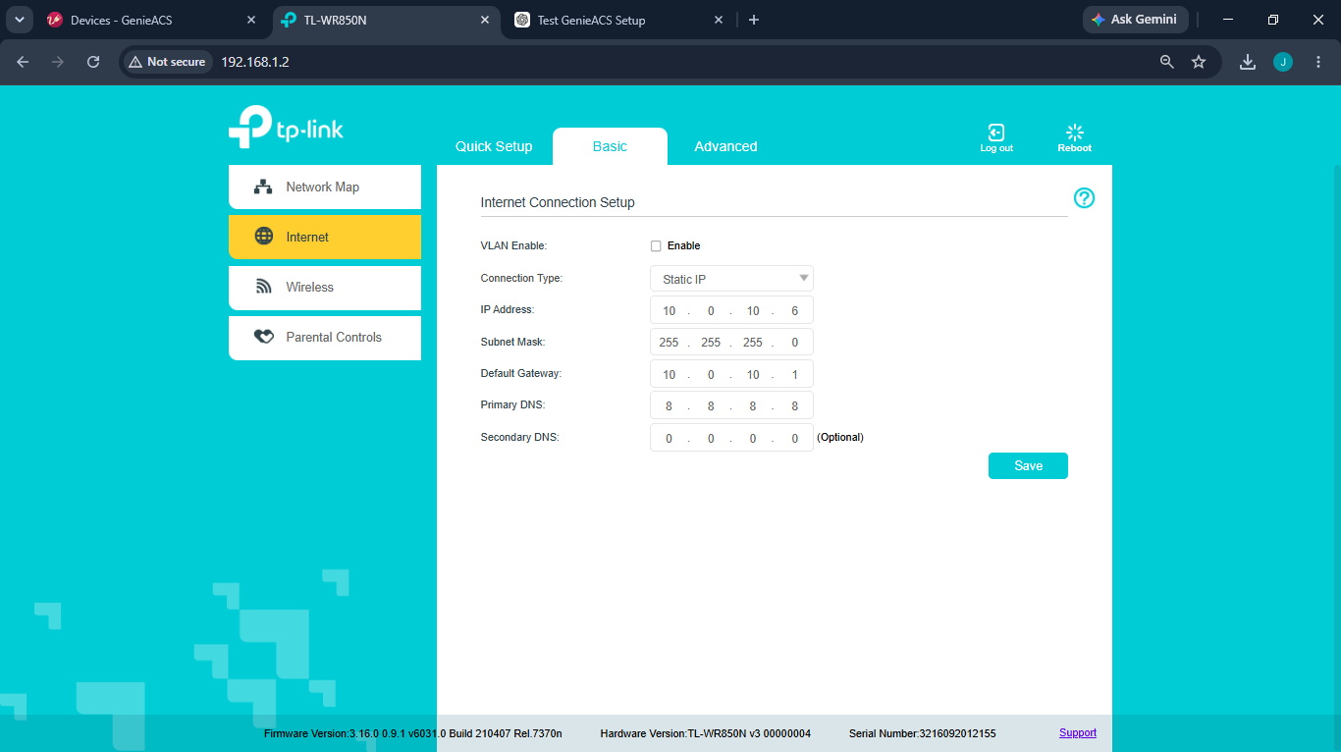

TC-007 Periodic Inform
Objective : Verify periodic CPE communication
Status : pass
Evidence
BEFOR INTERVAL
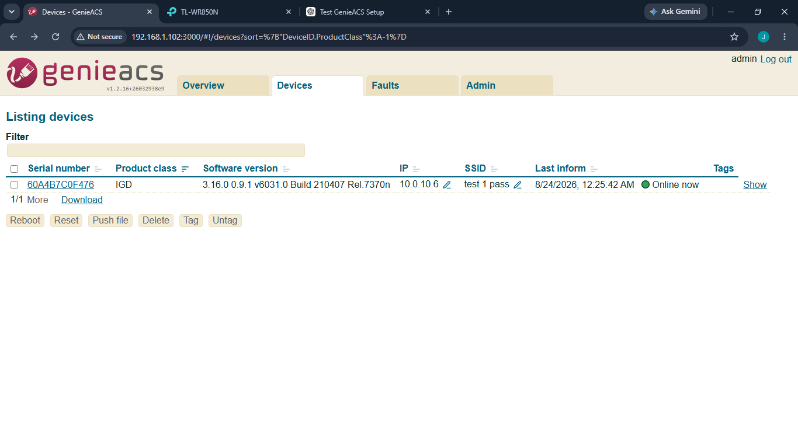
CONFORMING INTERVAL TIMING
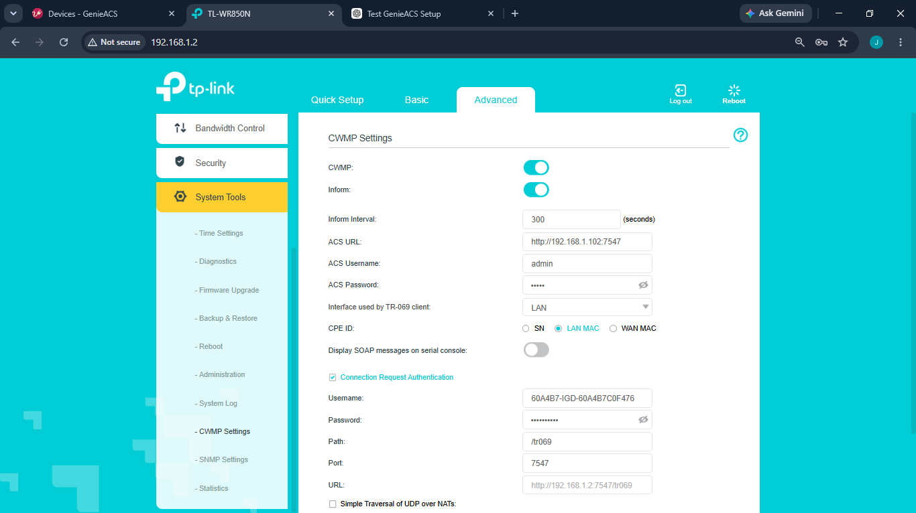

AFTER INTERVAL TIME

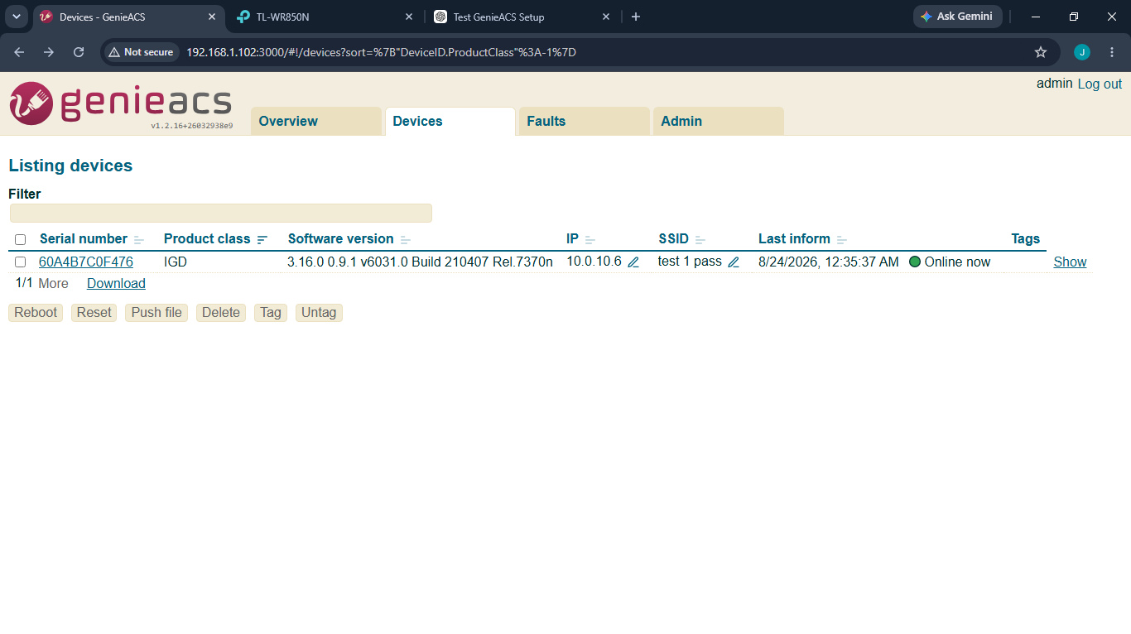
TC-008 Remote Reboot
Objective : Verify supported reboot operation
Status : pass
Evidence
Here show system uptime before remote reboot
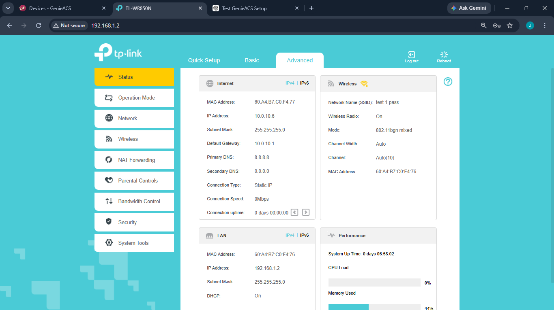

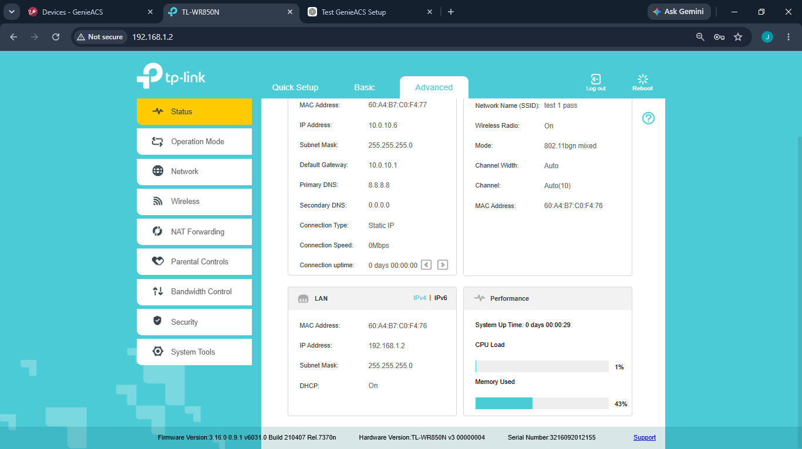
Uptime after testing
TC-009 Packet Capture
Objective : Observe CWMP traffic on TCP 7547
Status : pass
Evidence

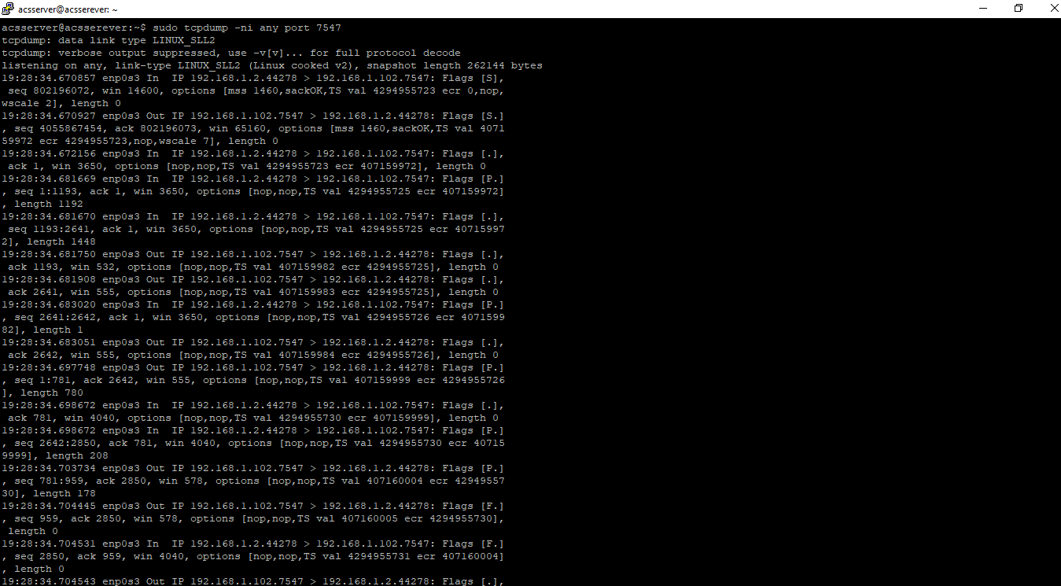
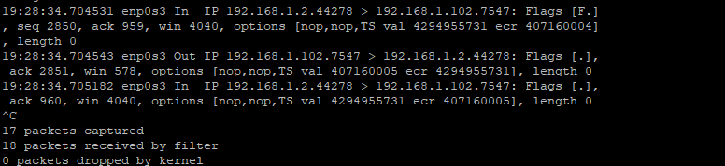

10. Packet Capture and Analysis
tcpdump was used to verify the network-level communication between the CPE and ACS. The capture was filtered on TCP port 7547, and the source/destination addresses and CWMP-related traffic were reviewed.
Command: sudo tcpdump -ni any port 7547
Evidence / Screenshot: Wireshark/tcpdump capture of CWMP traffic on TCP port 7547.
Observation: CWMP traffic between the TP-Link CPE (10.0.10.6) and GenieACS (192.168.1.102) was captured successfully on TCP port 7547.

11. Troubleshooting Log
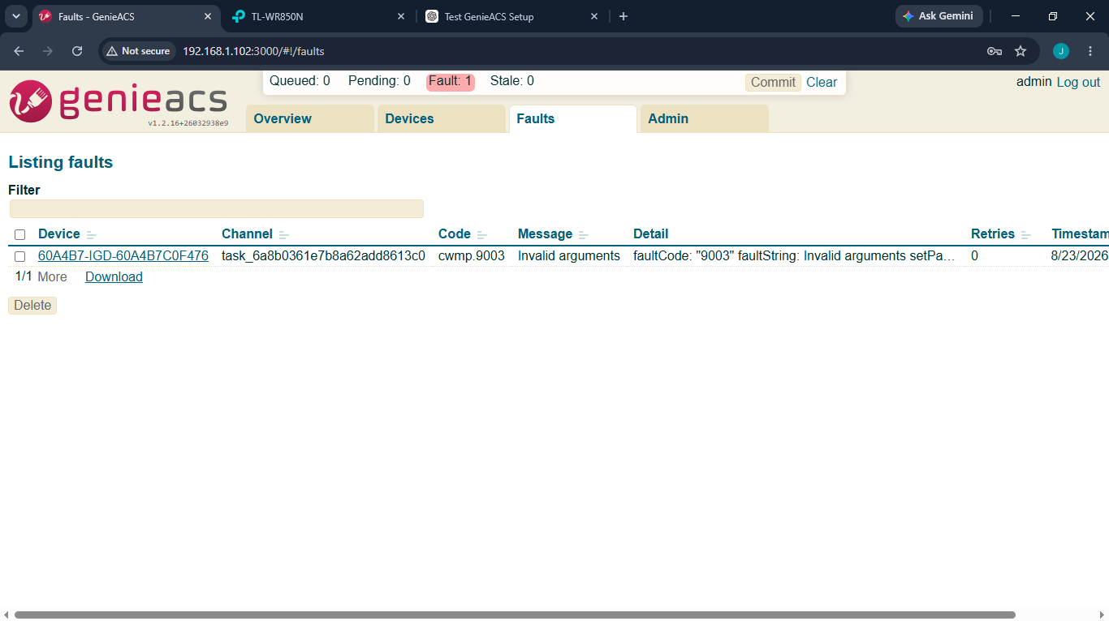
Issue and Root Cause:
I attempted to change the CPE's IP address directly from the device page in GenieACS. During the investigation, I found that the CPE's external IP address is automatically assigned based on the WAN connection type and network configuration. For example, when the CPE is configured as an extender, it may obtain its IP address from the main router. In an ISP/PPPoE setup, the IP address is typically assigned by the ISP. Therefore, the ExternalIPAddress parameter cannot be directly modified through GenieACS in this configuration. A static IP address can be configured when the WAN connection type is set to Static IP and the relevant parameters are writable and supported by the CPE firmware.
12. Test Summary

Test ID | Description | Final Result
TC-001 | Network Connectivity | PASS
TC-002 | CWMP Port Verification | PASS
TC-003 | CPE Registration | PASS
TC-004 | Device Discovery | PASS
TC-005 | Parameter Read | PASS
TC-006 | Parameter Write | PASS
TC-007 | Periodic Inform | PASS
TC-008 | Remote Reboot | PASS
TC-009 | Packet Capture | PASS

13. Findings
The lab deployment was completed successfully and the TP-Link CPE communicated with GenieACS using TR-069/CWMP. The device was discovered in the ACS, supported parameters were read successfully, and a supported writable parameter was changed and verified. Periodic Inform communication and the remote reboot operation were also verified.
One useful limitation was identified during testing. The ExternalIPAddress parameter could be read, but a direct write attempt was rejected by the CPE with fault code 9003 and parameter fault code 9002. Further investigation showed that the external IP is controlled by the WAN connection type and upstream network configuration in the tested setup. This was documented as a troubleshooting finding rather than treated as a GenieACS failure.
Packet capture also confirmed CWMP communication at the network level on TCP port 7547. Overall, the testing showed that GenieACS can manage the CPE effectively when the required parameters and operations are exposed and writable by the CPE firmware.
Record what was successfully demonstrated, which parameters were supported, which operations were unavailable, and any important limitations of the TP-Link firmware.

14. Conclusion
The GenieACS TR-069/CWMP environment was successfully deployed and tested in the laboratory. All nine planned test cases were completed successfully, covering connectivity, CWMP port verification, CPE registration and discovery, parameter read/write, Periodic Inform, remote reboot, and packet capture. The project also showed an important practical limitation: remote management depends on what the CPE firmware exposes as supported and writable parameters. The ExternalIPAddress write attempt was therefore useful as a real troubleshooting example rather than something to force into a PASS result. Overall, the project provided hands-on experience with ACS deployment, CPE management, CWMP communication, troubleshooting, and packet-level verification.

15. Future Scope
- Testing multiple CPE devices simultaneously.
- Automatic provisioning using GenieACS provisions.
- Firmware upgrade testing.
- Integration with an NMS or monitoring system.
- Large-scale CPE management simulation.
- Security hardening and HTTPS deployment.
- Research into TR-369 / USP as a successor technology.
16. Evidence Checklist
- GenieACS service status screenshot
- IP configuration screenshot
- Network topology diagram
- TP-Link TR-069 configuration screenshot
- Successful ping screenshot
- GenieACS Devices page screenshot
- Parameter read screenshot
- Parameter write screenshot
- Reboot test evidence
- tcpdump/Wireshark capture
- Troubleshooting evidence
- Final test summary

