GENIEACS TR-069 / CWMP
R&D AND TESTING REPORT
Local ACS Deployment and TP-Link CPE Testing
Prepared By: __________________________
Date: _________________________________
Project / Organization: ________________

How to Use This Template
Ye template first-time R&D documentation ke liye banaya gaya hai. Jahan [FILL AFTER TESTING] likha hai, wahan actual testing ke baad apna result, IP address, model number, screenshot ya observation add karna hai. Jo test abhi perform nahi hua hai usko PASS mat mark karna.

1. Introduction
Modern broadband networks require a centralized mechanism to remotely manage Customer Premises Equipment (CPE), such as routers and gateways. TR-069, also known as the CPE WAN Management Protocol (CWMP), provides a standardized way for a CPE to communicate with an Auto Configuration Server (ACS).
GenieACS is an open-source Auto Configuration Server that supports TR-069/CWMP based device management. It can be used to retrieve device information, manage supported parameters, perform provisioning operations, and execute supported remote operations.
In this project, GenieACS is deployed in a local laboratory environment on an Ubuntu Server. A TP-Link router is used as the TR-069 CPE and an Ethernet switch provides LAN connectivity between the server and the CPE. The project verifies basic network connectivity, CWMP communication, device discovery, parameter retrieval, supported parameter modification, and selected remote operations.

2. Objectives
- Understand the fundamentals of TR-069/CWMP and Auto Configuration Server architecture.
- Deploy and configure GenieACS in a Linux-based laboratory environment.
- Establish LAN connectivity between the GenieACS server and the TP-Link CPE.
- Configure the TP-Link router as a TR-069/CWMP client where supported.
- Verify communication between the CPE and ACS.
- Verify device discovery and retrieve supported device parameters.
- Test modification of supported writable parameters.
- Test periodic Inform communication.
- Test supported remote operations such as reboot.
- Capture and analyze CWMP traffic using tcpdump or Wireshark.
- Document failures, troubleshooting steps, observations, and final results.

3. Scope of the Project
The scope of this project is limited to laboratory deployment and functional testing of GenieACS as a TR-069 Auto Configuration Server. The project covers local ACS deployment, CPE connectivity, CWMP communication, device discovery, parameter operations, selected remote operations, traffic analysis, and troubleshooting. Production-scale high availability, large-scale ISP deployment, and complete security hardening are outside the primary scope of this laboratory test.

4. Lab Environment
Component | Details | Actual Value
ACS | GenieACS | GenieACS 1.2.16
Server OS | Ubuntu Server 24.04 LTS | Ubuntu Server 24.04 LTS
Database | MongoDB | MongoDB 8.0.28
CPE | TP-Link Router | TP-Link Router
Switch | Ethernet Switch | Oracle VirtualBox
Protocol | TR-069 / CWMP | TR-069 / CWMP
CWMP Port | ACS endpoint | 7547
Web UI Port | GenieACS UI | 3000

5. Network Topology
Internet
│
ISP ONU
192.168.1.1
│
│ Ethernet
▼
TP-Link Router
192.168.1.2
│
│ Ethernet
▼
Ubuntu Server
192.168.1.75
│
GenieACS

6. System and Service Verification
Record the commands and actual output used during testing.

ip addr
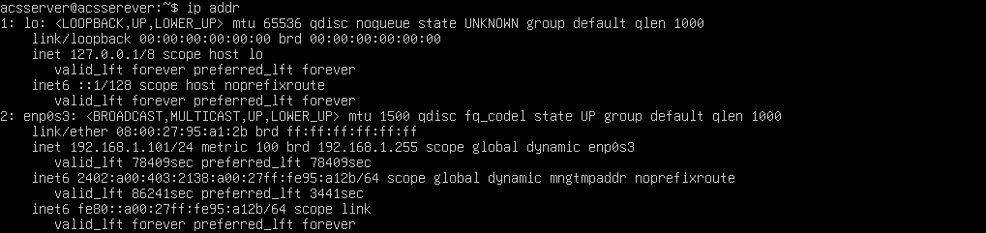
node –version
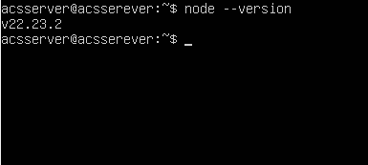

mongod –version
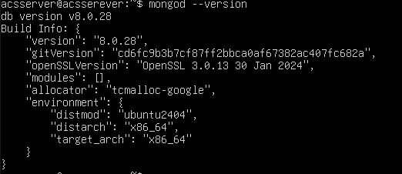

sudo systemctl status genieacs-cwmp
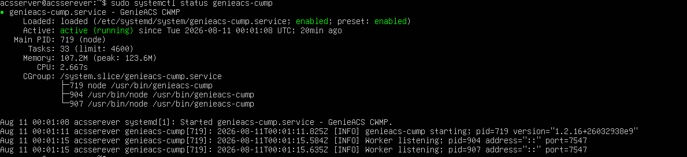
sudo systemctl status genieacs-nbi
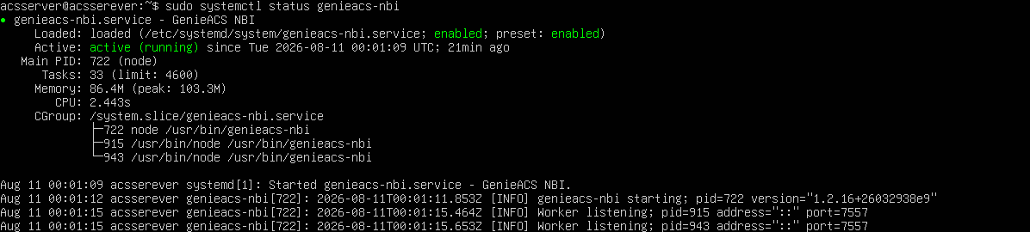
sudo systemctl status genieacs-fs
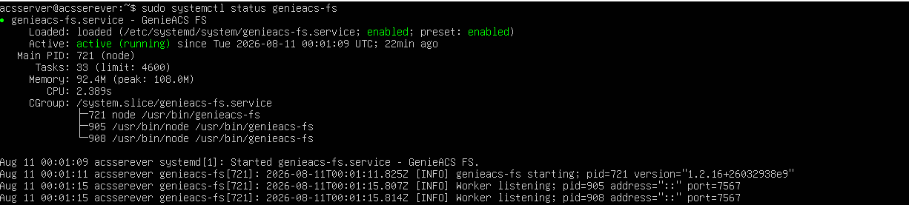
sudo systemctl status genieacs-ui
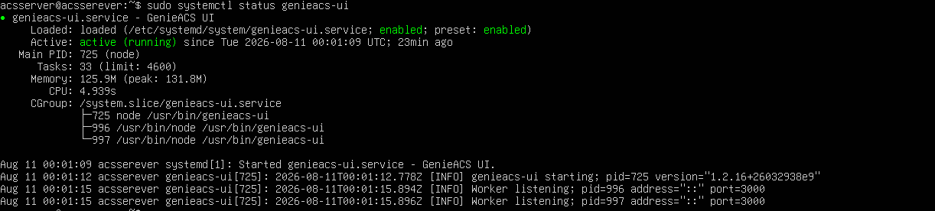
sudo ss –lntp
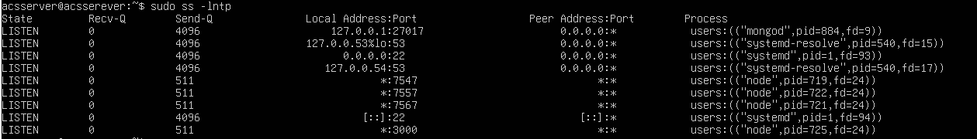

7. TP-Link CPE Configuration
Configure the TP-Link router's TR-069/CWMP settings if the firmware provides a compatible TR-069 client. Record the ACS URL and other non-sensitive settings.
Setting | Value
TR-069/CWMP | Enabled
ACS URL | http://192.168.1.75:7547
ACS Username | Admin
ACS Password | Admin
Periodic Inform | 300s

8. Testing Methodology
Testing is performed in stages. First, IP connectivity between the ACS and CPE is verified. Next, GenieACS services and the CWMP endpoint are checked. The CPE is then configured with the ACS URL and triggered to establish a CWMP session. After the device appears in GenieACS, supported parameters and operations are tested. Finally, CWMP traffic is captured to correlate the application-level behavior with network-level traffic.

9. Test Cases
TC-001 Network connectivity
Objective : Verify CPE reach ACS
Status : pass
Evidence

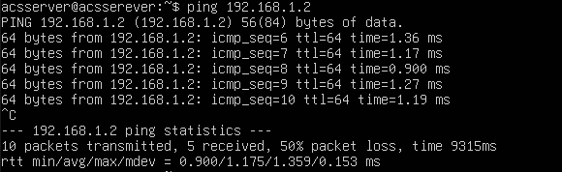
TC-002 CWMP Port Verification
Objective : Verify ACS is listening on TCP 7547
Status : pass
Evidence
TC-003 CPE Registration
Objective : Verify CPE appears in GenieACS
Status : pass
Evidence
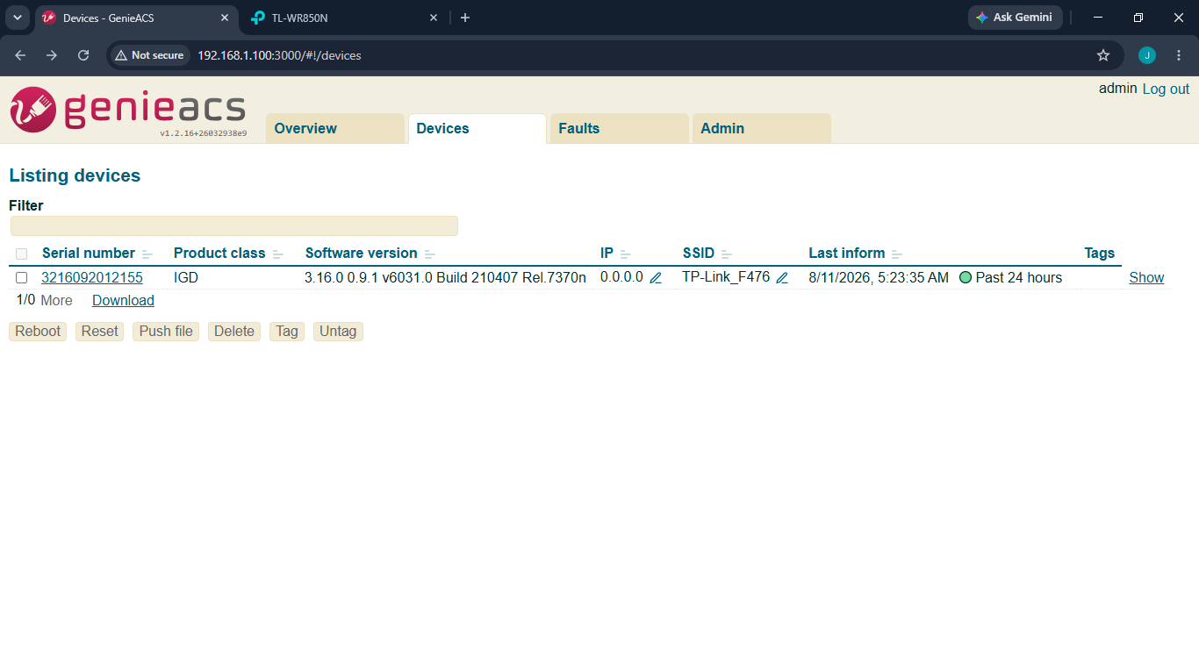
TC-004 Device Discovery
Objective : Verify device information is retrieved
Status : pass
Evidence
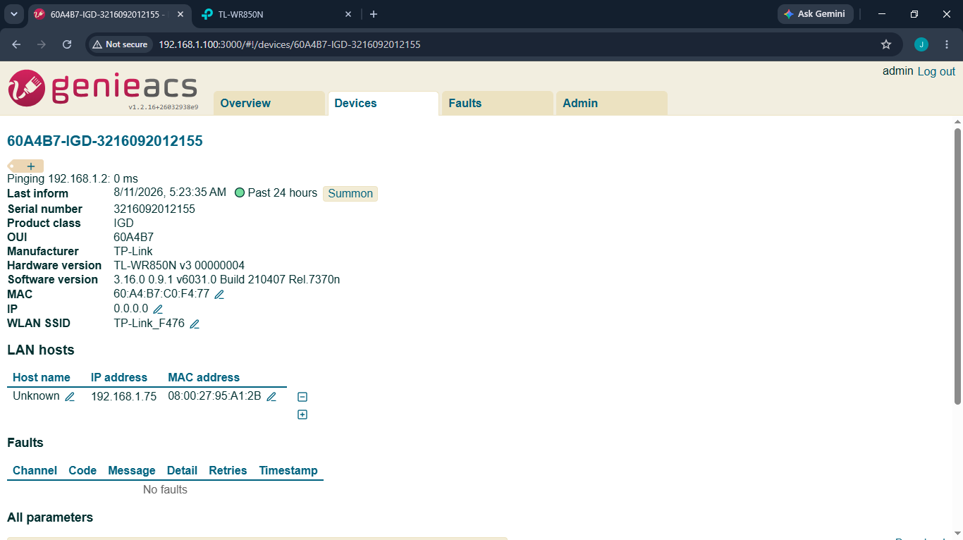
TC-005 Parameter Read
Objective : Read supported device parameters
Status : pass
Evidence
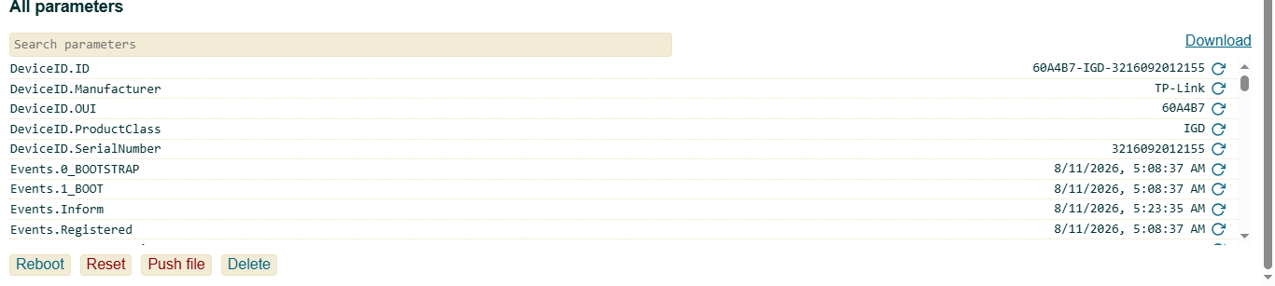
Here parameter we can use for gathering more information of CPE.
DeviceID.ID
DeviceID.Manufacturer
DeviceID.OUI
DeviceID.ProductClass
DeviceID.SerialNumber

TC-006 Parameter Write
Objective : Modify a supported writable parameter
Status : pass
Evidence

TC-006 | Parameter Write | Modify a supported writable parameter | [FILL] | [FILL] | [PASS/FAIL]
TC-007 | Periodic Inform | Verify periodic CPE communication | [FILL] | [FILL] | [PASS/FAIL]
TC-008 | Remote Reboot | Verify supported reboot operation | [FILL] | [FILL] | [PASS/FAIL]
TC-009 | Packet Capture | Observe CWMP traffic on TCP 7547 | [FILL] | [FILL] | [PASS/FAIL]

10. Packet Capture and Analysis
Use tcpdump or Wireshark to verify that the CPE and ACS exchange traffic. Example capture filter: tcp.port == 7547. Record the timestamp, source IP, destination IP, TCP connection, and relevant CWMP messages observed.
Command: sudo tcpdump -ni any port 7547
Evidence / Screenshot: [INSERT WIRESHARK/TCPDUMP SCREENSHOT]
Observation: [FILL AFTER TESTING]

11. Troubleshooting Log
Issue | Investigation | Solution | Result
[Issue 1] | [What you checked] | [What you changed] | [Resolved/Not Resolved]
[Issue 2] | [What you checked] | [What you changed] | [Resolved/Not Resolved]

12. Test Summary
Complete this section only after all planned tests have been performed.
Test ID | Description | Final Result
TC-001 | Network Connectivity | [PASS/FAIL/NOT TESTED]
TC-002 | CWMP Port Verification | [PASS/FAIL/NOT TESTED]
TC-003 | CPE Registration | [PASS/FAIL/NOT TESTED]
TC-004 | Device Discovery | [PASS/FAIL/NOT TESTED]
TC-005 | Parameter Read | [PASS/FAIL/NOT TESTED]
TC-006 | Parameter Write | [PASS/FAIL/NOT TESTED]
TC-007 | Periodic Inform | [PASS/FAIL/NOT TESTED]
TC-008 | Remote Reboot | [PASS/FAIL/NOT TESTED]
TC-009 | Packet Capture | [PASS/FAIL/NOT TESTED]

13. Findings
[FILL AFTER TESTING]
Record what was successfully demonstrated, which parameters were supported, which operations were unavailable, and any important limitations of the TP-Link firmware.

14. Conclusion
[FILL AFTER TESTING] Summarize whether GenieACS was successfully deployed, whether CWMP communication was established, which CPE management functions worked, and what was learned from the packet-level analysis.

15. Future Scope
- Testing multiple CPE devices simultaneously.
- Automatic provisioning using GenieACS provisions.
- Firmware upgrade testing.
- Integration with an NMS or monitoring system.
- Large-scale CPE management simulation.
- Security hardening and HTTPS deployment.
- Research into TR-369 / USP as a successor technology.

16. Evidence Checklist
- GenieACS service status screenshot
- IP configuration screenshot
- Network topology diagram
- TP-Link TR-069 configuration screenshot
- Successful ping screenshot
- GenieACS Devices page screenshot
- Parameter read screenshot
- Parameter write screenshot
- Reboot test evidence
- tcpdump/Wireshark capture
- Troubleshooting evidence
- Final test summary

17. Notes for First-Time Testing
Do not fill results before performing the test. Keep original screenshots and command outputs. Hide passwords, API credentials, public IP addresses, tokens, and other secrets before placing evidence in a GitHub repository. If a test fails, document the failure and root cause instead of changing the result to PASS.

