
SRM Institute of Science and Technology
SET B
Batch 2
College of Engineering and Technology
School of Computing
DEPARTMENT OF COMPUTING TECHNOLOGIES
SRM Nagar, Kattankulathur – 603203, Chengalpattu District, Tamilnadu
Academic Year: 2022-2023 (ODD/EVEN): ODD
Test: CLAT-2 Date: 14-10-2022
Course Code & Title: 18CSE356T - DOS Duration: 2 Periods
Year & Sem: III & V Max. Marks: 50

Course Articulation Matrix: (to be placed)
S.No. | Course Outcome | PO1 | PO2 | PO3 | PO4 | PO5 | PO6 | PO7 | PO8 | PO9 | PO10 | PO11 | PO12
1 | CO2 | 3 | 2 | 3 | 2 | 3 | 2 | - | - | 3 | 2 | - | 3
2 | CO3 | 3 | 3 | 3 | 3 | 3 | 2 | - | - | 3 | 2 | - | 3

Part – A
( 20 x 1 = 20 Marks)
Instructions: Answer all
Q. No | Question | Marks | BL | CO | PO | PI Code
1 | b. Connection oriented services | 1 | 1 | 2 | 1 | 1.6.1*
2 | c. transport layer | 1 | 1 | 2 | 1 | 1.6.1*
3 | b. data link layer | 1 | 1 | 2 | 1 | 1.6.1*
4. | a. TCP | 1 | 1 | 2 | 1 | 1.6.1*
5. | b. Packet switching | 1 | 1 | 2 | 1 | 1.6.1*
6. | b. AAL 3/4 | 1 | 1 | 2 | 1 | 1.6.1*
7. | a. send and receive | 1 | 1 | 2 | 1 | 1.6.1*
8. | a. mailbox | 1 | 1 | 2 | 1 | 1.6.1*
9. | c. Highly efficient and allows the most parallelism | 1 | 1 | 2 | 1 | 1.6.1*
10. | a. stub | 1 | 1 | 2 | 1 | 1.6.1*
11. | a. Head-of-line blocking | 1 | 1 | 2 | 1 | 1.6.1*
12. | b. 48 bytes | 1 | 1 | 2 | 1 | 1.6.1*
13. | a. Header | 1 | 1 | 2 | 1 | 1.6.1*
14. | c. session layer | 1 | 1 | 2 | 1 | 1.6.1*
15. | a. concurrent | 1 | 1 | 3 | 1 | 1.6.1*
16. | b. each process | 1 | 1 | 3 | 1 | 1.6.1*
17. | c. token ring algorithm | 1 | 1 | 3 | 1 | 1.6.1*
18. | b. centralized | 1 | 1 | 3 | 1 | 1.6.1*
19. | a. christian’s method | 1 | 1 | 3 | 1 | 1.6.1*
20 | d. mutual exclusion | 1 | 1 | 3 | 1 | 1.6.1*

Part – B
(3 x 10 = 30 Marks)
Instructions: Answer all
21a | Describe the various levels of protocols in OSI layers.  In the OSI model, when process A on machine 1 wants to communicate with process B on machine 2, it builds a message and passes the message to the application layer on its machine. This layer might be a library procedure, for example, but it could also be implemented in some other way (e.g., inside the operating system, on an external coprocessor chip, etc.). The application layer software then adds a header to the front of the message and passes the resulting message across the layer 6/7 interface to the presentation layer. The presentation layer in turn adds its own header and passes the result down to the session layer, and so on. Some layers add not only a header to the front, but also a trailer to the end. When it hits bottom, the physical layer actually transmits the message, which by now might look as shown in Fig. 2-2.  When the message arrives at machine 2, it is passed upward, with each layer stripping off and examining its own header. Finally, the message arrives at the receiver, process B, which may reply to it using the reverse path. The information in the layer n header is used for the layer n protocol.  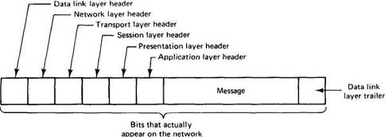  Fig. 2-2. A typical message as it appears on the network.  2.1.1. The Physical Layer  The physical layer is concerned with transmitting the 0s and 1s. How many volts to use for 0 and 1, how many bits per second can be sent, and whether transmission can take place in both directions simultaneously are key issues in the physical layer. In addition, the size and shape of the network connector (plug), as well as the number of pins and meaning of each are of concern here.  The physical layer protocol deals with standardizing the electrical, mechanical, and signaling interfaces so that when one machine sends a 0 bit it is actually received as a 0 bit and not a 1 bit. Many physical layer standards have been developed (for different media), for example, the RS-232-C standard for serial communication lines.  2.1.2. The Data Link Layer  The data link layer does its work by putting a special bit pattern on the start and end of each frame, to mark them, as well as computing a checksum by adding up all the bytes in the frame in a certain way. The data link layer appends the checksum to the frame. When the frame arrives, the receiver recomputes the checksum from the data and compares the result to the checksum following the frame. If they agree, the frame is considered correct and is accepted. It they disagree, the receiver asks the sender to retransmit it. Frames are assigned sequence numbers (in the header), so everyone can tell which is which.  At time 0, data message 0 is sent, but when it arrives, at time 1, noise on the transmission line has caused it to be damaged, so the checksum is wrong. B notices this, and at time 2 asks for a retransmission using a control message. Unfortunately, at the same time, A is sending data message 1. When A gets the request for retransmission, it resends 0. However, when B gets message 1, instead of the requested message 0, it sends control message 1 to A complaining that it wants 0, not 1. When A sees this, it shrugs its shoulders and sends message 0 for the third time.  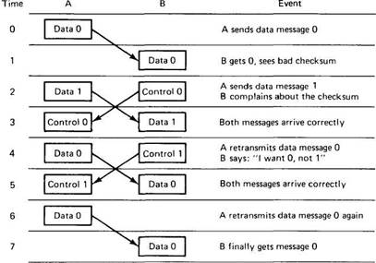  Fig. 2-3. Discussion between a receiver and a sender in the data link layer.  The point here is not so much whether the protocol of Fig. 2-3 is a great one (it is not), but rather to illustrate that in each layer there is a need for discussion between the sender and the receiver. Typical messages are "Please retransmit message n," "I already retransmitted it," "No you did not," "Yes I did," "All right, have it your way, but send it again," and so forth. This discussion takes place in the header field, where various requests and responses are defined, and parameters (such as frame numbers) can be supplied.  2.1.3. The Network Layer  The question of how to choose the best path is called routing, and is the primary task of the network layer.  The delay can thus change over the course of time. Some routing algorithms try to adapt to changing loads, whereas others are content to make decisions based on long-term averages.  Two network-layer protocols are in widespread use, one connection-oriented and one connectionless. The connection-oriented one is called X.25, and is favoured by the operators of public networks, such as telephone companies and the European PTTs. The X.25 user first sends a Call Request to the destination, which can either accept or reject the proposed connection. If the connection is accepted, the caller is given a connection identifier to use in subsequent requests. In many cases, the network chooses a route from the sender to the receiver during this setup, and uses it for subsequent traffic.  2.1.4. The Transport Layer  The official ISO transport protocol has five variants, known as TP0 through TP4. The differences relate to error handling and the ability to send several transport connections over a single X.25 connection. The choice of which one to use depends on the properties of the underlying network layer.  The DoD transport protocol is called TCP (Transmission Control Protocol) and is described in detail in (Comer, 1991). It is similar to TP4. The combination TCP/IP is widely used at universities and on most UNIX systems. The DoD protocol suite also supports a connectionless transport protocol called UDP (universal Datagram Protocol), which is essentially just IP with some minor additions. User programs that do not need a connection-oriented protocol normally use UDP.  The Session Layer  The session layer is essentially an enhanced version of the transport layer. It provides dialog control, to keep track of which party is currently talking, and it provides synchronization facilities. The latter are useful to allow users to insert checkpoints into long transfers, so that in the event of a crash it is only necessary to go back to the last checkpoint, rather than all the way back to the beginning. In practice, few applications are interested in the session layer and it is rarely supported. It is not even present in the DoD protocol suite.  The Presentation Layer  Unlike the lower layers, which are concerned with getting the bits from the sender to the receiver reliably and efficiently, the presentation layer is concerned with the meaning of the bits. Most messages do not consist of random bit strings, but more structured information such as people's names, addresses, amounts of money, and so on. In the presentation layer it is possible to define records containing fields like these and then have the sender notify the receiver that a message contains a particular record in a certain format. This makes it easier for machines with different internal representations to communicate.  The Application Layer  The application layer is really just a collection of miscellaneous protocols for common activities such as electronic mail, file transfer, and connecting remote terminals to computers over a network. The best known of these are the X.400 electronic mail protocol and the X.500 directory server. | 10 | 3 | 2 | 1 | 1.6.1*
OR
21b | i) Write short notes on Blocking versus Non-Blocking Primitives.  The message-passing primitives we have described so far are what are called blocking primitives (sometimes called synchronous primitives). When a process calls send it specifies a destination and a buffer to send to that destination. While the message is being sent, the sending process is blocked (i.e., suspended). The instruction following the call to send is not executed until the message has been completely sent, as shown in Fig. 2-1l(a). Similarly, a call to receive does not return control until a message has actually been received and put in the message buffer pointed to by the parameter. The process remains suspended in receive until a message arrives, even if it takes hours. In some systems, the receiver can specify from whom it wishes to receive, in which case it remains blocked until a message from that sender arrives.  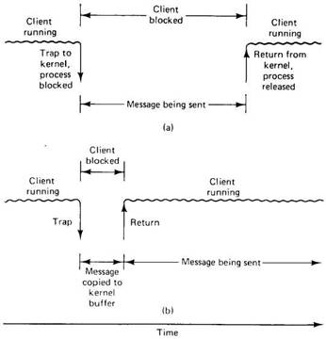  Fig. 2-11. (a) A blocking send primitive. (b) A nonblocking send primitive.  An alternative to blocking primitives are nonblocking primitives (sometimes called asynchronous primitives). If send is nonblocking, it returns control to the caller immediately, before the message is sent. The advantage of this scheme is that the sending process can continue computing in parallel with the message transmission, instead of having the CPU go idle (assuming no other process is runnable). The choice between blocking and nonblocking primitives is normally made by the system designers (i.e., either one primitive is available or the other), although in a few systems both are available and users can choose their favourite.  ii) Write short notes on Buffered versus Unbuffered Primitives.  Just as system designers have a choice between blocking and nonblocking primitives, they also have a choice between buffered and unbuffered primitives. The primitives we have described so far are essentially unbuffered primitives. What this means is that an address refers to a specific process, as in Fig. 2-9. A call receive(addr, &m) tells the kernel of the machine on which it is running that the calling process is listening to address addr and is prepared to receive one message sent to that address. A single message buffer, pointed to by m, is provided to hold the incoming message. When the message comes in, the receiving kernel copies it to the buffer and unblocks the receiving process. The use of an address to refer to a specific process is illustrated in Fig. 2-12(a).  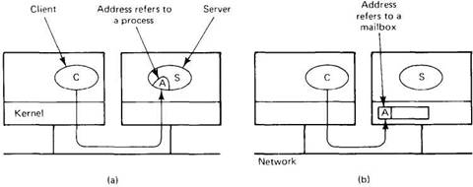  Fig. 2-12. (a) Unbuffered message passing. (b) Buffered message passing.  Buffers are needed and have to be allocated, freed, and generally managed. A conceptually simple way of dealing with this buffer management is to define a new data structure called a mailbox. A process that is interested in receiving messages tells the kernel to create a mailbox for it, and specifies an address to look for in network packets. Henceforth, all incoming messages with that address are put in the mailbox. The call to receive now just removes one message from the mailbox, or blocks (assuming blocking primitives) if none is present. In this way, the kernel knows what to do with incoming messages and has a place to put them. This technique is frequently referred to as a buffered primitive, and is illustrated in Fig. 2-12(b). | 5  5 | 2  2 | 2  2 | 1  1 | 1.6.1*  1.6.1*
22a | Explain and centralized and distributed clock synchronization algorithms and compare merits and demerits of both.  Physical clock synchronization algorithms can be classified as centralized and distributed.  1.Centralized clock synchronization algorithms  These have one node with a real-time receiver and are called time server node. The clock time of this node is regarded as correct and used as reference time.  The goal of this algorithm is to keep the clocks of all other nodes synchronized with time server node.  i. Cristian’s Algorithm  enter image description here  In this method each node periodically sends a message to the server. When the time server receives the message it responds with a message T, where T is the current time of server node.  Assume the clock time of client be To when it sends the message and T1 when it receives the message from server. To and T1 are measured using same clock so best estimate of time for propagation is (T1-To)/2.  When the reply is received at clients node, its clock is readjusted to T+(T1-T0)/2. There can be unpredictable variation in the message propagation time between the nodes hence (T1-T0)/2 is not good to be added to T for calculating current time.  For this several measurements of T1-To are made and if these measurements exceed some threshold value then they are unreliable and discarded. The average of the remaining measurements is calculated and the minimum value is considered accurate and half of the calculated value is added to T.  Advantage-It assumes that no additional information is available.  Disadvantage- It restricts the number of measurements for estimating the value.  ii.The Berkley Algorithm  This is an active time server approach where the time server periodically broadcasts its clock time and the other nodes receive the message to correct their own clocks.  In this algorithm the time server periodically sends a message to all the computers in the group of computers. When this message is received each computer sends back its own clock value to the time server. The time server has a prior knowledge of the approximate time required for propagation of a message which is used to readjust the clock values. It then takes a fault tolerant average of clock values of all the computers. The calculated average is the current time to which all clocks should be readjusted.  The time server readjusts its own clock to this value and instead of sending the current time to other computers it sends the amount of time each computer needs for readjustment. This can be positive or negative value and is calculated based on the knowledge the time server has about the propagation of message.  Advantages of Centralized System –  It is easy to secure and service the server and client nodes by virtue of their location  Smooth and elegant personal experience  Dedicated resources (memory, CPU cores, etc)  More cost-efficient for small systems up to a certain limit Quick updates are possible – Only one machine to update.  Easy detachment of a node from the system. Just remove the connection of the client node from the server and voila! Node detached.  Disadvantages of Centralized System –  Highly dependent on the network connectivity – The system can fail if the nodes lose connectivity as there is only one central node.  No graceful degradation of the system – abrupt failure of the entire system  Less possibility of data backup. If the server node fails and there is no backup, you lose the data straight away  Difficult server maintenance – There is only one server node and due to availability reasons, it is inefficient and unprofessional to take the server down for maintenance. So, updates have to be done on-the-fly(hot updates) which is difficult and the system could break.  2.Distributed algorithms  Distributed algorithms overcome the problems of centralized by internally synchronizing for better accuracy. One of the two approaches can be used:  i.Global Averaging Distributed Algorithms  In this approach the clock process at each node broadcasts its local clock time in the form of a “resync” message at the beginning of every fixed-length resynchronization interval. This is done when its local time equals To+iR for some integer i, where To is a fixed time agreed by all nodes and R is a system parameter that depends on total nodes in a system.  After broadcasting the clock value, the clock process of a node waits for time T which is determined by the algorithm.  During this waiting the clock process collects the resync messages and the clock process records the time when the message is received which estimates the skew after the waiting is done. It then computes a fault-tolerant average of the estimated skew and uses it to correct the clocks.  ii.Localized Averaging Distributes Algorithms  The global averaging algorithms do not scale as they need a network to support broadcast facility and a lot of message traffic is generated.  Localized averaging algorithms overcome these drawbacks as the nodes in distributed systems are logically arranged in a pattern or ring.  Each node exchanges its clock time with its neighbors and then sets its clock time to the average of its own clock time and of its neighbors.  Advantages of Distributed System –  Low latency than a centralized system – Distributed systems have low latency because of high geographical spread, hence leading to less time to get a response  Disadvantages of Distributed System –  Difficult to achieve consensus  The conventional way of logging events by absolute time they occur is not possible here. | 10 | 3 | 3 | 1 | 1.6.1*
OR
22b | Discuss any two algorithms for ensuring the mutual exclusion in distributed systems.  Mutual Exclusion ensures that no other process will use shared resources at same time.  1) Centralized Algorithm  One process is elected as coordinator.  Whenever process wants to enter a critical region , it sends request msg to coordinator asking for permission.  If no other process is currently in that critical region, the coordinator sends back a reply granting permission.  When reply arrives, the requesting process enters the critical region.  If the coordinator knows that a different process is already in critical regions, so it cannot be granted permission.  Centralized Algorithm:  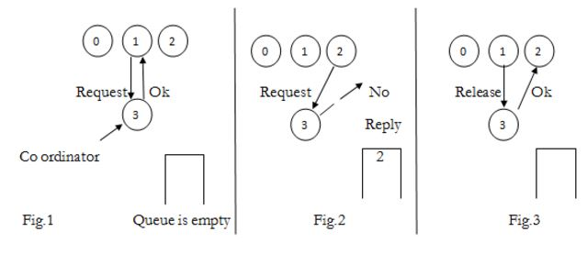  2) Distributed Algorithm  Timestamps are used for distributed mutual exclusion.  When process wants to enter critical region, it builds message containing name of critical region its process number and current time  It sends msg to all including itself.  If receiver if not in critical region and doesn’t want to enter it sends back Ok msg to sender.  If the receiver is already in critical region, it doesn’t reply, instead it queues request.  If the receiver wants to enter critical region but has not yet done, so it compares the timestamp in the incoming msg the lowest one wins.  If its own msg has lower timestamp, the receiver queues the incoming request and sends nothing.  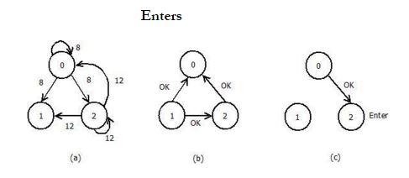  3) Token Ring Algorithm.  In software, a logical ring is constructed in which each process is assigned a position in the ring.  The ring positions may be allocated in numerical order of network address or some other means.  It does not matter what the ordering is all that matters is that each process knows who is next in line after itself.  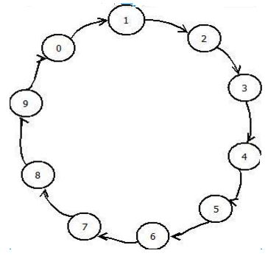 | 10 | 2 | 3 | 1 | 1.6.1*
23a | Explain the remote procedure call mechanism with various functional components.  Remote Procedure Call (RPC) is an interprocess communication technique. The Full form of RPC is Remote Procedure Call. It is used for client-server applications. RPC mechanisms are used when a computer program causes a procedure or subroutine to execute in a different address space, which is coded as a normal procedure call without the programmer specifically coding the details for the remote interaction.  This procedure call also manages low-level transport protocol, such as User Datagram Protocol, Transmission Control Protocol/Internet Protocol etc. It is used for carrying the message data between programs.  RPC architecture has mainly five components of the program:  Client  Client Stub  RPC Runtime  Server Stub  Server  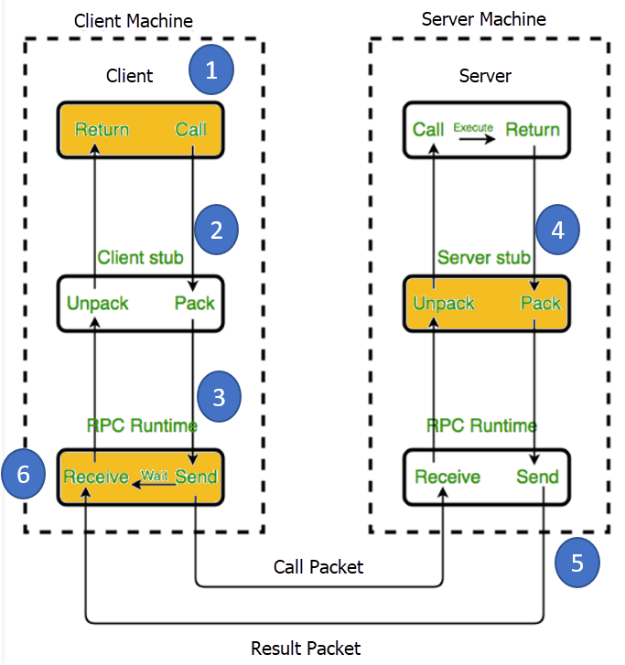  Following steps take place during the RPC process:  Step 1) The client, the client stub, and one instance of RPC run time execute on the client machine.  Step 2) A client starts a client stub process by passing parameters in the usual way. The client stub stores within the client’s own address space. It also asks the local RPC Runtime to send back to the server stub.  Step 3) In this stage, RPC accessed by the user by making regular Local Procedural Cal. RPC Runtime manages the transmission of messages between the network across client and server. It also performs the job of retransmission, acknowledgment, routing, and encryption.  Step 4) After completing the server procedure, it returns to the server stub, which packs (marshalls) the return values into a message. The server stub then sends a message back to the transport layer.  Step 5) In this step, the transport layer sends back the result message to the client transport layer, which returns back a message to the client stub.  Step 6) In this stage, the client stub demarshalls (unpack) the return parameters, in the resulting packet, and the execution process returns to the caller. | 10 | 2 | 2 | 1 | 1.6.1*
OR
23b | Briefly explain the client and server need to share some definitions in client server model with examples.  This something is often the client-server model that we introduced in the preceding chapter. The idea behind this model is to structure the operating system as a group of cooperating processes, called servers, which offer services to the users, called clients. The client and server machines normally all run the same microkernel, with both the clients and servers running as user processes, as we saw earlier. A machine may run a single process, or it may run multiple clients, multiple servers, or a mixture of the two.  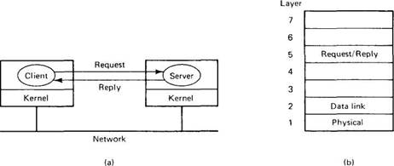  Fig. 2-7. The client-server model. Although all message passing is actually done by the kernels, this simplified form of drawing will be used when there is no ambiguity.  Both the client and server include these using the statement.  #include <header.h>  This statement has the effect of causing a pre-processor to literally insert the entire contents of header.h into the source program just before the compiler starts compiling the program.  /* Definitions needed by clients and servers. */  #define MAX_PATH 255 /* maximum length of a file name */  #define BUF_SIZE 1024 /* how much data to transfer at once */  #define FILE_SERVER 243 /* file server's network address */  /* Definitions of the allowed operations. */  #define CREATE 1 /* create a new file */  #define READ 2 /* read a piece of a file and return it */  #define WRITE 3 /* write a piece of a file */  #define DELETE 4 /* delete an existing file */  /* Error codes. */  #define OK 0 /* operation performed correctly */  #define E_BAD_OPCODE –1 /* unknown operation requested */  #define E_BAD_PARAM –2 /* error in a parameter */  #define E_IO –3 /* disk error or other I/O error */  /* Definition of the message format. */  struct message {  long source; /* sender's identity */  long dest; /* receiver's identity */  long opcode; /* which operation: CREATE, READ, etc. */  long count; /* how many bytes to transfer */  long offset; /* where in file to start reading or writing */  long extra1; /* extra field */  long extra2; /* extra field */  long result; /* result of the operation reported here */  char name[MAX_PATH]; /* name of the file being operated on */  char data[BUF_SIZE]; /* data to be read or written */  };  Fig. 2-8. The header.h file used by the client and server.  Let us first take a look at header.h. It starts out by defining two constants, MAX_PATH and BUF_SIZE, that determine the size of two arrays needed in the message. The former tells how many characters a file name (i.e., a path name like /usr/ast/books/opsys/chapter1.t) may contain. The latter fixes the amount of data that may be read or written in one operation by setting the buffer size. The next constant, FILE_SERVER, provides the network address of the file server so that clients can send messages to it. | 10 | 3 | 2 | 1 | 1.6.1*

*Performance Indicators are available separately for Computer Science and Engineering in AICTE examination reforms policy.

Course Outcome (CO) and Bloom’s level (BL) Coverage in Questions

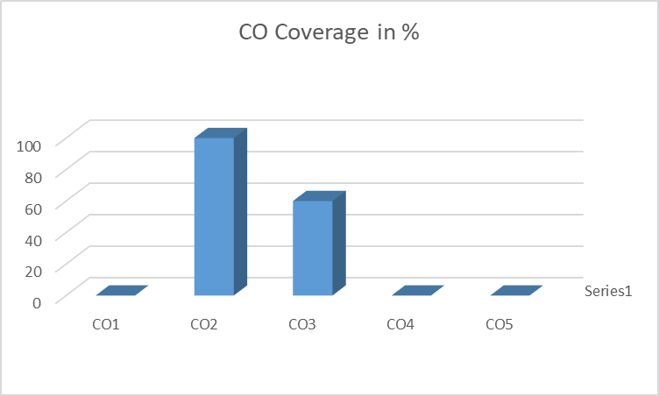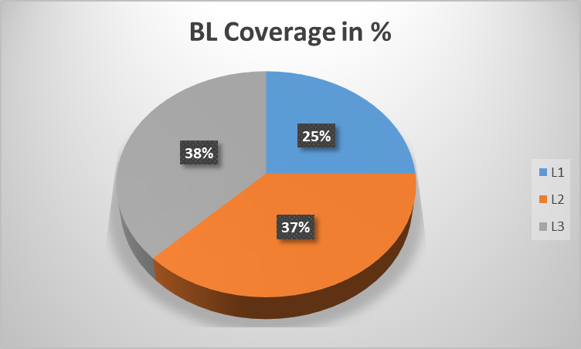

Prepared By Approved by the Audit Professor/Course Coordinator

