Reg Num.

SRM Institute of Science and Technology
SET B
Batch 2
College of Engineering and Technology
School of Computing
DEPARTMENT OF COMPUTING TECHNOLOGIES
SRM Nagar, Kattankulathur – 603203, Chengalpattu District, Tamilnadu
Academic Year: 2022-2023 (ODD/EVEN): ODD
Test: CLAT-3 Date: 16-11-2022
Course Code & Title: 18CSE356T - DOS Duration: 100 Minutes
Year & Sem: III & V Max. Marks: 50

Course Articulation Matrix: (to be placed)
S.No. | Course Outcome | PO1 | PO2 | PO3 | PO4 | PO5 | PO6 | PO7 | PO8 | PO9 | PO10 | PO11 | PO12
1 | CO4 | 3 | 3 | 3 | 3 | 3 | 2 | - | - | 3 | 2 | - | 3
2 | CO5 | 3 | 3 | 3 | 2 | 3 | 2 | - | - | 3 | 2 | - | 3

Part – A
( 10 x 1 = 10 Marks)
Instructions: Answer all (First 20 minutes to complete MCQ)
Q. No | Question | Marks | BL | CO | PO | PI Code
1 | The disks in the diskful workstation are used in any one of the following ways.  a. Paging and temporary files  b. Idle workstation  c. Low cost  d. Easy of maintainance | 1 | 1 | 4 | 1 | 1.6.1*
2 | If there are n processors, each with input rate λ and process rate µ then Mean response time will be  a. T1 = T/n b. T1 = T/µ  c. T1 = T/λ d. T1 = 1/(µ-λ). | 1 | 1 | 4 | 1 | 1.6.1*
3 | Which algorithm can be represented as a weighted graph, with each node being a process and each arc representing the flow of messages  between two processes.  a. Centralized Algorithm  b. Hierarchical Algorithm  c. Graph-Theoretic Deterministic Algorithm  d. Bidding Algorithm | 1 | 1 | 4 | 1 | 1.6.1*
4. | Which types of process scheduling techniques tasks are distributed among nodes so as to equalize the workload of nodes of the system?  a. Task assignment approach  b. Load-balancing approach  c. Load-sharing approach  d. No process allocation approach | 1 | 1 | 4 | 1 | 1.6.1*
5. | State information policies can be ----------------------  a. Exchange by polling  b. Selfish  c. Altruistic  d. Intermediate | 1 | 1 | 4 | 1 | 1.6.1*
6. | ---------------- is the collection of workstations connected by a LAN share a single paged, virtual address space.  a. Distributed File System  b. Distributed Shared memory system  c. Distributed Process System  d. Distributed Allocation System | 1 | 1 | 5 | 1 | 1.6.1*
7. | Which one of the following states the Memory is up-to-date, the block may be in other caches.  a. Invalid  b. Dirty  c. Clean  d. Home | 1 | 1 | 5 | 1 | 1.6.1*
8. | Which device contains an entry for each block in the shared address space,indexed by block number.  a. Processor block table  b. Numa Table  c. Memnet-Block Table  d. on-chip Block table | 1 | 1 | 5 | 1 | 1.6.1*
9. | The ____________ model is the strongest form of memory coherence, having the most stringent consistency requirement.  a. Sequential Consistency  b. Strict Consistency  c. Causal Consistency  d. Weak Consistency | 1 | 1 | 5 | 1 | 1.6.1*
10. | ______refers to the block size of the DSM system, i.e. to the units of sharing and the unit of data transfer across the network when a network block fault occurs.  a. Granularity  b. Coherence  c. Abstraction  d. Synchronization | 1 | 1 | 5 | 1 | 1.6.1*

Reg Num.

Part – B
(4 x 10 = 40 Marks)
Instructions: Answer all
11a | Describe the design issues for processor allocation algorithm.  The major decisions the designers must make can be summed up in five issues:  1. Deterministic versus heuristic algorithms.  Deterministic algorithms are appropriate when everything about process behavior is known in advance. Imagine that you have a complete list of all processes, their computing requirements, their file requirements, their communication requirements, and so on.  Requests for work depend on who's doing what, and can change dramatically from hour to hour, or even from minute to minute. Processor allocation in such systems cannot be done in a deterministic, mathematical way, but of necessity uses ad hoc techniques called heuristics.  2. Centralized versus distributed algorithms.  Collecting all the information in one place allows a better decision to be made, but is less robust and can put a heavy load on the central machine. Decentralized algorithms are usually preferable, but some centralized algorithms have been proposed for lack of suitable decentralized alternatives.  3. Optimal versus suboptimal algorithms.  Optimal solutions can be obtained in both centralized and decentralized systems, but are invariably more expensive than suboptimal ones. They involve collecting more information and processing it more thoroughly. In practice, most actual distributed systems settle for heuristic, distributed, suboptimal solutions because it is hard to obtain optimal ones.  4. Local versus global algorithms.  When a process is about to be created, a decision has to be made whether or not it can be run on the machine where it is being generated. If that machine is too busy, the new process must be transferred somewhere else. The choice here is whether or not to base the transfer decision entirely on local information.  5. Sender-initiated versus receiver-initiated algorithms.  Once the transfer policy has decided to get rid of a process, the location policy has to figure out where to send it. Clearly, the location policy cannot be local. It needs information about the load elsewhere to make an intelligent decision.  Each issues carries 2 marks | 10 | 2 | 4 | 1 | 1.6.1*
OR
11b | Explain the various policies used for designing Load-Sharing algorithm.  - Load estimation policies for Load-sharing algorithms.  Load sharing algorithms normally use all-or-nothing strategy.  To avoid processing power on nodes having zero process  load-sharing algorithms, a threshold value of two is used  instead of one.  - Process transfer policies for Load-sharing algorithms.  The threshold value of all the nodes is allotted as 1. A node turns into a receiver node if there is no process and on the other side a node becomes a sender node if it has more than 1 process.  - Location policies for Load-sharing algorithms.  The location policy in distributed load balancing is to locate the destination nodes to or from which tasks will be transferred. An efficient location policy is required to achieve high performance on distributed load balancing.  - State information exchange policies for Load-sharing algorithms  In load-sharing calculation, it is not required for the nodes to regularly exchange information, however, have to know the condition of different nodes when it is either underloaded or overloaded. | 10 | 2 | 4 | 1 | 1.6.1*
12a | Explain the various Implementation Issues for Processor Allocation Algorithms.  They studied three algorithms. In all cases, each machine measures its own load and decides for itself whether it is under loaded. Whenever a new process is created, the creating machine checks to see if it is overloaded. If so, it seeks out a remote machine on which to start the new process. The three algorithms differ in how the candidate machine is located.  Algorithm 1 picks a machine at random and just sends the new process there. If the receiving machine itself is overloaded, it, too, picks a random machine and sends the process off. This process is repeated until either somebody is willing to take it, or a hop counter is exceeded, in which case no more forwarding is permitted.  Algorithm 2 picks a machine at random and sends it a probe asking if it is underloaded or overloaded. If the machine admits to being underloaded, it gets the new process; otherwise, a new probe is tried. This loop is repeated until a suitable machine is found or the probe limit is exceeded, in which case it stays where it is created.  Algorithm 3 probes k machines to determine their exact loads. The process is then sent to the machine with the smallest load. | 10 | 3 | 4 | 1 | 1.6.1*
OR
12b | Explain the different issues in designing Load-Balancing algorithm.  There are several issues in designing Load Balancing Algorithms. To overcome these issues we use the load-sharing algorithm. The issues are:  - Load assessment: It decides how to evaluate the workload of a node in a distributed framework.  - Process transfer: It concludes whether the process can be executed locally or from a distance.  - Static information exchange: It decides how the framework loads information that can be exchanged among the nodes.  - Location policy: It decides the determination of an objective hub during process migration.  - Priority assignment: It decides the priority of execution of a bunch of nearby and remote processes on a specific node.  - Migration restricting policy: It decides the absolute number of times a process can move starting with one hub then onto the next.  1. Location Policies:  The location policy concludes the sender node or the receiver node of a process that will be moved inside the framework for load sharing.  2. Process transfer Policy:  All or nothing approach is used in this policy. The threshold value of all the nodes is allotted as 1. A node turns into a receiver node if there is no process and on the other side a node becomes a sender node if it has more than 1 process. If the nodes turn idle then they can’t accept a new process immediately and thus it misuses the processing power to overcome this problem, transfer the process in such a node that is expected to be idle in the future. Sometimes to ignore the processing power on the nodes, the load-sharing algorithm turns the threshold value from 1 to 2.  3. State Information exchange Policy:  In load-sharing calculation, it is not required for the nodes to regularly exchange information, however, have to know the condition of different nodes when it is either underloaded or  4. Load Estimation Policy:  Load-sharing algorithms aim to keep away from nodes from being idle yet it is adequate to know whether a node is occupied or idle. Consequently, these algorithms typically utilize the least complex load estimation policy of counting the absolute number of processes on a node.  5. Priority Assignment Policy: It uses some rules to determine the priority of a particular node. The rules are:  Selfish: Higher priority is provided to the local process than the remote process.  Altruistic: Higher priority is provided to the remote process than the local process. It has the best response time performance.  Intermediate: The number of local and remote processes on a node decides the priority.  6. Migration limiting policy: This policy decides the absolute number of times a process can move. | 10 | 3 | 4 | 1 | 1.6.1*
13a | Explain about the Bus-based Multiprocessor in distributed shared memory?  We see that the connection between the CPU and the memory is a collection of parallel wires, some holding the address the CPU wants to read or write, some for sending or receiving data, and the rest for controlling the transfers. Such a collection of wires is called a bus. This bus is on-chip, but in most systems, buses are external and are used to connect printed circuit boards containing CPUs, memories, and I/O controllers. On a desktop computer, the bus is typically etched onto the main board (the parent-board), which holds the CPU and some of the memory, and into which I/O cards are plugged. On minicomputers the bus is sometimes a flat cable that wends its way among the processors, memories, and I/O controllers.  When any of the CPUs wants to read a word from the memory, it puts the address of the word it wants on the bus and asserts (puts a signal on) a bus control line indicating that it wants to do a read. When the memory has fetched the requested word, it puts the word on the bus and asserts another control line to announce that it is ready. The CPU then reads in the word. Writes work in an analogous way.  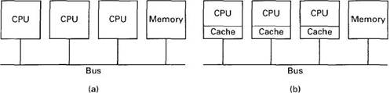  To prevent two or more CPUs from trying to access the memory at the same time, some kind of bus arbitration is needed. Various schemes are in use. For example, to acquire the bus, a CPU might first have to request it by asserting a special request line. Only after receiving permission would it be allowed to use the bus. The granting of this permission can be done in a centralized way, using a bus arbitration device, or in a decentralized way, with the first requesting CPU along the bus winning any conflict. | 10 | 1 | 5 | 1 | 1.6.1*
OR
13b | Explain the different types of consistency models in distributed shared memory.  A consistency model is essentially a contract between the software and the memory. It says that if the software agrees to obey certain rules, the memory promises to work correctly. If the software violates these rules, all bets are off and correctness of memory operation is no longer guaranteed. A wide spectrum of contracts have been devised, ranging from contracts that place only minor restrictions on the software to those that make normal programming nearly impossible. As you probably already guessed, the ones with minor restrictions do not perform nearly as well as the ones with major restrictions. Such is life. In this section we will study a variety of consistency models used in DSM systems.  (a) Consistency models not using synchronization operations. | 10 | 1 | 5 | 1 | 1.6.1*
  Consistency | Description
  Strict | Absolute time ordering of all shared accesses matters
  Sequential | All processes see all shared accesses in the same order
  Causal | All processes see all casually-related shared accesses in the same order
  Processor | PRAM consistency + memory coherence
  PRAM | All processes see writes from each processor in the order they were issued. Writes from different processors may not always be seen in the same order
  Weak | Shared data can only be counted on to be consistent after a synchronization is done
  Release | Shared data are made consistent when a critical region is exited
  Entry | Shared data pertaining to a critical region are made consistent when a critical region is entered
14a | Describe the NUMA multiprocessors with an example?  Complex data structures must be maintained by the hardware and intricate protocols, such as those of Fig. 6-8, must be built into the cache controller or MMU. The inevitable consequence is that large multiprocessors are expensive and not in widespread use.  However, researchers have spent a considerable amount of effort looking at alternative designs that do not require elaborate caching schemes. One such architecture is the NUMA (NonUniform Memory Access) multiprocessor. Like a traditional UMA (Uniform Memory Access) multiprocessor, a numa machine has a single virtual address space that is visible to all CPUs. When any CPU writes a value to location a, a subsequent read of a by a different processor will return the value just written.  The difference between UMA and NUMA machines lies not in the semantics but in the performance. On a NUMA machine, access to a remote memory is much slower than access to a local memory, and no attempt is made to hide this fact by hardware caching. The ratio of a remote access to a local access is typically 10:1, with a factor of two variation either way not being unusual.  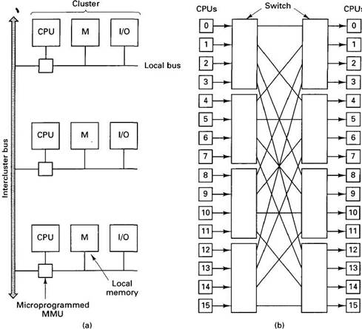  (a) A simplified view of the Cm* system. (b) The BBN Butterfly. The CPUs on the right are the same as those on the left (i.e., the architecture is really a cylinder).  NUMA machines have three key properties that are of concern to us:  1. Access to remote memory is possible.  2. Accessing remote memory is slower than accessing local memory.  3. Remote access times are not hidden by caching. | 10 | 2 | 5 | 1 | 1.6.1*
OR
14b | Explain about the object-based distributed shared memory?  The page-based DSM systems that we studied use the MMU hardware to trap accesses to missing pages. While this approach has some advantages, it also has some disadvantages. In particular, in many programming languages, data are organized into objects, packages, modules, or other data structures, each of which has an existence independent of the others. If a process references part of an object, in many cases the entire object will be needed, so it makes sense to transport data over the network in units of objects, not in units of pages.  Objects  An object is a programmer-defined encapsulated data structure, as depicted in Fig. 6-34. It consists of internal data, the object state, and procedures, called methods or operations that operate on the object state. To access or operate on the internal state, the program must invoke one of the methods. The method can change the internal state, return (part of) the state, or something else. Direct access to the internal state is not allowed. This property, called information hiding (Parnas, 1972). Forcing all references to an object's data to go through the methods helps structure the program in a modular way.  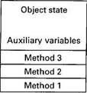  Fig. 6-34. An object.  Linda  Linda provides processes on multiple machines with a highly structured distributed shared memory. This memory is accessed through a small set of primitive operations that can be added to existing languages, such as C and FORTRAN to form parallel languages, in this case, C-Linda and FORTRAN-Linda. In the description below, we will focus on C-Linda, but conceptually the differences between the variants are small.  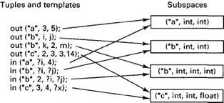  Orca  The Orca system consists of the language, compiler, and runtime system, which actually manages the shared objects during execution. Although language, compiler, and runtime system were designed to work together, the runtime system is independent of the compiler and could be used for other languages as well. After an introduction to the Orca language, we will describe how the runtime system implements an object-based distributed shared memory. | 10 | 3 | 5 | 1 | 1.6.1*

*Performance Indicators are available separately for Computer Science and Engineering in AICTE examination reforms policy.

Course Outcome (CO) and Bloom’s level (BL) Coverage in Questions

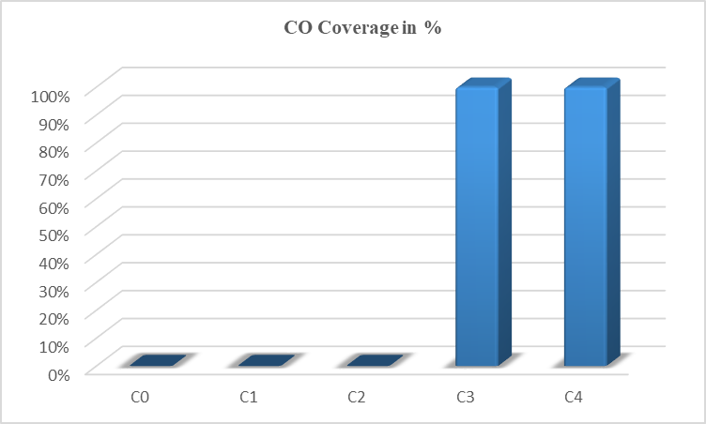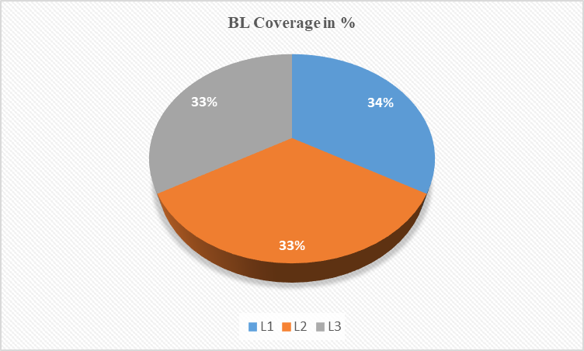

Prepared By Approved by the Audit Professor/Course Coordinator

