YUVAINTERN | WEEK 4

AI Project Deployment
& Capstone
Wine Classifier Prediction API
End-to-end machine learning • Model serialization • REST API • Testing
Prepared by: Sahil Sant
Deliverable: Technical report for Week 4
Stack: Python, scikit-learn, Joblib, FastAPI, Pydantic, Pytest
Educational demonstration. Class labels are cultivar categories, not wine-quality or safety grades.

1. Executive Summary
This project implements an end-to-end classification workflow and serves the trained model through a REST API. The application takes 13 numeric measurements from the scikit-learn Wine Recognition dataset and predicts one of three dataset class labels. The work covers dataset preparation, reproducible train/test splitting, cross-validation, candidate model comparison, held-out evaluation, Joblib serialization, request validation, API tests, and deployment configuration.
Requirement | Implementation evidence
Data preprocessing and model training | Reproducible training script exports the dataset, applies an 80/20 stratified split, and evaluates two model pipelines.
Testing and model evaluation | 5-fold stratified CV plus held-out accuracy, macro precision/recall/F1, classification report, and confusion matrix.
Serialization | Saved fitted pipeline: artifacts/wine_classifier.joblib; metadata and metrics are saved beside it.
Prediction API | FastAPI endpoints: /, /health, /model-info, and POST /predict; Pydantic validates input.
Deployment/documentation | Local Uvicorn instructions, interactive /docs, Dockerfile, Render configuration, report, and presentation.

2. Problem Statement and Scope
A model is more useful when another program can call it reliably, without rerunning training for every prediction. The goal is to package a trained classifier behind a small HTTP service with a documented input contract and structured output. The project is intended to demonstrate the deployment lifecycle rather than provide a commercial wine analysis product.

Project objectives
- Prepare a labeled dataset and compare two supervised classification algorithms using a reproducible workflow.
- Keep preprocessing together with the estimator when required, then serialize the fitted pipeline using Joblib.
- Expose validated prediction and health endpoints with readable API documentation.
- Verify behavior through repeatable automated tests and document local and optional cloud/container deployment.

3. Architecture
Request lifecycle: client JSON → Pydantic input validation → ordered feature row → saved scikit-learn pipeline → predicted class and class probabilities → JSON response.
Component | Responsibility
ml/train.py | Exports dataset, trains and compares models, evaluates results, saves model/metadata/metrics/figures.
artifacts/ | Contains serialized estimator pipeline, metadata, sample request, and evaluation results.
app/schemas.py | Defines strict request and response schemas; rejects extra or missing fields.
app/main.py | Loads artifacts on application startup and handles HTTP routes.

4. Dataset and Preprocessing
The dataset is the Wine Recognition dataset distributed with scikit-learn. It contains 178 observations, 13 numeric input features, and 3 cultivar class labels. Because the dataset is bundled with the installed library, training does not require a separate network download. The training script exports a readable copy to data/wine.csv for inspection.
Item | Project value
Rows / features / target classes | 178 / 13 / 3
Split strategy | Stratified train/test split; 80% training (142 rows), 20% testing (36 rows).
Random seed | 42 for repeatability of the split and models.
Candidate models | Logistic Regression pipeline with StandardScaler; Random Forest classifier.
Cross-validation | 5-fold StratifiedKFold on training data only.

Logistic Regression is sensitive to feature scale, so StandardScaler is fitted within its scikit-learn Pipeline. Keeping the scaler in the serialized pipeline ensures that the same fitted transformation is applied at prediction time and avoids fitting preprocessing separately on incoming requests. Random Forest is trained without scaling because tree-based splits do not require standardized features.

5. Model Evaluation Results
The model was evaluated using cross-validation on the training split and metrics on a separate held-out test split. The exact generated results are shown below.
Model | 5-fold CV accuracy | Test accuracy | Macro precision | Macro recall | Macro F1
Logistic Regression | 97.91% ± 2.77% | 97.22% | 97.78% | 96.67% | 97.10%
Random Forest | 97.91% ± 2.77% | 100.00% | 100.00% | 100.00% | 100.00%

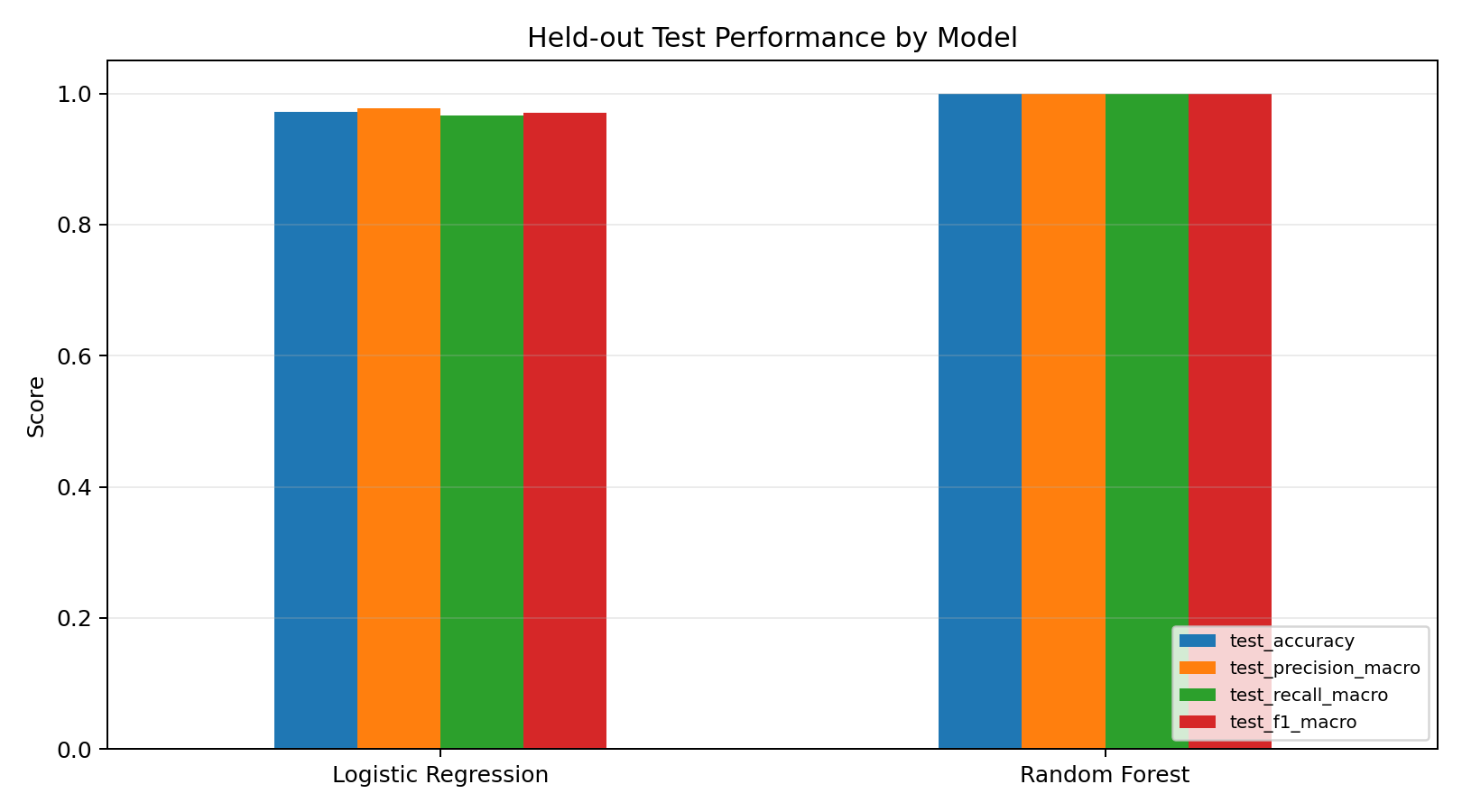
Figure 1. Held-out metrics for both candidate models.

Interpretation and selection
Both candidates achieved the same mean cross-validation accuracy (97.91%) and standard deviation (2.77%) on the training folds. Because cross-validation did not separate the candidates, the predefined tie-break favors Logistic Regression as the simpler baseline model; the held-out test set is not used to make the selection. The selected Logistic Regression pipeline achieved 97.22% test accuracy, 97.78% macro precision, 96.67% macro recall, and 97.10% macro F1. Random Forest scored 100% on this particular 36-row test split, but a perfect score on a small held-out set does not prove universal generalization. This distinction is documented rather than using the test set to select the winner.

6. Model Serialization and API Design
The complete fitted scikit-learn pipeline is saved with joblib to artifacts/wine_classifier.joblib. Metadata is saved separately in artifacts/model_metadata.json and includes the selected model name, ordered feature list, class labels, dataset identity, split details, and row counts. Evaluation metrics are stored in artifacts/metrics.json. This separation allows the API to report model information without retraining.
Method and route | Purpose | Expected behavior
GET / | Service overview | Returns links to docs, health, and prediction endpoint.
GET /health | Readiness check | Returns status=ok when model artifacts load; otherwise reports not_ready.
GET /model-info | Model metadata | Returns selected model, 13 expected features, three classes, and split sizes.
POST /predict | Prediction | Accepts 13 numeric features and returns class ID, class label, probability estimates, and model name.

Input validation and error handling
- Pydantic requires all 13 numeric fields, rejects extra keys, and rejects non-finite or non-positive values.
- Missing or incorrectly typed fields result in HTTP 422 validation responses rather than silently predicting from incomplete data.
- If the serialized model or metadata is unavailable, the health route identifies the service as not ready and prediction/model-info return a service-unavailable response.
- The API returns class probability estimates from the model; these values are not guarantees or a separate quality score.

Implementation example
# Save the complete fitted pipeline after training
joblib.dump(best_model, "artifacts/wine_classifier.joblib")
# Start the API from the repository root
uvicorn app.main:app --reload
# Send a JSON body to POST /predict
# Interactive form: http://127.0.0.1:8000/docs

7. Example Prediction
The following values are an actual observation from the held-out test split and are included as artifacts/sample_request.json for reproducible API testing.
{
"alcohol": 14.1,
"malic_acid": 2.16,
"ash": 2.3,
"alcalinity_of_ash": 18.0,
"magnesium": 105.0
}
... (8 additional required fields in artifacts/sample_request.json)

Actual API response: predicted class = class_0 (ID 0); model = Logistic Regression; probability for the predicted class = 99.97%.

8. Testing and Verification
The automated API smoke-test suite was run locally after training the model and generating all artifacts.
Test | Expected result | Result
Health endpoint | Model artifacts load and status is ok. | PASS
Model-info endpoint | Returns 13 features and 3 classes. | PASS
Prediction endpoint | Valid example returns a class and probabilities that sum to 1. | PASS
Missing feature validation | Incomplete request returns HTTP 422. | PASS
Total | Four API checks. | 4/4 passed

Command used: `python -m pytest -q`. The verified run completed with 4 passed tests and no test failures.

9. Run and Deployment Instructions

Local deployment (Windows PowerShell)
python -m venv .venv
.\.venv\Scripts\Activate.ps1
pip install -r requirements.txt
python -m ml.train
uvicorn app.main:app --reload

Open http://127.0.0.1:8000/health to check readiness and http://127.0.0.1:8000/docs to try the endpoints. Keep the terminal running while making API calls. The model is loaded at app startup; the training script is run before the service starts when preparing the project.

Container and cloud configuration
A Dockerfile packages the runtime and starts Uvicorn on the configured port. render.yaml provides a Render Web Service build command, start command, and /health check path. To obtain a public URL, push the repository to GitHub, create a service with a compatible provider, wait for a successful build, and verify /health and /docs using the service URL. This deliverable includes deployment configuration; it does not claim that a public cloud service has already been created.

10. Limitations and Future Improvements
- The dataset is small and educational; performance may not generalize to new data collected under different conditions.
- The three labels identify dataset classes, not wine quality, safety, origin authenticity, or suitability for consumption.
- Production deployment should add request logging, rate limiting, monitoring, dependency pinning, authentication if needed, and retraining/data-drift procedures.
- Future work could evaluate repeated cross-validation, calibration, model/version tracking, and a simple web front end.

11. Conclusion
The project completes the core deployment lifecycle required for Week 4: reproducible preprocessing and training, a documented model comparison, held-out evaluation, Joblib serialization, a validated FastAPI prediction service, automated tests, and local/container/cloud deployment instructions. The application is runnable from the repository root, and the report presents numeric results, test evidence, and the limitations of the dataset.

Reference
Scikit-learn documentation, “Wine recognition dataset”: https://scikit-learn.org/stable/datasets/toy_dataset.html#wine-recognition-dataset

