YuvaIntern - Week 2 Internship Report
Supervised Machine Learning Models
Classification + Regression | Python + Scikit-learn

Field | Details
Intern | Sahil Sant
Internship | AI Pioneers Internship (Machine Learning Internship)
Task | Week 2 - Supervised Machine Learning Models
Classification Dataset | Titanic Passenger Dataset (891 records)
Regression Dataset | Scikit-learn Diabetes Dataset (442 records)
Primary Tools | Python, Pandas, NumPy, Scikit-learn, Matplotlib, Joblib

1. Introduction
This project applies supervised machine learning algorithms to two common prediction settings: classification and regression. The classification workflow uses the Titanic passenger dataset to predict the binary target Survived. Four classification algorithms are implemented: Logistic Regression, Decision Tree, Random Forest, and K-Nearest Neighbors (KNN). A separate regression workflow uses Scikit-learn's built-in Diabetes dataset to demonstrate Linear Regression for a continuous numerical target. The project covers data loading, train-test splitting, preprocessing, model training, prediction, evaluation, visualisation, and comparison.

2. Objectives
- Implement supervised learning algorithms using Scikit-learn.
- Prepare data for machine learning using imputation, encoding, and scaling where appropriate.
- Train and evaluate Logistic Regression, Decision Tree, Random Forest, KNN, and Linear Regression.
- Compare classification models using accuracy, precision, recall, F1-score, and a confusion matrix.
- Evaluate Linear Regression using MAE, MSE, and R².
- Document each major implementation step with code examples and reasoning.

3. Dataset Description

3.1 Titanic - Classification
The Titanic dataset contains 891 passenger records and 12 original columns. For modelling, seven input features were retained: Pclass, Sex, Age, SibSp, Parch, Fare, and Embarked. The target is Survived, where 0 indicates did not survive and 1 indicates survived. This is consistent with the Week 1 preprocessing project, which documented the same 891-record Titanic dataset and identified missing values in Age, Cabin, and Embarked.
Feature | Type | Role
Pclass | Numeric/categorical ordinal | Input
Sex | Categorical | Input
Age | Numeric | Input
SibSp | Numeric | Input
Parch | Numeric | Input
Fare | Numeric | Input
Embarked | Categorical | Input
Survived | Binary | Target

3.2 Diabetes - Regression
The regression workflow uses Scikit-learn's built-in Diabetes dataset. It contains 442 observations, 10 input features, and a continuous target. Linear Regression is appropriate here because the target is numerical and continuous.

4. Data Loading and Initial Inspection
The first step is to load the data and inspect its structure before training any model. This confirms the row/column count, data types, and missing-value pattern.
import pandas as pd
df = pd.read_csv('data/titanic.csv')
print(df.shape)
print(df.info())
print(df.isna().sum())
The loaded Titanic dataset has 891 rows and 12 columns. Missing values are present in Age (177), Cabin (687), and Embarked (2).

5. Feature Selection and Target Definition
The identifier, high-cardinality text, and heavily missing Cabin field are not passed directly to the introductory model pipeline. The selected features focus on passenger class, sex, age, family-related counts, fare, and port of embarkation. The target column is removed from X so that the model cannot directly see the answer during training.
features = ['Pclass','Sex','Age','SibSp','Parch','Fare','Embarked']
X = df[features]
y = df['Survived']

6. Train-Test Split
The data is divided into training and test sets using an 80/20 split. The test set is kept unseen while the models learn patterns. `stratify=y` is used for the classification task so the class proportions are maintained as closely as possible between training and testing.
X_train, X_test, y_train, y_test = train_test_split(
X, y, test_size=0.20, random_state=42, stratify=y
)
Set | Rows
Training | 712
Testing | 179

7. Preprocessing Strategy
Preprocessing is placed inside Scikit-learn pipelines. This keeps the transformation logic attached to the model and ensures that values used for fitting preprocessing steps come from the training data rather than being learned from the test set.
Numerical columns use median imputation for missing Age values. Categorical columns use most-frequent imputation and one-hot encoding. StandardScaler is applied to Logistic Regression and KNN because these algorithms use numeric distances or coefficients that can be influenced by feature scale. Tree-based models do not require numeric standardization, so their preprocessing pipeline skips scaling.
numeric_features = ['Pclass','Age','SibSp','Parch','Fare']
categorical_features = ['Sex','Embarked']
# Numeric: median imputation + optional scaling
# Categorical: most-frequent imputation + one-hot encoding

8. Logistic Regression
Logistic Regression is a classification algorithm used to estimate the probability of a binary outcome. In this project, it predicts whether a passenger survived. Standardized numeric inputs are used through the preprocessing pipeline.
LogisticRegression(max_iter=1000, random_state=42)

9. Decision Tree
The Decision Tree learns if/else-style splitting rules. A maximum depth of 5 is used to keep the tree from growing unnecessarily complex for this introductory comparison.
DecisionTreeClassifier(max_depth=5, random_state=42)

10. Random Forest
Random Forest combines multiple decision trees and aggregates their predictions. One hundred trees are used in this project. The model is evaluated on the same test set as the other classifiers.
RandomForestClassifier(n_estimators=100, random_state=42)

11. K-Nearest Neighbors (KNN)
KNN predicts a new sample using the labels of its nearest observations. Because distance is central to KNN, numeric features are standardized before prediction. The example uses 5 neighbors.
KNeighborsClassifier(n_neighbors=5)

12. Classification Evaluation Metrics
The classification models are compared with four metrics. Accuracy measures the proportion of correct predictions overall. Precision measures how often positive predictions are correct. Recall measures how many actual positive samples are identified. F1-score combines precision and recall into a single balanced measure.
Metric | Interpretation
Accuracy | Overall proportion of correct predictions
Precision | Correctness of positive predictions
Recall | Coverage of actual positive cases
F1 Score | Balance between precision and recall

13. Classification Results
Model | Accuracy | Precision | Recall | F1 Score
K-Nearest Neighbors | 0.8156 | 0.8000 | 0.6957 | 0.7442
Random Forest | 0.8156 | 0.8103 | 0.6812 | 0.7402
Logistic Regression | 0.8045 | 0.7931 | 0.6667 | 0.7244
Decision Tree | 0.7654 | 0.7547 | 0.5797 | 0.6557
These values were generated from the fixed 80/20 test split with random_state=42. The comparison uses the same held-out test set for all four classification algorithms, making the metric values directly comparable within this experiment.
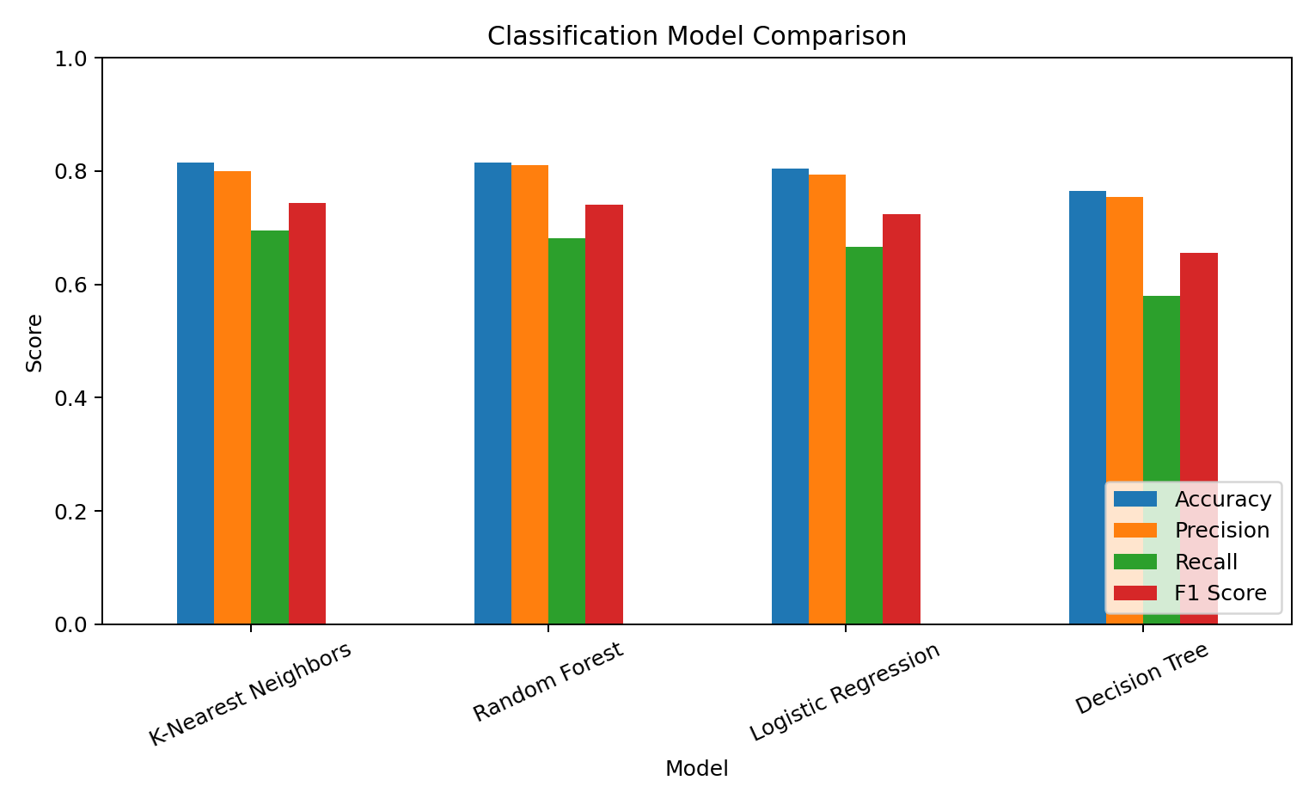
Figure 1. Classification model comparison across accuracy, precision, recall, and F1-score.
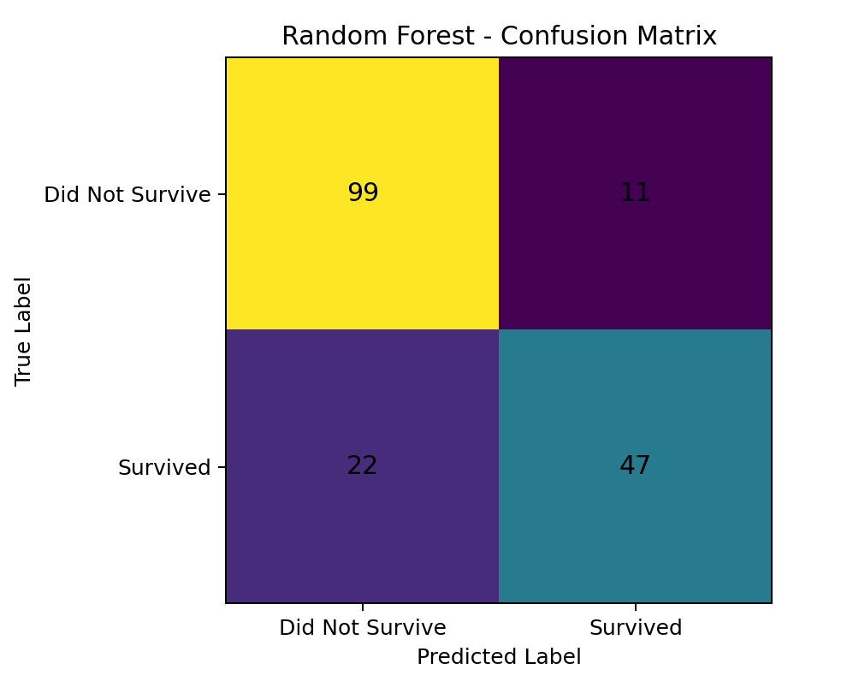
Figure 2. Random Forest confusion matrix on the held-out test set.

14. Regression with Linear Regression
Linear Regression is demonstrated separately because the Titanic target is binary classification rather than continuous regression. The Diabetes dataset from Scikit-learn provides a suitable continuous target for the regression objective.
from sklearn.datasets import load_diabetes
from sklearn.linear_model import LinearRegression
diabetes = load_diabetes(as_frame=True)
reg_df = diabetes.frame
X = reg_df.drop(columns=['target'])
y = reg_df['target']
The regression dataset is split into training and test data using the same 80/20 approach, without classification stratification because the target is continuous.
X_train, X_test, y_train, y_test = train_test_split(
X, y, test_size=0.20, random_state=42
)
model = LinearRegression()
model.fit(X_train, y_train)
predictions = model.predict(X_test)

15. Regression Evaluation
MAE measures the average absolute prediction error. MSE squares each error, giving larger errors more influence. R² measures the proportion of target variance explained by the linear model relative to a baseline based on the target mean.
Model | MAE | MSE | R²
Linear Regression | 42.7941 | 2900.1936 | 0.4526
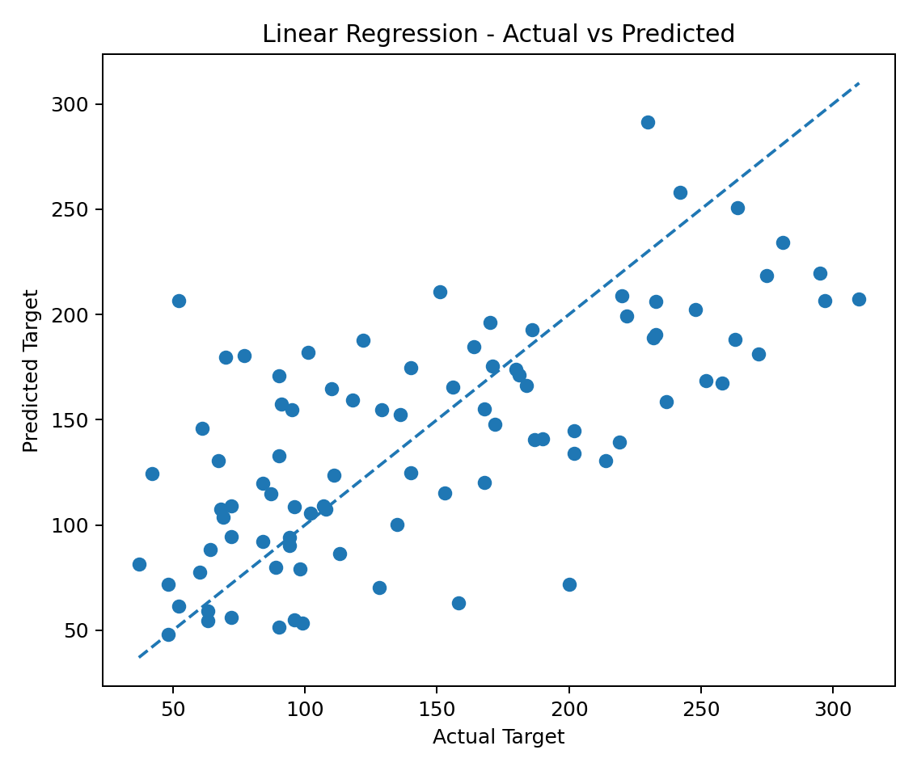
Figure 3. Linear Regression actual versus predicted values.

16. Model Comparison and Interpretation
Within this experiment, the highest measured classification accuracy is 0.8156 for K-Nearest Neighbors, while the highest measured F1-score is 0.7442 for K-Nearest Neighbors. These are descriptive results for this dataset, feature set, preprocessing pipeline, and single held-out split; they are not guarantees of future performance. For practical model selection, the metric should be aligned with the actual business or application objective.
The experiment also illustrates why comparing several algorithms is useful. Logistic Regression provides a simple linear decision boundary, a Decision Tree provides explicit rule-based splits, Random Forest reduces the instability of one tree by combining many trees, and KNN relies on distances between observations. The preprocessing pipeline is adjusted to match these modelling characteristics.

17. Reproducibility and Project Files
File | Purpose
data/titanic.csv | Original Titanic dataset used for classification
data/titanic_model_input.csv | Model-ready subset with key fields cleaned
data/diabetes.csv | Regression dataset exported for reproducibility
src/train_models.py | Standalone training and evaluation script
notebooks/supervised_ml_comparison.ipynb | Interactive notebook with explanations and code
results/classification_results.csv | Classification metric table
results/regression_results.csv | Regression metric table
figures/*.png | Evaluation and comparison figures
requirements.txt | Python package requirements
README.md | Repository documentation
The project fixes random_state=42 in the train/test split and relevant model initialisation. Model preprocessing is embedded in Scikit-learn Pipelines, which keeps transformations reproducible and connected to the estimator.

18. Limitations
- The datasets are educational benchmark datasets rather than production data.
- The classification results are based on one fixed held-out split; additional cross-validation could provide a broader estimate of variability.
- The feature set is intentionally limited to keep the internship task focused and interpretable.
- The model comparison does not claim that one algorithm will perform identically on different datasets or future data.

19. Conclusion
This Week 2 project demonstrates a complete introductory supervised machine learning workflow. The classification section uses four different algorithms on the Titanic dataset and compares their predictions with multiple classification metrics. The regression section uses Linear Regression on a continuous target and evaluates its predictions with MAE, MSE, and R². The project also demonstrates why preprocessing must be matched to the algorithm, why test data should remain unseen during training, and why several evaluation metrics are more informative than accuracy alone. The final repository is organised for reproducibility and includes source code, a notebook, datasets, saved model artifacts, result tables, figures, and documentation.

20. Submission Description (200+ Words)
This project focuses on implementing and evaluating supervised machine learning algorithms using Python and Scikit-learn. The work contains both classification and regression tasks to demonstrate two major forms of supervised learning. For classification, the Titanic passenger dataset is used to predict the binary target Survived. The dataset is inspected and prepared using appropriate preprocessing techniques, including median imputation for missing numerical values, most-frequent imputation for categorical values, one-hot encoding for categorical features, and StandardScaler for models affected by feature scale. Logistic Regression, Decision Tree, Random Forest, and K-Nearest Neighbors models are then trained on an 80/20 train-test split. Their performance is evaluated using accuracy, precision, recall, F1-score, and a confusion matrix. A separate regression task is implemented using Scikit-learn's built-in Diabetes dataset so that Linear Regression can be applied to a continuous numerical target. Regression performance is evaluated with Mean Absolute Error, Mean Squared Error, and R² score. The project emphasises not only model training but also understanding how different algorithms behave, why preprocessing choices are made, and how evaluation metrics should be interpreted. The final repository contains a Jupyter notebook, standalone Python training script, datasets, result tables, evaluation figures, saved model pipelines, requirements, and a README for reproducibility. This provides a complete workflow from data preparation to model evaluation and documentation.

