YUVAINTERN • WEEK 3
Unsupervised Learning
& Model Evaluation
K-Means • Hierarchical Clustering • PCA • Cross-Validation • Hyperparameter Tuning

Report detail | Value
Intern | Sahil Sant
Internship | AI Pioneers Internship (Machine Learning Internship)
Task | Week 3 — Unsupervised Learning & Model Evaluation
Dataset | Scikit-learn Breast Cancer Wisconsin Diagnostic benchmark
Tools | Python, Pandas, NumPy, Scikit-learn, Matplotlib, Joblib

Measured outcomes from a reproducible run
Outcome | Measured value
Best K-Means silhouette (k=2) | 0.3450
Variance explained by PCA’s first two components | 63.24%
Best supervised test ROC-AUC (Logistic Regression) | 0.9960
Best supervised test accuracy | 96.49%

Educational benchmark analysis only — not for clinical diagnosis or treatment.

Executive Summary
This project demonstrates two distinct workflows: an unsupervised analysis in which clusters are learned from standardized numerical predictors without diagnosis labels, and a separate supervised classification experiment in which labels are used as the prediction target. It covers K-Means, Agglomerative (hierarchical) clustering, silhouette analysis, PCA, cross-validation, confusion matrices, precision, recall, F1-score, ROC-AUC, and hyperparameter tuning.
The dataset has 569 observations and 30 predictors (357 benign and 212 malignant labels). K-Means with k=2 produced the best silhouette score within the tested range, 0.3450. The first two PCA components explain 63.24% of the variance in the standardized predictors.
In the supervised experiment, Logistic Regression and Random Forest both reached 96.49% test accuracy. Logistic Regression had the higher test ROC-AUC (0.9960) and malignant-class recall (0.9286); Random Forest had slightly higher precision. This illustrates why model selection should compare several metrics instead of using accuracy alone.

1. Objectives and Scope
- Apply K-Means and Agglomerative (hierarchical) clustering to a numeric dataset.
- Use a silhouette-score sweep to compare cluster counts from k=2 through k=6.
- Apply Principal Component Analysis (PCA) to reduce the standardized feature space to two components for visualization and report the explained variance.
- Use cross-validation and GridSearchCV to tune supervised models on training data.
- Evaluate held-out predictions with confusion matrices, precision, recall, F1-score, ROC-AUC, and accuracy.
- Provide measured results, code snippets, detailed metric interpretation, reproducible artifacts, and limitations.

2. Dataset and Target Definition
The Scikit-learn Breast Cancer Wisconsin Diagnostic benchmark is used because it contains 30 numerical predictors and a binary label, allowing an unsupervised feature-only exploration and a separate supervised evaluation. The dataset contains 569 rows, 30 predictor columns, and no missing values in the exported benchmark CSV. The label was recoded for readability: diagnosis_malignant=1 means malignant and diagnosis_malignant=0 means benign.
Critical separation of tasks: during clustering, the diagnosis column is dropped before scaling and fitting. K-Means and Agglomerative Clustering receive only the 30 predictors. Diagnosis labels are only used afterward to calculate an external comparison metric (ARI) and describe cluster composition. For the supervised workflow, the same label is used as the target as required for model evaluation.
import pandas as pd
df = pd.read_csv('data/breast_cancer.csv')
X = df.drop(columns=['diagnosis_malignant'])
y = df['diagnosis_malignant'] # 1 = malignant; 0 = benign
print(df.shape) # (569, 31)
print(df.isna().sum().sum()) # 0 missing values

Dataset check | Observed value
Rows | 569
Predictors | 30 numerical features
Benign label (0) | 357
Malignant label (1) | 212
Missing values in exported CSV | 0

3. Experimental Design and Reproducibility
A fixed random seed (42) is used for K-Means, the supervised train/test split, and cross-validation shuffling. For supervised evaluation, 20% of the data is held out as test data using stratification, producing 455 training observations and 114 test observations. Hyperparameter search and cross-validation are performed using only the training split; the test set is reserved for final reporting.
Feature scaling is performed before clustering because distances can be dominated by variables measured on larger numeric scales. Logistic Regression also receives scaled predictors. Random Forest uses median imputation but not scaling because tree splits are based on feature thresholds rather than Euclidean distances. The dataset has no missing values, but the imputation step keeps the supervised pipelines robust to missing numeric entries.
Supervised data split | Rows | Role
Training set | 455 | Cross-validation, tuning, model fitting
Held-out test set | 114 | Final evaluation only

4. Unsupervised Learning

4.1 Standardization and clustering methods
StandardScaler transforms each numeric predictor to a comparable scale. K-Means partitions points around centroids and uses distance-based assignment; it is sensitive to scaling. Agglomerative Clustering builds a hierarchy by repeatedly merging clusters; Ward linkage is used here. Both algorithms are evaluated for k values 2, 3, 4, 5, and 6.
from sklearn.preprocessing import StandardScaler
from sklearn.cluster import KMeans, AgglomerativeClustering
from sklearn.metrics import silhouette_score, adjusted_rand_score
X_cluster = df.drop(columns=['diagnosis_malignant'])
y_reference = df['diagnosis_malignant'] # excluded from cluster fitting
X_scaled = StandardScaler().fit_transform(X_cluster)
for k in range(2, 7):
labels = {'K-Means': KMeans(n_clusters=k, random_state=42, n_init=20).fit_predict(X_scaled),
'Hierarchical': AgglomerativeClustering(n_clusters=k, linkage='ward').fit_predict(X_scaled)}
for name, pred in labels.items():
print(name, k, silhouette_score(X_scaled, pred), adjusted_rand_score(y_reference, pred))

The silhouette score summarizes how well observations fit within their own cluster compared with the nearest alternative cluster. Larger values indicate better separation/compactness on this scale. ARI compares cluster assignments with known labels after the fact; it does not mean clusters were trained with the labels, and it is not the criterion used to choose k.
Algorithm | k | Silhouette | Post-hoc ARI
K-Means | 2 | 0.3450 | 0.6707
Agglomerative (Hierarchical) | 2 | 0.3394 | 0.5750
K-Means | 3 | 0.3144 | 0.5107
Agglomerative (Hierarchical) | 3 | 0.3301 | 0.5363
K-Means | 4 | 0.2803 | 0.5549
Agglomerative (Hierarchical) | 4 | 0.2982 | 0.5434
K-Means | 5 | 0.1585 | 0.3316
Agglomerative (Hierarchical) | 5 | 0.2434 | 0.5038
K-Means | 6 | 0.1604 | 0.3322
Agglomerative (Hierarchical) | 6 | 0.1199 | 0.2865

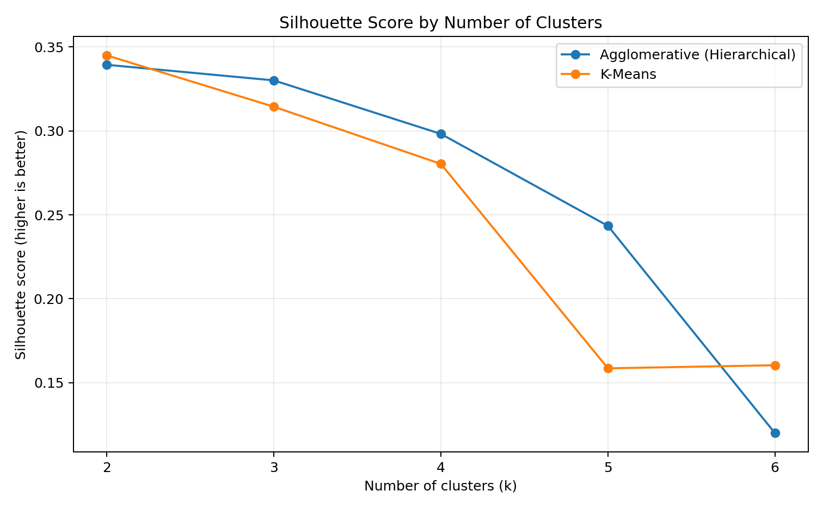
Figure 1. Silhouette score across tested cluster counts; selection is based on silhouette, not ARI.
Among the tested settings, K-Means with k=2 gave the highest K-Means silhouette score (0.3450). The best Agglomerative setting by silhouette also used k=2 (0.3394). On this run, K-Means had higher silhouette and a higher post-hoc ARI than Agglomerative Clustering at its best setting. This is a dataset-specific comparison, not proof that K-Means is always superior.

4.2 Cluster profile and interpretation
The selected K-Means solution has two clusters. The profile below shows their sizes and feature averages. The malignant fraction is shown only as a post-hoc comparison against the provided labels; cluster assignment itself used the numeric predictors only.
Cluster | Count | Malignant fraction* | Mean radius | Mean texture | Mean perimeter
0 | 189 | 92.6% | 17.56 | 21.36 | 116.41
1 | 380 | 9.7% | 12.42 | 18.26 | 79.81

*Malignant fractions are calculated after clustering for descriptive evaluation only. They are not used to create or assign clusters.
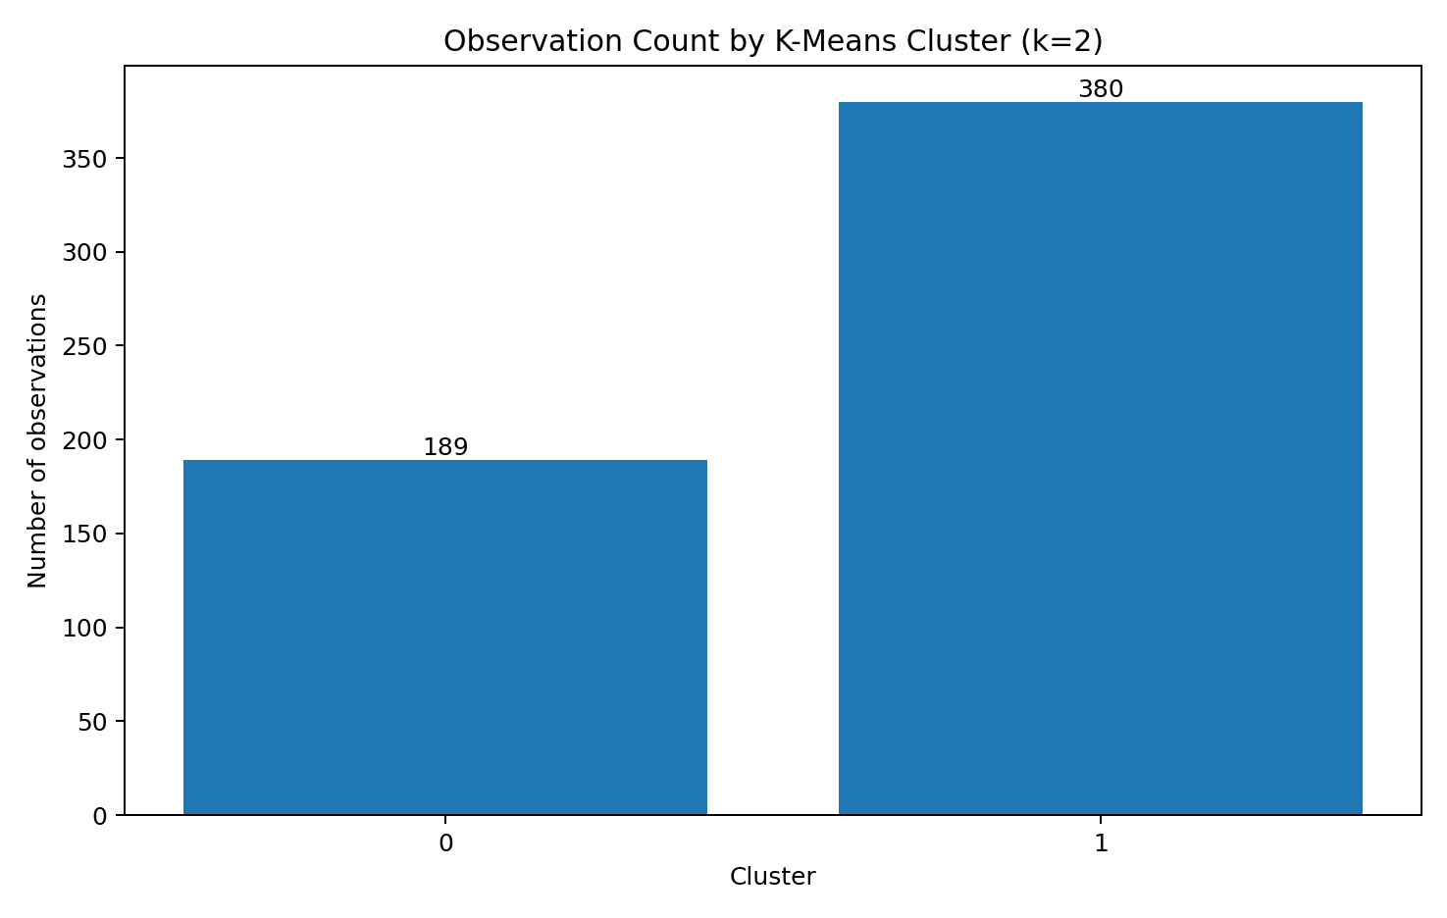
Figure 2. Number of observations in each selected K-Means cluster.
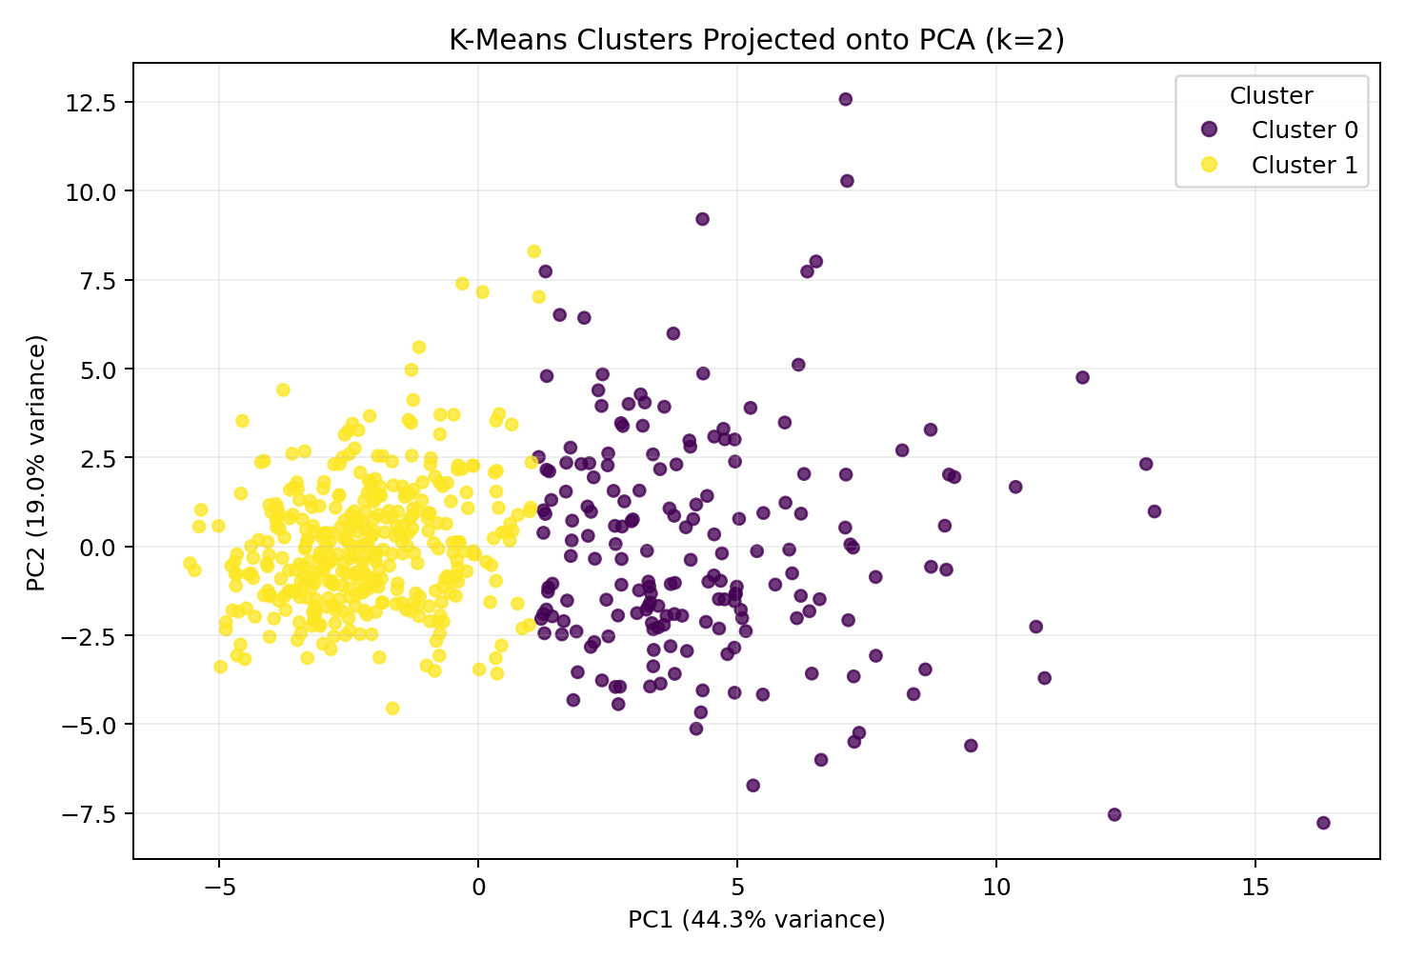
Figure 3. PCA projection of clusters fitted in the full standardized 30-dimensional feature space.

4.3 Dimensionality reduction with PCA
PCA creates new axes (principal components) that capture directions of variance rather than selecting original columns. The 2D chart is a projection of clusters fitted on all 30 standardized features; it is not a new clustering fitted only on two components.
Component | Variance explained | Cumulative variance
PC1 | 44.27% | 44.27%
PC2 | 18.97% | 63.24%

5. Supervised Model Evaluation

5.1 Cross-validation and hyperparameter tuning
Two classifiers are evaluated separately from clustering: Logistic Regression and Random Forest. A stratified 80/20 train/test split keeps class proportions similar. StratifiedKFold uses five shuffled folds on the training set; GridSearchCV tests a predefined hyperparameter grid and selects the model configuration with the highest mean validation ROC-AUC. The held-out test data is not used to tune hyperparameters.
from sklearn.model_selection import train_test_split, StratifiedKFold, GridSearchCV
from sklearn.pipeline import Pipeline
from sklearn.impute import SimpleImputer
from sklearn.preprocessing import StandardScaler
from sklearn.linear_model import LogisticRegression
from sklearn.ensemble import RandomForestClassifier
X_train, X_test, y_train, y_test = train_test_split(
X, y, test_size=0.20, stratify=y, random_state=42
)
cv = StratifiedKFold(n_splits=5, shuffle=True, random_state=42)
logistic_pipeline = Pipeline([
('imputer', SimpleImputer(strategy='median')),
('scaler', StandardScaler()),
('model', LogisticRegression(max_iter=5000, random_state=42))
])
logistic_grid = {'model__C': [0.1, 1.0, 10.0],
'model__class_weight': [None, 'balanced']}
search = GridSearchCV(logistic_pipeline, logistic_grid,
scoring='roc_auc', cv=cv, n_jobs=-1, refit=True)
search.fit(X_train, y_train)
# Apply the same process to Random Forest using a separate parameter grid.

Model | Hyperparameter search | Best selected parameters | Mean CV ROC-AUC
Logistic Regression | C: 0.1, 1.0, 10.0; class_weight: None/balanced | C=1.0; class_weight=None | 0.9958
Random Forest | n_estimators: 100/200; max_depth: None/8; min_samples_leaf: 1/3 | 200 trees; max_depth=8; min_samples_leaf=1 | 0.9891

5.2 Metrics and held-out test results
The positive class is malignant (label=1). Precision indicates how many predicted malignant cases were malignant in the test set. Recall indicates how many actual malignant cases were detected. F1 is the harmonic mean of precision and recall. ROC-AUC evaluates how well predicted scores rank positive cases above negative cases across thresholds. Accuracy is the overall fraction of correctly classified test observations.
Model | Accuracy | Precision | Recall | F1 | Test ROC-AUC | CV ROC-AUC
Logistic Regression | 0.9649 | 0.9750 | 0.9286 | 0.9512 | 0.9960 | 0.9958
Random Forest | 0.9649 | 1.0000 | 0.9048 | 0.9500 | 0.9940 | 0.9891

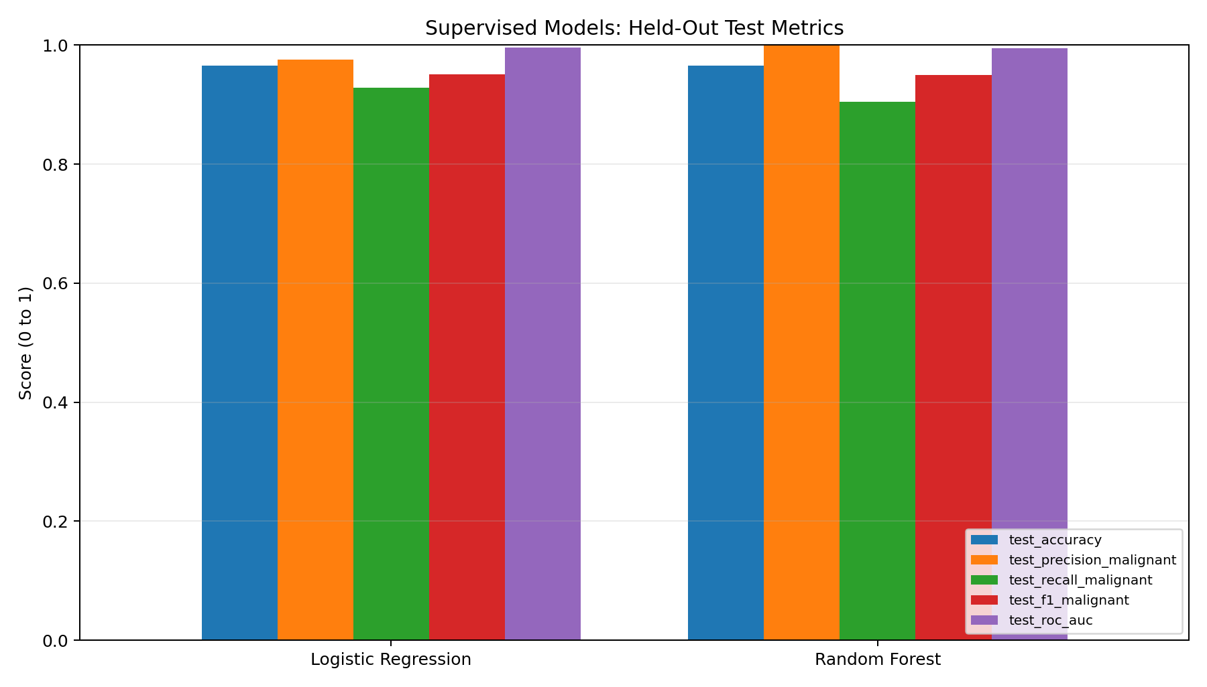
Figure 4. Held-out test metrics for the two tuned classifiers.
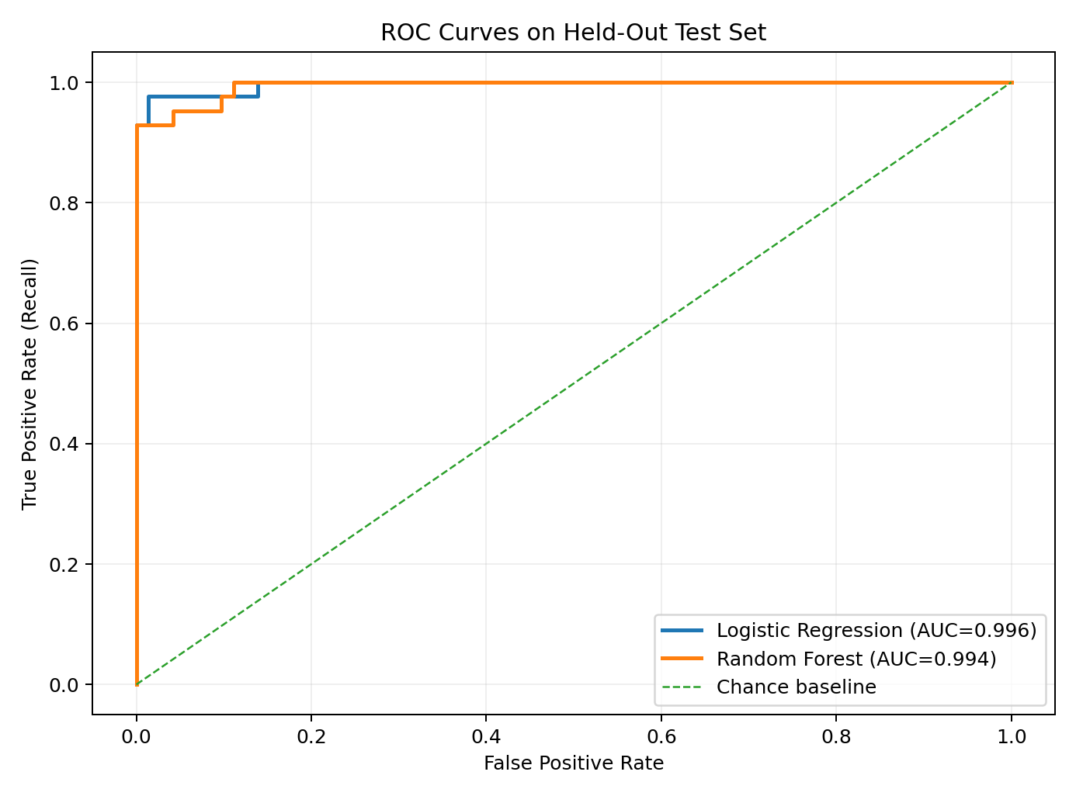
Figure 5. ROC curves measured on the held-out test set.

5.3 Confusion-matrix evidence
The confusion matrix counts actual versus predicted labels. In the table below, rows are actual labels and columns are predicted labels; order is benign then malignant. Therefore, a false negative means a malignant observation was predicted as benign.
Model | True benign → benign | Benign → malignant (FP) | Malignant → benign (FN) | True malignant → malignant
Logistic Regression | 71 | 1 | 3 | 39
Random Forest | 72 | 0 | 4 | 38

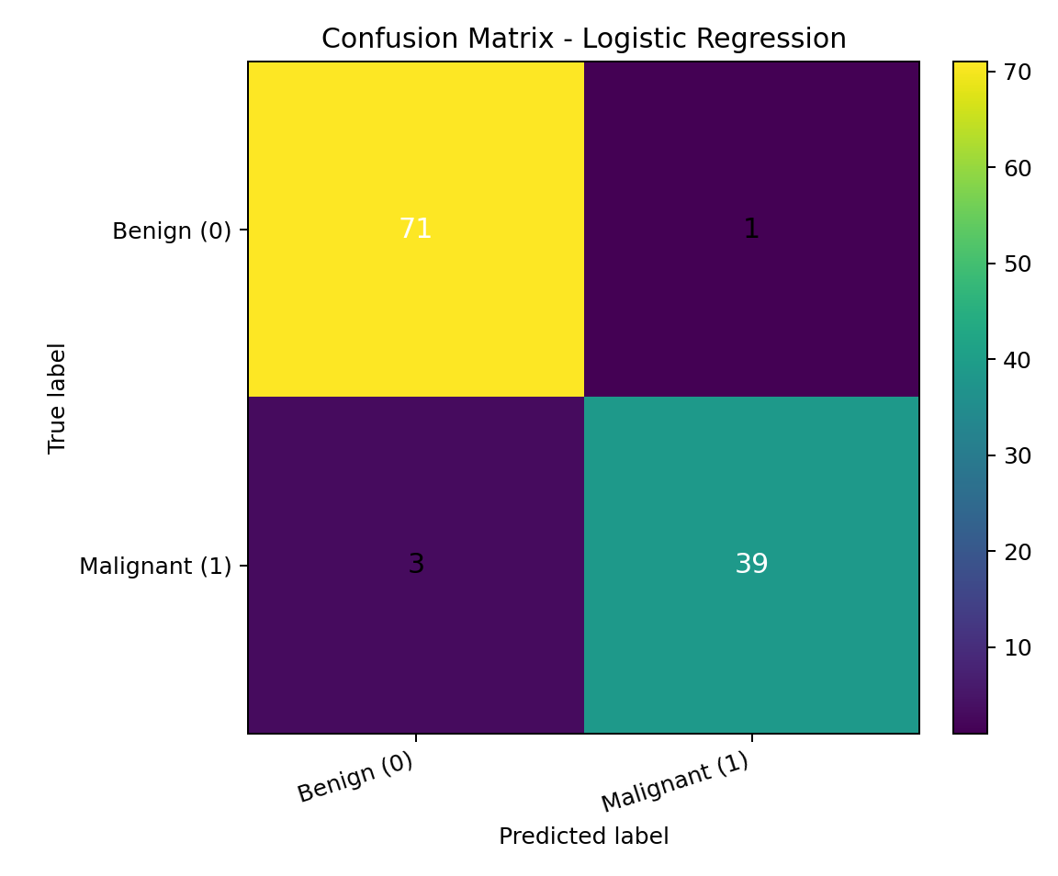
Figure 6. Confusion matrix for the model with the higher held-out test ROC-AUC.

6. Detailed Model Comparison and Findings
Both models correctly classified 110 of 114 held-out observations and reached the same accuracy of 0.9649 (96.49%). Accuracy alone therefore does not distinguish the models.
Logistic Regression achieved precision 0.9750, recall 0.9286, F1 0.9512, and test ROC-AUC 0.9960. Its confusion matrix shows 71 true benign predictions, 1 false positives, 3 false negatives, and 39 true malignant predictions.
Random Forest achieved precision 1.0000, recall 0.9048, F1 0.9500, and test ROC-AUC 0.9940. Its matrix shows 72 true benign, 0 false-positive, 4 false-negative, and 38 true malignant predictions. It had no false positives here but missed one more malignant observation than Logistic Regression.
The best Logistic Regression configuration was C=1.0 with no class weighting (mean five-fold ROC-AUC 0.9958); Random Forest selected 200 trees, maximum depth 8, and minimum leaf size 1 (mean CV ROC-AUC 0.9891). Logistic Regression edged ROC-AUC, recall, and F1, while Random Forest had higher precision. Fold-level scores are saved in `results/best_models_cv_fold_scores.csv`. This ranking is specific to one held-out split, not universal.

7. Limitations and Responsible Use
- The dataset is a small built-in benchmark and does not represent every real-world population or measurement setting.
- The supervised results use one held-out 20% split. Cross-validation helps with tuning, but repeated splits or external validation would be needed to assess broader generalization.
- The cluster numbers are arbitrary identifiers. Clustering is unsupervised; post-hoc agreement with diagnosis labels does not turn the groups into validated diagnostic categories.
- The PCA chart preserves 63.24% of standardized variance in two components, so some information is necessarily omitted from the visualization.
- The dataset and trained models are intended only for educational demonstration. They must not be used for patient diagnosis, treatment, or other clinical decisions.

8. Reproducibility and Project Files
The repository includes the exported dataset, reusable analysis script, Jupyter notebook, measured CSV tables, JSON run summary, plots, and fitted pipelines. The analysis can be regenerated by installing the dependencies and running the script from the project root.
python -m pip install -r requirements.txt
python src/run_analysis.py

File / folder | Purpose
src/run_analysis.py | Runs data export, clustering sweep, PCA, model tuning, evaluation, figures, and saved models.
notebooks/week3_unsupervised_and_evaluation.ipynb | Interactive, explanatory entry point for the complete run.
results/clustering_metrics.csv | Silhouette and post-hoc ARI for both clustering algorithms across k=2..6.
results/supervised_model_metrics.csv | Test metrics, CV scores, confusion counts, and selected hyperparameters.
results/best_models_cv_fold_scores.csv | Validation ROC-AUC from each of the five folds for the selected configurations.
results/run_summary.json | Compact machine-readable summary of the measured run.
figures/ | Clustering, PCA, ROC, confusion-matrix, and metric-comparison plots.
models/ | Saved scaler, PCA transform, selected K-Means model, and tuned classification pipelines.
submission_description.txt | 200+ word summary for the internship submission form.

Conclusion
This project met the main Week 3 learning objectives by comparing K-Means and hierarchical clustering, applying PCA, tuning supervised models through five-fold cross-validation, and evaluating predictions with multiple metrics and confusion matrices. Within the tested clustering range, K-Means with k=2 gave a silhouette score of 0.3450, and the first two PCA components explained 63.24% of variance. In supervised testing, both models achieved 96.49% accuracy; Logistic Regression had the higher test ROC-AUC (0.9960) and malignant recall (0.9286), while Random Forest had the higher precision (1.0000). The measured tables and confusion-matrix counts make the conclusion traceable to numeric evidence. All findings are limited to this benchmark and split and are not suitable for medical decisions.

