**INDIVIDUAL FINAL PROJECT**

Table of Contents

Introduction 3

Design Elaboration 3

Implementation 5

Content of Computer Science Portfolio 6

Explanation of the structure of the portfolio website and its corresponding GitHub repository 7

Justification of the design decisions 7

Clarification of the tools/technologies 8

Strengths/Weaknesses of the portfolio 9

Conclusion 11

Bibliography 12

# Introduction

This is the portfolio of Sahil Bhagat comprising achievements in software engineering during his work at Gisma University of Applied Sciences. This portfolio is the point of entry for technical abilities, initiatives, and career goals.

In the field of software engineering, efficiency encompasses programming languages Java, Python, and C++ as well as HTML, CSS, and JavaScript as the Web development language. These skills form the basis of the capacity to think and to design and execute novel conceptual strategies in the information age.

The analysis of contexts is well-structured pointing at educational activities and aims while the deeds emphasize problem-solving skills and an original approach to software design. Every one of them is proof of the technical knowledge and the willingness to expand the expertise in the newly introduced technologies.

However, equally relevant experience can be acquired from internships as well the collaborations in actual software development. These experiences enrich the portfolios of skills and enhance comprehension of the basic concept of teamwork and project implementation in industrial profiles.

Move through the work to find out about specific projects and the schooling and plans of individuals. Specifically, for potential employers, collaborators, or any software engineering enthusiasts, the portfolio prompts interaction with passion and a forum for discussing the making of change through software applications. Welcome, and as you will see, connection scenarios are on the horizon.

# Design Elaboration

The layout and structure of Sahil Bhagat’s portfolio website is to make it professional, neat, simple, and responsive to meet the objectives of highlighting the skills, work samples, and accomplishments of the designer. The first and foremost aim is to give convenient navigation for any kind of visitor, which can be a potential employer or a collaborator, or anything like that; secondly, it should represent Sahil Dhanjal’s ability to work with the web, applications, etc.

**Visual Design**

visually the website follows a simplistic layout and it mostly features tones of white, grey, and black. This decision guarantees the relative uniqueness of the content as well as ensures the site remains neat and professionally designed. The Arial font has been chosen for readability purposes, thus repeated use of the same font adds to the consistent look of the site. It uses the overall layout that is a header, a navigation bar, the main content, and the footer sections to give the users a familiar feel of the website.

**Navigation**

Ergo, the distinct navigation bar that runs across the page has Home, About, Projects, Resume, and Contact options. It is implemented using a flexbox layout to achieve responsiveness to the different interfaces of various devices. In the case of using the site on a small screen, the layout of the navigation changes its position and becomes vertical to stay convenient on a mobile device. This design decision is essential for accessibility and guarantees all the visitors to find the necessary data using any device.

**Content Layout**

As a result, each page of the created portfolio contains a defined hierarchy.

**Home Page:** Touches base with Sahil with a small welcome note and Sr. Professional profile picture. It introduces himself, showing his readers the kind of person they are dealing with and a sneak peek at the rest of the site.

**About Page:** The one shared here contains a longer biography that also includes the fields of study in college as well as career focus. To apply a more personal caveat, it also includes a profile picture for the user.

**Projects Page**: Card-based design is used to propose individual projects. To that, it is integrated into each of the cards the title of a project, its description, as well as a link to the corresponding repository on GitHub. This is the logical and aesthetical structure of the layout where visitors can glance through the project list and drill down to the details if required.

**Resume Page:** This gives a downloadable PDF copy of Sahil’s resume and a preview of it in case one needs to refer to it. This helps the employer without even having to ask to be in a position to assess his qualifications as and when necessary.

**Contact Page:** Includes a basic contact form implemented with the help of Formspree that allows the users to send a message. The form is simple and color-coded with labels hoping to eliminate confusion and hectic input fields.

**Accessibility and Responsiveness**

The site is designed with principles of web accessibility by having proper heading structure, proper use of links, and title attributes, and by having proper color contrast. Attached to the CSS, media queries exist to change the format according to a user’s device: desktop, tablet, or mobile. This responsivity is paramount in meeting the fluidity of the presentation across different platforms and devices, as well as considering the site’s accessibility to all its visitors.

# Implementation

Following the design principles of Sahil Bhagat’s portfolio website is highly systematic as it constitutes the right online tools and materials that can portray the right image of the expert’s prowess. Starting with the use of a GitHub repository to manage versions and hosting of the project, the project involves creating HTML files for the sections including About, Projects, Resume, and Contact. For instance, every page adheres to a similar layout where it is comprised of a header that also contains a navigation menu.

Hence, the content aims to present Sahil’s education, technical skills, and work experience in brief descriptions, links to the projects hosted on the GitHub account, and an integrated or downloadable resume. It is adapted again by utilizing the CSS media queries to improve the visibility of the website’s layout across devices. Accessibility is achieved through deployment on GitHub Pages; updating regularly guarantees that the portfolio corresponds to Sahil’s progress and accomplishments in the software engineering field. This kind of structure not only builds a more professional image for Sahil but also enables the user, employer, or any party interested in the deeper assessment of Sahil’s proficiency to do so easily.

# Content of Computer Science Portfolio

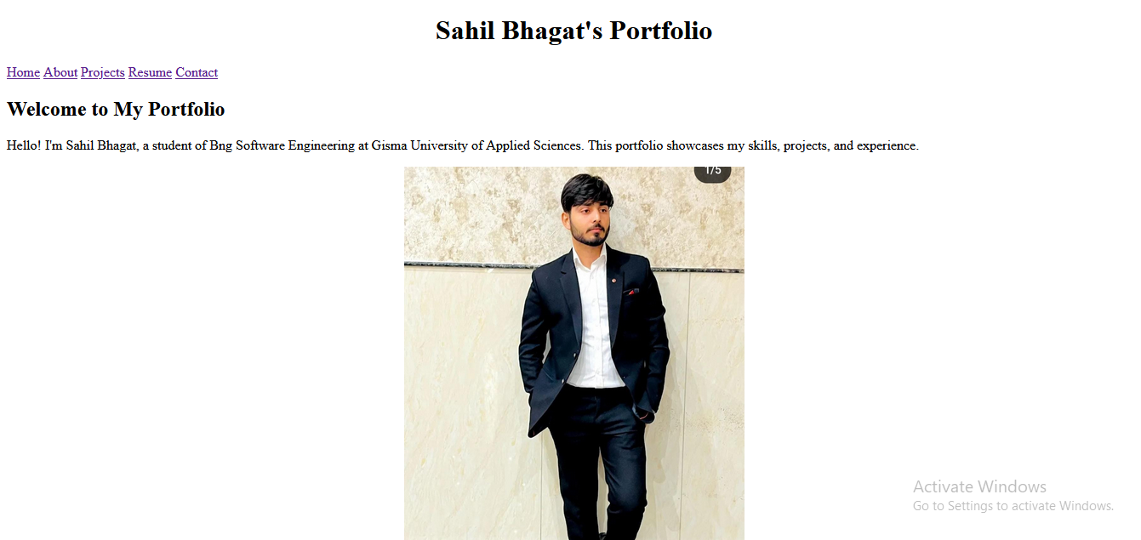

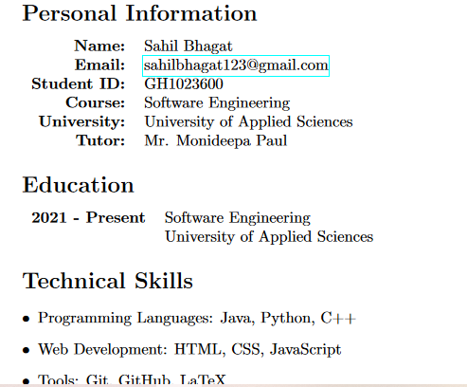

**Figure 1: Outliers of CV**

## Explanation of the structure of the portfolio website and its corresponding GitHub repository

The organization of Sahil Bhagat’s work portfolio is perfect to ensure maximum amortization of his professional outlook and surrender dexterity. The page is easy to recognize since it is usually an entrance or landing page to a website and it swiftly presents the website’s brief description and easy access to the main areas. The About page provides more information on Sahil, his education and experiences, and the expert’s bio, which makes the viewers feel closer to him through the use of a professional photograph. Sahil’s work is showcased on the/projects page and each of the projects is detailed through description and links to the specific GitHub repositories. This portion of the text proves his software development skills as well as his ability to apply skills in real-life situations.

The Resume page presents all the relevant information about Sahil’s education, skills, and experience in tabular and bullet point format for easy readability and comes in a PDF format for easy downloading. For direct interaction, on the Contact page, there is a simple form by which visitors can contact Sahil immediately and without difficulties. Across the website, the stylistic consistency and accessibility of the page layout on device platforms and screens are provided thanks to a CSS StyleSheet (styles. css). The image or the profile picture is in the folder of images (profile-pic. jpeg) and the resume in PDF format (CV. pdf) is likewise located in a proper folder on the GitHub site with proper structures for easy recognition and documentation. Aside from the benefit of increasing Sahil’s online visibility, this organized framework can also build up his reliability and competency to possible employers and partners in software engineering.

## Justification of the design decisions

**Clear Navigation and Information Architecture:** The choice of a static menu bar on all pages: Home, About, Projects, Resume, and Contact makes it easier for the users to navigate through Sahil’s portfolio. This is useful to the visitor to enable them to locate the information they want as easily as possible, free from any confusion, thus improving their experience.

**Professional Presentation:** The clean and simple design also lies in the fact that the color scheme of this site is quite professional, sticking to a blue and gray theme. This approach complies with the norms and erases any possible gap between Sahil’s formal business attitude and work performance.

**Responsive Design:** Using the elements of responsive design the portfolio is made responsive to different devices and multiple screen sizes. What is beneficial with CSS media queries is the layout adjustment is catered for both desktops, tablets, and smartphones thus reaching out to more people.

**Content Organization:** Arrange by various categories like About, Projects, and Resume keeps all the information orderly making it easier to convey information about Sahil’s experiences and capabilities. As it is observed, each section of the profile is developed to reflect a particular aspect that aims at assisting the visitors to get a glance at his expertise.

**Visual Elements:** A welcome addition to the About page is the inclusion of a professional profile picture which aids in the creation of rapport with the visitors. Professional images and typeset font add substance and make the text easy on the eye, which adds to the perception of Sahil’s professionalism.

**Interactive and Functional Elements:** The choice to incorporate practical features such as the GitHub project links and the contact form raises participation. Since the nature of the portfolio is more than informative, the visitor can go straight to reading Sahil’s projects and can easily communicate with him, which creates a chance for collaboration.

**Accessibility and Performance:** Additionally, the portfolio is hosted on GitHub Pages which guarantees that it will be hosted well and will have a short loading time.

**Documentation and Maintenance:** This is why it is necessary to also add a README. portfolio README. md file in the GitHub repository explains the portfolio use, layout, and deployment information. To keep the content fresh and up-to-date, the site has to be updated frequently, the content showing Sahil’s progress and new accomplishments in software engineering.

## Clarification of the tools/technologies

**HTML (HyperText Markup Language):** This is applied in the organization of web content to give a proper meaning and layout of the items that are on the Web page such as the headings, the paragraphs, and hyperlinks.

**CSS (Cascading Style Sheets):** These involve creating the website’s format, its color schemes, and the type of font to use among other tasks related to the website’s makeover. It helps to maintain the identity of the design throughout all the pages and adapt to the clients’ screens’ requirements.

**GitHub:** Used for everyday programming and hosting of the repository. GitHub Pages in particular, live website hosting is done by it while being a free and efficient web hosting service from the repository.

**Responsive Design:** Utilized CSS media queries to provide the ability to adjust the website layout on different devices thus improving the experience of the users engaging the developed site on different devices including desktops, tablets, or smartphones.

**JavaScript:** The option of using JavaScript is not stated in the description, but it can be optionally used for interactivity, form validation, or boosting usability, in general, it is not essential in this portfolio.

**Formspree (or similar service):** Embedded into the Contact section for processing the form data safely. One thing that Formspree does is minimize the steps of form handling if one does not wish to write backend code.

**LaTeX:** Applied to make Sahil’s resume in PDF format so that it has a good outlook and can simply be downloaded on the Resume page in [. pdf folder as CV. pdf].

**Graphics and Images:** To give the website more attractiveness and a developed look, High-quality images for example Sahil’s profile picture are saved in the images/ folder as profile-pic. jpeg.

**Markdown (README. md):** A README doc is created in the GitHub repository with information on what the portfolio is for, how it is laid out, and how to deploy it. It assists in the organization and simplicity of future modifications or additions by other clients.

All these tools and technologies enhance a well-designed and functional portfolio website for Sahil Bhagat to provide the employer or any collaborator with adequate information regarding his expertise, completed projects, and professional experience. Each tool is chosen to achieve maximum efficiency in development, the beautiful appearance, and active usage of the created resource, following the trends in the sphere of web development.

## Strengths/Weaknesses of the portfolio

**Strengths of the Portfolio:**

**Clear Navigation and Structure:** The layout of the portfolio website follows a logical structure of sections and sub-sections, so there is no problem with easy site navigation for the user, who can quickly find all the materials concerning Sahil Bhagat. Thus, each section, Home, About, Projects, Resume, and Contact, is convenient and enhances the reception of users.

**Professional Presentation:** The design of the website under analysis is professional with moderator color, a simple layout, and comfortable fonts. On its own, this format adds authority to Sahil’s professional persona and can therefore be beneficial when seeking employees or partners.

Showcasing Projects and Skills: This part of the Projects section is also efficient in emphasizing Sahil’s technical abilities. All projects are explained with the necessary information and, along with descriptions, contain a link to the project on GitHub where he is showcased.

**Responsive Design:** The application of responsive design plays a crucial role in making sure that the portfolio is responsive and functional in terms of the device preferred and the size of the screen being used. This makes web designs more usable and also taken into consideration in accommodating a larger number of users.

**Interactive Elements:** Linked ‘projects’ and the contact form on GitHub contribute to the interaction. People can also independently access Sahil’s completed projects in one place and can reach out to him for professional-related connections and business in one place.

**Weaknesses of the Portfolio:**

**Limited Interactivity:** While the links to projects and the contact form are considered to be the main and rather simple forms of interactivity in the portfolio, the latter can be supplemented with more complex interactive features or even dynamic content.

**Content Depth:** There are some parts, for instance, the About and Resume tabs, which may not be as informative in terms of disclosing certain information about Sahil’s experience, achievements, or projects. It is also found that the addition of more elaborate and explanatory content could improve the spectrum of the communicated portfolio.

**Visual Creativity:** From a design point of view the design is quite business-like and formal looking, though what could be seen as a drawback the design does not contain flamboyance in the creation process aspect hence the portfolio lacks the impressive look in aspects of graphic design or artworks among others. Increasing subjective qualities such as graphics or design could increase attractiveness as well.

**Technical Integration:** Based on technical expertise and visions, the portfolio might be useful to integrate complex technologies or to prove knowledge of new tools appropriate in Sahil’s field of study, for example, frameworks, and interactive elements.

**Performance Optimization:** Some other comprehensible areas of improvement are related to performance: making the page load even faster, using as few resources as possible, and so on. This may cover such aspects as image and code size reduction or the use of caching strategies.

# Conclusion

It can be concluded that the overall structure and navigation of Sahil Bhagat’s portfolio is impressive and that could reflect his activity as a full-time web Developer. These and other features as clear navigation, responsiveness, and a united visualization make the experience of a website’s visiting effective, and it is easy to get acquainted with his work and achievements. One can consider the general layout of the portfolio successful as it contains detailed descriptions of projects, numerous distinct elements allowing for better interactivity, and a download of the resume, which, in turn, stresses Sahil’s preparedness for potential vacancies and his technical skills. Nevertheless, there are suggestions left where one can improve, for instance, making interactivity smoother, content more substantial, integrating more creativity into the design, and improving the site’s performance for a better experience. By explicating these features, Sahil can continue enriching his portfolio and transform it into an inspiring and progressive presentation of one’s skills and experience.

# Bibliography

Gouglas, D. and Marsh, K., 2021. Prioritizing investments in rapid response vaccine technologies for emerging infections: A portfolio decision analysis. *PLoS One*, *16*(2), p.e 0246235.

Ling, L.P. and Dasril, Y., 2023. Portfolio Selection Strategies in Bursa Malaysia Based on Quadratic Programming. *Journal of Information System Exploration and Research*, *1*(2).

Martins, P.J.P., 2022. *Development of an e-portfolio social network using emerging web technologies* (Doctoral dissertation).

Nilsson, S. and Palm, E., 2024. Optimization of Portfolio Management How to prioritize work within different departments and portfolios.

Peykani, P., Mohammadi, E., Jabbarzadeh, A., Rostamy-Malkhalifeh, M., and Pishvaee, M.S., 2020. A novel two-phase robust portfolio selection and optimization approach under uncertainty: A case study of Tehran stock exchange. *Plos one*, *15*(10), p.e0239810.