* Creating a customer table:

CREATE TABLE Customer (

customer_id INT PRIMARY KEY,

customer_name VARCHAR(100,

city VARCHAR(100),

grade DECIMAL(5),

salesman_id INT,

FOREIGN KEY (salesman_id)

REFERENCES Salesman(salesman_id)

);

* And insert data:

INSERT INTO Customer (customer_id, customer_name, city, grade, salesman_id)

VALUES (3001,’brad guzan’,’London’,200,5005),

(3002,’Nick Rimando’ ,’New York’,200,5005),

(3003,’Jozy Altidor’ ,’Moscow’,200,5005),

(3004,’Fabian Johnson’ ,’Paris’,200,5005),

(3005,’Graham Zusi’ ,’California’,200,5005),

(3006,’Brad Davis ‘ ,’New York’,200,5005),

(3007,’Hulian Green’ ,’London’,200,5005),

(3008,’Geoff Cameron’ ,’Berlin’,200,5005);

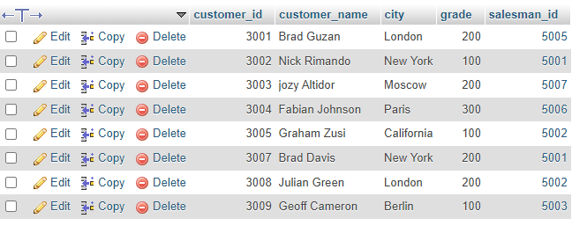

* Creating salesman table:

CREATE TABLE Salesman ( salesman_id INT PRIMARY KEY,

salesman name VARCHAR(100),

city VARCHAR(100),

commission DECIMAL(10, 2));

* Insert data into salesman:

INSERT INTO Salesman (salesman_id, name, city, commission)

VALUES (5001, 'James Hoog', 'New York', 0.15),

(5002, 'Nail Knite', 'Paris', 0.13),

(5003, 'Lausin Hen', ‘San Jose', 0.12),

(5004, 'Pit Alex', 'London', 0.11),

(5005, 'Mc Lyon', 'Paris', 0.14),

(5006, 'Paul Adam', 'Rome', 0.13);

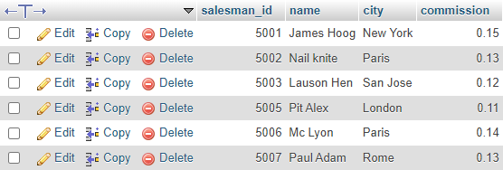

* find the salesperson(s) and the customer(s) represented here. Return the Customer Name, City, Salesman, commission: -

SELECT

C.customer_name AS Customer_Name,

C.city AS Customer_City,

S.name AS Salesman_Name,

S.commission AS Salesman_Commission

FROM

Customer C

INNER JOIN

Salesman S ON C.salesman_id = S.salesman_id;

