**Advance Sql**

Q-1. Find all employees whose Employee name ends with 'N'. List the

employee number, the Employee name, and the last character of the Employee name.

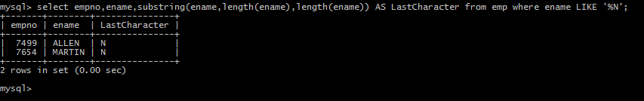

Q-2. Write a procedure to increment the salary of employee who works in sales department.

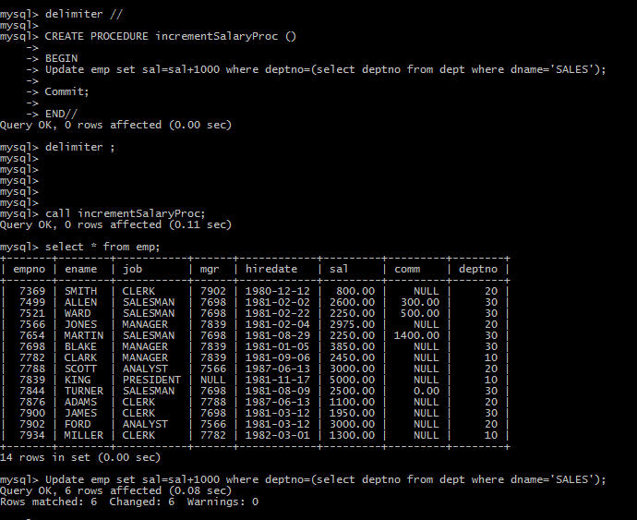

Q-3 Write a function to find the total salary of employees, who works in Accounts department.

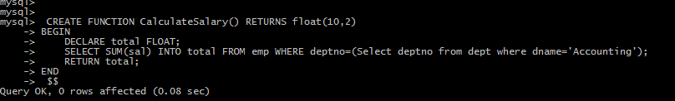

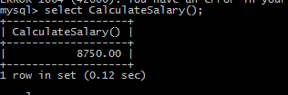

Q-4 create a new  table for keeping transaction records,record will be updated in this table when there is deduction in the salary,when salary is deducted a trigger is executed which insert employee name ,updatedby ,changedsalary,updateddate in new table.



