Exercise on Version Control

Q1. Git Setup https://confluence.atlassian.com/bitbucket/set-up-git-744723531.html

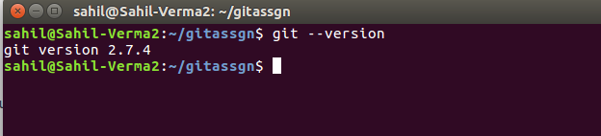

Q2. Initialize a Git Repository

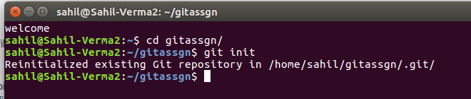

Q3. Add files to the repository

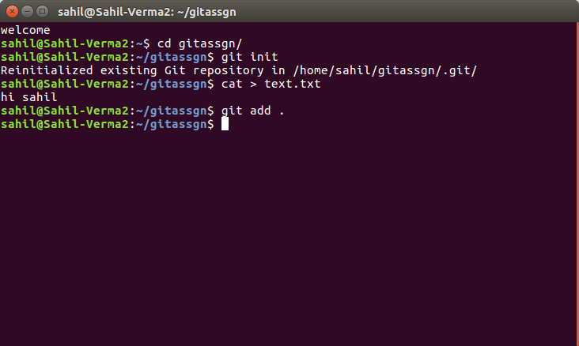

Q4. Unstage 1 file

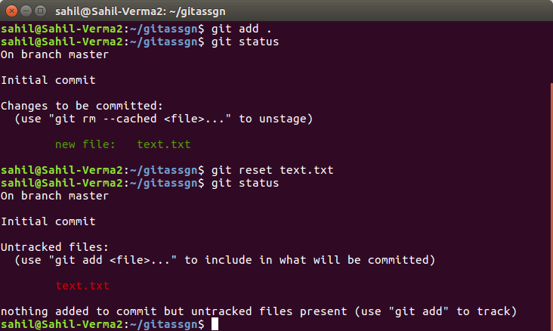

Q5. Commit the file

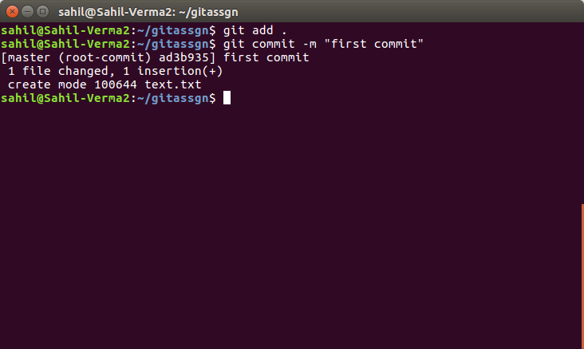

Q6. Add a remote

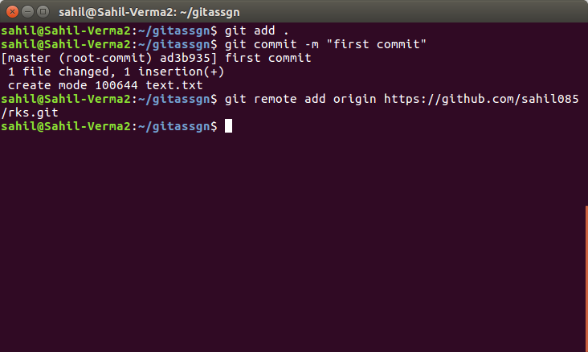

Q7. Undo changes to a particular file

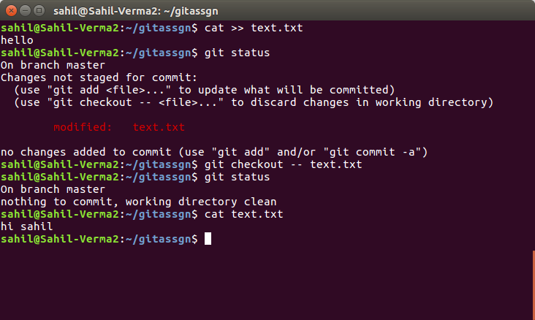

Q8. Push changes to Github

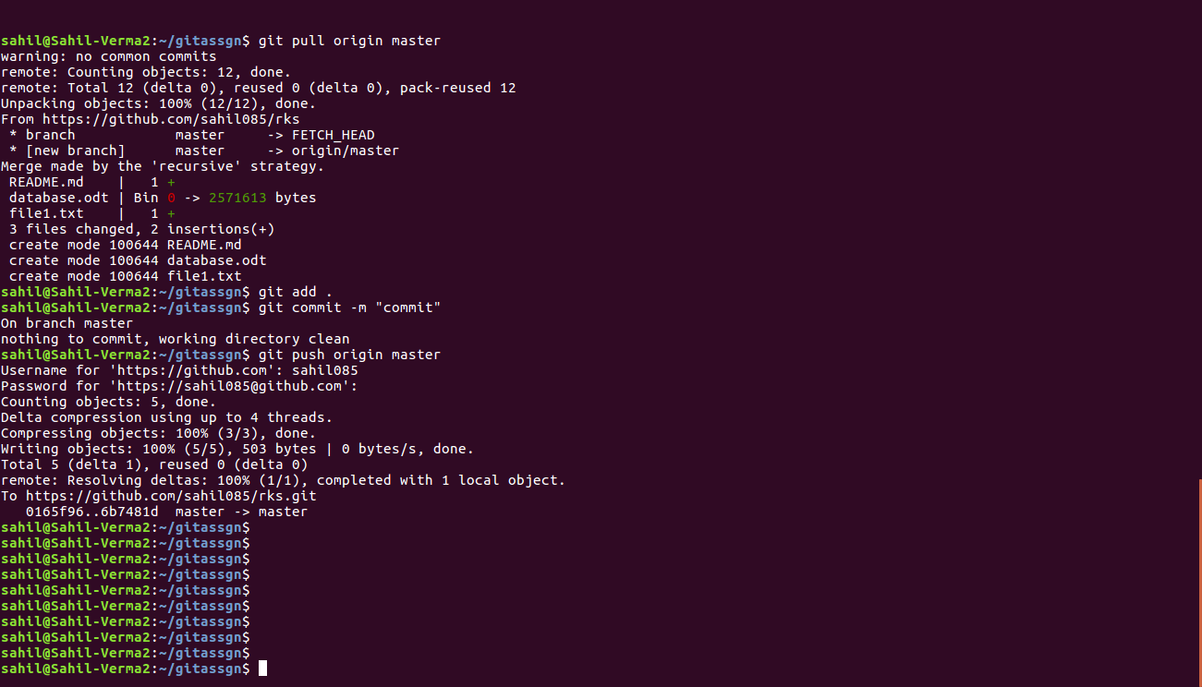

Q9. Clone the repository
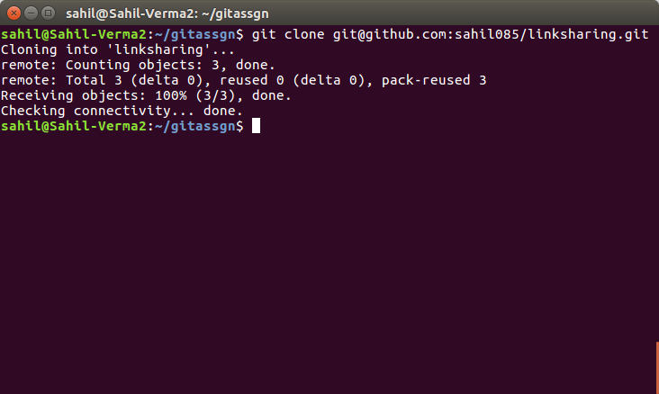
Q10. Add changes to one of copies and pull the changes in the other.

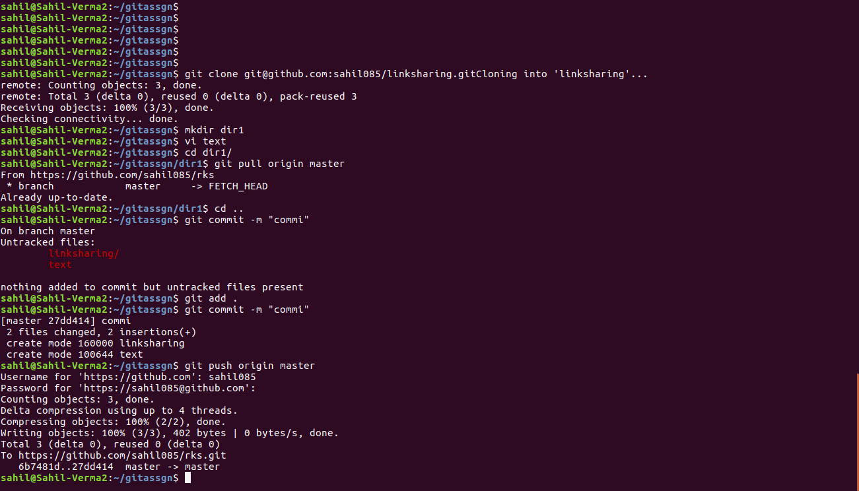

Q11. Check differences between a file and its staged version

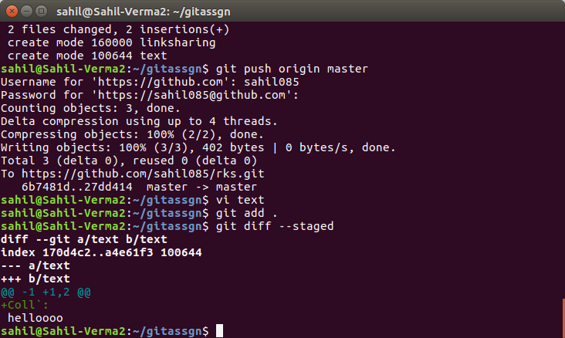

Q12. Ignore a few files to be checked in

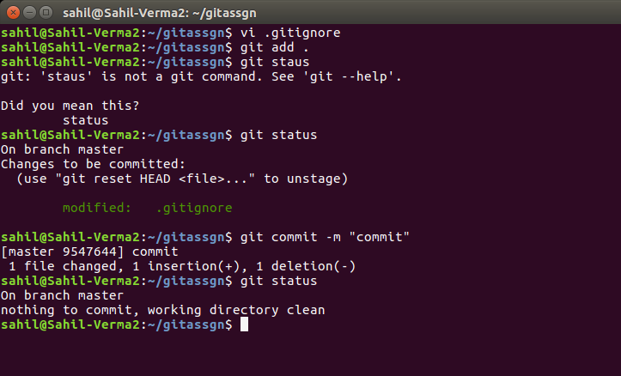

Q13. Create a new branch.

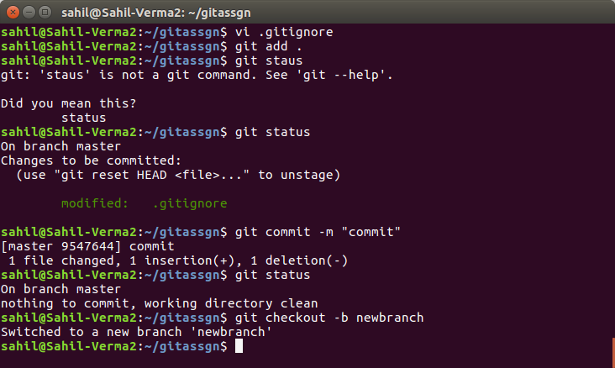

Qtn 14. Diverge them with commits
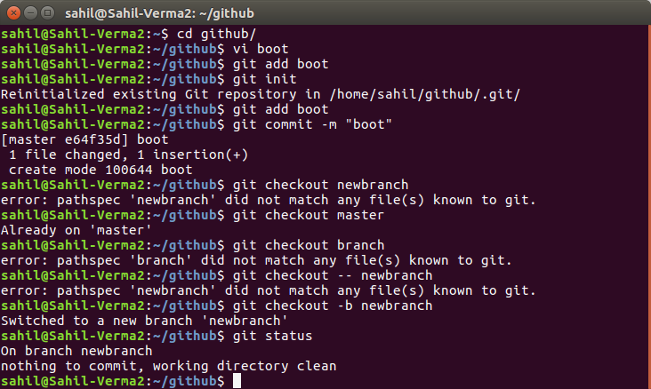

Q15 Edit the same file at the same line on both branches and commit
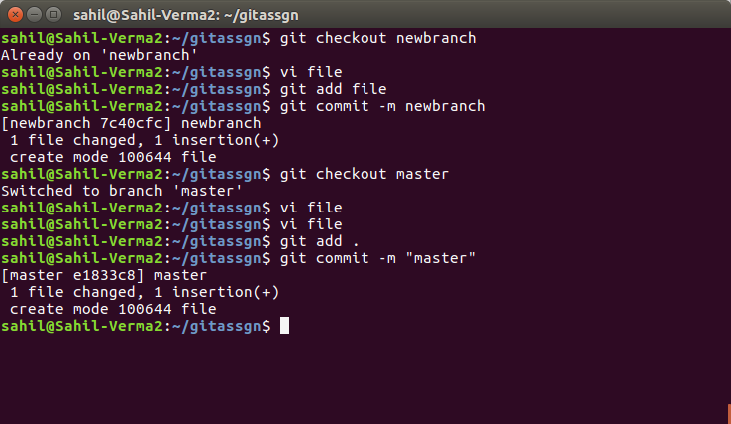

Q16. Try merging and resolve merge conflicts
Merging Conflict:
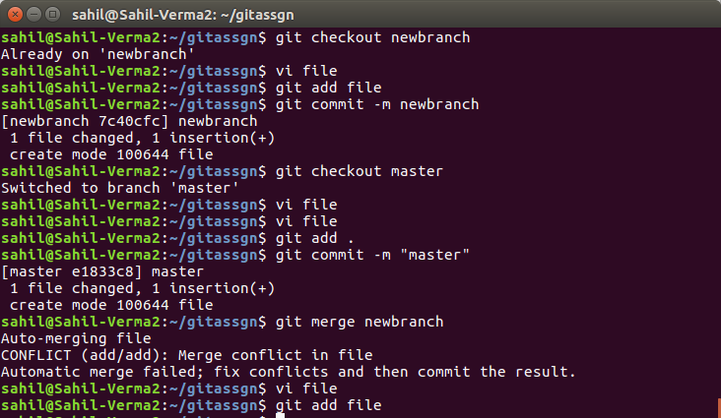

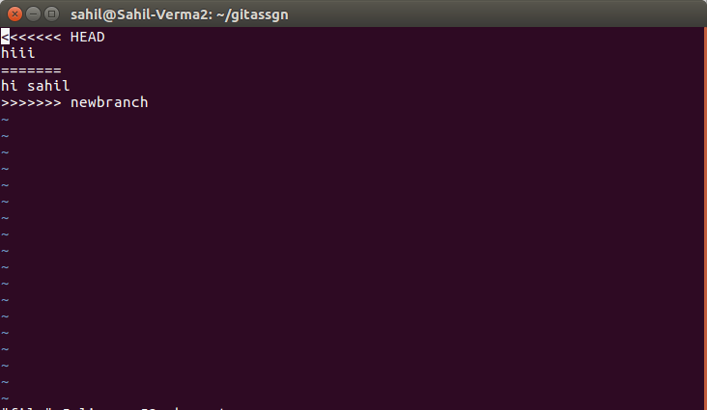
Resolving Conflict:

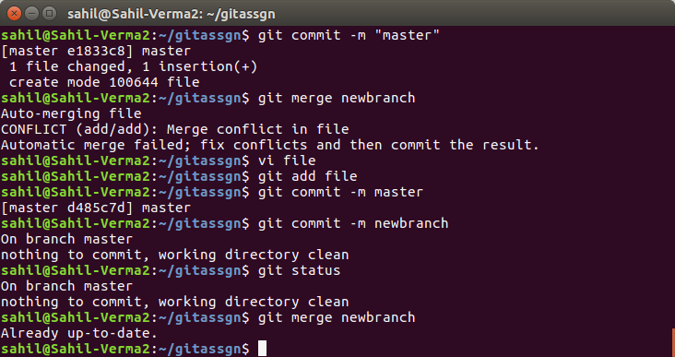

Q17. Stash the changes and pop them
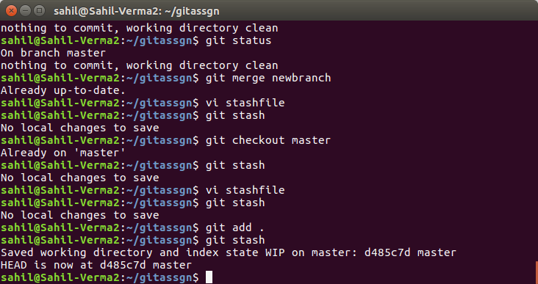

POP :
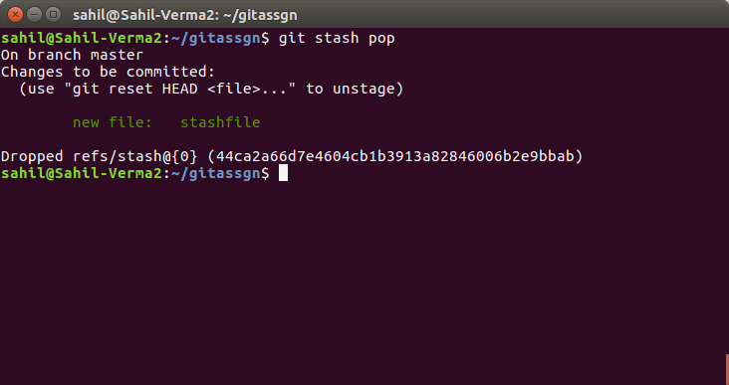

Q18. Add the following code to your .bashrc file :
color_prompt="yes"
parse_git_branch() {
git branch 2> /dev/null | sed -e '/^[^*]/d' -e 's/* \(.*\)/(\1)/'
}
if [ "$color_prompt" = yes ]; then
PS1='\u@\h\[\033[00m\]:\[\033[01;34m\]\W\[\033[01;31m\] $(parse_git_branch)\[\033[00m\]\$ '
else
PS1='\u@\h:\W $(parse_git_branch)\$ '
fi
unset color_prompt force_color_prompt
