**Customer Analytics for Cinemark**

**MKT 6342.501  
Marketing Consumer Insights Development  
Fall 2017**

**The University of Texas at Dallas**

**Naveen Jindal School of Management**

SAHIL ARORA

Contents

Executive Summary 3

Overall Project Summary 3

Data Selection 4

Problem Statement 8

Industry Overview 9

Movie Industry 9

1) Opportunities/Threats (External) 9

2) Cinemark (and sub brands) vs Top tier competitors 10

Analysis 11

1) Movie Theaters and PODV Amongst Customers 11

2) Cinemark Visit and Loyalty Analysis 15

3) Decision Order and Desired Attributes 18

4) Theater Experience Importance 21

Strategy 24

What amenities appeal to Young Professionals? 24

How do Young Professionals experience movies? 25

Recommendations 25

Conclusion 26

Appendix 27

Regression Analysis 27

Uxpressia Customer Journey Map 28

Uxpressia Personas 29

Word Clouds 30

References 31

# Executive Summary

## **Overall Project Summary**

The consumer video entertainment industry – currently comprised of many players, from movie theater chains and film studios to streaming content services - is going through one of the biggest transformations in its history. Traditionally, consumers seeking entertainment had to go to their local theater to watch one of few select movies, as previously arranged between the theater chain and film studios. Over time, more theaters introduced more showtimes and television became a more compelling product – meaning more people were staying home for entertainment. This transformation continued slowly, creating an industry that offered the consumer more and more video content, accelerating with an explosion of options appearing in the last decade.

Individuals now have more ways to consume video entertainment than ever before. Movie theaters and televisions still exist, but popular, direct-to-consumer options such as Netflix, Amazon Prime and Hulu provide an array of content on demand. Not only is it simple to access video content, it’s just as simple to create and share – due to sites like YouTube and other social media platforms, users are consuming more video content than any other point in time.

Generational changes have also had an impact, younger generations are consuming their video in shorter and shorter increments than before. As indicated in Figure 1 below, as a video grows in length, consumer engagement declines. This is a common problem across video content services and platforms, but perhaps one of the most impacted segments is the movie theater industry. Movie theaters are continually challenged on how to create an engaging value proposition that consumers are willing to experience over other options.

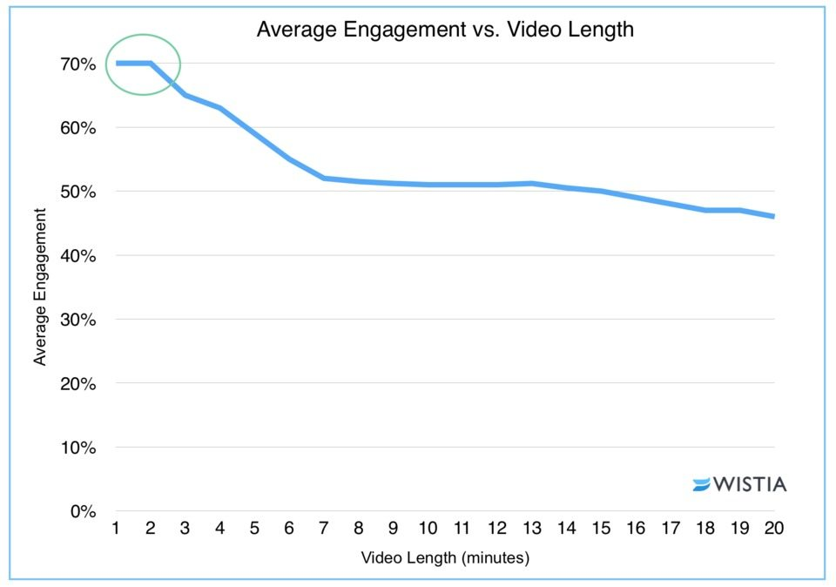

*Figure 1: Engagement vs. length (* (Wistia, 2016)*)*

## **Data Selection**

This study utilizes a robust data set of survey responses for Cinemark Theaters, a top movie theater chain in the United States and Latin America (Cinemark, n.d.). The survey in question was administered in early 2016 across the United States, and yielded over 2000 complete responses. Through careful data analysis, our aim is to understand what consumers find compelling about the movie theater experience, and how this ultimately impacts their purchase decisions.

Age Dispersion of Respondents

As noted in the Figure 2 below, most age ranges have a comparable dispersion of male to female responders.

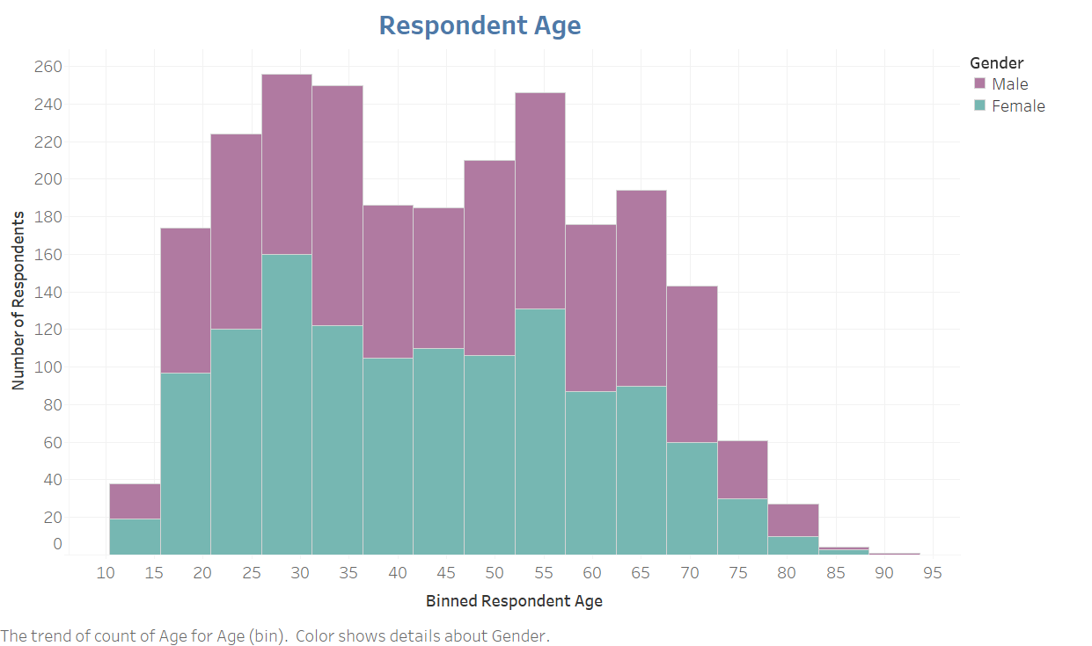

*Figure 2: Age of survey respondents by gender (Tableau)*

The data has been split into four age brackets for analysis:

1. Children and Teens – Age 0-19 – 7.5% of Data set
2. Young Professionals – Age 20-39 – 35.4% of Data set
3. Senior Executives – Age 40-59 – 31.5% of Data set
4. Retired – Age over 60 – 25.6% of Data set

Our analysis focuses on the “Young Professionals” demographic, as defined in the data set. This demographic includes individuals between 20 and 39 years old, and represent 35.4% of the data set. By focusing on the “Young Professionals” age range, we are focusing on the growing share of the video consumption market from a movie-goer viewpoint.

Geographic Dispersion of Respondents

From a geographic perspective, survey responses came from across the United States. Survey respondents could select their “visit frequency” for Cinemark Theaters (referring to the Cinemark Brand or one of their sub brands – Century Theaters, Tinseltown, CineArts, or Rave). Visit frequency was classified from *frequently,* meaning Cinemark Theaters was the top choice to see a movie, to *light,* meaning Cinemark Theaters is one of the consumer’s choices for movie-going. *Non-visitor* indicated the survey respondent did not opt to visit a Cinemark Theater.

Most of the data is concentrated in urban pockets across California, Texas and the upper Midwest. As shown in Figure 3, the largest pockets of frequent visitors are in northern California, throughout Texas, Chicago, and western Pennsylvania.

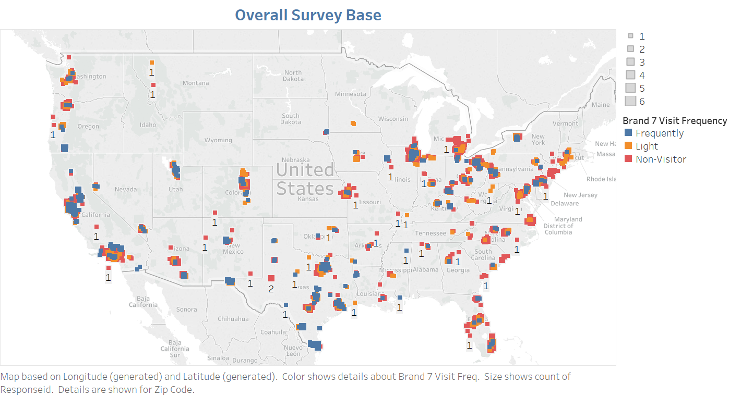

*Figure 3: Overall survey base across the United States (Tableau)*

Income Dispersion of Respondents

The income dispersion of respondents is comparable across all income brackets, with the respondents over-indexing in the “Over 100K” bracket as seen in Figure 4. This could be a misrepresentation in the data as an influx of those in the “Child and Teen” (age under 20) demographic selected this bracket. Since we are focusing on the “Young Professionals” demographic, we are not concerned with this anomaly.

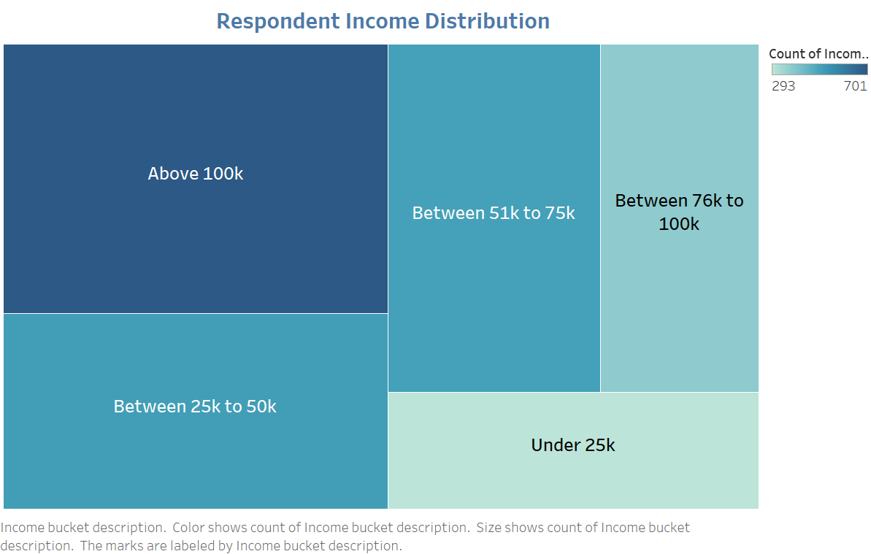

*Figure 4: Income distribution by respondents (Tableau)*

Ethnicity of Respondents

Figure 5 indicates the ethnicity of the respondents -- the majority being Caucasian, followed by Hispanic and African American. This distribution is also found in the Young Professionals demographic, as seen in Figure 6.

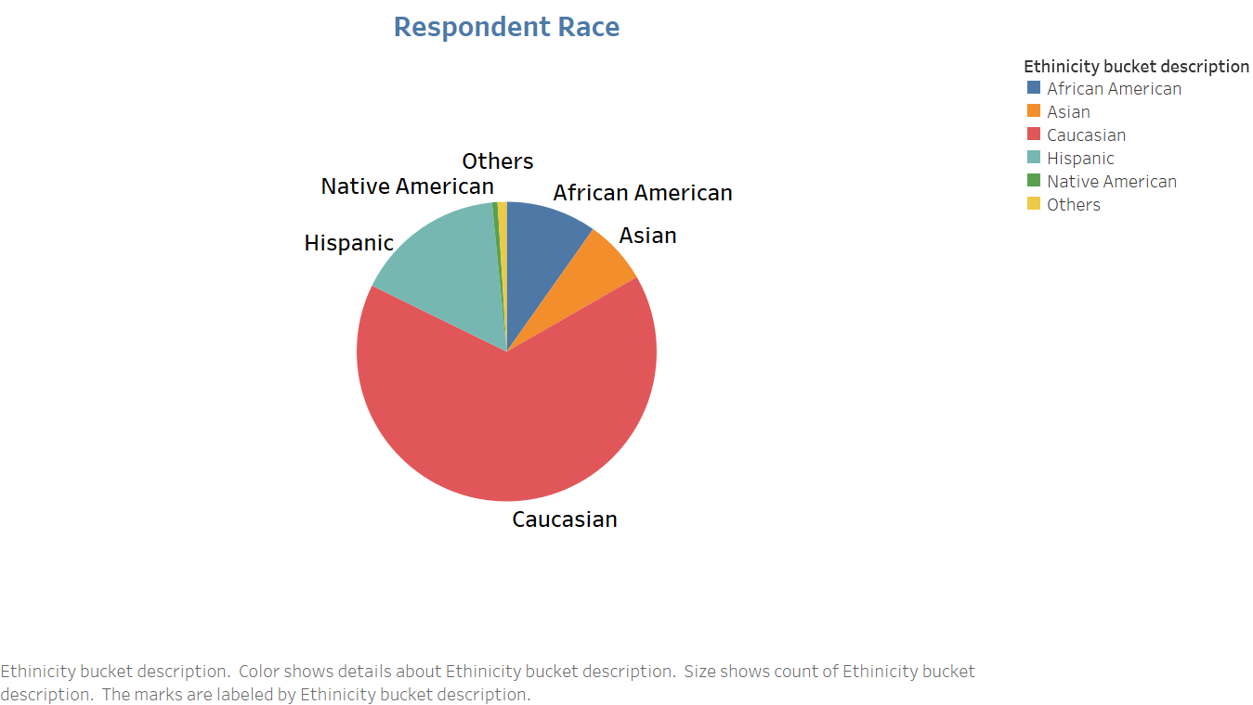

*Figure 5: Ethnicity of respondents (Tableau)*

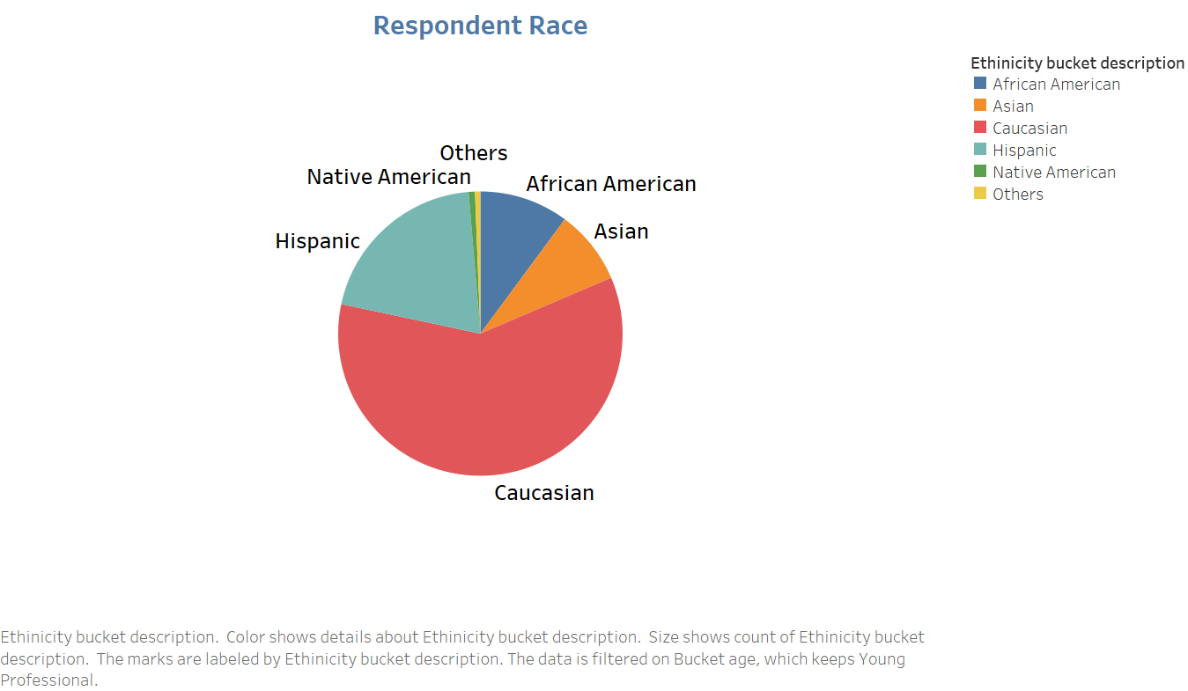

*Figure 6: Ethnicity of Young Professional respondents (Tableau)*

**Conclusions**

The Young Professional market will forever change how movies are viewed, but their impact is not as drastically negative as in some other industries.

Young Professionals are looking for similar amenities as other age buckets, with the movie title being of the most important factor in deciding to go to the theater or not. Additionally, comfort and cleanliness of the theater itself are of primary importance for Young Professionals (as it is with almost all age buckets).

Where the largest insight in the analysis is gained, is the way Young Professionals experience movies. Young Professionals tend to experience movies in a manner different then generations before. All of these insights will be outlined in further detail in the analysis section, but they provide an opportunity for Cinemark to differentiate themselves as the key destination for Young Professional movie goers.

# Problem Statement

With the changing landscape of the video entertainment industry, what are the attributes that appeal most the Young Professional’s demographic?

This analysis will evaluate the growing number of options for Young Professionals, and how this demographic desires to spend their discretionary income on entertainment. The analysis will attempt to determine the following:

* Why Young Professionals select a movie theater over other forms of video content entertainment
* What amenities are most preferred within Cinemark Theaters, to encourage Young Professionals to pick Cinemark over competitors.
* Factors related to why Young Professionals select a particular movie
* What amenities are most important during the movie-watching experience

# Industry Overview

## **Movie Industry**

### Opportunities/Threats (External)

The movie entertainment industry is currently in a state of decline. Summer 2017 movie ticket sales in North America, traditionally a booming period of box office hits, “failed to top $4 billion in a summer for the first time since 2006.” (Fortune, 2017) There are currently numerous threats to movie industry players, both from a direct competitor standpoint, as well as from comparable industries competing for consumers’ disposable income.

Threats

External products outside the movie theater industry offer comparable entertainment experiences at competitive prices. These products are split into three broad buckets:

1. PODV (Personal on demand video) – streaming services such as Netflix, Amazon Prime, Hulu, and others.
   1. These firms both create their own content, as well as stock other produced content on their platforms. Customers are able to access and play the content at their leisure (generally advertisement-free) for a recurring monthly fee.
2. Live/Recorded Television – Cable and Satellite providers
   1. These firms provide live (and some on-demand and/or recording capabilities) channel packages that customers are usually locked into via lengthy contracts with specific stipulations. Traditionally, consumers have been limited in their channel package options, generally limited to a few packages as determined by the provider.
3. Single view on-demand (pay-per-view, on-demand movies) – iTunes, Amazon, etc.
   1. These platforms offer the ability to watch a single movie for a one-time fee. Customers are able to purchase and watch content through personal tech devices.

Traditionally, the titles offered by movie theaters compared to the above competitors differ. Movie theaters have the first mover advantage on large, crowd-pleasing films by making deals with various film studios. As the time gap between in-theater and online content availability becomes shorter and shorter, consumers are able to access films at home sooner, and do not need to go to the theater to watch newly-released films.

Additionally, movie producers are finding other venues to sell films to shortly after their release. For example, the airline industry; it is likely frequent flyers will visit movie theaters less if they have already seen a film en route.

Opportunities

There are numerous opportunities to make the in-theater experience appealing, through a combination of theater amenities, film offerings, and food and beverage experiences. These offerings allow consumers to see a movie theater as more of a “full evening” experience in one place for a shorter amount of travel time – therefore, they may be more willing to go out for entertainment instead of staying in.

New partnership opportunities could also work as a competitive advantage. Movie theaters can partner with content creators and film studios to provide exclusive video content, such as mini film series or movie viewings that aren’t available through other platforms or competitors. The rise of “binge” viewing could extend to an opportunity where a series could be released through a movie theater earlier than at home platforms.

Theaters also have an opportunity to offer special “experience” evenings for particular movies. These could be “watch parties,” “fan events,” or other offerings that focus on the social aspect of the film and encourage consumers to interact with the theater in different ways then traditionally done.

### Cinemark (and sub brands) vs Top tier competitors

The domestic movie theater industry is made up of numerous players, but dominated by a set of three firms. The 3 firms make up over half of the total market share available domestically.

All three competitors offer the same product and experiences, so threats and opportunities extend across the three firms.

## **Analysis**

### 1) Movie Theaters and PODV Amongst Customers

The survey data starts by looking at how often individuals are visiting any movie theater (not only a Cinemark location). As Figure 7 outlines below, approximately 25% of the survey respondents have visited a movie theater in the last three months. The other 75% have visited a movie theater within the last year.

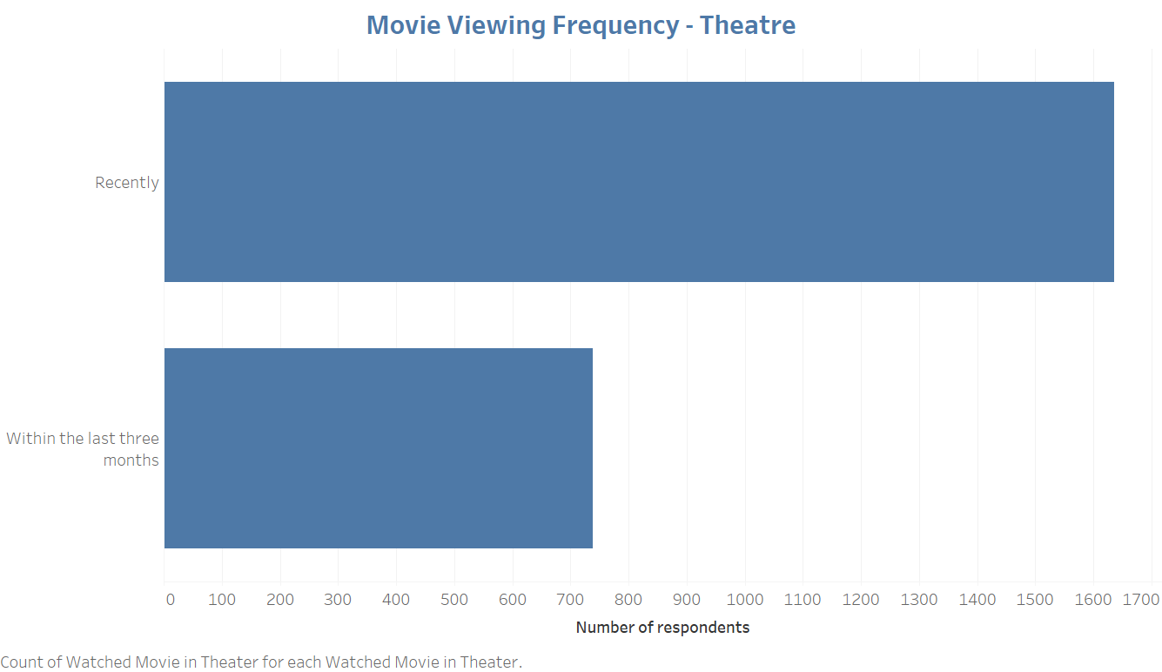

*Figure 7: Frequency of movie theater visits by survey respondents (Tableau)*

In Figure 8, movie viewing frequency is further segmented by age demographic. It quickly becomes evident that Young Professionals are the largest and key drivers of theater traffic. This is a strong indicator that this demographic should be a top focus area of any business strategy.

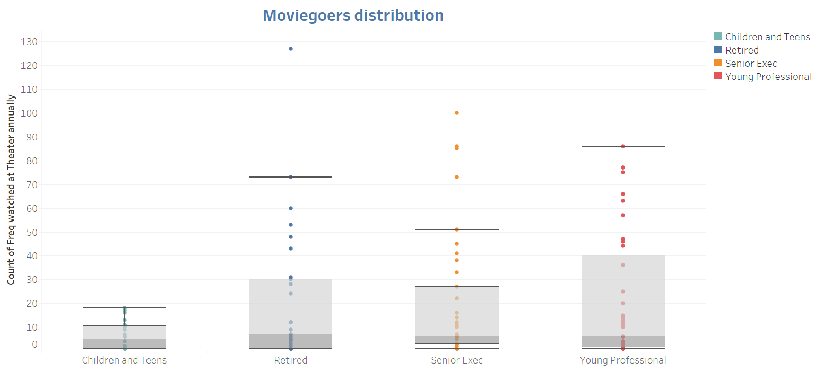

*Figure 8: Movie theater visits by age bucket (Tableau)*

The data was then analyzed to study, of the movie theater visitors, how many are also subscribed to a PODV service (such as Netflix, Amazon Prime, etc.). The analysis reveals that about 4/5 of survey respondents goers also subscribe to a PODV service and therefore become the market we focus on.

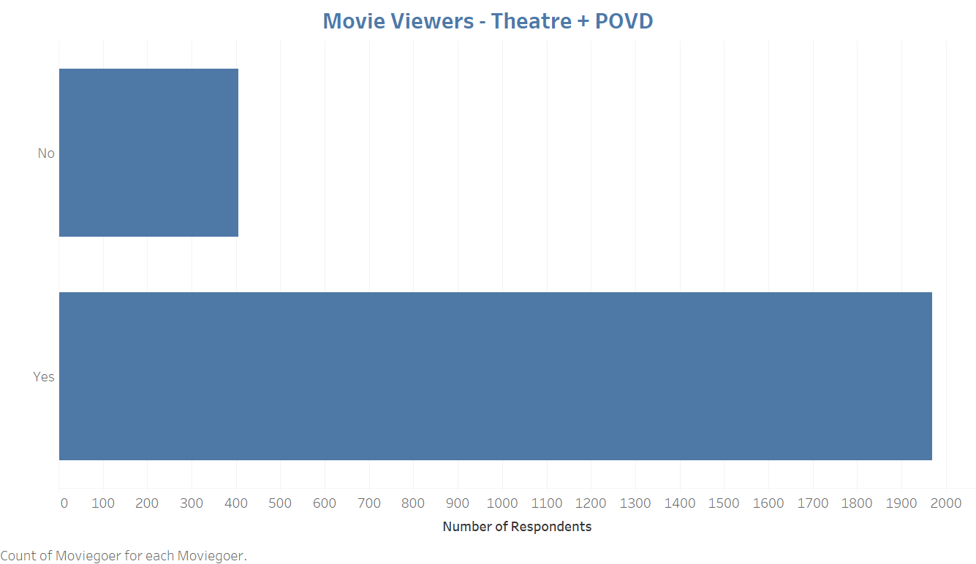

*Figure 9: Number of respondents who attend a theater and subscribe to a PODV (Tableau)*

Figure 10 notes, of those customers who subscribe to a PODV service, how often they use a movie theater as a medium to view their entertainment. As the data shows, over 70% of surveyed respondents are only visiting theaters *occasionally* or *rarely*. Cinemark should evaluate these customers' preferences to understand what amenities and services they can provide, and convert them *frequent* movie theater visitors.

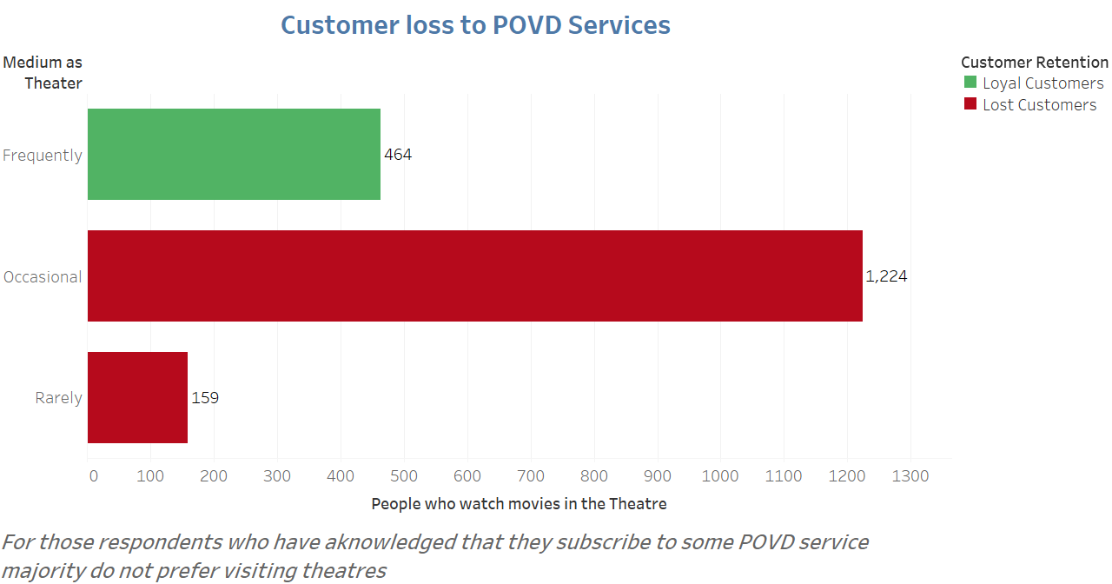

*Figure 10: Of PODV subscribers, how often respondents watch a movie in theaters (Tableau)*

Additionally, there is a target market of customers who do not subscribe to a PODV service, but still *rarely* or *occasionally* visit a movie theater; this view is outlined below in figure 11. Since these customers are not PODV users, Cinemark does not compete with those services directly, but should still consider how to convert these customers from non-movie theater goers to movie theater goers.

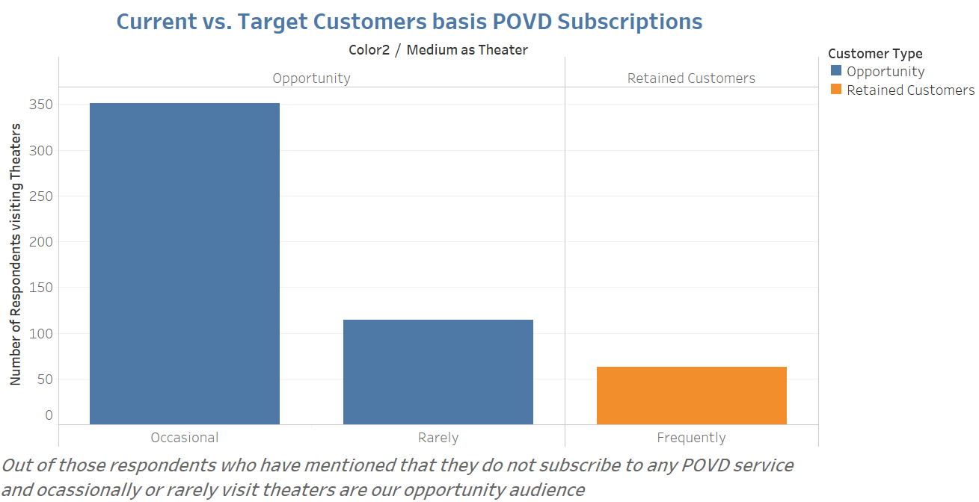

*Figure 11: Of the non-PODV users, how often do they visit the theater (Tableau)*

Figure 12 outlines which services PODV users identify with according to demographic. Not surprisingly, streaming service Netflix is the clear leader amongst all age groups, with Amazon Prime a distant second. The subscriber view by platform also quickly identifies that Young Professionals (our focus market for this analysis) are the leading consumers of PODV, and therefore greatly impact movie theater traffic in that demographic.

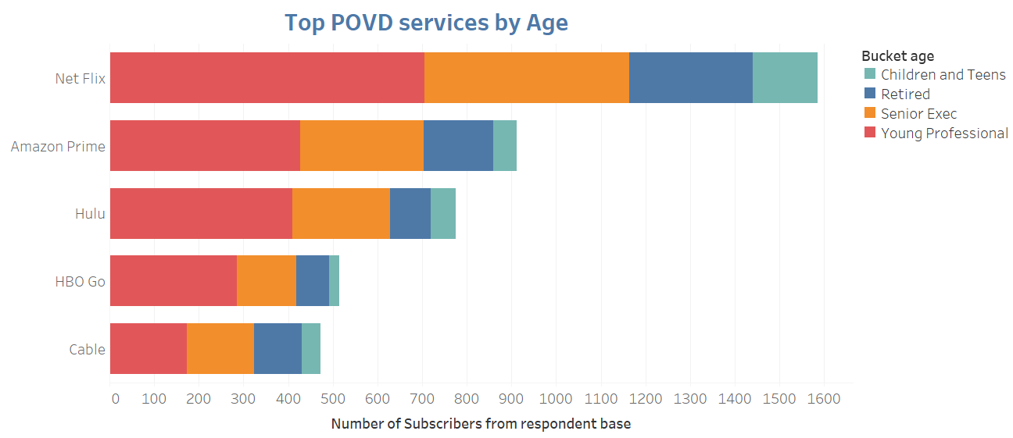

*Figure 12: Subscribers to PODV by age bucket (Tableau)*

The PODV-focused analysis indicates that even though individuals are still visiting movie theaters, they are likely to have some sort of PODV service at home that decreases the amount of time they could be spending at the theater.

By cross-sectioning PODV subscribers and theater visit frequency, it is apparent where the opportunity for attracting new customers to the movie theater lies. Also indicated is the fact that Young Professionals are the leading consumers of PODV, and in many ways one of the leading reasons for the changing landscape of the movie entertainment industry.

### 2) Cinemark Visit and Loyalty Analysis

The next section of our analysis moves on to look at how many survey respondents visit Cinemark Theaters. These respondents are classified as “loyalists” and then compared to other, competitor loyalists.

As figure 13 shows, just under 2/5 of respondents identify as *frequent* or *light* visitors of Cinemark Theaters – 3/5 of survey respondents are, therefore, Cinemark non-visitors. These visitors are likely mostly frequenting one of the other two top firms in the industry.

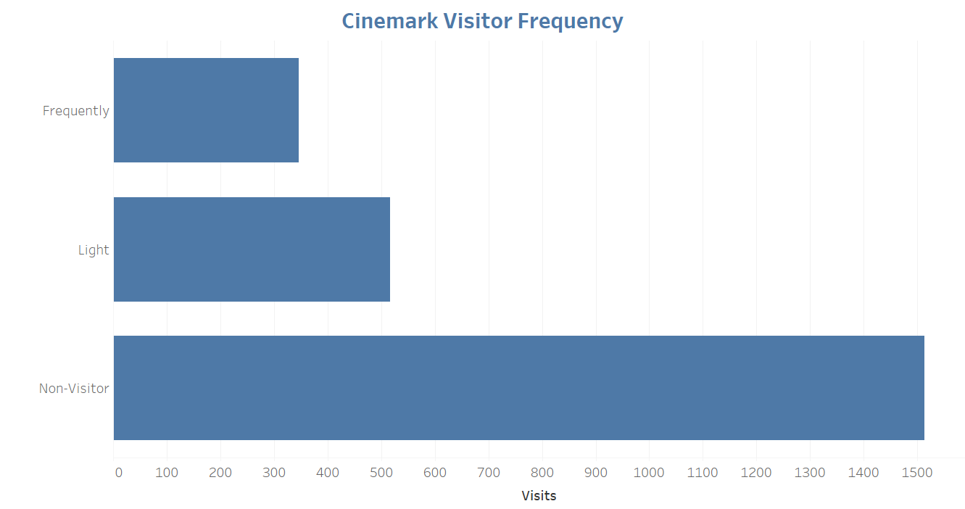

*Figure 13: Visitors to Cinemark theaters (Tableau)*

Further analysis is done among the identified Cinemark visitors to identify trends (*constant*, *decreasing* or *increasing*) with Cinemark location visits. Within the *frequent* bucket (about 2/5 of the previously identified *frequent* and *light* Cinemark visitors), the trends are promising; the largest group of visitors are classified as *constant*; with 3 times as many respondents saying they are increasing their visits when compared with respondents decreasing their visits.

For the *light* Cinemark visitors, an even larger portion identifies as *constant* visitors, but a very comparable number of both increasing and decreasing. This isn’t that surprising, as it would make sense as a survey respondent to identify as “light” when decreasing their amount Cinemark theater visits.

Overall, the trending shows positive movements with a stable, constant base and a good portion of increasing patrons (particularly in the *frequent* bucket).

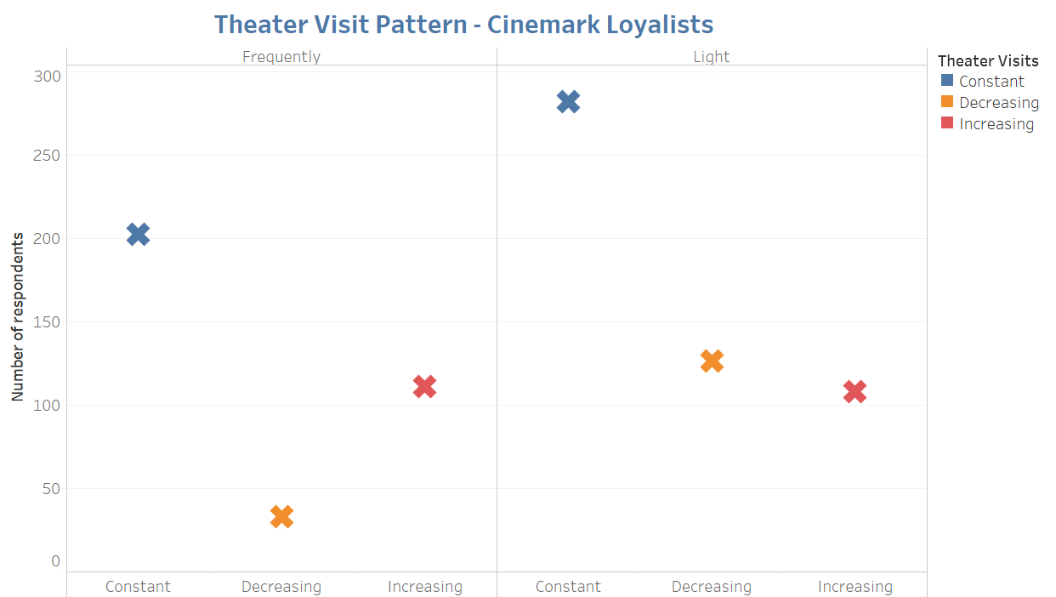

*Figure 14: Changes in frequent and light Cinemark visitors (Tableau)*

We then dive into the PODV patterns for the Cinemark loyalists (*frequent* and *light*). It is quickly noted that in this case, PODV usage is constant or increasing in nature for all Cinemark loyalists.

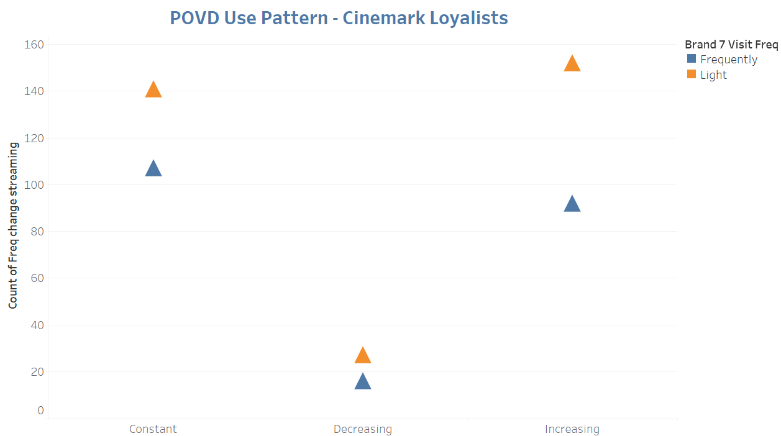

*Figure 15: Of the frequent and light visitors, their PODV use patterns (Tableau)*

In terms of loyalty programs, Cinemark Connections (a free, membership based program that offers points on every movie ticket and concession purchase, which can be exchanged for movie prizes and exclusive content) is the newest and third largest of the mentioned brands. The loyalty program is less than half the size of the largest brand (17), and about 2/3 the size of brand 2. More than likely, these brands are the other two top competitors in the industry.

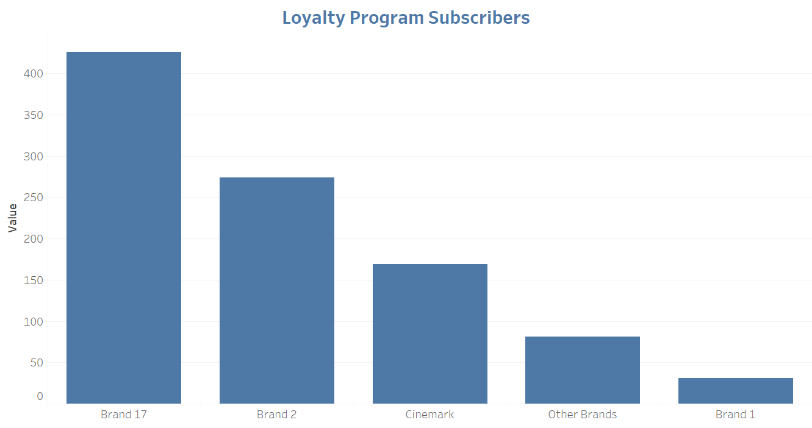

*Figure 16: Loyalists across brands (Tableau)*

For Cinemark, the loyalists bucket is sizeable and showing positive patterns. In general, Cinemark loyalists are either constant in the number of, or increasing the amount of visits. Additionally, these individuals are showing similar patterns with their PODV habits, which could have an impact on theater visits.

### 3) Decision Order and Desired Attributes

Once a consumer has made the decision to attend a movie at a movie theater, 3 different attributes were identified and ranked related to decision order. Across all age groups, it is evident that selecting a movie to watch first is the top most priority for most people. This clearly indicates that consumers are more concerned about the movie they are going to watch, rather than the showtime or theater. This means that above all else, the titles being offered by Cinemark are the most important aspect to the movie theater experience across all demographics.

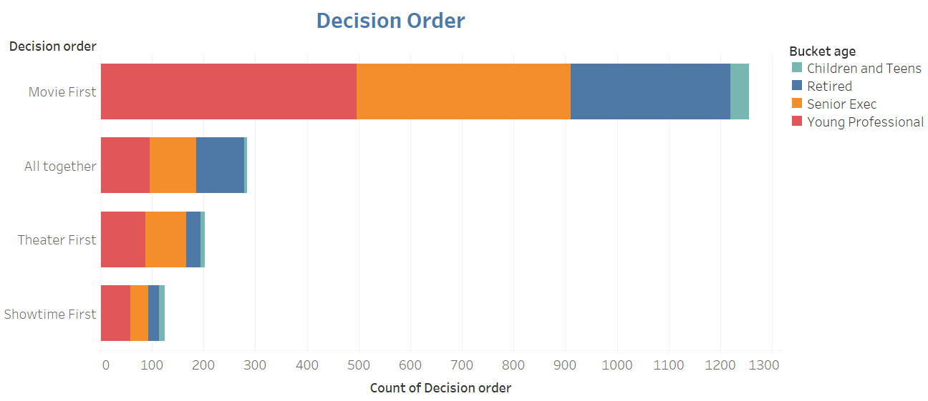

*Figure 17: Decision order by age bucket (Tableau)*

When evaluating customer preferences, the survey divided desired attributes across 4 broad categories: movie, food and beverage, sound and quality, and safety and value. Within these four categories, other attributes were identified and ranked by importance to the survey respondent.

The movie category was divided into three attributes: *desired movie*, *multiple showtimes*, and *multiple movie options*. As previously indicated, decision order dictates that the movie playing is the key driver in making a decision. This attribute comparison further solidifies that point, as *desired movie* is the most highly correlated to extremely important. It can be concluded that this is the most important movie-specific attribute, according to survey respondents.

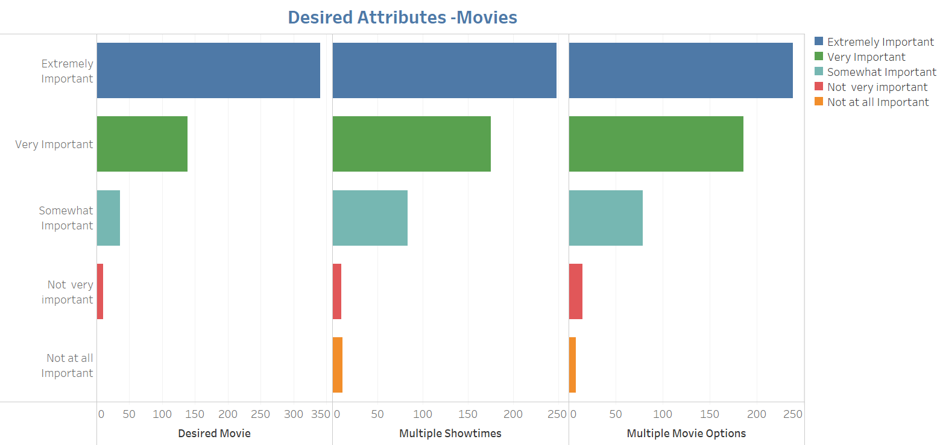

*Figure 18: Importance of desired movie attributes (Tableau)*

The food and beverage category focused on *free refills*, *food freshness*, and *cleanliness*.

The survey results point to the importance of cleanliness of the theater for survey respondents – this is the mostly closely aligned with *extremely importan*t in the results. Additionally, customers are expecting free refills and consider that to be one of the important factors for choosing a theater. Since free refills seem to be a customer favorite, Cinemark should consider pushing this offering, which may help in customer retention and increase of sales.

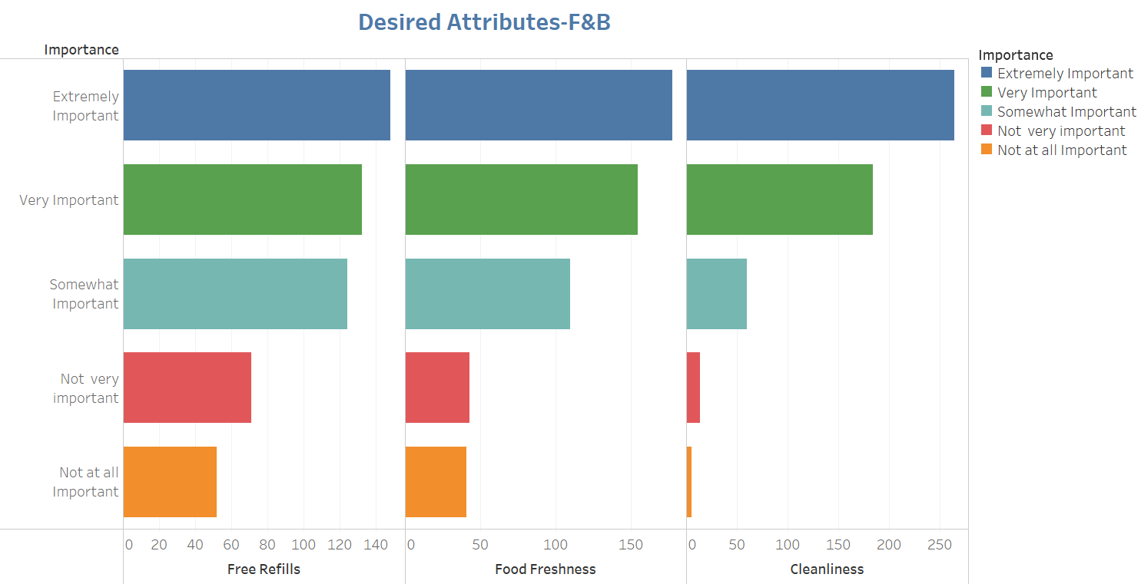

*Figure 19: Importance of desired food and beverage attributes (Tableau)*

The comfort and quality category focused on *screen quality*, *comfort*, *sound* and *DND (or Do Not Disturb) policy*.

One undeniable fact as to why customers watch movies in theaters is to experience the sort of high screen and sound quality that cannot be experienced at home. It is very difficult to distinguish your brand from competitors based on these attributes, because each top competitor has a their own, similar version of quality screen and sound system. One major factor where it is possible to distinguish Cinemark Theaters from others is the *overall comfort* they provide to the customers.

Providing ample leg space and having recliners will have a positive impact on customers retention, as *comfort* is one of the most highly identified with attributes.

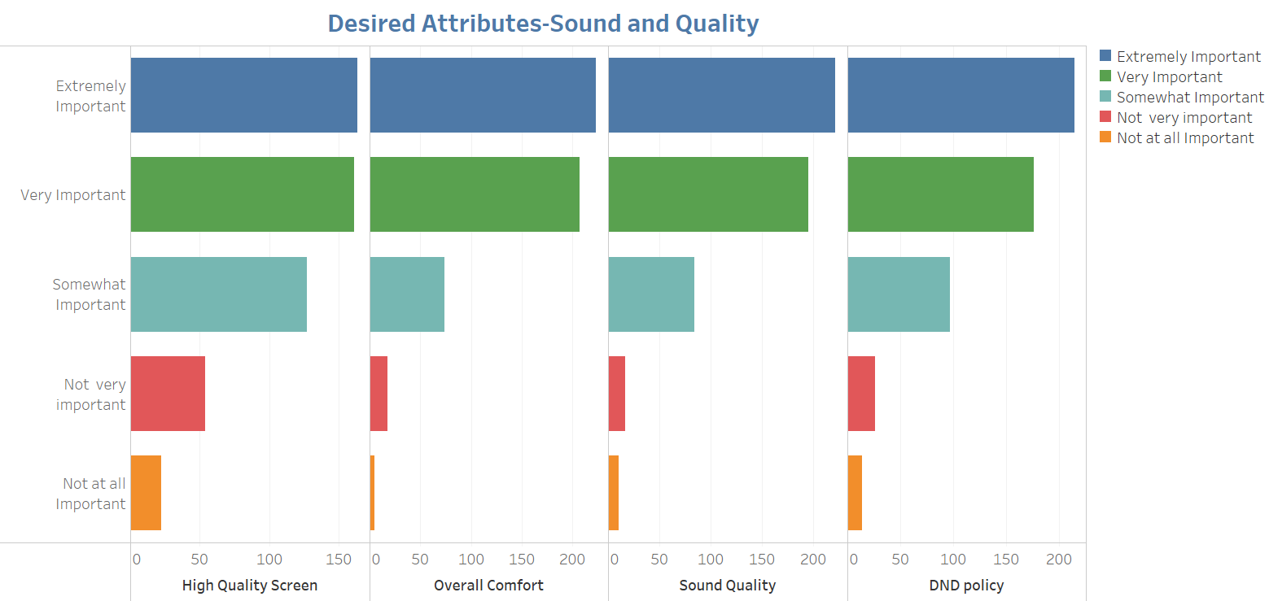

*Figure 20: Importance of comfort and quality attributes (Tableau)*

The safety and value category focused on *value for money*, *safety* both outside and inside the theater, and how *family friendly* the movie theater is.

Naturally, respondents are looking for a safe and valuable environment to view their movie in. Inside and outside safety were considered the most important of the four attributes, with value and family friendliness being important to almost all respondents as well. Value for money is a hard attribute to quantify, as value has many different meanings to many different customers.

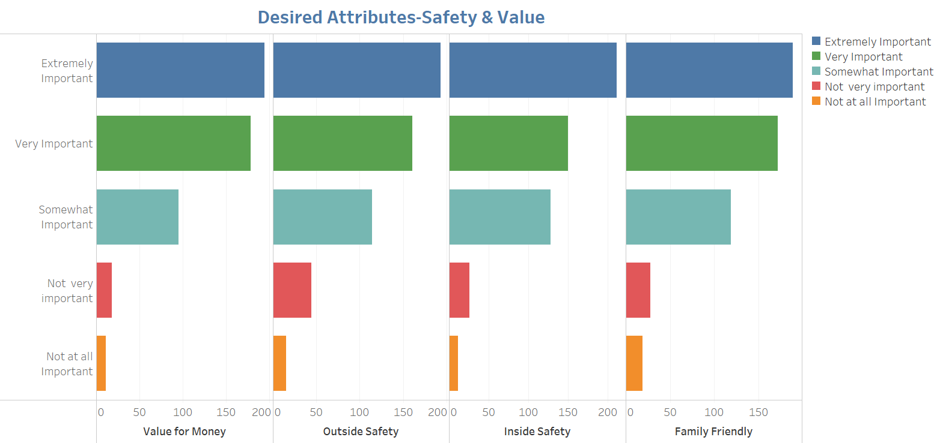

*Figure 21: Importance of safety and value attributes (Tableau)*

After evaluating each of the attribute categories in turn, decision order immediately points to the importance of having the movies that customers want to view available. Digging deeper into the desired attributes, movie offerings is still the key decision making driver for survey respondents; additionally, survey respondents are looking for quality, value and comfort in their movie viewing experience.

### 4) Theater Experience Importance

The survey results indicate that majority of people book tickets right before the show, across all demographics. For the Young Professional segment, there is a higher proportion of individuals who book in advance when compared to the other demographics. This indicates Cinemark should continue to encourage advance ticket purchasing, and perhaps offer some consumer benefit for doing so.

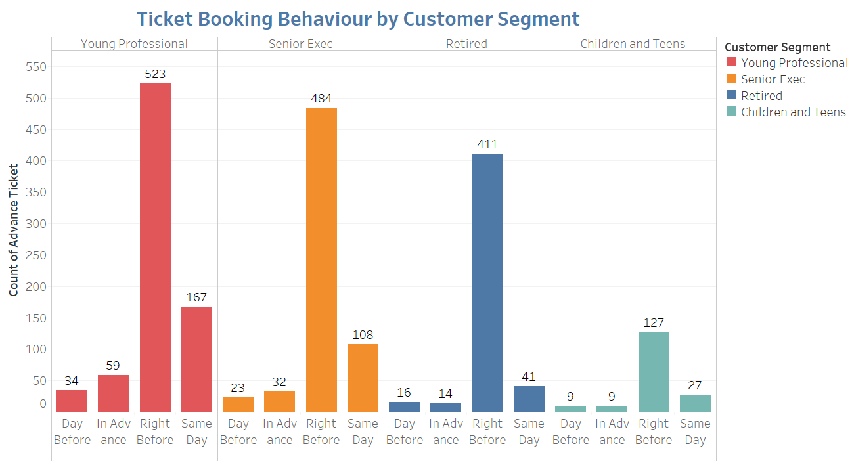

*Figure 22: Ticket booking behavior by age bucket attributes (Tableau)*

From the survey, it is clearly noted that customers prefer weekend showings overall. Young Professionals are just as likely to attend weekday evening showings as weekday noon showings. There is an opportunity to offer some sort of weekday evening discount or BOGO ticket offer, which would appeal to Young Professionals who have the weekday flexibility that other demographics may not have.

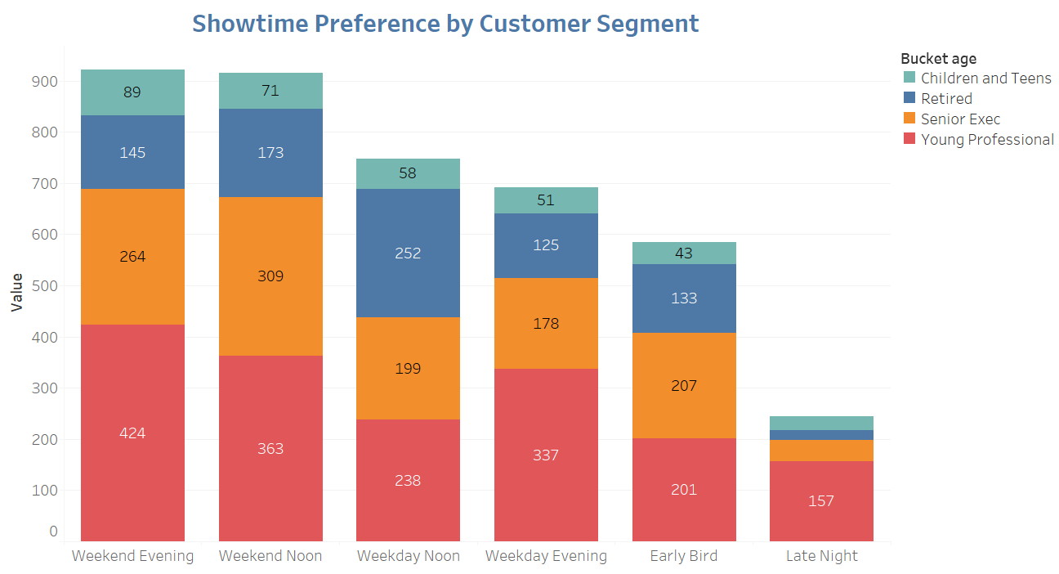

*Figure 23: Showtime preferences for survey respondents attributes (Tableau)*

As figure 23 demonstrates, it is apparent that customers do not prefer to travel long distances to watch a movie. The majority of customers feel that 30 minutes is the maximum time they can afford to travel to a theater to watch a movie, and no longer.

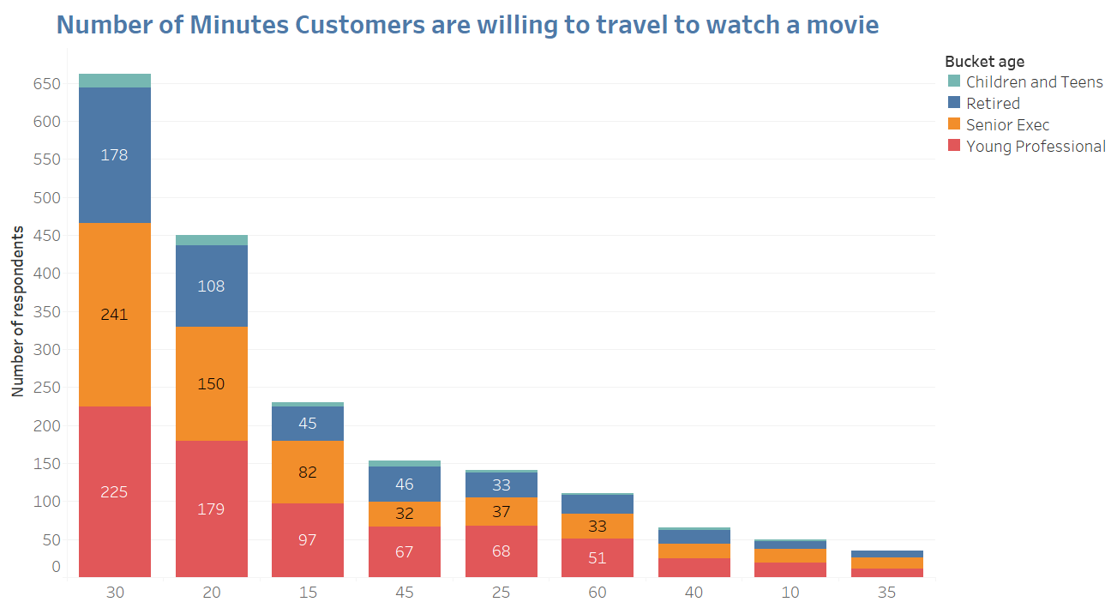

*Figure 24: Distance willing to travel to watch a movie (Tableau)*

The survey notes that most of the respondents prefer to watch a movie with their partners or family. Cinemark may consider running special promotional offers for families and spouses, which may help increased customer traffic and retention. Young Professionals in particular highly index to *partner* movie viewing. This is a prime opportunity to take advantage of some sort of “date night” movie special to continue to drive Young Professional traffic.

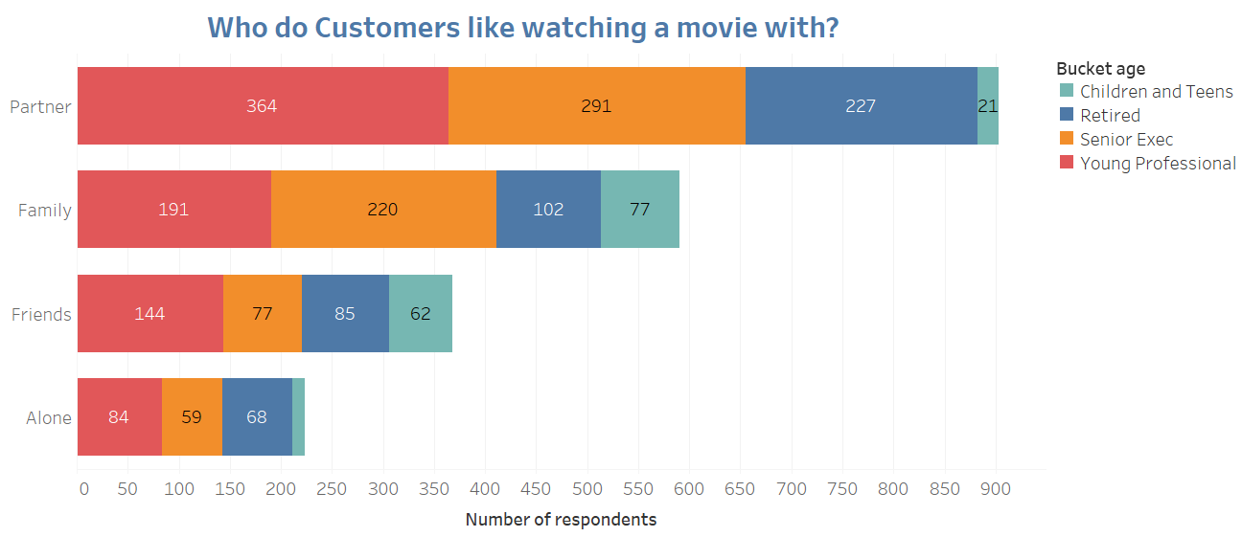

*Figure 25: Customers movie party viewing habits (Tableau)*

# Strategy

## **What amenities appeal to Young Professionals?**

Young Professionals, just like all other surveyed demographics, place movie selection above any other attribute in terms of importance (as seen in figure 17). When attending a movie, individuals start the decision-making process with the movie itself at a resounding rate. This means that having the most desirable movies by Young Professionals is of utmost importance over any other potential attribute.

Once Young Professionals have determined the move they want to see, they consider amenities in the three additional layers, each with amenities analyzed:

1. Food and Beverage

When it comes to food and beverage and in movie experience, having a clean environment is the most important attribute. A clear majority of survey respondents rated cleanliness as *extremely important* to their theater experience. They additionally rated *free refills* and *food and beverage options* as important, meaning there is additional opportunity to focus on these offerings and specifically target them towards Young Professionals.

1. Comfort and Quality

When it comes to comfort and quality, Young Professionals index similarly with most movie goers in our survey in that they are looking for high quality video and sound in a comfortable environment. For Young Professionals, comfort and cleanliness are key to their movie experience.

1. Safety and Value

For Young Professionals, value is an important aspect of their movie experience. Young Professionals generally are at a point in their life going through large financial changes, and therefore want to know they are getting value in their purchases, including entertainment.

## **How do Young Professionals experience movies?**

Young Professionals have a few ways of experiencing movies that Cinemark can take advantage of:

1. Ticket Booking Behavior

A vast majority of survey respondents across all demographics said they purchase movies immediately before the showing, but where Young Professionals differed is the higher number of advance ticket purchases. There is an opportunity to continue to exploit this advanced ticketing purchasing habits to help drive Young Professional traffic and, potentially, more predictable theater traffic.

1. Showtime Behavior

Young Professionals over-index to weekday evening shows. Where as most age groups have weekend night and weekend day as the two most likely times to visit a movie, Young Professionals list weekday evenings as their second most frequented time (after weekend evening). This is an enormous opportunity for Cinemark to drive traffic on evenings where other age buckets are not as prone to visiting the theater.

1. Who they go to the movies with

For Young Professionals, attending the movie with their partner is the most noted way to attending the movie theater. This leaves a large opportunity for Cinemark to take advantage of “date night” deals and offers such as BOGO or combos. This can be done in conjunction with the weekday evening show times to take advantage of two natural trends of this age bucket.

# Recommendations

When it comes to movie viewing and attribute importance, Cinemark does not need to focus on anything in particular to attract the Young Professional market. Rather, what is important to most survey respondents is important to most Young Professionals and the movie title rises above all else.

From an experience point of view, Young Professionals have particular ways of attending movies that can be exploited upon. The following recommendations will look to do that:

1. Expand weekday evening offers (currently, discount Tuesdays run all day Tuesday, for a flat ticket rate) – consider expanding this offering to other days of the week
2. Provide “date night” rates to attract Young Professionals and continue to drive their weekday evening behavior
3. Offer benefits for advance ticket booking to Young Professionals. Consider offering a small discount or some sort of benefit (maybe first seat choice or something of that nature).

# 

As outlined in the recommendations, they are some key strategic decisions that can be made to capture the attention of Young Professionals, and in that vein maintain the business for years to come.

What is most paramount about all this analysis, is that Young Professionals value “the experience” of the theater in ways different than ever before. Whenever Cinemark is considering options for the theater and how to attract customers, this fact must always remain center of focus.

# Appendix

## **Regression Analysis**

In an attempt to try to align attributes with likelihood of going to a movie, we did a few layers of regression analysis. This included PCA analysis and an additional weighting of random forest. The PCA Analysis was not successful from an R value perspective (little to no reliable accuracy). In the random forest weighting we were able to obtain 60% accuracy if we know the presence of certain attributes.

The ultimate issue in approaching this from that analysis is threefold:

1. There are 56 attributes making up the importance list…that is simply not manageable from Cinemark’s perspective
2. No one attribute is worth more then 3% on the importance list
3. There are many attributes that simply aren’t controllable by Cinemark (maybe indirectly influenceable at best):
   1. Customers Dating
   2. Customers on a Special Occasion
   3. Etc.

There are certainly some key learnings and takeaways that can be used from the data, but not a “concrete” model that can be used from our data set. Below is a list of the measured attributes and their “importance” in the model by percentage.



## **Uxpressia Customer Journey Map**

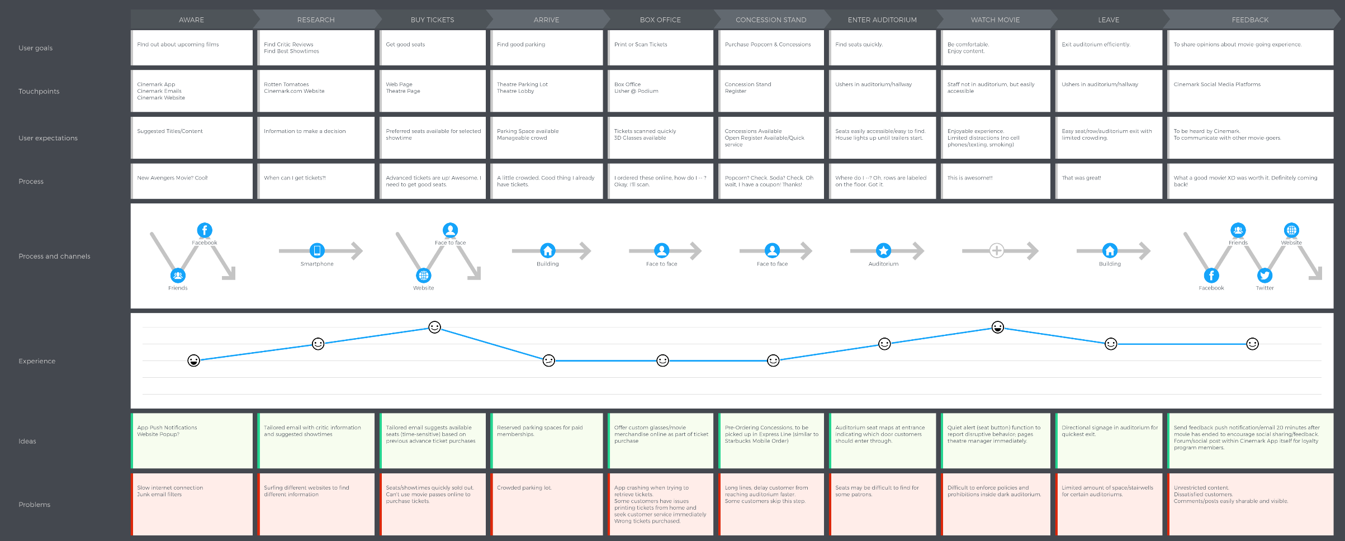

## **Uxpressia Personas**

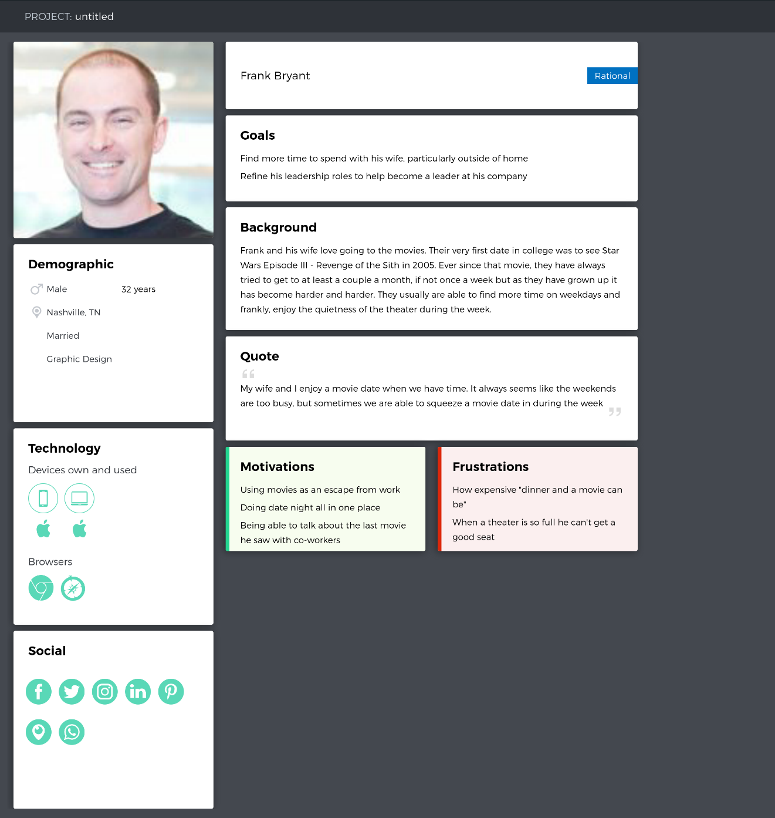 We have created two personas below to help articulate what the “Young Professionals” demographic looks like. First is Frank Bryant, a married 32-year old who enjoys the movies with his wife when he has the time. Secondly, Teresa Vega is a 22-year old student who is a movie buff. She loves to go to the movies with friends as much as possible and sometimes will even go by herself.

## 

## **Word Clouds**

We built word clouds based on the survey results. Given some of the sporadic responses to certain questions, we decided not to include in the analysis, but wanted to include here as a reference point:

**

*Word Cloud 1: How can we improve the theater experience*

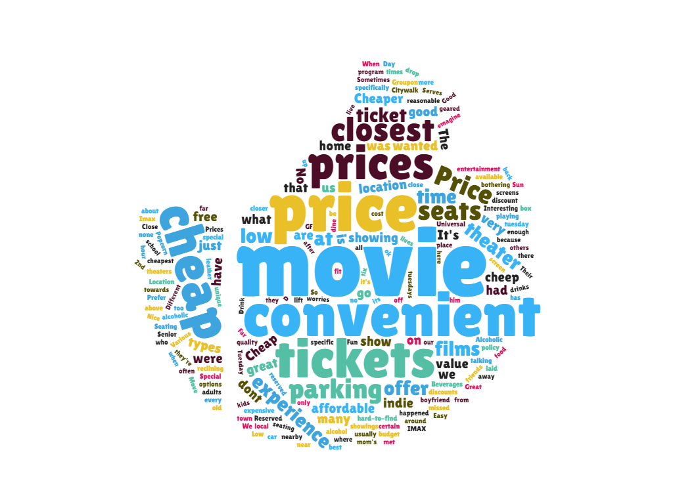

*Word Cloud 2: Reasons why you visit a theater*

**

*Word Cloud 3: What you love about the theater*

# References

Cinemark. (n.d.). *Contact Us*. Retrieved from Cinemark: https://cinemark.com/contact-us

Fortune. (2017, August 31). *Fortune*. Retrieved from Hollywood Summer Box Office Movie Stocks: http://fortune.com/2017/08/31/hollywood-summer-box-office-movie-stocks/

Wistia. (2016, July 5). *How Long Should Your Next Video Be?* Retrieved from Wistia: https://wistia.com/blog/optimal-video-length