1d). Calculating line lengths and statistics.

Step 1:- Go to Layer → Add Layer. Then add the following file to the project.

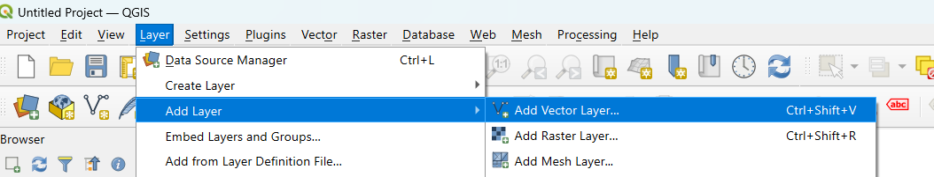

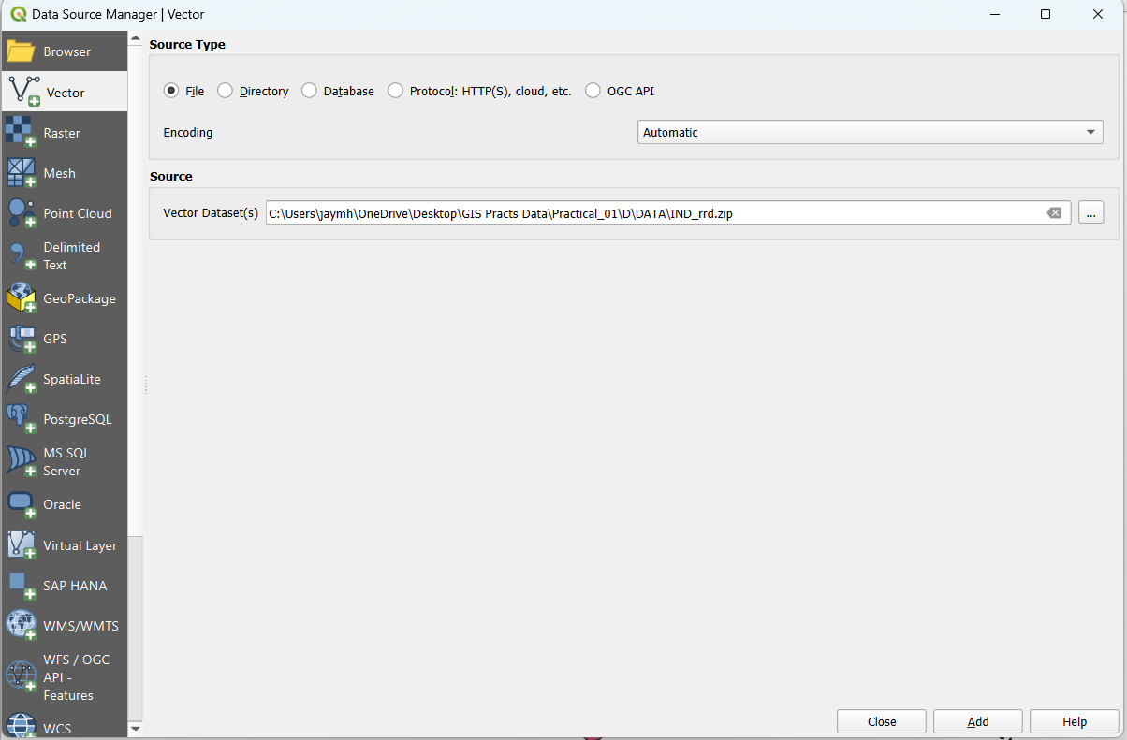

Step 2:- Do the same and also add the India Administrative Map along with India Rails shapefile.

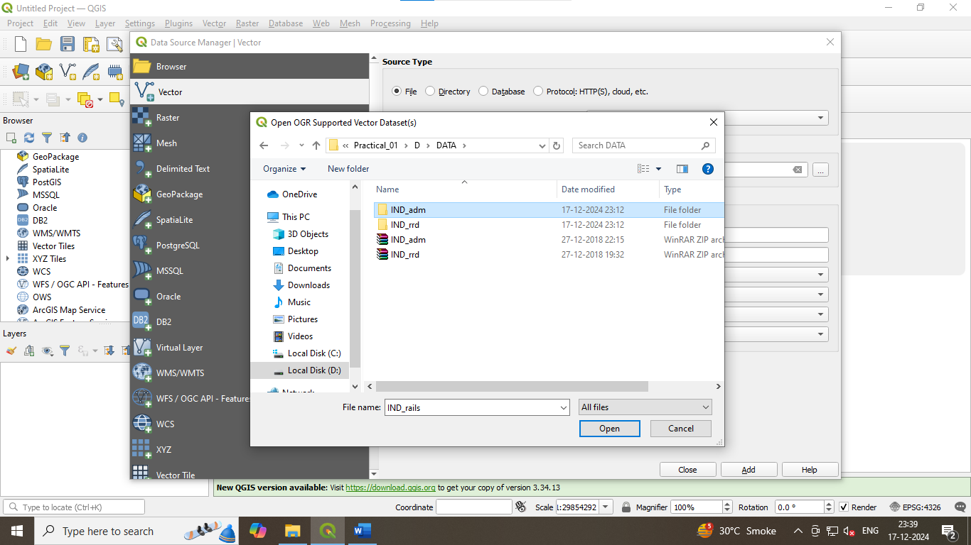
Step 3:- Right click on the Indian Rails option and select Open Attribute Table command and access the practical 1D file associated to Indian Railroad.

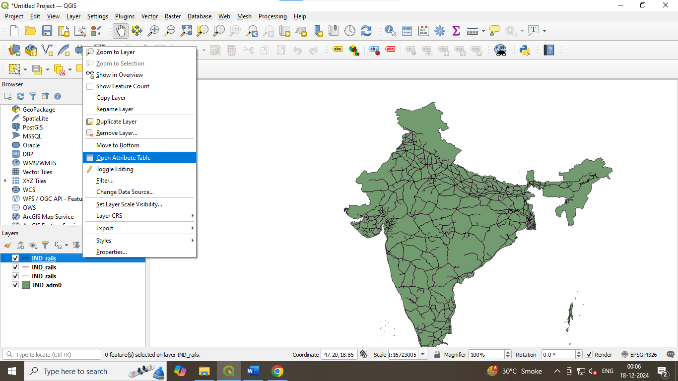

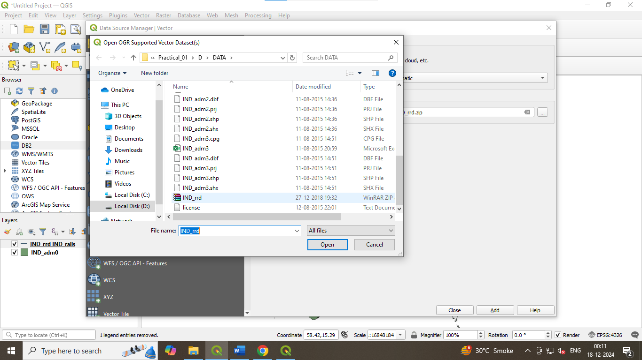

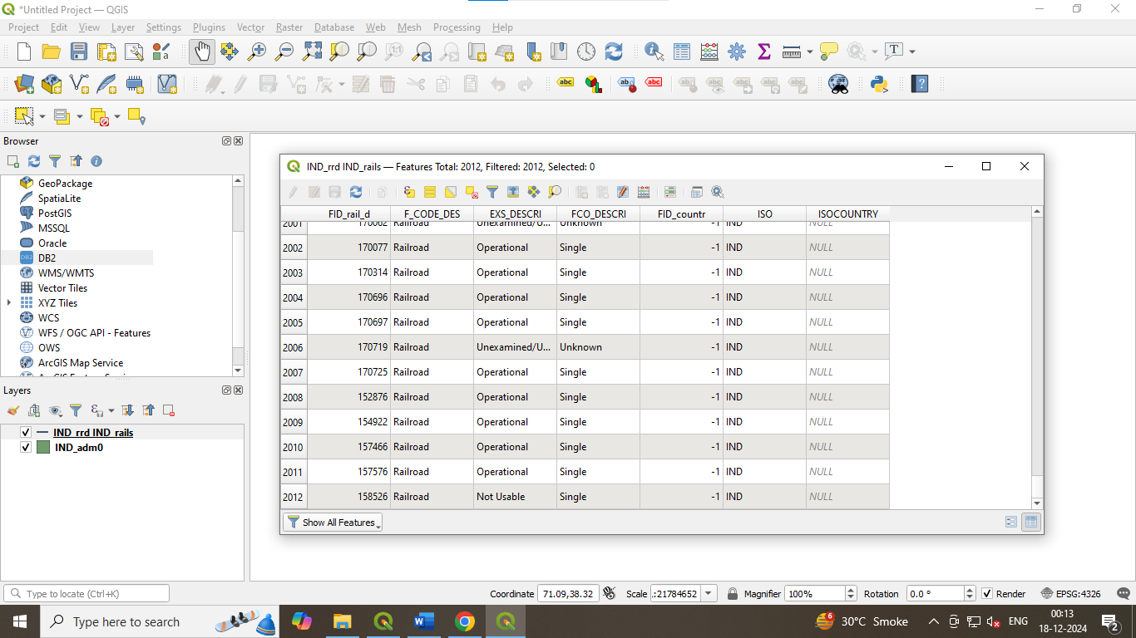

Step 4: Click on the Open Field Calculator button. Configure the output field name as "root_Len" and set the field type to Decimal Number.

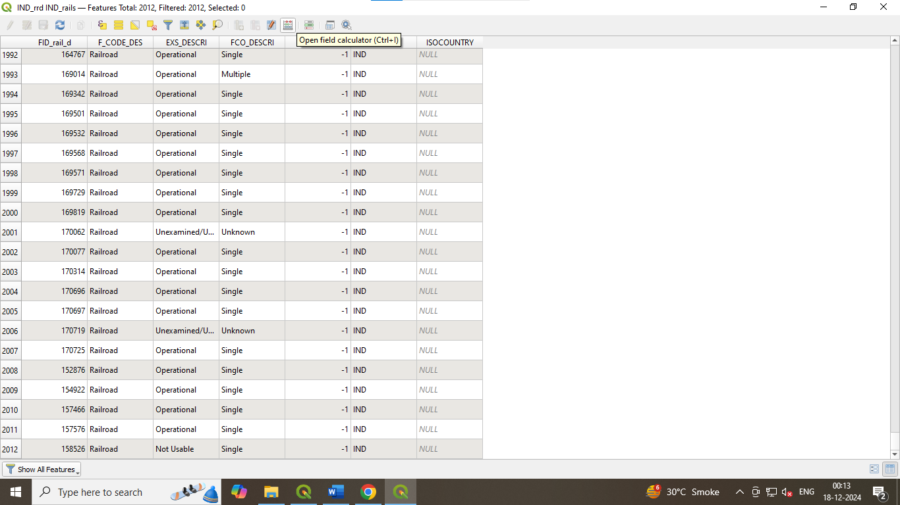

Step 5: From the Function List, search for $length or navigate to Geometry and select $length. Set the expression as:

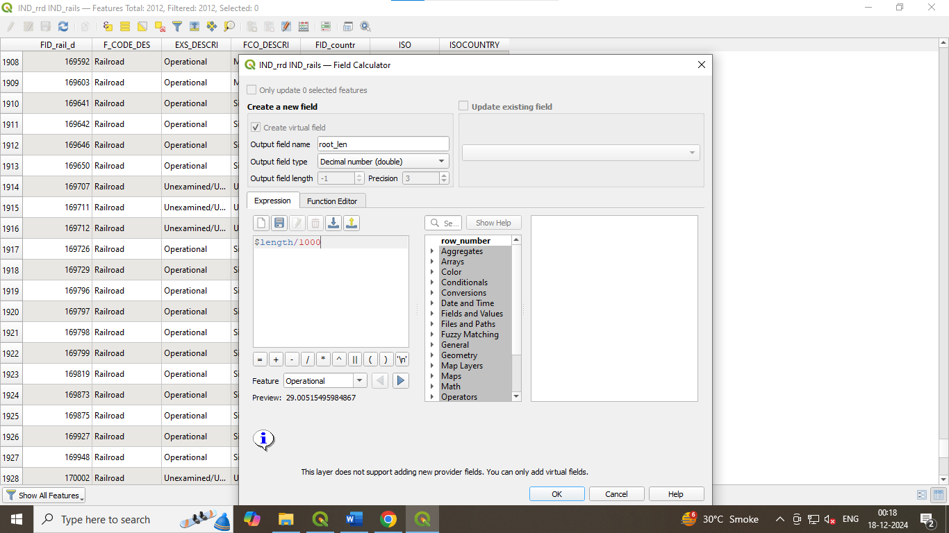

A new column has been added to the Attribute Table, displaying values that represent the length of the track in kilometers (KM).

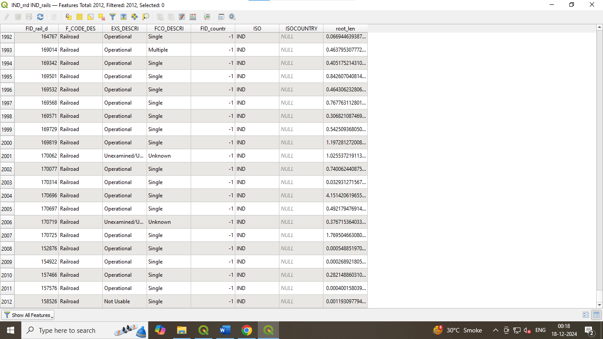
Step 6: Close the attribute table. Now, to calculate total length of railway tracks in India, we go to:
Vector → Analysis Tools → Basic Statistics for Fields. Choose the IND_rails layer as the input layer. Then, select Track_Len in the Field to Calculate Statistics On option.

