3a). Making a Map.

Step 1: Go to Project → Open → Making_A_Map.qgs

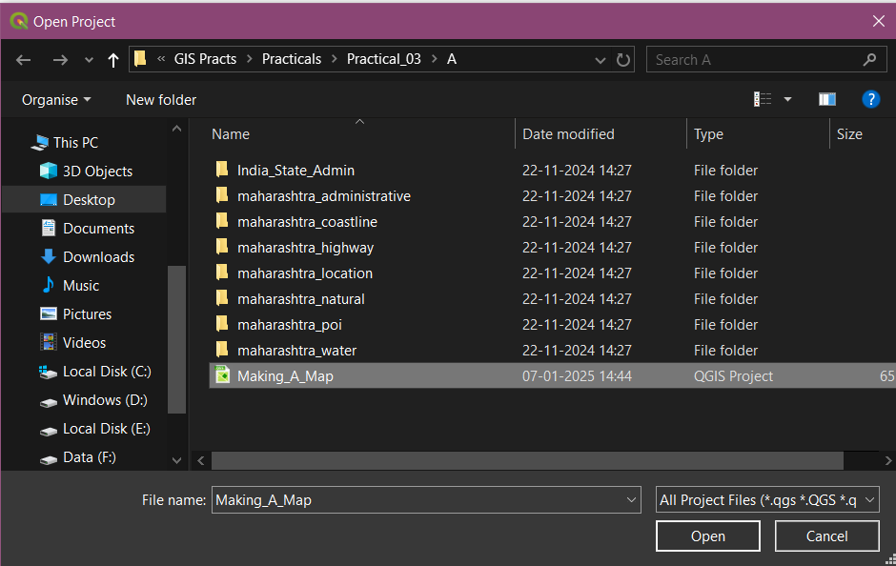

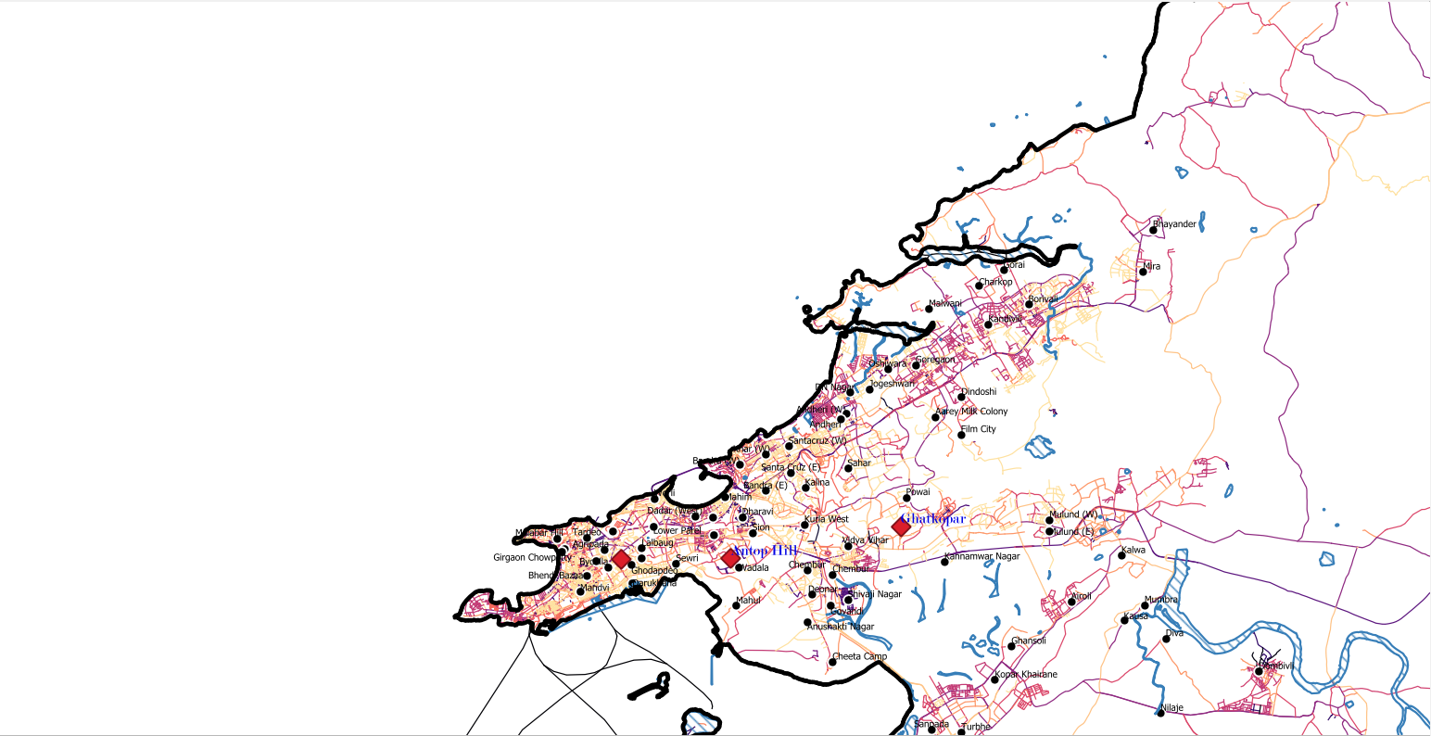

Step 2: Go to Project → New Print Layout. Then Insert a suitable title and press OK.

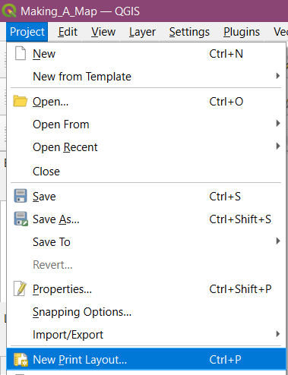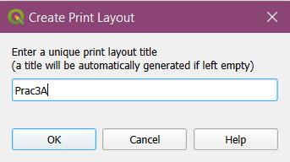

Step 3: Go to Add Item → Add Map and readjust layout to show the map, then go to Item Properties → Map1 → Layers. Check on Lock Layers and Lock Styles for Layers.

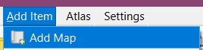

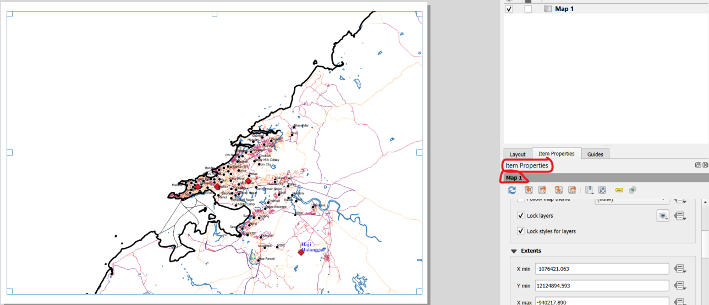
Step 4: Add another map by repeating the same process. And then go to Add Item → Add Picture → Place at appropriate location and adjust image rotation.

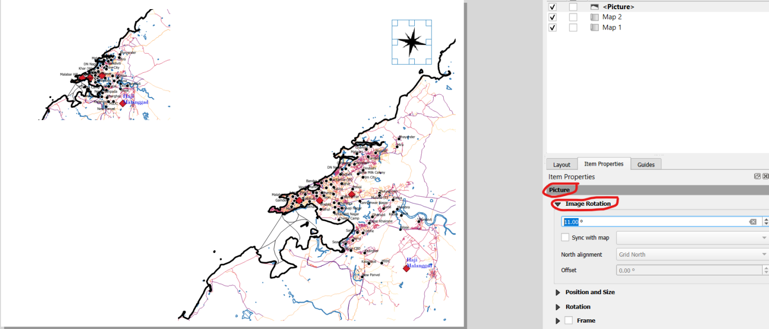

Step 5: In Item Properties → Overview → using icon add an overview. Select the checkbox Draw overview. Name the Picture object representing inset (Map1 in our case).

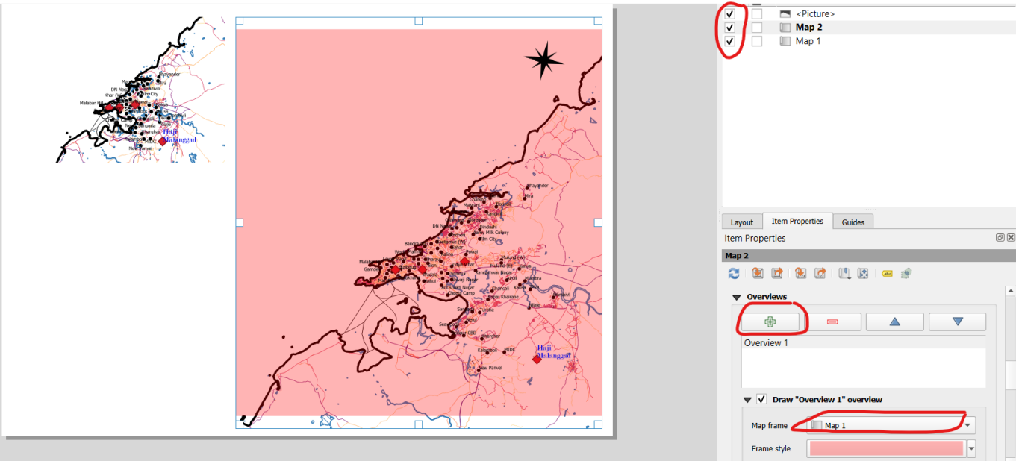

Step 6: Go to Add Item → Add Label. Then go to Item Properties and change appropriate name and font.

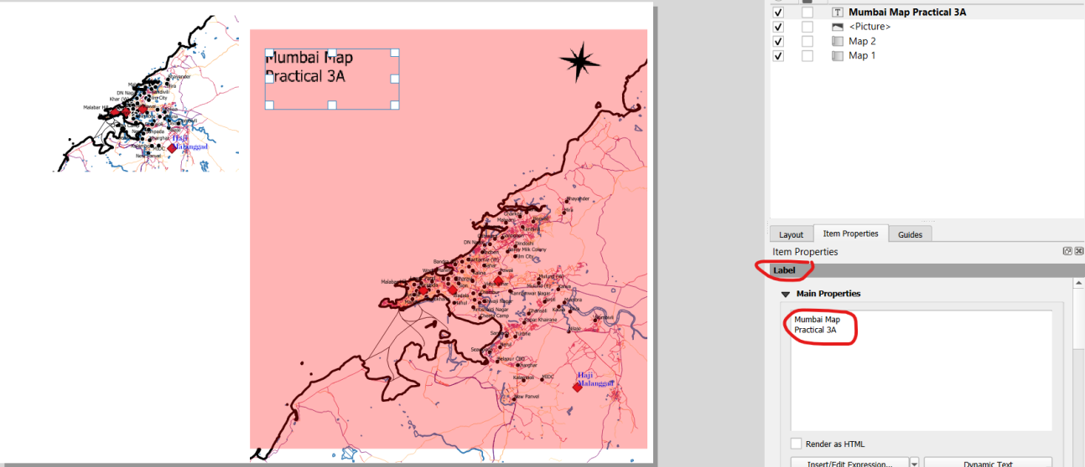

Step 7: Go to Add Item → Add Legend → Place legend indicator at appropriate location. Then go to Add Item → Add Scale Bar and put in appropriate location.
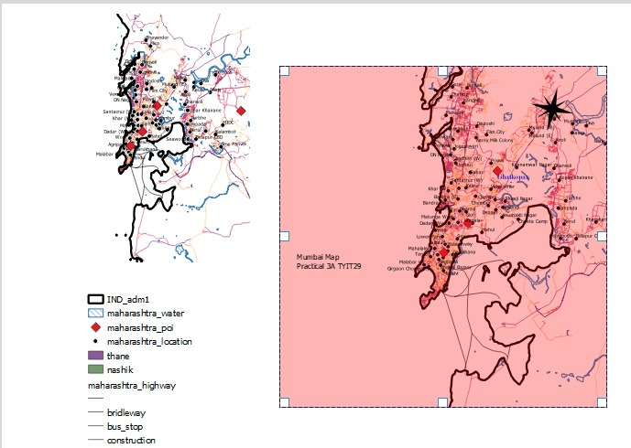


Step 8: Export the following as image and do the following resolution settings.

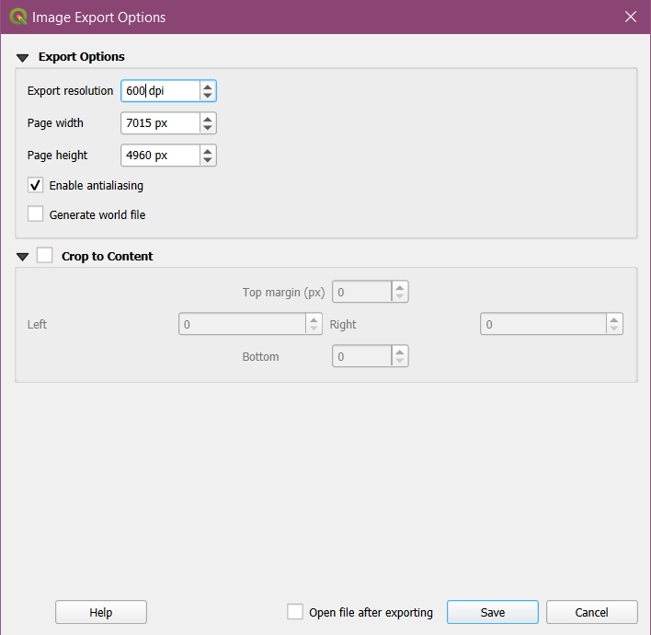



3b). Importing Spreadsheets or CSV files.

Steps: Go to Layer → Add Layer → Add Delimited Text Layer. Then select Sample.csv file from Practical 3 folder. Then click on Add. The final output is:

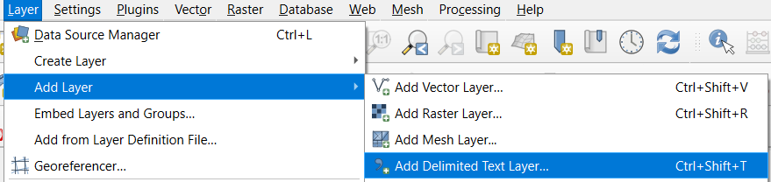

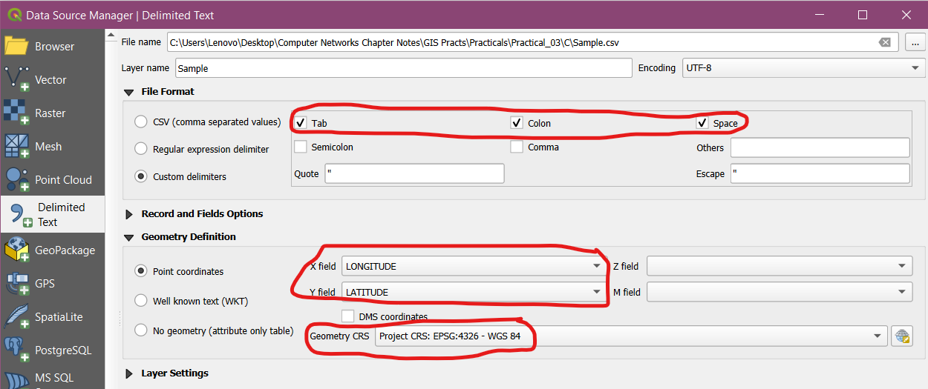

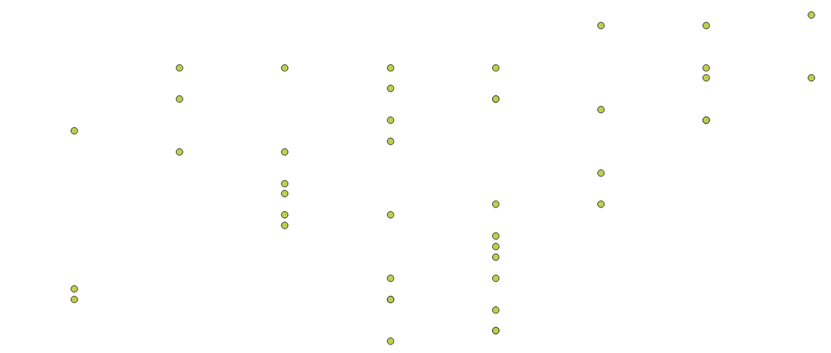

3c). Using Plugins.

Step 1: Click on Plugins → Manage and Install Plugins.

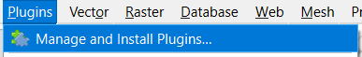

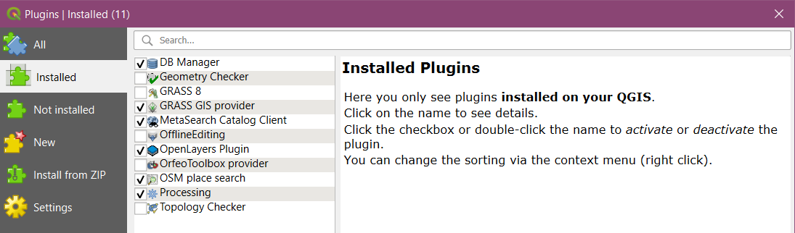

To enable a plugin, check on the checkbox next to Plugin. This will enable the plugin to use it.

External plugins are available in the QGIS Plugins Repository and need to be installed by the users before using them.

Click on Not Installed or Install from ZIP.

Once the plugin is downloaded and installed, you will see a confirmation dialog.

Click on Plugins → <<new Plugin Name>>

The plugin if marked experimental plugin can be installed from settings. Check on:

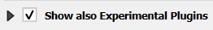 or
A  tab will be added to Plugin Manager window.

Click on plugin name and click Install.

3d). Searching and Downloading OpenStreetMap Data.

Step 1: Go to Plugins → Manage and Install Plugins → Check on Show also Experimental Plugins from Settings tab, and go to Not Installed to install “OpenLayers Plugin” and “OSM Place Search” plugins.

Step 2: Go to Web → OpenLayers Plugin → OpenStreetMap → OpenStreetMap. A world map appears on the screen.

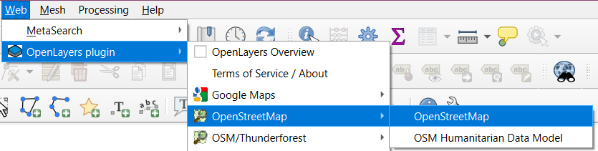

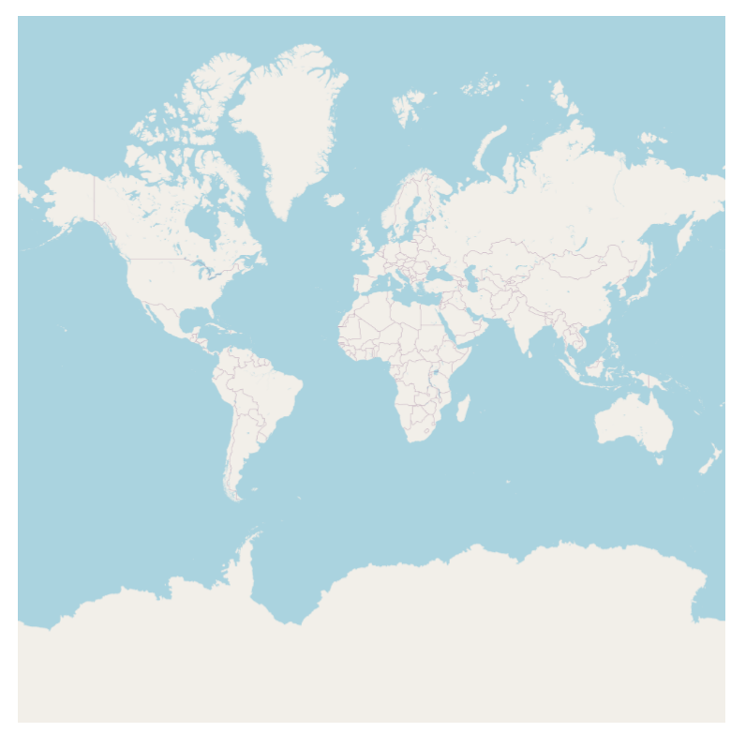

Step 3: Go to OSM Place Search tab on the bottom left and type “Mumbai University”

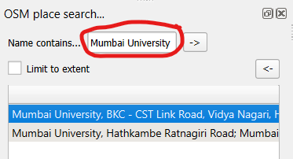

The following output is shown:

