4a). Working with attributes.

Step 1: Layer → Add Layer → Add Vector Layer → Select the populated places zip file in Practical 4 folder.

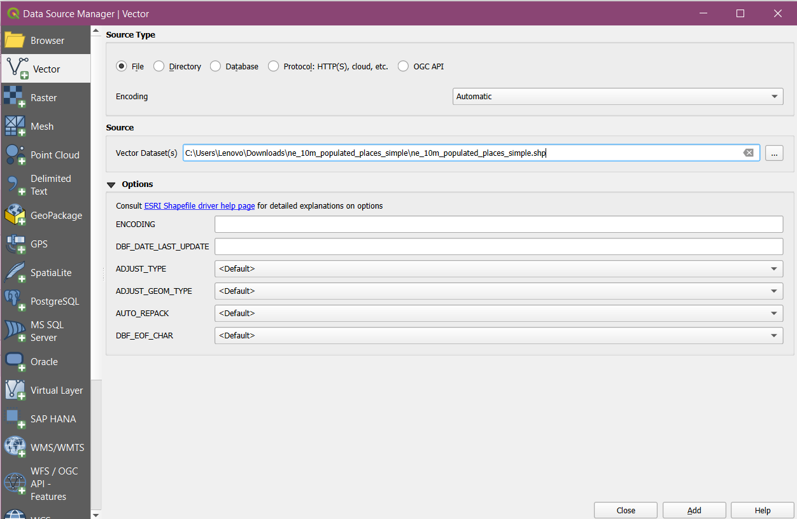

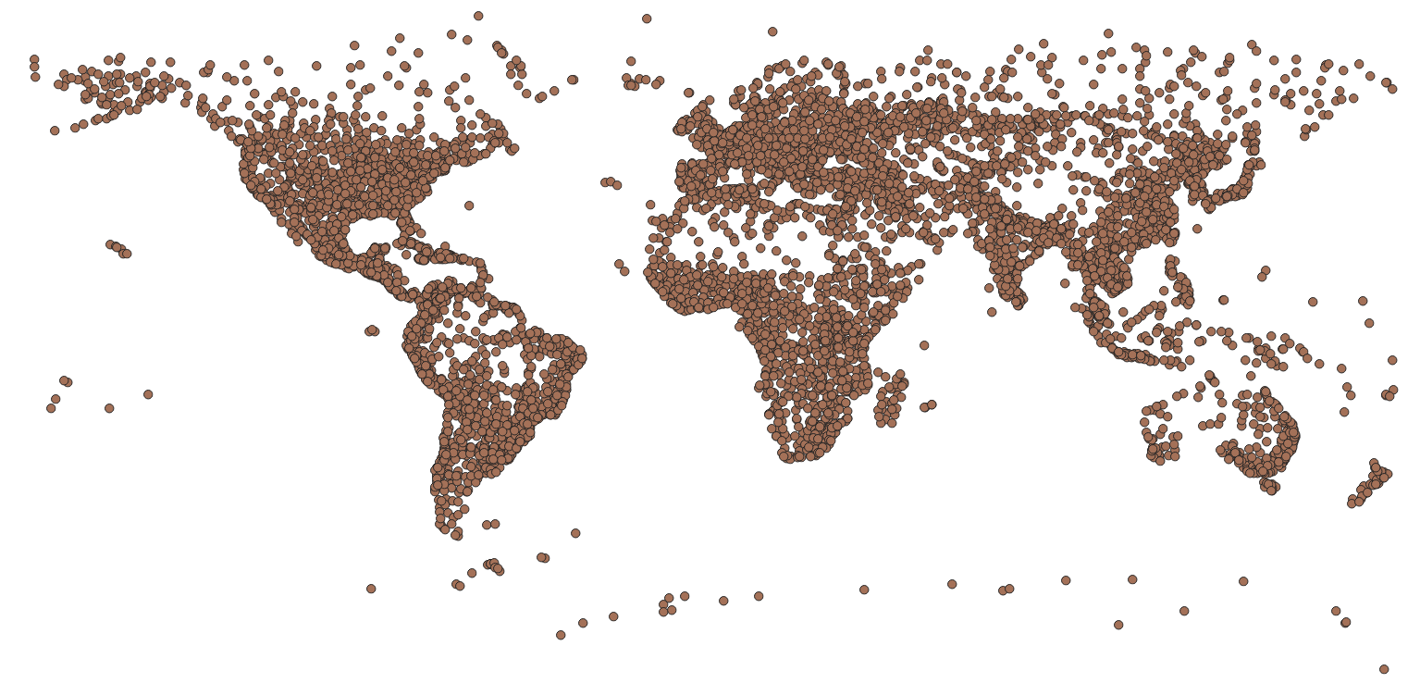

Step 2: Right click on the layer in Layer panel → Attribute table → go to pop_max section to find place with maximum population.

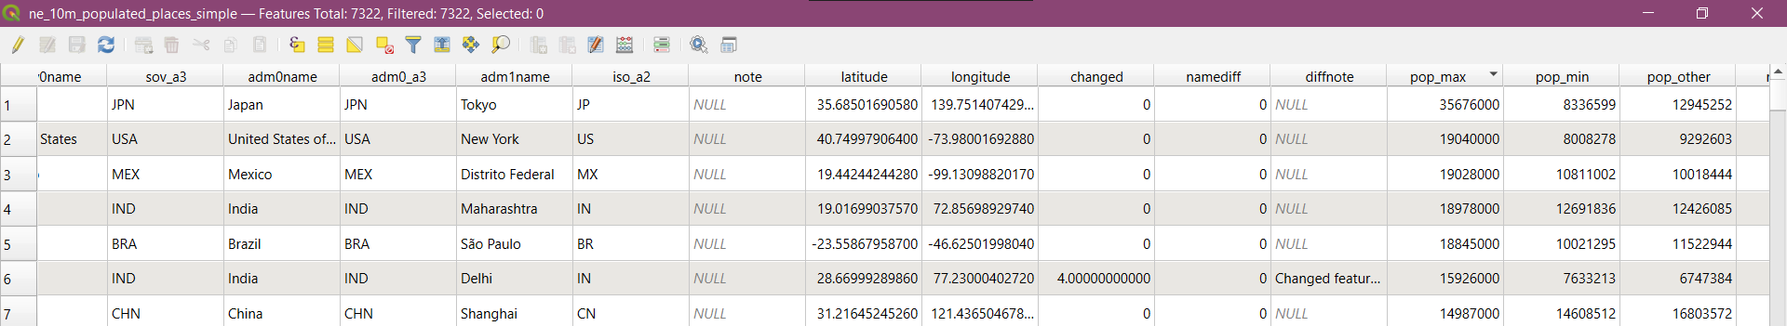

Step 3: On clicking this the following window will appear. Then enter the following command shown in the window: pop_max > 100 and pop_max < 10000. then click the 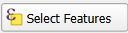 button.

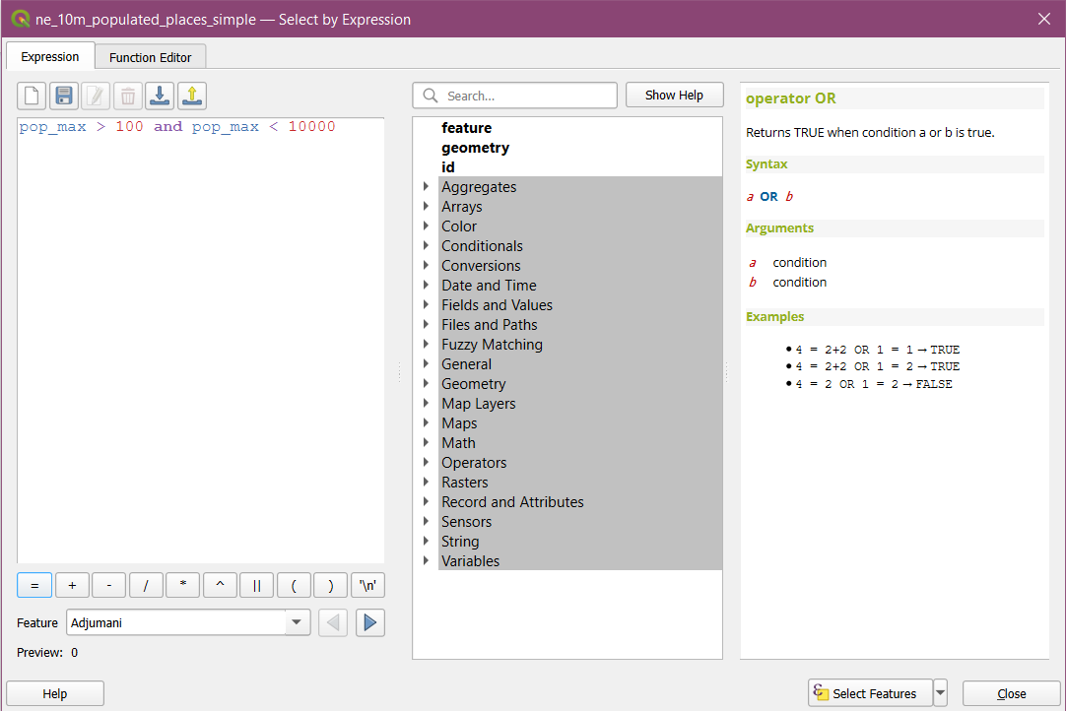

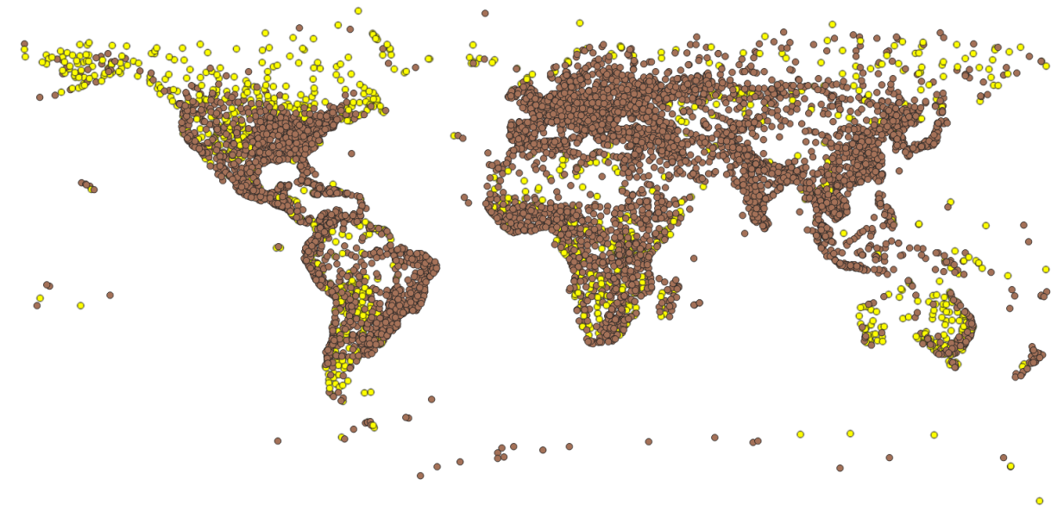
Step 4: You can do the same for India as well, but increase value of pop_max < 10000 to 100000. The following result will be this. Deselection is done by selecting this button. (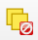)

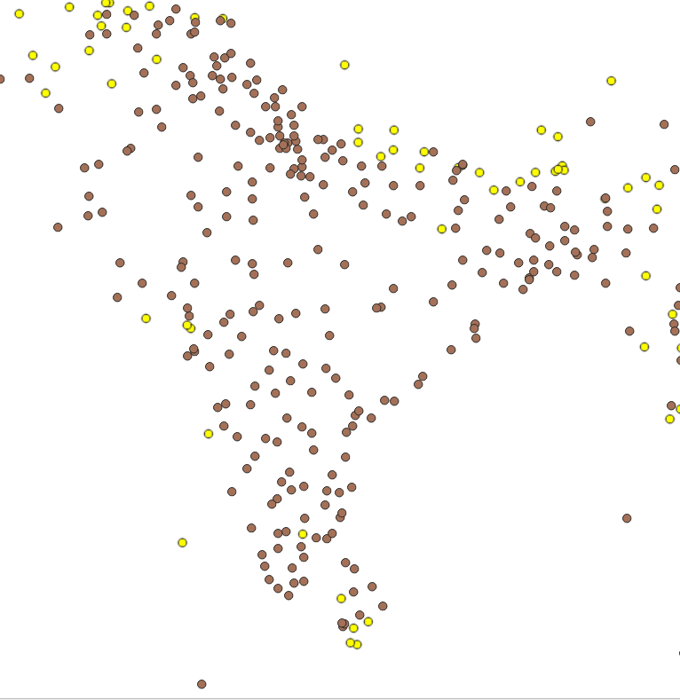

Step 5: Give a suitable title to the map, by going to View → Decorations → Title Label.

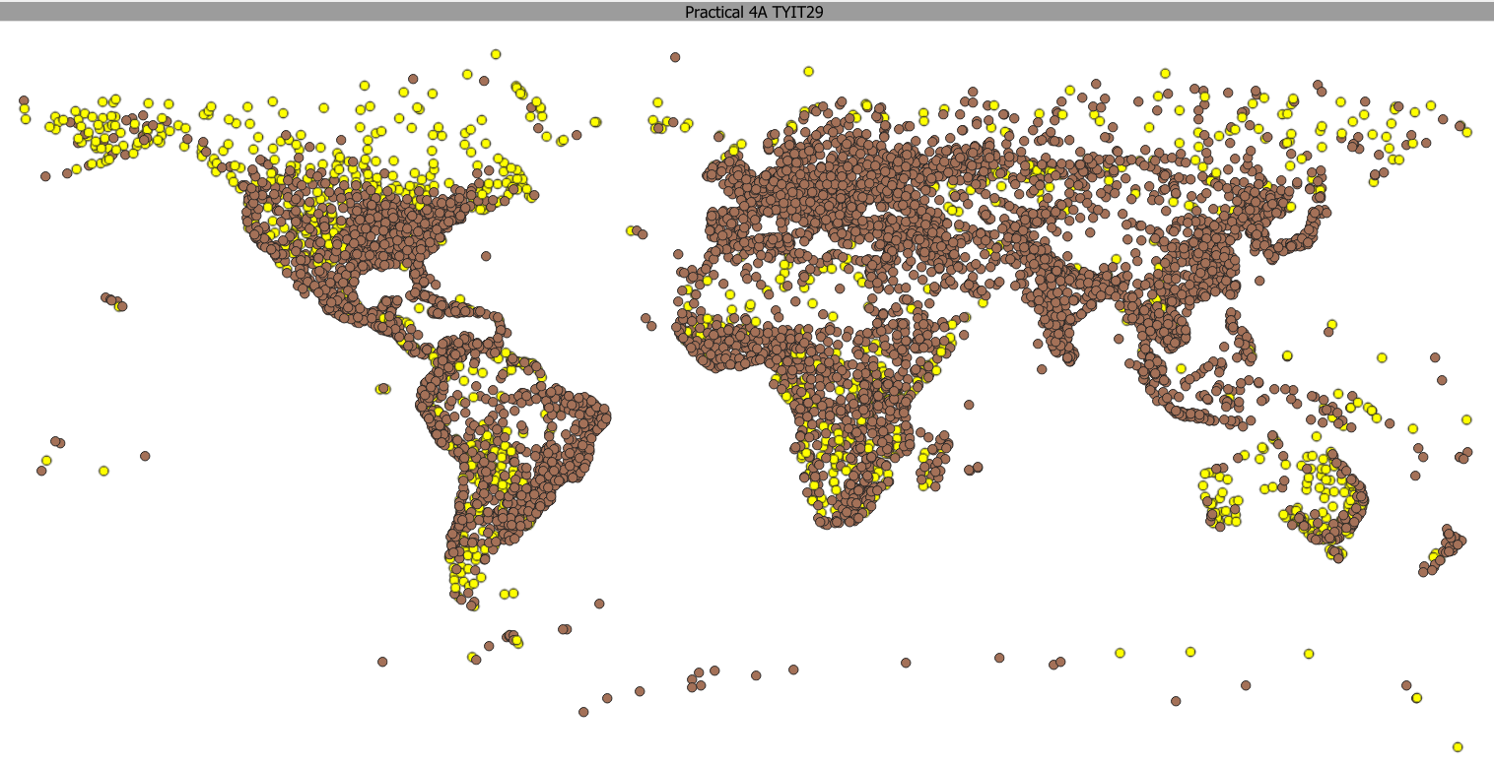

4b). Terrain Data and Hill Shade Analysis.

Step 1: Go to Layer → Add Raster Layer → Select the raster layer “10n060e_20101117_gmted_mea300.tif” from the 4B folder.

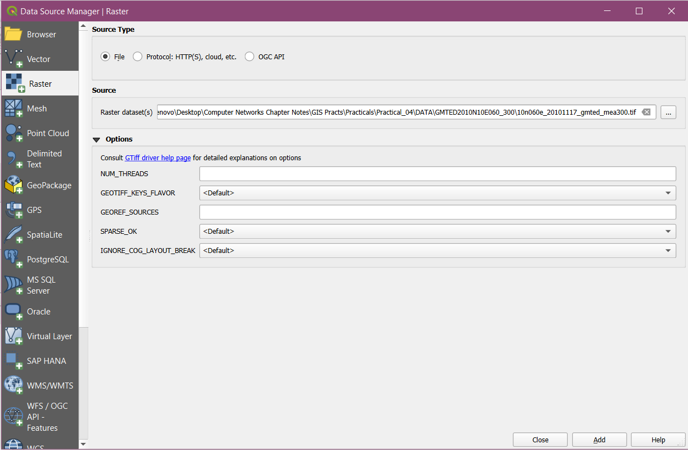

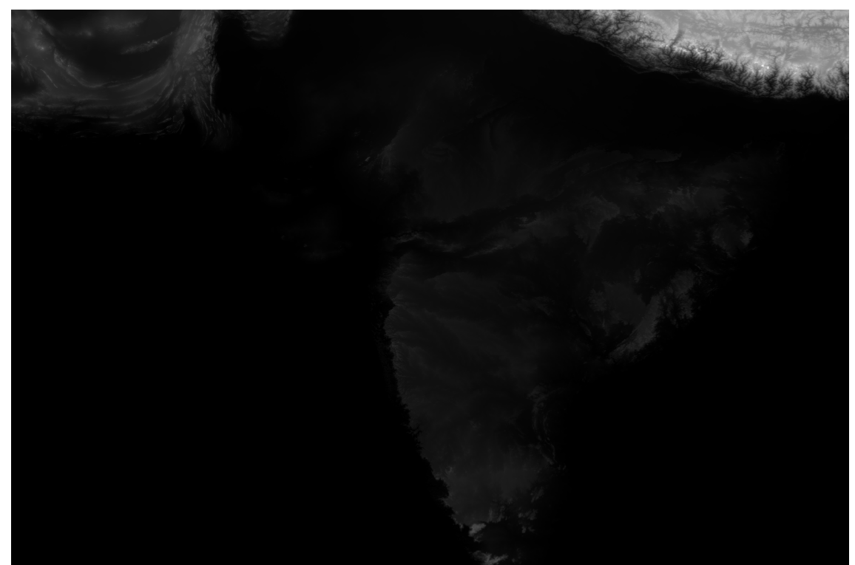

Step 2: Zoom in to this particular region as shown in the image below, and crop only that image.

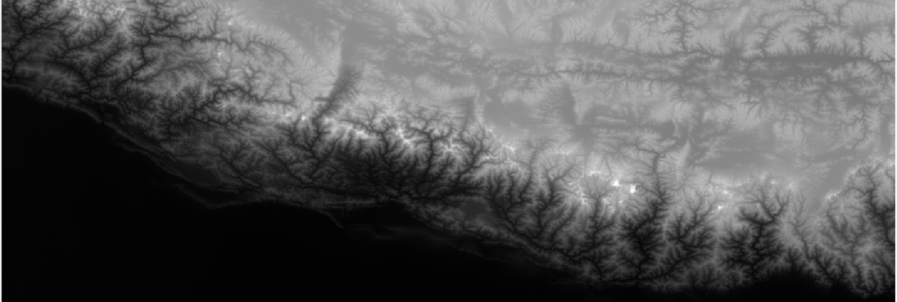

Step 3: Go to Raster → Extraction → Clip Raster by Extent.

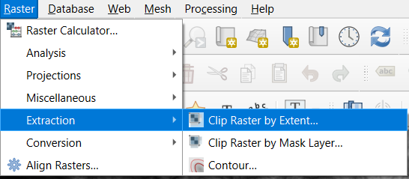

Step 4: Select the raster, then adjust the following settings. Then press on Run.

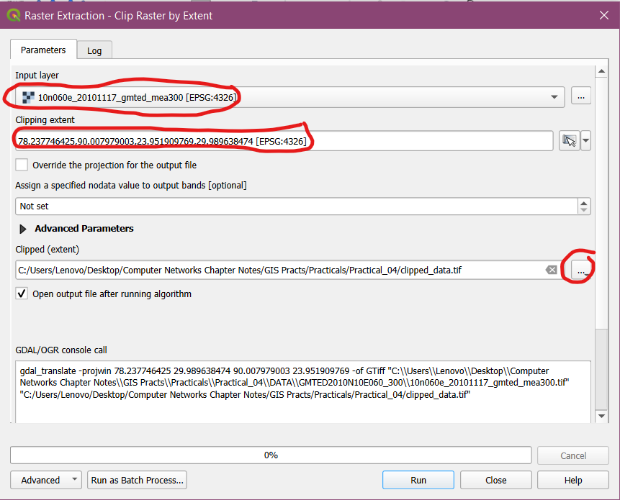
Step 5: Remove the original one and select the clipped one. Then go to Raster → Extraction → Contour. Adjust the configurations shown below and press Run. End result is the following contour.

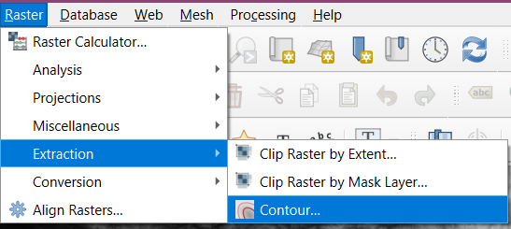

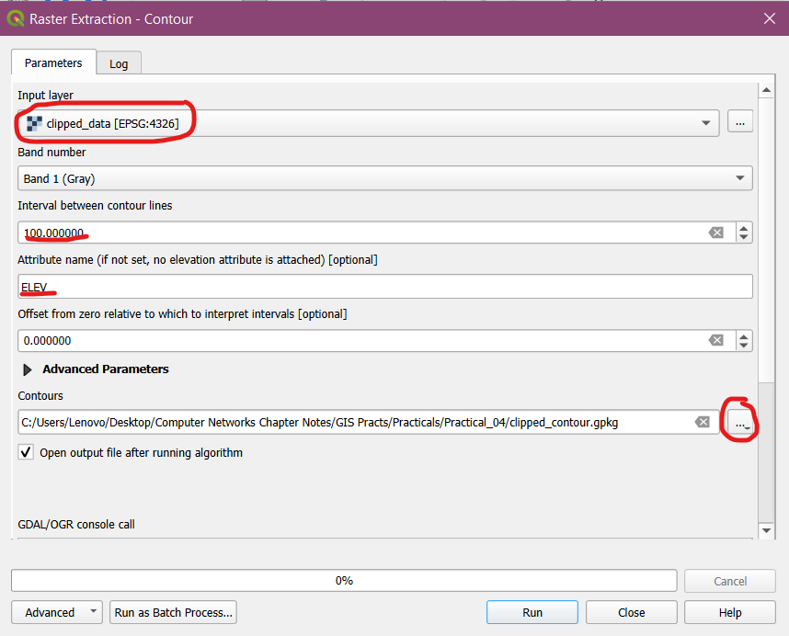

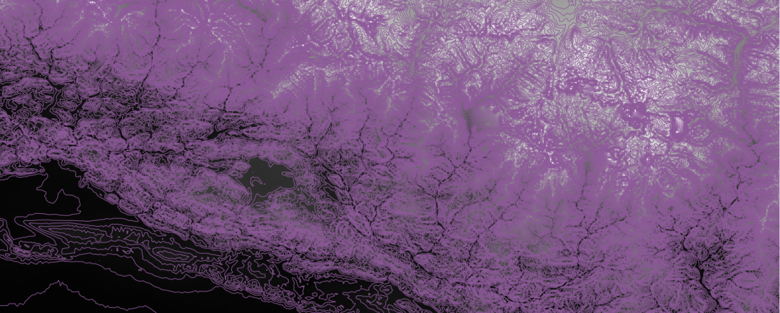
Step 6: Label the layer using ELEV field and set appropriate symbols.

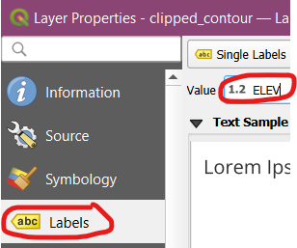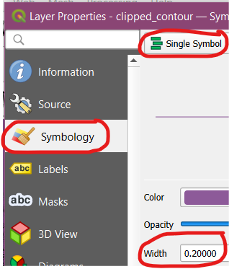

Step 7: Open attribute table of the contoured layer and select the one with the highest altitude → Right click and Zoom to Feature.

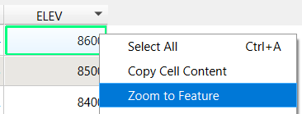

Step 8: Go to View → Decorations → Title Label. Set it as shown in image below. For text annotation, go to symbol.

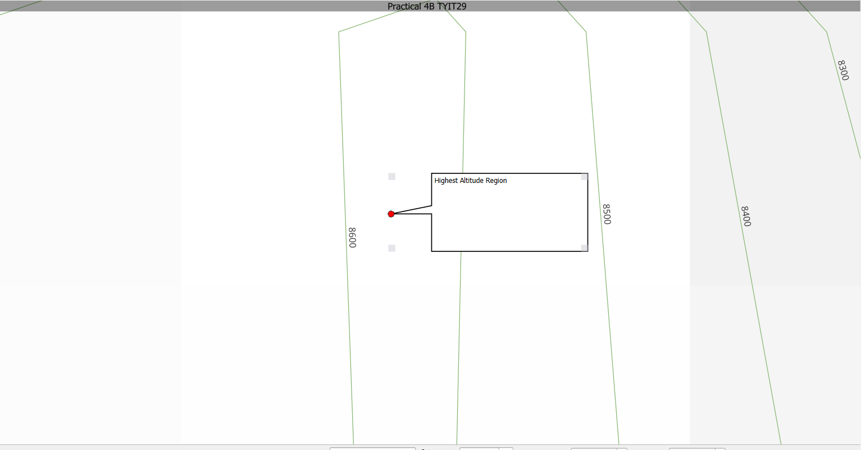
Step 9: For Hill Shade Analysis, go to Plugins → Install Georeferencer Extension. After installation, go to Raster → Analysis → Hillshade.

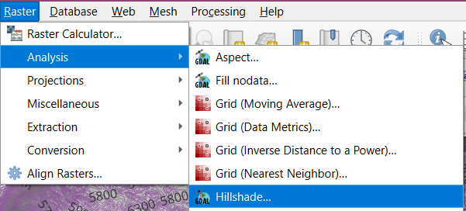

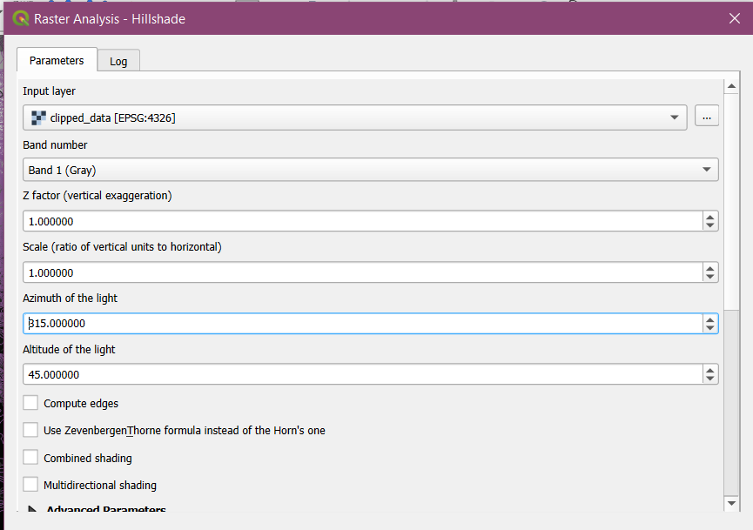

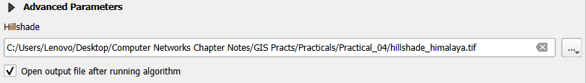

Output:

