5). Working with Projections and WMS Data.

Step 1: Go to Layer → Add Layer → Add Vector Layer. Then add the “ne_10m_admin_0_countries.zip” Layer.

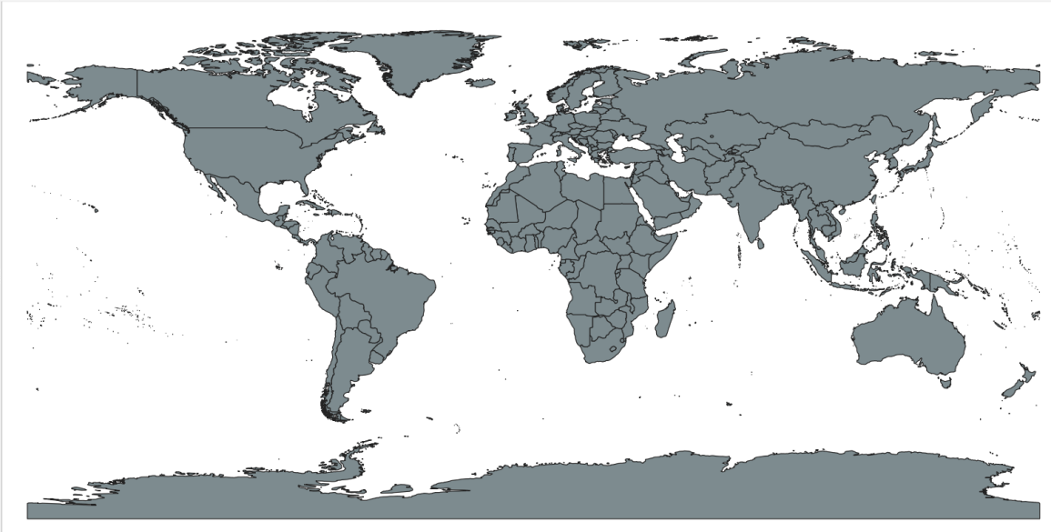

Step 2: Go to Layer → Save As ESRI Shapefile → Do the following changes.

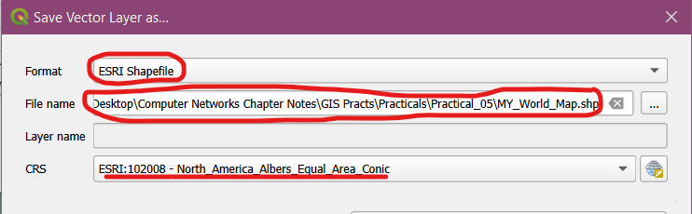

Step 3: Press OK and deselect the original image.

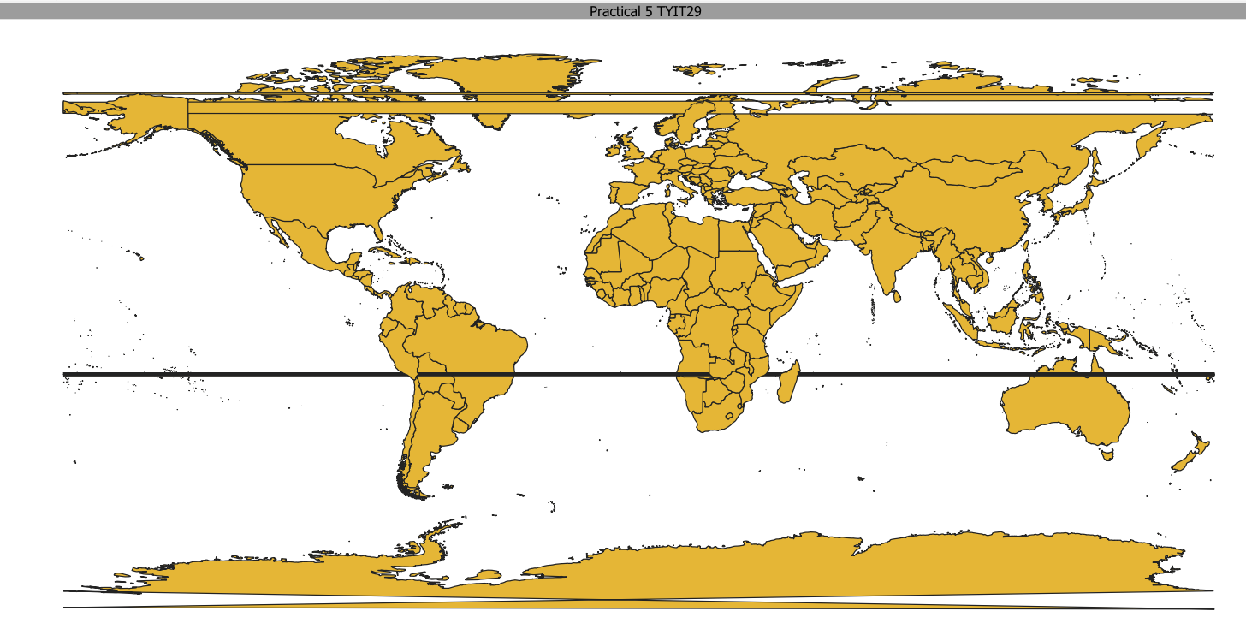

Step 4: Go to Layer → Add Raster Layer → Select MiniScale_(standard)_R17.tif from file location. Right click on selected layer → Go to CRS → Set CRS → British National Grid.

