6a). Georeferencing Topo Sheets and Scanned Maps.

Step 1: Go to Layer → Add Layer → Add Vector Layer. Select IND_adm0.shp file and zoom to Mumbai region of the layer.

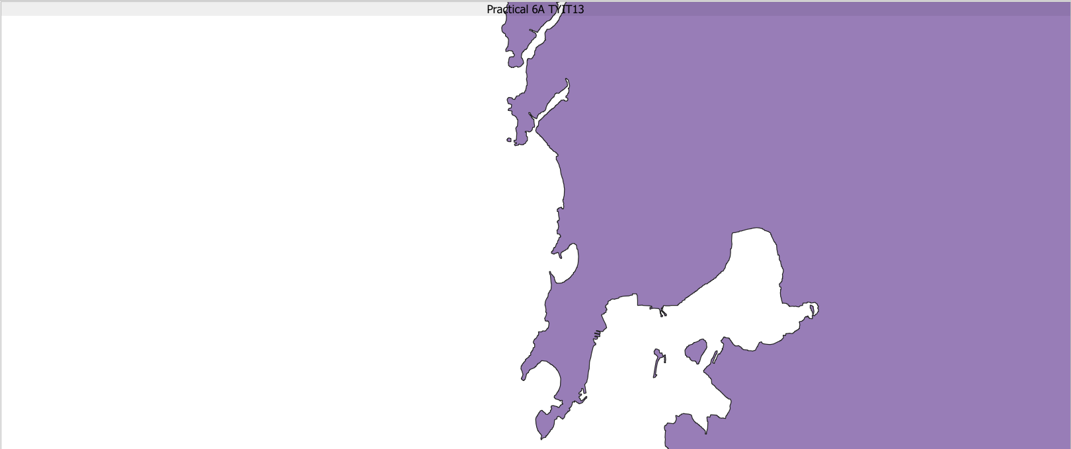

Step 2: Install Georeferencer from plugins, and then go to Raster → Georeferencer. Then in that, go to File → Open Raster, Select Bombay_1909.jpg.

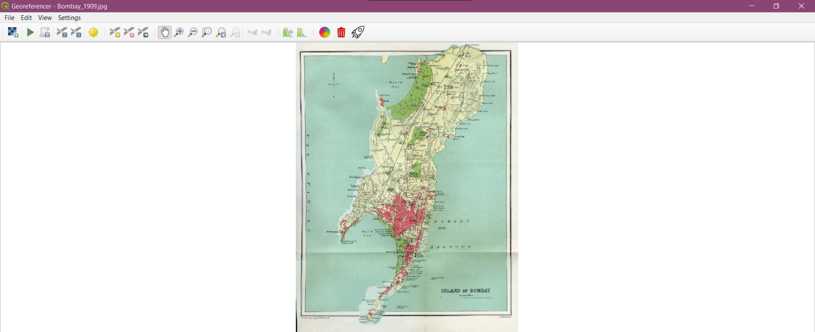

Step 3: Go to Settings → Transformation Settings → Do the following settings.

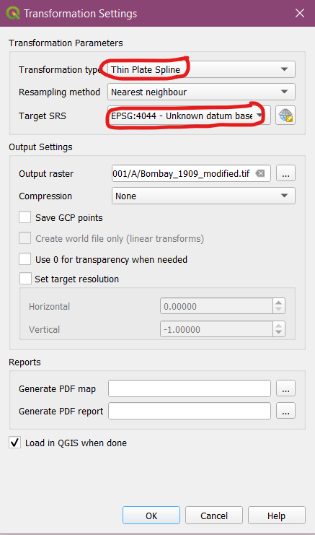

Step 4: Click on Add Point → Select the following points on map by the “From Map Canvas Button”.

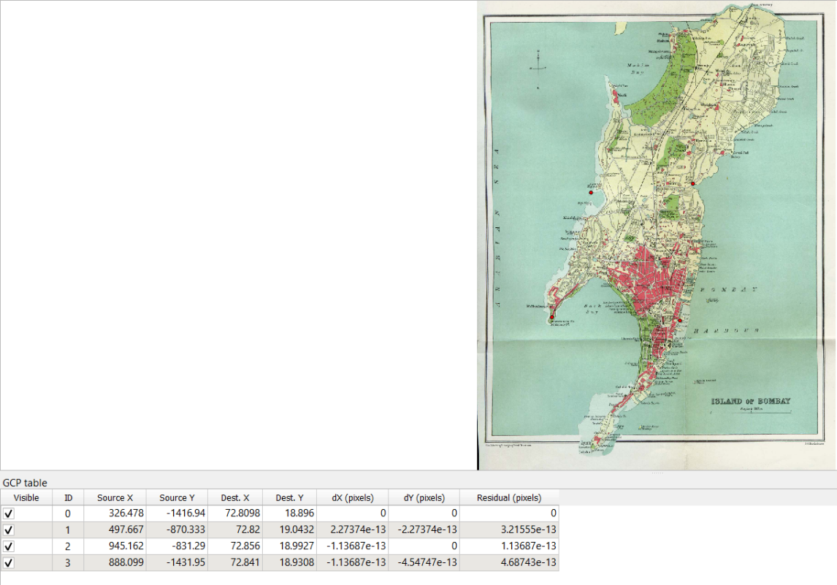
Step 5: Press Run. Then right click on modified layer → Properties → Transparency → Set to 38%.

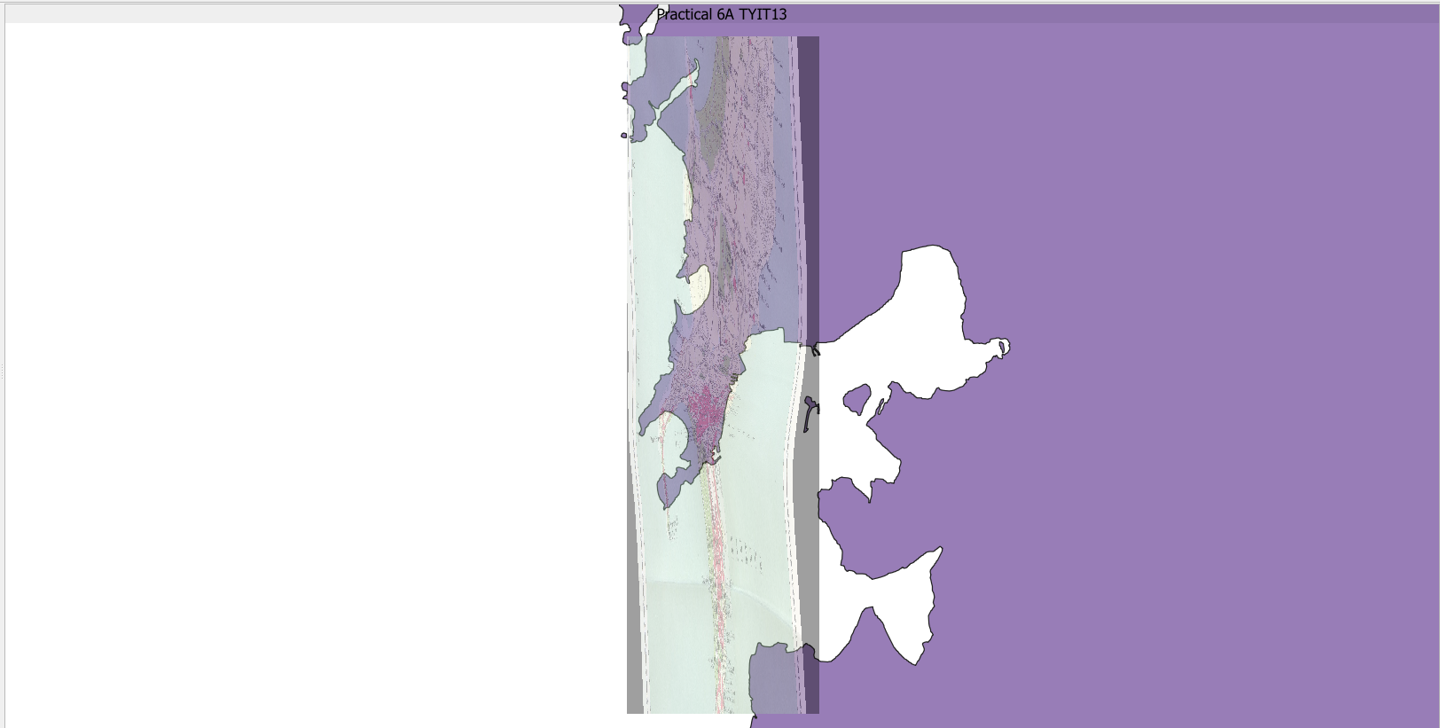

6b). Georeferencing Aerial Imagery.

Step 1: Go to Web → OpenLayers Plugin → OpenStreetMap. Then Search for Gateway of India and select it. It will appear like this.

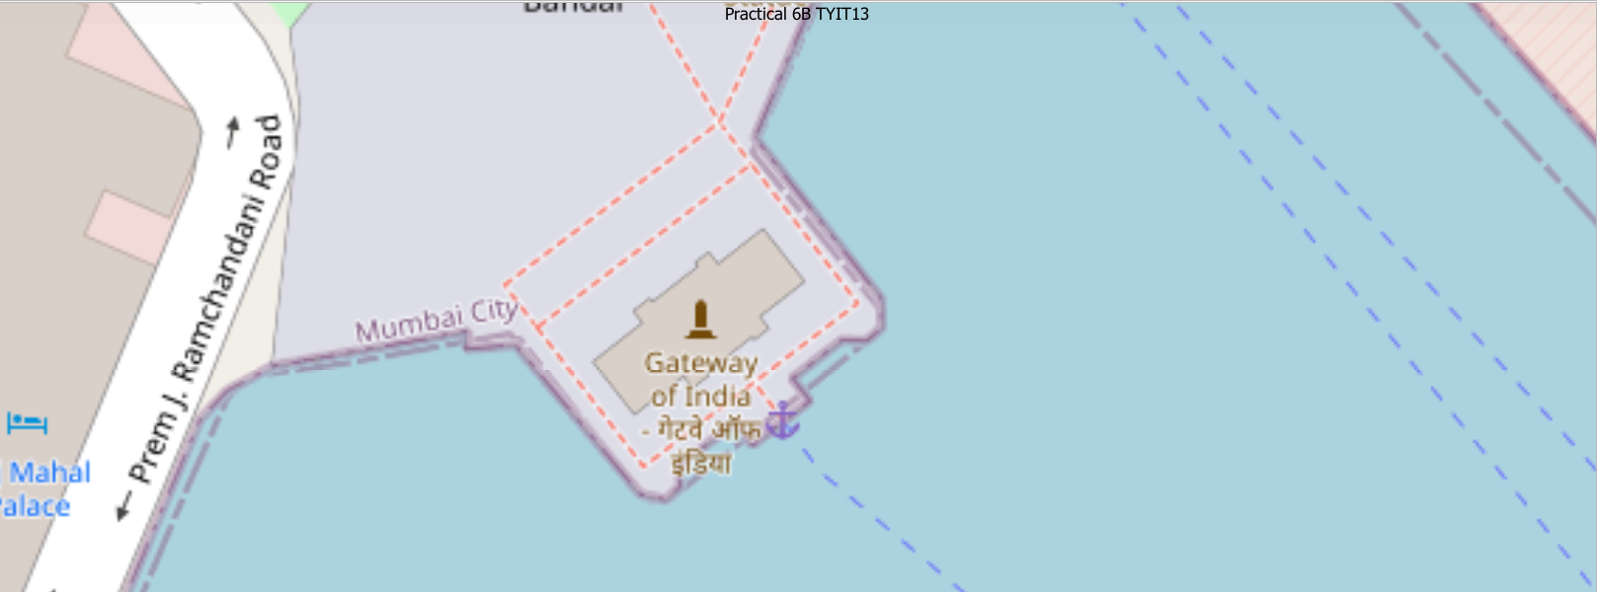

Step 2: Go to Raster → Georeferencer. Then go to File → Open Raster → Select Gateway_Imagery.tif.

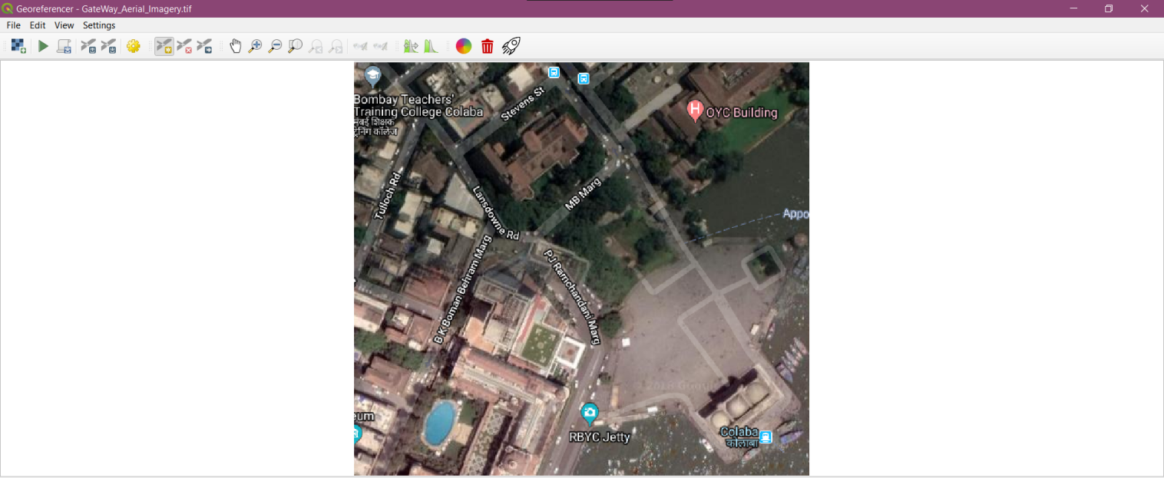

Step 3: Go to Edit → Add Point → Set points as shown in images below by selecting “From Map Canvas”.

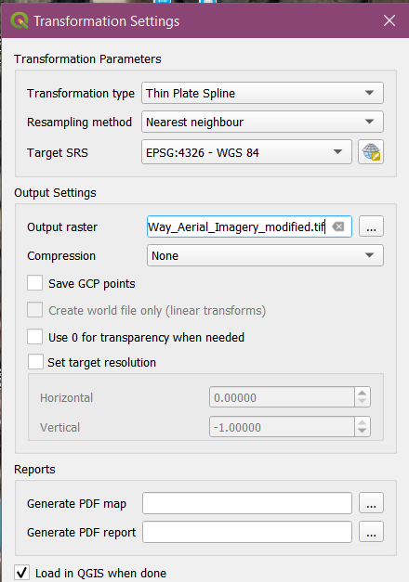

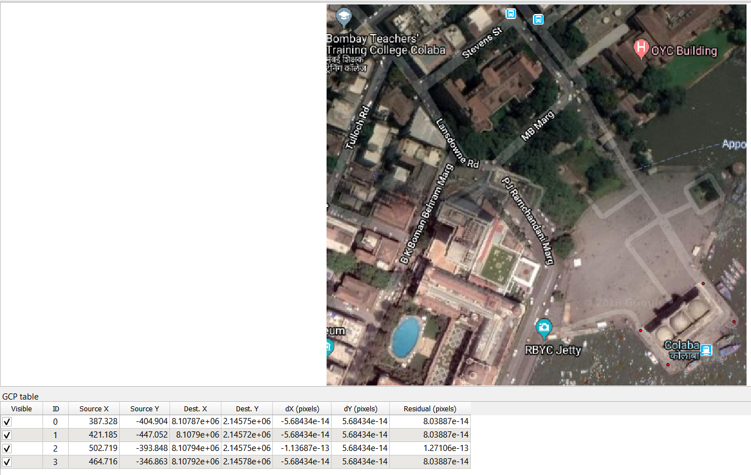

Step 4: Press Run.

OUTPUT:

