Practical 6C: Digitizing Map Data.

Step 1: Go to Layer → Add Layer → Add Raster Layer → Gis Practicals data-20250121T121829Z-001\Gis Practicals data\Practical_06-20211217T154357Z-001\C\Christchurch Topo50 map.tif

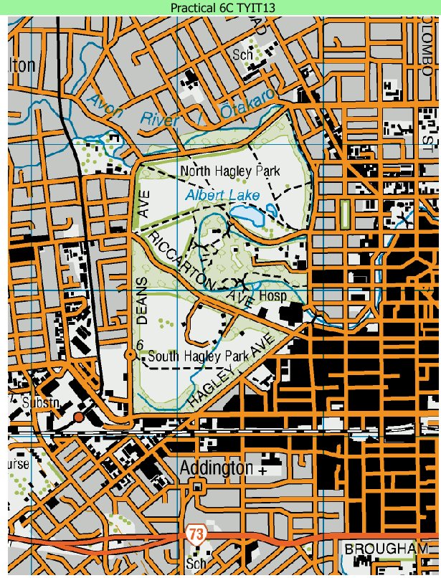

Step 2: Right click on selected layer → Properties → Pyramids → On the right side in Resolutions panel, select all resolutions by clicking on the control button. Then click on “Build Pyramid”, then OK.

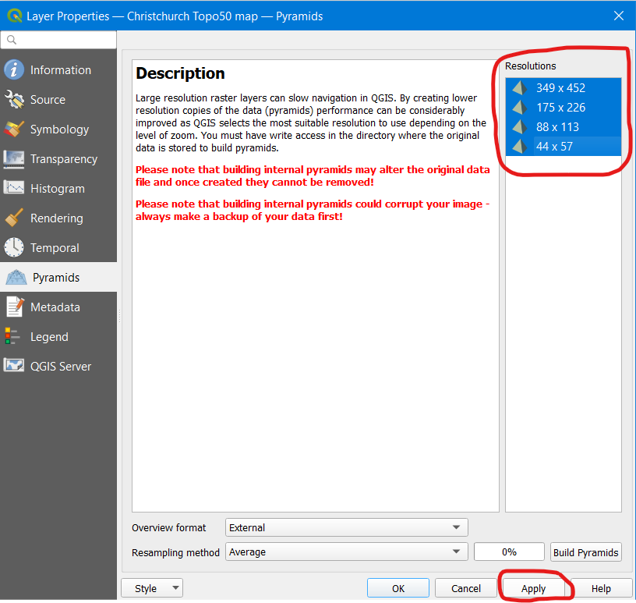
Step 3: Go to Settings → Options → Digitizing → In Snapping, select “Enable Snapping by Default” → Click on OK.

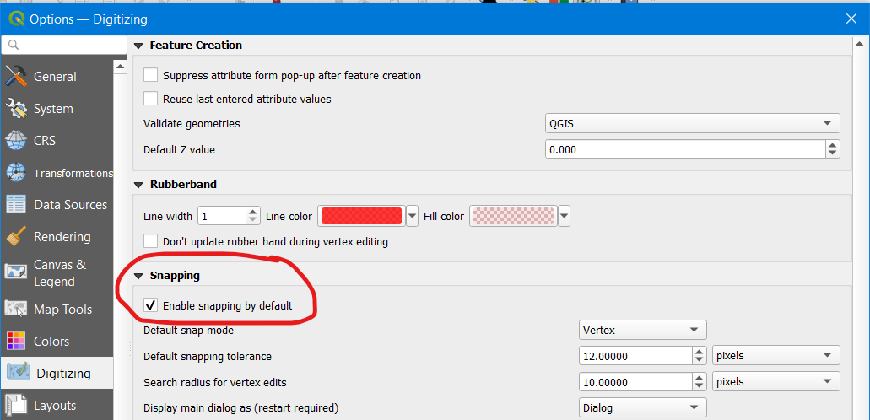

Step 4: Go to Layer → Create Layer → New SpatiaLite layer. Set database name as Digitization, Layer Name as Digitizedroad, select Geometry Type as LineString and set co-ordinate as EPSG:4167 (NZGD2000). Then Go to New Field, set Field Names as: 1) Name 2) Class. Then click OK.

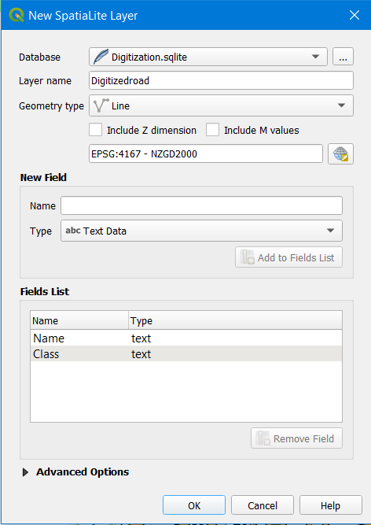

Step 5: Draw lines on Raster Layer and add Name and Class fields by using these features 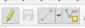 and
Give the name as Road , give the class as Street.

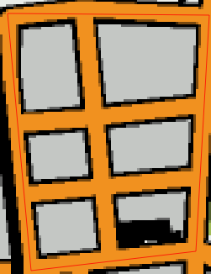

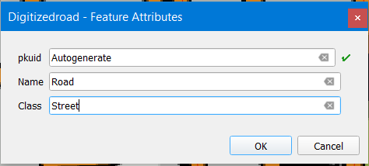

Step 6: Go to Digitizedroad → Right click and select Properties → go to Symbology → search for “neon” and select “Effect Neon”, and apply.

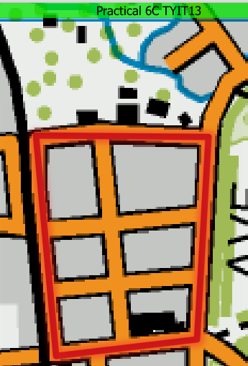

Step 7: Add another SpatiaLite layer. Set the following properties:

Database :- Give the Name to Database as Digitization
Layer name :- Digitized_garden
Geometry type :- Select Geometry type as Polygon
Coordinate: Set co-ordinate as EPSG:4167 (NZGD2000).
New Field: Set new field as Name.

Click on OK.

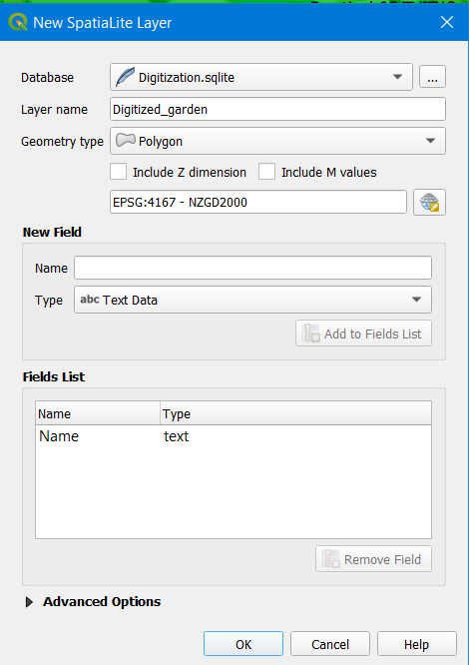

Step 8: Draw lines on Raster Layer and add Name and Class fields by using these features  and
Give the name as Garden 1, and Garden 2 respectively.

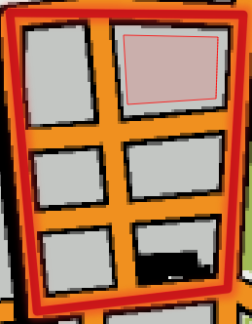

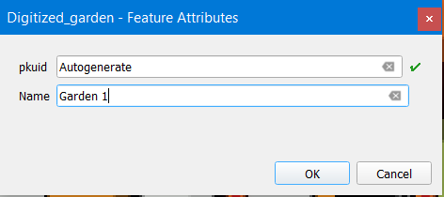

Step 9: To reveal the names of the gardens, go to Digitized_garden layer → right click and select properties → Labels → Single Label → Apply → OK.

Final Output:

