7). Managing Data Tables and Spatial Data Sets:
a). Table Joins

Step 1: Layer → Add Layer → Add Vector Layer → Go to Practical 7 folder and add tl_2013_06_tract.zip file.

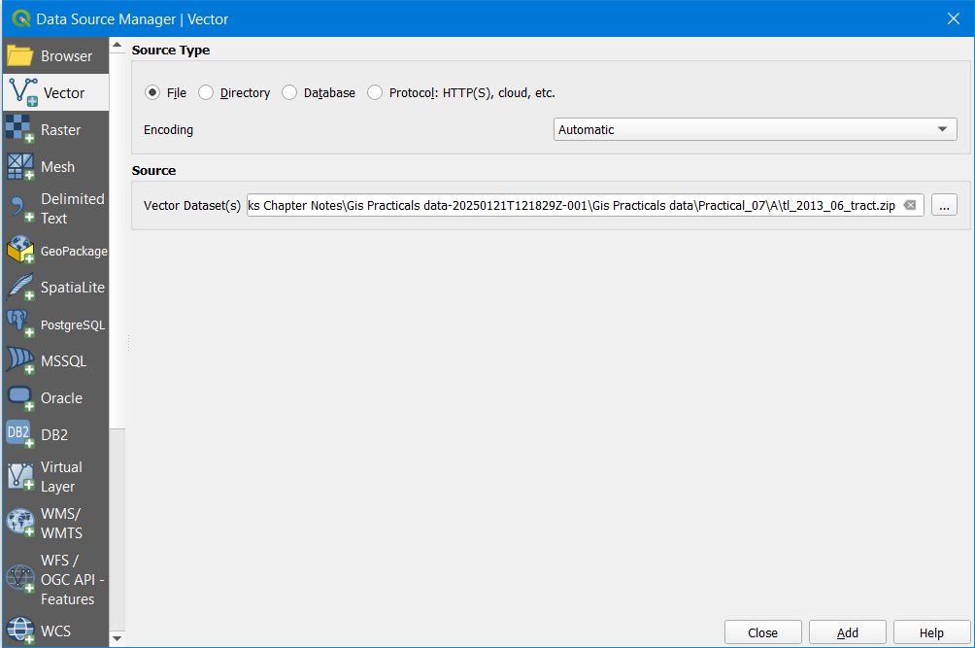

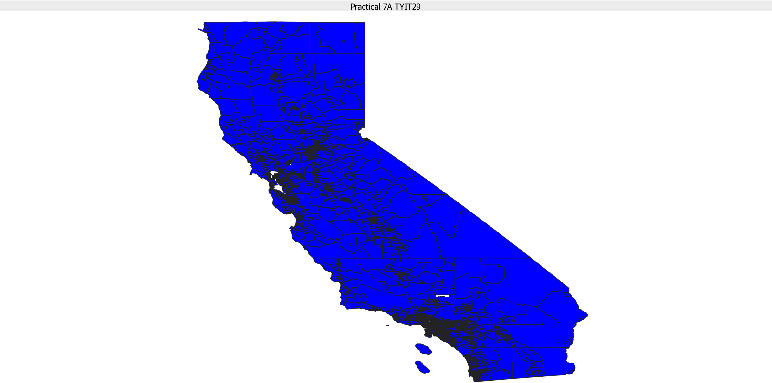

Step 2: Layer → Add Layer → Add delimited text layer → Select the ca_tracts_pop.csv file from Practical 7A folder.

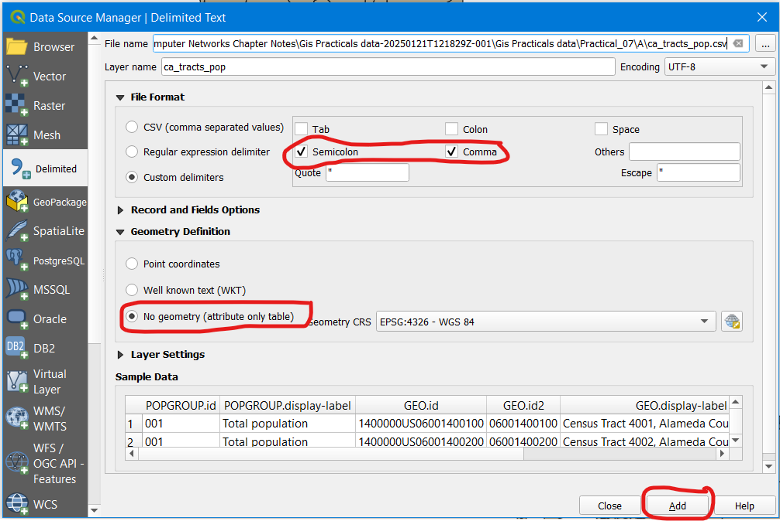

Step 3: Right click on the “tl_2013_06_tract” layer and select Properties → Joins → Click on to add the new join.

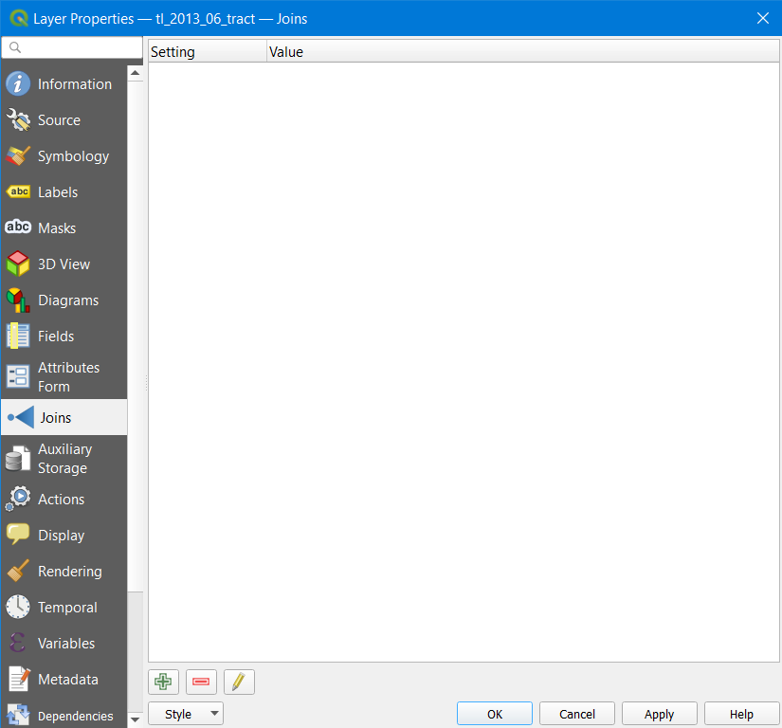
Step 4: Do the following:

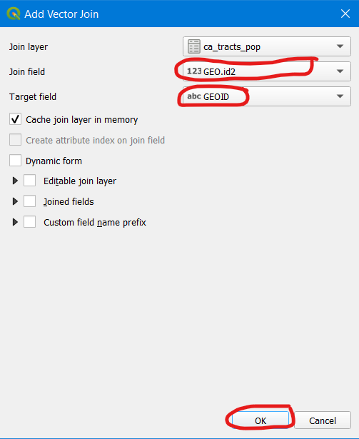

Step 5: Confirm and click on Apply.

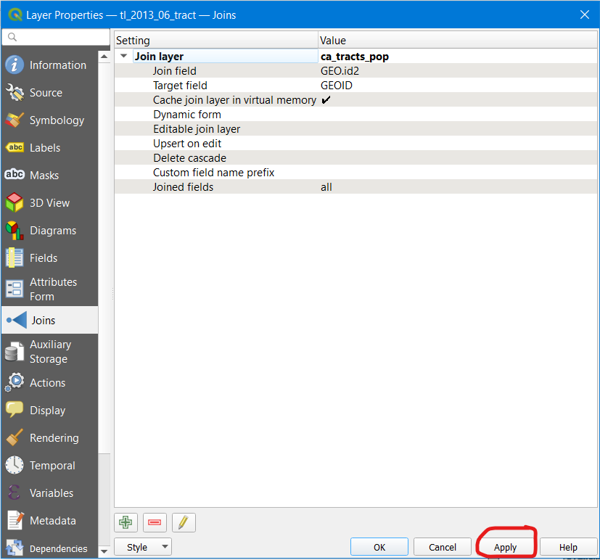
Step 6: For a clearer output, right click on the “tl_2013_06_tract” layer → Symbology → Set the following properties.

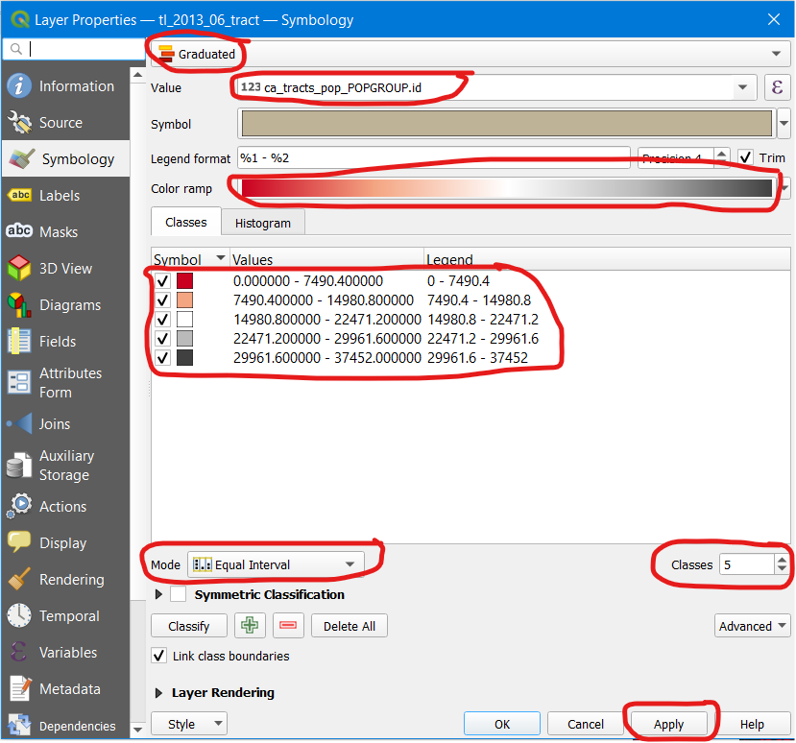

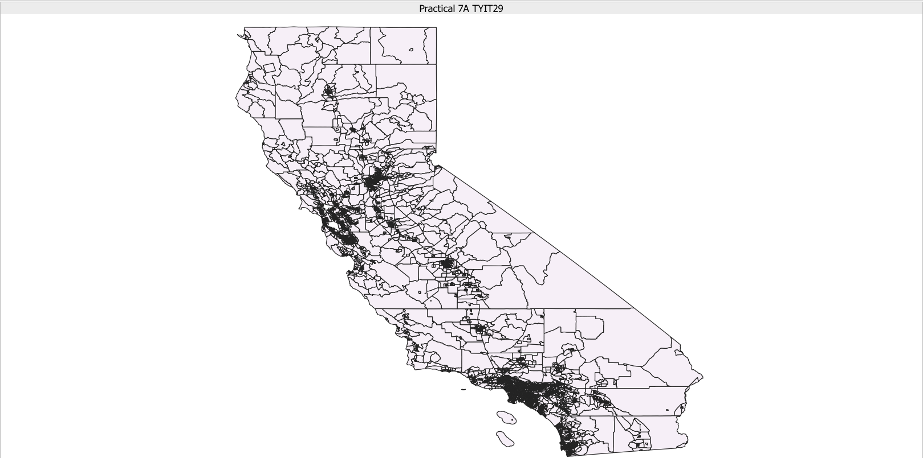

7b). Spatial Joins

Step 1: Layer → Add Layer → Select nybb.shp and OEM_NursingHomes_001.shp files from Practical 7B folder.

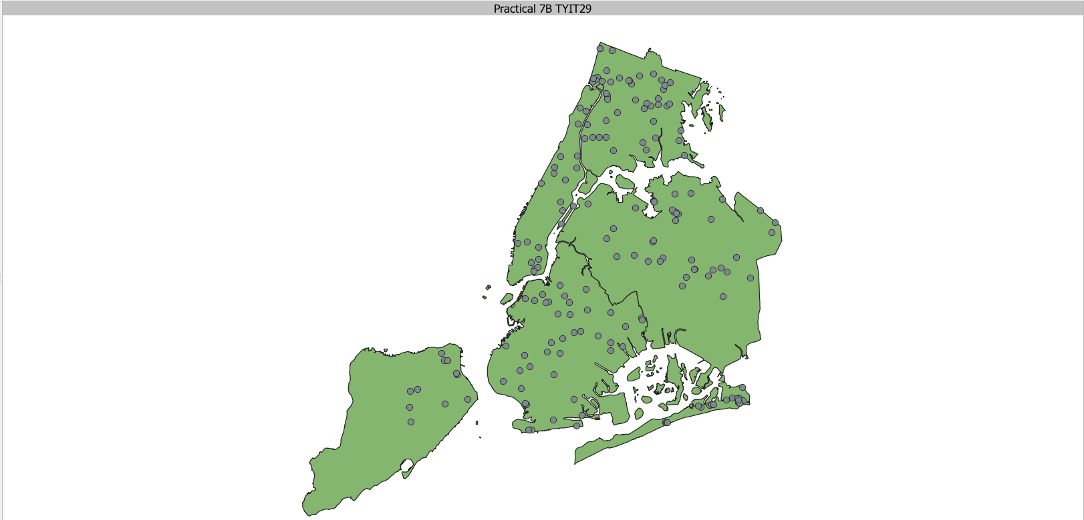

Step 2: Go to attribute table of OEM_Nursing Homes, and observe the data. The image below shows table before it was being used by join operation.

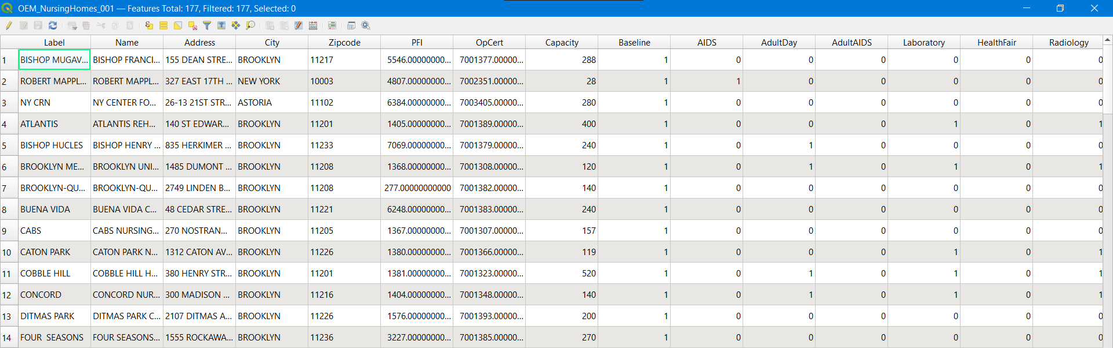
Step 3: Vector → Data Management Tools → Join Attributes By Location. Then perform the following in the second image.

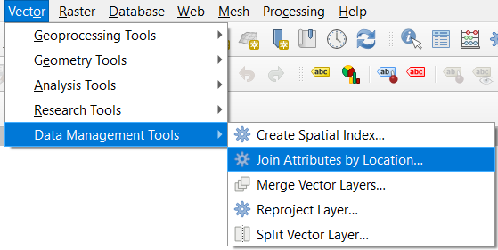

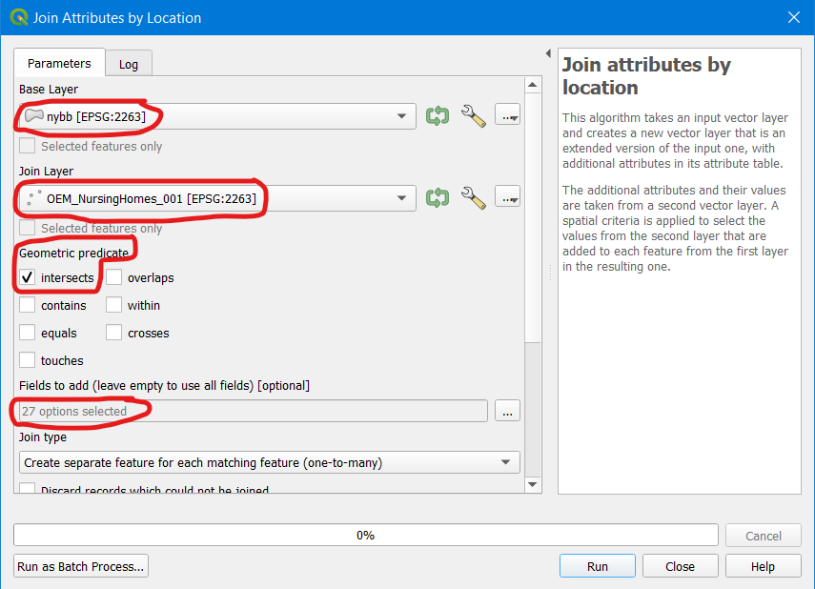

Step 4: Below shows the attribute table of OEM_NursingHomes_001.

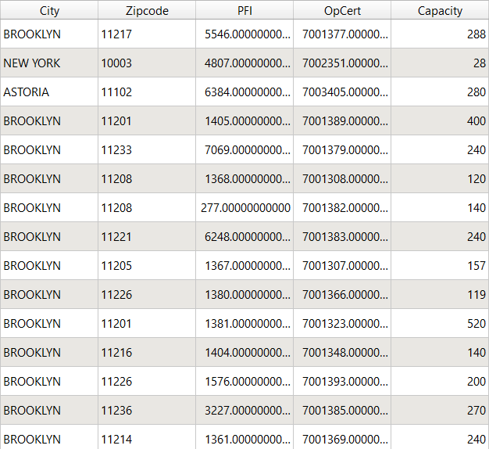
Step 5: The output looks like this. Then use the Identify Feature button  to find relevant information as shown in the second image.

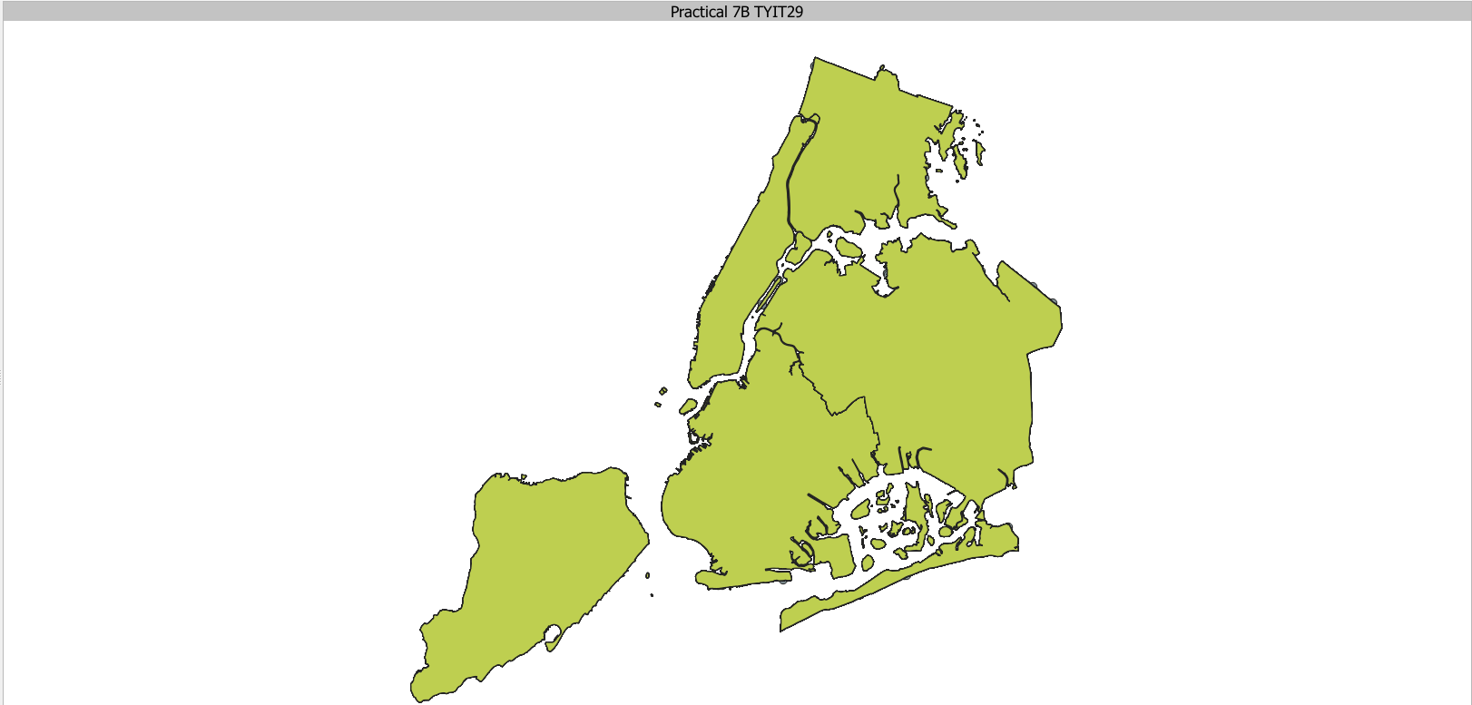

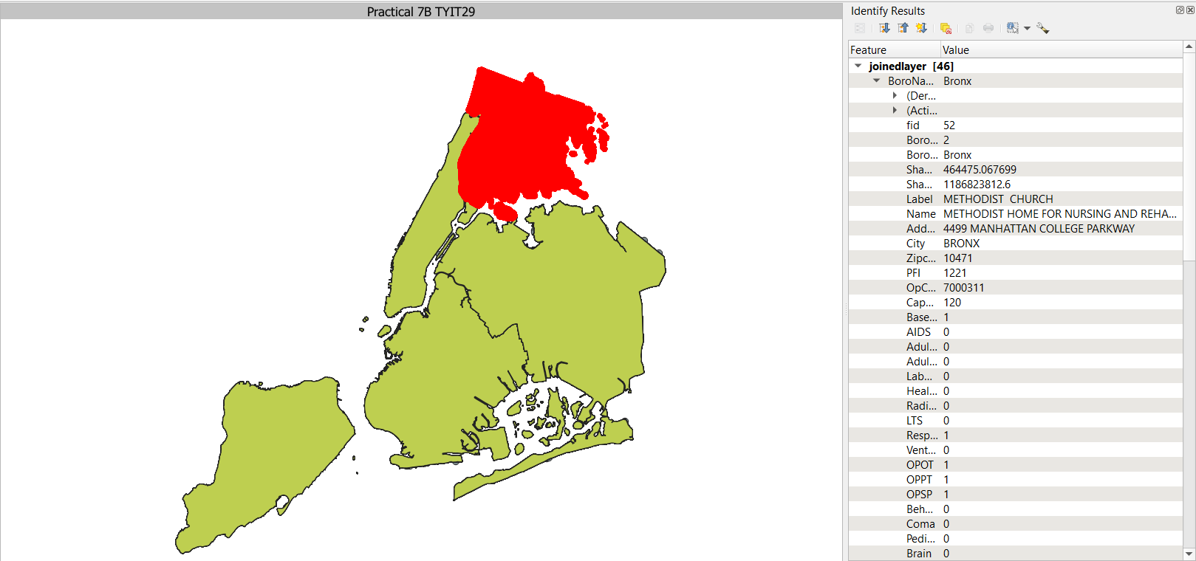
7c). Points in Polygon Analysis.

Step 1: Layer → Add Layer → Add Delimited Text Layer. Select EarthQuakeDatabase.txt file.

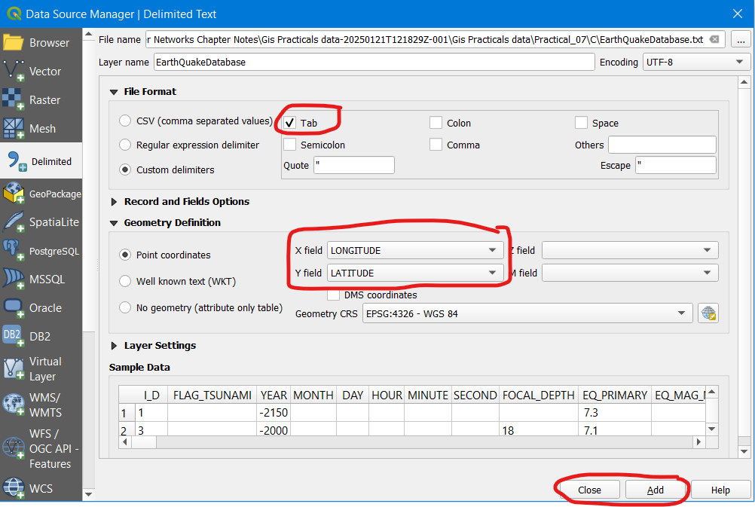

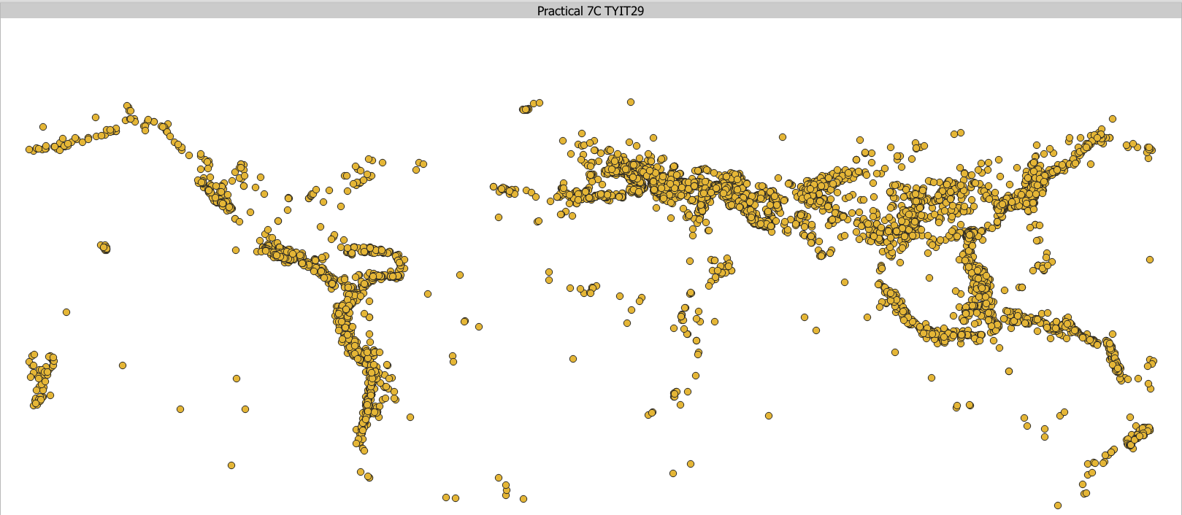

Step 2: Add a vector layer “ne_10m_admin_0_countries.zip” file.

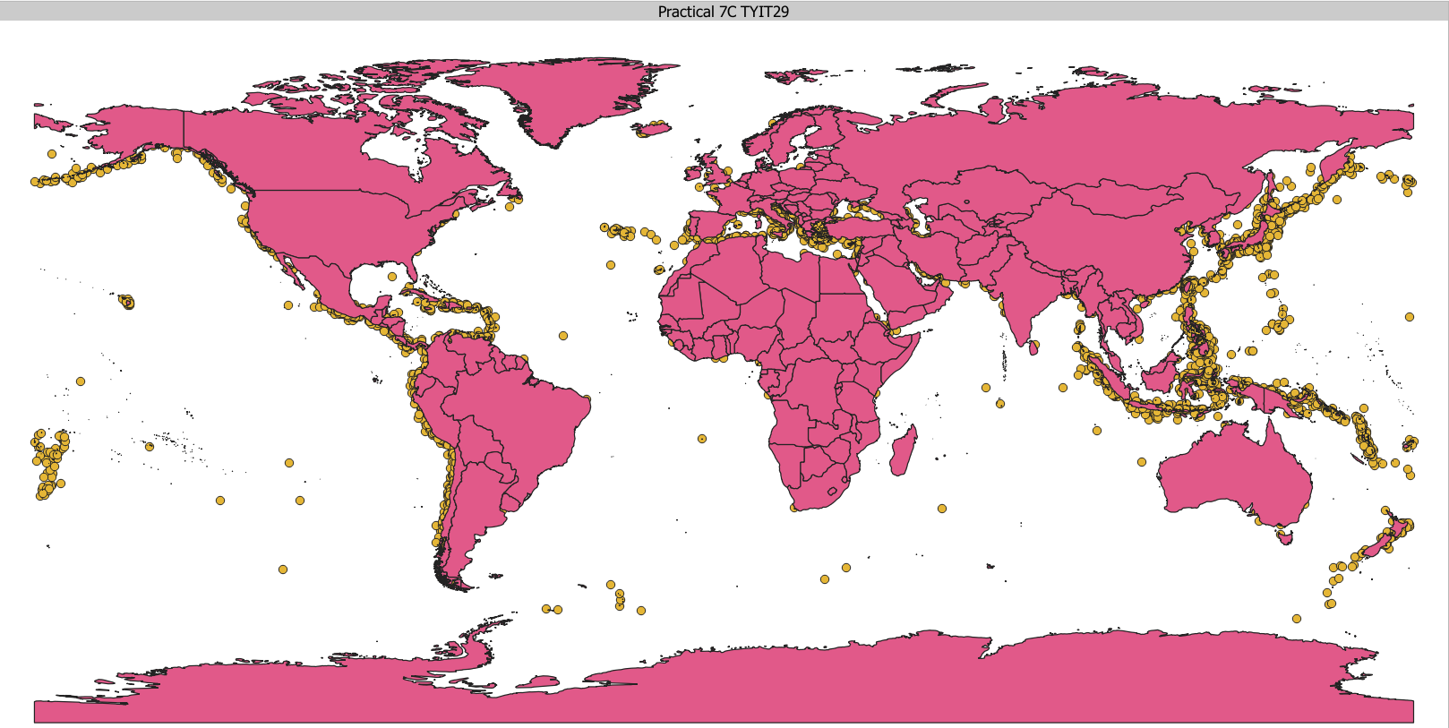

Step 3: Go to Vector → Analysis Tools → Count Points in Polygon and perform the following:

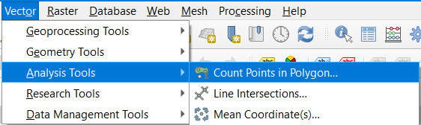

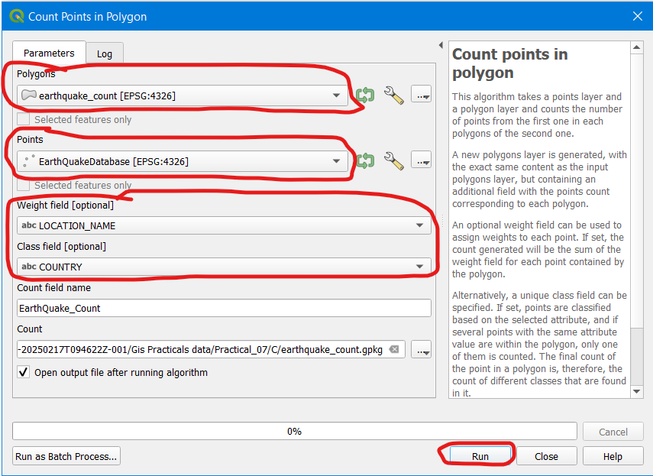
Step 4: Final output is this. Use the Identify Feature button  to find relevant information as shown in the second image.

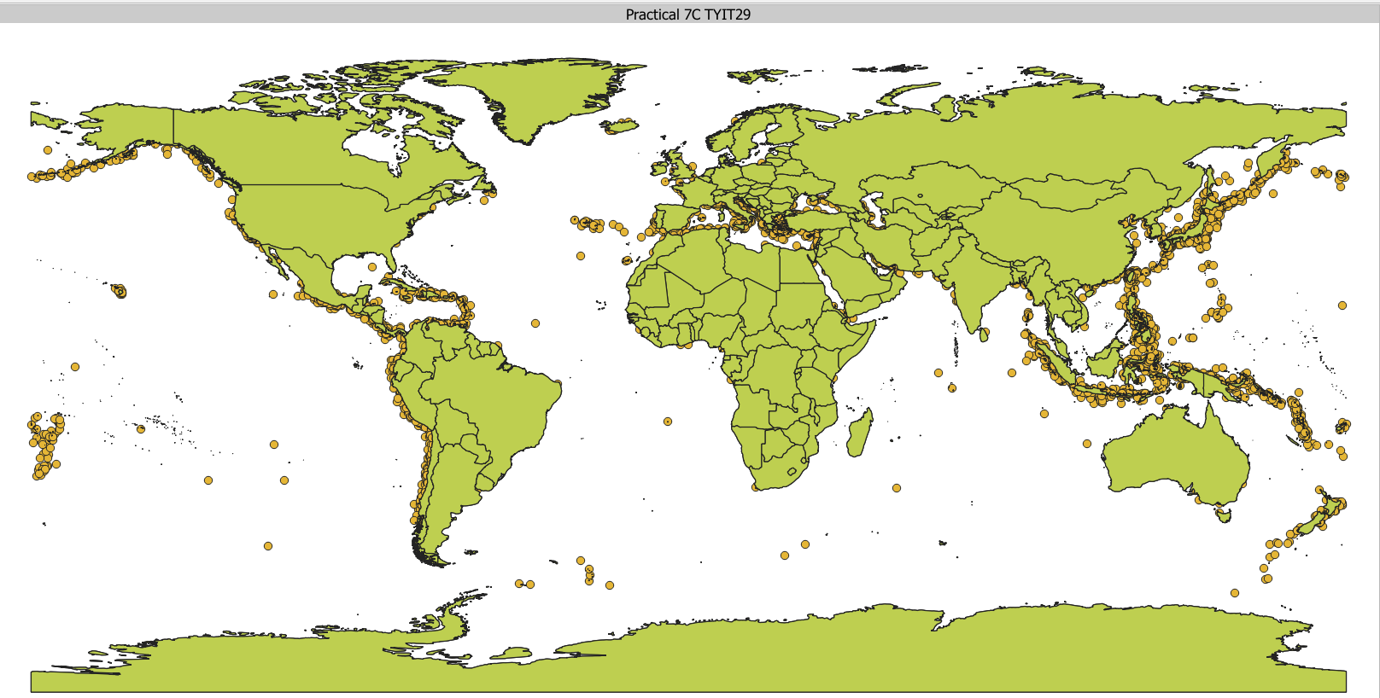

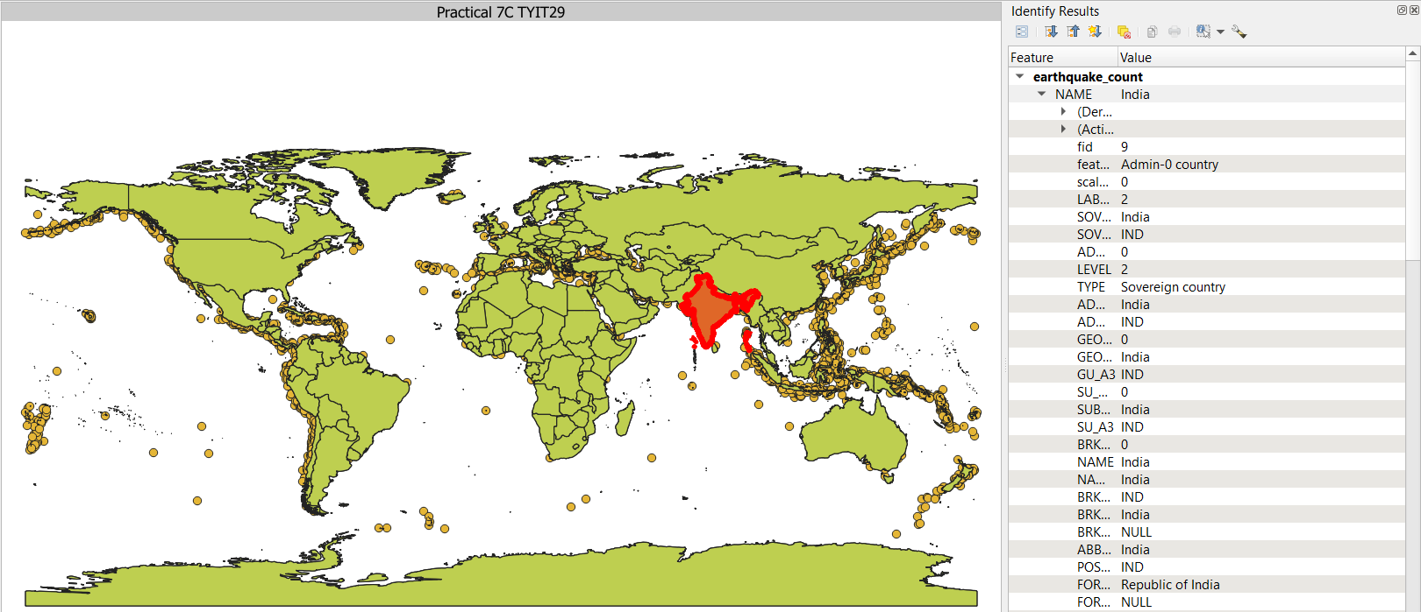

7d). Performing Spatial Queries

Step 1: Layer → Add Layer → Add Vector Layer → Add these files:

“ne_10m_populated_places_simple.shp”

“ne_10m_rivers_lake_centerlines.shp”

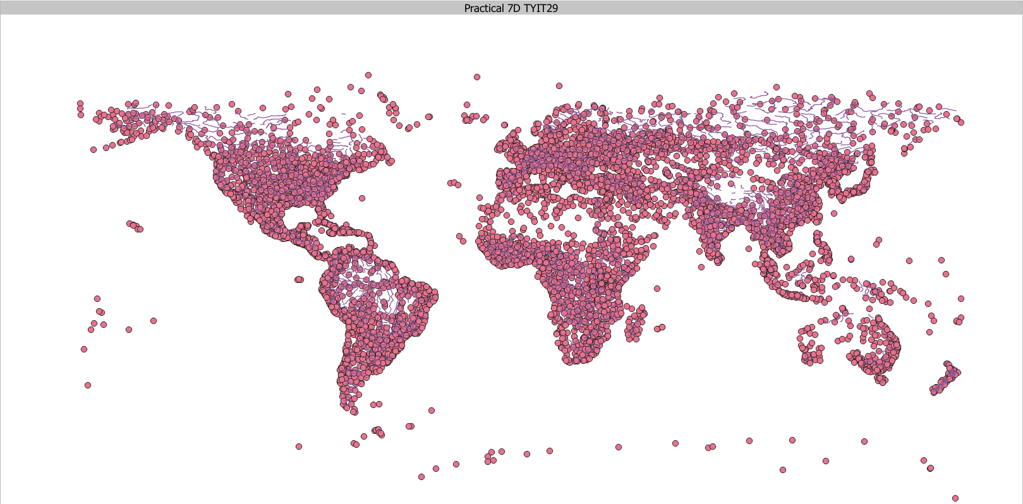

Step 2: Go to Project → Properties → CRS → Set it to “World_Azimuthal_Equidistant EPSG 54032”

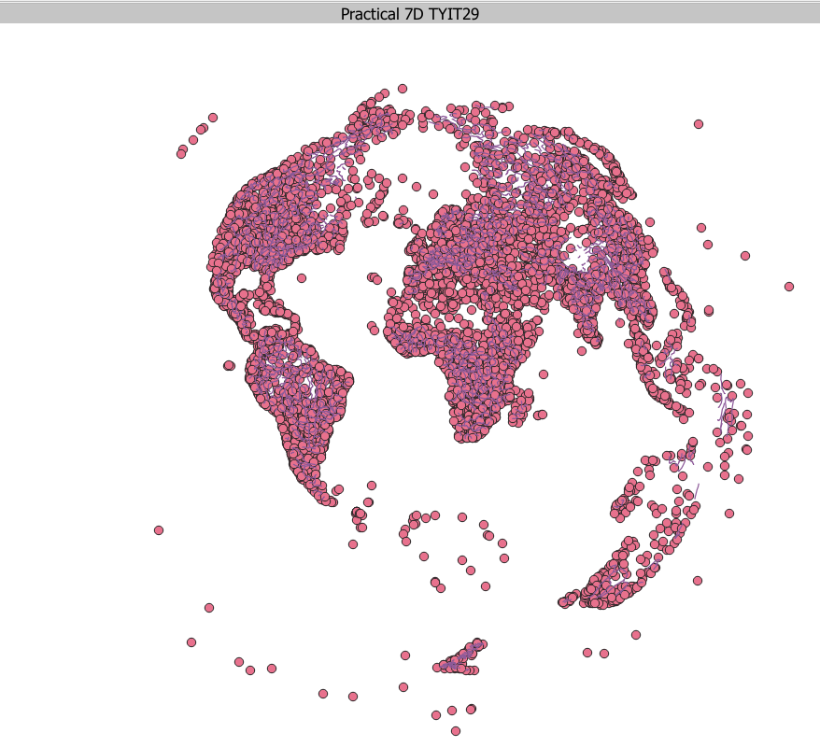
Step 3: Go to Vector → Geoprocessing Tools → Buffer → Implement following steps in second image. The result is shown in third image when zoomed in.

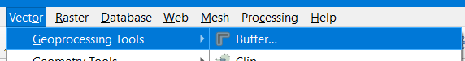

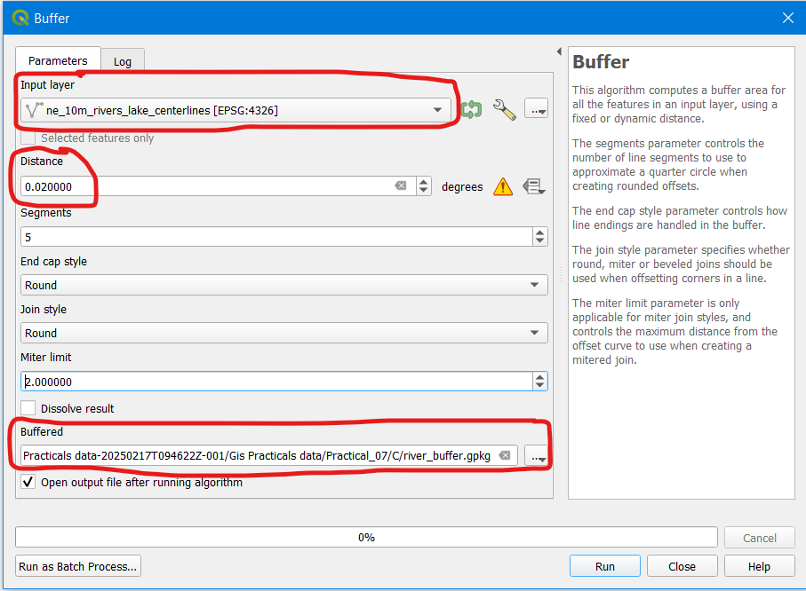

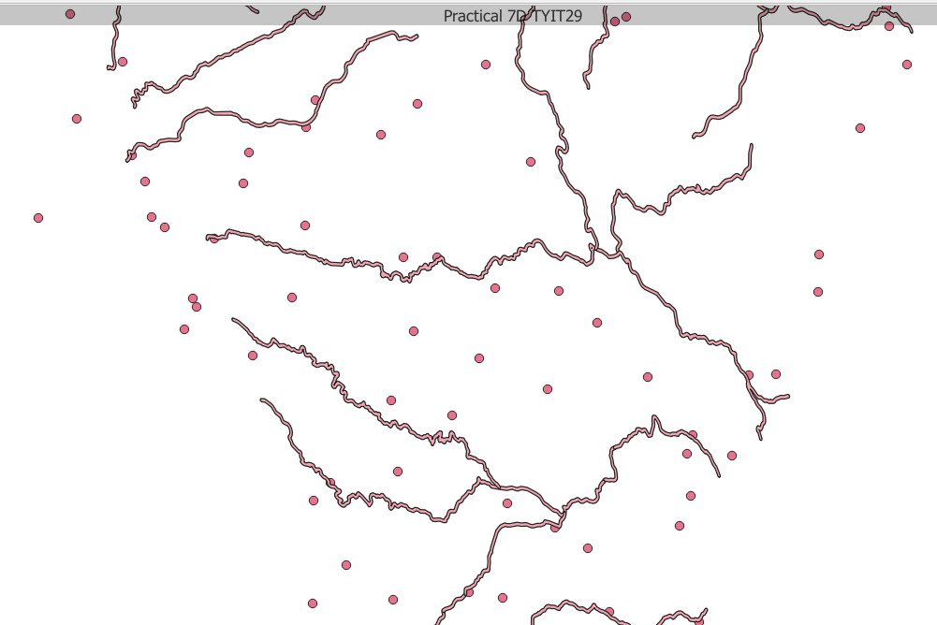

Step 4: Go to Vector → Research Tool → Select By Location. Implement the following as shown in the second image. Final Output is seen in third image.

