9). Validating Map Data.
Part 1). Format of the Database:

Step 1: Open the “Kenya_epidemiological_data.xls” in Excel, and not in QGIS. Go to View Tab → Click on Panes → Click on “Freeze Panes” and choose “Freeze Top Row”

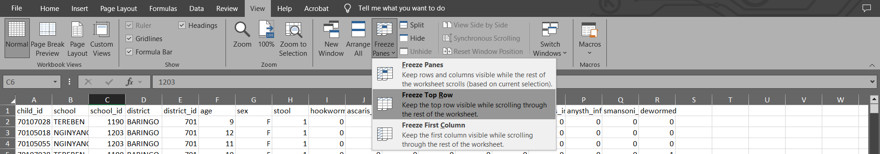

Step 2: Select the entire “child_id” column and go to Home → Conditional Formatting → Highlight Cell Rules → Select Duplicate Values. Now select the first combo box and select Duplicate and select Light red fill with Dark red text in the next combo box as shown in figure.

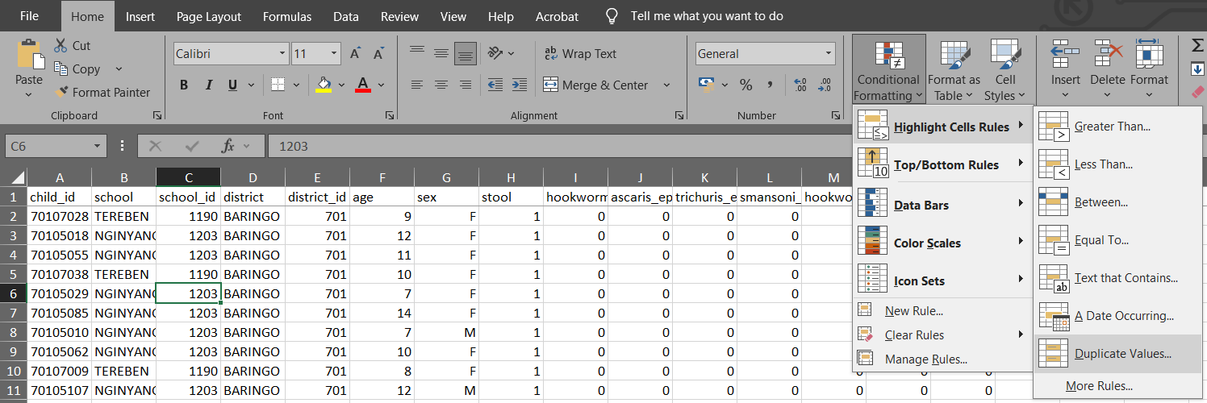

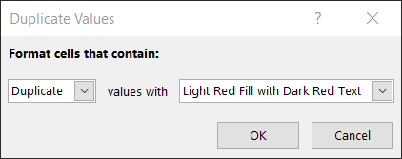

Part 2). Removing Duplicates.

Step 1: Select all the columns of existing worksheet. Now go to Data Tab, then select Filter, and select Remove Duplicates.

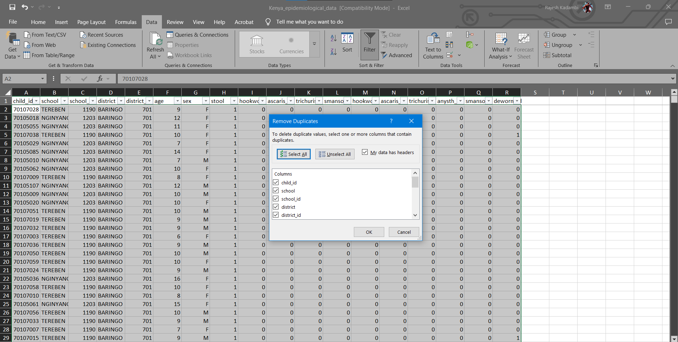

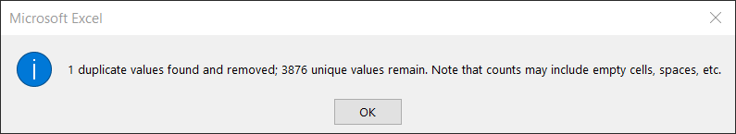

Part 3). Verifying Plausibility of Data.

Step 1: In the current worksheet, select the sex column. Now type Ctrl + F and use Replace Function and Replace as follows:
M-1
F-2
Please keep track of how many values are getting replaced.

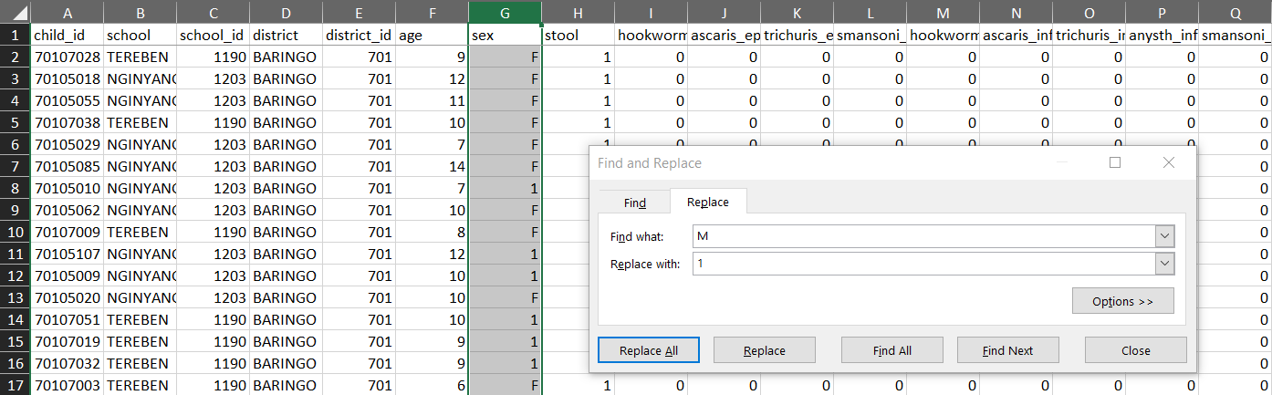

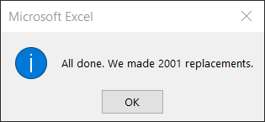

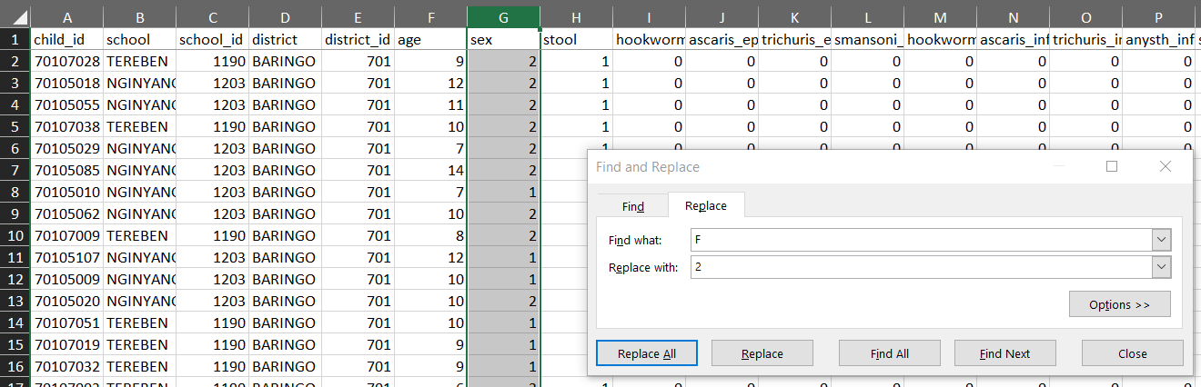

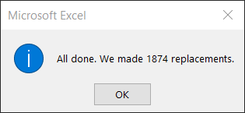

Step 2: Coding of variables:
Select the age column in the existing worksheet. Now go to Insert tab and select Scatter. You will set chart as shown below.

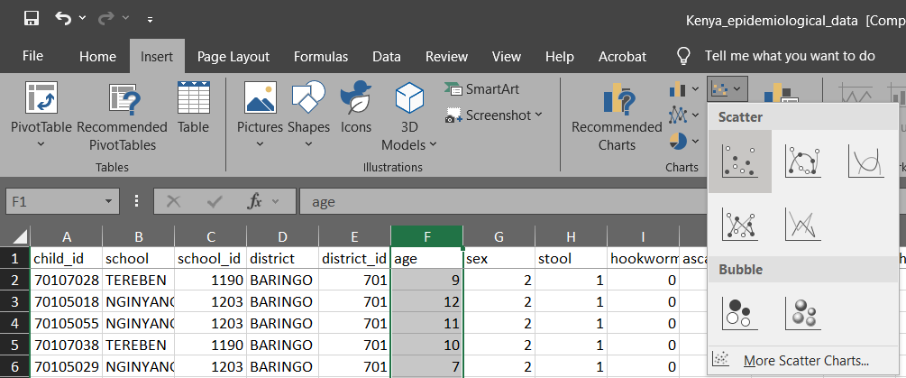

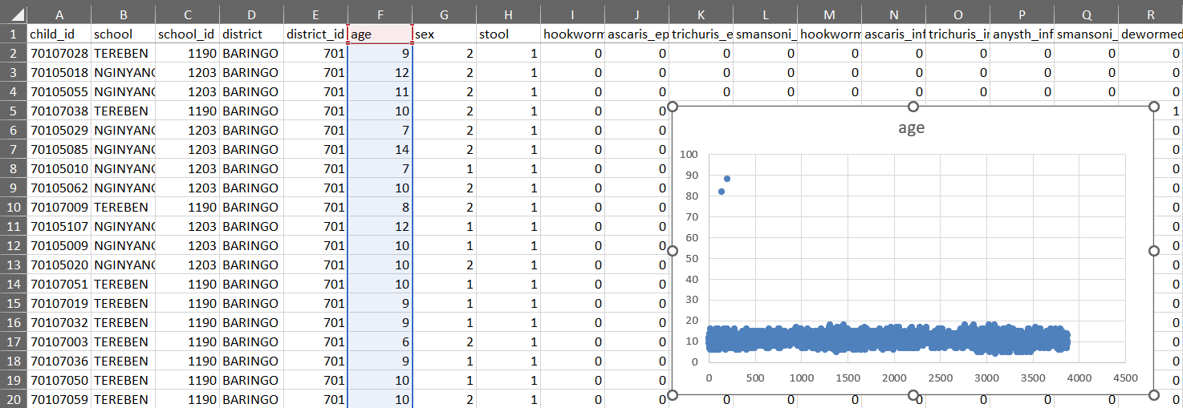

Step 3: Using a filter to detect outliners
First go to the Home Tab>Sort and Filter>Filter. Click and apply the filter to all the columns of the worksheet.
Now click on age filter and click on Number Filter> Greater Than option and type the value 20 in greater than field.

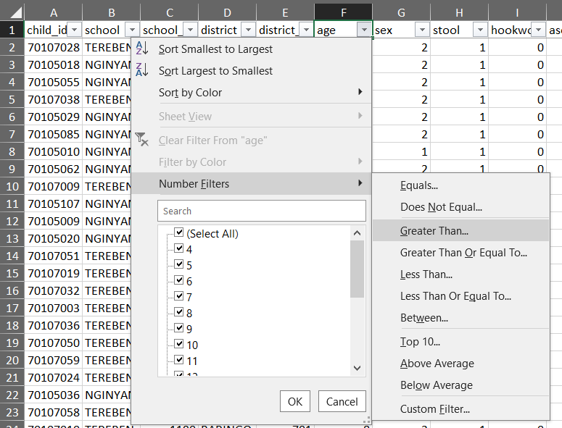
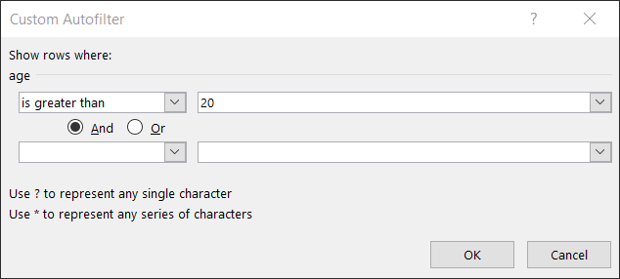

Part 4). Logical Data Checks

Step 1: Cross Tabulations
Open the existing worksheet. Now go to Insert Tab and select Pivot table function.

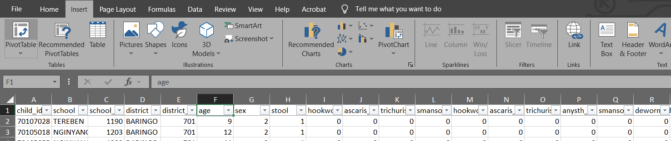

Select New Worksheet and click OK.

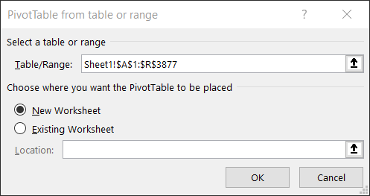

Step 3: An empty table is inserted in a new sheet and a window will open on the right-hand side named PIVOT TABLE FIELD LIST.

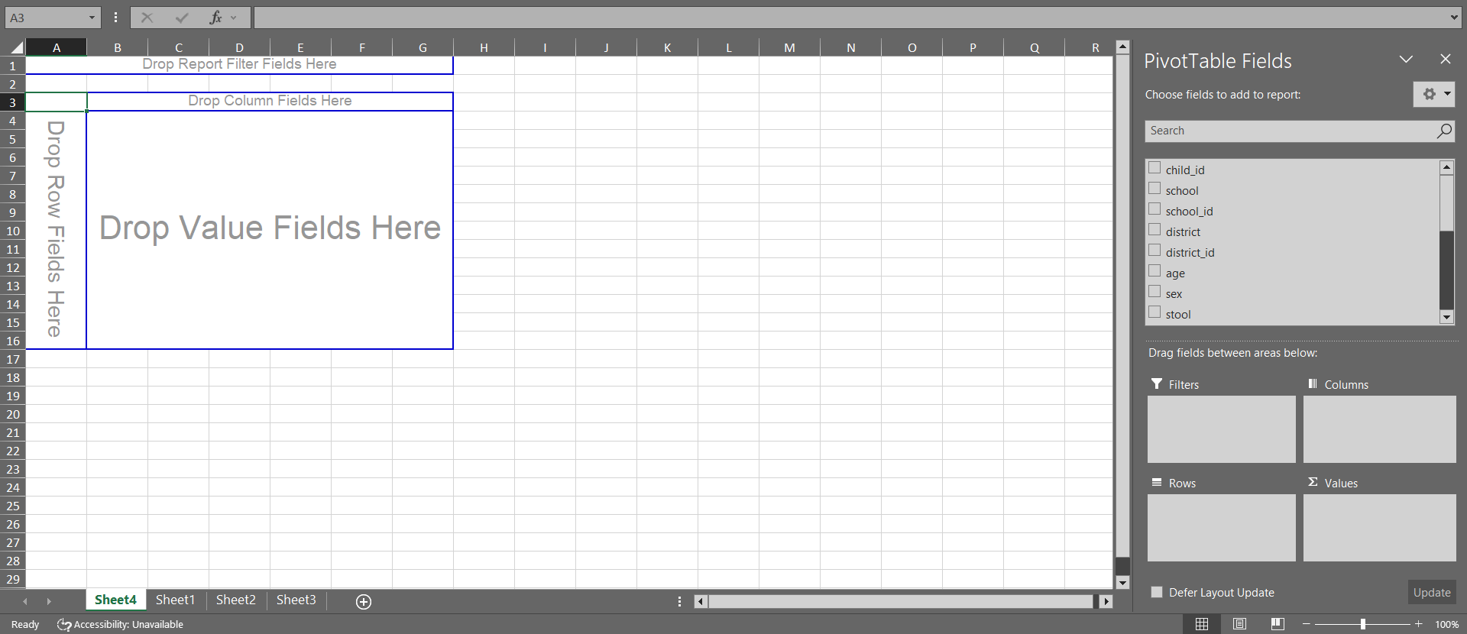

Step 4: From the PivotTable Field List, drag the “stool” item and drop it into the “Row Label” field as show above.
Similarly, click on anysth_inf and draw it into the “Column labels” and “Σ Values” field.
To include the count of observations in the table you might need to change the value field settings to count.
Click on the combo box Sum of stools and Click on Value Field Settings.
Change the value in Summarize value filed by to Count and click OK. Table is updated with count values as shown below.

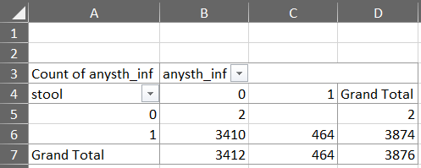

Step 5: Formulas
Open the existing worksheet. Create a new column with the variable called check. Type the following formula in S2 column of worksheet =IF(AND(H2=0, NOT(P2="")),1,0).
Now copy the formula to all other cells (ensure that the formula is copied to all rows in your dataset)
Now use the filter to show only entries with a check value of 1.

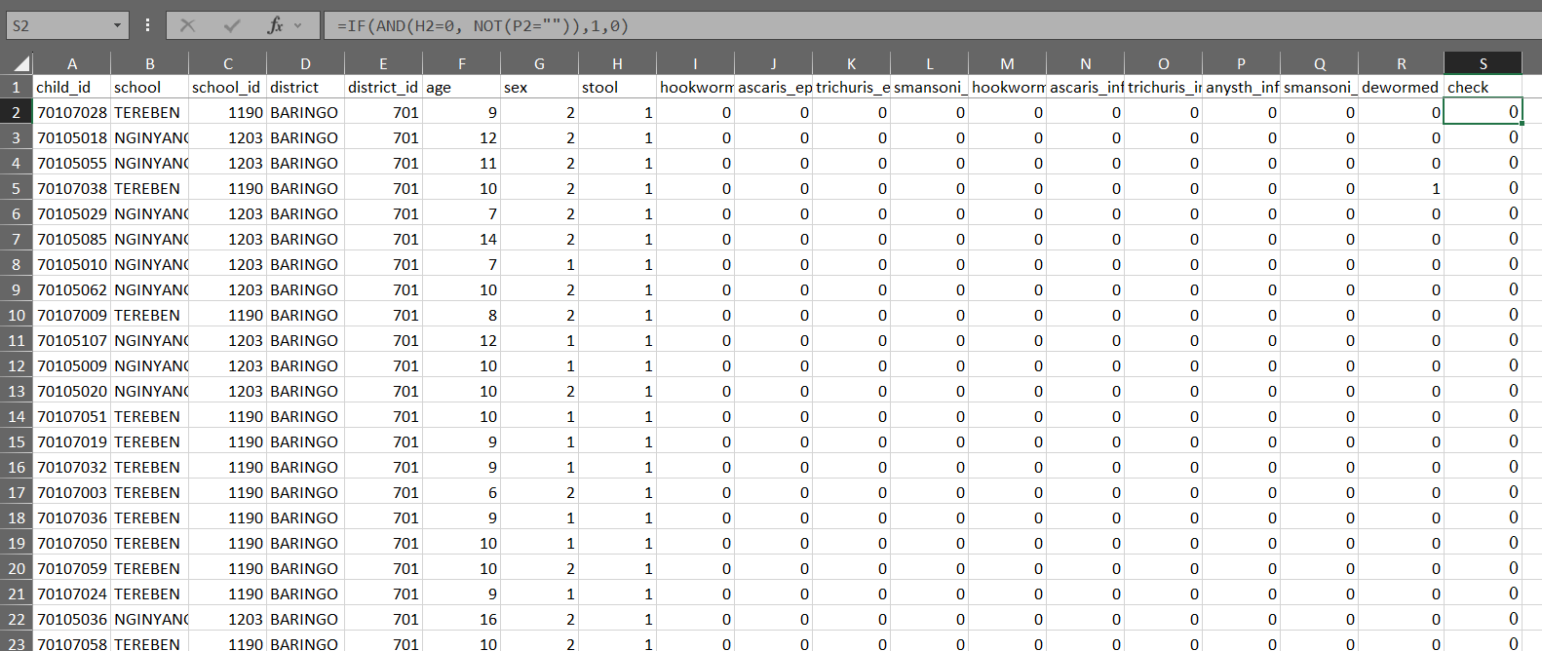

Part 5). Actual QGIS Implementation.

Step 1: Go to Layer → Add Layer → Add Vector Layer → Select the file “Kenya admin.shp”

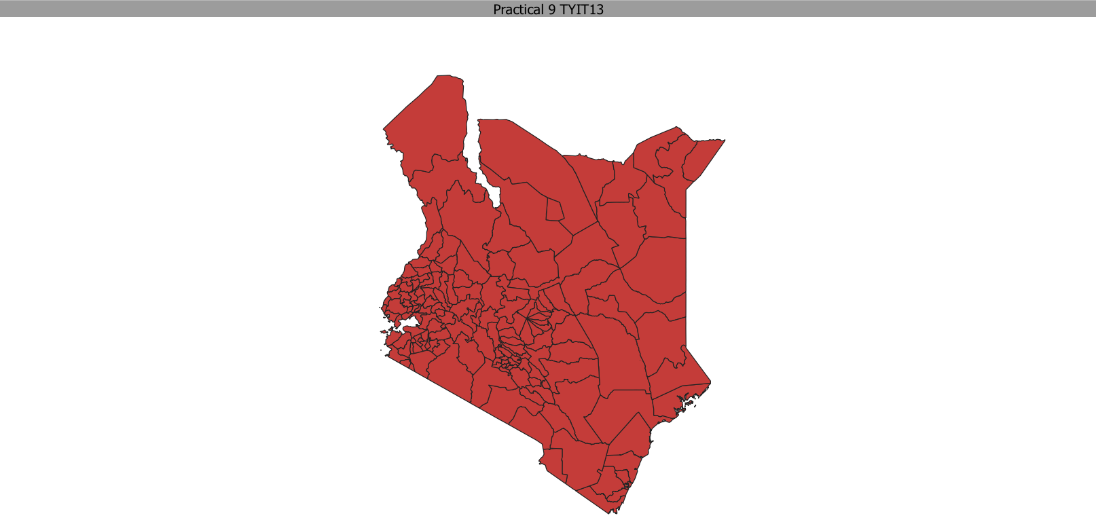

Step 2: Go to Layer → Add Layer → Add Delimited Text Layer → Fill the info as below. Set the file name as Kenya_school_location.csv. file format: CSV, Geometry Definition: Point Coordinates. Geometry CRS: EPSG:4326 - WGS84.
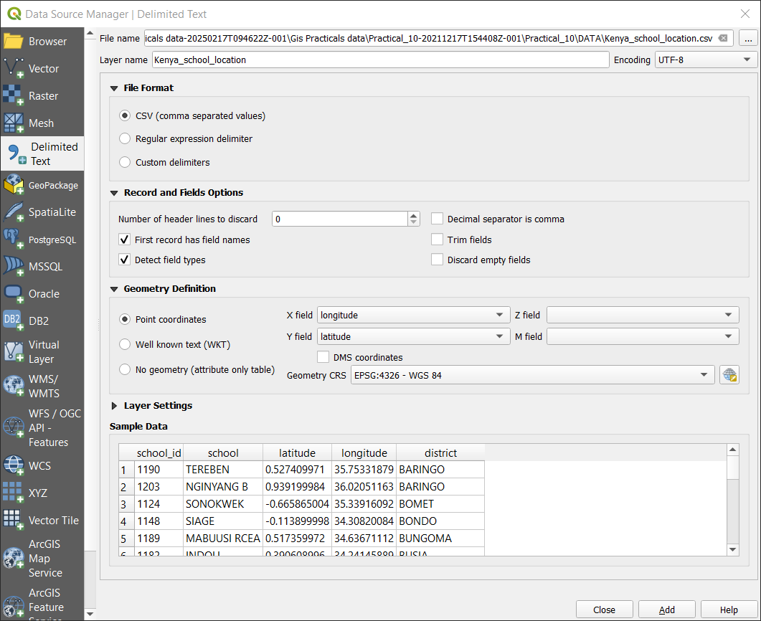

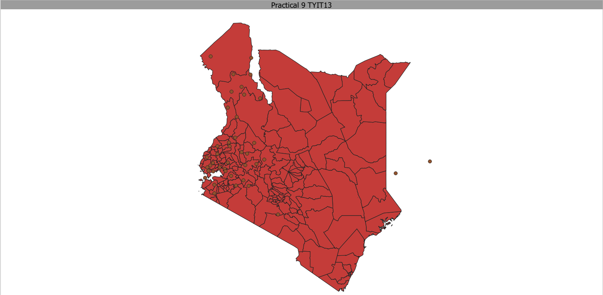

Step 3: As you can see 2 points are not on the map. To examine this, we need to save these layers as a Shapefile, to do that select both the layers Kenya_school_location and Kenya admin, then right click on them and choose Save Features As…

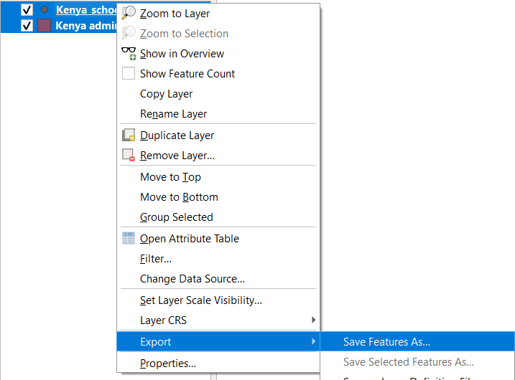
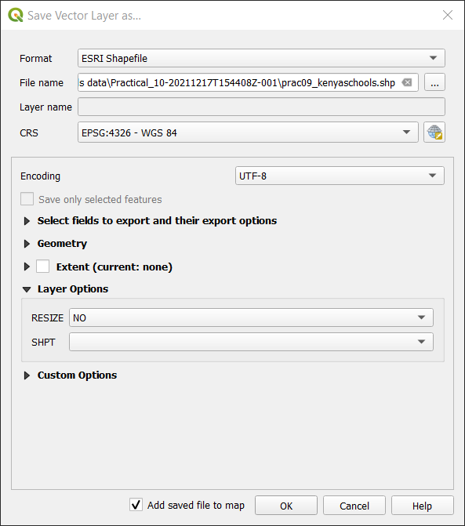

Save it and unselect the Kenya_school_location layer.

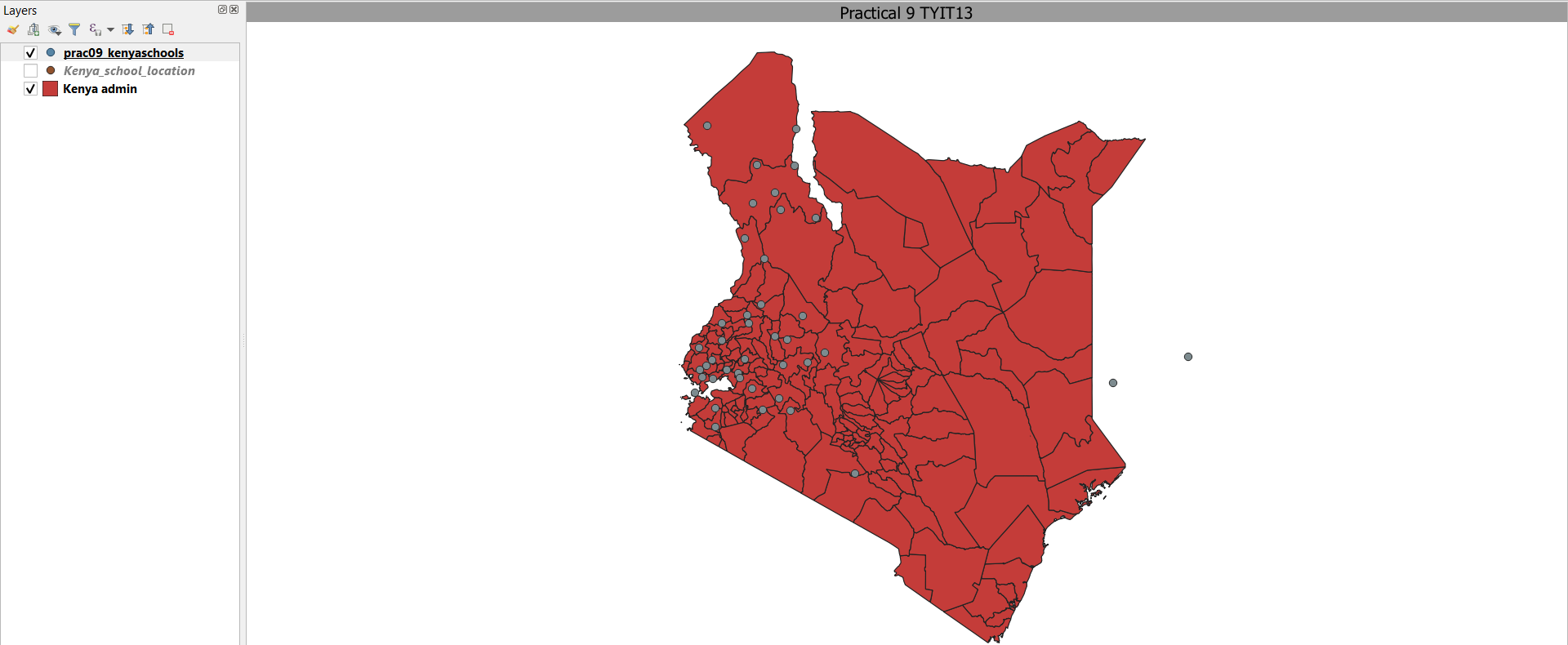

Step 4: Click on the  button and use it to find features of the school location on the map.

