5A). A client server-based program using TCP to find if the number entered is prime.

Theory:
This program utilizes a client-server architecture where the client sends a number to the server using TCP (Transmission Control Protocol) sockets. The server receives the number, performs a primality test, and sends the result back to the client.
Client-Side:
- The client accepts user input for a number to be checked for primality.
- It establishes a TCP connection with the server.
- It sends the number to the server over the established TCP connection.
Server-Side:
- The server waits for incoming TCP connections from clients.
- Upon connection from a client, it receives the number.
- It performs a primality test on the received number.
- It sends the result (whether the number is prime or not) back to the client over the same TCP connection.
Primality Test:
- The server utilizes a primality test algorithm to determine whether the received number is prime.
- Common algorithms include the trial division method, the Sieve of Eratosthenes, or probabilistic methods like the Miller-Rabin primality test.
- The selected algorithm checks whether the number is divisible by any integer between 2 and the square root of the number (for efficiency).
- If the number is found to be divisible by any integer other than 1 and itself, it is not prime; otherwise, it is prime.
TCP Communication:
- TCP (Transmission Control Protocol) is used for communication between the client and server.
- TCP ensures reliable, ordered, and error-checked delivery of data between applications.
- It provides a connection-oriented protocol, establishing a virtual circuit between the client and server.
- TCP sockets are utilized to establish and manage the communication channels between the client and server.

Code:
svrPrime.java
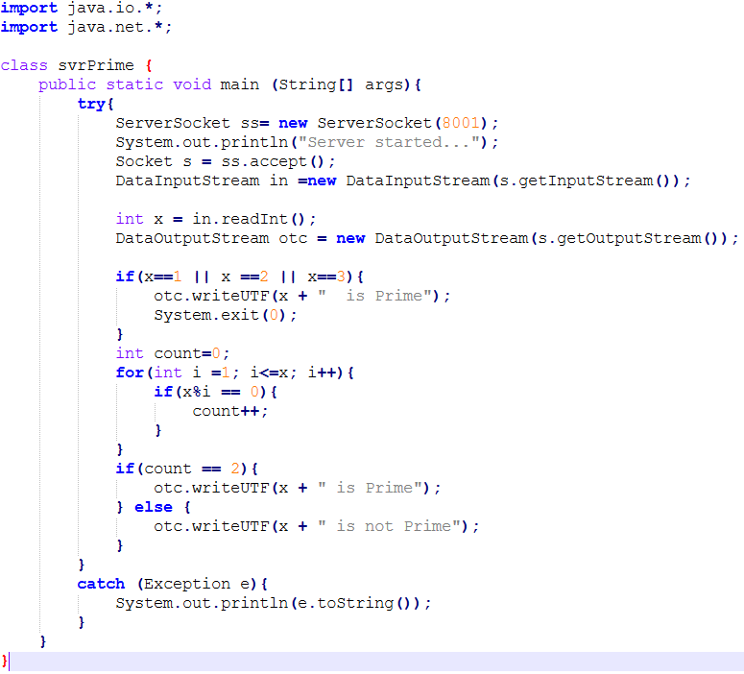

clntPrime.java
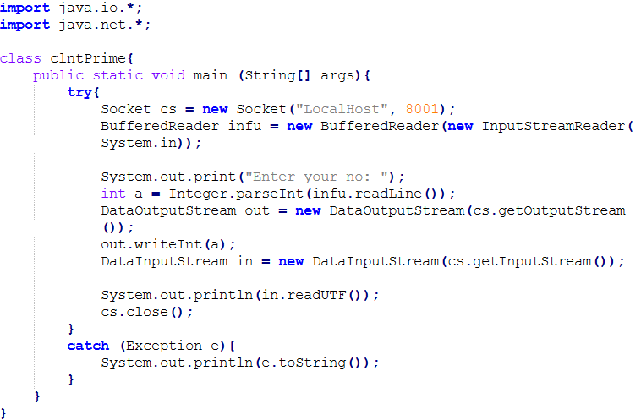

Output:
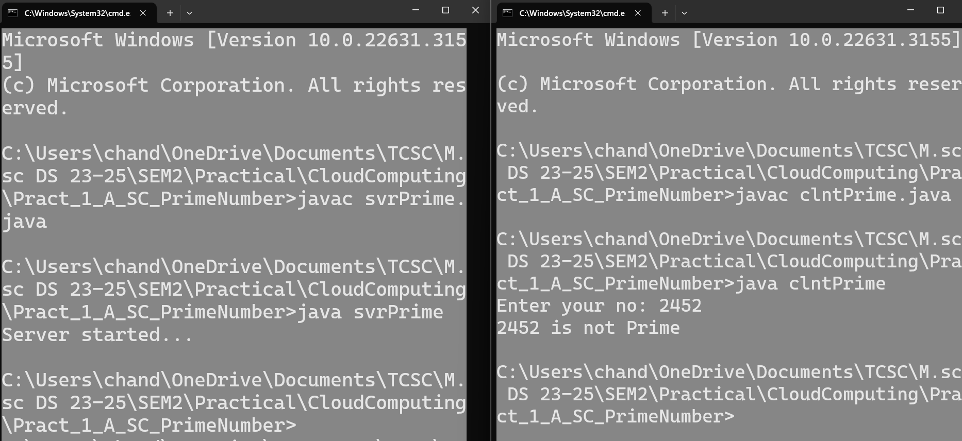
5B). A client server TCP based chatting application.

Theory:
This program utilizes a client-server architecture where the client sends a message to the server using TCP (Transmission Control Protocol) sockets. The server receives the message and also sends message to the client.
Client-Server Model:
- The application follows a simple client-server model where one client connects to a single server.
- The client sends messages to the server, which relays them back to the same client in this simplified setup.
Connection Establishment:
- The client initiates a TCP connection to the server by specifying its IP address and port number.
- Upon successful connection, the client can send and receive messages through this TCP connection.
Message Exchange:
- The client sends messages to the server over the established TCP connection.
- The server receives the messages and echoes them back to the same client.
- The client displays both sent and received messages in its user interface.
TCP Protocol:
- TCP is used for communication between the client and server.
- TCP ensures reliable, ordered, and error-checked delivery of messages.
- It provides a connection-oriented protocol, establishing a virtual circuit between the client and server.

Code:
svrChat.java
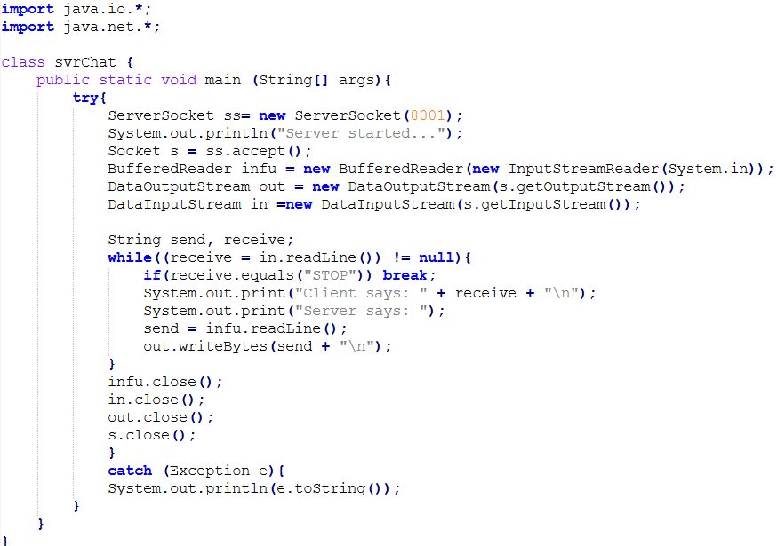

clntChat.java
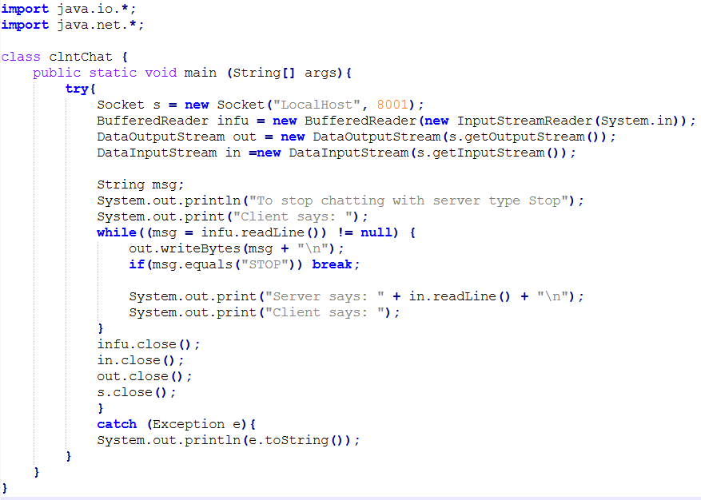

Output:
