6A) A client server-based program using UDP to find if the number entered is even or odd.
svrUdpEO.java:
import java.io.*;
import java.net.*;
public class svrUdpEO {
public static void main(String[] args) {
try {
System.out.println("Server started...");
DatagramSocket ds = new DatagramSocket(2000);
byte b[] = new byte[1024];
DatagramPacket dp = new DatagramPacket(b, b.length);
ds.receive(dp);
String str = new String(dp.getData(), 0, dp.getLength());
System.out.println("Recieved Number: " + str);
int a = Integer.parseInt(str);
String s = new String();
if (a % 2 == 0)
s = "Number is even";
else
s = "Number is odd";
byte b1[] = new byte[1024];
b1 = s.getBytes();
DatagramPacket dp1 = new DatagramPacket(b1, b1.length, InetAddress.getLocalHost(), 1000);
ds.send(dp1);
} catch (Exception e) {
e.printStackTrace();
}
}
}

clntUdpEO.java:
import java.io.*;
import java.net.*;
public class clntUdpEO {
public static void main(String args[]) {
try {
DatagramSocket ds = new DatagramSocket(1000);
BufferedReader br = new BufferedReader(new InputStreamReader(System.in));
System.out.print("Enter a number: ");
String num = br.readLine();
byte b[] = new byte[1024];
b = num.getBytes();
DatagramPacket dp = new DatagramPacket(b, b.length, InetAddress.getLocalHost(), 2000);
ds.send(dp);
byte b1[] = new byte[1024];
DatagramPacket dp1 = new DatagramPacket(b1, b1.length);
ds.receive(dp1);
String str = new String(dp1.getData(), 0, dp1.getLength());
System.out.print(str);
} catch (Exception e) {
e.printStackTrace();
}
}
}

Output:

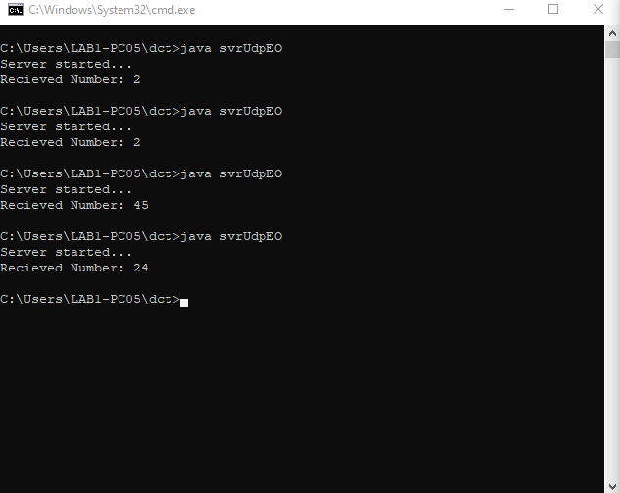

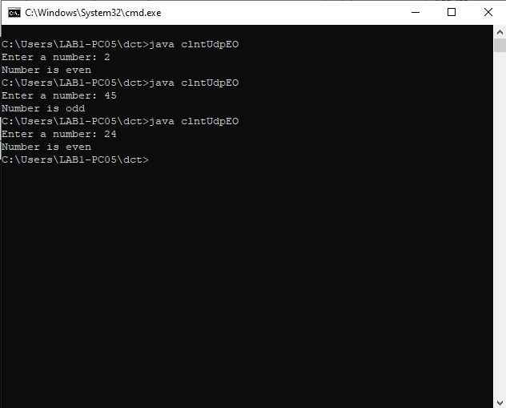

6B) A program to implement simple calculator operations like addition, subtraction, multiplication & division.

svrRPC.java:
import java.util.*;
import java.net.*;
class svrRpc {
DatagramSocket ds;
DatagramPacket dp;
String str, methodName, result;
int val1, val2;
svrRpc() {
try {
ds = new DatagramSocket(1200);
byte b[] = new byte[4096];
while (true) {
dp = new DatagramPacket(b, b.length);
ds.receive(dp);
str = new String(dp.getData(), 0, dp.getLength());
if (str.equalsIgnoreCase("q")) {
System.exit(1);
} else {
StringTokenizer st = new StringTokenizer(str, " ");
int i = 0;
while (st.hasMoreTokens()) {
String token = st.nextToken();
methodName = token;
val1 = Integer.parseInt(st.nextToken());
val2 = Integer.parseInt(st.nextToken());
}
}
System.out.println(str);
InetAddress ia = InetAddress.getLocalHost();
if (methodName.equalsIgnoreCase("add")) {
result = "" + add(val1, val2);
} else if (methodName.equalsIgnoreCase("div")) {
result = "" + div(val1, val2);
} else if (methodName.equalsIgnoreCase("sub")) {
result = "" + sub(val1, val2);
} else if (methodName.equalsIgnoreCase("mul")) {
result = "" + mul(val1, val2);
}
byte b1[] = result.getBytes();
DatagramSocket ds1 = new DatagramSocket();
DatagramPacket dp1 = new DatagramPacket(b1, b1.length, InetAddress.getLocalHost(), 1300);
System.out.println("result: " + result + "\n");
ds1.send(dp1);
}
} catch (Exception e) {
e.printStackTrace();
}
}

public int add(int val1, int val2) {
return val1 + val2;
}
public int sub(int val1, int val2) {
return val1 - val2;
}
public int mul(int val1, int val2) {
return val1 * val2;
}
public int div(int val1, int val2) {
return val1 / val2;
}
public static void main(String[] args) {
new svrRpc();
}
}

clntRPC.java:
import java.io.*;
import java.net.*;
class clntRpc {
clntRpc() {
try {
InetAddress ia = InetAddress.getLocalHost();
DatagramSocket ds = new DatagramSocket();
DatagramSocket ds1 = new DatagramSocket(1300);
System.out.println("\nRPC Client\n");
System.out.println("Enter method name and parameter like add 3 4\n");
while (true) {
BufferedReader br = new BufferedReader(new InputStreamReader(System.in));
String str = br.readLine();
byte b[] = str.getBytes();
DatagramPacket dp = new DatagramPacket(b, b.length, ia, 1200);
ds.send(dp);
dp = new DatagramPacket(b, b.length);
ds1.receive(dp);
String s = new String(dp.getData(), 0, dp.getLength());
System.out.println("\nResult = " + s + " \n");
}
} catch (Exception e) {
e.printStackTrace();
}
}
public static void main(String[] args) {
new clntRpc();
}
}

Output:

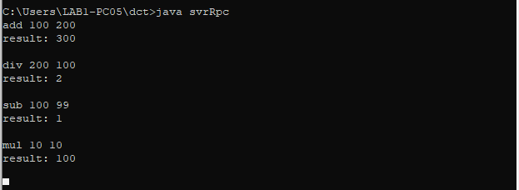

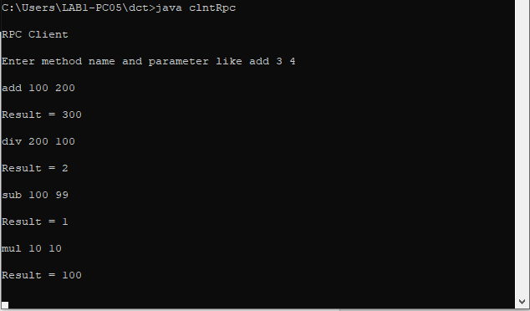

7) Multicast Socket example.

svrBroadcast.java:
import java.net.*;
import java.io.*;
import java.util.*;
public class svrBroadcast {
public static final int PORT = 1234;
public static void main(String args[]) throws Exception {
//Creating a Multicast Socket (one sender multiple receivers)
MulticastSocket socket;
DatagramPacket packet;
InetAddress address;
address = InetAddress.getByName("239.1.2.3");
socket = new MulticastSocket();
socket.joinGroup(address);
byte[] data = null;
for (;;) {
Thread.sleep(10000);
System.out.println("Sending ");
String str = ("This is Lufffy Calling....");
data = str.getBytes();
packet = new DatagramPacket(data, str.length(), address, PORT);
socket.send(packet);
}
}
}

clntBroadcast.java:
import java.net.*;
import java.io.*;
public class clntBroadcast {
public static final int PORT = 1234;
public static void main(String args[]) throws Exception {
MulticastSocket socket;
DatagramPacket packet;
InetAddress address;
address = InetAddress.getByName("239.1.2.3");
socket = new MulticastSocket(PORT);
socket.joinGroup(address);
byte[] data = new byte[100];
packet = new DatagramPacket(data, data.length);
for (;;) {
socket.receive(packet);
String str = new String(packet.getData());
System.out.println("Message received from " + packet.getAddress() + "Message is: " + str);
}
}
}

Output:

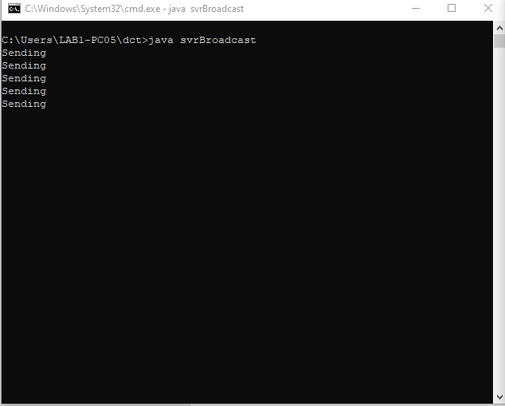

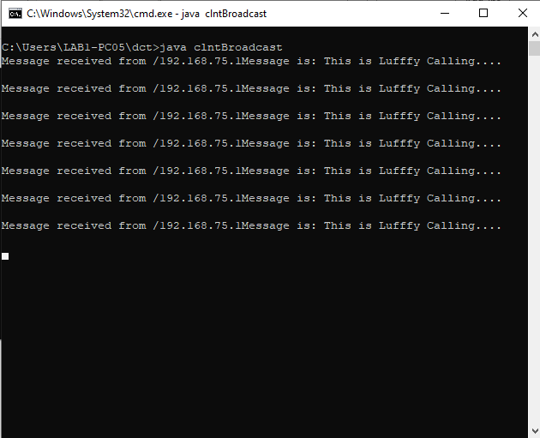

8) RMI based application program to display current date & time.

InterDate.java:
import java.rmi.*;

public interface InterDate extends Remote{
String display() throws Exception;
}

ServerDate.java:
import java.rmi.*;
import java.rmi.server.*;
import java.util.*;
public class ServerDate extends UnicastRemoteObject implements InterDate {
public ServerDate() throws Exception {}
public String display() throws Exception {
String str = "";
Date d = new Date();
str = d.toString();
return str;
}
public static void main(String args[]) throws Exception {
ServerDate s1 = new ServerDate();
Naming.bind("DS", s1); //Bind the server to the RMI Registry
System.out.println("Object registered.....");
}
}

ClientDate.java:
import java.rmi.*;
import java.io.*;
public class ClientDate {
public static void main(String args[]) throws Exception {
String s1;
InterDate h1 = (InterDate) Naming.lookup("DS");
s1 = h1.display();
System.out.println(s1);
}
}

Output:

