1. Menus are the additional options that can be displayed using menu button present on mobile. Options that are not directly visible on the UI are displayed by the menu. They are mainly used to save space of the activity.
2. Options menu is the primary collection of the menu items for an activity. If one is using Android 2.3 or lower , the options menu can be revealed by clicking the Menu button. For Android 3.0 or higher version items of the options menu can be presented by the action bar as a combination of on screen action items and overflow options.

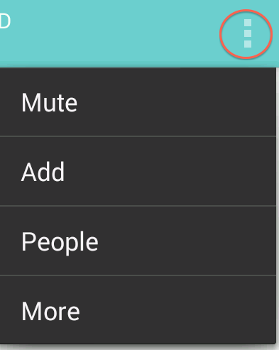

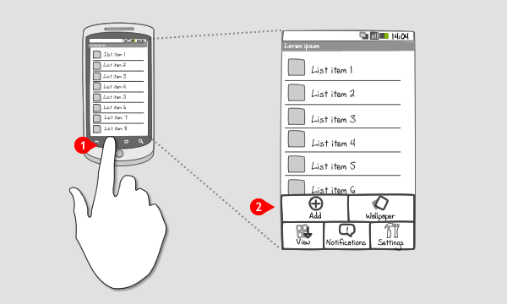

1. Context menu is a type of menu that is displayed when user taps and holds on the view. Once displayed different actions can be performed . Different views can have different context menu.

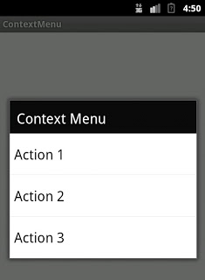

1. If the ActionBarActivity is deprecated one can use AppCompatActivity .So that is the alternative.