

School of Future Tech

DSA Mini Project — Case Study 5

on

Video Streaming Buffer Optimization

Determining Minimum Buffer Size for Stall-Free Playback

Group NO -5

NAME - SAHIL KUMAR
ROLL NO - 150096725039

INDEX
- Introduction
- Problem Statement & Abstract
- Case Study Design
- Methods & Algorithms Used
- Implementation Details
- Results & Analysis
- Conclusion
- References

1. Introduction
Video streaming platforms such as YouTube and Netflix rely on continuous data delivery to ensure smooth playback. However, network bandwidth is often unstable, leading to interruptions known as buffering. This negatively impacts user experience.
This case study focuses on designing a system to determine the minimum buffer size required to ensure uninterrupted video playback, even under fluctuating network conditions.
The system simulates real-world streaming scenarios and applies Data Structures and Algorithms (DSA) concepts to compute the optimal buffer efficiently.

2. Problem Statement & Abstract

Problem Statement
Given:
- A sequence of bandwidth values (KB/s) over time
- A fixed video bitrate (KB/s)
Find:
The minimum initial buffer size required such that the video plays without any interruption (buffer never becomes negative).

Abstract
This project presents a solution to optimize video streaming using algorithmic techniques. It models the buffer as a dynamic system where data is added (bandwidth) and consumed (bitrate). Two approaches are implemented:
- Binary Search with simulation
- Optimal Prefix Sum method
The system also includes:
- Network analysis
- Playback simulation
- Automated testing
The results demonstrate that efficient algorithms can significantly improve streaming performance while minimizing memory usage.

3. Case Study Design
The system is designed as a pipeline:

1. Input Stage
- User provides bandwidth data OR selects preset scenarios

2. Processing Stage
- Apply Binary Search to find buffer
- Apply Optimal O(n) method

3. Analysis Stage
- Compute network statistics
- Identify worst network conditions

4. Output Stage
- Display buffer size
- Show recommendations
- Simulate playback

4. Methods & Algorithms Used

1. Binary Search
- Used to find minimum buffer efficiently
- Works on monotonic property
- Time Complexity: O(n log n)

2. Linear Simulation
- Simulates playback second-by-second
- Checks if buffer becomes negative
- Time Complexity: O(n)

3. Prefix Sum (Optimal Method)
- Calculates running deficit
- Finds worst case directly
- Formula:
Buffer = max(0, -minimum prefix sum)
- Time Complexity: O(n log (n × bitrate))

4. Sliding Window
- Finds worst consecutive bandwidth period
- Helps in network analysis

5. Data Structures Used
- vector<int> → stores bandwidth
- struct → stores network statistics

5. Implementation Details
The program is written in C++ and consists of the following components:

1. Input Module
- Accepts user input or preset scenarios

2. Core Functions

a) Playback Simulation
- Checks if buffer is sufficient

b) Binary Search Function
- Finds minimum buffer using search

c) Optimal Function
- Computes buffer using prefix sums

3. Additional Features
- Network analysis (average, jitter, stability)
- Buffer recommendation (minimum, safe, robust)
- Visual playback simulation

4. Menu System
User options:
- Custom input
- Preset scenarios
- Test suite
- Complexity analysis
- Exit

6. Results & Analysis

Sample Output
The program successfully computes buffer values for different scenarios.
Example:
- Required buffer: 130 KB
- No stalls observed
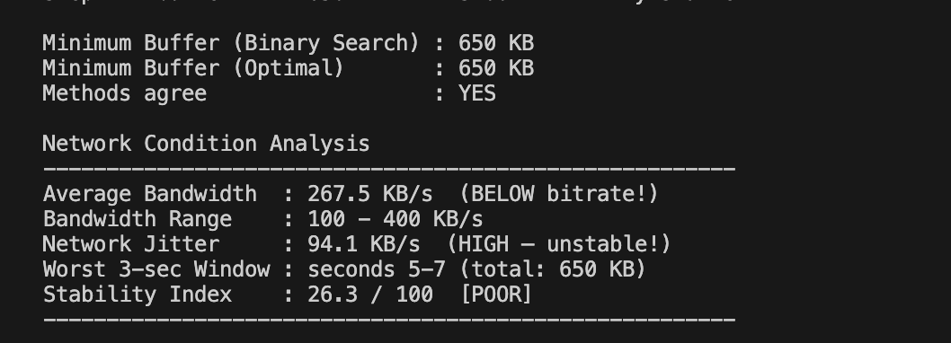

Test Results
All test cases passed:
- Edge cases ✔
- Real-world cases ✔
- Extreme cases ✔

Network Analysis
The system provides:
- Average bandwidth
- Jitter (stability)
- Worst-case periods



Buffer Recommendation
Type | Description
Minimum | Exact value
Safe | +20% margin
Robust | +50% margin

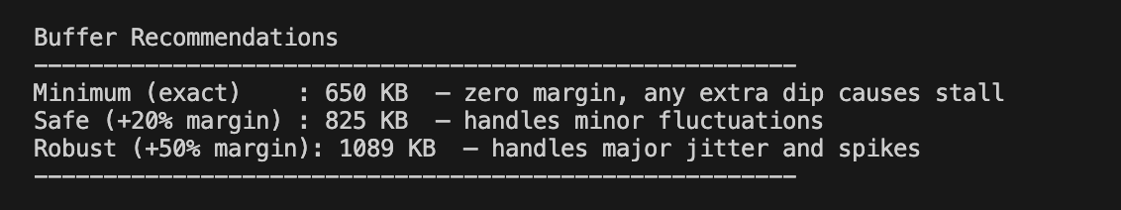

Playback Simulation

- The playback simulation shows second-by-second buffer updates
- based on bandwidth variation and video bitrate consumption.
- The system ensures smooth playback without stalls.

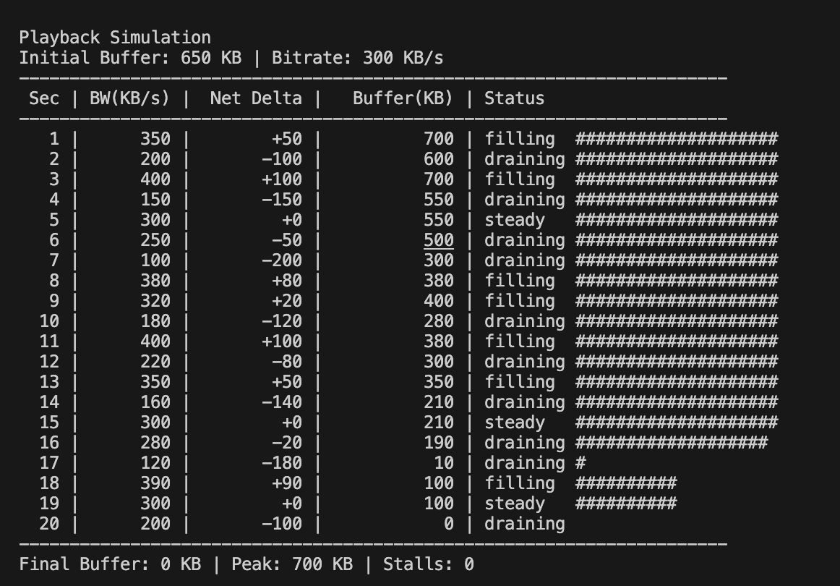

7. Conclusion
This project successfully demonstrates how DSA concepts can solve real-world problems in video streaming systems for efficient buffer optimization.
Key achievements:
- Determined minimum buffer size accurately
- Implemented efficient algorithms
- Simulated real-world network conditions
- Improved user experience

Key Learnings
- Binary Search can be applied to answer space
- Prefix Sum provides optimal solutions
- Sliding Window helps analyze real-time data

8. References
- C++ Standard Library Documentation
- Data Structures and Algorithms textbooks
- Online resources on streaming systems
- Lecture materials

